Science week 12- 29/06/20

HOW TO MAKE A SQUARE BUBBLE
Bubbles are made from a thin film of soapy water filled with air. When you blow a bubble, the film of soapy water expands outwards to form a sphere. Whatever shape bubble wand you use you’ll always get a spherical bubble.
You can make your own bubble wands made into different shapes with pipe cleaners and straws.
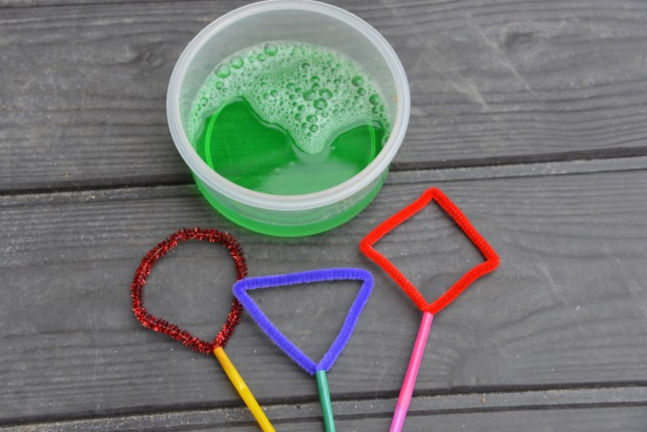

WHY ARE BUBBLES ROUND?
The forces acting between the molecules of the bubble cause it to form the shape that encloses the most volume with the least surface area — a sphere. That is why when you try to blow a bubble through a shaped wand it still becomes a circle.

WHY DO YOU SEE COLOURS INSIDE BUBBLES?
Light from the sun contains a range of colours all with different wave lengths.These colours are: RED, ORANGE, YELLOW, GREEN, BLUE, INDIGO AND VIOLET. When the light shines through the bubble film it is reflected and dispersed, which splits it into different wave lengths and showing all the colours.

WHAT YOU NEED TO MAKE A SQUARE BUBBLE
Materials to make a square frame – pipe cleaners or straws work well and Strong bubble mix

INSTRUCTIONS
Create a square frame like the one in the image below.
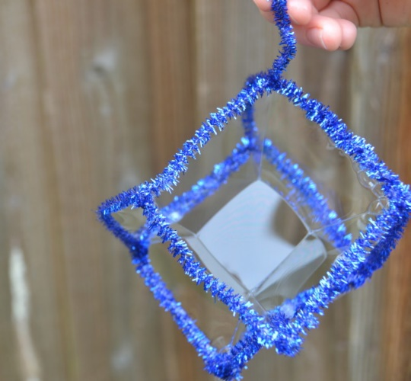
Dip your square frame into the bubble mix, so all side are covered in mix.
Carefully lift out the frame and admire your square bubble.

WHY IS THE BUBBLE SQUARE?
The soap film sticks to all six sides of the cube, the bubbles on the side push against the middle bubble giving it corners and sides like a cube.
You should notice however that the bubble isn’t a perfect square, it’s still trying to become a sphere and doesn’t have straight lines.
See link for a video: https://www.science-sparks.com/how-to-make-a-square-bubble/

Science – 06/07/20

EGGY ZIP WIRE
Can you build a harness to transport an egg down a zip wire? This is a great activity for learning about friction. Try changing the type of string used to make the zip wire to investigate. Once you’ve built a suitable harness for a chocolate egg, you could try a real egg ( maybe boil it first ) and test to see if the harness works for that too.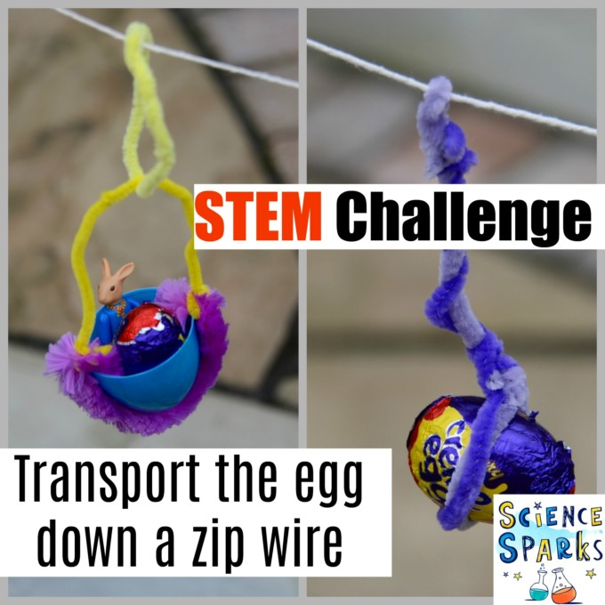
WHAT YOU’LL NEED TO MAKE AN EGG ZIP WIRE
String, wire or wool
Pipe cleaners and straws
Plastic eggs/chocolate eggs/eggs
Timer

EGG ZIP LINE METHOD- This is a great activity for learning about setting up an investigation as a fair test.
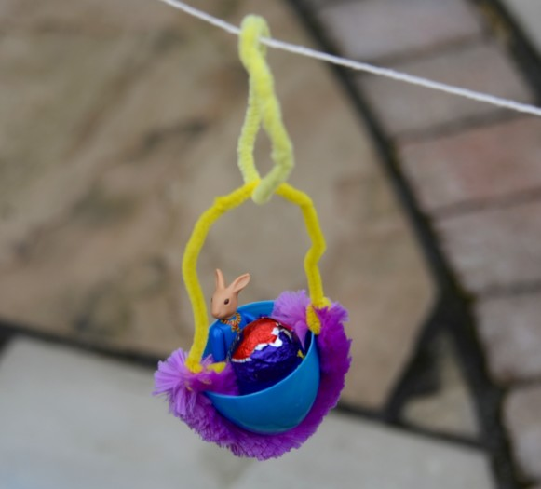
Variables
Type of zip wire
Incline of zip wire
Weight of egg
Type of harness
To test one variable, all the others must remain the same each time you test. For example, to investigate whether the weight of the egg changes how long it takes to travel down the zip wire, keep the type of wire, incline and harness exactly the same and change ONLY the weight of the egg. We usually repeat each test 3 times and calculate the average time.
Once you’ve identified the variables, choose one to test. If you want to investigate how the material the zip wire is made from affects the speed the egg travels down the wire, you’ll need to use the same harness, same egg and have the zip wire at the same incline when you test each type of zip wire.

THINGS TO THINK ABOUT
Friction – we found our egg took longer to travel down a zip wire made with rough string than smooth wire, this is because there was more friction between the rough string and harness than smooth string and harness.
Try a harness made using a segment of straw running over the zip wire. The inside of a straw is smooth meaning there shouldn’t be much friction between the straw and wire.
https://www.science-sparks.com/egg-stem-challenge/

