

Reading extract:

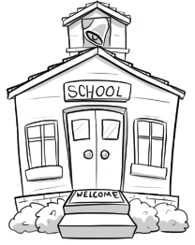
Victorian Academy
A new school for the 1890s

Now that you can’t send your little ones up a chimney or down a mine, where can you be sure that they’ll learn equally tough lessons in life? Victorian Academy (formally the Ragged School) is the answer you should have given. Now, write it out one hundred times.
Ours is a school with values – Victorian values. But, as we approach the end of both the century and Queen Victoria’s reign, we also want to look forward to the future. That is why we promise the very best in modern teaching.
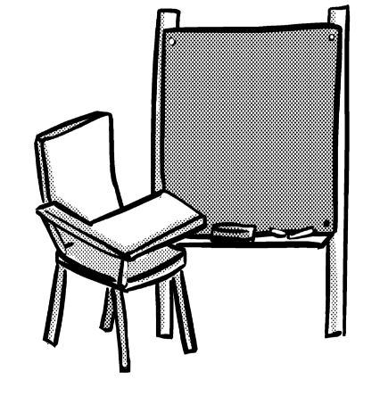
Lessons for today’s Britain
As you would expect, we have a clear focus on ‘the three Rs’ – Reading, wRiting and aRithmetic. However, we also believe that ‘the three Ds’ are just as important – Discipline, Dullness and the Dunce’s Hat. Our children enjoy a wide range of English lessons, from copying down what is written on the blackboard, to copying down what the teacher is saying. In maths, they experience the sheer joy of chanting times tables for hours on end. In topic, they might also learn exciting lessons about the world around them by reciting the names of all the stations on a given railway line. Whoo-whoo!
Stern staff
Hand-picked for their meanness and scary scowls, our super-strict teachers make sure the first thing the children learn is not to breathe without permission. Regular use of the cane ensures that the only colour in their lessons is black and blue! We also value experience in our teaching support staff (much more than skill or knowledge). Most of them will have been pupils themselves very recently and will be keen to give as good as they got last year.
No room for fun
We offer the perfect setting for focused learning. Our cold, drab classrooms can pack-in up to sixty pupils at a time. They have high-set windows to prevent children getting distracted by anything of interest. And of course, we keep boys and girls as far apart as possible.
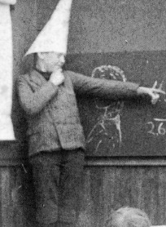
When you send your children to the Victorian Academy, you can rest assured that they will hate every minute of it – as every child should. What’s more, with all the repetition, misery and harsh rules, you can be sure that they’ll never learn to think for themselves. There is simply no better preparation for today’s workplace!
Victorian Academy
It’s free, isn’t it? What did you expect?

Questions Week 1

Vocabulary:

1. Look at the first paragraph. Find and copy a word that means hard.

_________________________________________________________________

2. … Regular use of the cane … What does regular mean?

_________________________________________________________________

3. … you can rest assured … Which group of words means the same as rest assured? Tick one.

sit back tell them

scare them be confident

Retrieval
4. Where can parents no longer send their children?

_________________________________________________________________

5. What were “the three Ds”?

_________________________________________________________________

6. What does it say children might learn in topic?

_________________________________________________________________

Inference
7. … Now write it out one hundred times … How does this sentence make the reader feel about the academy?

_________________________________________________________________

8. Look at the section headed Lessons for today’s Britain. What does it suggest about the English lessons?

_________________________________________________________________

9. Look at the last paragraph. What do you think jobs in Victorian Britain were like?

____________________________________________________________________________________

Summarise
10. Here are some summaries of different paragraphs in the text. Number them from 1 to 4 to show the order in which they appear in the text.

Victorian school lessons were boring.
Victorian schoolrooms were dull.
Victorian teachers were strict and horrible.
The Victorian Academy is a modern school (for the 1890s)

Predict
11. What do you think parents would say about the Victorian Academy if they were:

- living in Victorian times?________________________________________________________

- living now?___________________________________________________________________

Questions week 2

Vocabulary:

1. Look at the first paragraph. Find and copy a word that means the same.

_________________________________________________________________

2. … the three Ds are just as important – Discipline, Dullness and the Dunce’s Hat … Which group of words means the same as discipline in this sentence? Tick one.

other subjects rules and punishment

fun and games circle time

3. …. experience the sheer joy of chanting times tables … What does chanting mean?

_________________________________________________________________

Retrieval
4. Apart from the century, what is approaching its end?

_________________________________________________________________

5. What were ‘the three Rs’?

_________________________________________________________________

6. What does the text say that the pupils of Victorian Academy would never be able to do?

_________________________________________________________________

Inference
7. Look at the first paragraph. What are the Academy’s lessons as tough as?

_________________________________________________________________

8. Look at the section headed Lessons for today’s Britain. Why does it end with the words Whoo-whoo?
Give two reasons.

a. ___________________________________ b. _________________________________________

9. Regular use of the cane ensures that the only colour in their lessons is black and blue! This means …

___________________________________________________________________________________

Summarise
10. Using the whole text, tick one box in each row to show whether each statement is true or false.

 | True | False
The Victorian Academy believes it is a good school.
The Victorian Academy likes to teach fun and exciting lessons.
The boys and girls are allowed to sit together.

Authorial intent
11. … they will hate every minute of it – as every child should … What does this tell you about the attitudes of the Victorians?

_____________________________________________________________________________________

_____________________________________________________________________________________

Answers for Victorian Academy
Week 1:

Vocabulary:
1. tough
2. often/the children were often hit with a cane
3. be confident
Retrieval:
4. up a chimney or down a mine
5. Discipline, Dullness and the Dunce’s Hat
6. the world around them/to recite the names of all the stations on a given railway line
Inference:
7. It makes the Academy seem very strict – so strict that even the reader is punished for getting an answer wrong.
8. They are boring and always involve doing the same thing/all they do is copy/ing.
9. They were repetitive and miserable with harsh rules and didn’t encourage people to think for themselves.
Summarise:
10.

2 Victorian school lessons were boring.
4 Victorian schoolrooms were dull.
3 Victorian teachers were strict and horrible.
1 The Victorian Academy is a modern school (for the 1890s).

Predict:
11. Accept answers that convey similar sentiments to the following:
- Good! Schools should be harsh and strict.
- That’s terrible! I’m not sending my children there!

Commissioned by The PiXL Club Ltd. July 2019
This resource is strictly for the use of member schools for as long as they remain members of The PiXL Club. It may not be copied, sold nor transferred to a third party or used by the school after membership ceases. Until such time it may be freely used within the member school.
All opinions and contributions are those of the authors. The contents of this resource are not connected with nor endorsed by any other company, organisation or institution.
PiXL Club Ltd endeavour to trace and contact copyright owners. If there are any inadvertent omissions or errors in the acknowledgements or usage, this is unintended and PiXL will remedy these on written notification.

© Copyright The PiXL Club Limited, 2019

Answers for Victorian Academy
Week 2:

Vocabulary:
1. equally
2. rules and punishment
3. repeating words over and over (in a rhythmic way) (all together as a class)
Retrieval:
4. the reign of Queen Victoria
5. Reading, wRiting and aRithmetic
6. think for themselves
Inference:
7. working up a chimney or down a mine
8.
- It sounds like a train.
- It can be an expression of excitement or joy.
9. Lessons were boring (lacked colour)/children would get bruised (black and blue) from the cane.
Meaning as a whole:
10.
 | True | False
The Victorian Academy believes it is a good school. | √
The Victorian Academy likes to teach fun and exciting lessons. |  | √
The boys and girls are allowed to sit together. |  | √

Authorial intent:
11. The Victorians believed in the importance of hard work and strict discipline. It didn’t matter whether children enjoyed school or not; what mattered was that they were learning and doing what they were told.

Commissioned by The PiXL Club Ltd. July 2019
This resource is strictly for the use of member schools for as long as they remain members of The PiXL Club. It may not be copied, sold nor transferred to a third party or used by the school after membership ceases. Until such time it may be freely used within the member school.
All opinions and contributions are those of the authors. The contents of this resource are not connected with nor endorsed by any other company, organisation or institution.
PiXL Club Ltd endeavour to trace and contact copyright owners. If there are any inadvertent omissions or errors in the acknowledgements or usage, this is unintended and PiXL will remedy these on written notification.

© Copyright The PiXL Club Limited, 2019

