
Learning Activities
Year 4 2019-20

self-isolation learning Week 12
 | Lessons set | Additional comments
Monday  29/06/2020 | Maths: Please find all maths sheets in the document named ‘Maths week 12-13’.  Complete at least 5 sessions of TT Rockstars.  Measure: finding the perimeter  SLOR: All reading extracts can be found in the document named ‘SLoR WEEK 12-13’. https://www.bbc.co.uk/bitesize/articles/z2ycf82 Look at the lesson on BBC bitesize and learn about authors. Complete activities 1 & 2.  English: English weeks 12-13 document contains resources needed for the next two weeks.  Read the Mission Possible story then answer the questions in the English document. Complete the True or False quiz then create your own.  Science: See Science weeks 12-13 for instructions.  How to make a square bubble. | MATHS: Videos uploaded weekly to our year group YouTube channel: https://www.youtube.com/channel/UCwrDzSuycugd5WfI9kO5-2A  PE- Complete a yoga session from the link below:  https://www.youtube.com/user/CosmicKidsYoga  Art for Kids Hub on You Tube has some good tutorials for different drawings.  Reading Challenge  Read for at least 10 minutes each day and then choose a challenge to complete from the document labelled ‘Reading Challenge’.
Tuesday | Maths: Complete at least 5 sessions of TT Rockstars.  Measure: Finding the area by counting squares and multiplying.  SLOR: Read the text. Answer questions 1-3 labelled vocabulary. Use the answer page at the bottom of the document to mark your answers. If your answer is incorrect think about what went wrong and make your corrections  English: Order the story using the story mountain. Then complete the wonderful words activity.  PSHE/ Jigsaw: The Colour Monster  https://youtu.be/Ih0iu80u04Y  At the start of the story, the Colour Monster is feeling confused. When have you felt confused? What did you do in this situation? What can we do when we feel confused in the future?  In this story, yellow refers to happiness, red is for anger and blue is linked to sadness. Do you agree with those colour choices? Why?  Make a list of different emotions and think of times when you have experienced them.  Think of other emotions and choose colours that might represent them (e.g. frustration, disgust, envy)  Make a poster of individual colour monsters showing colours you associate with the different emotions that haven’t been mentioned in the story. | PE – Just dance  https://www.youtube.com/results?search_query=just+dance+kids  Dance for at least 30 minutes!  Maths  Please find all maths sheets in the document named ‘Maths week 12-13’.  SLOR  All reading extracts can be found in the document named ‘SLoR WEEK 12-13’.  English  Please find all English sheets in the document named ‘English week 12-13’.  Reading Challenge  Read for at least 10 minutes each day and then choose a challenge to complete from the document labelled ‘Reading Challenge’.
Wednesday | Maths: Complete at least 5 sessions of TT Rockstars.  Area and perimeter word problems  SLOR: Re-Read the text. Answer questions 4-6 labelled retrieval. Use the answer page at the bottom of the document to mark your answers. If your answer is incorrect think about what went wrong and make your corrections.  English: Who is your favourite story character? Draw a picture of them and write a paragraph to explain why they are your favourite.  Then create character profiles for each of the character in the Mission Possible story.  Art: Cubism is a style of art which aims to show all of the possible viewpoints of a person or an object all at once. It is called Cubism because the items represented in the artworks look like they are made out of cubes and other geometrical shapes. Cubism was first started by Pablo Picasso and Georges Braque. Create a piece of art inspired by cubism.  Examples:  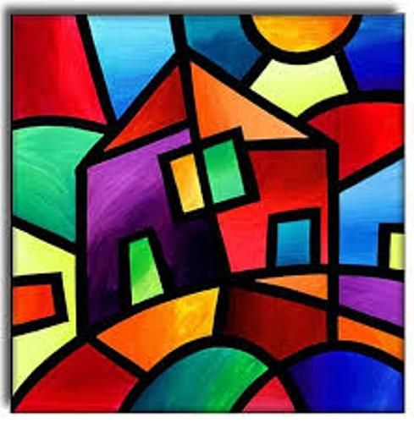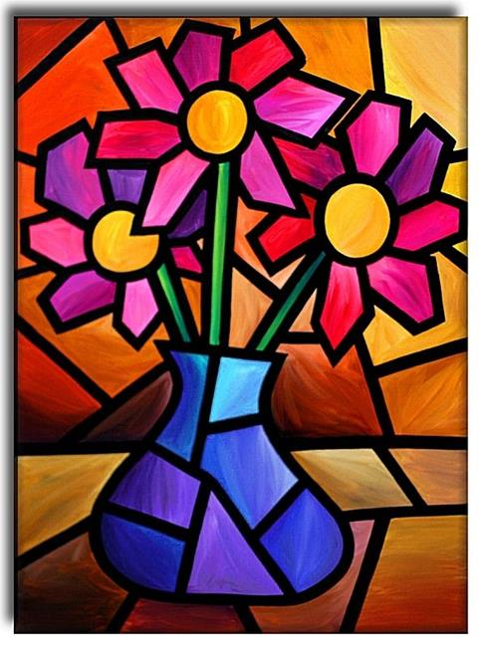 | PE- Complete a yoga session from the link below:  https://www.youtube.com/user/CosmicKidsYoga  Maths  Please find all maths sheets in the document named ‘Maths week 12-13’.  SLOR  All reading extracts can be found in the document named ‘SLoR WEEK 12-13’.  English  Please find all English sheets in the document named ‘English week 12-13’.  Reading Challenge  Read for at least 10 minutes each day and then choose a challenge to complete from the document labelled ‘Reading Challenge’.
Thursday | Maths: Complete at least 5 sessions of TT Rockstars.  Torn shapes investigation  SLOR: Re-Read the text. Answer questions 7-9 labelled inference. Use the answer page at the bottom of the document to mark your answers. If your answer is incorrect think about what went wrong and make your corrections.  English: Complete the characters names activities in the English weeks 12-13 document.  Topic: Design and create a model of a Motte and Bailey castle using recyclable materials (if this is not possible then you can make it from paper or create a 3D style drawing). Take pictures to send to us or tag @swingateprimary in your tweets! | PE – Just dance  https://www.youtube.com/results?search_query=just+dance+kids  Dance for at least 30 minutes!  Maths  Please find all maths sheets in the document named ‘Maths week 12-13’.  SLOR  All reading extracts can be found in the document named ‘SLoR WEEK 12-13’.  English  Please find all English sheets in the document named ‘English week 12-13’.  Reading Challenge  Read for at least 10 minutes each day and then choose a challenge to complete from the document labelled ‘Reading Challenge’.
Friday | Maths: Complete at least 5 sessions of TT Rockstars.  Complete the week 12 arithmetic.  Area and perimeter quiz  SLOR: Re-Read the text. Answer questions 10 - 12. Use the answer page at the bottom of the document to mark your answers. If your answer is incorrect think about what went wrong and make your corrections.  English: Complete the GPaS quiz in the English document then  complete word wonder.  Use a Dictionary and Thesaurus to find the definition of and synonyms for funny.  The antonym of funny is serious. Use a dictionary to find the meaning of this word. Then use a thesaurus to find synonyms.  Write 2 sentences using synonyms of funny.  Write 2 sentences using antonyms of funny.  Topic: Complete one activity from the home learning grid | PE- Complete a yoga session from the link below:  https://www.youtube.com/user/CosmicKidsYoga  Maths  Please find all maths sheets in the document named ‘Maths week 12-13’.  SLOR  All reading extracts can be found in the document named ‘SLoR WEEK 12-13’.  English  Please find all English sheets in the document named ‘English week 12-13’.  Reading Challenge  Read for at least 10 minutes each day and then choose a challenge to complete from the document labelled ‘Reading Challenge’.

Learning Activities
Year 4 2019-20

self-isolation learning Week 13
 | Lessons set | Additional comments
Monday  6/06/2020 | Maths: Complete at least 5 sessions of TT Rockstars.  Converting between different units of measure (mm, m, cm, km)  SLOR: https://www.bbc.co.uk/bitesize/articles/z2ycf82 Look at the lesson on BBC bitesize and learn about authors. Complete activity 3.  English: Complete the your characters and your settings part of the English document.  Science: See Science weeks 12-13 for instructions. Eggy zip wire | PE- Complete a yoga session from the link below:  https://www.youtube.com/user/CosmicKidsYoga  Maths  Please find all maths sheets in the document named ‘Maths week 12-13’.  SLOR  All reading extracts can be found in the document named ‘SLoR WEEK 12-13’.  English  Please find all English sheets in the document named ‘English week 12-13’.  Reading Challenge  Read for at least 10 minutes each day and then choose a challenge to complete from the document labelled ‘Reading Challenge’.
Tuesday | Maths: Complete at least 5 sessions of TT Rockstars.  Measuring to the nearest half centimetre  SLOR: Read the text. Answer questions 1-3 labelled vocabulary. Use the answer page at the bottom of the document to mark your answers. If your answer is incorrect think about what went wrong and make your corrections  English: Complete the speech marks activity.  PSHE/ Jigsaw: Mixed – A Colourful Story  Please find the story and task in the document named ‘PSHE’. | PE – Just dance  https://www.youtube.com/results?search_query=just+dance+kids  Dance for at least 30 minutes!  Maths  Please find all maths sheets in the document named ‘Maths week 12-13’.  SLOR  All reading extracts can be found in the document named ‘SLoR WEEK 12-13’.  English  Please find all English sheets in the document named ‘English week 12-13’.  Reading Challenge  Read for at least 10 minutes each day and then choose a challenge to complete from the document labelled ‘Reading Challenge’.
Wednesday | Maths: Complete at least 5 sessions of TT Rockstars.  Capacity cocktails! Use your times table facts or you can add the prices together to work out the price of the cocktails.  SLOR: Re-Read the text. Answer questions 4-6 labelled retrieval. Use the answer page at the bottom of the document to mark your answers. If your answer is incorrect think about what went wrong and make your corrections.  English: Using the box plan in the English document plan your new story. Use the Mission Possible story to help you plan your own story. Remember to include the new character and setting you created earlier in the week.  Topic: Research other Norman castles (also look at Rochester castle). Using the information you have learnt write non-chronological report about them. | PE- Complete a yoga session from the link below:  https://www.youtube.com/user/CosmicKidsYoga  Maths  Please find all maths sheets in the document named ‘Maths week 12-13’.  SLOR  All reading extracts can be found in the document named ‘SLoR WEEK 12-13’.  English  Please find all English sheets in the document named ‘English week 12-13’.  Reading Challenge  Read for at least 10 minutes each day and then choose a challenge to complete from the document labelled ‘Reading Challenge’.
Thursday | Maths: Complete at least 5 sessions of TT Rockstars.  Solving two-step word problems  SLOR: Re-Read the text. Answer questions 7-9 labelled inference. Use the answer page at the bottom of the document to mark your answers. If your answer is incorrect think about what went wrong and make your corrections.  English: Write your own version of the Mission Possible story. Remember to include adjective, adverbs and similes where appropriate.  Art: Using what you learnt about cubism last week design a stained-glass window inspired by cubism.  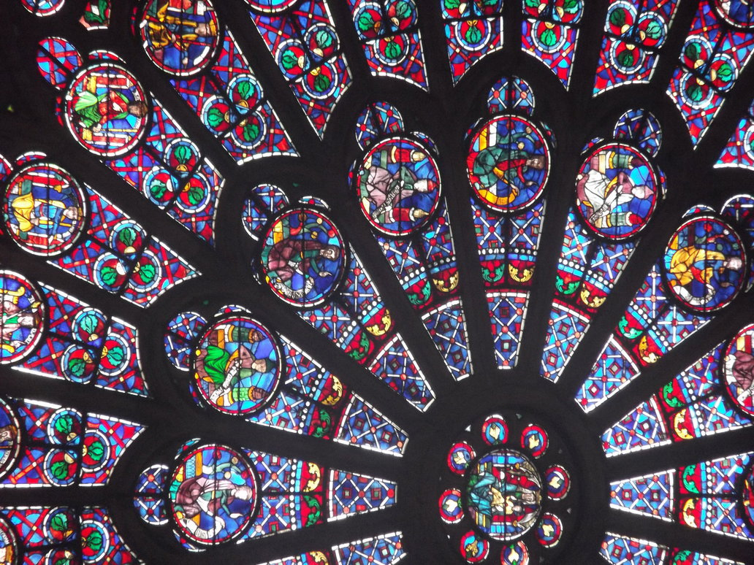 | PE – Just dance  https://www.youtube.com/results?search_query=just+dance+kids  Dance for at least 30 minutes!  Maths  Please find all maths sheets in the document named ‘Maths week 12-13’.  SLOR  All reading extracts can be found in the document named ‘SLoR WEEK 12-13’.  English  Please find all English sheets in the document named ‘English week 12-13’.  Reading Challenge  Read for at least 10 minutes each day and then choose a challenge to complete from the document labelled ‘Reading Challenge’.
Friday | Maths: Complete at least 5 sessions of TT Rockstars.  Complete the week 13 arithmetic test.  Measures quiz  SLOR: Re-Read the text. Answer questions 10 - 12. Use the answer page at the bottom of the document to mark your answers. If your answer is incorrect think about what went wrong and make your corrections.  English: Edit and publish your story. There is publishing paper available in the English document if you would like to use it. If not they why not create your own border?  Then complete word wonder.  Use a Dictionary and Thesaurus to find the definition of and synonyms for disgusting.  The antonym of disgusting is delicious. Use a dictionary to find the meaning of this word. Then use a thesaurus to find synonyms.  Write 2 sentences using synonyms of disgusting.  Write 2 sentences using antonyms of disgusting.  Topic: Complete one activity from the home learning grid | PE- Complete a yoga session from the link below:  https://www.youtube.com/user/CosmicKidsYoga  Maths  Please find all maths sheets in the document named ‘Maths week 12-13’.  SLOR  All reading extracts can be found in the document named ‘SLoR WEEK 12-13’.  English  Please find all English sheets in the document named ‘English week 12-13’.  Reading Challenge  Read for at least 10 minutes each day and then choose a challenge to complete from the document labelled ‘Reading Challenge’.

