Art Week 10:
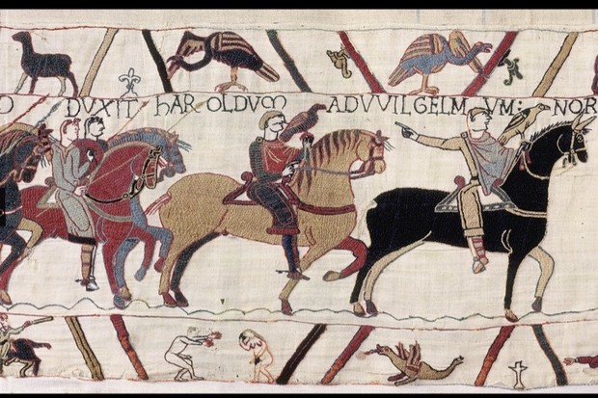
Recreate part of the Bayeux Tapestry. You could paint it, sketch it or use tissue paper to recreate the Tapestry the choice is yours.
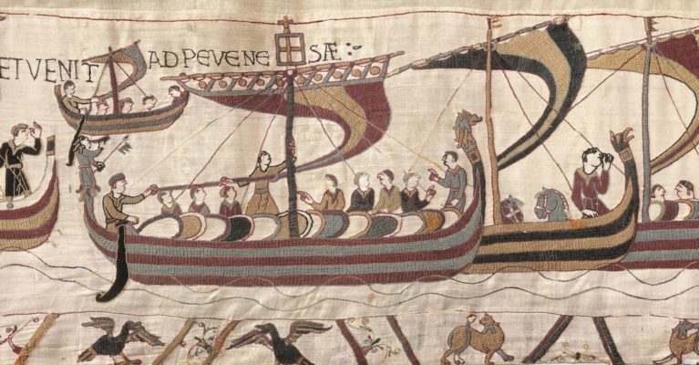

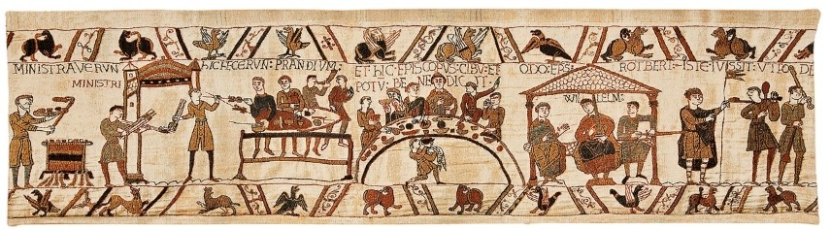

Art week 11:
Create a Motte and Bailey Castle. This could be a 2D or 3D representation.


