Monday: Below are pictures of parts of the Bayeux Tapestry. Choose a character from the tapestry and write a description about that person. Think about their personality and how they might be feeling as well as what they look like. Remember to use a thesaurus and dictionary to find synonyms.

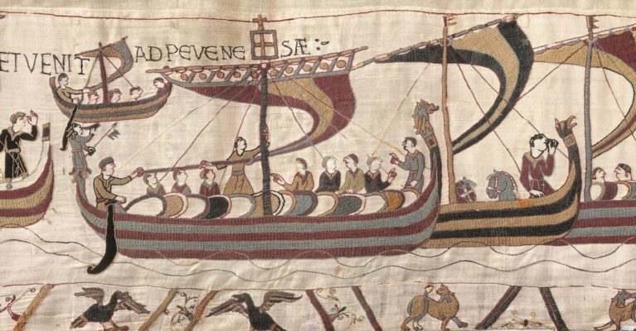
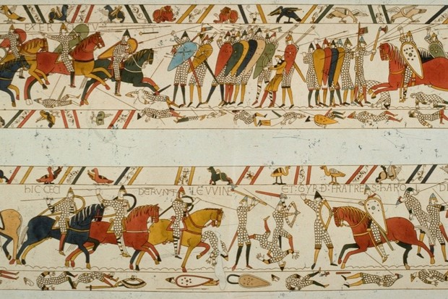
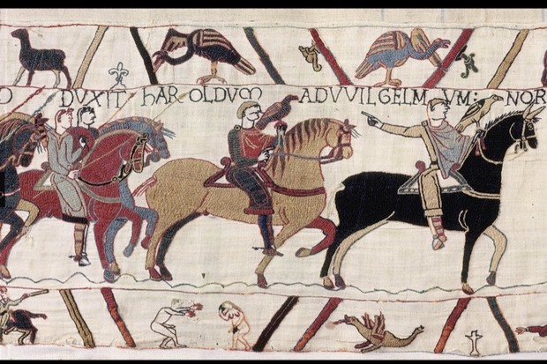
Tuesday: Imagine you are the character your described yesterday. Write a diary entry pretending to be that character, heading into battle. How are you feeling? What can you see? Are there any questions you might be asking yourself? Remember to use the features of a diary:

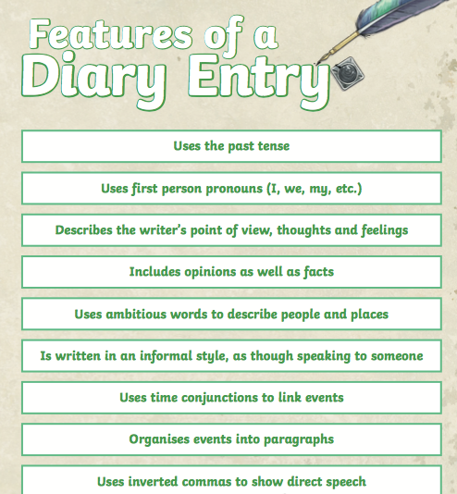

Wednesday: Using what you learnt about the Battle of Hastings and William the Conqueror when creating your booklet, write a diary entry from the perspective of William the conqueror either before the battle or after the battle. Remember to use the features above when writing your diary entry.

Thursday: On Sunday it is Father’s Day. Create an acrostic poem using father or the adults name. You could create the poem for your Dad, uncle, grandad whoever is an important person in your life. An example of an acrostic poem is below.
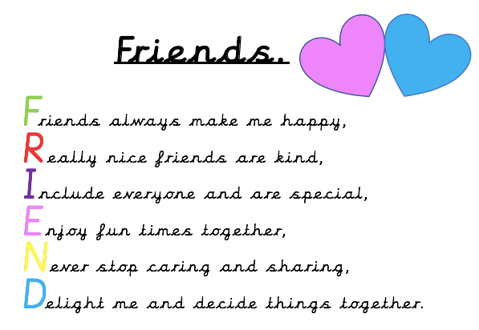

Qu. | Quiz Answers | Notes
1 | Sam and Paul could either choose to go  swimming or bowling but not to go to the zoo. | Answers must not include capital letters.
2 | Kate is very sporty and enjoys playing with her  friends. Football is her favourite sport.
3 | toys (Option 4)
4 | I was walking to the shops. (Option 2)
5 | He kicked the ball hard. (Option 1)  He completed his homework speedily. (Option 4)
6
  sentence |  |  |  |  |  |  | function
  What a strange thing to do |  |  |  |  |  |  | sentence
  It is a nice day |  |  |  |  |  |  | exclamation
  What did the young man say |  |  |  |  |  |  | command
  Put the knife on the table |  |  |  |  |  |  | question
7
  prefix |  | word
  mis |  | able
  in |  | active
  dis |  | lead
8 | hadn’t | Also accept answers that have been underlined.

Week 11: Monday: Carry out research about Motte and Bailey castles. Make notes on what you discover and then write these notes up into paragraph as we will later be making these into a poster. Some information has been provided if required, see Motte and Bailey Document.

Tuesday: Begin to create your poster. Remember to make it eye catching and colourful. Do not rush to finish the poster as we will continue this tomorrow. Use your best presentation skills.
Remember to use:
- A title,
- Subheadings,
- Bullet point (if appropriate),
- Questions e.g. Did you know?
- Paragraphs ,
- Illustrations.

Wednesday: Finish creating your poster. Remember to include illustrations, try to draw a motte and bailey castle.

Thursday: Editing GPaS activity.

Secretarial editing Task 1

- Read the following extract from a non-chronological report about keeping fit.

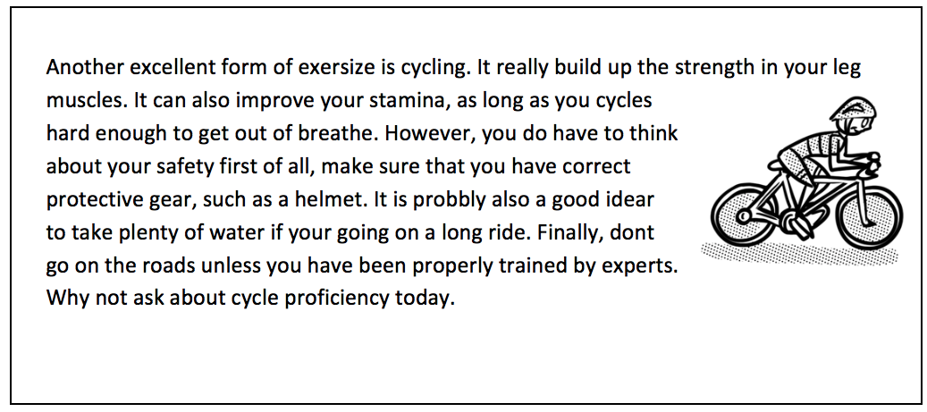

2. After reading the extract, check for the following aspects and underline them:
- Check if there are any punctuation mistakes.
- Check if there are any spelling mistakes – use a dictionary for tricky words.
- Check if there are any grammar mistakes.
- Identify a feature which could be improved.

3. Complete the grid below.
List any punctuation mistakes.
List any spelling mistakes.
List any grammar mistakes.
Identify a feature which could be improved.

4. Rewrite the extract, making the amendments which you have identified in the grid above.

Secretarial editing Task 1
ANSWERS
1. Read the following extract from a non-chronological report about keeping fit.

Subheading
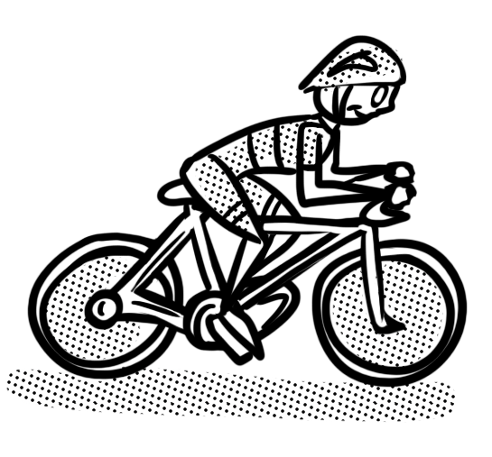
Another excellent form of exersize is cycling. It really build up the strength in your leg muscles. It can also improve your stamina, as long as you cycles hard enough to get out of breathe. However, you do have to think about your safety first of all, make sure that you have correct protective gear, such as a helmet. It is probbly also a good idear to take plenty of water if your going on a long ride. Finally, dont go on the roads unless you have been properly trained by experts. Why not ask about cycle proficiency today.

3. Complete the grid below.
List any punctuation mistakes. | full stop after safety  capital for first  apostrophe in dont  ? question mark after today
List any spelling mistakes. | exersize  breathe  probbly  idear
List any grammar mistakes. | It really build up the strength …  … as long as you cycles hard …  your/you’re
Identify a feature which could be improved. | Add a subheading

4. Rewrite the extract, making the amendments which you have identified in the grid above.

Another excellent form of exercise is cycling. It really builds up the strength in your leg muscles. It can also improve your stamina, as long as you cycle hard enough to get out of breath. However, you do have to think about your safety. First of all, make sure that you have the correct protective gear, such as a helmet. It is probably also a good idea to take plenty of water if you are going on a long ride. Finally, don’t go on the roads unless you have been properly trained by experts. Why not ask about cycle proficiency today?

Friday: GPaS Quiz.
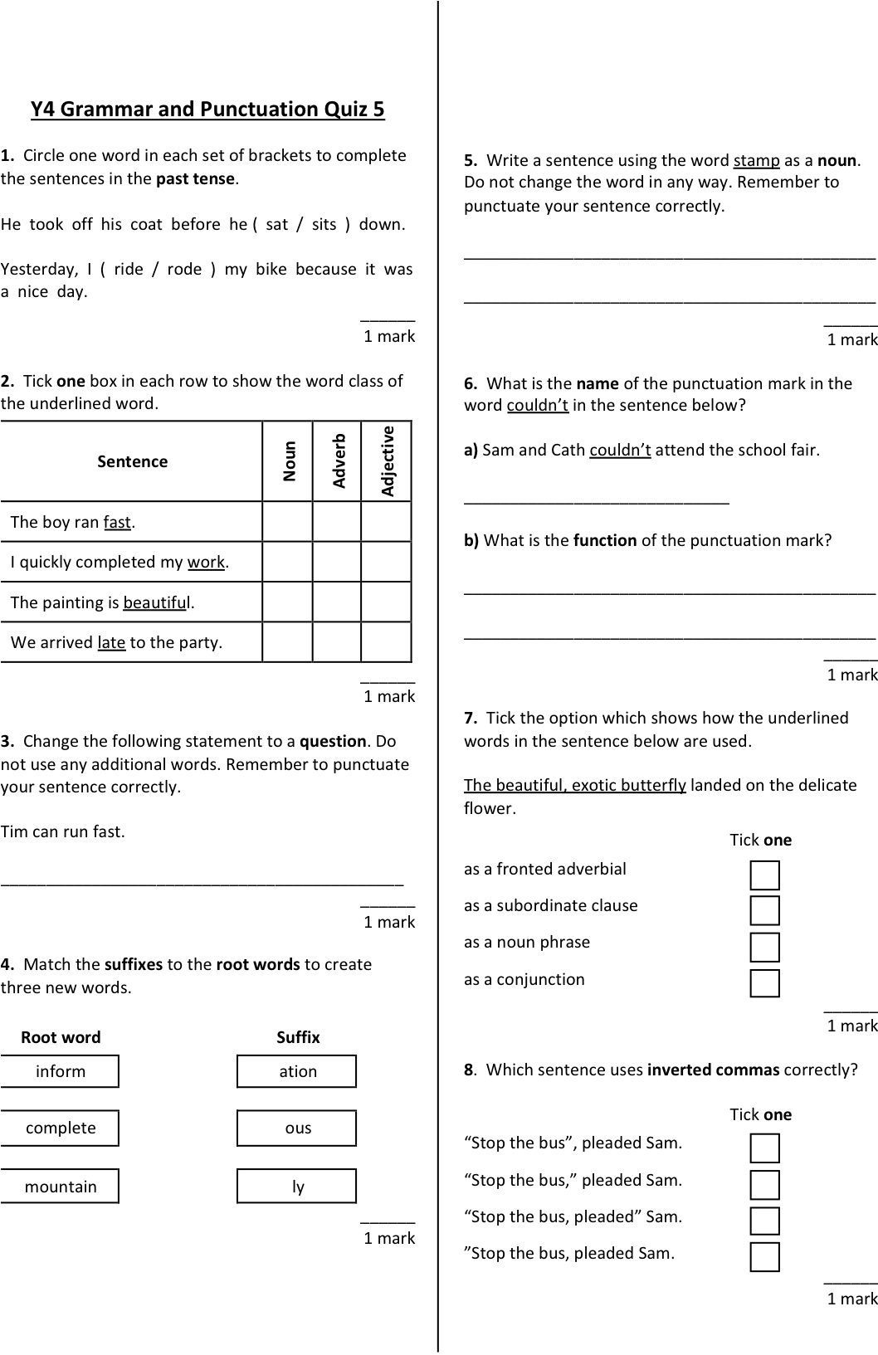

Qu. | Quiz 5 Answers | Notes
1 | sat, rode | Also accept answers that have been underlined.
2
  Sentence | Noun | Adverb | Adjective
  The boy ran fast. |  | 
  I quickly completed my work.
  The painting is beautiful.
  We arrived late to the party.
3 | Can Tim run fast? | The sentence must be punctuated correctly.
4
  Root word |  | Suffix
  inform |  | ation
  complete |  | ous
  mountain |  | ly
5 | Any sentence correctly using stamp as a noun.  E.g. Put the stamp on the letter.  Can I buy a stamp?  Do not accept sentences using stamp as a verb.  E.g. Stamp your foot. | The sentence must be punctuated correctly. Allow minor spelling errors that do not change the meaning of the sentence. Do not accept sentences where children have changed the word, e.g. stamps.
6 | a) apostrophe  b) Any answer referring to the appostrophe being used to indicate omission.  E.g.The apostrophe is for missing letters.  Couldn’t has the ‘o’ missing from could not.  There is a letter missing when you shorten could not to couldn’t. | Allow minor spelling errors that do not change the meaning.
7 | as a noun phrase (Option 3)
8 | “Stop the bus,” pleaded Sam. (Option 2)

