Motte and Bailey Castles
What were the first castle like?
The first proper castles built in England were the Motte and Bailey castles.
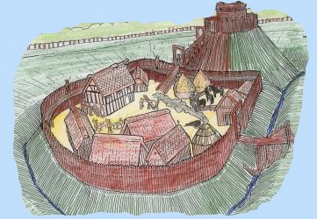
A drawing of the old motte and bailey castle of Tonbridge
The term motte and bailey castle comes from Norman French words for mound and enclosed land.
Motte - mound or 'clod of earth'
Bailey - enclosure.
Who introduced the Motte and Bailey Castles to England?
The Normans from France, introduced the Motte and Bailey castle to England, when they invaded the country in 1066. It is believed that as many as 1000 Motte and Bailey Castles were built in England by the Normans.
How were Motte and Bailey Castles built?
The most important part of the Motte and Bailey castle was the Keep. It was built on a huge mound (the motte). Mottes ranged from 25 feet (8 metres) to over 80 feet (24 metres) in height
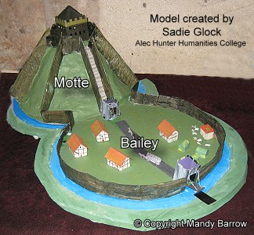
The sides of the motte were so steep that it would have been impossible to run up them in one go For added potection, a deep ditch was dug around the bottom of the motte.
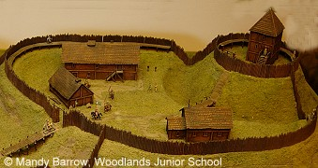
At the bottom of the motte was the bailey. The bailey varied in size from one to three acres.
Inside the bailey, lived the followers of the Lord who ran the castle. There were many buildings inside the bailey including stables, storehouses, bakeries, kitchens, houses, and quarters for soldiers.
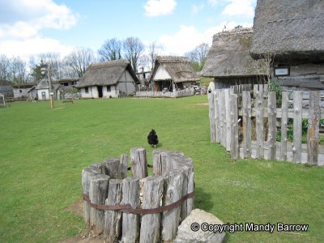
A strong wooden fence (palisade) surrounded the buildings.
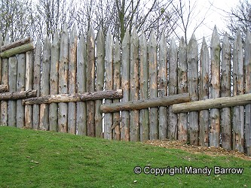
Wooden fence (palisade)
The bailey was surrounded by a ditch, called a fosse.
Windsor Castle - the first motte and Bailey castle
There were motte and bailey castles all over England and along the frontier of Wales. Many of England's existing castles began as motte and bailey castles. Windsor Castle in Berkshire, started life as a motte and bailey castle.
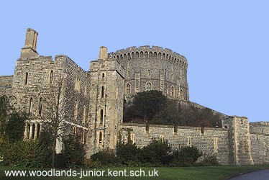
Windsor Castle - originally a motte and bailey castle
Windsor castle is one of the many homes of our present day Queen.
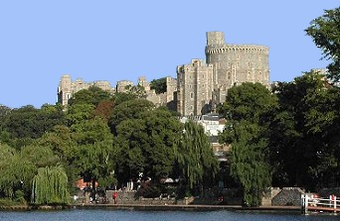
View of Windsor Castle from the River Thames
What were the advantages of motte and bailey castles?
Motte and bailey castles were quick and cheap to erect - - some only took a couple of weeks!
The huge motte with its timber tower on top gave the defenders an advantage.
The bailey was designed so that any point on its circumference (outer edge) would be within bowshot of the tower.
What were the disadvantages of motte and bailey castles?
How and why did Norman castle building material change?
Wooden castles were not very strong.
The wooden structures caught fire easily.
Stone was much stronger
From around 1100 onwards, people began to build castles in stone.

Motte and Bailey Castles
Motte and bailey castles were made up of two main parts. The motte was a tall, steep hill which would usually have been man-made. The sides were steep to prevent attackers running up them quickly. The slower they ran, the easier it was for archers to hit them with arrows from the keep.
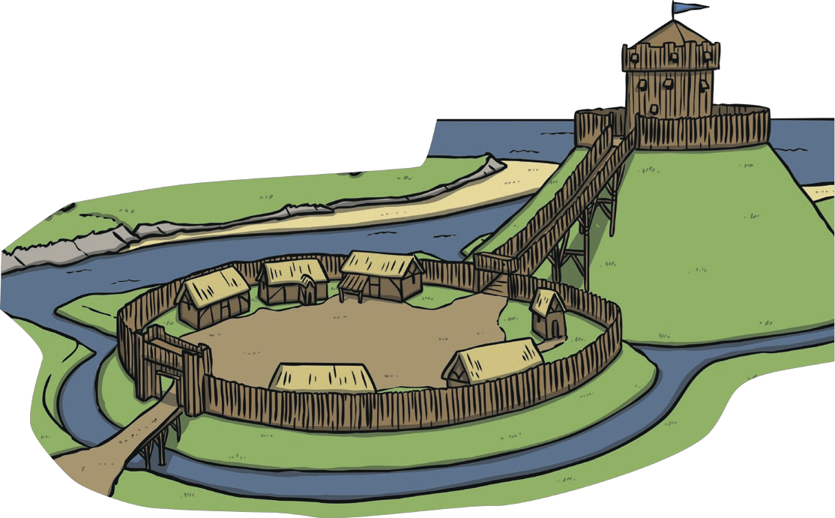
Bailey
Motte
Keep

The keep was the building where the owners of the castle would live. It was the safest place in the castle.
The bailey was open, flat ground surrounded by a tall, wooden fence, often topped with spikes.

Who Built Motte and Bailey Castles?
Motte and Bailey castles were built by the Normans. They came to England from northern France after they won the Battle of Hastings in 1066. The winning king, William the Conqueror, decided to settle in England and his people came to settle with him. They wanted a way to stay safe in a new country so needed castles that could be built quickly.
What Else Was in a Motte and Bailey Castle?
The space inside the bailey was filled with lots of different buildings. There were barracks for the soldiers to stay
in, as well as stables for the horses. The bailey also
had kitchens and bakeries.

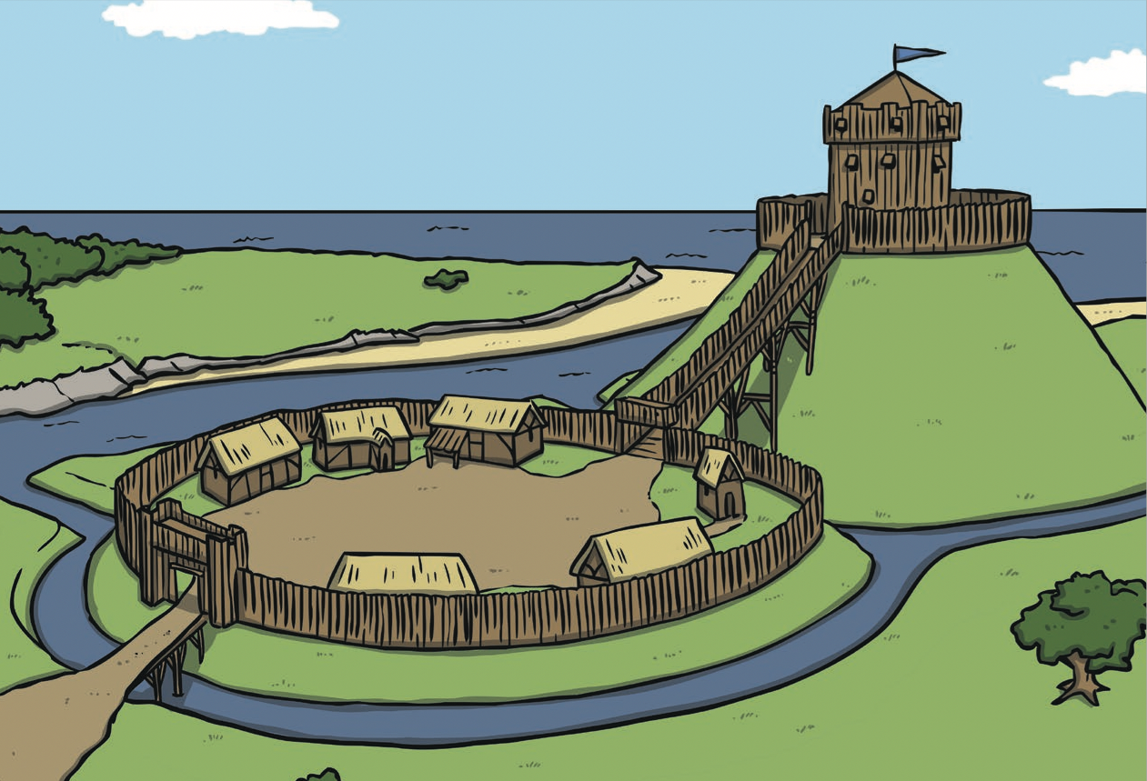
Moat
As well as the motte, bailey and keep, there was also a moat surrounding the castle. This was a deep ditch that was usually filled with water. This made it even more difficult for anyone to attack the castle.



