Main activity 1 -Taking foot measurements – Instructions.
Video instructions available here: https://www.bbc.co.uk/teach/terrific-scientific/KS2/z74y92p
Worksheet follows.
Equipment needed (for each pair of students):
2 x sheets of A4 Paper.
1 x pencil.
2 x 30cm rulers (with square edges).
Guide on the measurements we are looking for. Calculator (for Arch Height Index).
Student worksheet.
Method / procedure
Ask children to take their shoes and socks off (any children who wish
to keep their socks on can, as long as they are still able to lift their toes).
Measurements
If the 0 cm mark is not at the bottom of the ruler you will need to do the following to get the correct height of the foot.
Measure how far the 0cm mark is from the bottom of the ruler; record this on the student worksheet.
You will need to add this number to the height to get the accurate calculated height of the foot.
For example if the 0 cm mark is 4mm from the start of the ruler you will need to add 4mm to the height you measured. Please remember to add this measurement on when you record the height.
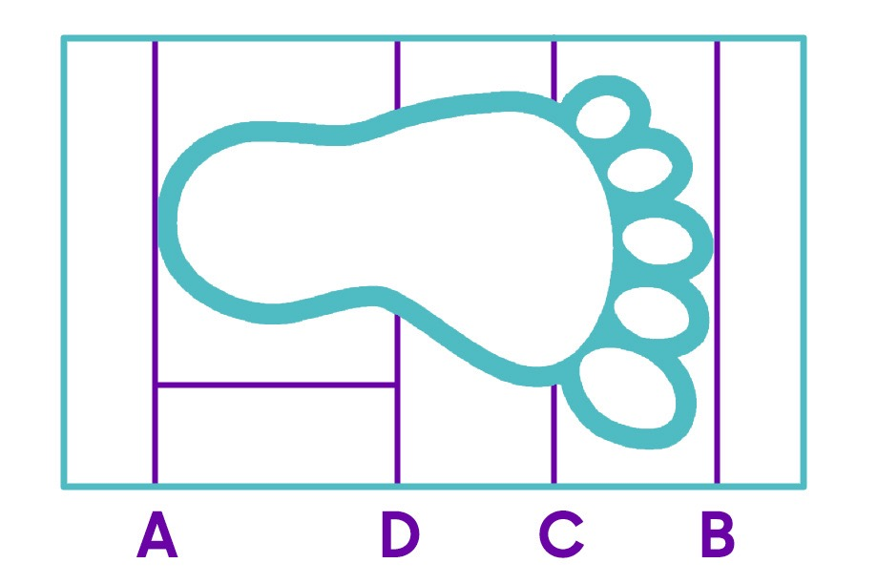
Place your ruler on the paper parallel to the shorter edge. Use your ruler to draw a straight line across the width of the paper. This should be the width of the ruler away from the edge.
Label this line, A.
- Student 1 stands up and places their LEFT foot on the paper, parallel
to the edge of the paper, taking care to line their heel up with Line A - making sure it touches it but isn’t over the line. Placing the long edge of a ruler on the line and standing it up on its edge can provide a surface for the foot to be backed up to. When the foot is in the correct position ensure they are standing up straight with their arms by their sides, feet a shoulder width apart and heel touching this line. Make sure the student’s centre of gravity is over their feet, i.e. they’re not leaning forwards or backwards.
- Student 2 should draw another straight line in line with the top of the longest toe. The longest toe is not always the big toe. Label this B.
- Without removing Student 1’s foot from the paper, carefully measure the distance between A and B and record it on your sheet.
- Calculate the midpoint between A and B, by dividing this measurement in half.
- Use your ruler to measure and draw another straight line exactly at the midpoint. Line D on the diagram above. This is also labelled on the student worksheet.
- Student 2 will now measure the height of Student 1’s foot, stand one ruler next to the inside of the foot precisely on the midpoint line, D, you have marked. One side of the ruler must touch line D and the other should be closest to line A (see picture). Hold a second ruler on the top of the foot parallel to the floor and where it touches the upright ruler on the midpoint is the height of the foot. This will help you make an accurate measurement. Record this measurement on the pupil-recording sheet.
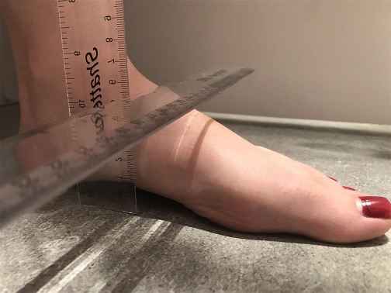

- Now ask Student 1 to lift up their toes a little. Slide the ruler under their toes until you feel it touch the ball of their foot. Be gentle so you do not hurt their foot. Use this ruler to draw another straight line (parallel to the short edge of the paper here) label it C.
- Carefully measure the distance between Line A and Line C. Pupils should write this down on their worksheet.
- Once you have all your measurements, repeat this method in full but with a new piece of paper and Student 1 sitting down while you do it. Make sure their foot is relaxed when measurements are taken.
- Finally repeat all of this above for Student 2 both standing and sitting.
Distance from bottom of ruler to 0 cm=__________mm

 | Distance  A to B (mm) | Height of foot (mm) | Distance  A to C (mm)
Left foot Standing
Left foot Sitting
Calculating foot flexibility
First you need to work out the Arch Height Index (AHI) of the foot for both the standing and sitting measurements.
To calculate AHI:
Divide the height of the foot by the distance A to C.
Write the AHI of each foot on your sheet. Now you can calculate how exible the foot is.
Divide the AHI standing by the AHI sitting.
Record your result to two decimal places (as for this investigation we are asking pupils to work to two decimal places).
You should get a figure between 0 and 1.
a) 1.0 is very in flexible, 0.10 is very flexible.
If your answer is over 1 please check all your measurements and working out again.
 | AHI Standing | AHI Sitting | Foot Flexibility (AHI standing divided by AHI sitting)
Left foot

Worksheet.

A to B: ________________________________mm

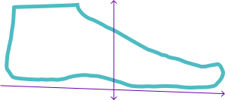
A Midpoint D C B

Height measured at midpoint D = ___________________mm
Midpoint (D) A to B ÷ 2 = __________________________mm
A to C = _________________________mm
Please write the type of surface you mostly walk on here | Distance  A to B in mm | Height of foot in mm | Distance  A to C in mm | Arch Height Index (AHI) which is Height divided A to C in mm
Left foot standing Student 1
Left foot sitting Student 1
Left foot standing Student 2
Left foot sitting Student 2
Distance from bottom of ruler to 0 cm mark = __________mm

 | Arch Height Index (AHI) standing | Arch Height Index (AHI) sitting | Foot exibility  AHI standing ÷ AHI Sitting
Left foot Student 1
Left foot Student 2
The type of surface I spend most of my time on is.
___________________________________________________________

Week 11: Parachute activity.
Using different materials around the house (tin foil, paper, fabric, bin liner) , create 3 or 4 different parachutes for an object (you may need string to tie your object to your parachute). Make sure you use the same object for each parachute to make it a fair test. Predict which material you think will make the parachute fall the fastest/slowest. Then carry out the experiment, time how long each parachute takes to fall when dropped from the same height. Record your findings in your table. Write your conclusion focusing on which parachute fell the fastest? Which parachute fell the slowest? Which material would you choose to make a parachute out of and why?
Parachute experiment.
Predictions.
Which parachute do you think will fall the fastest?
Which parachute do you think will fall the slowest?
Results.
Parachute material | Time taken to fall | Rank (1 the quickest – 4 the slowest)

Conclusion.
Was your prediction correct? Why? Why not? Reflecting on what you have learnt which material would you choose to make a parachute out of and why?

