Week 8 - Hovercrafts

Link to website: http://www.sciencefun.org/kidszone/experiments/paper-hovercrafts/

Materials:

Square Paper

Instructions:
- Start by folding the square in half corner to corner to make a triangle.
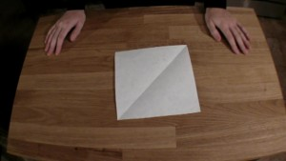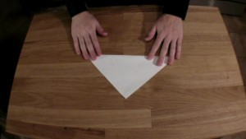
- Fold that triangle in half corner to corner to form a smaller triangle.
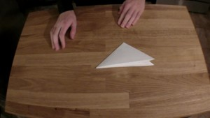
- Unfold the previous fold to get the larger triangle. Fold the edges of the triangle into the newly-made crease to form a kite shape.
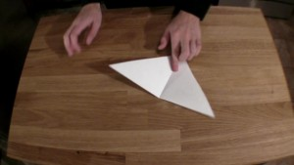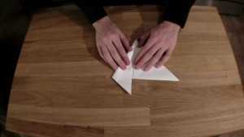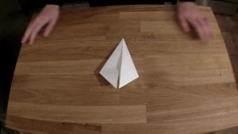
- Fold the inside edges of the kite shape toward the outside edges as shown.
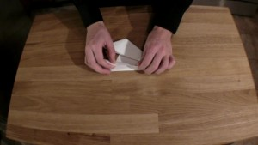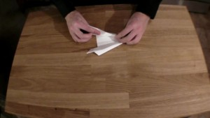
- Turn the paper upside down and blow gently into the open end. Your hovercraft should zoom away!

Discuss how it works:
The pocket under the hovercrafts trap air and create a zone of high pressure. Further, the air moving over the craft has lower pressure. This difference creates lift and gets rid of the friction that normally holds the paper in place on the table. Without friction holding it back, a little breath is all it takes to get the hovercraft speeding on its way!

Experiment Extension.

Create hovercraft from different materials:

Cardboard, tin foil, newspaper.

If you do not have different materials try creating hovercrafts that are different sizes.

Record your findings of which one travels the fastest or takes the most breath to get moving.

Week 9 - Floating Egg
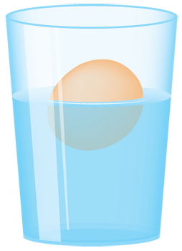
What happens when you put an egg in a glass of regular water?
Write a prediction in your book.

Materials:
- One egg
- Water
- Salt (1 – 2 cups)
- A tall drinking glass
- A spoon

Instructions:
1. Pour water into the glass until it is about half full.
2. Place an egg in the glass of water and see if it sinks or floats (it should sink).
2. Stir in lots of salt. Start with 1 table spoon and stir it until the salt dissolves. Keep adding more salt until the egg floats.
3. Next, carefully pour more fresh water until the glass is nearly full (be careful to not disturb or mix the salty water with the plain water). If you’re very careful, you can get the egg to float between the fresh and saltwater!

How It Works:
The egg is denser than the fresh water (more molecules per square inch), this causes it to sink. When you start dissolving salt in the water, this is increasing the density (adding more molecules per square inch). Eventually the water becomes denser than the egg causing the egg to float. When you carefully add fresh water again, this fresh water is less dense than the salt water so it floats right on top!

Write in your red book how you carried out the experiment and your results.

