01/06/20 – Comparing and ordering angles
Cut out and order the angles from smallest to largest. If you don’t have access to a printer, number each box then order them.

90 ° |  |  | 10 °
 |  | 25 °
170 °
 | 75 ° |  | 45 °

03/06/20 – Comparing and classifying shapes (help sheet)
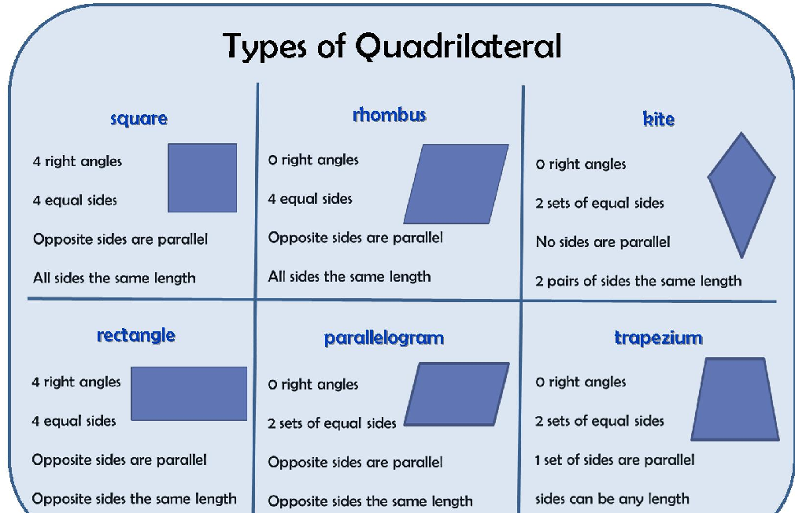

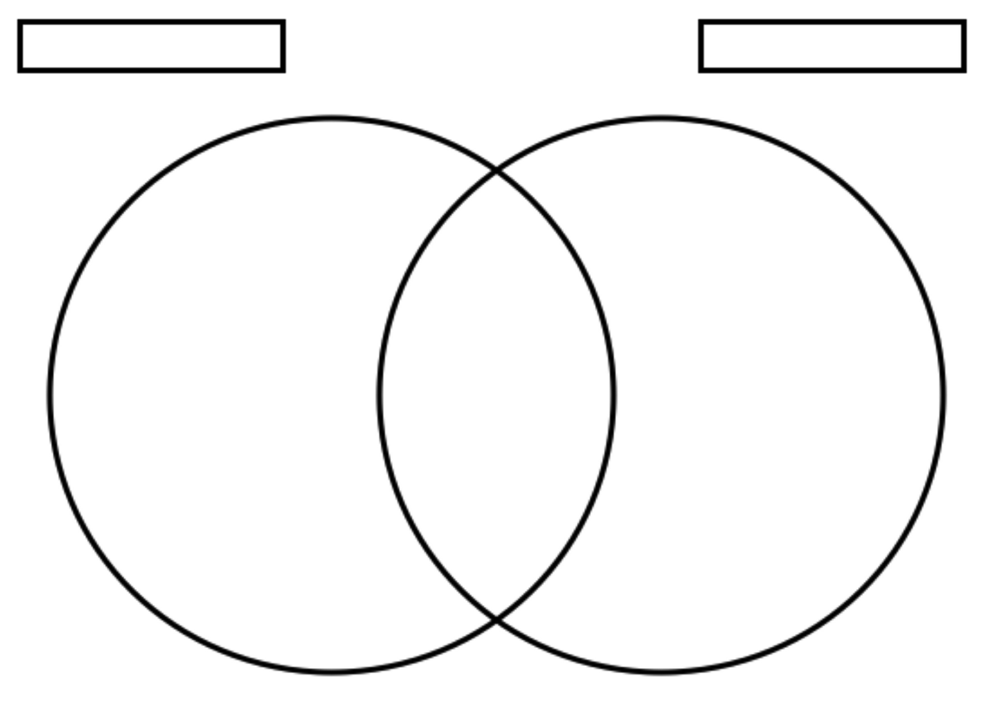
Comparing and classifying shapes worksheet – sort the names of the shapes above into this venn diagram. If you want to challenge yourself use shape names from the poster you made yesterday. You can use any labels you’d like, for example, shapes with 4 right angles and shapes with 4 equal sides. Try two different ones.
04/06/20 - Identifying lines of symmetry
1. Write on if the polygon is regular or irregular and why
2. Draw on the line symmetry of each polygon

08/06/20 – Complete the times table grid and see which times tables you still find difficult. Create a song or rap to help you remember these. If you know them all then well done! Your challenge today is to send your teacher a Rock Slam.
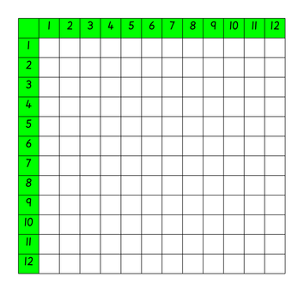

09/06/20 – Multiplying three digits.
Top tip – find the best place to start, for example:
3 x 2 x 9 =
I would start with 3 x 9 = 27 because I know that multiplying by 2 is the same as adding the same number twice so now all I need to do is 27 + 27 = or 27 x 2 = 54 (I could use the column method to help me here). Your starting point might be different to mine.
- 2 x 3 x 3 = 5. 1 x 1 x 2 =
- 4 x 5 x 2 = 6. 8 x 4 x 3 =
- 6 x 5 x 0 = 7. 6 x 7 x 0 =
- 10 x 10 x 1 = 8. 0 x 5 x 12 =

Challenge
Reasoning and Problem Solving
Make the target number 30 by using three of the digits below.

_____ x _____ x _____ = 30

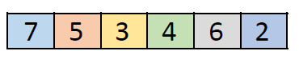

Challenge
Reasoning and Problem Solving
Ella the Egyptian has been looking at this calculation.
6 x 3 x 5 > 3 x 5 x 6
Do you agree with Ella> Why? Why not?

10/06/20 – Factor pairs
A factor is a whole number that multiplies by another number to make a product e.g. 3 × 5 = 15, factor × factor = product.
Factor pairs for 12 – begin with 1 × 12, 2 × 6, 3 × 4. At this stage, children recognise that they have already used 4 in the previous calculation therefore all factor pairs have been identified.
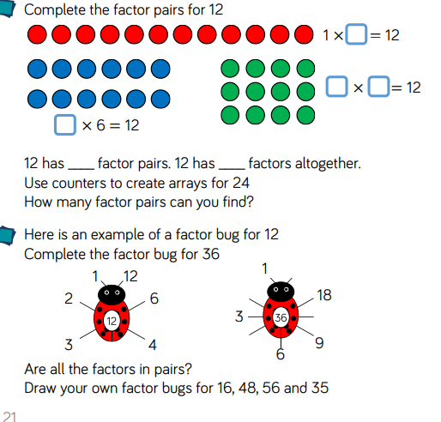
Using what you have learnt find all the factor pairs for 6, 24 and 30.
Challenge: Miss Sahota thinks that the higher the number, the more factor pairs it has. Do you agree with her? Why? Why not?

11/06/20 – Using multiplication and division facts to calculate mentally
Use your knowledge of times tables and multiplying by 10 and 100 to answer the calculations.
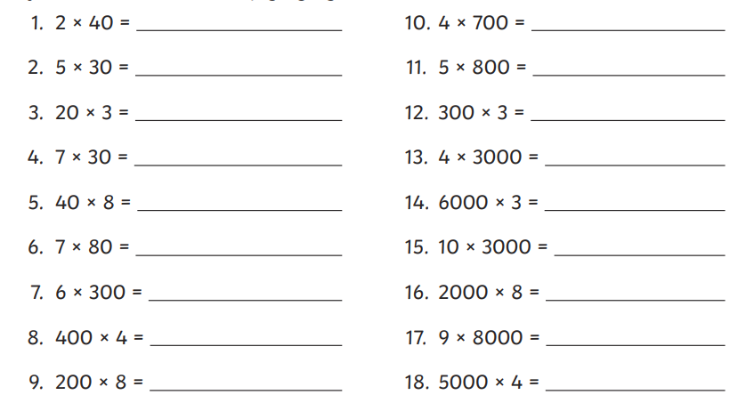

Challenge:
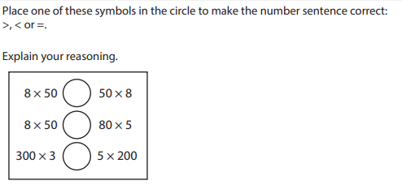

12/06/20- Multiplying two and three digit numbers by a one digit number
Using your times table knowledge and the column method, find the answers to these calculations.
Here is an example:
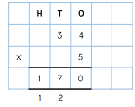
Your turn


