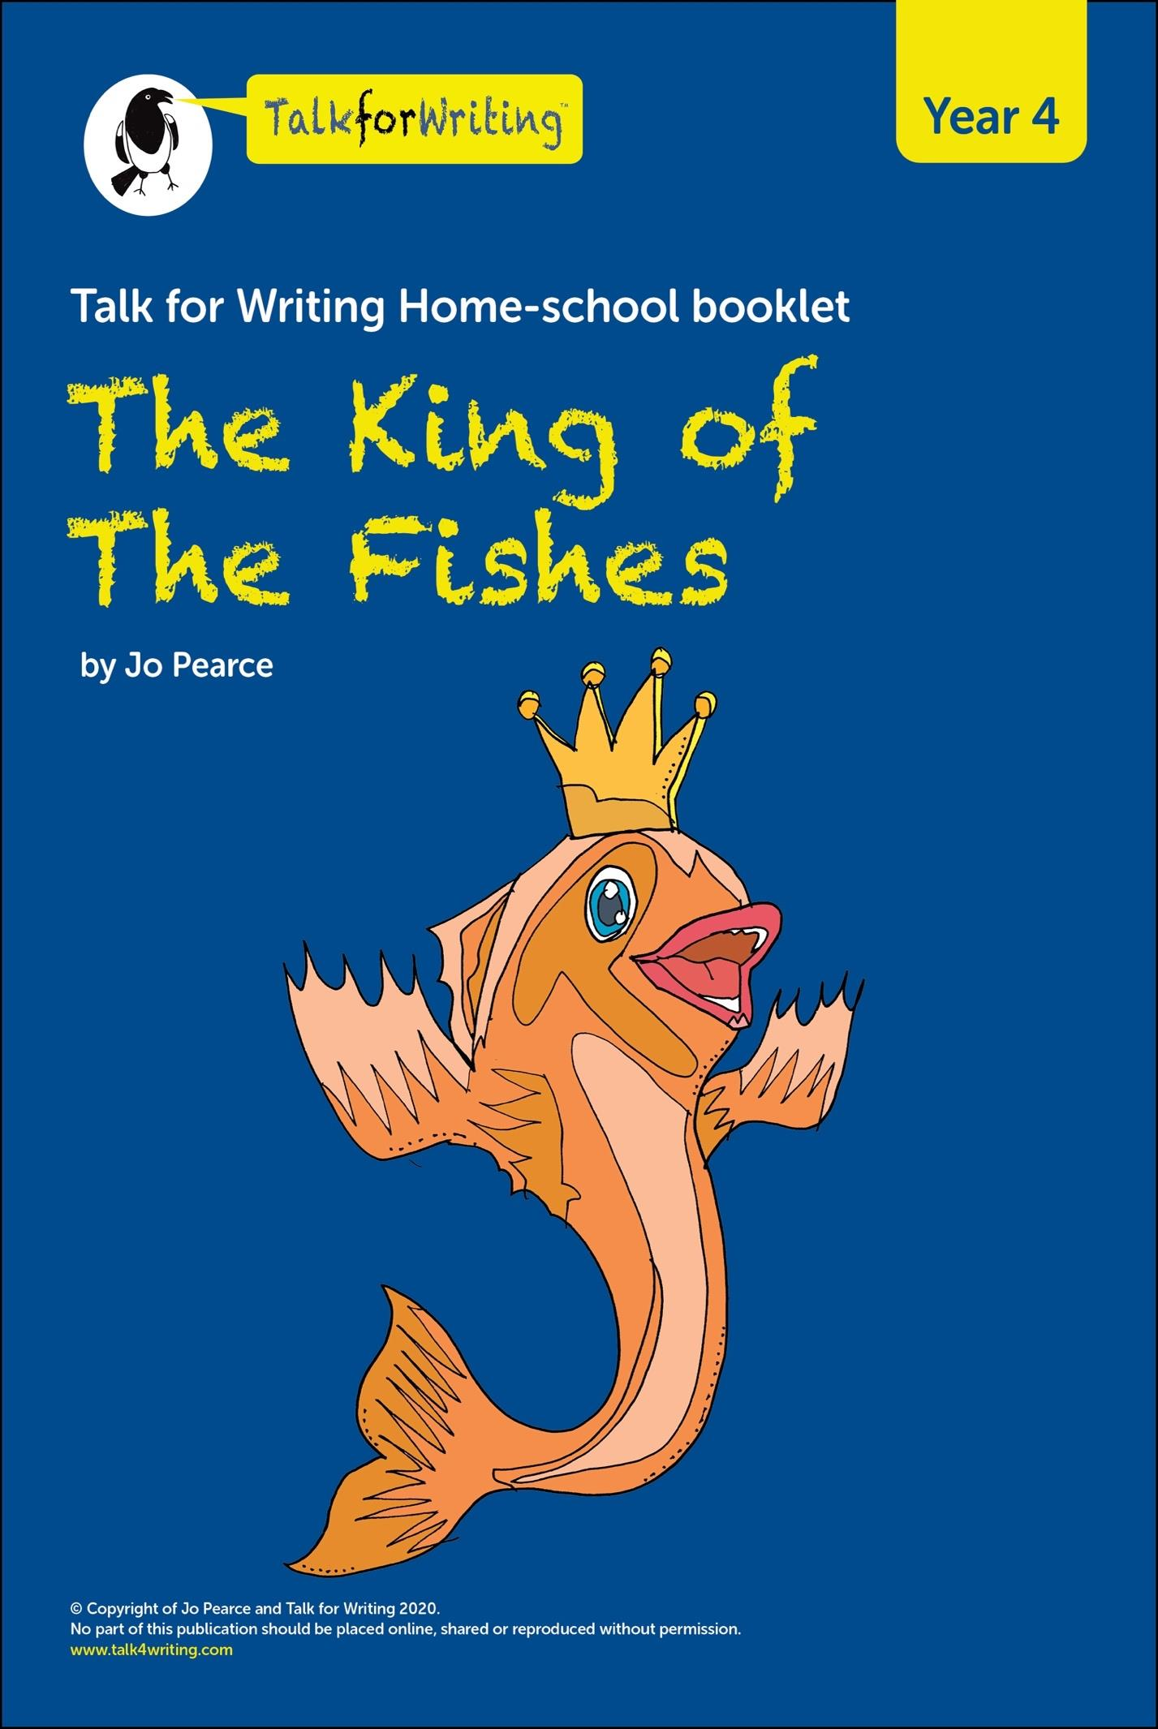

Monday:
‘The King of the Fishes ’is a wishing tale. A wish is a magical request for something that you want.
So, your first challenge is, answer this question: What you would ask for if you were given three wishes?
My three wishes:
- I wish ……. because …….
- I wish ……. because ……
- I wish …….. because …..

Our story
The story we are going to look at is ‘The King of the Fishes’. This traditional story has been passed around the world by many people which means that there are many different versions of the story out there. Our story is Pie Corbett’s version.

After reading the story answer these questions in your red book:
- What did you like about the story?
- What surprised you?
- What did it remind you of?
Tip: Remember to use the word because to extend your answer and give evidence from the text to support your argument.

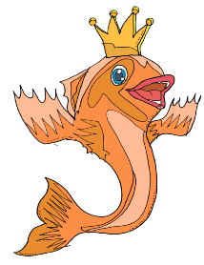 The King of the Fishes.
Once upon a time there was a poor fisherman called Li.
Every day, he went down to the sea to fish. There he stood on the rocks and threw the nets into the icy waters and waited patiently. When he pulled the nets in, he would take any fish back to the market and sell them.
One day, he caught a huge fish. It had silver scales that glittered in the sunlight, blood–red fins and a golden crown. It was so beautiful that Li stood, amazed, staring at the fish as it thrashed about in the net. Suddenly Li felt guilty. It was so beautiful, and surely it must have a family...
So, he scooped it up out of the net and set it free. Li stood watching as the fish swam out to sea. Then, to his amazement, it turned and spoke to him.
“Li, you have saved the King of the Fishes. I grant you one wish. When the moon is high in the sky, come back here and tell me your heart’s desire.’ With a flick of his fin, the King of the Fishes was gone.
Immediately, Li hurried home, wondering what on earth he should wish for. There were so many things that his family needed. First, he asked his elderly father. “Father, if you had one wish, what would it be?” There was a silence and then his father spoke, ‘Why son, I would wish for new eyes, for I am blind and will never see again.’
Next, he asked his mother. “Mother, if you had one wish, what would it be?” His mother thought for a minute and then said, “Why son, I would wish for money, for the roof needs mending and the winter winds whip through the house and make my bones shiver so.”
Finally, he asked his beautiful wife. “Wife, if you had one wish, what would it be?” There was a silence and then his wife whispered, “Why Li, I would wish for a baby, for who will care for us when we are old? Yes, nothing would be more precious than a child.”
Poor Li could not make up his mind – they needed the money certainly, but his father was blind and that was a terrible thing. However, he also knew that a child would bring joy to them all. All evening, Li paced up and down trying to decide what the wish should be.
Suddenly, he stopped pacing and grinned. Yes, he had it! He rushed out of the house, through the forest and down to the sea. The moon was high in the sky and so it was time to talk to the King of the Fishes. Li ran down onto the rocks and stood there with the foam crashing about him. He could see the moon’s reflection on the waves, and then came the King of the Fishes.
“What do you wish for Li?” called the King in a high, silvery voice.
“I wish for my father to see our son in a cradle made of gold,” shouted Li. There was a silence and the great fish disappeared. The waves stilled and Li could see the stars like silvery freckles in the dark night sky. Then out of the darkness he heard a noise, drifting down through the forest. It was a baby crying...
© Pie Corbett

Words! Words! Words!
Go back over the story and underline or highlight any words that you don’t know.
Ask an adult to help you find the meaning or look in a dictionary or online. You might also want to use google images to see pictures of the word.
Can you see I have highlighted my words in yellow? Let’s investigate those together:
1. My first word is whip.
★ Whip has many meanings. Can you match the definition to the picture?
I’ve done the first one for you.

Definition |  | Picture
To beat a liquid fast to make it light and fluffy |  | 
To move fast and suddenly |  | 
A length of rope or material used to hit animals or people |  | 
A member of a political party who makes sure that other members turn up to meetings and vote |  | 
 Write a short sentence to match each picture. Make sure you use the word ‘whip’, ‘whipping’ or ‘whipped’.
Last week, the chief whip ordered members of the party to vote in favour of schools closing.

2. My second word is precious. Precious means ‘something very special to be treated with care’.
★ Squeeze the word: What do you think of when you hear the word precious? Add your ideas to mine below:

time with my family precious gold

Tuesday:
Read and Understand
First re-read the story. Then try to answer the questions below.
In your red book write your answers to the following:

- What did Li usually do with the fish that he caught?
take them to market to sell put them back eat them
- What was special about the king of the fishes?
it was large it was beautiful it had a family
- How did Li save the King of the Fishes?
he scooped it up he put it back in the sea he gave it a wash
- How long did it take Li to decide on his wish?
all evening a few weeks all day
- Whose baby did Li hear at the end?
his and his wife’s. a neighbour’s someone’s in the forest
Spellings!
  Here is your spelling list. Practise the words so that you know how to spell them and then copy them correctly into the sentences. I have done the first one for you.
precious | whip | reflection
decide | caught | thought
Put the correct word in these sentences:
- Julia was upset that the thief had stolen her precious painting.
- Luckily, the police ____________________the thief red-handed.
- The courts must ______________________what the thief’s punishment should be.
- In Victorian times, the thief may have been hit with a_______________.
- Unfortunately for the thief, the courts ____________________that he should be sentenced to time in prison.
- In prison, the thief had time for ___________________and decide to change his ways in the future.

Similar or different?
a) The writer of our story uses ‘fronted adverbials ’to tell the reader where, when or how something is happening. Two examples:
Immediately, Li hurried home, wondering what on earth he should wish for. Suddenly, he stopped pacing and grinned.
b) These fronted adverbials – immediately and suddenly – have a similar meaning: ‘to do something very fast, without waiting.’ ‘Suddenly’ also makes the reader feel as though it has been a surprise; something unexpected.
c) Sort the words below. Are they similar to the meaning of ‘immediately’ or are they more like ‘slowly’? Write them under the word they are most similar to, or in the middle if you’re not sure!
d) Practise them in sentences of your own.
Leisurely, | Steadily, | Straight away, | As quick as flash,
All at once, | Gradually, | Suddenly, | Bit by bit,

Wednesday:
Innovation Ideas
- In your story, your main character will need to rescue a King or a Queen of a species.
- Here’s a chance to get creative. Pick an animal and draw or describe what the King or Queen of its kind would look like. You could use paper and coloured pens or pencils. You could make a model or use a computer.
The King of Aliens. The queen of iguanas.
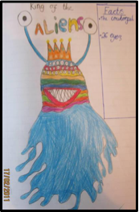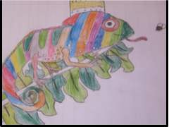
Write a description of your new character. Think about your characters personality as well as looks.

Thursday:
Boxing up
 The King of the Fishes is a wishing tale. Let’s look at the underlying pattern of the story by putting each section of the plot into a separate box. Later, we can use this to help us plan a new story.
A typical wishing tale will follow this type of plot:
Main character (MC) really wants something
MC tries to get what they want
A barrier gets in the way
MC overcomes the barrier
MC gets what they wished for
Sometimes all is well – sometimes not!
When you box up The King of the Fishes, it follows a similar pattern:
King of the Fishes | Plot Pattern | My New Story Plan
Li is a poor fisherman. | MC is poor
Li catches the King of the fishes but chooses to put it back | MC rescues an animal that is the King or Queen of its kind.
The King of the Fishes grants Li 1 wish. | The animal grants the MC one wish.
Li asks each member of his family what they would wish for. He struggles to decide. | The MC struggles to decide what to wish for.
Li combines three wishes into one and asks the King of the Fishes for his wish. | The MC chooses his wish, asks the creature and his wish is granted.
Everyone is happy. | All is well. The MC is now rich.
Now plan your own story using your new character. Will you choose to keep your story close to the model text or will you change it? Keep your story similar to the plot pattern.

Friday: Today, using your plan from yesterday write your story. Remember to use fronted adverbials, commas, adjectives and adverbs in your writing.

