A compass is a tool for finding direction. A simple compass is a magnetic needle mounted on a pivot, or short pin. The needle, which can spin freely, always points north. The pivot is attached to a compass card. The compass card is marked with the directions. To use a compass, a person lines up the needle with the marking for north. Then the person can figure out all the other directions.
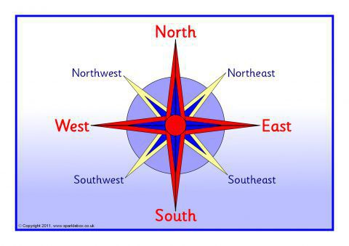

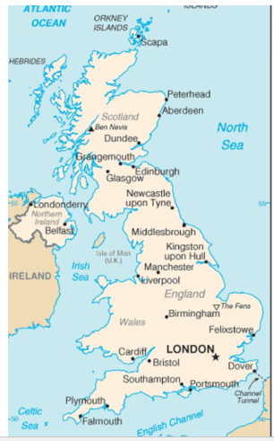
Look at the compass points: Use these points to answer the questions below:
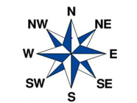
- Find London and circle it.
- List the cities that are North of London
- What direction is Felixstowe from London?
- What direction is Birmingham from London?
- Which city is Southeast from London?
- Which cities are Southwest from London?
- What is the name of the sea North from London?
- Which direction is Ireland from London?

