18/05/20 – Coordinates.
Coordinates describe the position of something on a grid. Remember when we last learnt about coordinates, to help us remember which axis to use first we went along the corridor and up the stairs.
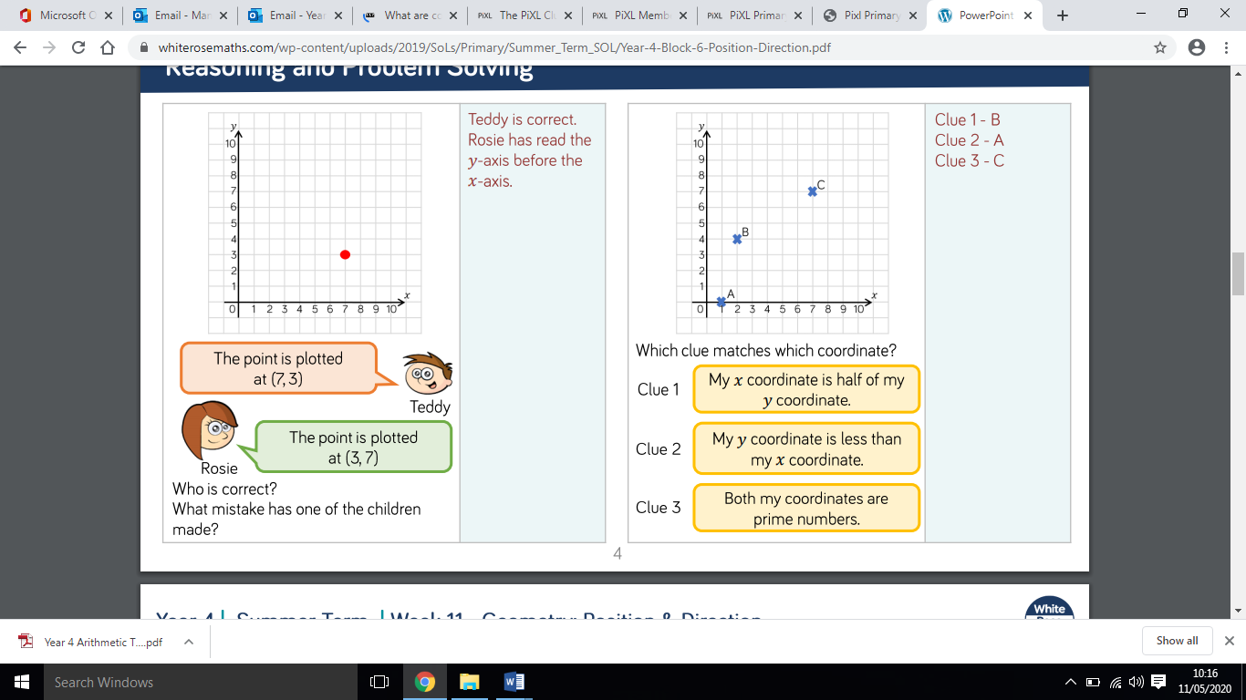

19/05/20 – Coordinates continued
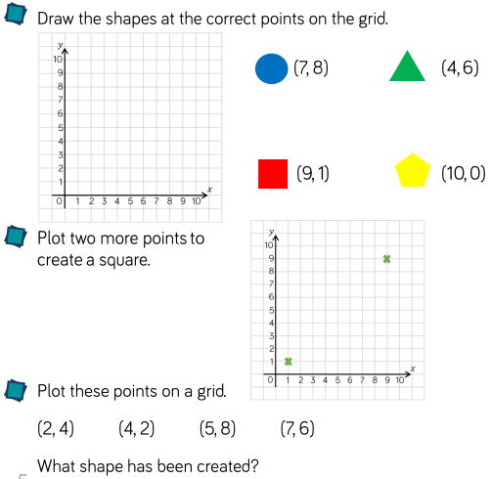
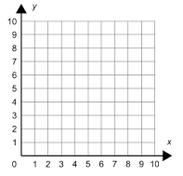
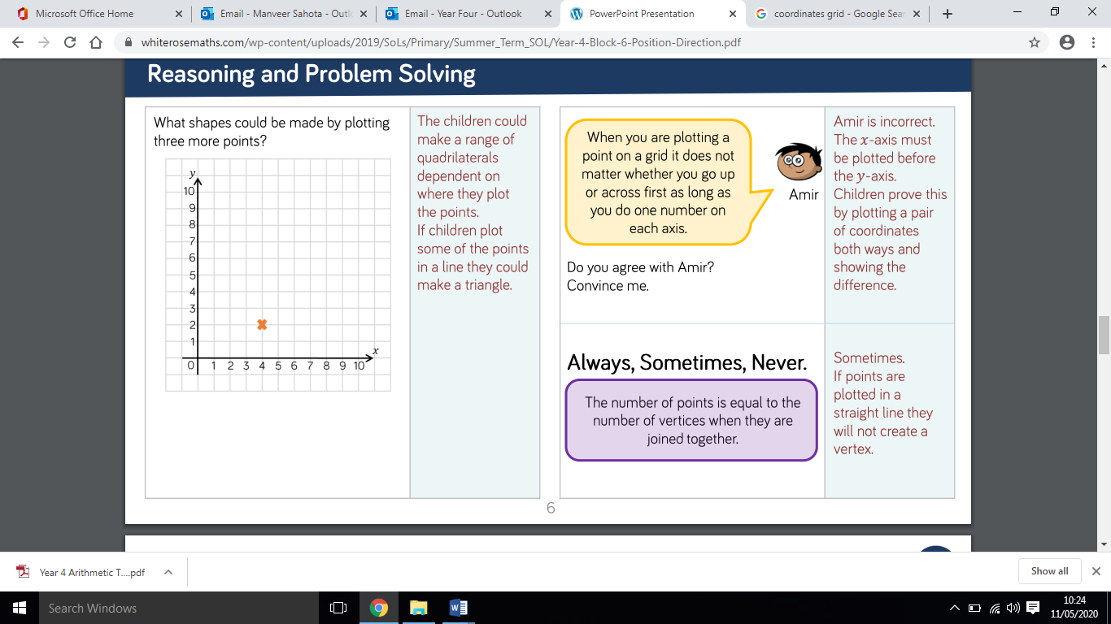
Reminder: Vertices are where two edges of a shape meet (a corner).

20/05/20 – Translation. When you translate a shape you are moving it to change its position on a grid. Since you are changing its position you are also changing its coordinates.
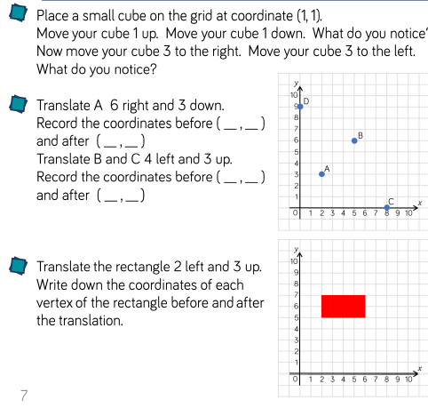
When translating a shape, you must remember to keep the original shape the same size. Therefore, this rectangle must remain two squares long and four squares wide.

21/05/20 – Describing movement. Use the answer stem below to describe the movements of the shapes.
Example answer for the first question. The triangle is translated two spaces to the right and two spaces down to the cross.
Answer stem: ________ is translated _____ right/left and ____ up/down.
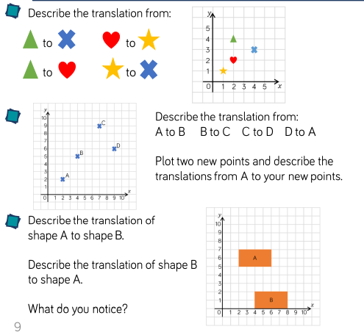

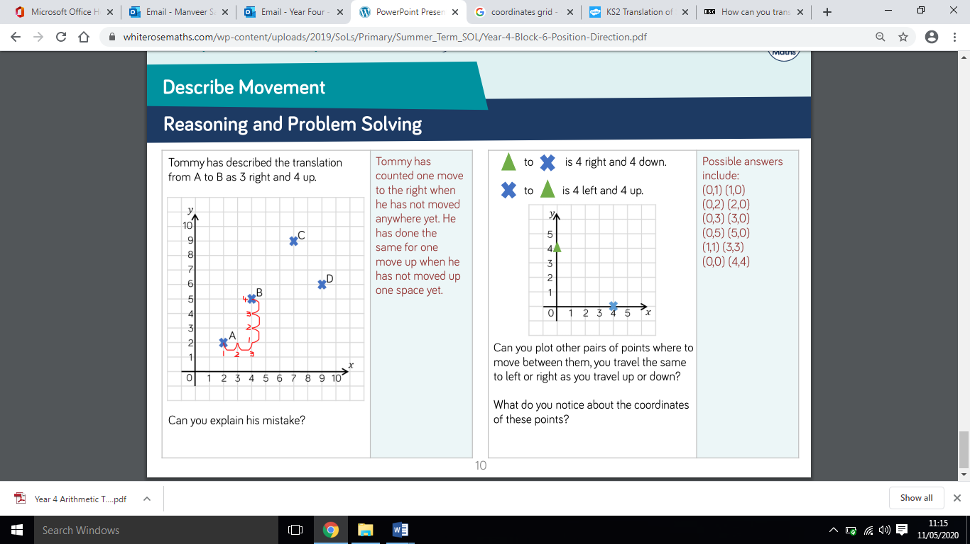

22/05/20 – Plotting shapes to complete a shape.
Follow the instructions to complete the shapes and then write the coordinates for each point.


