Science
Week 5: Bug Hotel Examples:

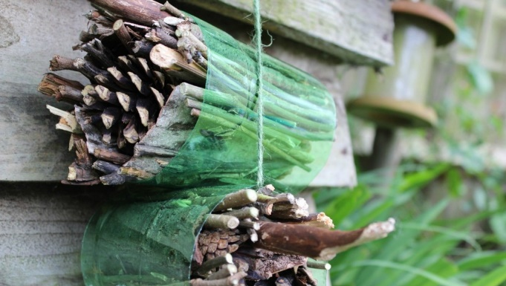
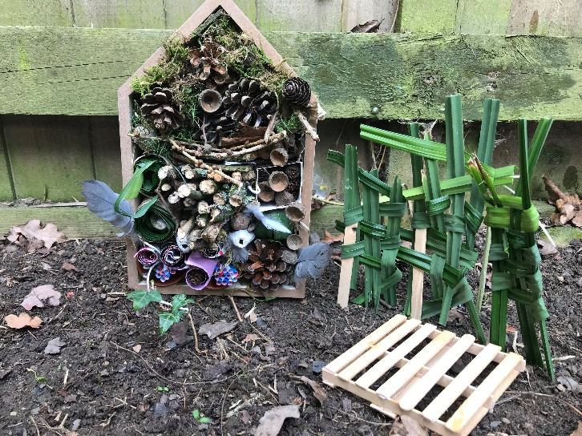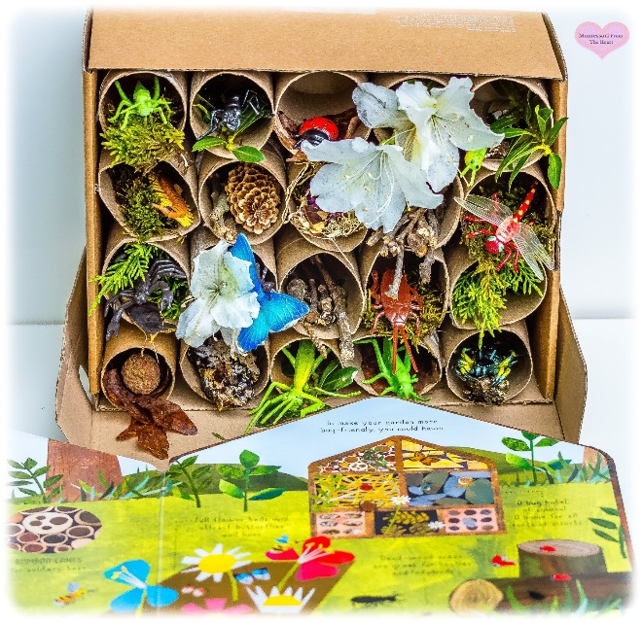

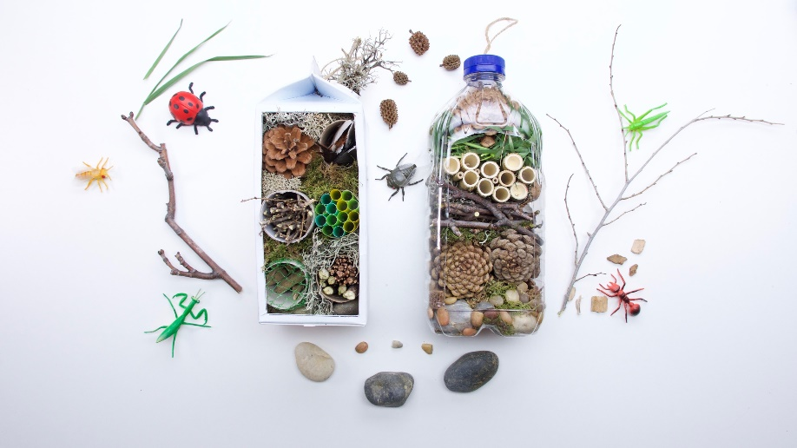

Recording sheet children could draw this in their book rather than printing:

Date | Insects seen

Week 6: research and create a fact file about an insect or animal you have seen in your local area/garden

Example:


