Maths 04/05/20 – 1000 more, 1000 less

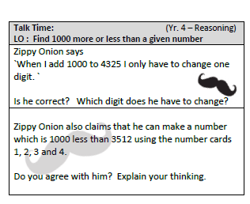

05/05/20 – Comparing sums of money
To compare two amounts of money they must be converted to the same unit.
For example: I cannot compare 562p with £5.23 because one is written in pounds and the other in pence. So, to change them to the same unit of measure I need to:
Pounds to pence x100
Pence to pounds divide by 100
£5.23 x 100 = 523p
Therefore, 562p is more than 523p
I could also write it as 562p > 523p
Now it’s your turn! Complete the sheet on the next page. Use this place value chart if you need it.
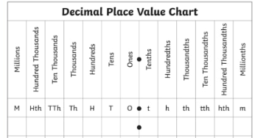

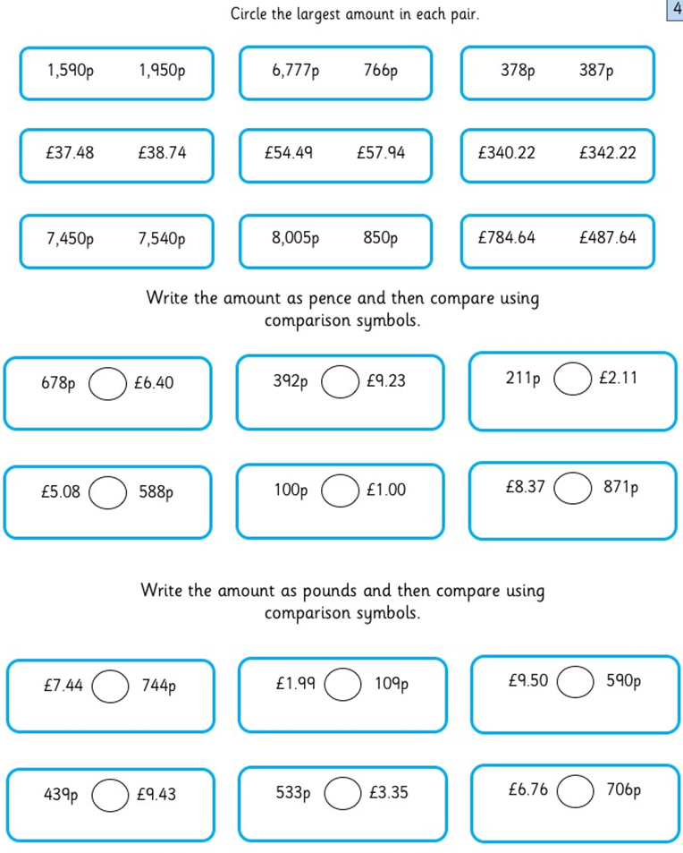
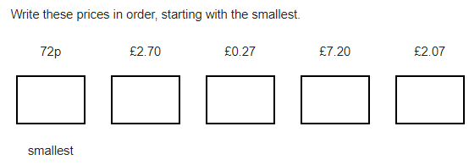
06/05/20 – comparing and reasoning about amounts of money (this is a talking activity)

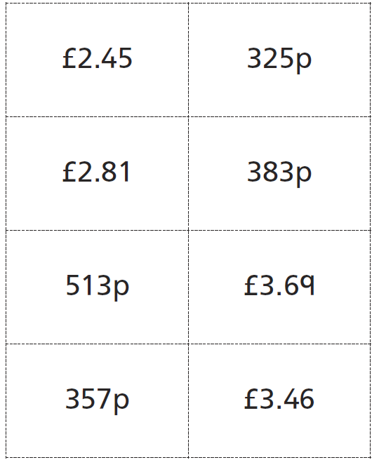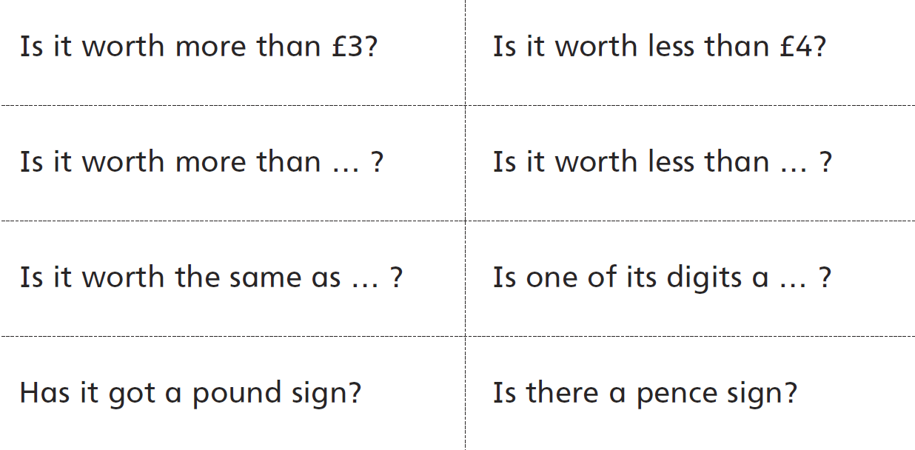
Partner 1: Choose a sum of money.
Partner 2: Use the question stems below to work out what sum of money your partner has.

For example: I have chosen 513p. My partner asks me is it worth less than £4. I would respond no so my partner will need to continue questioning me until they guess which one I have chosen.
Challenge: see if you can guess it in less than 10 questions!
Then match these statements to the correct amount of money.
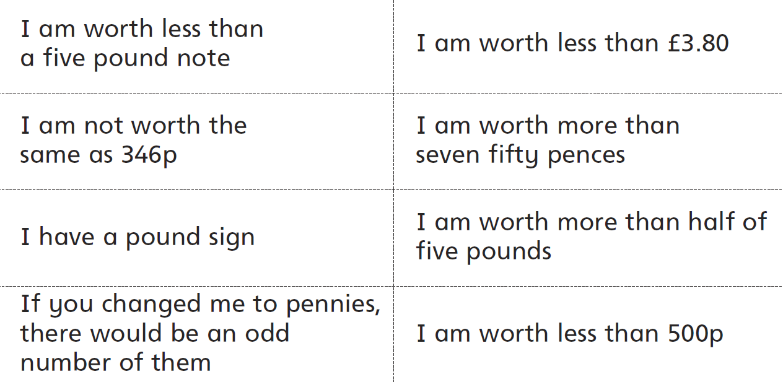

07/05/20 - Temperature Activity (including negatives)
Sally Cloudburst is a weather presenter, she has to report the temperatures for different cities in the UK. Unfortunately a large gust of wind has just blown her notes away and she only has a few clues about today’s lunchtime temperatures in a higgledy-piggledy order. Can you help her piece the facts together and then label the map with the correct information?
Today, Aberdeen is 6°C colder than Newcastle is. | The temperature in Cardiff this lunchtime is exactly halfway between that of Manchester and Southampton.
This lunchtime, Southampton is 11°C warmer than Belfast. | The temperature in Norwich will be 8°C warmer than Edinburgh today.
Today, the temperature in Leeds will be 6°C below that in Plymouth. | (Clue- start here) The temperature in Manchester this lunchtime is -2°C.
Birmingham is 3°C warmer than Manchester today. | This lunchtime, the temperature in Edinburgh will be exactly halfway between that of Birmingham and Aberdeen
The temperature in Newcastle is 5°C colder than Cardiff today. | This lunchtime, London will be 4°C warmer than Leeds.
Today, the temperature in Plymouth is 1°C warmer than Norwich. | Belfast is 6°C colder than Birmingham is this lunchtime.

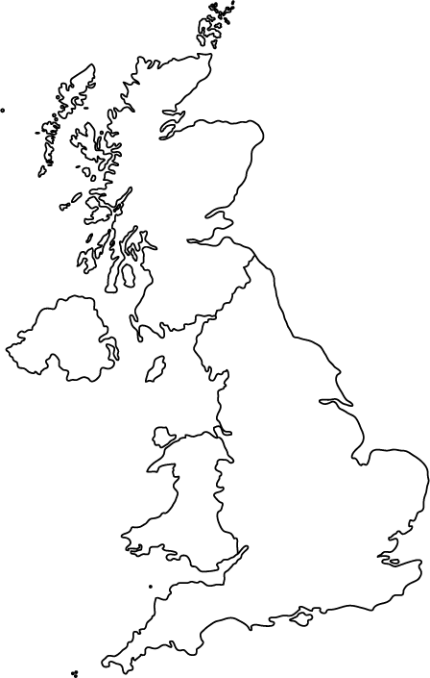
__Edinburgh____ ___°C
______________ _-3°C
_Plymouth_ ___°C
______________ _6_°C
______________ _-1°C
_______ _______ ___°C
__Belfast______ ___°C
______________ _-9°C
______________ _4°C
__Cardiff______ ___°C
______________ _1_°C
_Manchester__ ___°C

11/05/20 – Addition and subtraction
Find the answers using the column method – don’t forget to check the sign and make sure your decimal points are lined up correctly!
- 345+ 261 =
- 1721 + 292 =
- £3.52 – £1.20 =
- 9869 – 3877 =
- £75.86 + £13.34 =
- 5626 – 792 =
- 8432 + 1909 =
- £67.14 - £37.13 =
- £21.67 + £79.50=
- 9874 – 4168 =

Extension:
Can you put one of the calculations into the bar model? Remember the whole is what you have altogether and your two parts must make up the whole.
+

-

12/05/20 – Bar model explanation
The bar model helps us when it comes to understanding inverse calculations and word problems which is why we always encourage its use.

The top of the bar
Is the whole. It’s what
I have altogether.
10
-
-
-
4
6
The bottom shows how many parts there are

+

The symbols are just a reminder of what calculation I need to do so it’s always best to write them.
See below how to correctly place the numbers from a word problem into the bar model.
Problem: A piece of ribbon has been cut into two pieces. One ribbon is 76cm, the other is 24 cm. How long was the ribbon before it had been cut?

100

-
-
76
24

+

One part of my ribbon was 76cm and the other part was 24cm. If I know all the parts then I must add (that’s also why the add sign is there as a reminder). When I add my parts together, I get my whole so 76+24 =100. If I don’t have my parts I cannot add them so I must need to subtract (don’t forget the biggest number must go first).
Bar model task – use the word problems to put the numbers correctly in the bar. Draw your bar with a ruler if you have one. If you would like a challenge, cover the answer and work the answer out first.

- A tracksuit top costs £12.75 and matching tracksuit bottoms cost £9.50, how much does the tracksuit cost altogether? The answer is £22.25

- In one month 382 adults and 65 children stayed in a hotel. How many people stayed at the hotel altogether? The answer is 447 people

- A car park has room for 275 cars. 129 cars are parked in the car park, how many spaces are left? The answer is 146 spaces

- Cilla wants to buy a new car for £6450. She has £4880 in her savings account. How much more money does she need to save? The answer is £1570

- Daniel planned to cycle 364 miles in one week. On the first day he cycled 72 miles. How much further did he have to go? The answer is 292 miles

- Daniel is 151cm tall. His friend’s height is 138cm. What is the difference in their height? The answer is 13cm

13/05/20 – fact families
Use the bar model to tell me what you know. For example:
20
+

-
5
15

_Plymouth_ ___°C
______________ _6_°C
_______ _______ ___°C
Using this bar I know that:
15 + 5 = 20
5 +15 = 20
20 – 15 = 5
20 – 5 = 15
Your turn – use the numbers in the bar to tell me 4 calculations.
+

-
1000
250
750
4424
5441
9865
2501
1261
3762

+

-
+

-

14/05/20 – Using the inverse to find the missing number.
The bar in a very helpful tool when finding out the missing number and this is how:
2345 + _____ = 4686
+

-
4686

2341

2345

Add what you know already to the bar first. So I know that my whole is always the biggest value. When I add any numbers together I know I will end up with more, so my whole is at the end of the calculation. So 4686 must be my whole. This means 2345 is one part. This is where the signs are useful; I can’t add the two parts together because I only have one part. Therefore, I need to take away my part from my whole. I would now use the column method to work out 4686-2345= the answer to this calculation will be my missing part.

Your turn:
1. 854 + ____ = 958
2. 9854 - ____ = 1352
3. ____ - 468 = 157
5. 24 + ____ = 4687
6. 4466 - ____ = 2222
7. ____ - 764 = 999
8. 5975 + _____ = 9547
15/05/20 – your teachers wanted to see how much we remember how to add and subtract, please can you draw the bar model and use the inverse to check their answers? I don’t think they got many correct!
For example:
To check this answer I would do the inverse. The inverse of subtraction is addition. I know I can’t add 983 and 145 because 983 is my whole, it’s the biggest number in my number sentence. My two parts therefore must be 145 and 838. If the answer is correct when I add these two digits together, I should get the answer 983. If I don’t then I would mark it wrong but if I do that means my answer is correct.
983 - 145 = 838 I got the answer 983 so I was right!

983

+

-

838

145

Mrs Hopcraft
237 + 138 = 417

586 + 439 = 1025

891 - 473 = 389

Miss Harpum
63.7 + 24.2 = 87.9

376.3 - 135.12 = 128.2

238.38 + 126.2 = 364.58

Miss Sahota
937 - 452.3 = 563.7

893.9 + 56.23 = 1028.32

2918.4 - 736.76 = 2181.64

