Week 5:
English Activity 1:



Look at this picture. Imagine you are walking in the forest and you come across this. Write a descriptive paragraph. Thinking about how you feel, what you can see, smell and hear. Remember to use commas when you are writing more than one adjective consecutively in a sentence.

English Activity 2:
Looking again at this picture.

- Using the picture as a stimulus, write brief notes about three different ideas for a story.

- Choose your favourite idea, then write more notes to suggest how you could develop it in more detail.


English Activity 3:
Looking at your notes from yesterday, plan a short story based on your idea and the picture.

Things you may want to consider:
- Who do you think made the circles?
- How long do you think they have been there?
- Do the stones on the ground have any significance?
- What happens when your character steps through the circles?
Remember to plan each section of your story, you can magpie ideas from stories you have read in the past.
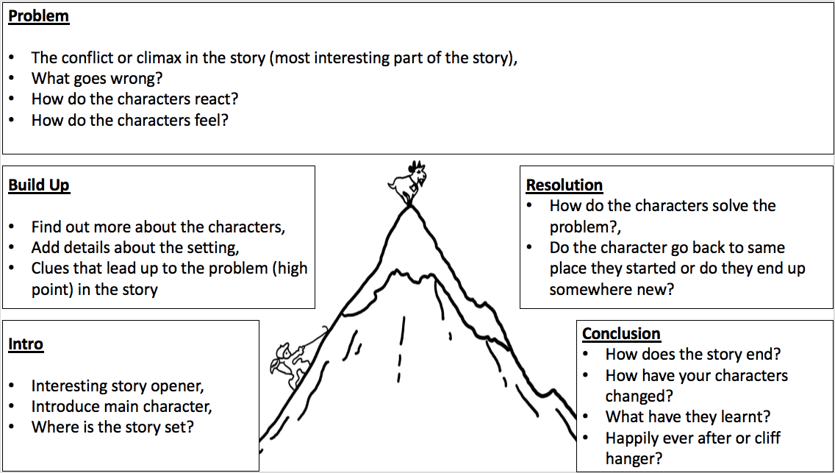

English Activity 4: Using your plan from yesterday, write your story. Remember to use paragraphs and to re-read and edit your learning.

English Activity 5: (Adults: the answers are on the following page)
Editing for Meaning Task.

- Read the extract below.

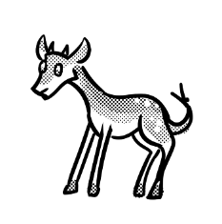
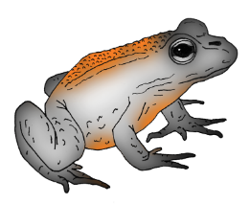
A walk on the wild side

Where can you take your kids for a fun day out that exercises their
minds as well as their bodies. Look no than Saxon Wood.

Saxon Wood was so more than just an area of outstanding natural beauty. It has wooden sculptures of people and animals from olden stories like Little Red Riding Hood and The Three Little Pigs and so on that the younger children will enjoy. There is a massive adventure playground packed with thrilling equipment to scramble over. There is even a nature study centre, complete with a lake in which to go pond dipping or spotting frogs who could ask for more.

At only £5 per family group, it was also great value. So, pack a picnic, put on your and enjoy a great day out.

2. After reading the extract, check for the following aspects and underline them:
- Check if there are any missing words.
- Check if there is any missing punctuation.
- Check if there are any problems with the tense.
- Find at least one part that could be improved.

3. Complete the grid below.
List any missing words.
List any missing punctuation.
List any problems with the tense.
Write a sentence which could be improved.

4. Rewrite the extract, making the amendments which you have identified in the grid above.

Editing for Meaning Task
ANSWERS
1. Read the extract below.

A walk on the wild side

Where can you take your kids for a fun day out that exercises their minds as well as their bodies. Look no than Saxon Wood.

Saxon Wood was so more than just an area of outstanding natural beauty. It has wooden sculptures of people and animals from olden stories like Little Red Riding Hood and The Three Little Pigs and so on that the younger children will enjoy. There is a massive adventure playground packed with thrilling equipment to scramble over. There is even a nature study centre, complete with a lake in which to go pond dipping or spotting frogs who could ask for more.

At only £5 per family group, it was also great value. So, pack a picnic, put on your and enjoy a great day out.

3. Complete the grid below.
List any missing words. | Look no than Saxon Wood.  … put on your and enjoy ...  Saxon Wood was so more than …
List any missing punctuation. | Where can … their bodies.  … spotting frogs who could …  Who could ask for more.
List any problems with the tense. | Saxon Wood was so …  … it was also great value.
Write a sentence which could be improved. | It has wooden sculptures of people and animals from olden stories like Little Red Riding Hood and The Three Little Pigs and so on that the younger children will enjoy.

4. Rewrite the extract, making the amendments which you have identified in the grid above.

A walk on the wild side

Where can you take your kids for a fun day out that exercises their minds as well as their bodies? Look no further than Saxon Wood.

Saxon Wood is so much more than just an area of outstanding natural beauty. It has wooden sculptures of favourite characters from traditional tales. There is a massive adventure playground packed with thrilling equipment to scramble over. There is even a nature study centre, complete with a lake in which to go pond dipping or spotting frogs. Who could ask for more?

At only £5 per family group, it is also great value. So, pack a picnic, put on your wellies and enjoy a great day out.

Week 6: English Activities:
Activity 1:
Think about and discuss what a good friendship is. Think about the relationship you have with your friend rather than just being a friend. Explore ideas such as fairness, equity, trust and kindness. Write a list of ingredients for a good friendship and then explain how it feels to have a good friendship with someone.

Activity 2:
Think about who your best friend is. This might be a friend in school or a friend outside of school. Think about the things you like to do together and why you are such good friends. Think about things you would like to do with your friend once we are able to meet again. Think about what you would like to tell them about what you have been doing in recent weeks.
We are going to be creating a postcard to give to our friend once we are able to. In your book, write a message to your friend thinking about the ideas above. Remember a postcard is similar to a letter so you need to begin with Dear _____, and you need to write who the postcard is from. Make sure you have re-read and edited your postcard ready to write up tomorrow.

Activity 3:
On the next page there a template of a postcard to print. Alternatively, you could create your own on a piece of paper. Write up the message you would like to send to your friend. I have changed the layout of the postcard so that the address is at the top of the postcard next to the stamp, so there is more room to write your message. If you do not know your friends address do not worry as you will be able to hand them the postcard once we are able to meet them again.


Activity 4: Grammar, Punctuation and Spelling Activities. - Homophones

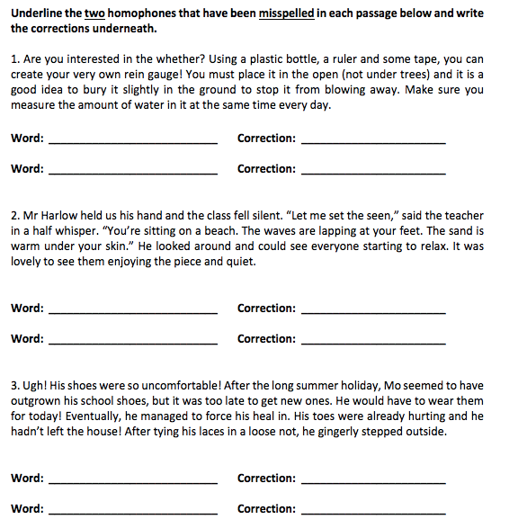

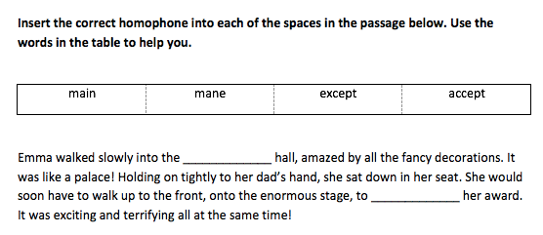

Activity 4 continued: Editing.

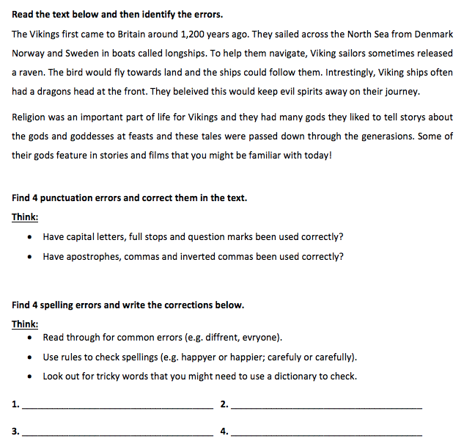

Dictionary work

Choose one tricky word that you might need to check the spelling of in the dictionary. Write the definition below as well as the spelling of at least one linked word (e.g. inform, information).

Word: _________________________________

Definition: _______________________________________________________________________

Linked word(s): ______________________________________________________________________
Answers: Homophones
Included in each answer is a possible strategy that teachers could use to support pupils in remembering each homophone.

1. weather: we are enjoying the weather
rain: rain is a pain
2. scene: scan the scene
peace: a peaceful pea
3. heel: heels on your feet
knot: k-not

1. main: get on the main train
2. accept: I ac - cept

Answers: Editing

The Vikings first came to Britain around 1,200 years ago. They sailed across the North Sea from Denmark, Norway and Sweden in boats called longships. To help them navigate, Viking sailors sometimes released a raven. The bird would fly towards land and the ships could follow them. Interestingly, Viking ships often had a dragon’s head at the front. They believed this would keep evil spirits away on their journey.

Religion was an important part of life for Vikings and they had many gods. They liked to tell stories about the gods and goddesses at feasts and these tales were passed down through the generations. Some of their gods feature in stories and films that you might be familiar with today!

Spelling Corrections & Explanations:

1. interestingly – missing letter: use the clue ‘in – ter – est’ to hear all the letters in the root word

2. believed – tricky word: Year 3/4 spelling list word: use the clue ‘i believe in xmas eve’

3. stories – rules error: change the ‘y’ to an ‘i’ before adding the suffix ‘es’ (unless there is a vowel before the ‘y’)

4. generations – rules error: ‘shn’ is usually spelled ‘tion’. Use a dictionary to help check if needed.
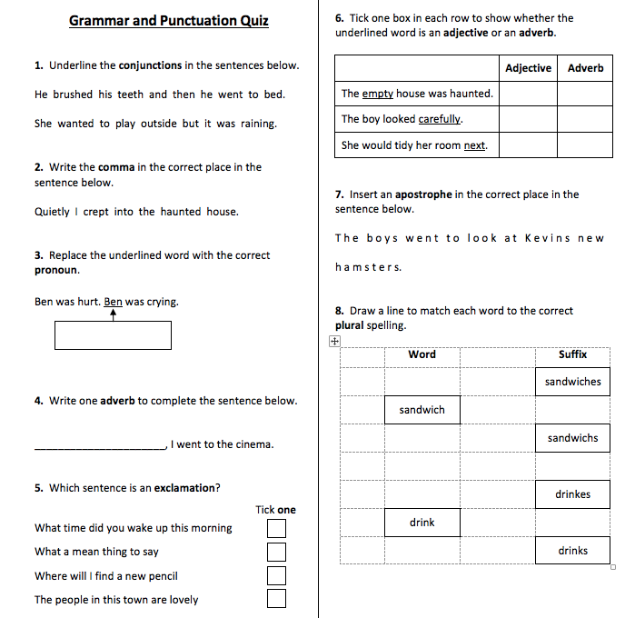
Activity 5:

Activity 5 Answers:
Qu. | Quiz 1 Answers | Notes
1 | and, but | Also accept answers that have been circled.
2 | Quietly, I crept into the haunted house. | Commas must be the correct size and must be curved to the left.
3 | He | Answers must be spelt correctly.
4 | Any appropriate adverb.  E.g. Yesterday, Earlier, Excitedly | Answers must be spelt correctly and must start with a capital letter.
5 | What a mean thing to say (Option 2)
6
   | Adjective | Adverb
  The empty house was haunted. | 
  The boy looked carefully.
  She would tidy her room next.
7 | T h e b o y s w e n t t o l o o k a t K e v i n’ s n e w  h a m s t e r s. | Apostrophes must be curved to the left.
8
   | Word |  | Suffix
   |  |  | sandwiches
   | sandwich
   |  |  | sandwichs
   |  |  | drinkes
   | drink
   |  |  | drinks

Other activities:


