Maths week 1
20/04/20 – Division
Watch the youtube video link and answer the following questioning using the bus stop method. youtu.be/MOv2xc2YtTA
- 46 ÷ 2 =

- 248 ÷ 2 =

- 363 ÷ 3 =

- 84 ÷ 4 =

- 330 ÷ 3 =

Extension:
Choose a number sentence to write as a word problem and give it to a member of your family (who is older than you). Don’t forget to include key words that we associate with division.
For example: In year 4 there are 42 children but only two classes. How many children are in each class?

21/04/20 – division continued

Practice what you learnt yesterday using the bus stop method. Watch the video again, to see how to exchange.

- 132 ÷ 2 =

- 520 ÷ 2 =

- 738 ÷ 3 =

- 680 ÷ 4 =

- 129 ÷ 3 =

Challenge: Complete a challenge card or two from the attached document ‘Multiplication and division challenge cards’.

22/04/20 – division with a mix of exchanging and non-exchanging.

- 246 ÷ 2 =

- 368 ÷ 2 =

- 363 ÷ 3 =

- 524 ÷ 4 =

- 99 ÷ 3 =

Challenge: Complete a challenge card or two from the attached document ‘Multiplication and division challenge cards’.

23/04/20 – Division word problems. Can you complete some of them without using place value counters?


1. I have 726 cupcakes to sell at the fair. The fair lasts for 3 days. How many do I want to sell each day?

2. There are 484 children in the school. They need to be split into 4 groups. How many children will there be in each group?

3. Five hundred and nineteen penguins need to be put into 3 pools. How many will go in each pool?
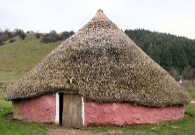
4. There are 847 Anglo-Saxons living in 7 villages. How many live in each village?
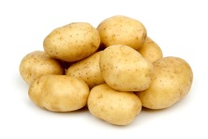
5. There are 964 potatoes in the bags and 4 enormous pans in the kitchen. How many potatoes will the chef put in each?

6. There are 309 paint brushes in the cupboard and 3 trays for them. How many paint brushes should go in each tray?

7. 428 children need to go to the theatre. Four buses are sent to take them there. How many children should go on each bus?
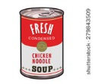
8. A supermarket has 4 shelves for soup and 564 tins to put on them. How many tins should they put on each shelf?

Challenge: 2 step word problem
120 boys and 130 girls go on a school trip. They travel on 5 coaches. How many children are there on each coach?

24/04/20 – finding fractions of larger amounts

Watch the video to remind yourself of how to do this.
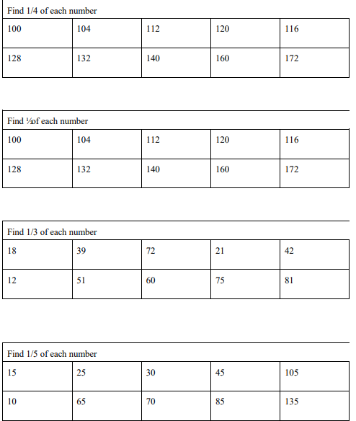

Week 2
28/04/20 - Estimating and measuring weight and capacity.

Here is an example of how you could draw your tables to record what you have found.

Object | Estimated weight | Actual weight
Item 1

Item 2

29/04/20 – Converting measures
g to kg – ÷ by 1000 kg to g - x by 1000
ml to l – ÷ by 1000 l to ml - x by 1000
Top tip: 1000 has 3 zeros so you must jump three places.
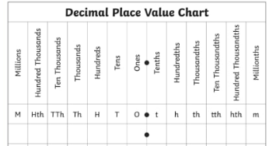
Convert these measures using the key above to help you.
- 23 g = _____kg
- 6000 kg = _____ g
- 780g = _____ kg
- 0.76g = _____ kg
- 9.6g = _____kg
- 49l = _____ml
- 7ml = ______l
- 568l = _____ ml
- 12ml = _____ l
- 0.29ml = ____ l

Now write 5 of your own measures to convert.

30/04/20 – Time
Keep a time table of what you do today. (You could do this every day!) Then draw these times on the analogue clocks and write the 24 hour digital time underneath. 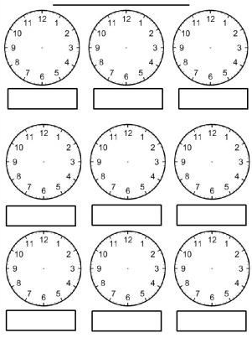
01/05/20 – Converting time
Super challenge:
Complete the following to remind you:
_________ minutes in an hour
_________ hours in a day
_________ days in a week
_________ months in a year
Don’t forget to show your working out! (These will be multiplication calculations)
- How many days in 6 weeks?
- How many months in 4 years?
- How many minutes in 2 hours?
- How many days in 5 weeks?
- How many months in 8 years?
- How many hours in 3 days?
- How many hours in 7 days?
- How many minutes in 10 hours?
- How many hours in 2 days?
- How many months in 5 years?
For the next ones you will need to divide.

- How many hours is the same as 180minutes?
- How many hours is the same as 360minutes?
- How many days is the same as 72 hours?
- How many days is the same as 144 hours?
- How many years is the same as 48months?
- How many years is the same as 96months?
- How many years is the same as 24months?
- How many weeks is the same as 21 days?
- How many weeks is the same as 56days?
- How many weeks is the same as 14 days?

