
Learning Activities
Year 2019-20

self-isolation learning Week 3
 | Lessons set  This terms topic: Landscapes Across the UK  This weeks maths topic: Division  English: letter writing | Additional comments
Monday | Maths: Complete at least 5 sessions of TT Rockstars.  Watch the video below to learn how to divide using the bus stop method. Then complete the division questions drawing the place value counters if you need to.  youtu.be/MOv2xc2YtTA  SLOR: Read extract one from the SLoR activities sheet and answer the suggested questions at the bottom of the page. Remember to give evidence for your answers  English: Throughout this week you will be writing a letter to an elderly person (either a neighbour or you could send it to a care home). The elderly will be finding self-isolation challenging as they are not allowed to have visitors, this includes their families. We are going to write letters and draw pictures to cheer them up.  For today’s lesson there is letter attached to this sheet. From what we learnt during our letter writing last term, can you identify the following features:  Address of sender,  Address of recipient,  Date,  Appropriate greeting,  Introduction,  Conclusion,  Complimentary close (from/ yours sincerely etc.)  Signature or name of sender,  Fronted adverbials followed by a comma,  The use of paragraphs.  Once you have labelled the features of the letter, think of what you might like to write in your letter to make them feel happier. You could tell them about a fond memory you have. You might like to talk about things you are looking forward to later in the year. Write your ideas in your book so you can go back to them when you are writing the letter.  Science: Go on a mini-beast hunt in your garden, record in a table which mini beast you find and where its habitat is. | Take part in the Joe Wicks daily P.E lessons at 9am each morning https://www.youtube.com/user/thebodycoach1/featured  Maths  Please find all maths sheets in the document named ‘Maths week 3 -4’.  Complete a challenge card or two after each maths lesson. The document is called ‘Multiplication and Division challenge cards’.  SLoR  Reading extracts and accompanying questions can be found in the separate document labelled ‘Week 3-4 SLoR activities’.  English  There is an example text to label at the end of this document. If you are unable to print the letter, write down examples from the text of each feature.  A fronted adverbial information poster is also attached.  Reading  Enjoy reading 10 minutes of your favourite book or your current reader in the most creative places possible and send us your photos via the school twitter account!
Tuesday | Maths: Complete at least 5 sessions of TT Rockstars.  Today you will be dividing but you will need to exchange.  Challenge: Can you answer some of the questions using your division facts and without drawing place value counters?  SLOR: Read extract two from the SLoR activities sheet and answer the suggested questions at the bottom of the page. Remember to give evidence for your answers  English: Using the example letter from yesterday, write a first draft of your letter. Remember to use the correct layout. Use the schools address rather than your personal address.  Jigsaw: Have a look through the link below  https://families.jigsawpshe.com/stuck-at-home/ it will take you through a jigsaw lesson. Look at the story ‘Fowley’s Wings’. | Maths  Watch the link from Monday to find out exactly how to do this. youtu.be/MOv2xc2YtTA  English  Schools address: Swingate Primary School, Sultan Road, Lordwood, Kent, ME5 8TJ  Reading  Enjoy reading 10 minutes of your favourite book or your current reader in the most creative places possible and send us your photos via the school twitter account!
Wednesday | Maths: Complete at least 5 sessions of TT Rockstars.  Using the bus stop method to support you can you solve the division questions, some will require you to exchange, some won’t.  SLOR: Read extract three from the SLoR activities sheet and answer the suggested questions at the bottom of the page. Remember to give evidence for your answers  English: Read through your letter and make sure that it makes sense and that you have used the correct spelling and punctuation. Once you are happy with it. Write it up in your best handwriting to send to an elderly neighbour or to a local care home.  Art: Once you have finished your letter draw and colour a picture to accompany your letter. | Maths  Watch the link from Monday to find out exactly how to do this.  youtu.be/MOv2xc2YtTA  English  When writing up, have a look at the handwriting video Miss Sahota posted on Twitter.  A cover note which you can print if you are able and a list of care homes is attached at the end of this document.  Reading  Enjoy reading 10 minutes of your favourite book or your current reader in the most creative places possible and send us your photos via the school twitter account!
Thursday | Maths: Complete at least 5 sessions of TT Rockstars.  Solve the division word problems, see if you can answer some of them without place value counters.  SLOR: Read extract four from the SLoR activities sheet and answer the suggested questions at the bottom of the page. Remember to give evidence for your answers  English: The corona virus pandemic is something that has never happened before. Therefore, we feel that it is important to remember this time as it will be an important part of our history in the future. Using what you have learnt about letter writing this week, we would like you to write a letter to yourself to read when you are older. You might want to include how you are feeling, what you have been doing each day, what advice would you give yourself in the future?  Topic: Research your local area (your home town). Make a list of all the places to go in your area e.g. local parks, shops, leisure centres, schools etc. Use google maps to help you draw a map and label the places you found on the map. Can you locate your house? | Maths  Watch the link from Monday to find out exactly how to do this.  youtu.be/MOv2xc2YtTA  English  Remember you need to use the features you learnt earlier in the week.  Reading  Enjoy reading 10 minutes of your favourite book or your current reader in the most creative places possible and send us your photos via the school twitter account!
Friday | Maths: Complete at least 5 sessions of TT Rockstars.  Complete the week 3 10 in 10 arithmetic.  Using what you have learnt about how to divide to find fractions of larger amounts.  SLOR: Read extract five from the SLoR activities sheet and answer the suggested questions at the bottom of the page. Remember to give evidence for your answers  English: Write up the letter in your best handwriting. Make sure you write the date and your age on the letter as a reminder of this time. Then put your letter in a safe place ready for when you are older and want to reflect on this.  Topic:  Complete one activity from the home learning grid | Maths  Click on the link to take you to the school youtube account where you will find a video explaining how to find fractions of amounts https://www.youtube.com/channel/UCDdEt2aTkih-P4lCPG-sKew  English  When writing up, have a look at the handwriting video Miss Sahota posted on Twitter.  Reading  Enjoy reading 10 minutes of your favourite book or your current reader in the most creative places possible and send us your photos via the school twitter account!

Week 3: English Lesson 1: English fronted adverbials explained.

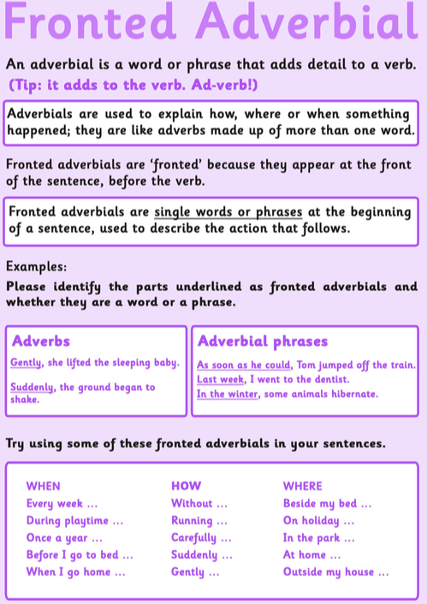

Week 3: English Lesson 1: Label the features of this letter.

Dani King,
66 School Lane,
Hucking,
Kent,
ME17 1QS
Thursday 26th March 2020.

Sabrina Cross,
24 Rose Street,
Oxford,
England,
OX1 1BD

Dear Sabrina,

Thank you for your letter, it was great to hear from you. You asked me to tell you about my favourite say of the week. Well, it’s definitely Friday.

First of all, I like Fridays because I have my favourite subjects at school: PE and Science. Science is great because we do experiments in the lab and our teacher, Mr King, is so funny. In PE, we usually play basketball, which is my favourite sport. I am good at it because I am quite tall and out team usually wins.

Secondly, we also have ICT which is very interesting. At the moment, I’m creating a webpage for our basketball team. After school, I hang out with my friends and then in the evening I play football at the sports centre. Sometimes, on a Friday night we have a family night and watch a film on the sofa, or we play games together. We can relax a bit on Friday evenings because there’s no school on Saturday.

Tell me about your favourite day in your next letter. I hope to hear from you soon.

Love From,

Dani.


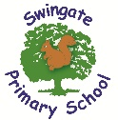

Swingate Primary School,
Sultan Road,
Lordswood,
ME5 8TJ

To whom it may concern,

Year 4 at Swingate Primary School, Lordwood, have been writing letters and drawing pictures to send a little cheer to others during this pandemic. The children have completed this activity as part of their home learning.

Many of us are finding the current situation quite challenging as we cannot socialise with our loved ones as we usually would. We hope that these letters and drawing find you well and help you to remember fond memories or give you something to look forward to in the future.

We hope the enclosed brightens your day a little.

Keep safe,

_________________________________

Year 4, Swingate Primary School.

List of care homes: if you know of any other care homes or would like to send your letter to someone else please feel free to do this.

Victory Care Home,
Nelson Court,
Nelson Terrace,
Chatham,
ME5 7JZ

Copper Beeches Care Home,
5 Sylewood Close,
Borstal,
Rochester,
Kent,
ME1 3LL

Amherst Court,
Palmerston Road,
Chatham,
Kent,
ME4 6LU

Aquarius Care Home,
8 Watson Avenue,
Chatham,
Kent,
ME5 9SH

Rochester Care Home,
Robert Bean Lodge,
Pattens Lane,
Rochester,
ME1 2QT

Learning Activities
Year 2019-20

self-isolation learning Week 4
 | Lessons set  Maths topic: measures  English topic: Poetry | Additional comments
Monday | Maths: Complete at least 5 sessions of TT Rockstars.  Explore capacity and weight around your house. What units do we measure them in? What equipment do you have in your house to measure them? Your task today is to help an adult cook something that involves measuring the weight or capacity of ingredients. Then in your book compare three of the ingredients using < > =.  For example, 110g butter = 110g sugar < 175g flour. You can do with as many of the ingredients as you’d like.  SLOR: Read extract six from the SLoR activities sheet and answer the suggested questions at the bottom of the page. Remember to give evidence for your answers  English: Attached is a copy of an elephant poem.  Using Talk for Writing, think of some actions to help you remember the poem. You could create a text map to help you.  Think about what the pattern is in the poem, what language have they used?  (Parents/Guardians: on the sheet it tells you what each line of the poem consists of, use this to support your child if they are finding it challenging to identify the pattern/language)  Science: Look at the powerpoint named ‘living things and their habitats’ and see if you can make your own branching key. | Take part in the Joe Wicks daily P.E lessons at 9am each morning https://www.youtube.com/user/thebodycoach1/featured  English  Talk about verbs, adjectives, similes and sentence types eg. questions, commands, statements and exclamations.  Reading  Enjoy reading 10 minutes of your favourite book or your current reader in the most creative places possible and send us your photos via the school twitter account!
Tuesday | Maths: Complete at least 5 sessions of TT Rockstars.  Choose 10 items from around the house, estimate the weight of each item then weigh them to see how good your estimate was. Then do the same for capacity, choose 10 items you could estimate and measure the capacity of using water. Then measure using a measuring jug to see how good your estimate was.  Record your information in two separate tables, one for weight and one for capacity.  SLOR: Read extract seven from the SLoR activities sheet and answer the suggested questions at the bottom of the page. Remember to give evidence for your answers  English:  To help you remember the poem you looked at yesterday, use your talk for writing actions to perform the poem.  Today we will be innovating our poem. Can you adapt the poem so that it written about a wild animal you might find in the UK. You might want to carry out some research on a chosen animal so that you can describe how it looks, moves etc.  Jigsaw: https://families.jigsawpshe.com/stuck-at-home/ it will take you through a jigsaw lesson. Look at the story ‘The Switch Watch’. | Maths  Think about what unit of measure would be best to use, a book won’t be more than 1kg.  Reading  Enjoy reading 10 minutes of your favourite book or your current reader in the most creative places possible and send us your photos via the school twitter account!
Wednesday | Maths: Complete at least 5 sessions of TT Rockstars.  Converting measures. Look at the measures you have been given and convert them into a different unit of measure by multiplying and dividing by 10, 100 and 1000. The guidance is at the top of the page.  SLOR: Read extract eight from the SLoR activities sheet and answer the suggested questions at the bottom of the page. Remember to give evidence for your answers  English: Looking back at the poems you have learnt/ written over the past 2 days, can you write a second poem about another animal you would find in the UK. Use different vocabulary to describe this animal.  Topic: Look at the photos (attached to this document) of the Medway towns in history and then now. Write down how the areas have changed over time, include as many details as you can find. Why do you think some of these changes have happened? | Maths  Use the place value chart to help you.  Reading  Enjoy reading 10 minutes of your favourite book or your current reader in the most creative places possible and send us your photos via the school twitter account!
Thursday | Maths: Complete at least 5 sessions of TT Rockstars.  Time: Write a time table of your day, for example, the time you brush your teeth, start your Jo Wicks workout, your snack time, when you complete your English etc. Then draw the hands on the clocks to show these times and write it in 24 hour digit time underneath.  SLOR: Read extract nine from the SLoR activities sheet and answer the suggested questions at the bottom of the page. Remember to give evidence for your answers  English: Perform the 2 poems you have written this week. Are there any changes you would like to make? Ensure you have checked you spelling and that it is a similar style to the model text.  Once you are happy with your first draft of your poems, write them up to produce a published piece. Add illustrations to each poem, this will help the reader to visualise the animal you have written about.  Art: Look out your window, go in to your garden or use the internet to search for a picture from your local area. Sketch what you can see using the sketching skills you have learnt. | Maths  We have learnt how to do this but if you need to recap with your child, please see the powerpoint named ‘digital time’.  English  When writing up, have a look at the handwriting video Miss Sahota posted on Twitter.  Art for Kids Hub on You Tube has some good tutorials for different drawings.  Reading  Enjoy reading 10 minutes of your favourite book or your current reader in the most creative places possible and send us your photos via the school twitter account!
Friday | Maths: Complete at least 5 sessions of TT Rockstars.  Complete the week 4 10 in 10 arithmetic. Has your score improved from last week?  Answer the time questions by converting between, minutes and hours, days and weeks and months and years.  SLOR: Read extract ten from the SLoR activities sheet and answer the suggested questions at the bottom of the page. Remember to give evidence for your answers  English: Using what you have learnt this week write a final poem about your favourite animal. Then draw an illustration to accompany it.  Topic: Complete one activity from the home learning grid | Reading  Enjoy reading 10 minutes of your favourite book or your current reader in the most creative places possible and send us your photos via the school twitter account!

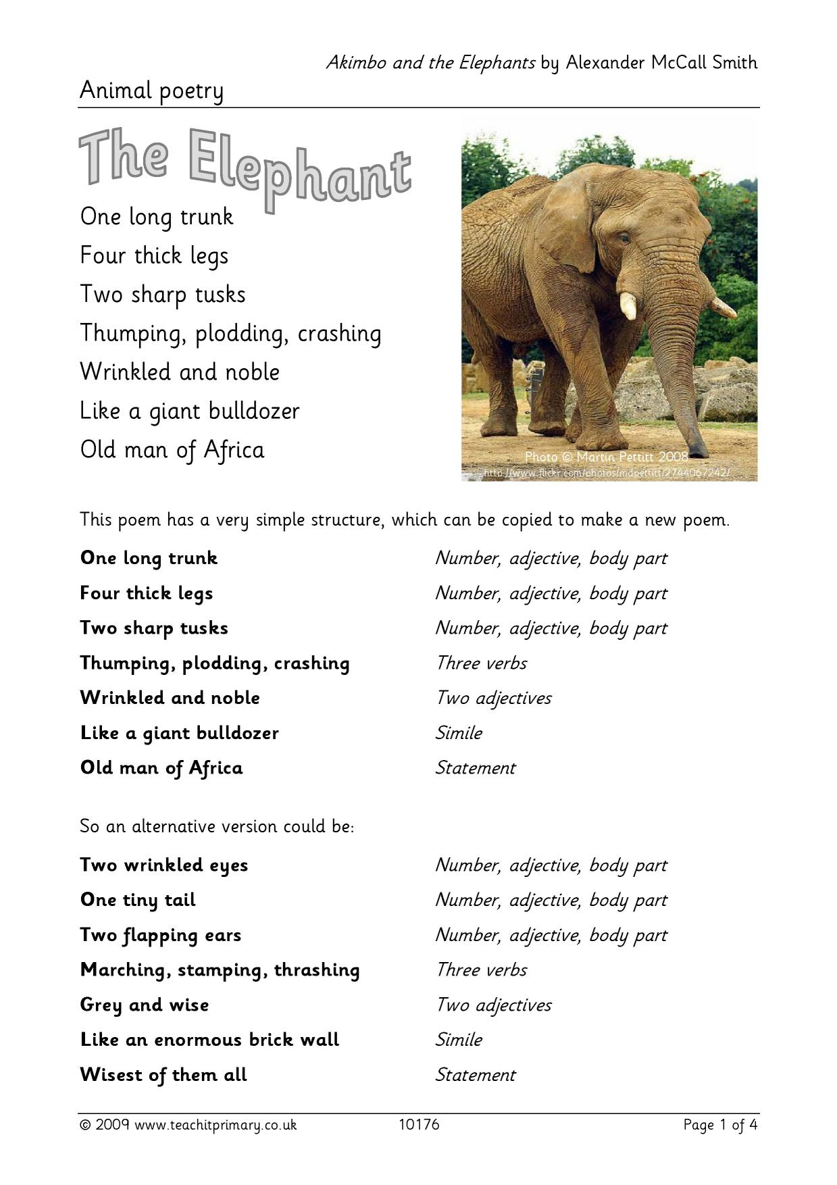

Topic



