
Learning Activities
Year 4 2019-20

Self-isolation learning Week 1
 | Lessons set | Additional comments
Monday | Maths: Complete at least 5 sessions of TT Rockstars.  Complete the addition number sentences using the column method to show your working.  SLOR: Read a chapter of your book. Who is your favourite character and why?  English: Carry out research on the Viking God Thor to help you plan a story tomorrow. | Each day complete 1 activity from the home learning grid found on the website.  Please complete all tasks in a clear and neatly presented way.
Tuesday | Maths: Complete at least 5 sessions of TT Rockstars.  Complete the subtraction number sentences using the column method to show your working.  SLOR: Read a chapter of your book. Write the next chapter of your book. What do you think will happen next?  English: Use the research you carried out yesterday to plan a story about Thor. Remember you need a problem and a resolution in the middle section of your story. | Each day complete 1 activity from the home learning grid found on the website.  Please complete all tasks in a clear and neatly presented way.
Wednesday | Maths: Complete at least 5 sessions of TT Rockstars.  Complete the multiplication number sentences.  SLOR: Read a chapter of your book. Write 3 questions you would like to ask the main character in your story.  English: Write your story about Thor using the plan you created yesterday. | Each day complete 1 activity from the home learning grid found on the website.  Please complete all tasks in a clear and neatly presented way.
Thursday | Maths: Complete at least 5 sessions of TT Rockstars.  Complete the subtraction number sentences.  SLOR: Read a chapter of your book. Create a question for debate based upon your book.  English: Edit and improve your story, check for spelling and punctuation errors. | Each day complete 1 activity from the home learning grid found on the website.  Please complete all tasks in a clear and neatly presented way.
Friday | Maths: Complete at least 5 sessions of TT Rockstars.  Complete the 10 in 10 Arithmetic sheet.  SLOR: Read a chapter of your book. Summarise what you have read this week in 5 sentences.  English: Using the edited story from yesterday, create a published piece using your best handwriting and correct spelling and punctuation. | Each day complete 1 activity from the home learning grid found on the website.  Please complete all tasks in a clear and neatly presented way.

Learning Activities
Year 4 2019-20

Self-isolation learning Week 2
 | Lessons set | Additional comments
Monday | Maths: Complete at least 5 sessions of TT Rockstars.  Complete the word problems. Remember to show your working.  SLOR: Read a chapter of your book. Write a description of the main character based on what you know from the text.  English: Research Viking raids, what do you think it would have been like to be a Viking? | Each day complete 1 activity from the home learning grid found on the website.  Please complete all tasks in a clear and neatly presented way.
Tuesday | Maths: Complete at least 5 sessions of TT Rockstars.  Complete the word problems. Remember to show your working.  SLOR: Read a chapter of your book. How have the main character’s feeling changed throughout the book?  English: Write a diary entry as of you were a Viking raiding a monastery. Use your senses to help you describe. Remember to use exciting vocabulary. | Each day complete 1 activity from the home learning grid found on the website.  Please complete all tasks in a clear and neatly presented way.
Wednesday | Maths: Complete at least 5 sessions of TT Rockstars. Complete the word problems. Remember to show your working.  SLOR: Read a chapter of your book. Draw an illustration of your favourite part of the story.  Science: Find out what a food chain is. What do the terms producer, consumer, predator and prey mean? What is the longest food chain you can create? Remember to label it. | Each day complete 1 activity from the home learning grid found on the website.  Please complete all tasks in a clear and neatly presented way.
Thursday | Maths: Complete at least 5 sessions of TT Rockstars.  Complete the word problems, remember to show your working out.  SLOR: Read a chapter of your book. Which character would you like to spend the day with and why?  English: Research orangutans and the use of palm oil. Make some notes for tomorrows learning. | Each day complete 1 activity from the home learning grid found on the website.  Please complete all tasks in a clear and neatly presented way.
Friday | Maths: Complete at least 5 sessions of TT Rockstars.  Maths: Complete at least 5 sessions of TT Rockstars.  Complete the 10 in 10 Arithmetic sheet.  SLOR: Write a book review for a book you have read recently. Would you recommend it to others, why/ why not? What were your favourite parts of the story? What age group would you recommend it for?  English: Using the information you found out yesterday, create a fact file about orangutans and the use of palm oil. Add relevant illustrations to make it eye catching. | Each day complete 1 activity from the home learning grid found on the website.  Please complete all tasks in a clear and neatly presented way.

Week 1: Monday -Addition
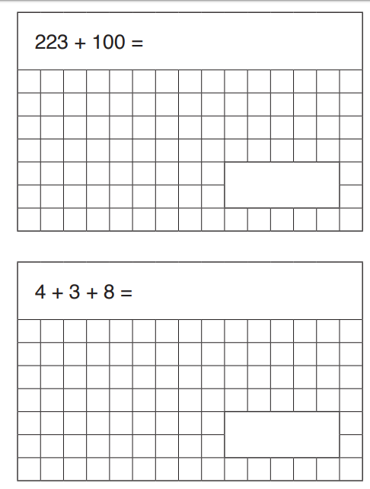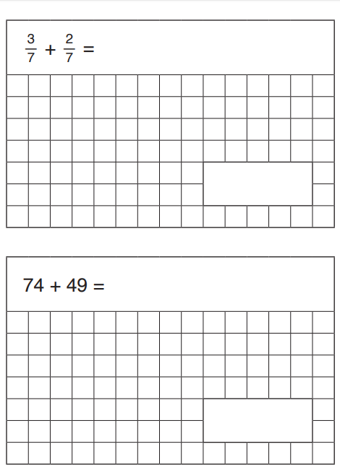
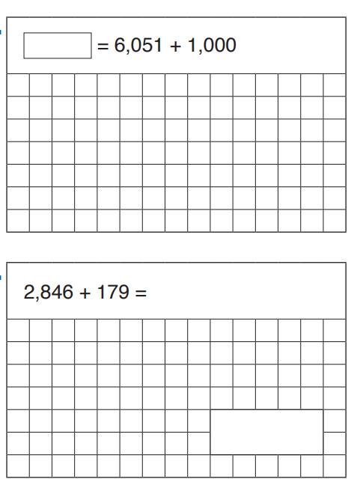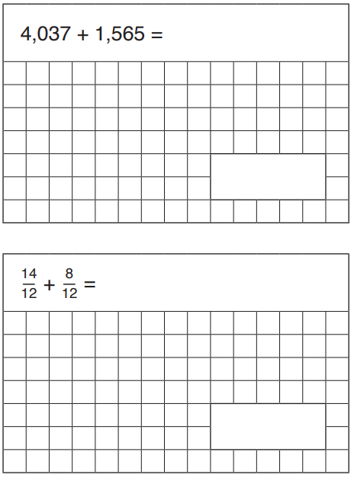

Tuesday - Subtraction
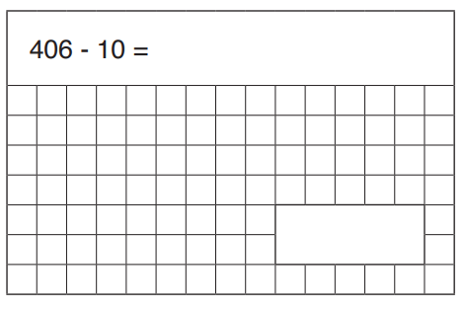
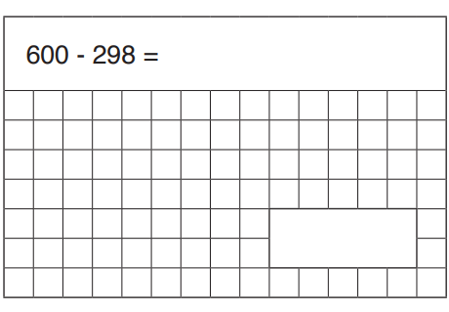
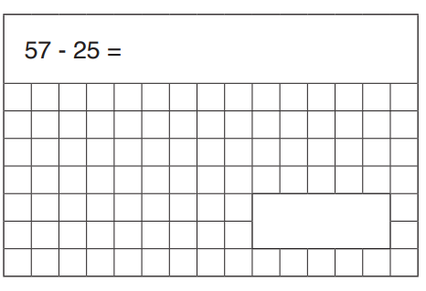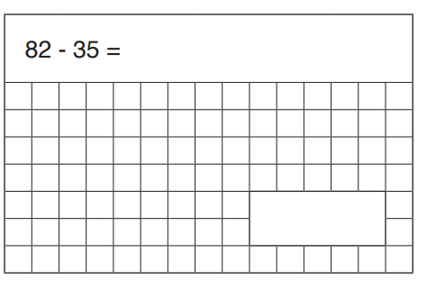
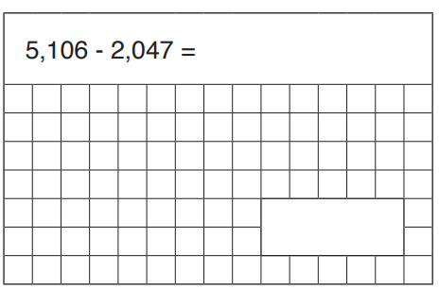
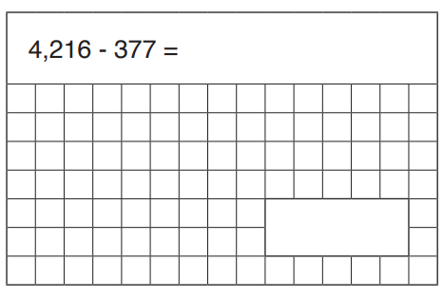

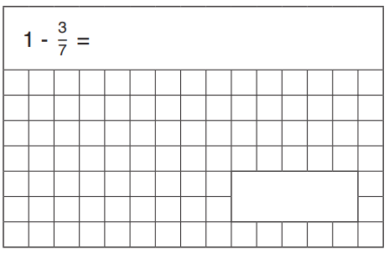

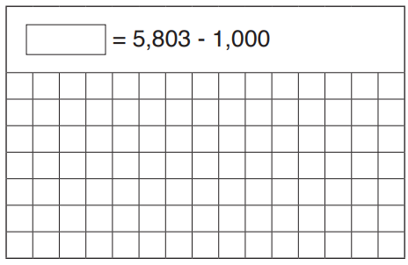

Wednesday - Multiplication
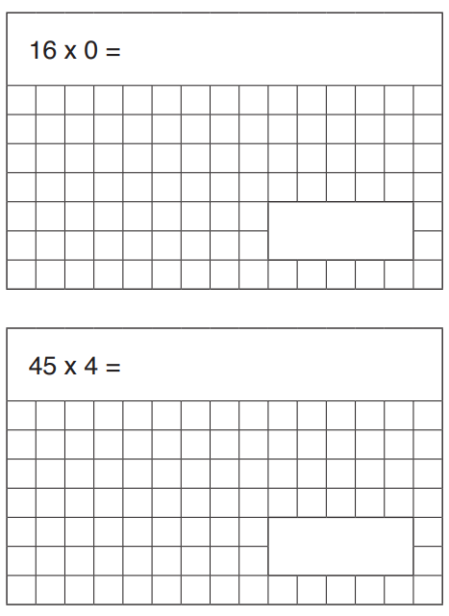
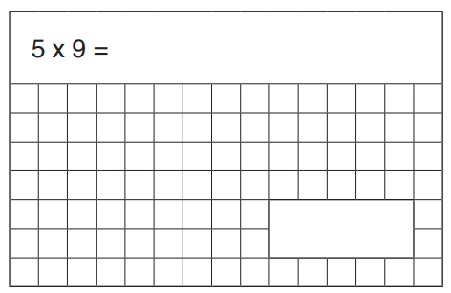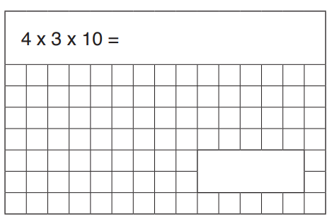
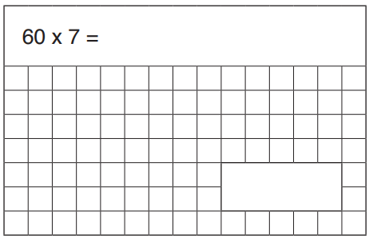
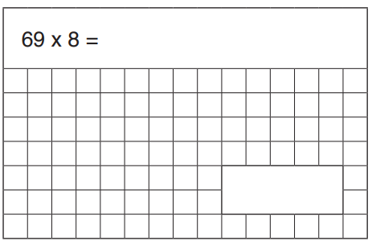
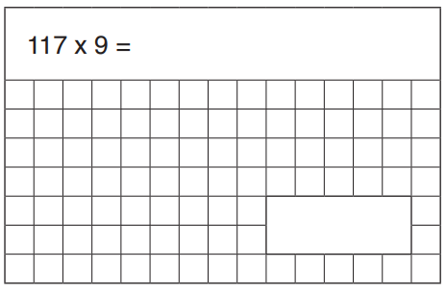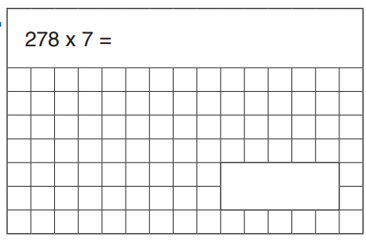

Thursday - Dividing
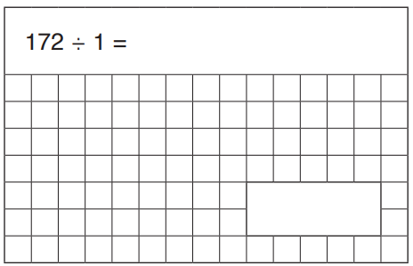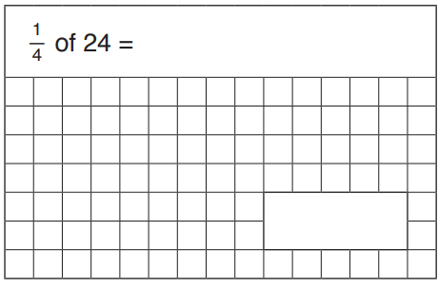
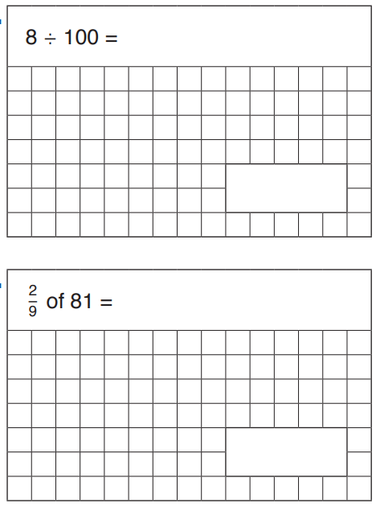
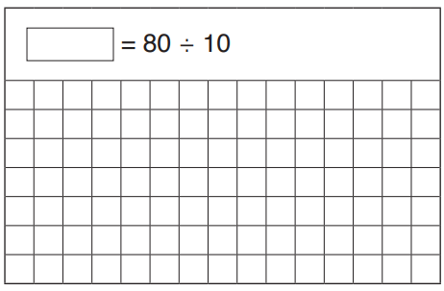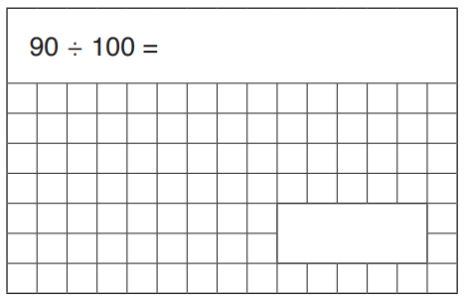
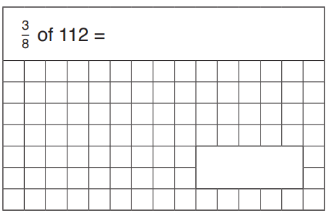
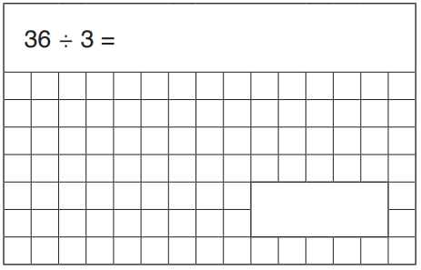

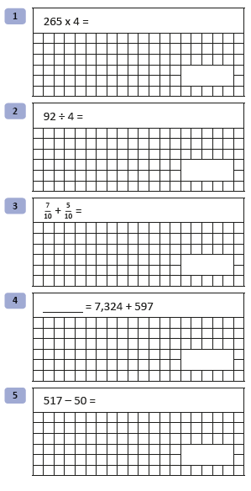
Friday – 10 in 10, time how long it takes you to complete these questions. Write your time on your sheet.

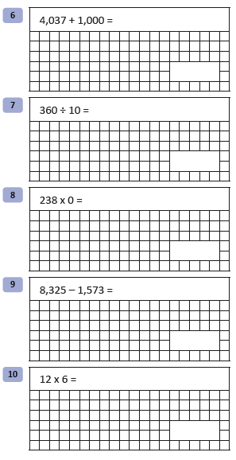

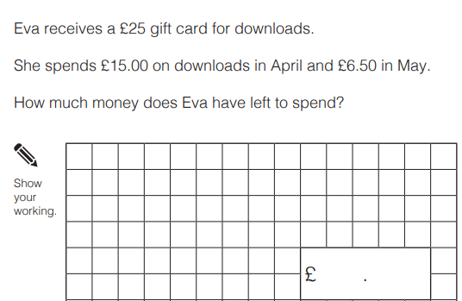
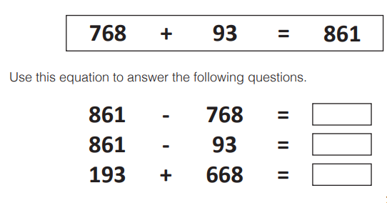
Week 2: Monday - Addition & Subtraction

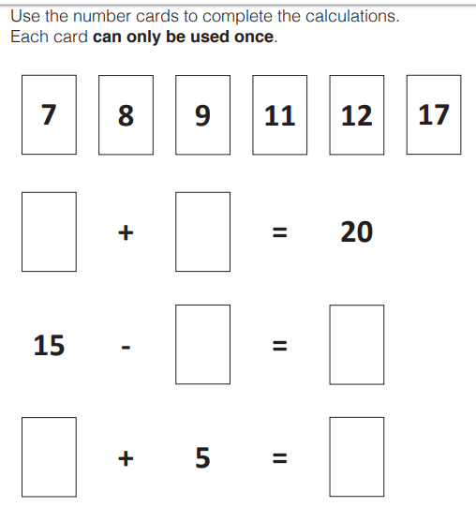
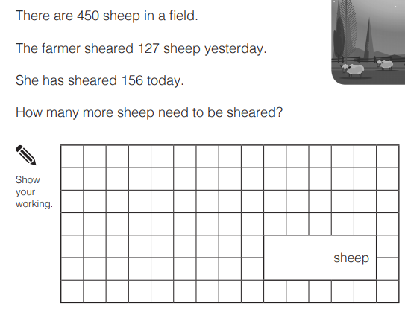
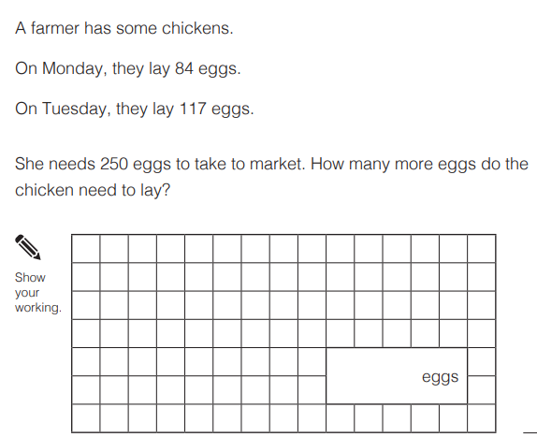
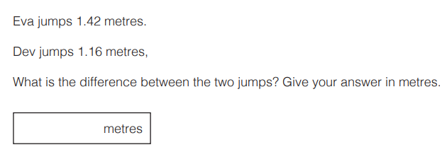

Tuesday - addition and subtraction
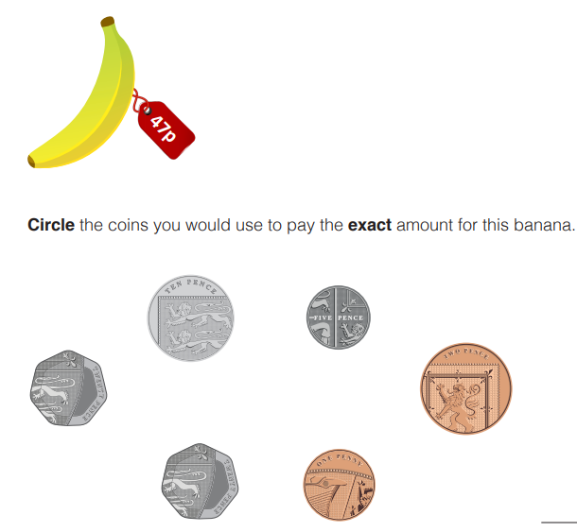
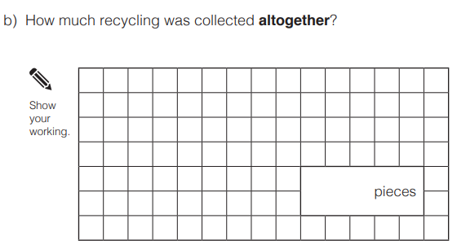
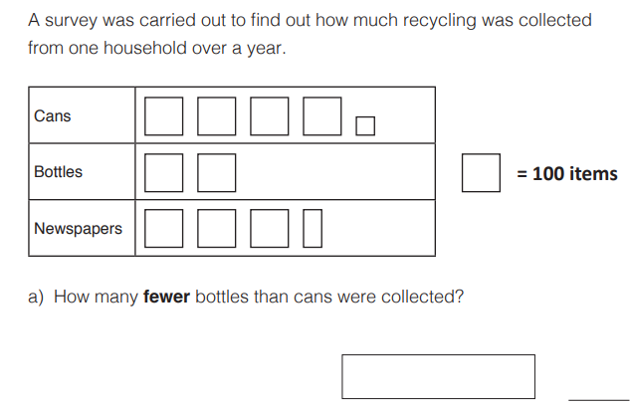
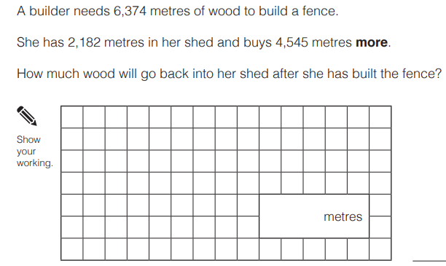
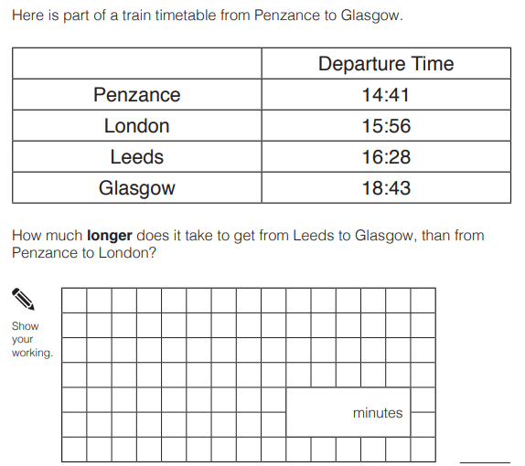
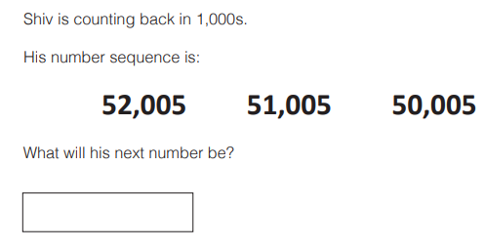

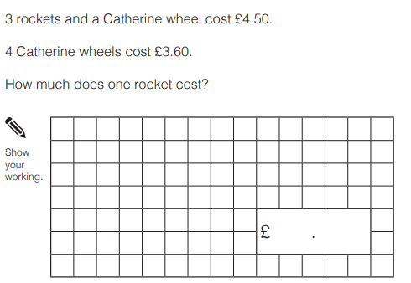
Wednesday - Multiplication and division
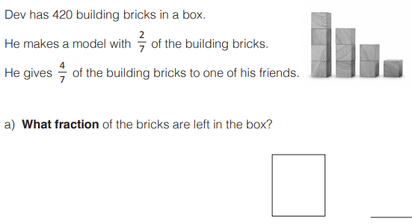
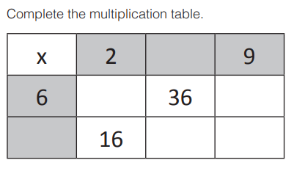
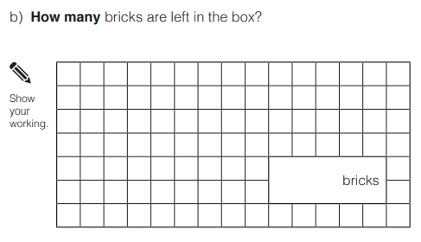

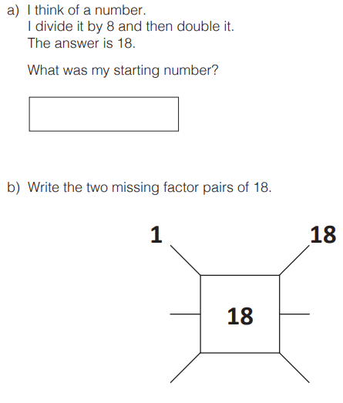
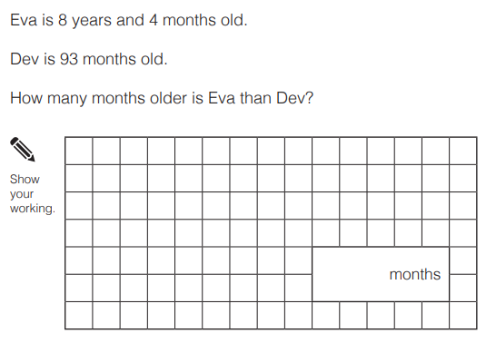

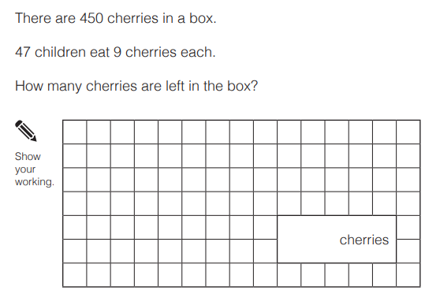
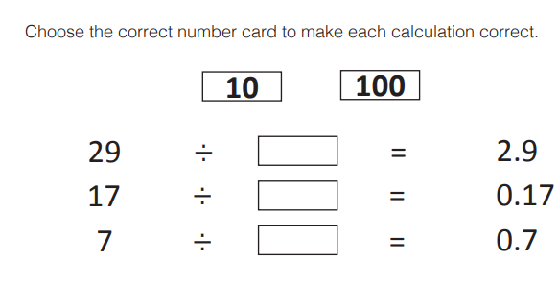
Thursday – Multiplication and Division
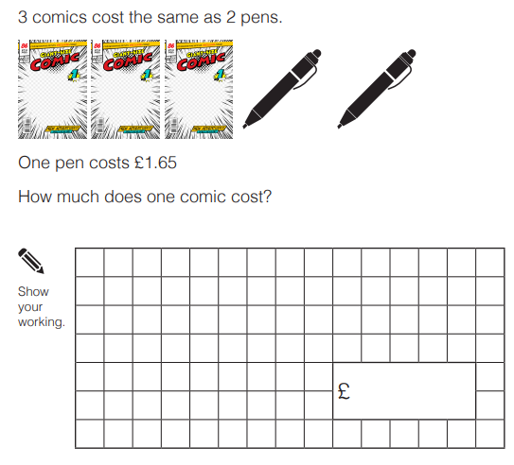
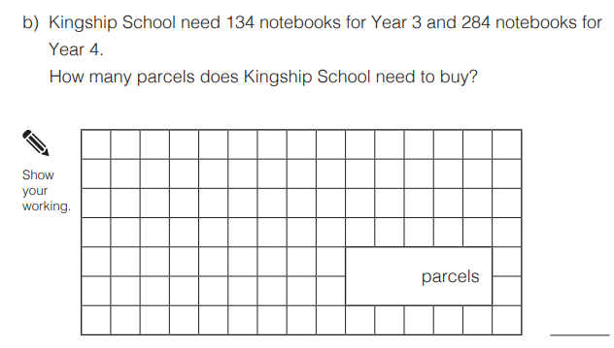
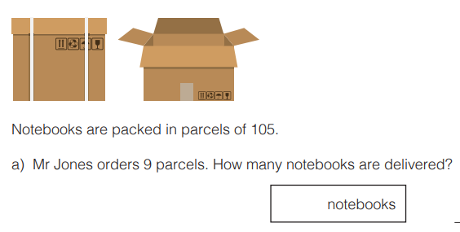
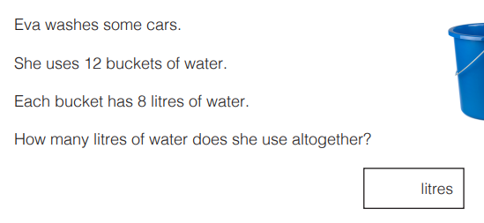
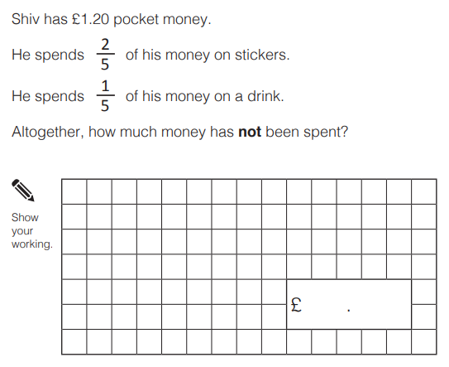

Friday – 10 in 10, time how long it takes you to complete these questions. Write your time on your sheet.


