

Learning Activities
Year 3
2019-20
Home Learning
Week 14 (Worksheets)

Monday
Maths: Minibeast Investigation English (GPAS): Adverbs
SLOR: The Travels of Ermine (Chapter 9)

Tuesday
Maths: Angles Investigation English: Passport to Year 4 Jigsaw: Ribbon Baton-

Wednesday
Maths: No sheet attached English (GPAS): Quiz 4
Science: No sheets attached

Thursday
Maths: English: No sheets attached Topic: No sheets attached

Friday
Maths: Arithmetic test English: spellings
PE: No sheets attached

Monday 13th July Maths Investigation
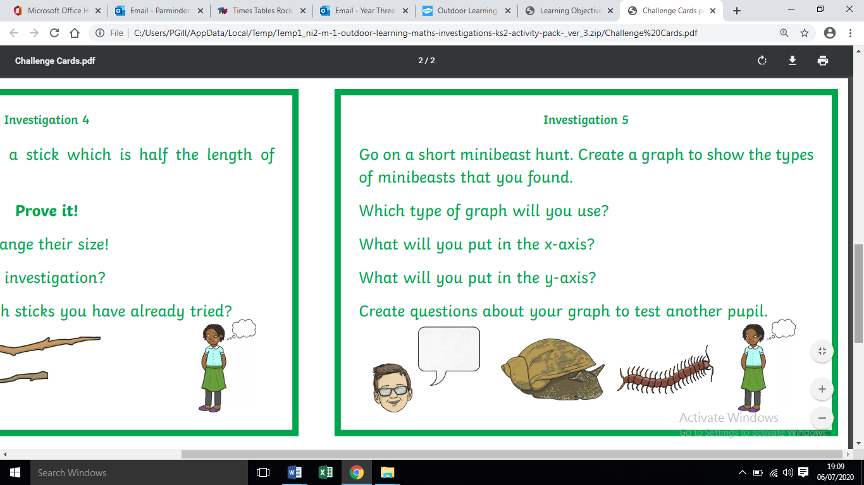
Notes for parents
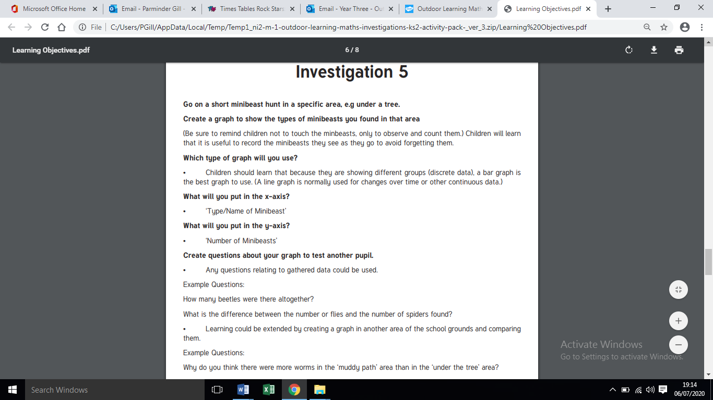
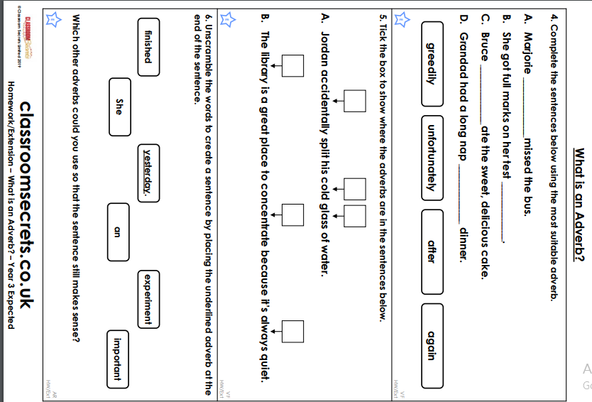
Monday 13th July-GPaS-Adverbs and adverbial phrases
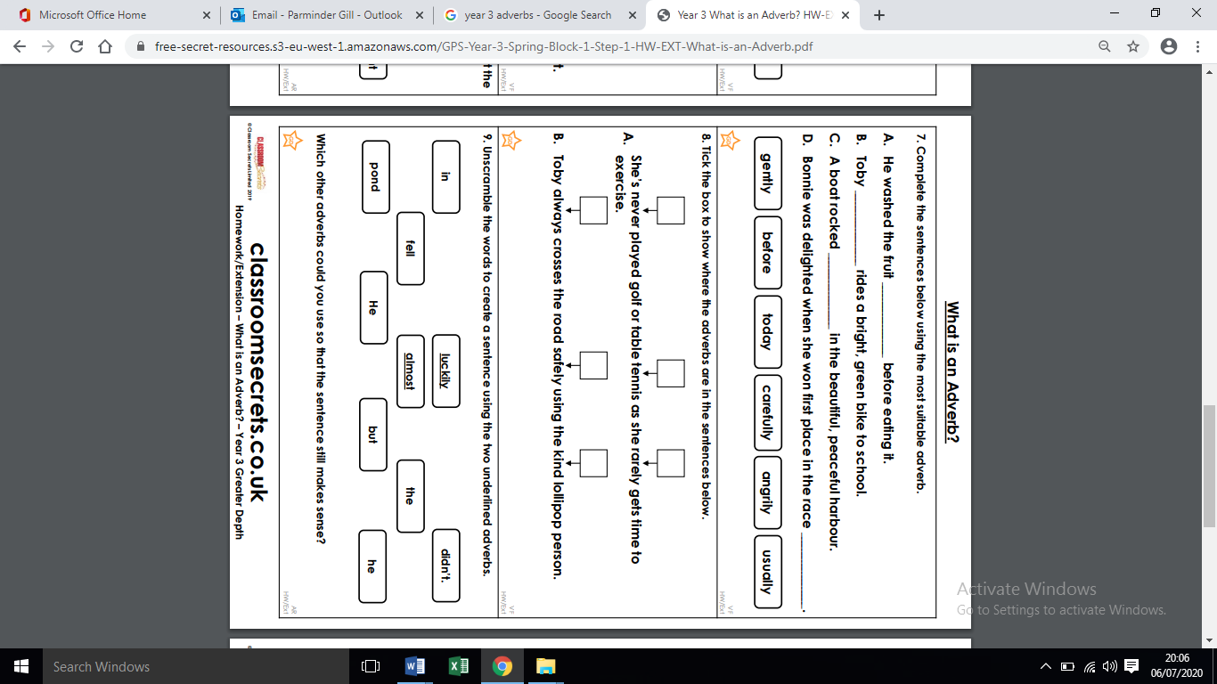
Monday 13th July-GPaS- Adverbs sheet 2

Monday 13th July- GPaS answers
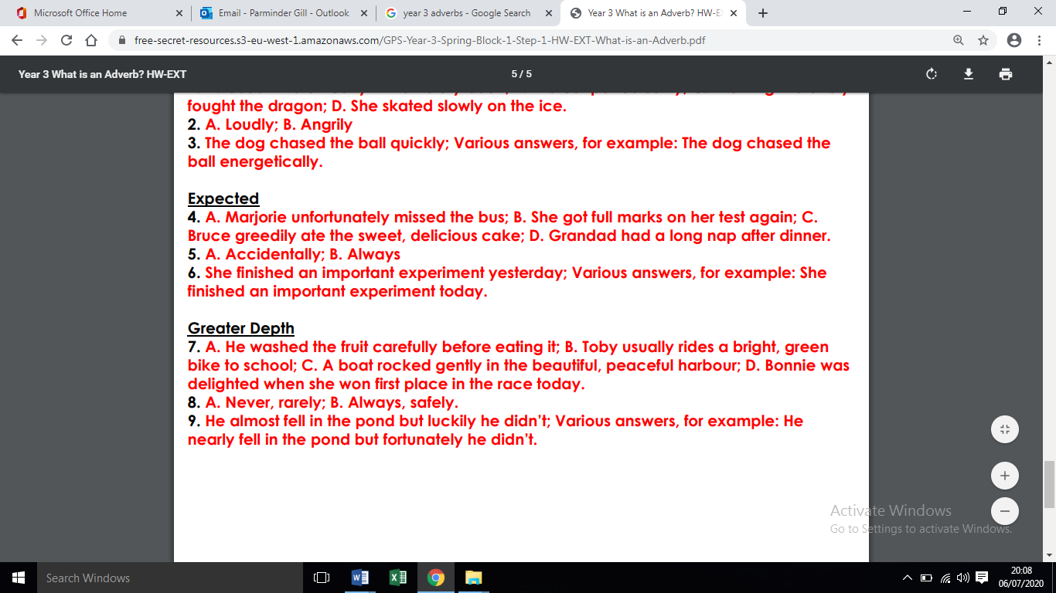
Monday 13th July-SLoR- Chapter 9 of ‘’The travels of Ermine”
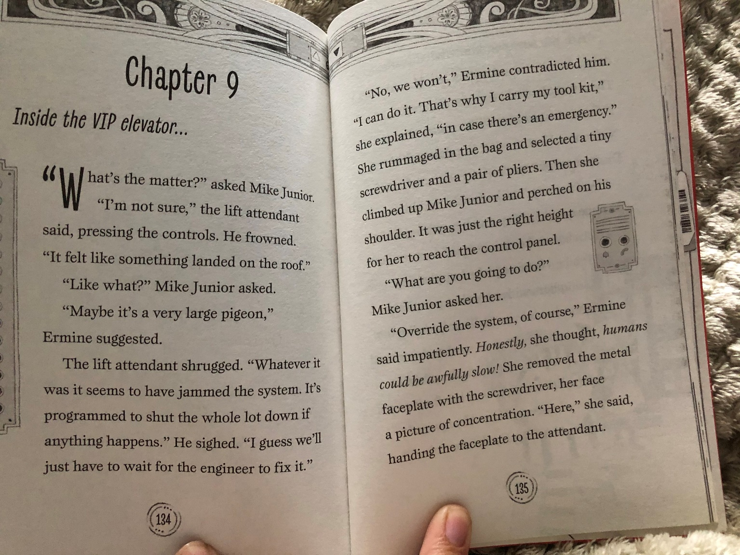

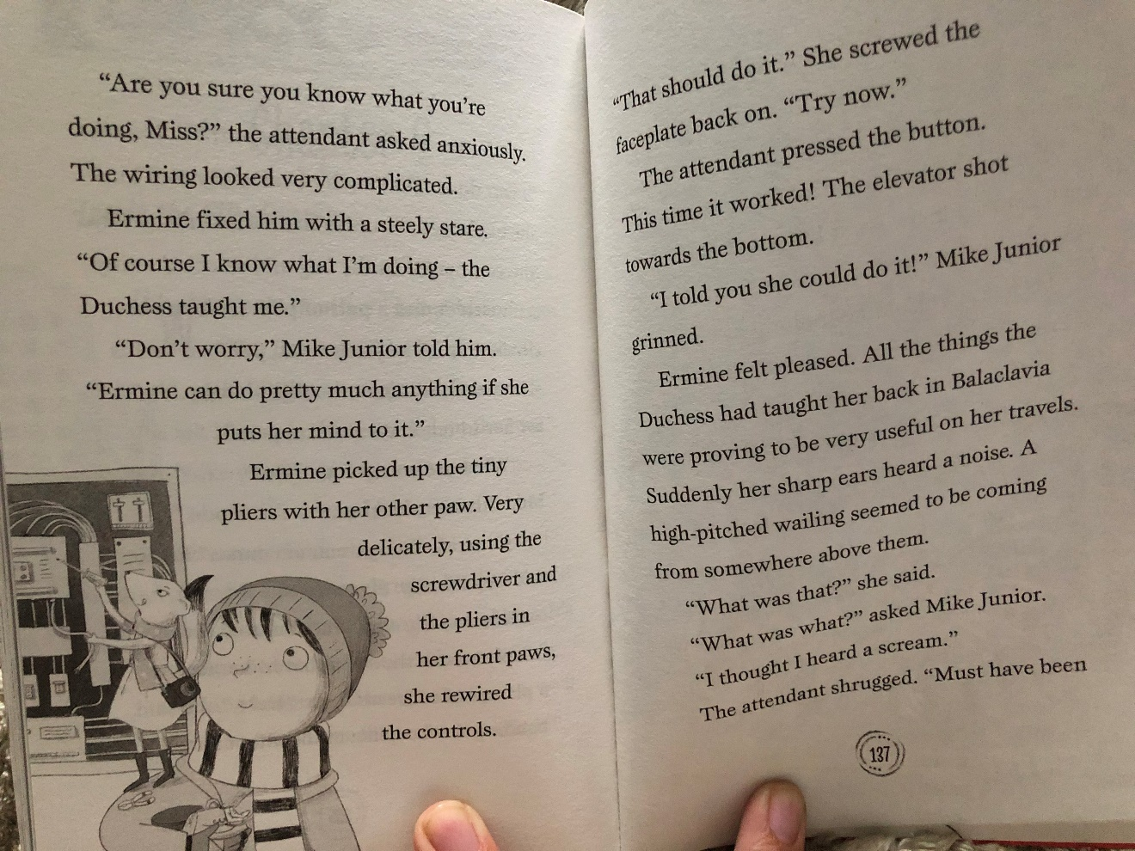

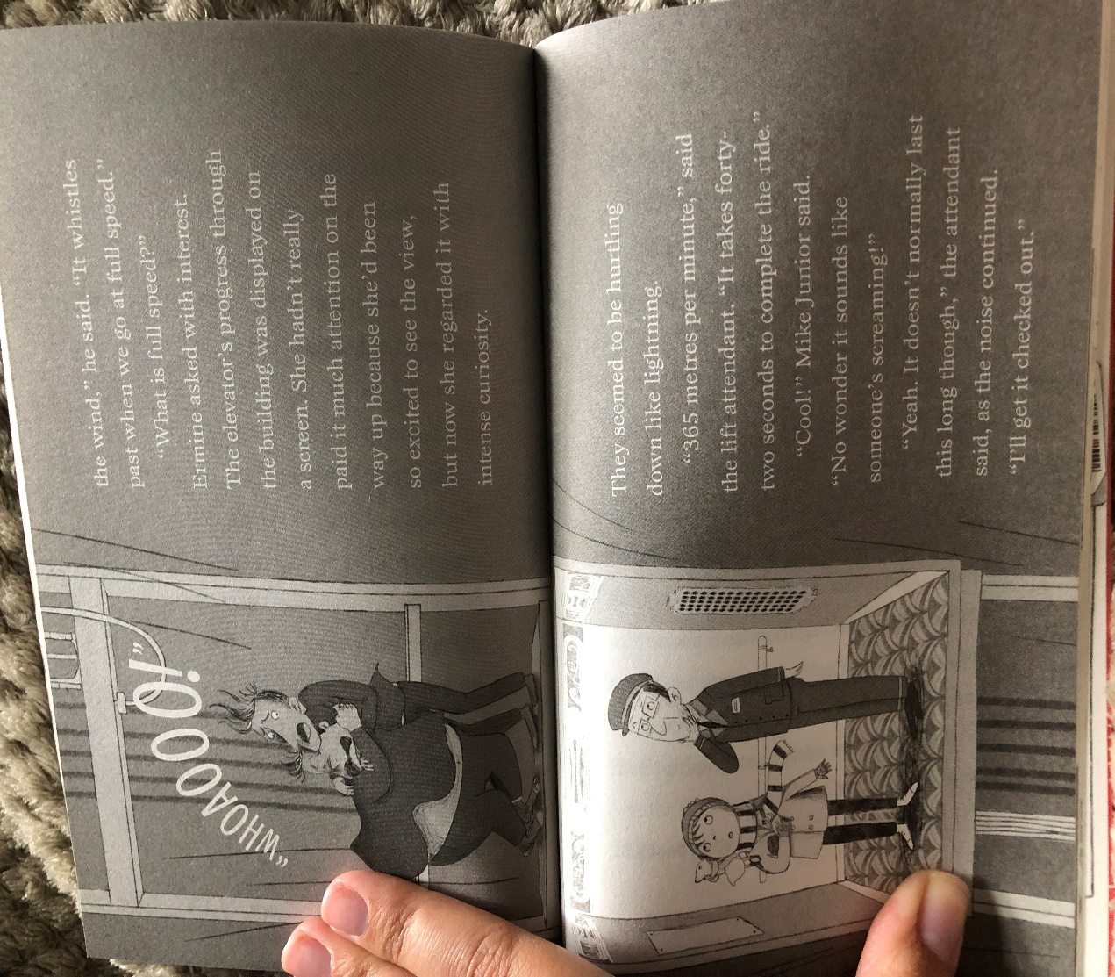
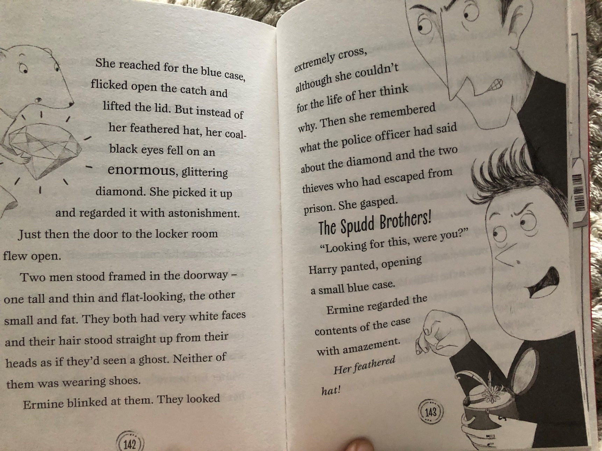
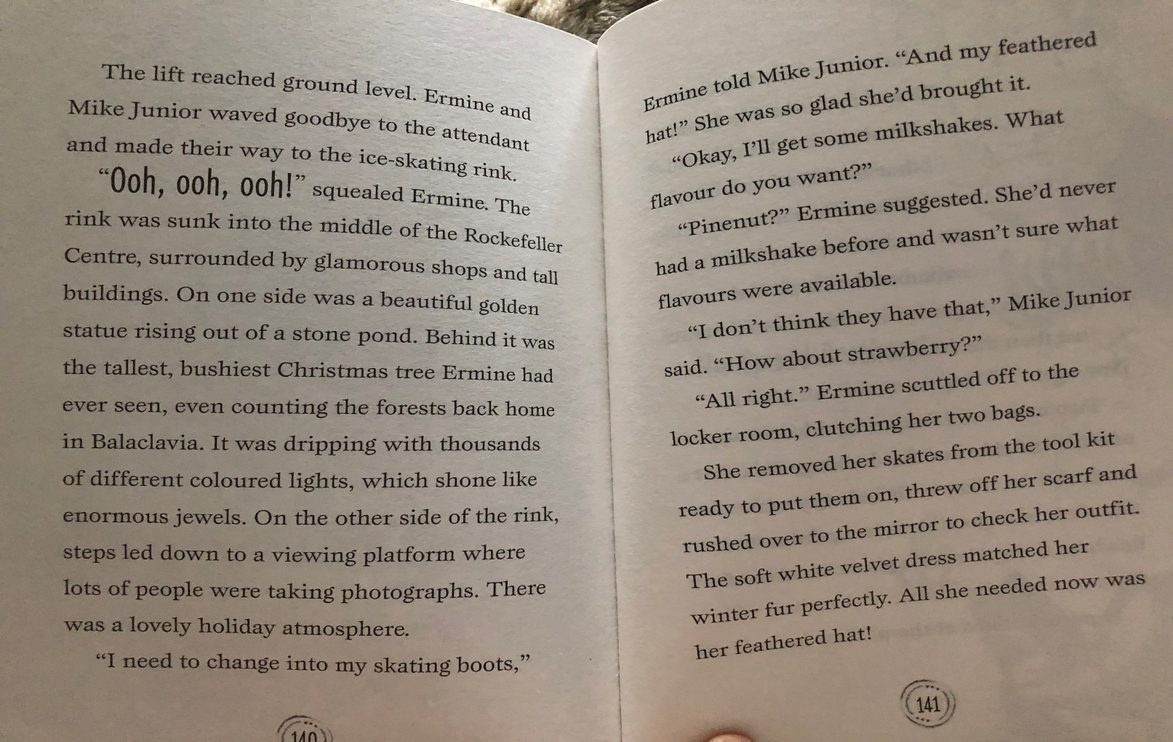
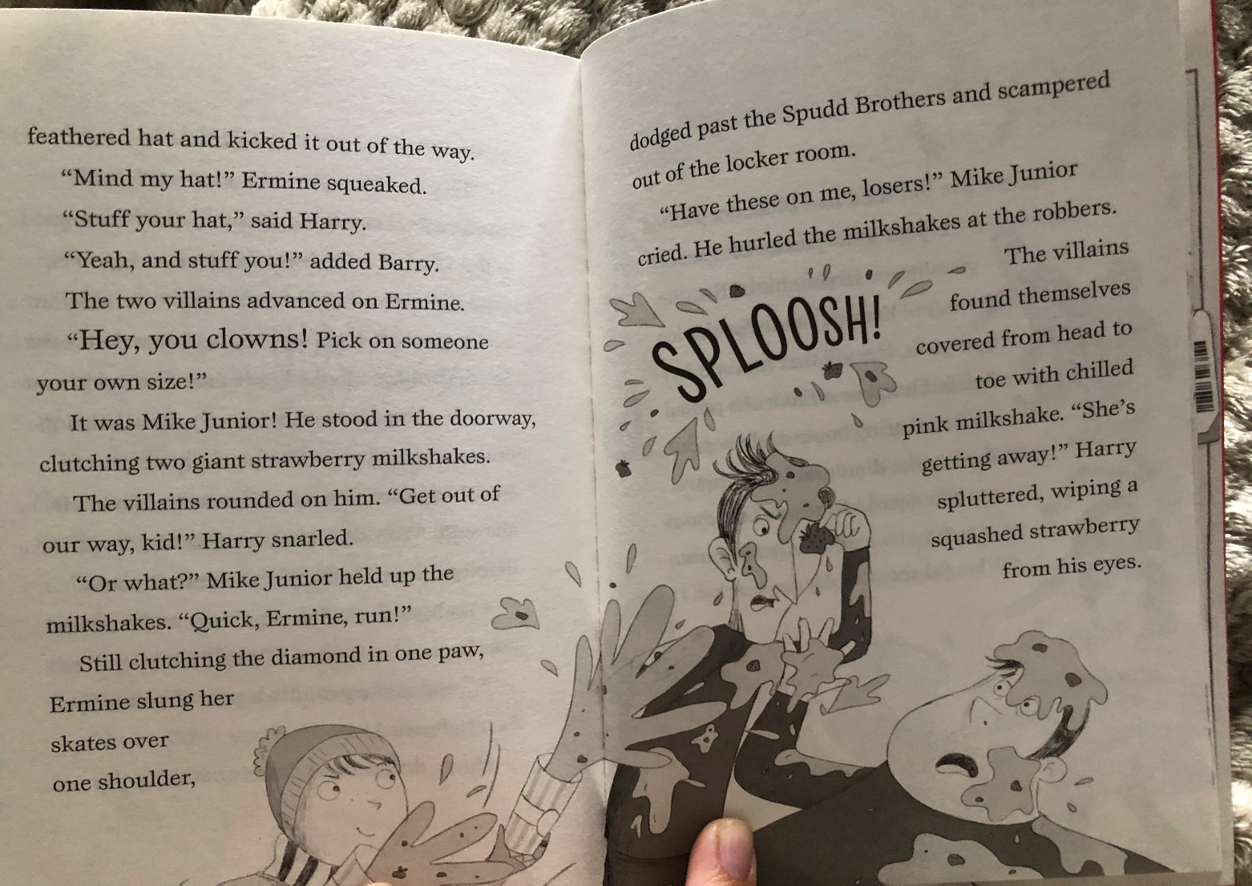
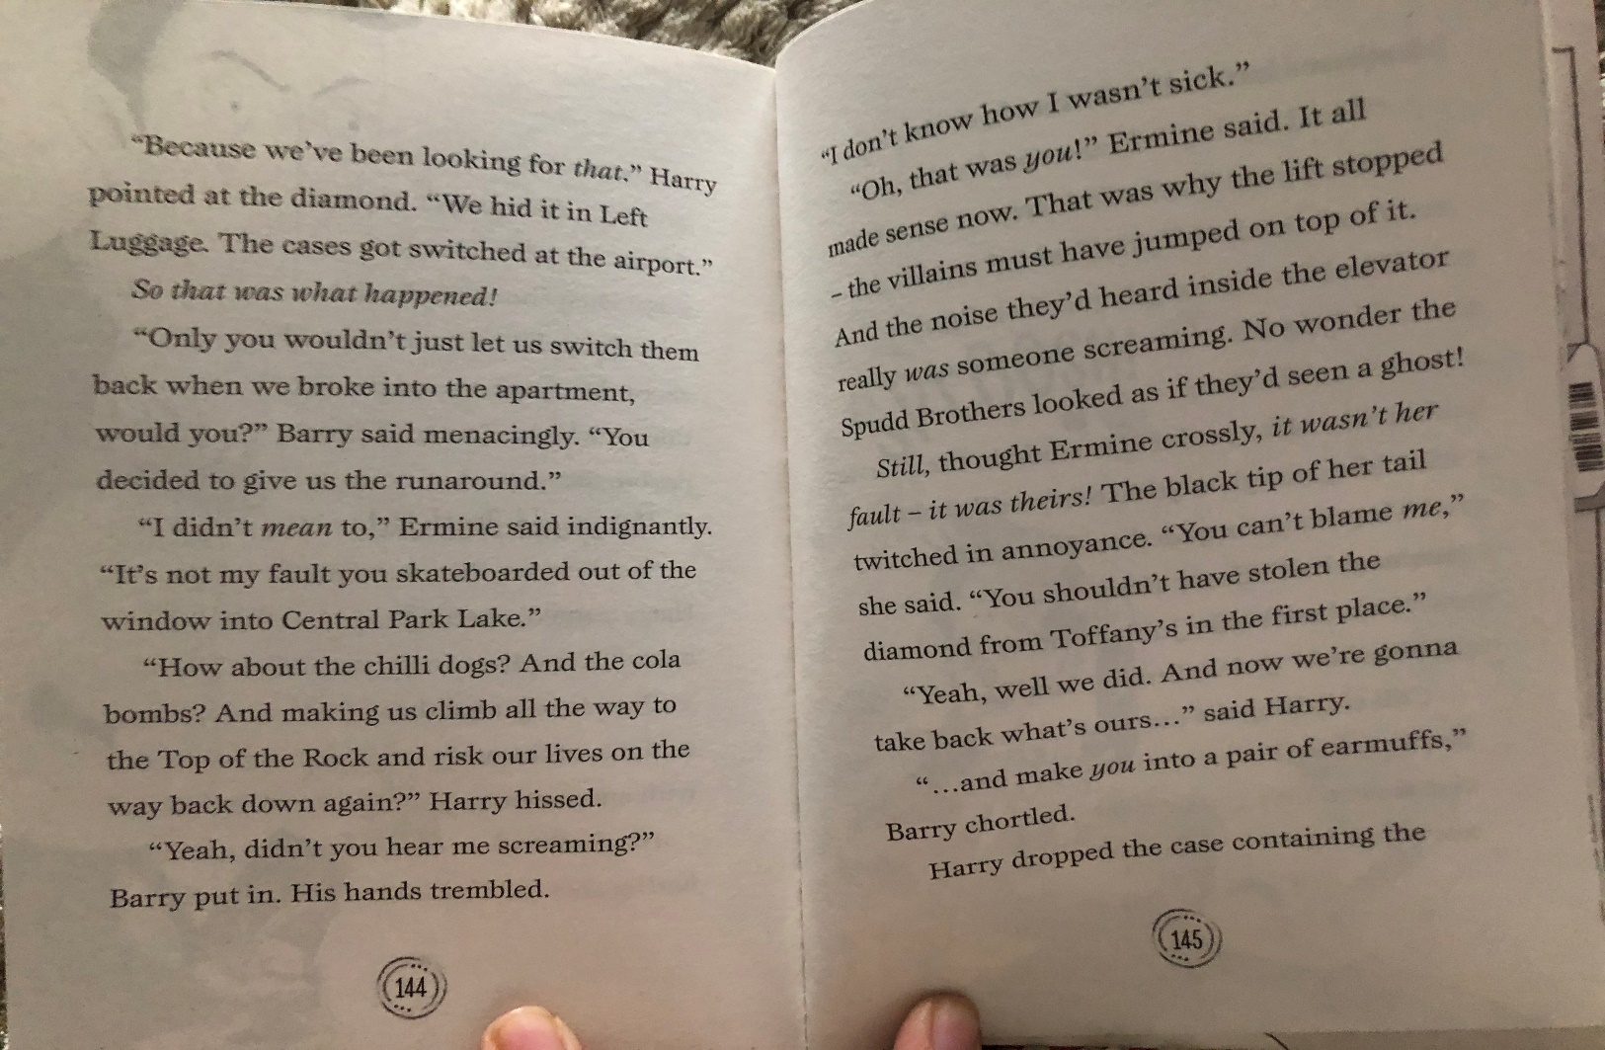

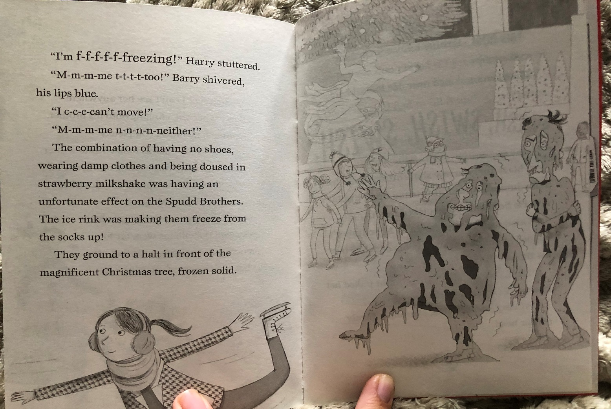
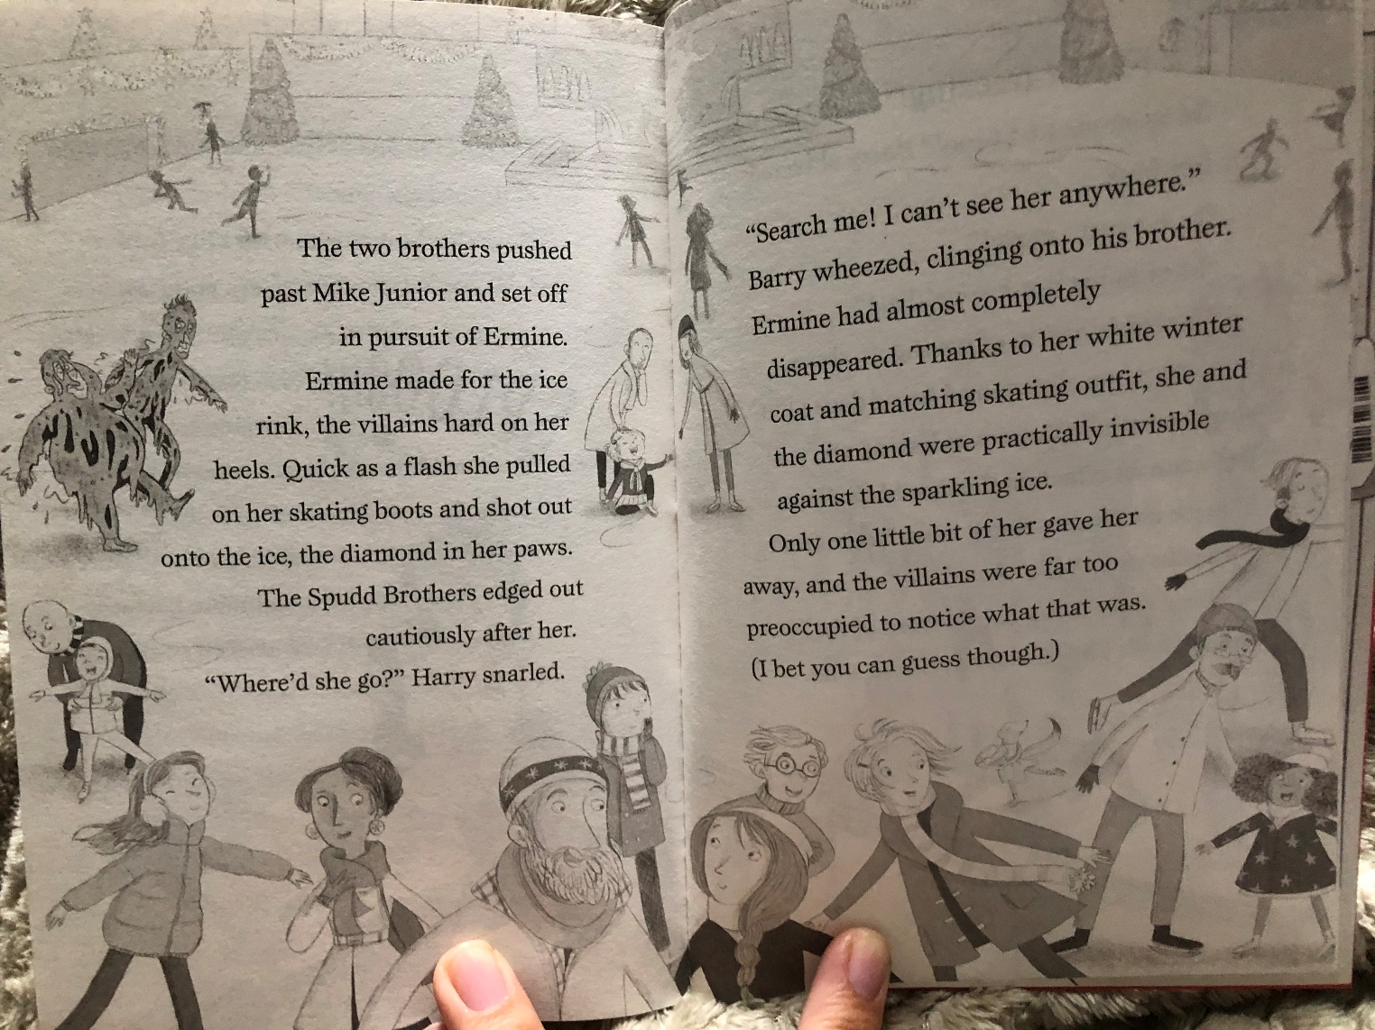
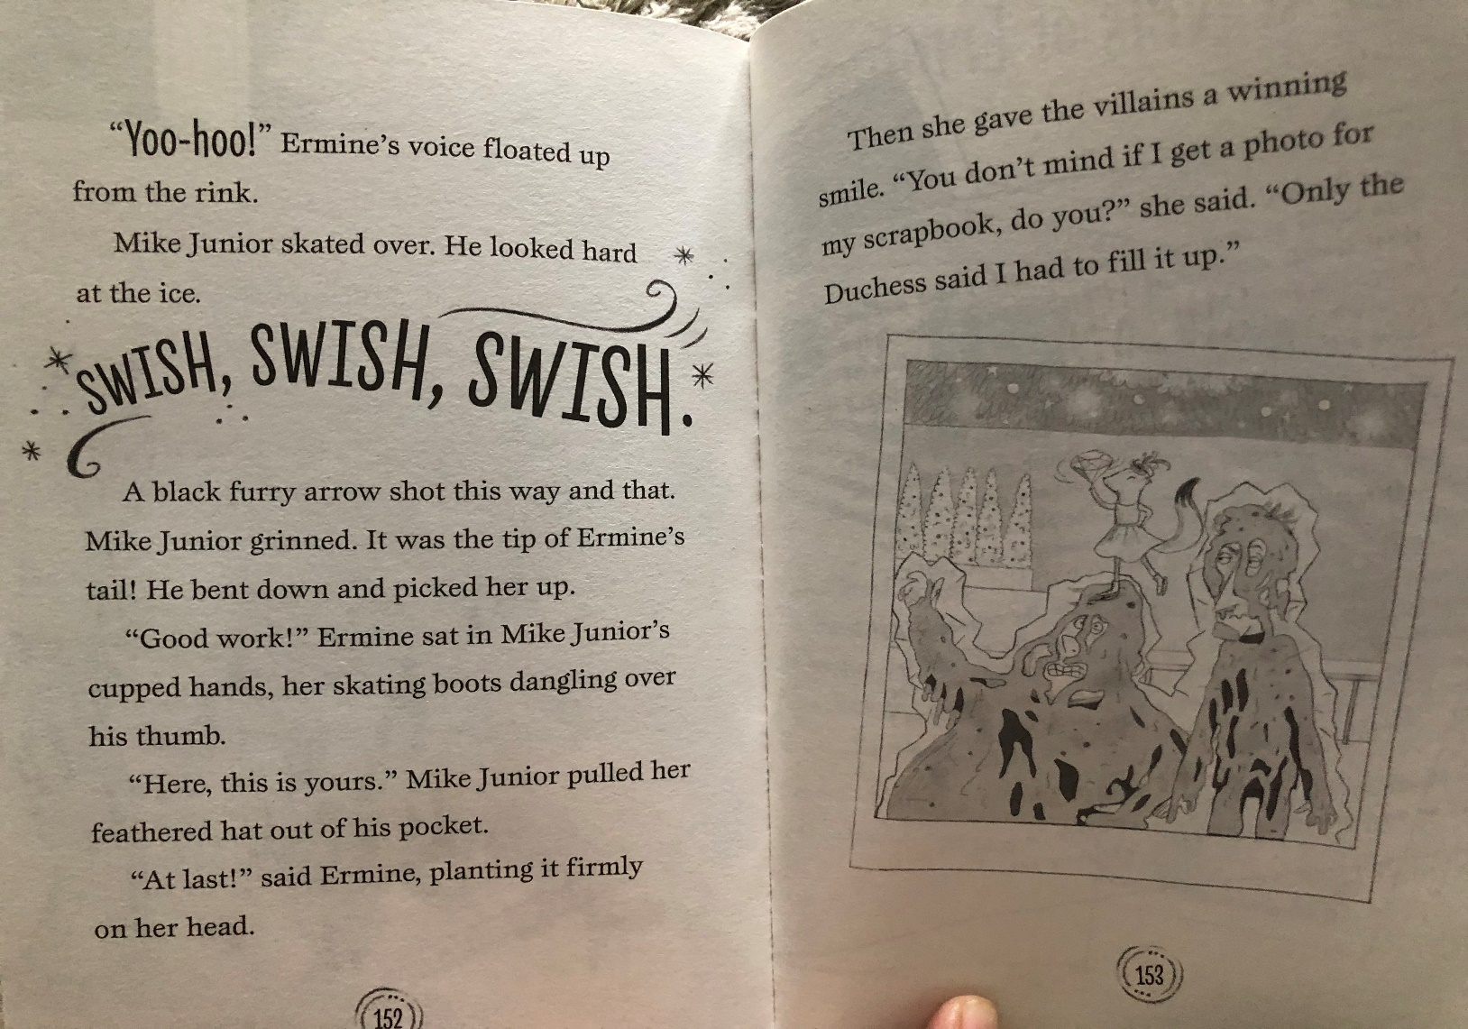
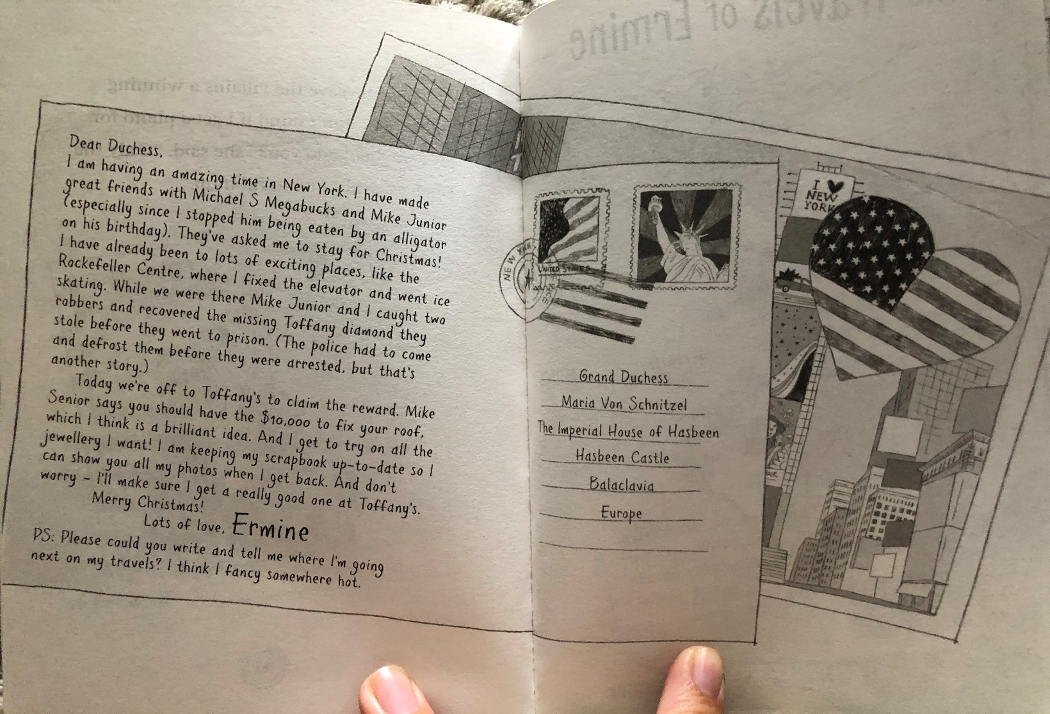
Monday 13th July 2020- SLoR activities
Task one:

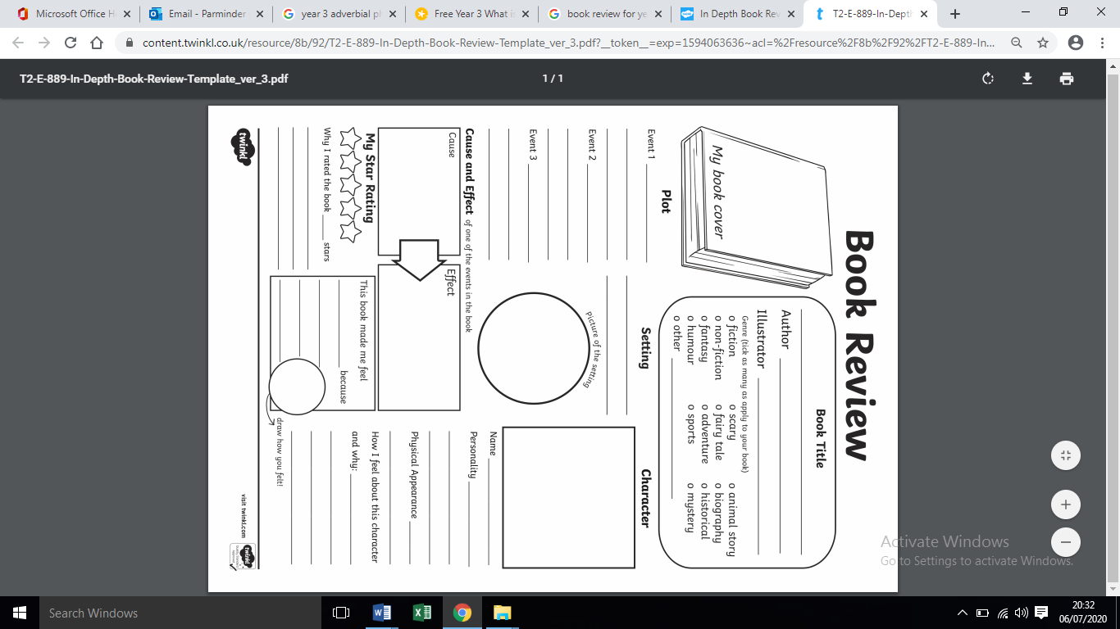

Tuesday 14th July- Maths Outdoor activity

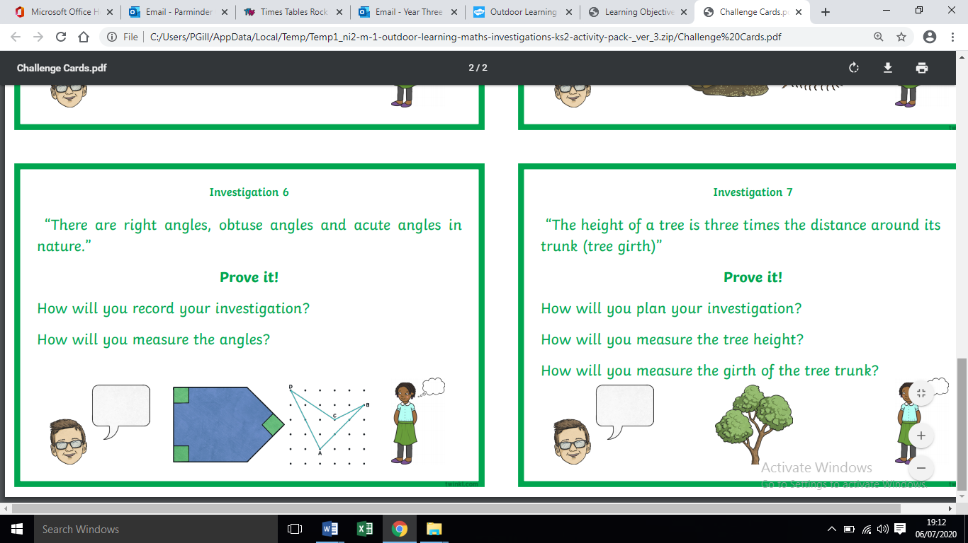

Notes for parents

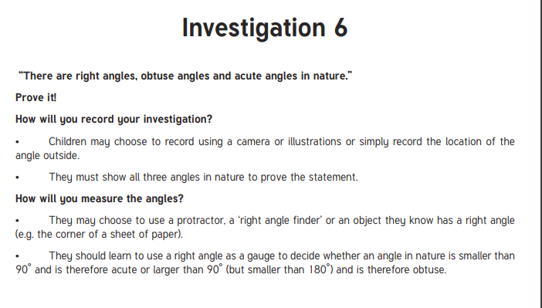

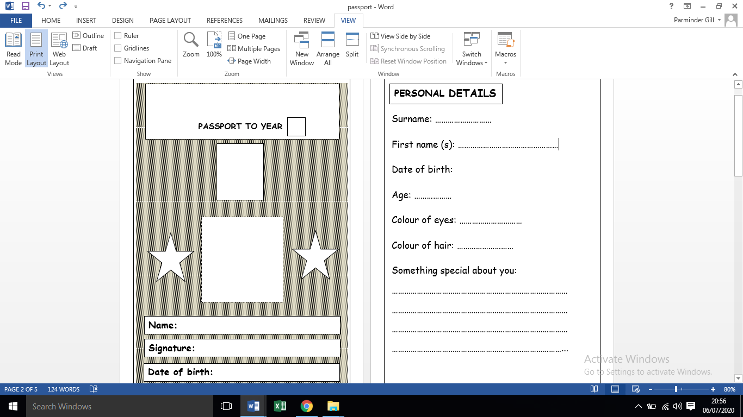
Tuesday 14th July- English- Passport to Year 4
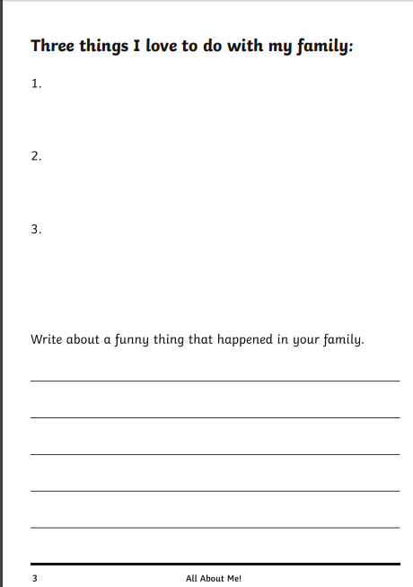
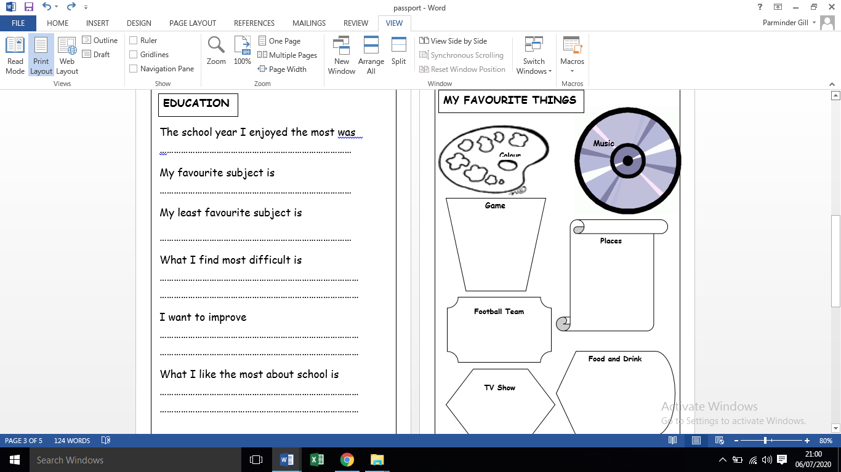
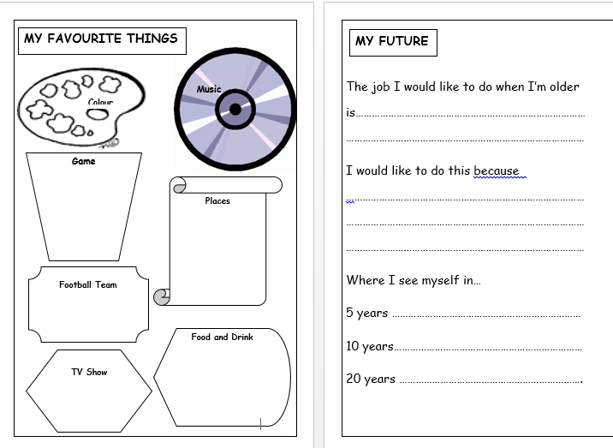

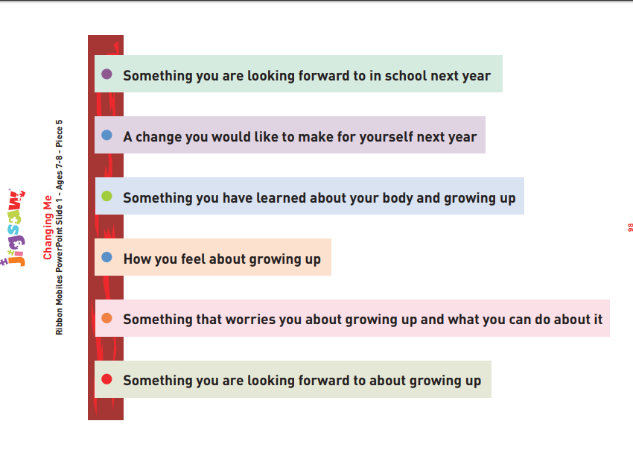
Tuesday 14th July-Jigsaw – Ribbon mobile aide memoire

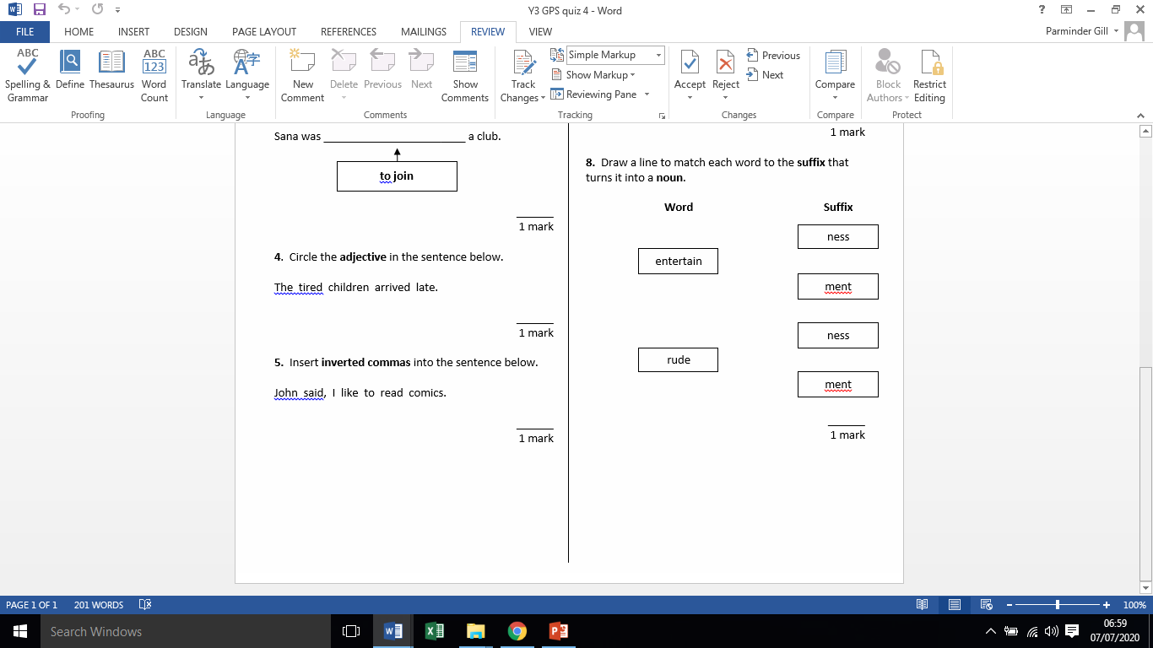
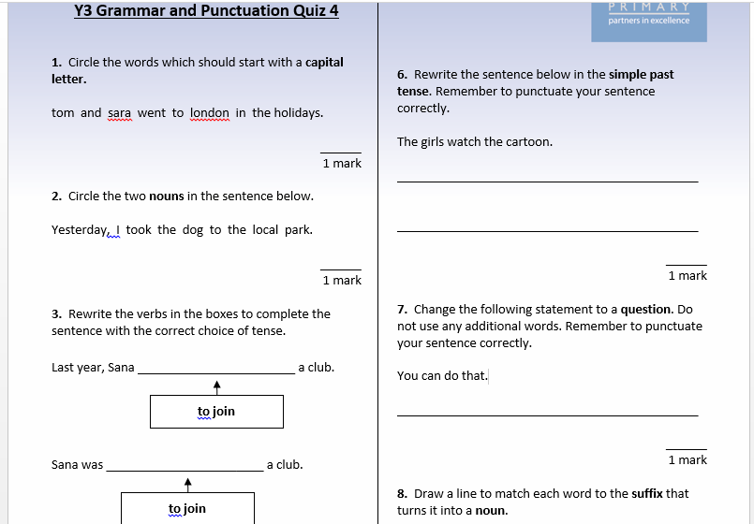
Wednesday 15th July 2020 – GpaS Quiz 4

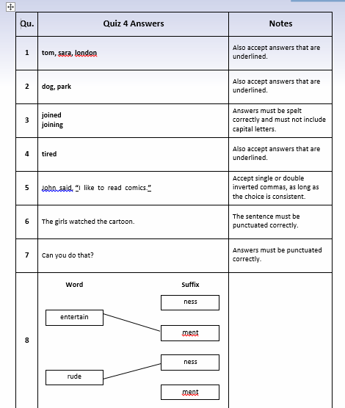
Wednesday 15th July- GPaS answers

Friday 17th July 2020 Spellings
Suffix - conjunctions
because
although
unless
which
before
since
until
as soon as
Here are your weekly spellings to learn. Remember to learn them first and then write them into descriptive sentences.
MILD

Words with the e_e sound
here
these
theme
gene
delete
complete

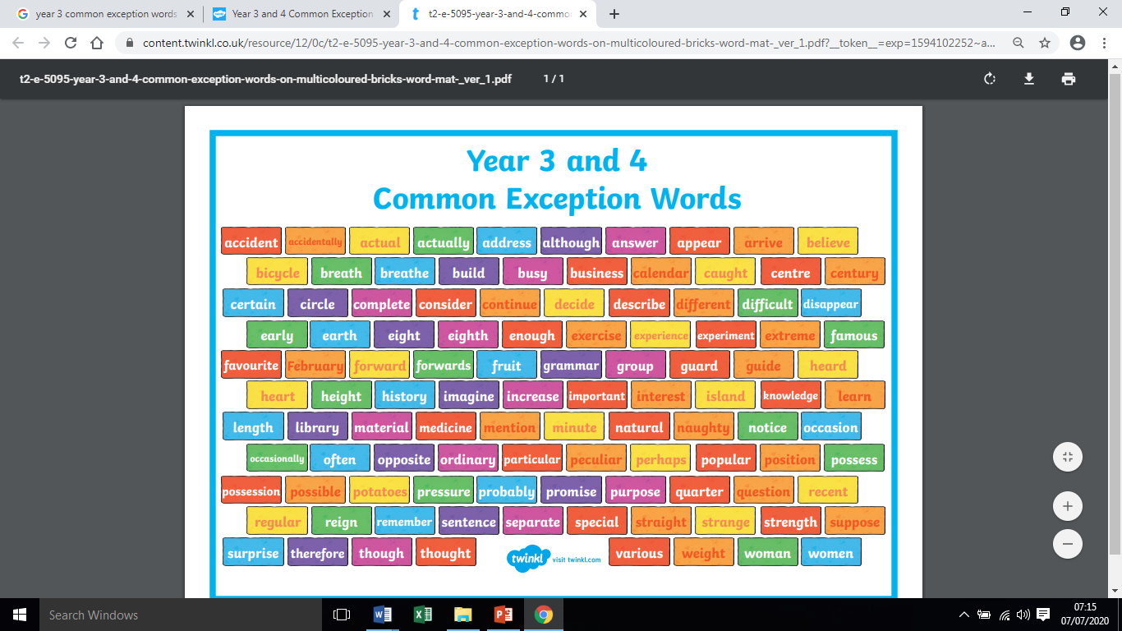
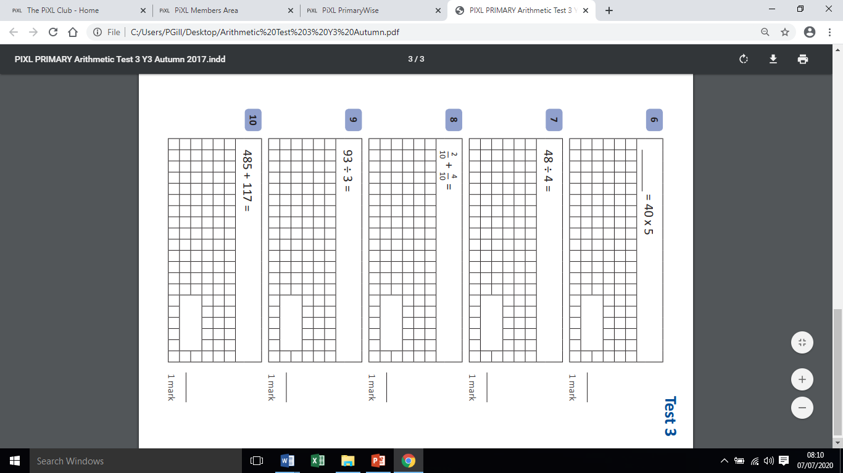
Friday 17th July- Maths arithmetic test

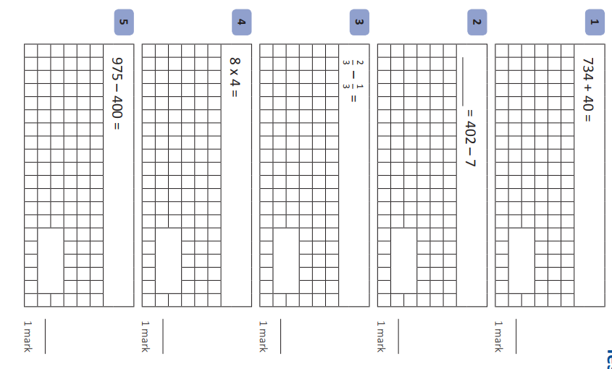

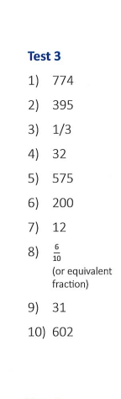
Answers

