
Learning Activities
Year 3 2019-20

Week 14
Lessons set  Every child is expected to complete three pieces of learning per day. Most of what is listed below has been taught in school. This is for revision and will allow children to practise skills already learnt. Where new skills are being introduced, we will provide as much support as possible by means of videos, pictures and websites. Please do not hesitate to email the year 3 email address if you have any questions regarding the learning.  It’s the final week of home-learning for TERM 6! Well done to you, your parents, grandparents and carers for your incredible hard work over the pandemic! This week is a fun week, most activities have been planned so children can reflect on their short but fun time in Year 3 and reminisce on all the memories created.  Please share your hard work on Twitter and via email, we would love to see how you are all getting on! |  | Additional comments  Worksheets attached do not need to be printed. Use them to access questions matching LOs (learning objectives). They can be copied and written onto paper for children to complete.
Monday | Maths  Starter: 3 x table.  Sing: https://www.youtube.com/watch?v=dzVyBQ5uTbo  L.O. Outdoor Maths Investigation- Minibeasts  Instructions attached for you and your parents, you may need adult support. If you have chalk and outdoor garden space, why not create your bar chart using chalk! Remember to send us pictures!  Try a daily 10: https://www.topmarks.co.uk/maths-games/daily10  English (GPAS): Adverbs  Remember an adverb describes how an action (verb) is carried out. He walked (verb) slowly (adverb) down the road.  Complete the activities attached. The second sheet attached is more challenging! Mark your work with an adult after you have completed the activities.  SLOR: Read THE FINAL chapter- chapter 9 of ‘The travels of Ermine’ attached and complete activity attached.  Task Complete a book review on ’The travels of Ermine’ There is a template attached but you can use that to create your own if you wish. | Remember to play 10 garage games of TT Rockstars every week.  Maths Investigation attached.  Worksheets attached.  Remember to continue to read at least 3 times at home.  Story and activity attached.
Tuesday | Maths  Starter: 8 times tables  Sing: https://www.youtube.com/watch?v=z_BJjR9rdwA  Play: https://www.timestables.co.uk/8-times-table.html  L.O: Outdoor Maths investigation- Angles  Instructions attached for you and your parents, you may need adult support.  Try a daily 10: https://www.topmarks.co.uk/maths-games/daily10  English: Passport to Year 4  Complete your very own passport to year 4. Remember to use your best handwriting and make it as colourful as possible!  Jigsaw: L.O To be able to identify what I’m looking forward to when I move to my next class.  Task 1: Create a mind map of all the things you are looking forward to next year, maybe discuss with your siblings or parents/carers for ideas.  Task 2: Create a Ribbon mobile.  The ribbon mobile is made from normally a wooden baton with different lengths of coloured paper stuck to it. You can use a suitable alternative for the wooden baton if you don’t have one. You need to write on each strip of paper according to the instructions below:  The 6 ribbons each show something different as follows:  1. Something the children are looking forward to next year e.g. a residential, starting swimming lessons etc.  2. A change they would like to make for themselves e.g. getting better at reading  3. Something they have learned about their bodies and growing up  4. How they feel about growing up  5. Something that worries them about growing up and how they can manage these feelings  6. Something that they are looking forward to about growing up | Maths Investigation attached  Worksheets attached  Ribbon mobile aide memoire attached.
Wednesday | Maths: Starter: 4 times tables  Play: Hit the button to practise your 4 times tables.  https://www.topmarks.co.uk/maths-games/hit-the-button  Sing: https://www.youtube.com/watch?v=UJY1_fzzM6Y  L.O. Outdoor Maths ball game  In pairs or a small group, with a parent or sibling you can throw and catch a ball. Each time a successful catch is made you count up in a particular multiple e.g. your 3/4 times table or any time table of your choice. If you drop the ball you have to go back to the start. You can make this more of a competition by setting a time limit and seeing the quickest you can get to the highest multiple. You could also set a 5 second limit in which you need to give an answer.  Or  Play Bouncing Sums You can spend hours playing catch, so why not make it a bit more challenging with this maths activity? Bouncing sums is a game that you can play with your parents, or your siblings.  Use a permanent marker to write random numbers all over a ball. Then when you throw the ball to each other, the person that catches it has to call out the number closest to their right thumb. The next person who catches the ball does the same but also adds their number to the previous number. So the longer you spend playing the game, the higher the number you’ll finish on. The game ends when someone drops the ball.  Each time you play this game, you should record the highest number that you reach in a game. Then you can try and beat this number when they play again.  Activity 2:Outdoor Maths activity- Position and direction  Get together with a parent or sibling or split your family into teams. The challenge is to direct your team mates around the garden using only turns (turn 90s clockwise, turn 180 anticlockwise) along a particular route. Make this harder by blindfolding the person following the instructions or setting obstacles for them to avoid.  Language to use: half a turn clockwise/anticlockwise; 90 degrees clockwise; three quarter turn clockwise; 180 degrees/full turn etc.  Try a daily 10:  https://www.topmarks.co.uk/maths-games/daily10  English –GPaS Quiz 4  Please complete quiz attached and mark your work with an adult.  Science: To be able to write a conclusion of the year.  Cast your mind back to all the fun Science topics we have covered in school so far this year; Rocks and Soils, Forces and Magnets, Light & Shadow, Science invention, Animals including humans and all the experiments you have completed at home during lockdown. Which was your favourite topic? Why? What incredible facts did you learn? Can you remember some of the experiments and scientific language you learnt?  Task: Write a conclusion about your favourite Science topic.  Your writing must include:  Name of the favourite topic  Why it was your favourite topic  Fascinating things you learnt  Favourite science activity in that topic  Draw a picture of anything related to that topic.  Final paragraph- Write about any other activities you enjoyed during science this year. | Quiz and answers attached.
Thursday | Maths:  Starter: 8 times tables  Sing: https://www.youtube.com/watch?v=0X620IeUkYE  https://www.youtube.com/watch?v=kN3RG5iLKpo  L.O. Mathematical Bowling  Task: Everyone loves ten pin bowling, and you can create your very own bowling alley at home. Save ten plastic bottles and write a number between one and ten on each. If you want your homemade skittles to look extra glitzy, you can decorate them.  Once you have the skittles, find a ball that you can use as a bowling ball. The whole family can take turns bowling, and when you knock skittles down, add up the numbers on each of the bowling pins to work out your score.  For an extra challenge, you could number the skittles with larger, more random numbers rather than with single-digit numbers.  Try a daily 10:  https://www.topmarks.co.uk/maths-games/daily10  English:  L.O: To be able to write an end of year report.  Task 1: Firstly create a thought shower like the one below, jotting down all your favourite memories from year 3.  Memories in Year 3  Task 2: You need to write an end of year report using the following sentence starters. You could write a paragraph for each-  This is me- Write about how you started at the beginning of the year, your thoughts, worries and how you now feel at the end of the year.  Funniest memory-  Memories you will treasure:  Best outdoor classroom activity  Best classroom activity-  My Friends- old and new  My favourite book- (This could be a class book/SLoR book or one you have read yourself)  My Teacher and teaching assistant  Lockdown- share your thoughts/feelings/favourite memories from lockdown  What you have loved about the school year.  It is up to you how you set this out, it could be a page of writing with paragraphs for each and a nice border around the edge. Or you could set it out like the example below, we have not attached a template for you because it is up to you!  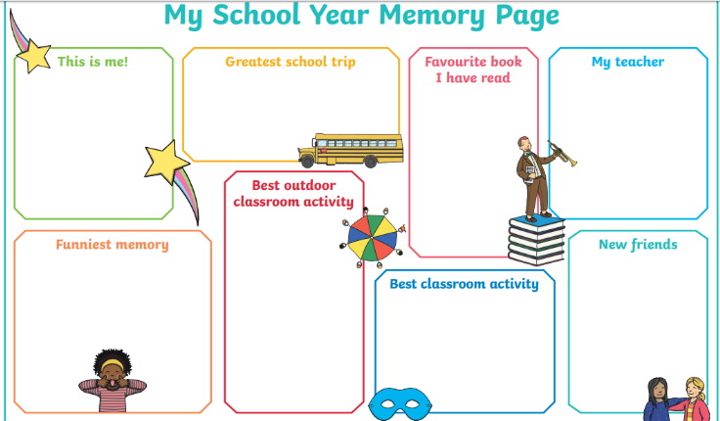  Topic: L.O TO create a factfile or poster about your favourite topic.  This year we learnt all about The Stone Age to the Iron Age, The Ancient Egyptians and Land of hope and glory.  Task1: Choose your favourite topic.  Task 2: Create an eye-catching, colourful and full of facts poster on your favourite topic. Make sure you include lots of fun facts and pictures. Remember to email or send them on twitter for us to see!
Friday | Maths:  Starter: 8 times tables  Play: https://www.topmarks.co.uk/times-tables/coconut-multiples  L.O Arithmetic test  Task: Complete the arithmetic test attached. You will notice they start off easy compared to last week but they will get harder. Please mark your tests together with an adult.  Note to parents: Please be advised that these tests are designed to assess Year 3 skills that pupils should have secured earlier in KS2.  Extension: Find out what you still need to work on, what you still find tricky. Identify where you went wrong. Ask an adult to help you with the method, remember there are videos on our school website that show you how to calculate using the different methods. Practise adding, subtracting, multiplying and dividing because these are always easy marks to get on a test and you will thank yourself later on in year4, 5 and 6 when you master these methods!  Try a daily 10:  https://www.topmarks.co.uk/maths-games/daily10  English: Spellings  Weekly homework spellings are attached. Remember to write the spellings into sentences once you have confidently learnt them.  Weekly spelling practise: Year 3 common exception words.  This week we have attached the common exception words for year 3 and 4 that you must know how to spell.  Learn a few (8-10) you don’t know each week, then ask your parents or siblings to take part in a spelling challenge with you at the end of each week!  Have a score sheet set up for each week and someone timing and testing you. Whoever loses the challenge each week has to do a chore or something really boring for the following week, it’s up to you what the rules and consequences are but make it as fun as possible!  PE: Create your own P.E game ready to play when you are back at school or you can plan and set up your own sports day in your back garden for you and your family.  Things to think about when creating your own P.E game:  Name of the game, description of the game, number of players needed, rules of the game, time limit? Equipment needed. Draw a picture to illustrate how it is played.  EXT: More to try:  Joe Wicks the body coach’s daily PE lessons:  https://www.youtube.com/user/thebodycoach1  Have a marvellous weekend! | Weekly spellings attached.  Common exception words attached.

