

Learning Activities
Year 3
2019-20
Self-isolation learning
Week 13 (Worksheets)

Monday
Maths: 3 x tables and capacity English (GPAS): GPaS test 3
SLOR: The Travels of Ermine (Chapters 7& 8)

Tuesday
Maths: 8 x tables and volume English: Asking relevant questions
Jigsaw: Well-being activity

Wednesday
Maths: 4 x tables and add amounts of money English (GPAS): Word families
Science: Germs experiment

Thursday
Maths: 8 x tables and subtract amounts of money English: Interview your parent
Topic: Poster of a European country

Friday
Maths: 8 x tables and mental arithmetic tests 1 & 2 English: Spellings
PE: Following instructions activity

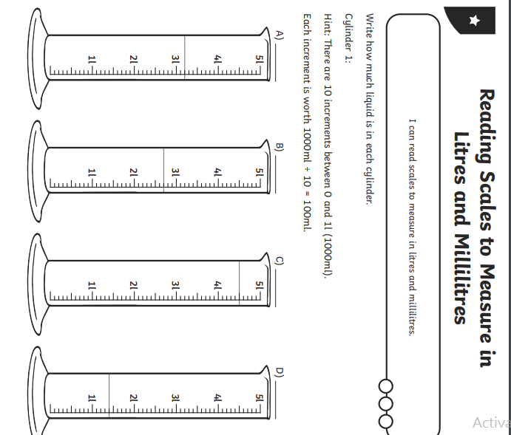
Monday 6th July Maths- Reading scales page 1

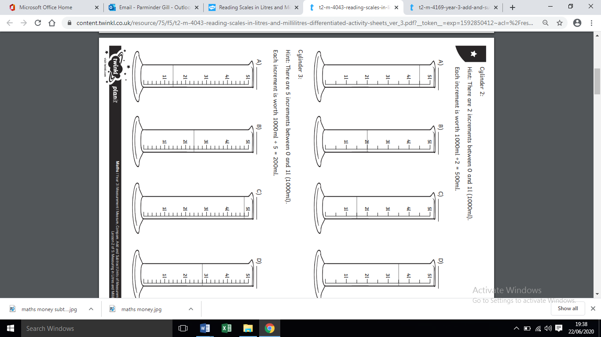
Monday 6th July Maths- Reading scales page 2

Monday 6th July maths-Extension activity

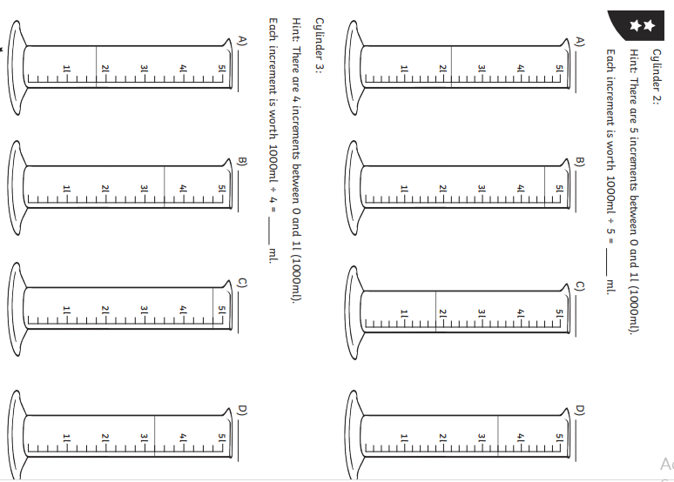

Monday 6th July-Maths reading scales answers

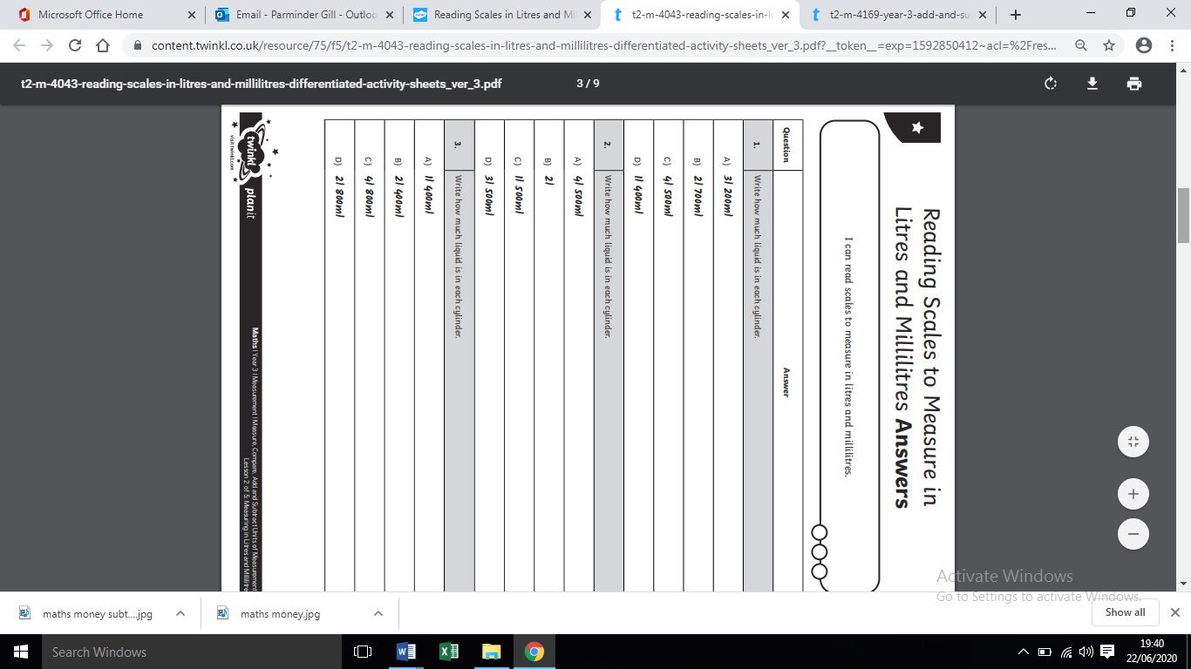

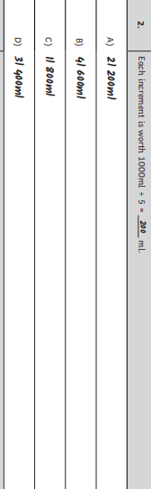

Answers to extension

Tuesday 7th July-Maths –Add and subtract volume

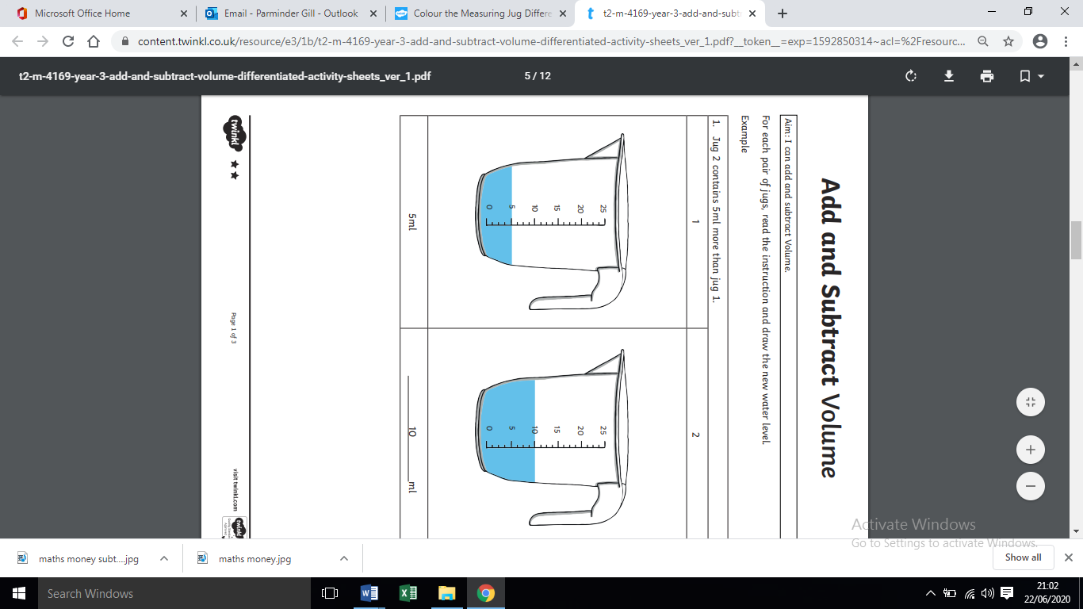
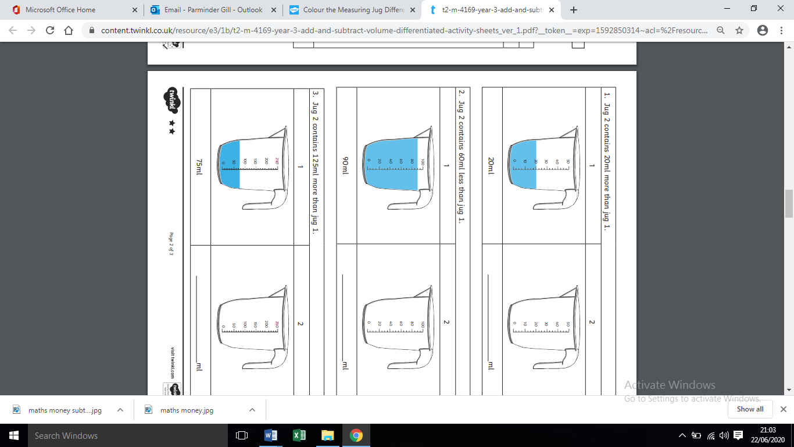

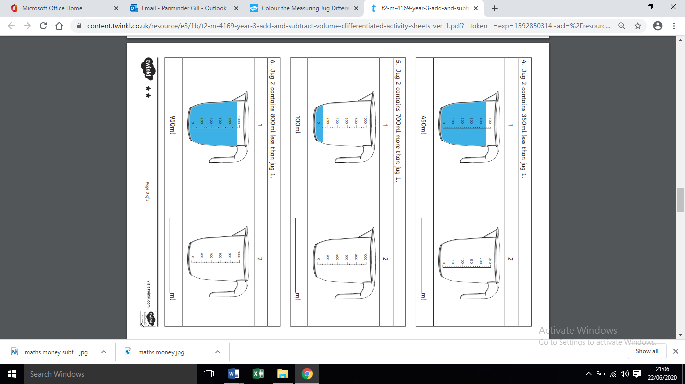
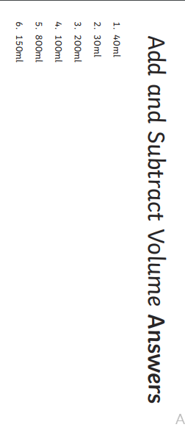

Wednesday 8th July- Maths money
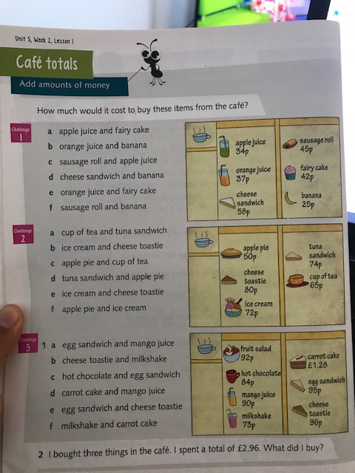

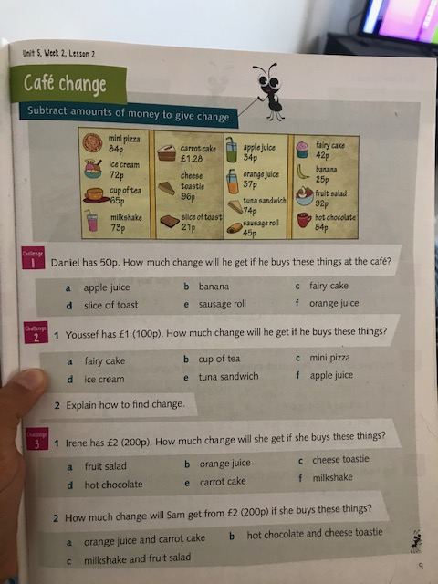
Thursday 9th July – Maths -Subtract amounts of money

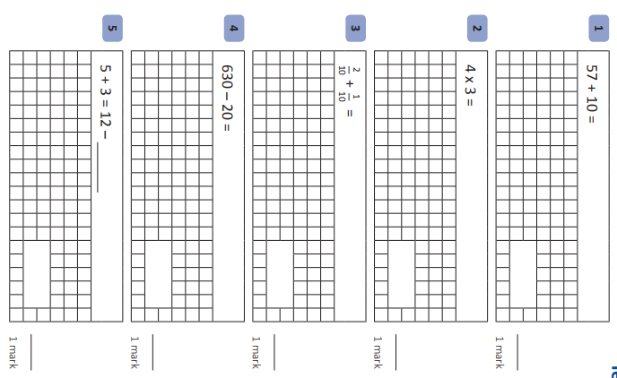
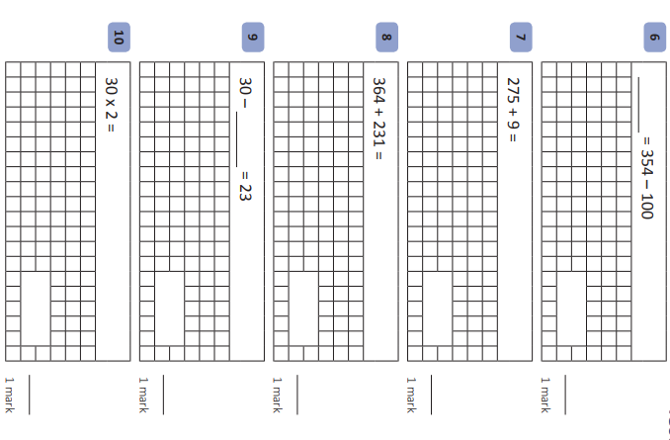
Friday 10th July-Maths Mental arithmatic test 1

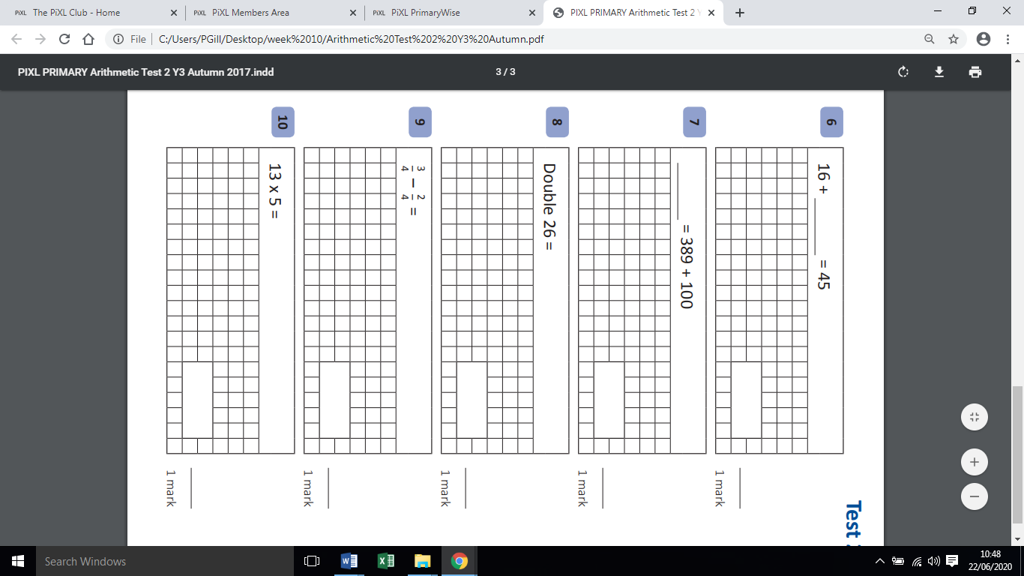
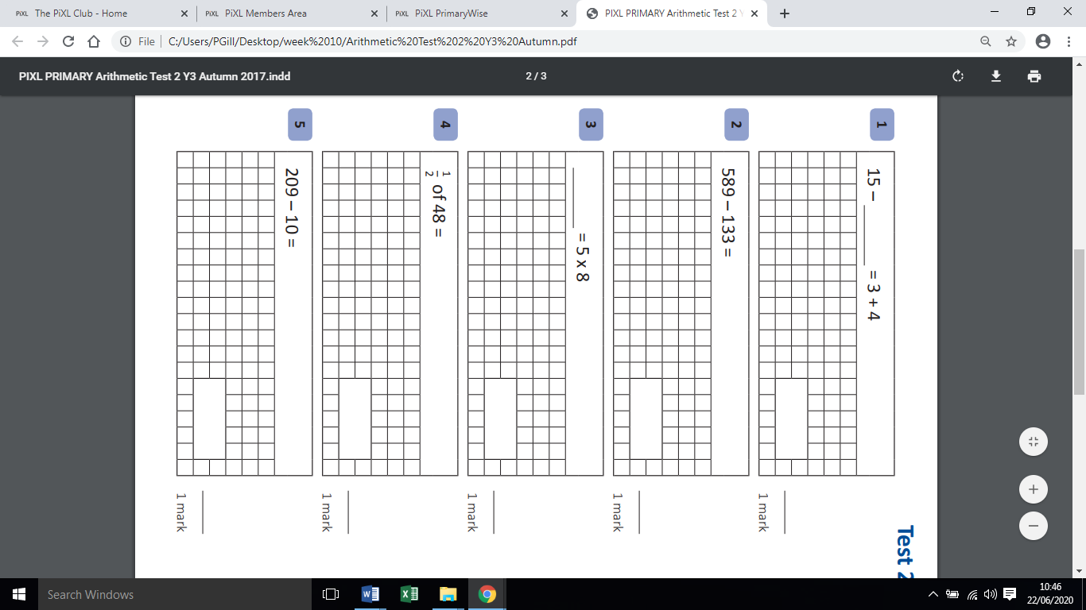
Friday 10th July- Maths Arithmatic test 2

Friday 10th July mental arithmatic answers
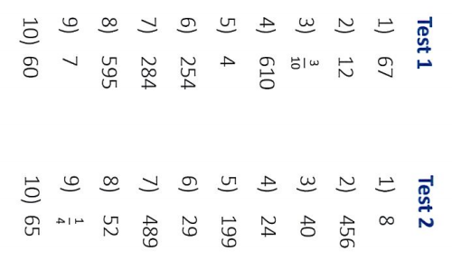

Monday 6th July GPaS Y3 Grammar and Punctuation Quiz 3
6. Rewrite the sentence below into the simple past tense. Remember to punctuate your sentence correctly.

Tom kicks the football.

____________________________________________

______
1 mark

7. Insert a comma in the correct place in the sentence below.

I bought a banana two apples and a bunch of

grapes from the supermarket.

______
1 mark

8. Draw a line to match each word to the suffix that turns it into a noun.

 | Word |  | Suffix
 |  |  | ness
 | kind
 |  |  | ment
 |  |  | ness
 | state
 |  |  | ment

______
1 mark

1. Circle the words which should start with a capital letter.

the family went to blackpool on holiday.

______
1 mark

2. Circle the two nouns in the sentence below.

The young boy was playing with the ball.

______
1 mark

3. Rewrite the verbs in the boxes to complete the sentence with the correct choice of tense.

Earlier, Ben was _________________with his brother.
to play

Yesterday, Ben had _________________with his brother.
to play

______
1 mark

4. Write one adverb to complete the sentence below.

The children were playing ______________________.

______
1 mark

5. Insert an apostrophe in the correct place in the sentence below.

T h e g i r l s w e n t t o T i n a s p a r t y.

______
1 mark

Qu. | Quiz 3 Answers | Notes
1 | the, blackpool | Also accept answers that are underlined.
2 | boy, ball | Also accept answers that are underlined.
3 | playing  played | Answers must be spelt correctly and must not include capital letters.
4 | Any appropriate adverb.  E.g. noisily, energetically, nicely, earlier | Answers must be spelt correctly and must not include capital letters.
5 | T h e g i r l s w e n t t o T i n a’ s p a r t y. | Apostrophes must be curved to the left.
6 | Accept accurate sentence in the past tense.  E.g.  Tom kicked the football. | The sentence must be punctuated correctly.
7 | I bought a banana, two apples and a bunch of  grapes from the supermarket. | Commas must be the correct size and must be curved to the left.
8
   | Word |  | Suffix
   |  |  | ness
   | kind
   |  |  | ment
   |  |  | ness
   | state
   |  |  | ment
Monday 6th July- GPaS Quiz 3 answers
Monday 6th July- SLoR – Chapters 7 & 8 - The Travels of Ermine

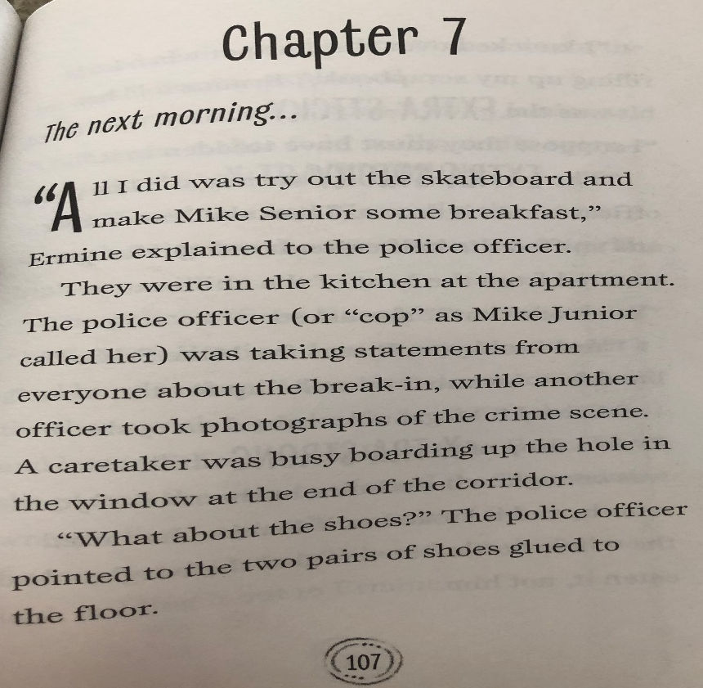
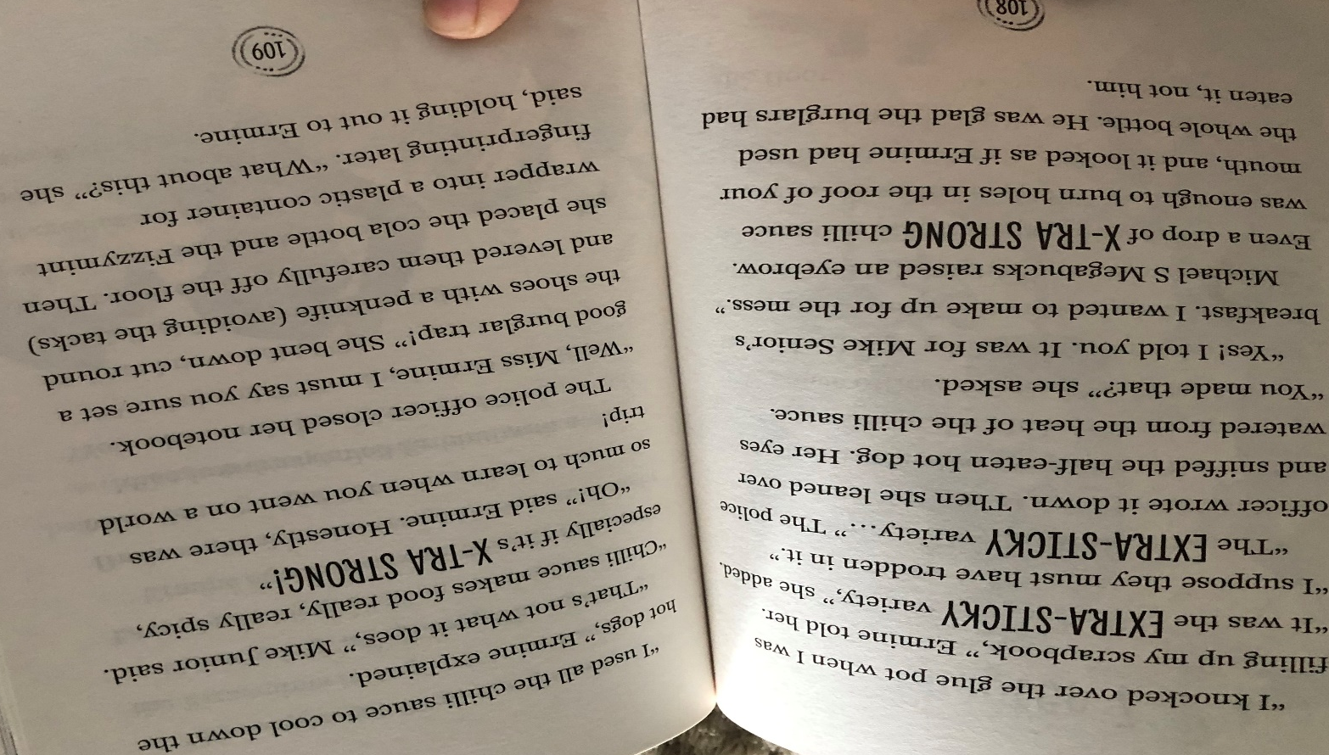

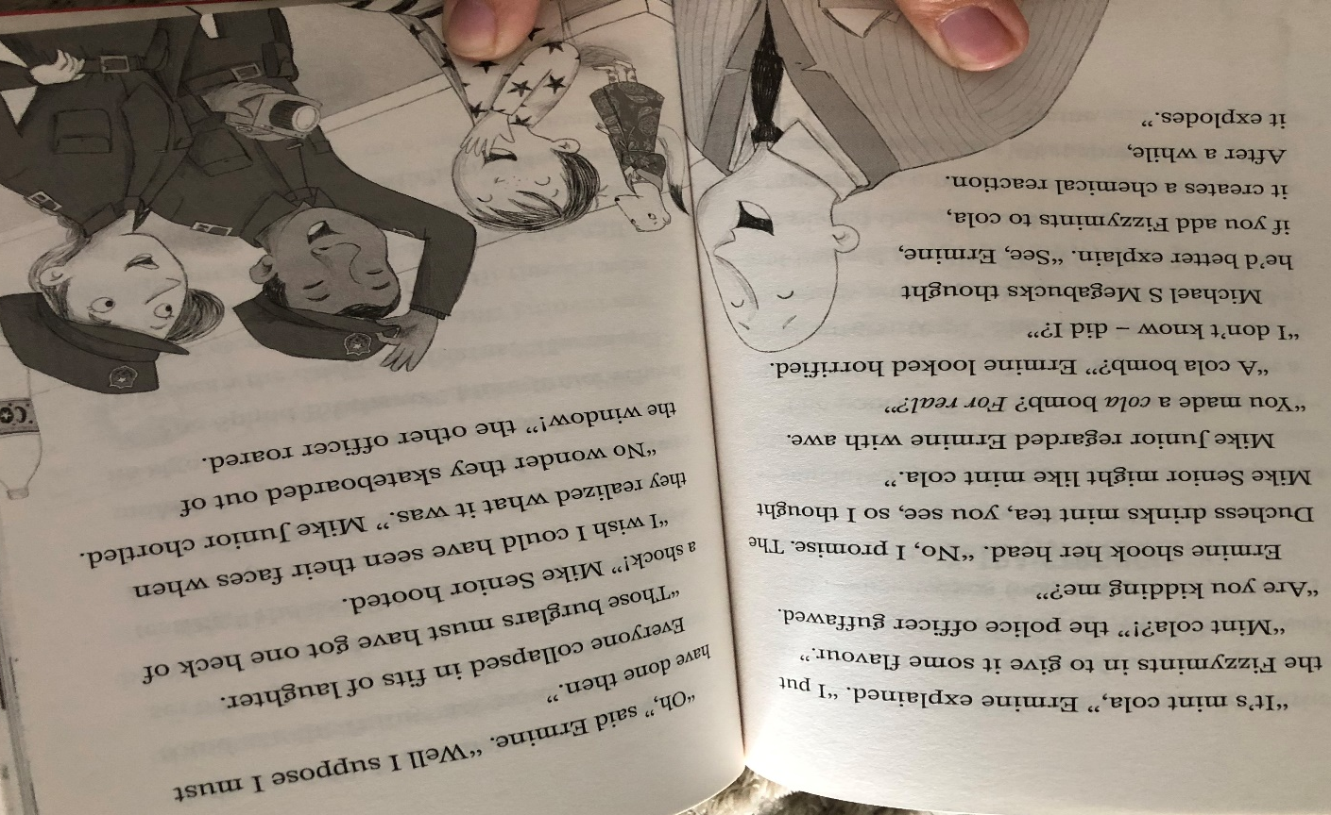
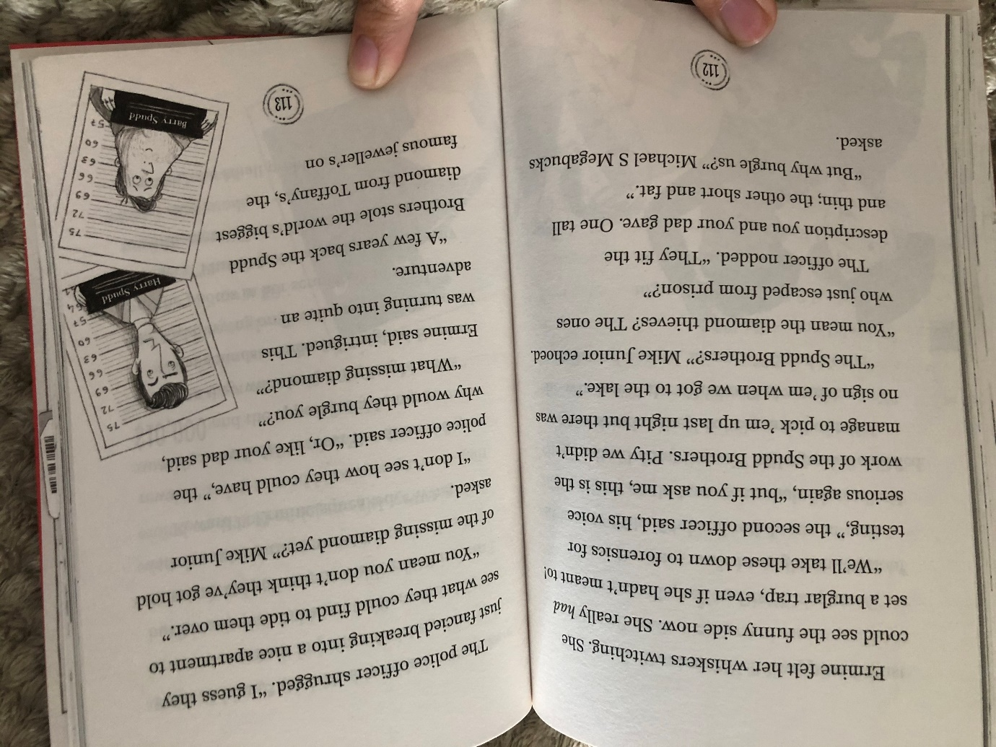

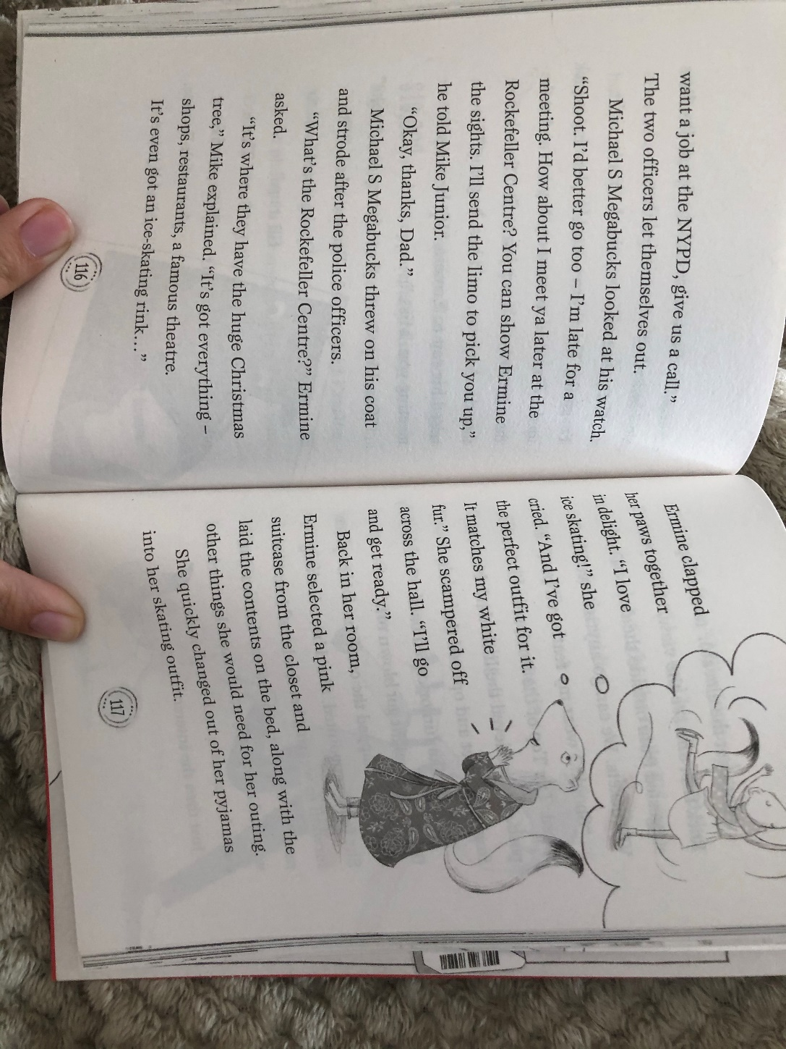
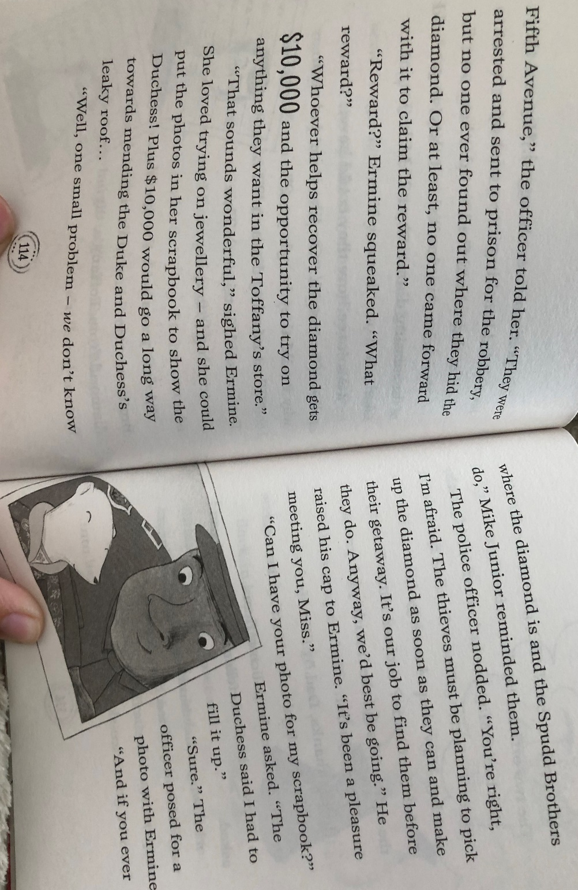

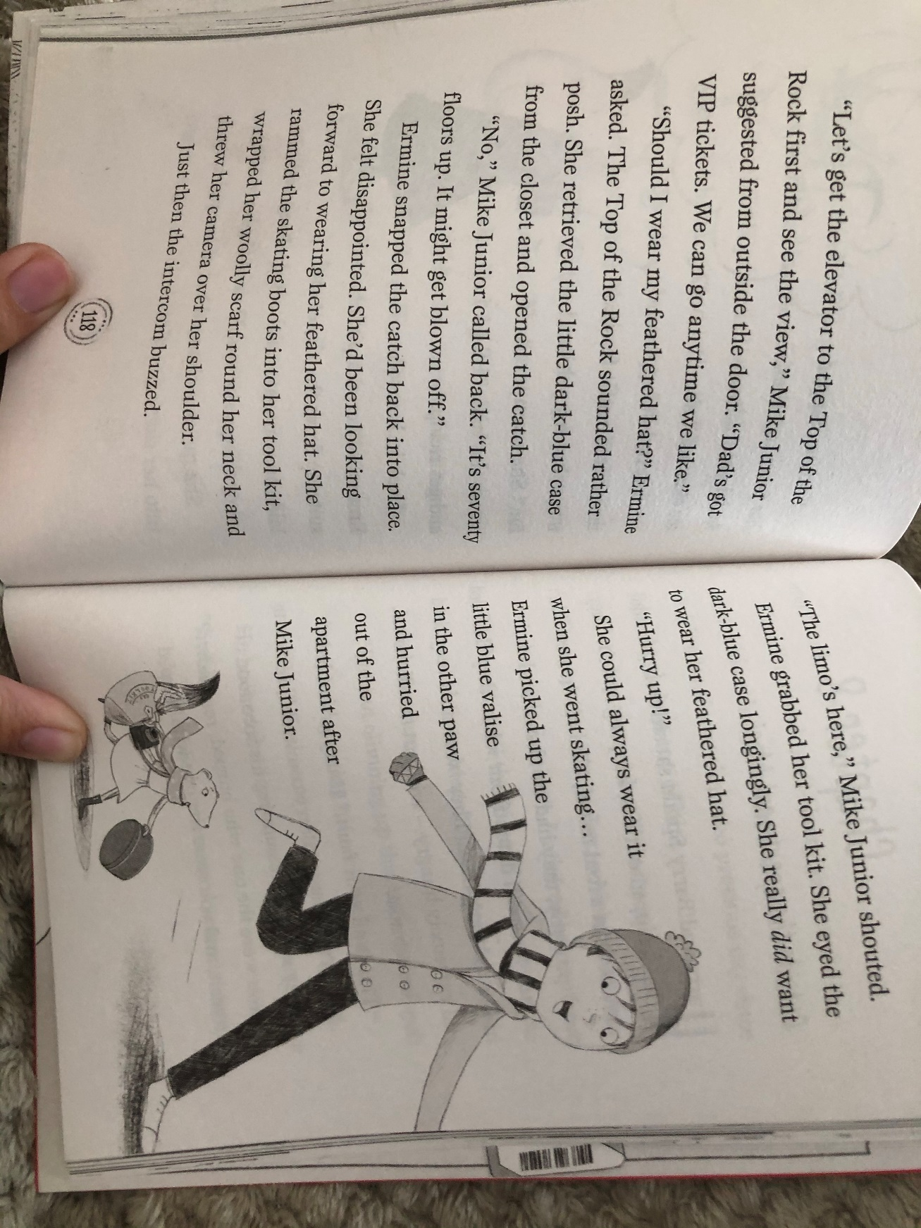
Task 1- Answer the following questions.

- What two things were the police officers doing in the apartment?
- Look at the line “The police officer (or “cop” as Mike Junior called her) was taking statements from everyone…” Explain what you think a statement is.
- Name three things the police officers can take away from the crime scene as evidence.
- Look on page 10 and explain what you think the word “guffawed” means and why.
- Name three things you can do at the ‘Rockefeller Centre’.
- In Chapter 8, what do you think will happen and why? Explain using evidence from the text that you have just read.

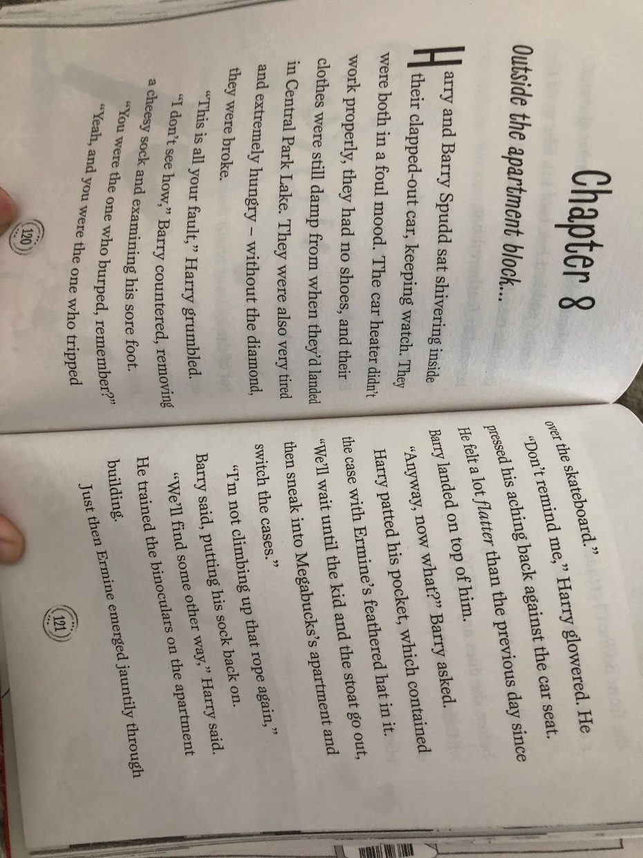
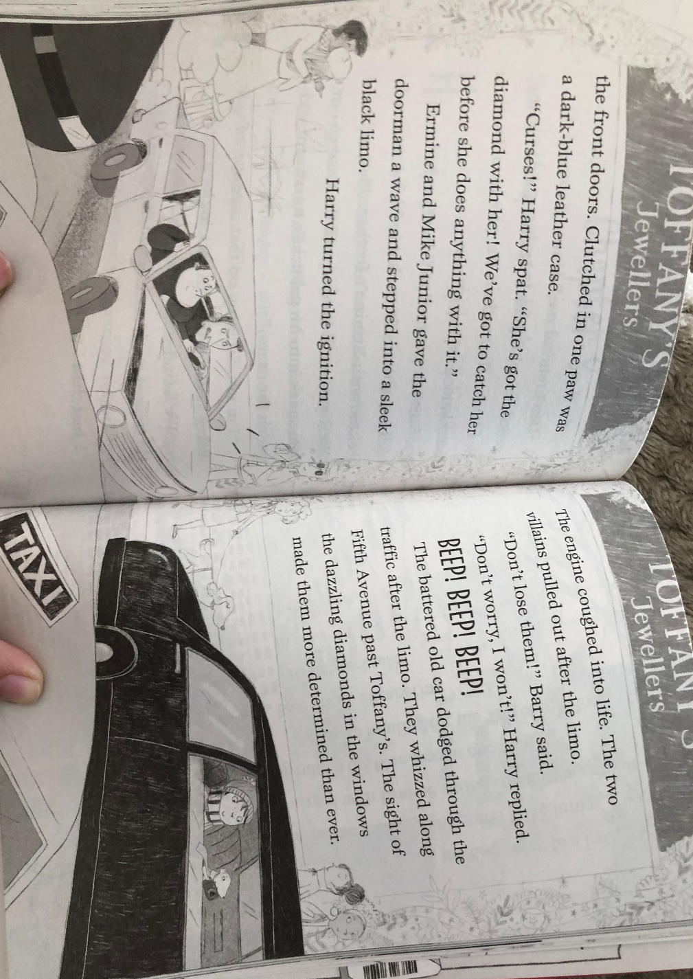

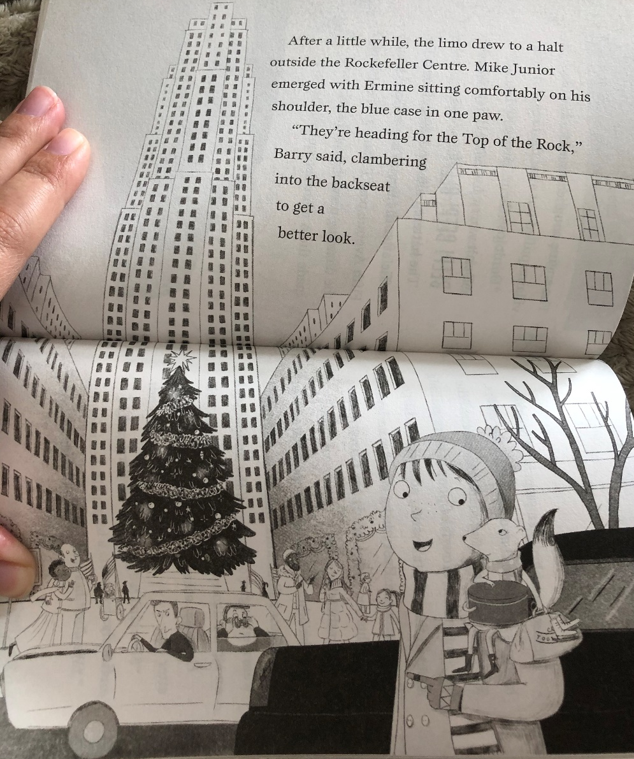
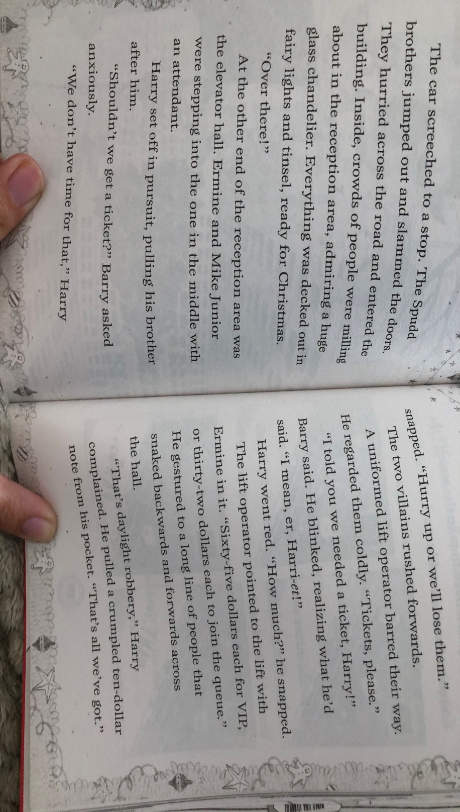

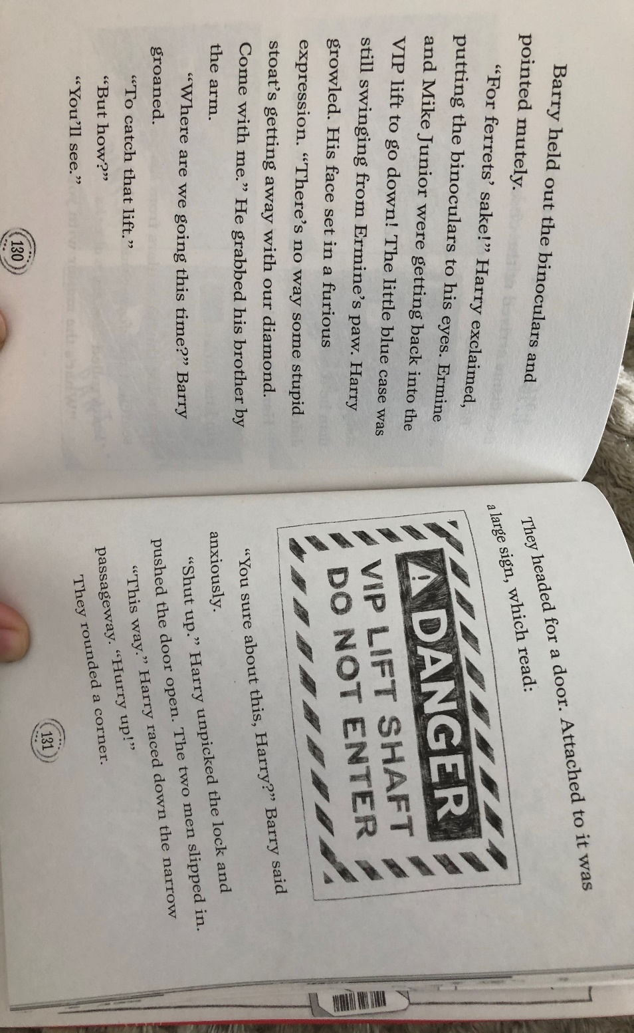
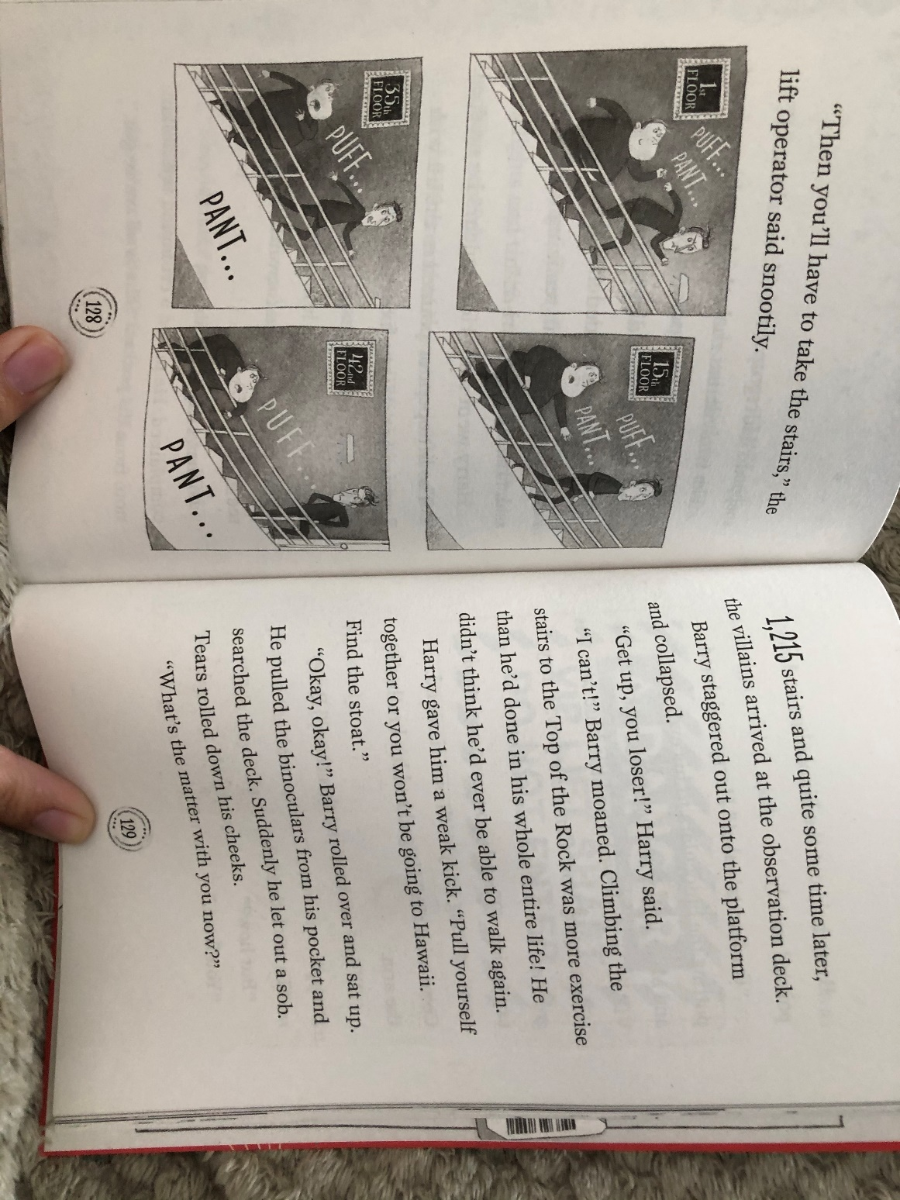

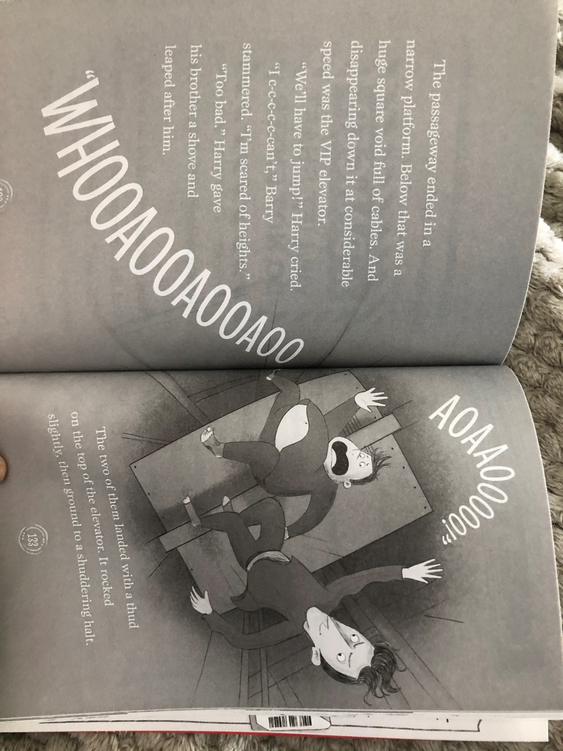

Task 2: Draw a storyboard of events on chapter 8. Your final box should include what you think will happen next.
Your storyboard should have at least 6 boxes that look something like this with a description underneath of what is happening:

Wednesday 8th July - GPaS - Word families- Read the information on the poster

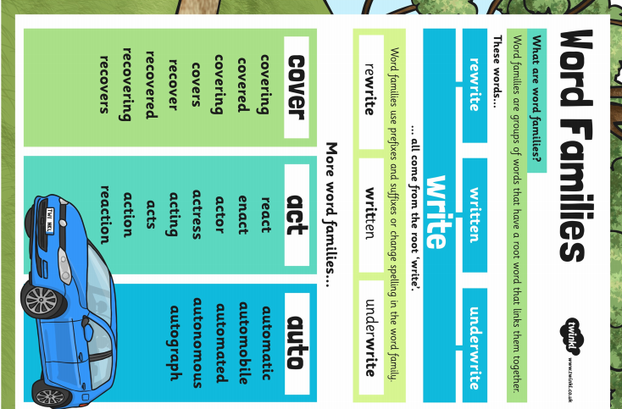

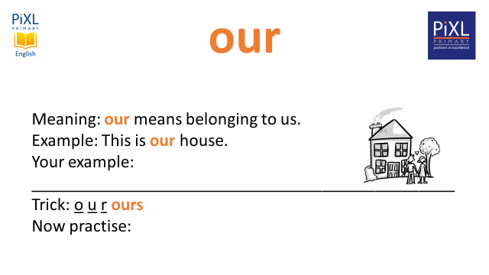
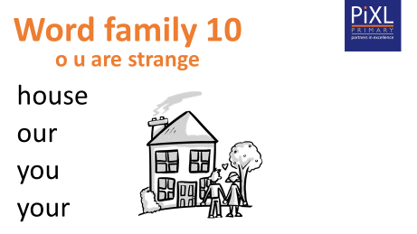
Wednesday 8th July – GpaS - Page 2 - Read the information and complete the activities
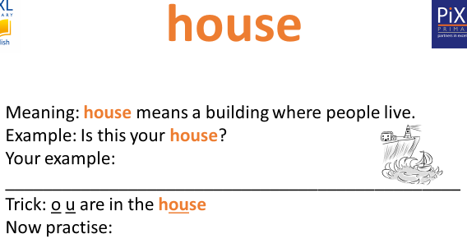

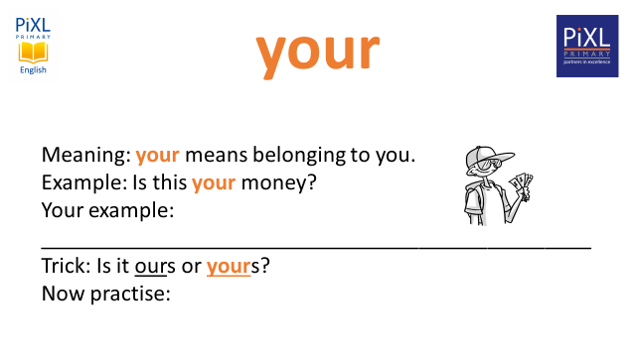
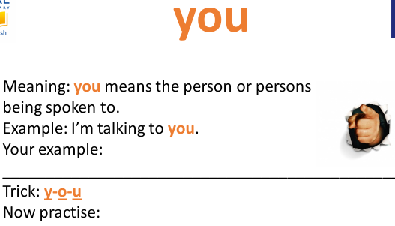

Common Exception Words – Family 10
Word 1: house
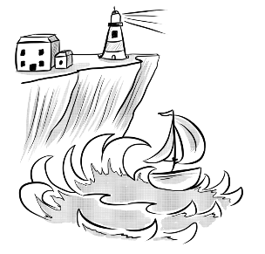
Meaning: house means a building where people live.
Example: Is this your house?
Your example: ________________________________________________
Trick: o u are in the house

Now practise:

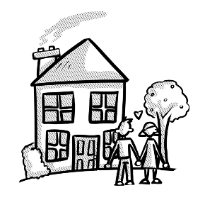
Word 2: our
Meaning: our means belonging to us.
Example: This is our house.
Your example: ________________________________________________
Trick: o u r ours

Now practise:

Word 3: you
Meaning: you means the person or persons being spoken to.

Example: I’m talking to you.
Your example: ________________________________________________
Trick: y-o-u

Now practise:

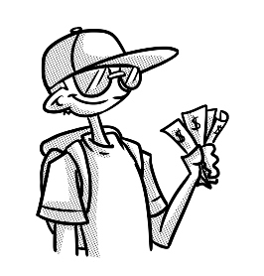
Word 4: your
Meaning: your means belonging to you.
Example: Is this your money?
Your example: ________________________________________________
Trick: Is it ours or yours?

Now practise:

Friday 10th July - Spellings
Suffix - homophones
their
there
they’re
sea
see
one
won
whole
hole
Please practise your weekly spellings, remember to write them into descriptive sentences once you have learnt how to spell them.
MILD

Words with the a_e sound
cake
make
bake
flake
take
wake

Friday 10th July – Spelling rule 13 - Contractions

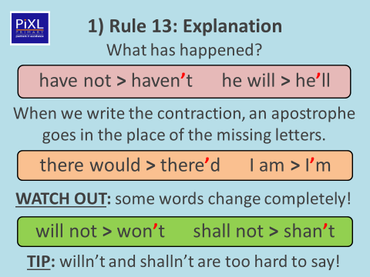

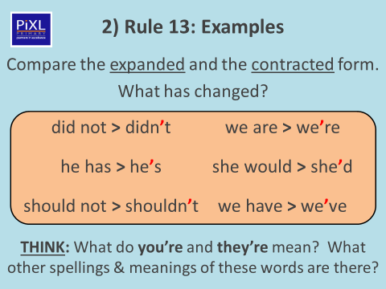

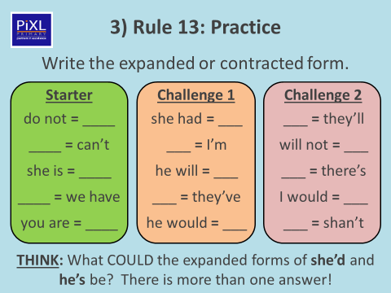

Activity 1 - Complete

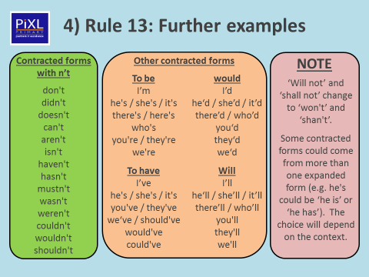

Activity 2 - Choose words from each coloured box and write them into descriptive sentences.

Challenge:
Can you use inverted commas in your sentences using these spelling words? E.g.

“I haven’t got my pen license yet, but I’m working hard with my handwriting” explained Joe.

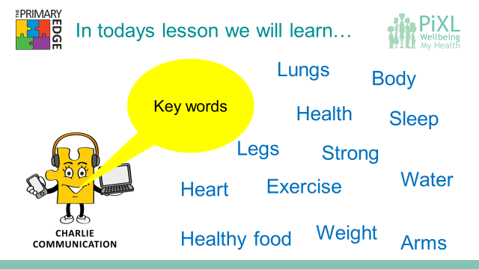
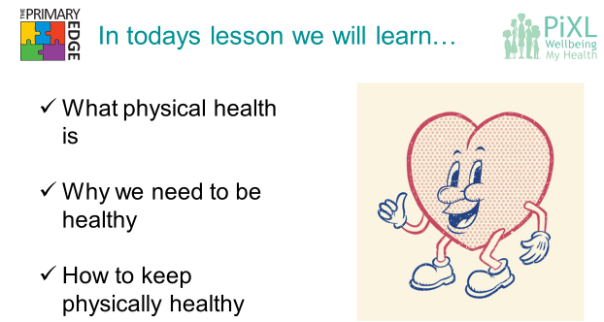
Tuesday 7th July – Jigsaw - Well-being
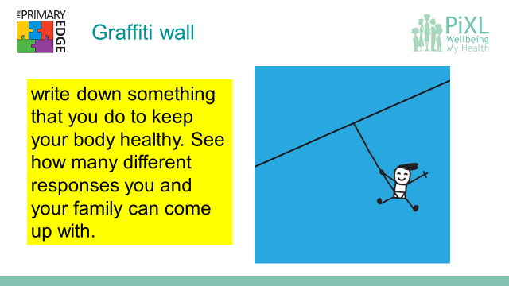

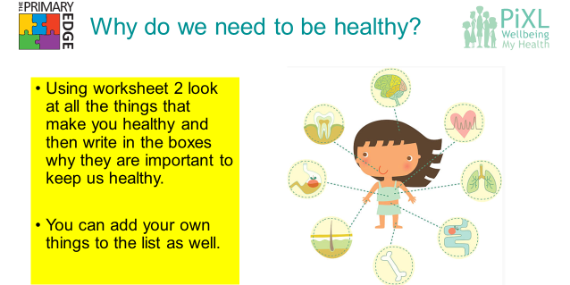
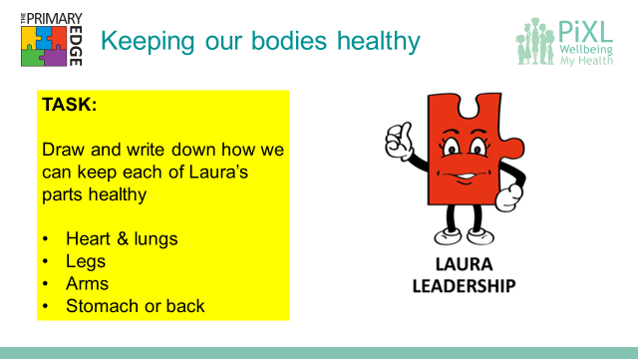
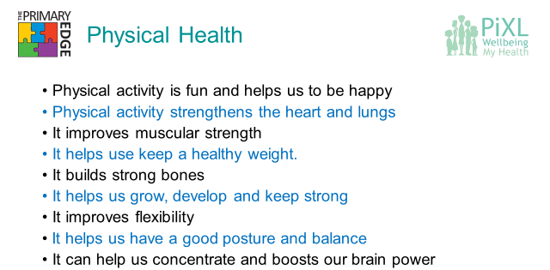
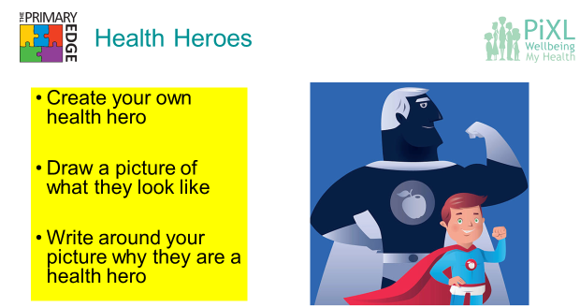
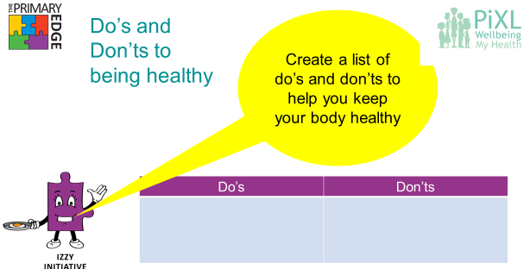

Tuesday 7th July - Jigsaw - Well-being page 2
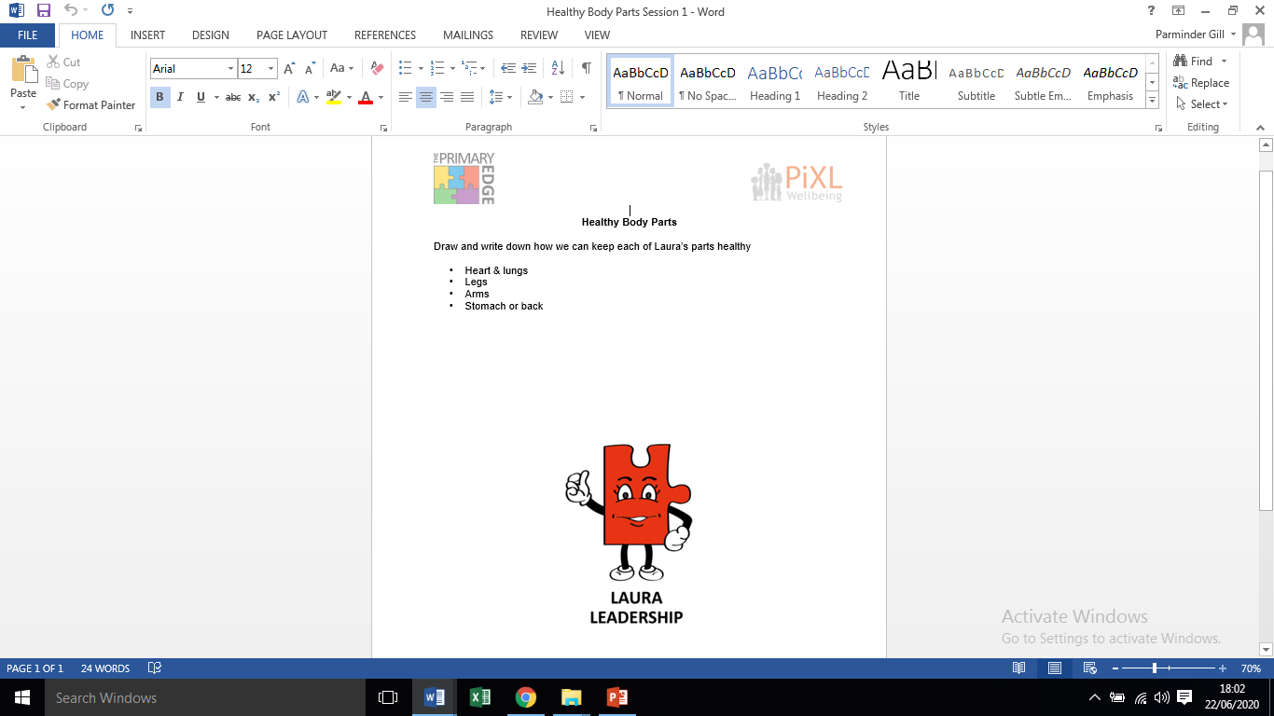

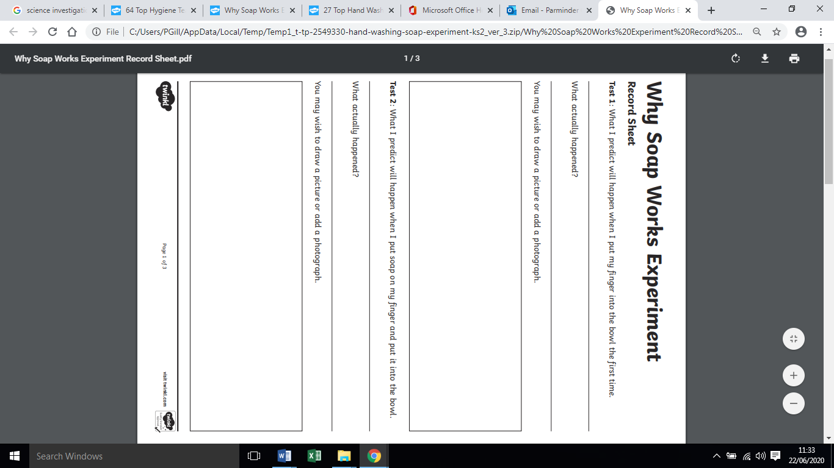
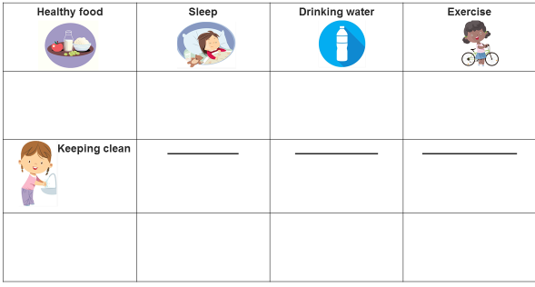
Wednesday 8th July – Science - Germs experiment page 1
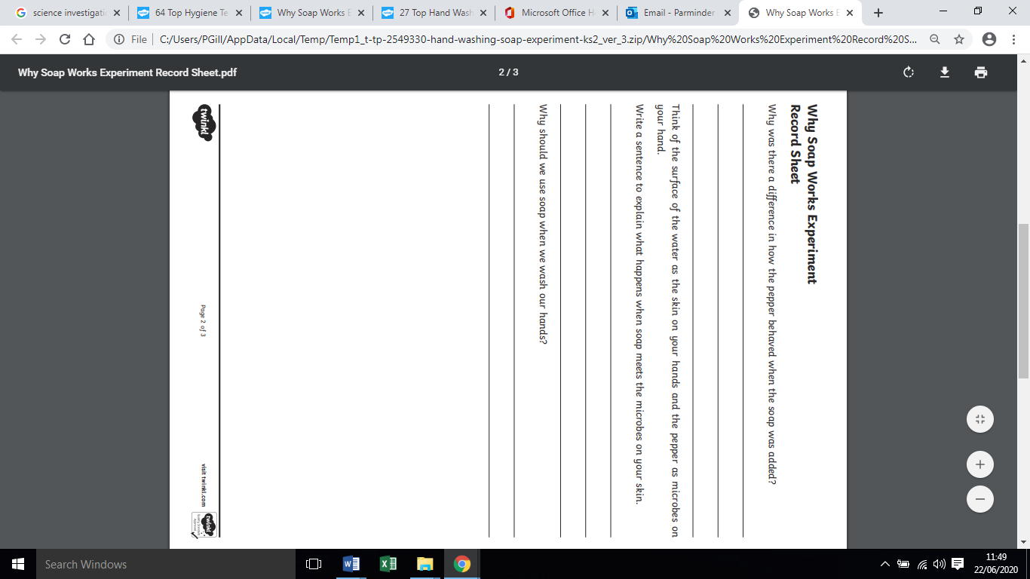
Wednesday 8th July – Science - Germs experiment page 2

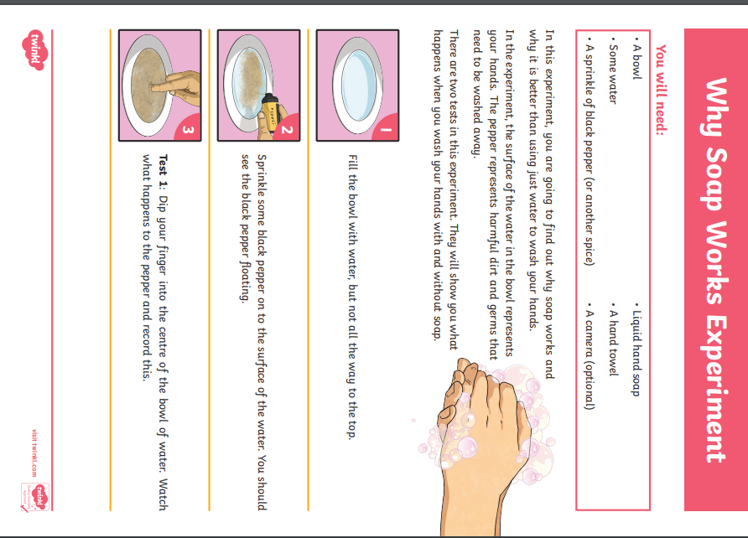
Wednesday 8th July – Science - Germs experiment page 3

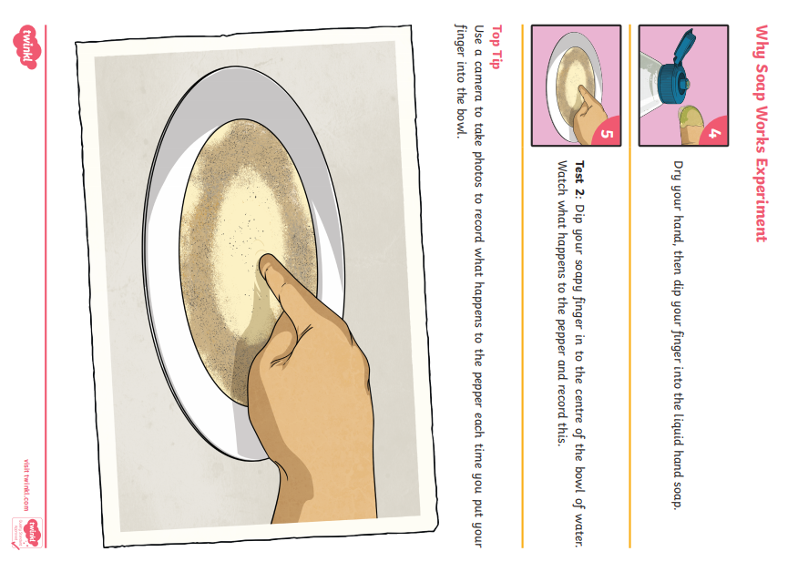
Wednesday 8th July – Science - Germs experiment page 4

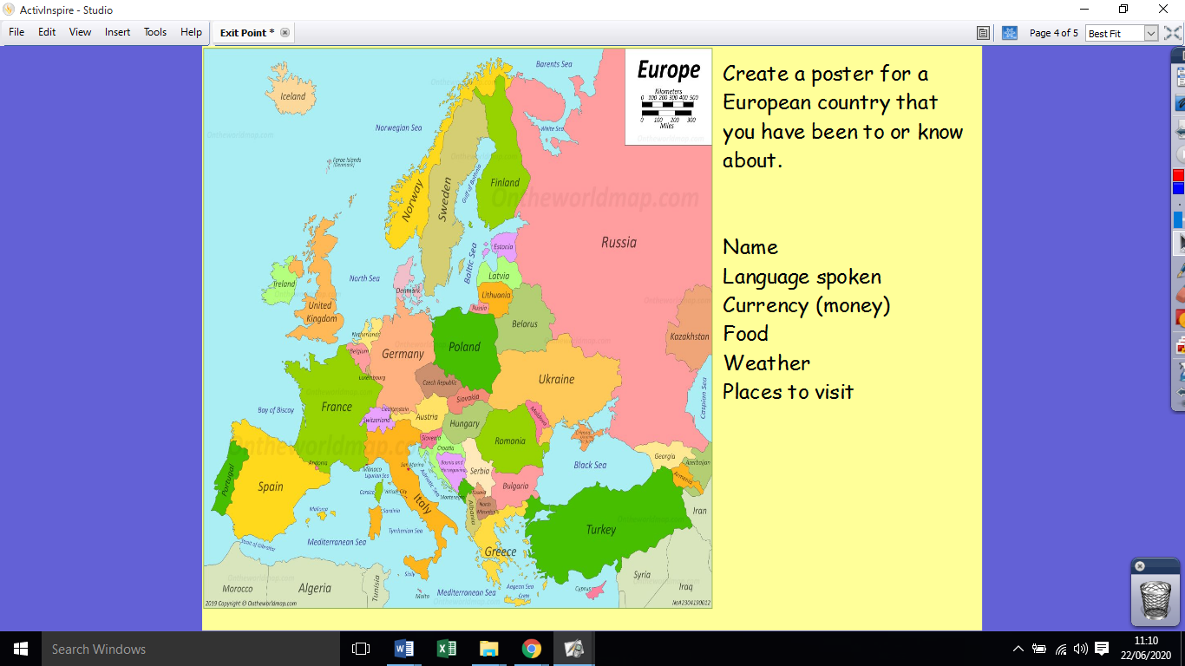
Thursday 9th July – Topic - Create a poster for a European country

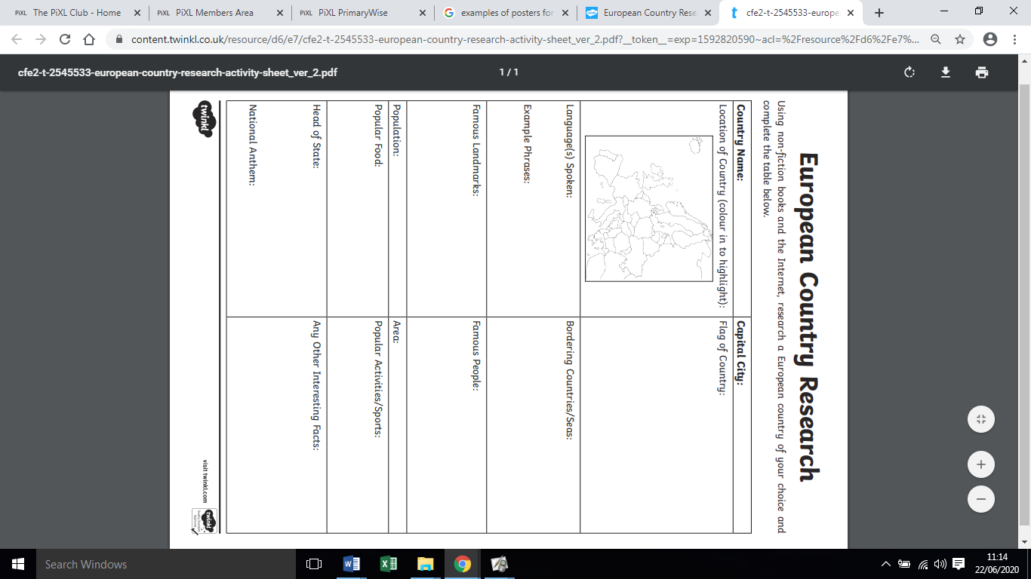
You may use this planning sheet to help you:

