

Learning Activities
Year 3
2019-20
Self-isolation learning
Week 12 (Worksheets)

Monday
Maths: Practise 3 times tables and Place Value English (GPAS): Prefixes
SLOR: The Travels of Ermine

Tuesday
Maths: Practise 4 times tables and Place Value English: Postcard
PSHE: Well-Being and Kindness

Wednesday
Maths: Practise 4 times tables and times tables English (GPAS): Suffixes
Science: Create your own investigation

Thursday
Maths: 8 times table practise and Direction and Position English: Dictionary skills
Topic: European Cities

Friday
Maths: 8 times table practise and Arithmetic test English: Spellings
PE: Build an obstacle course

Monday 29th June - Maths:
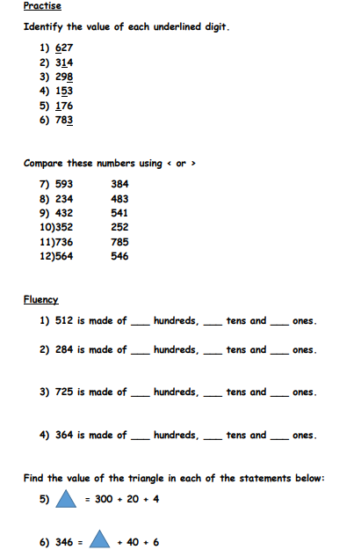
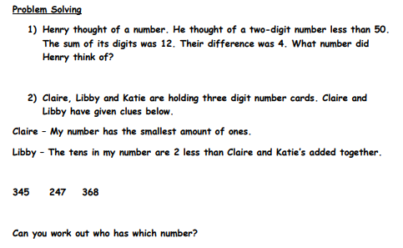
Extension:

Monday 29th June - English:

Prefix
A prefix is a group of letters you add to the start of a word. Sometimes the meaning of the word changes completely and becomes the opposite. This happens when you add the prefix –un, -in, -il, -dis, -ir or –im

Un Dis In
e.g. Unkind Dishonest inefficient

Task 1: Underline the word that has a prefix, then try and write the sentence again only without the prefix.

- The ungrateful boy had lots of lovely presents.
- Most people think it is naughty to be dishonest.
- The little girl was very unkind to her granny.
- “I was quite unaware of what happened,” said the man.
- “Do you think we’ll get into trouble if we do something illegal?” asked the boy.
- “You must try to be less irresponsible,” shouted mum.

Task 2: Complete the table using the words below.

un | dis | in
il | ir | im

aware - appear - honest - regular - legal - proper - probable - perfect - approve - connect - sane - considerate - kind - certain - important - obedient - responsible - patient.

Task 3: Choose one word from each part of the table, write a sentence using the word with and without the prefix.

e.g. if you choose grateful.
- The boy was very grateful when he received a present.
- The boy was very ungrateful when he received a present.

Monday 29th June - SLOR:

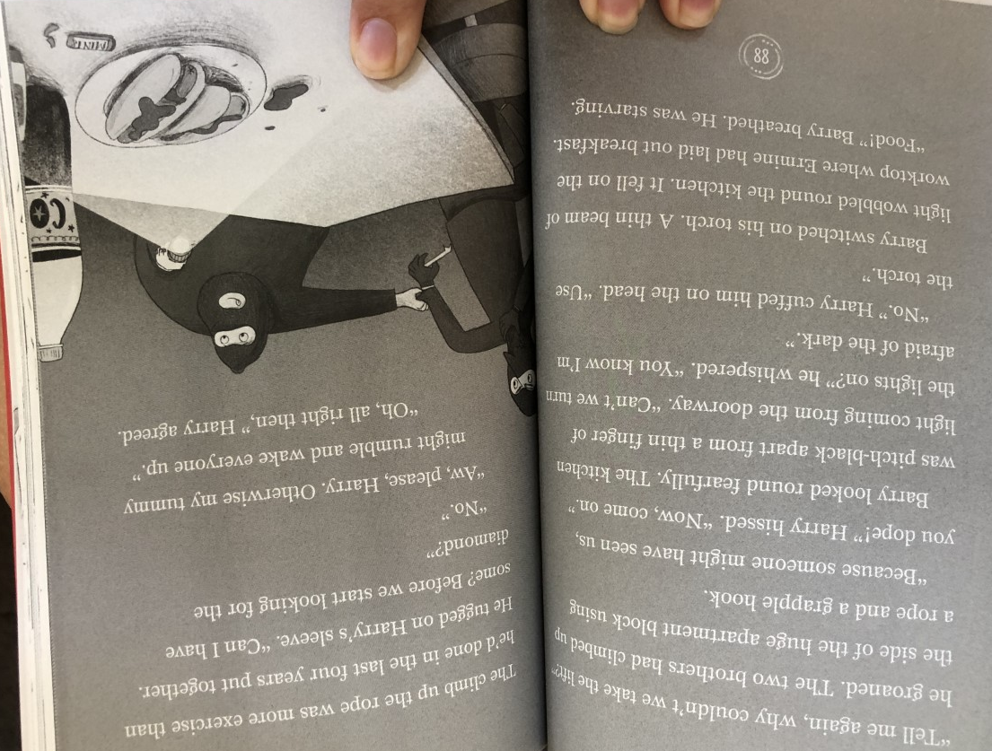
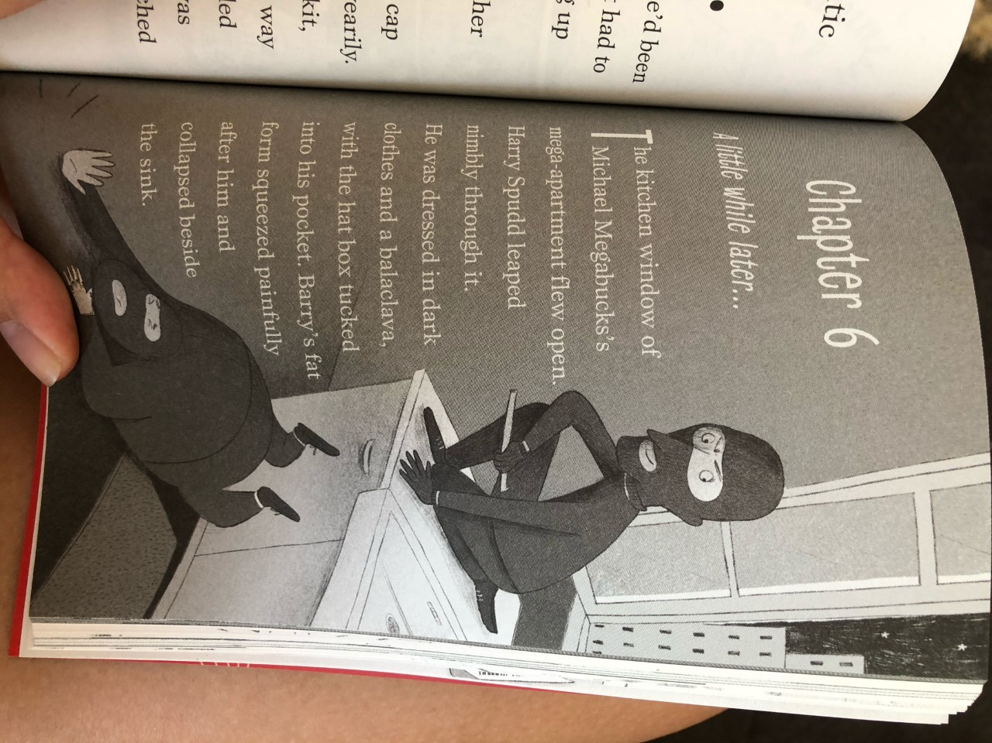
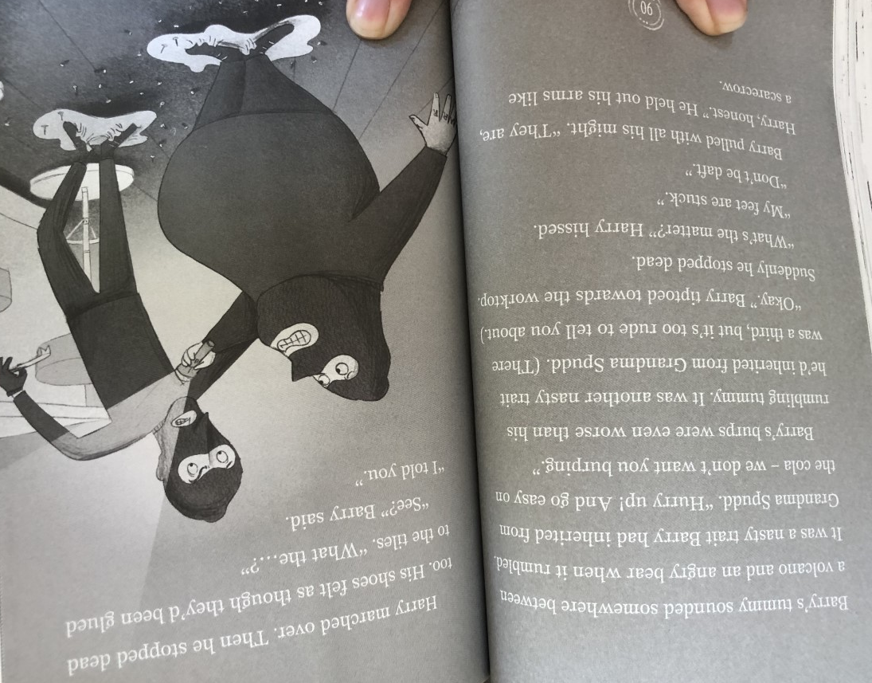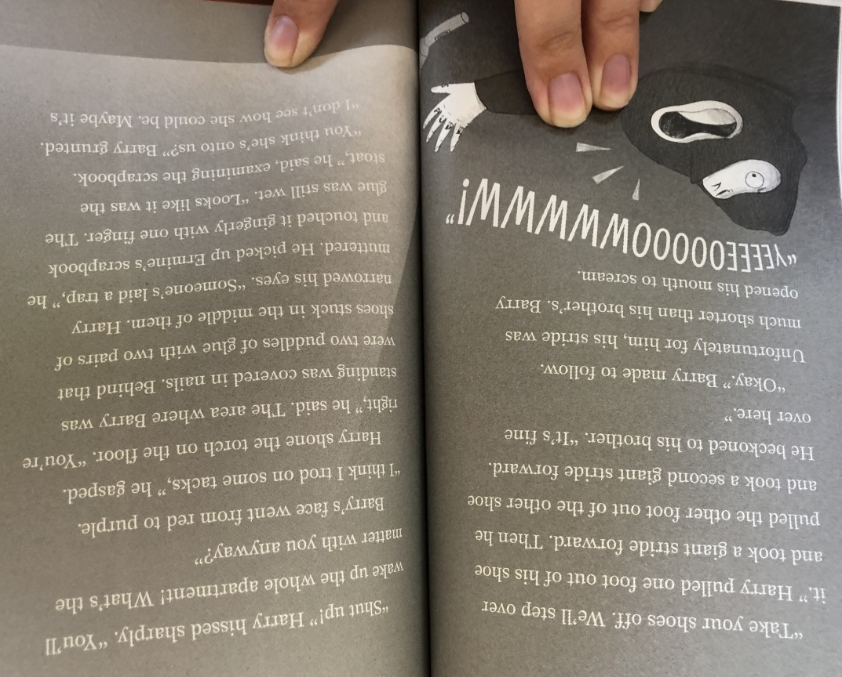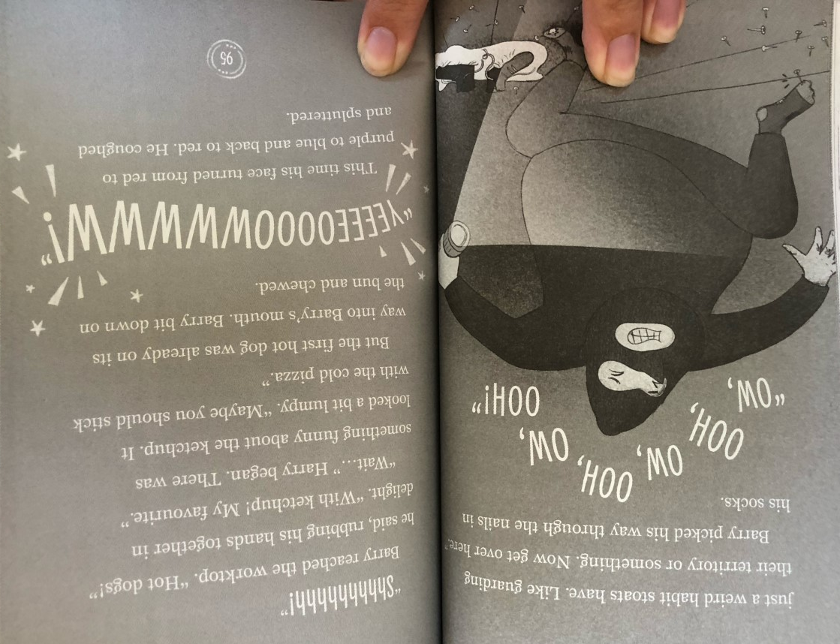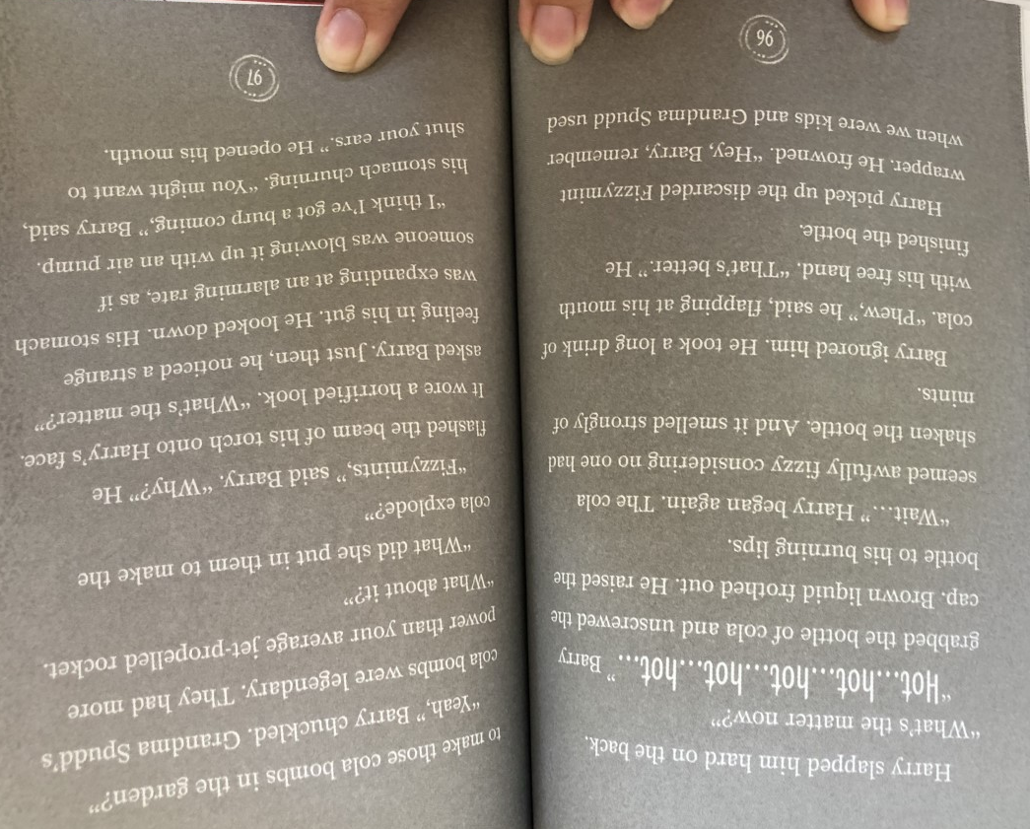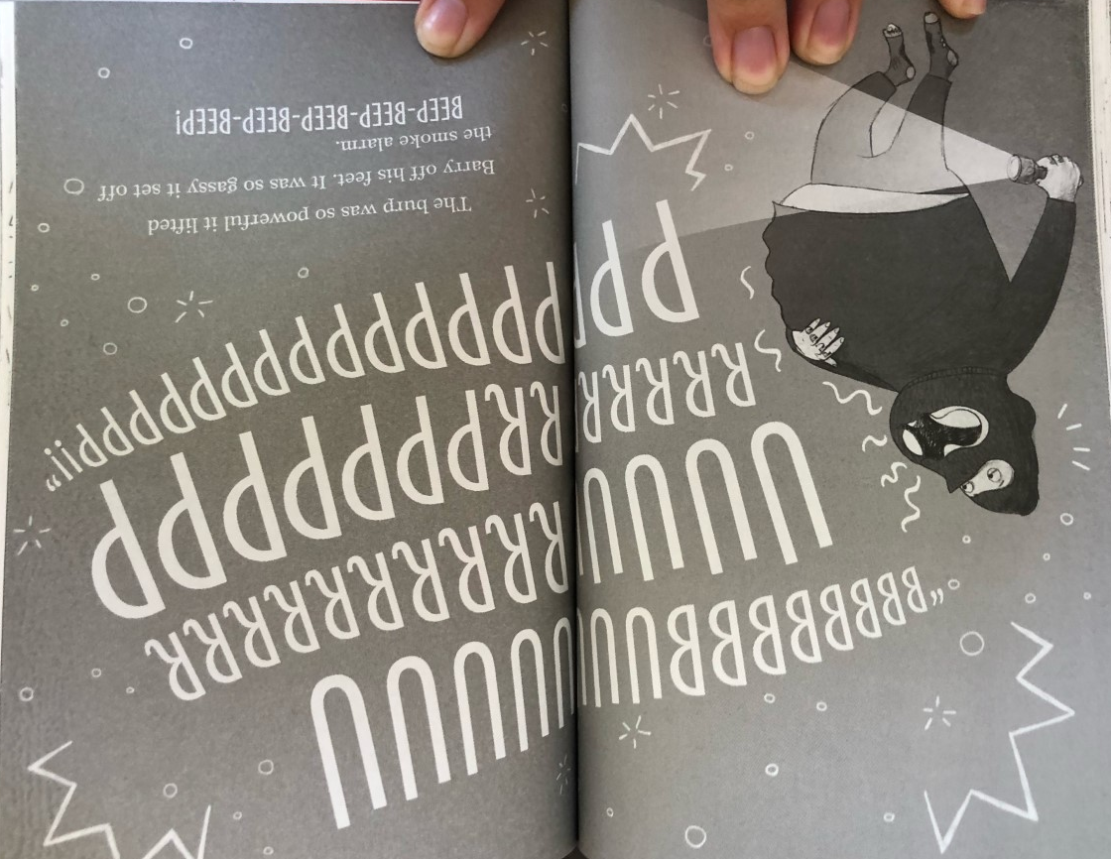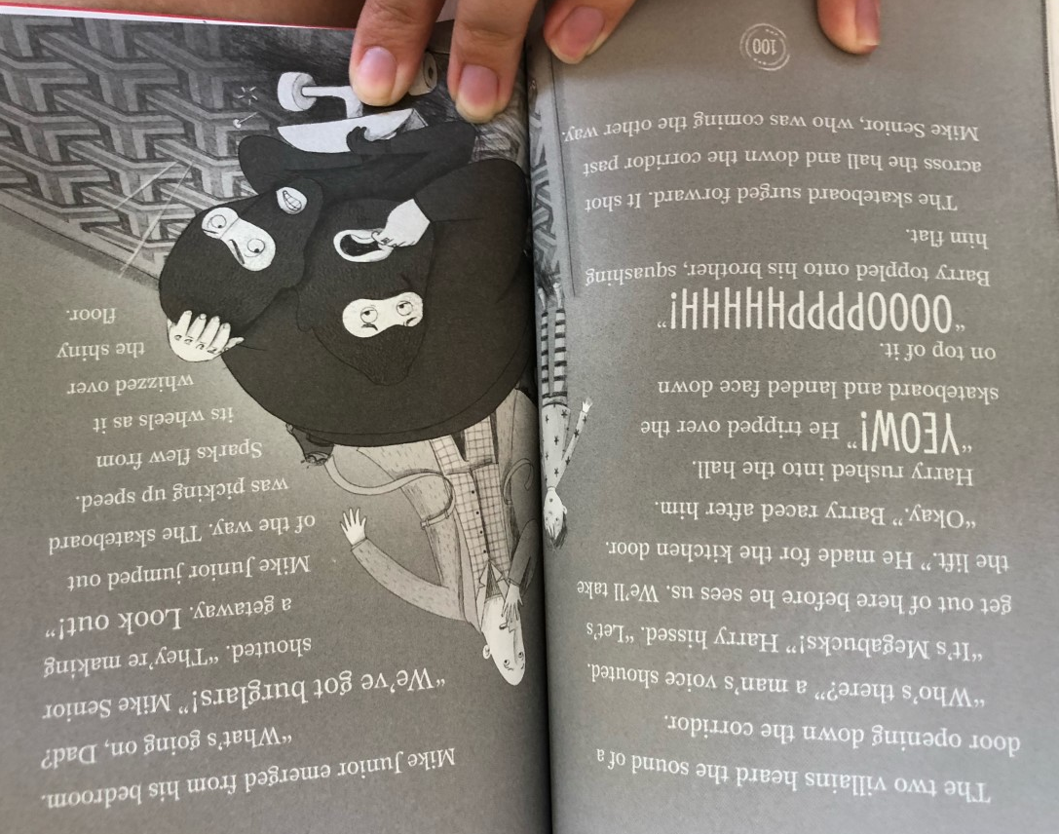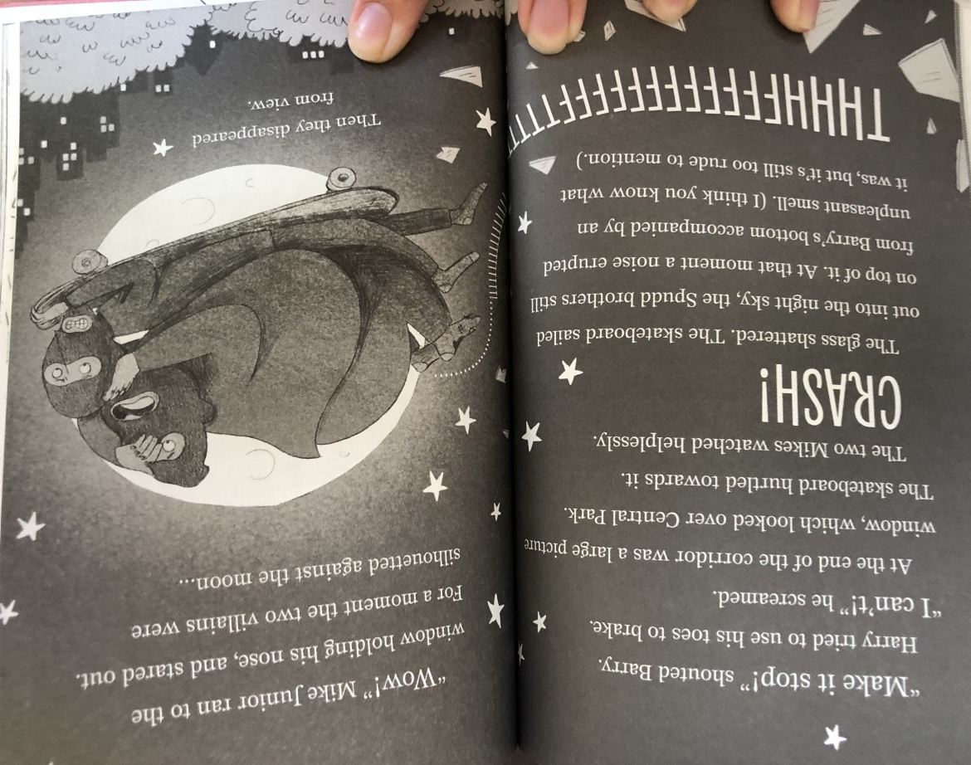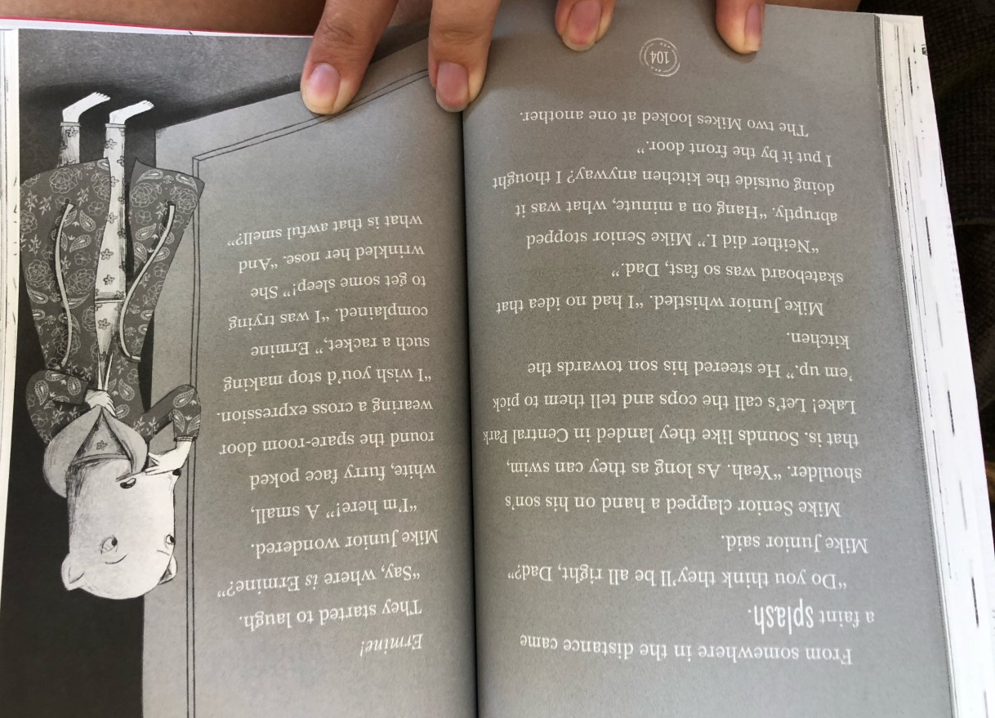
TASK TWO
Draw five pictures (in chronological order) summarising the main parts of the story. Write a simple sentence underneath each picture.

Example:
Barry and Harry snuck into the kitchen through the window.
TASK ONE
Knowledge: What were the two nasty traits that Barry had picked up from his grandma Spud?

Comprehension: How would you compare Barry and Harry?

Apply: If you were Barry, would you have eaten the food?

Analysis: Why do you think Ermine set the traps?

Evaluation: Do you think it was fair that the burglars landed in the lake?

TASK ONE: Answers
Knowledge: What were the two nasty traits that Barry had picked up from his grandma Spud?
His loud rumbling tummy noises and his loud burps. (Also his smelly bottom burps)

Comprehension: How would you compare Barry and Harry?
You can compare both the similarities and differences between the characters.
Examples:
Barry is silly whereas Harry is clever.
Harry is skinny and Barry is fat.

Apply: If you were Barry, would you have eaten the food?
Yes or no, please ensure you have given an explanation for your answer.

Analysis: Why do you think Ermine set the traps?
To protect the house and stop the burglars.

Evaluation: Do you think it was fair that the burglars landed in the lake?
Yes because they didn’t steal the diamond and now the police can get them
Or
No because they should have been caught by Mike junior and Mike senior in the house.

Tuesday 30th June - Maths:
Count from 0 in multiples of 4, 8, 50 and 100.
- Count on in multiples of 4
+ 4
+ 4
+ 4
+ 4
+ 4

0

- Count on in multiples of 8
0

- Count on in multiples of 50
0

- Count on in multiples of 100
0

- Count back in multiples of 4 from 40
40

- Count back in multiples of 8 from 56
56

- Count back in multiples of 50 from 550
550

- Count back in multiples of 100 from 1100
1100

Extension:
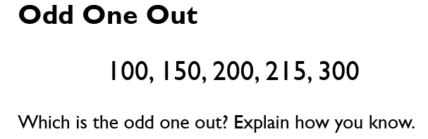

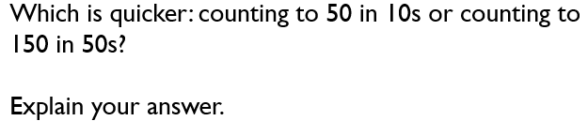

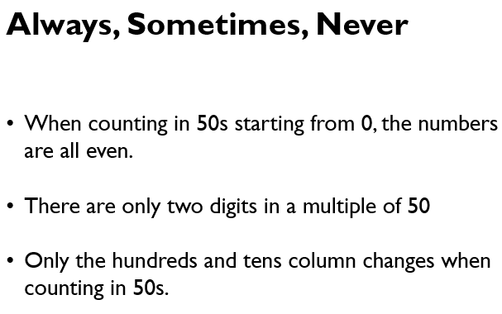

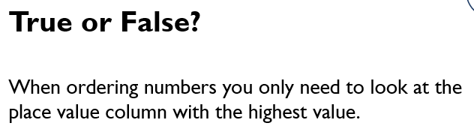

Tuesday 30th June - Jigsaw: Task One
Warm Glow
Contender characteristic: Explain the effects of kindness on others
Little Carl was grumpy. He was mumbly and grumbly; he was whingy and whiny, and Dad was losing patience.
Dad asked Carl’s big sister, Ellie, to play with him for a while, just while he finished making tea.
‘What’s in it for me?’ demanded Ellie.
‘Um, I suppose you could have a biscuit,’ offered Dad.
Ellie sat with Carl for a bit and helped him build a tower with his bricks. But soon she was bored. Carl seemed to be happy enough stuffing wooden blocks into his mouth, so Ellie got out her phone to check her messages.
When Jack, Ellie’s younger brother, came down, he took one look at Carl, then found his teething ring on the sofa and gave it to him. After a couple of games of ‘bee-bo’, Carl was chewing and gurgling happily, so Jack went into the kitchen and began to lay the table, ready for tea.
Just for a moment, the lines melted away from Dad’s face and he beamed at his boy. Then he reached down the biscuit tin from the shelf and headed out of the kitchen. A deal was a deal.
Ellie had just about managed to stuff her phone back into her pocket and start babbling at Carl when Dad came in.
‘Thank you love, that was a great help. Here you are,’ Dad added, handing Ellie the opened tin. She chose her favourite and stuffed it into her mouth. Surprisingly, it didn’t taste as good as she was expecting. Tea, however, was unusually pleasant. Dad cooed at Carl while he bounced him on his knee and sang him the songs that had given them all a warm glow when they were little.

Warm Glow: Questions
- How did Jack’s kindness affect Dad?

- How did Jack’s kindness affect Jack?

- How did Ellie’s actions affect her?

Jigsaw: Task Two
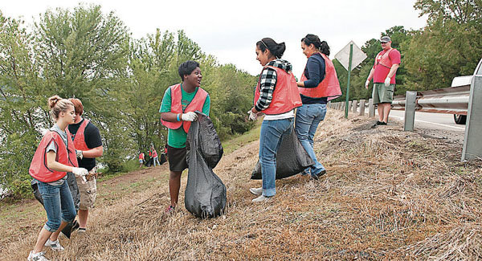



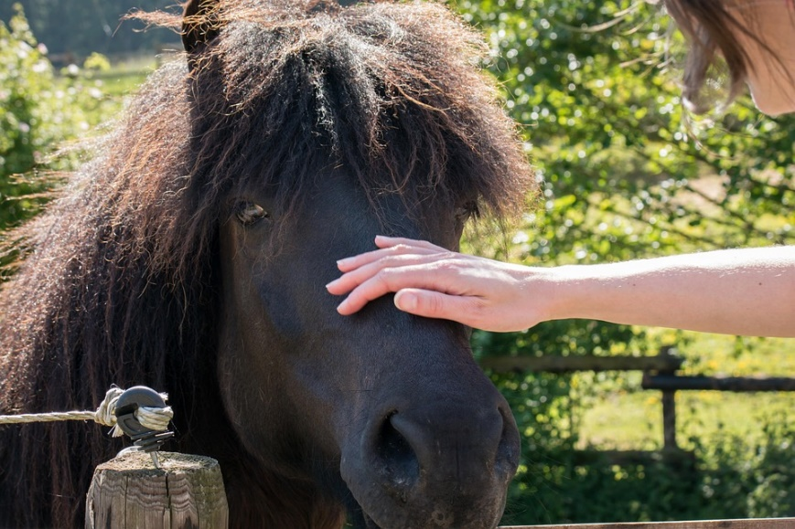

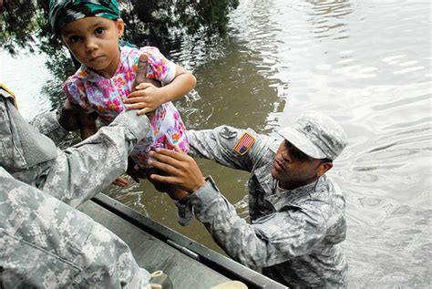

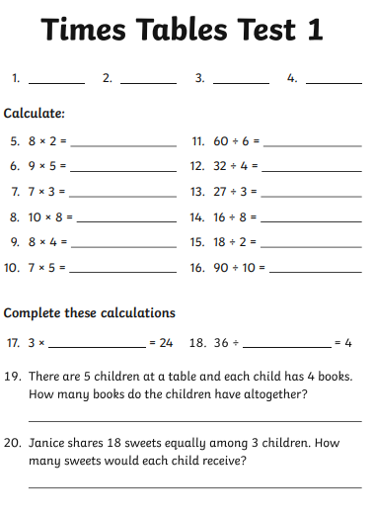
Wednesday 1st July - Maths:
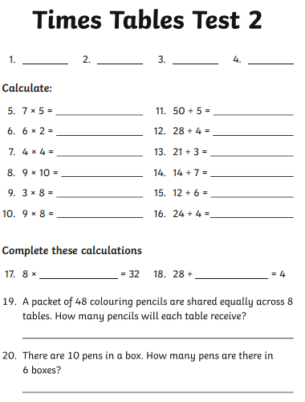

Wednesday 1st July - English:
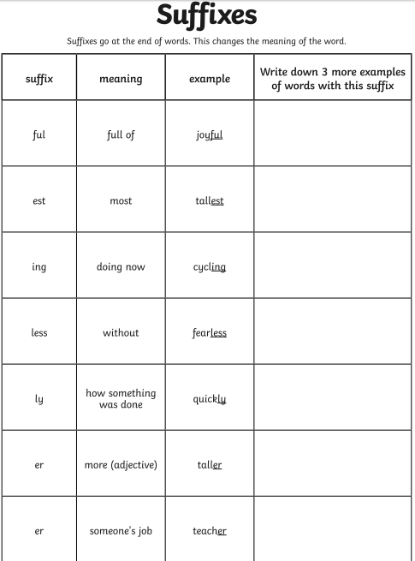

Wednesday 1st July - Science:
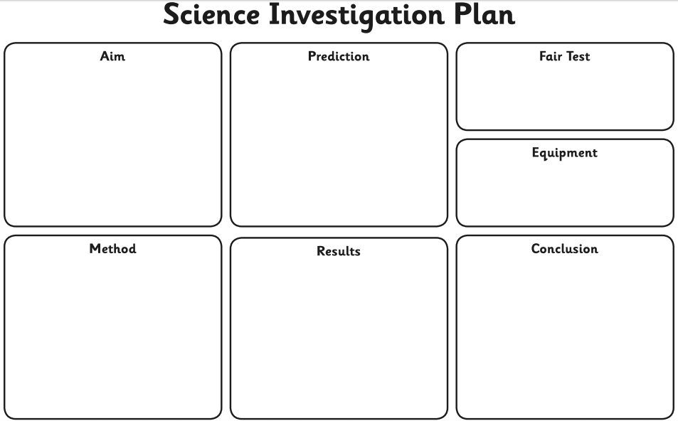
Thursday 2nd July - Maths:

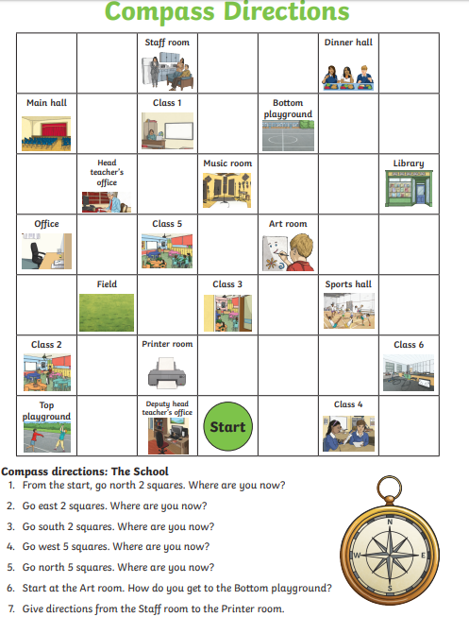

Thursday 2nd July - English:
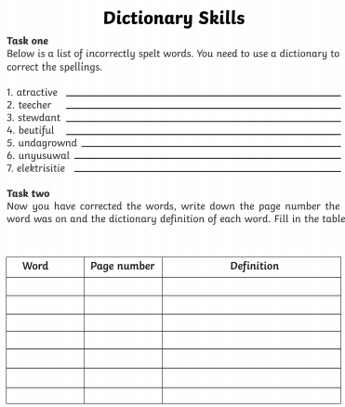
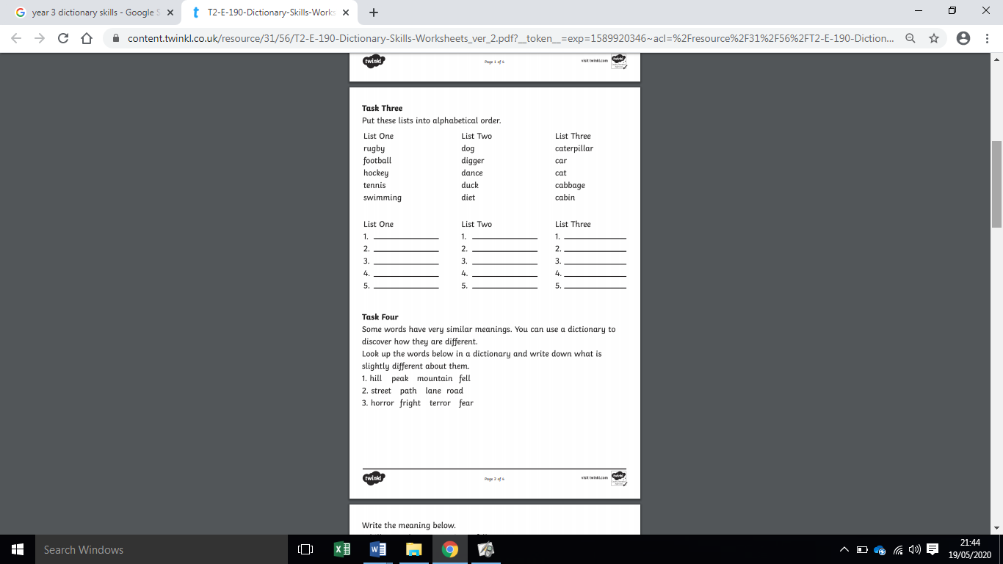

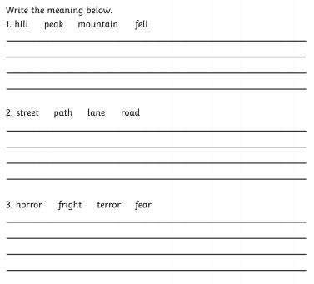

Thursday 2nd July - Topic:

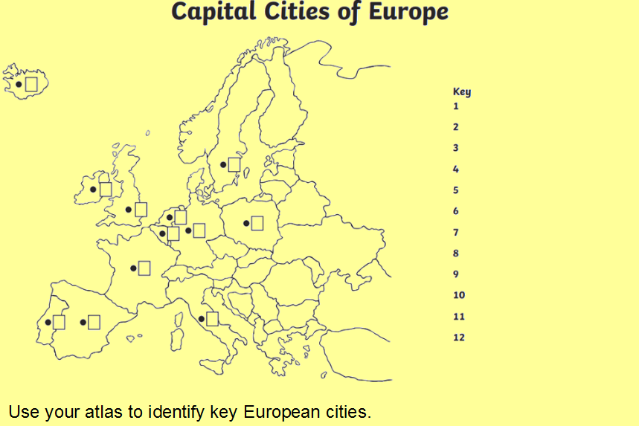

Answers
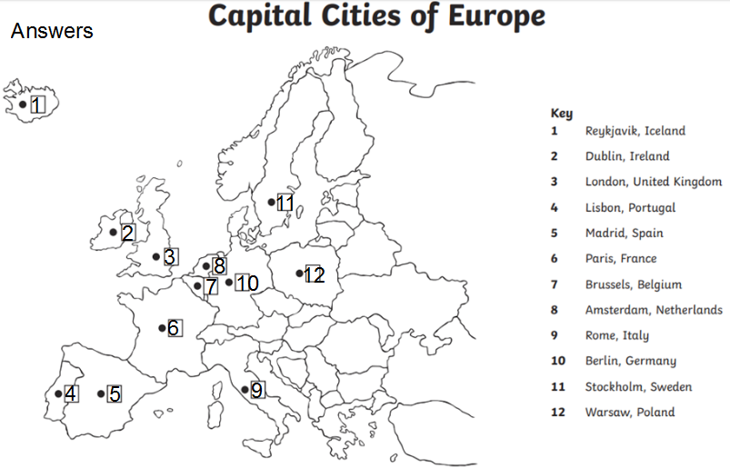

Friday 3rd July - Maths:
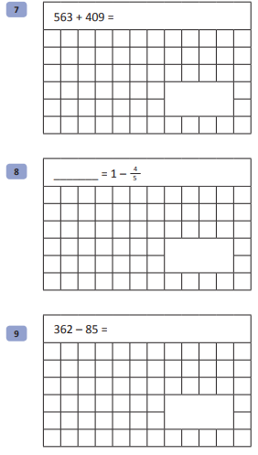
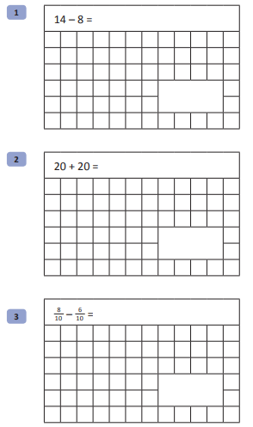
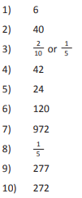
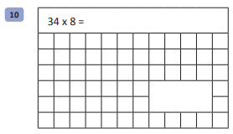
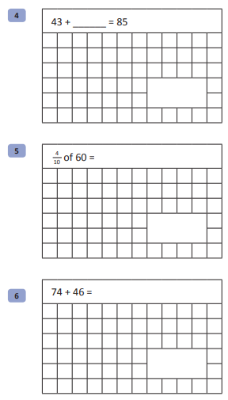
Answers

Week 12 - Spellings:

Suffix - less
fearless
helpless
useless
harmless
careless
thoughtless
homeless
heartless

MILD
Words with the ey sound
key
money
honey
donkey
alley
turkey

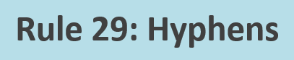
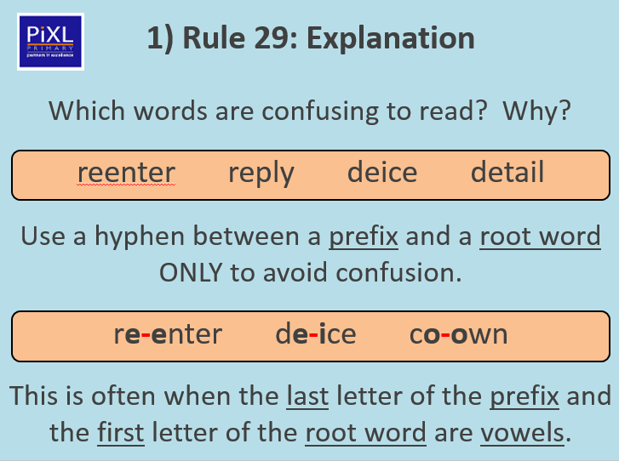

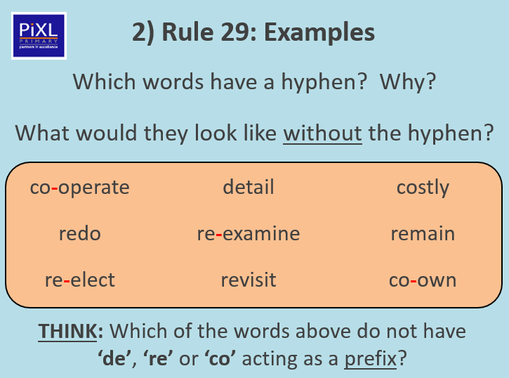

Activity one: Add a hyphen to the words that should have a hyphen.
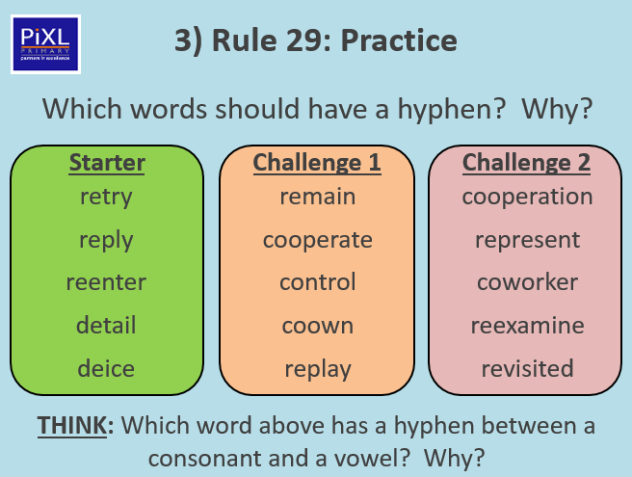

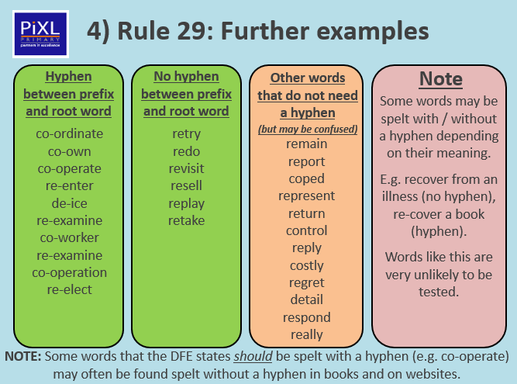
ACTIVITY TWO – Choose three words from each column and put them into nine different sentences.

