
Learning Activities
Year 3 2019-20

Self-isolation learning Week 12
Lessons set  Every child is expected to complete three pieces of learning per day. Most of what is listed below has been taught in school. This is for revision and will allow children to practise skills already learnt. Where new skills are being introduced, we will provide as much support as possible by means of videos, pictures and websites. Please do not hesitate to email the year 3 email address if you have any questions regarding the learning.  For every piece of learning completed to a good standard will be rewarded with 5HP.  Please share your hard work on Twitter and via email, we would love to see how you are all getting on! |  | Additional comments  Worksheets attached do not need to be printed. Use them to access questions matching LOs (learning objectives). They can be copied and written onto paper for children to complete.
Monday | Maths  Starter: 3 times tables  Recite: Say your 3 times tables out loud from 0 to 36. Can you do it backwards?  Extension: Play some 3 times table games on topmarks.  Place Value.  Complete the worksheet to recap place value.  Practise: Start by identify the value of the underlined digit. Example - 384 = 80.  Compare numbers using the greater than, less than and equal signs (>,<,=). Remember the crocodile likes to snap up the bigger number.  Fluency: Fill in the blanks to show what the number is made up of. Example - 384 = three hundreds, eight tens and four ones.  Find the value of the triangle in each of the statements below. (Try to use place value to add the numbers rather than the column method).  Extension: Complete Place Value problem solving questions.  Try a daily 10: https://www.topmarks.co.uk/maths-games/daily10  English (GPAS): Prefixes  Watch: BBC bitesize links and complete activities/quizzes (you can access these by scrolling down the page). https://www.bbc.co.uk/bitesize/topics/z8mxrwx/articles/z9hjwxs  Task: Complete attached worksheets on prefixes.  SLOR: Read Chapter 6 of ‘The Travels of Ermine’ attached.  Task 1: L.O. To check that the text makes sense to them, discussing my understanding and explaining the meaning of words in context.  Task 2: L.O. To identify the main ideas drawn from a story and summarise them. | Remember to play 10 garage games of TT Rockstars every week.  Worksheets attached.  Remember to continue to read at least 3 times at home.  Story and activities attached.
Tuesday | Maths  Starter: 4 times tables - sing 4 times table song:  Recite: Say your 4 times tables out loud from 0 to 48. Can you do it backwards?  Extension: Play some 4 times table games on topmarks.  L.O: To count in multiples of 4, 8, 50 and 100s.  Task: Fill in the boxes to complete the sequences. Counting on in multiples of 4, 8, 50 and 100s.  Extension: Complete the place value reasoning and problem solving questions.  Try a daily 10:  https://www.topmarks.co.uk/maths-games/daily10  English: Postcards  LO: To be able to write a postcard from my “holiday”.  Write a postcard to a family member/friend/teacher/pet. You are going to write a postcard about your “holiday” from your favourite European country (choose one that we have learnt about in topic if you want to make the task easier). One side of the postcard should contain your recount whilst the other should have a bright and colourful picture from the country.  You can google more facts about the country if you need to (such as famous landmarks, food, average weather, local traditions etc.)  Remember to include the following -  -use past tense  -time adverbials  - describe how you felt  -use first person (I, we, my etc.)  -use exciting vocabulary  PSHE: A mind to be kind  L.O To explain the effects of kindness on others.  Task 1: Read the short story ‘Warm Glow’ (attached) and discuss the key questions.  - How did Jack’s kindness affect Dad?  - How did Jack’s kindness affect Jack?  - How did Ellie’s actions affect her?  Key point – our acts of kindness can affect others.  Think: If you are kind to someone, what effect did the act have on them?  Task 2: Look at the photographs attached. For each photo think and discuss the following questions:  - What is the act of kindness?  - How do you think the people in the photograph feel?  - What is the effect of the act of kindness on others?  Key point: acts of kindness can affect us in different ways depending on what the act is and the intention behind it.  Your challenge for today is to be kind to someone to help them feel included. | Worksheets attached.  Short story attached.  Photographs attached.
Wednesday | Maths:  Starter: 4 times tables  Recite: Say your 4 times tables out loud from 0 to 48. Can you do it backwards?  Extension: Play some 4 times table games on topmarks.  L.O. To use my knowledge of the 3, 4 and 8 times tables.  Complete the two tests to practise simple equations and worded problems.  Parents: Questions 1-4 are chosen by you so you can focus on the times tables that your child find more difficult.  Try a daily 10:  https://www.topmarks.co.uk/maths-games/daily10  English (GPaS): Suffixes  Recap: Watch the BBC Bitesize video https://www.bbc.co.uk/bitesize/topics/z8mxrwx/articles/zwgbcwx  Task: Complete the sheet to show your understanding of how suffixes change the meaning of the word.  Science:  L.O. To create my own investigation.  Today you are going to create your own investigation! To do this you need to think of a question that you would like to answer!  Examples: Which material is the best for a paper aeroplane, how does light travel, do heavy or light materials fall the fastest.  Now think about what equipment you will need and how to keep it a fair test.  Watch ‘How do you make sure a test is fair?’ https://www.bbc.co.uk/bitesize/topics/z2ddmp3/articles/zpctrwx  Watch ‘How to use scientific equipment’: https://www.bbc.co.uk/bitesize/topics/zxjj6sg/articles/z2qqj6f  You can use the investigation sheet attached or create your own. It is always a good idea to make a prediction at the start of the investigation (You will either be right or learn something new!).  Now investigate away and record your findings! Once you have done this, write a conclusion to summarise what you have found out.  Watch: ‘How do you record and represent your findings?’  https://www.bbc.co.uk/bitesize/topics/zxjj6sg/articles/zg496yc  Watch: ‘Drawing conclusions and evaluating’  https://www.bbc.co.uk/bitesize/topics/zxjj6sg/articles/z98xb82 | Tests attached.  Worksheet attached.  Investigation sheet attached.
Thursday | Maths:  Starter: 8 times tables  Recite: Say your 8 times tables out loud from 0 to 96. Can you do it backwards?  Extension: Play some 8 times table games on topmarks.  Position and Direction: North, South, East and West  Watch: https://www.youtube.com/watch?v=f2I81_BFb-s  Task 1: Create your own Mnemonic to help you remember North, East, South, West  Examples: Never Eat Shredded Wheat  Never Ever Support Westham  Task 2: Complete worksheet on compass directions. Start from the start box and follow the directions (north = up, south = down, east =right and west = left).  Try a daily 10:  https://www.topmarks.co.uk/maths-games/daily10  English: Dictionary Skills  Today we will recap how to use a dictionary. Remember the letters are in alphabetic order. If you do not have a dictionary at home you can use the internet – it is still useful to learn definitions for words to better your understanding.  Task: Complete activities one, two and three on the worksheet. Correcting spellings, finding the definition of words and putting words into alphabetical order.  Extension: Complete activities 4 on the worksheet. Use a dictionary to discover how similar words are different.  Topic: European Cities  L.O: To be able to locate important European cities.  Think and discuss: What is the difference between a city, a country and a continent?  Watch: https://www.youtube.com/watch?v=yJZV7NC3TPs  https://www.youtube.com/watch?v=valDGQsDQI0  Task: Use an atlas (if you don’t have one at home you can use google) to identify key European cities. Complete the key with the name of the city and the country.  For example: Number 6 is Paris, France. | Worksheet attached.  Worksheet attached.
Friday | Maths:  Starter: 8 times tables  Recite: Say your 8 times tables out loud from 0 to 96. Can you do it backwards?  Extension: Play some 8 times table games on topmarks.  Arithmetic test practise: Answer the questions from the arithmetic test. Try to remember the methods you have learnt in school.  Try a daily 10:  https://www.topmarks.co.uk/maths-games/daily10  English: Spellings  Practise the Year 3 Spellings. You can do this by drawing the word, covering, acting, spelling out loud, tests etc.  Weekly spelling rule: Hyphens.  PE: Create your own obstacle course.  Using items in your garden or around the house, make an obstacle course. Consider how you can challenge yourself. What will you include? Jumping, balance, climbing, sliding, throwing, kicking.  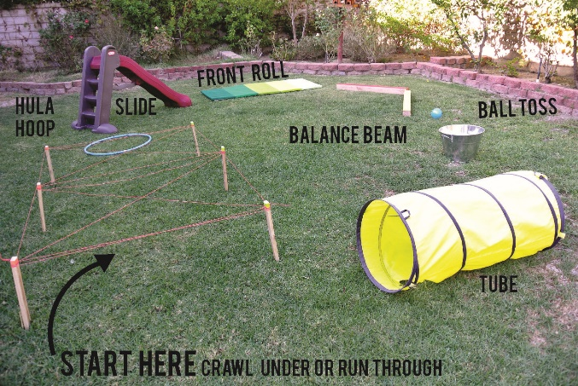  EXT: More to try:  Joe Wicks the body coach’s daily PE lessons:  https://www.youtube.com/user/thebodycoach1  Cosmic kids yoga has loads of different sessions to try:  https://www.youtube.com/user/CosmicKidsYoga  Try moving whilst learning with these videos:  https://www.bbc.co.uk/teach/supermovers/ks2-collection/zr4ky9q | Test attached.  Weekly spellings and lessons on the weekly spelling rule are attached.

Learning Activities
Year 3 2019-20

Self-isolation learning Week 13
Lessons set  Every child is expected to complete three pieces of learning per day. Most of what is listed below has been taught in school. This is for revision and will allow children to practise skills already learnt. Where new skills are being introduced, we will provide as much support as possible by means of videos, pictures and websites. Please do not hesitate to email the year 3 email address if you have any questions regarding the learning.  For every piece of learning completed to a good standard will be rewarded with 5HP.  Please share your hard work on Twitter and via email, we would love to see how you are all getting on! |  | Additional comments  Worksheets attached do not need to be printed. Use them to access questions matching LOs (learning objectives). They can be copied and written onto paper for children to complete.
Monday | Maths  Starter: 3 x table.  Sing: https://www.youtube.com/watch?v=dzVyBQ5uTbo  L.O. I can read scales to measure in litres and millilitres  Today we will be revising capacity.  Capacity is the amount of liquid a container can hold.  Remember millilitres are smaller than one litre. There are 1000 millilitres (ml) in 1 litre (L) 1000ml= 1L  Read through the explanation and have a go at the activity attached. You will need to read the scales carefully to identify how much water each contains.  Challenge: Worksheet attached. Work out what the increments are worth on each scale and identify how much water each contains.  Try a daily 10: https://www.topmarks.co.uk/maths-games/daily10  English (GPAS): Please complete the GPaS quiz attached.  Mark your work with an adult and see if there is anything you still need to work on.  SLOR: Read Chapters 7 and 8 of ‘The Travels of Ermine’ attached and complete activities also attached.  Task 1: L.O. To be able to answer questions about the text.  Task 2: L.O. To summarise events and make a prediction using evidence from the text. | Remember to play 10 garage games of TT Rockstars every week.  Worksheet attached.  Extension attached.  Quiz attached.  Remember to continue to read at least 3 times at home.  Story and activities attached.
Tuesday | Maths  Starter: 8 times tables  Sing: https://www.youtube.com/watch?v=z_BJjR9rdwA  Play: https://www.timestables.co.uk/8-times-table.html  L.O: I can add and subtract volume.  For each pair of jugs on the sheet, read the instruction and draw the new water level.  Task: Complete worksheets attached.  Try a daily 10: https://www.topmarks.co.uk/maths-games/daily10  English: LO: I can ask relevant questions to extend my understanding and knowledge.  Today you will need to think of at least 8-10 questions to ask a character from a book you have read or have been reading or you can think of questions to ask your parents/ grandparents about a European holiday they’ve been on. Next lesson you will be interviewing your parents about their holiday or they will need to pretend they are the character from the book, so make sure they’ve read it too!  Jigsaw: Wellbeing and kindness  Read through the slides attached and complete activities.  Task 1: Draw and write down how we can keep each of Laura’s body parts healthy.  Task 2: Create your own health hero, draw a picture of what they look like and write around your picture why they are a health hero. | Worksheets attached.  Slides and activities attached.
Wednesday | Maths:  Starter: 4 times tables  Play: Hit the button to practise your 4 times tables.  https://www.topmarks.co.uk/maths-games/hit-the-button  Sing: https://www.youtube.com/watch?v=UJY1_fzzM6Y  L.O. To be able to add amounts of money  Complete challenge 1 and 2 using the formal method of addition that you learnt at school and have been practising using during lockdown. If you need a reminder, watch the stage 3 video from the school website for a helpful tutorial:  https://www.swingate.medway.sch.uk/page/?title=Addition&pid=99  Try a daily 10:  https://www.topmarks.co.uk/maths-games/daily10  English – GPaS- Word families.  Word families are groups of words that have a root word that links them together.  This week you are learning about the ‘ou’ word family- house, our, you and your.  A lot of you always get ‘our’ and ‘are’ mixed up in your writing so this will be great practise to use the words in the correct context. Read the information and complete the activities attached.  Science: EXPERIMENT TIME!  L.O: I can carry out a germs experiment.  Today’s experiment is so much fun! It teaches you the importance of washing your hands at all times and how hand sanitizers and soap actually work.  Read the step by step instructions and complete the sheet attached in full sentences.  Extension: Once you have mastered how to do the experiment share with your family and friends! | Worksheets attached.  Slides and worksheet attached.  Slides and worksheet attached.
Thursday | Maths:  Starter: 8 times tables  Sing: https://www.youtube.com/watch?v=0X620IeUkYE  https://www.youtube.com/watch?v=kN3RG5iLKpo  L.O. I can subtract amounts of money to give change.  Task: Complete challenge 1 and 2 using the formal method of subtraction that you learnt at school and have been practising at home during lockdown. If you need a reminder, watch the stage 3 video from the school website for a helpful tutorial:  https://www.swingate.medway.sch.uk/page/?title=Subtraction&pid=100  Extension: Complete challenge 3 attached.  Try a daily 10:  https://www.topmarks.co.uk/maths-games/daily10  English:  L.O: I can ask relevant questions, listen and respond appropriately to adults.  Get your mics ready! Today you are taking on the all-important role of an interviewer! Make sure you dress smartly and have a camera at the ready to film it!  Remember at the beginning to introduce yourself.  For example: “Good morning, I am Joe Bloggs and today we have invited Mr Jack Bloggs to answer some vital questions about his trip abroad. How are you Jack?” ….etc. Then you can start asking your questions.  If they don’t answer in enough detail, remember you can ask them to explain further or elaborate more.  Topic:  L.O: I can create a poster for a chosen European country.  Today, you are going to create an informative poster about any European country of your choice that you have researched or know about. This poster should persuade people to want to go and visit that country.  Things you should include:  -Capital city  -Flag  -Landmarks to visit  -Famous food/dishes  -Famous festivals  -Cultural dress  Think about how you are going to set it out, maybe do a rough plan first. You must also ensure your poster is colourful, eye-catching and clear to read- don’t squash up your writing.  Extension: Can you find out 2 different ways to get to that country and add it your poster? For example- car/ferry/aeroplane and include the time it would take and how much it might cost. | Worksheet attached.  Extension attached.  Information attached.
Friday | Maths:  Starter: 8 times tables  Play: https://www.topmarks.co.uk/times-tables/coconut-multiples  L.O. Arithmetic test  Task: Complete the two arithmetic tests attached. You will notice that the questions start off easy compared to last week but they will get harder. Please mark your tests together with an adult.  Note to parents: Please be advised that these tests are designed to assess Year 3 skills that pupils should have secured earlier in KS2.  Extension: Find out what you still need to work on, what you still find tricky. Identify where you went wrong. Ask an adult to help you with the method, remember there are videos on our school website that show you how to calculate using the different methods. Practise adding, subtracting, multiplying and dividing because these are always easy marks to get on a test and you will thank yourself later on in years 4, 5 and 6 when you master these methods!  Try a daily 10:  https://www.topmarks.co.uk/maths-games/daily10  English: Spellings  Weekly homework spellings are attached. Remember to write the spellings into sentences once you have confidently learnt them.  Weekly spelling rule 13 - Contractions: Complete the activities attached once you have read through the explanations.  PE: Outdoor adventurous activity  L.O. I can follow instructions.  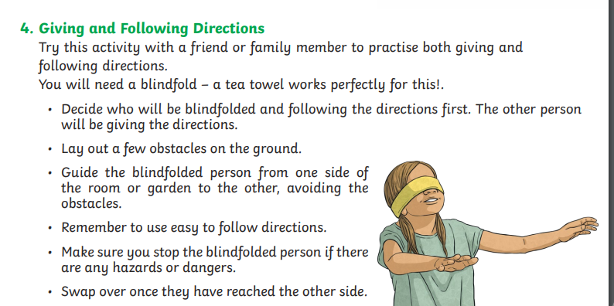  EXT: More to try:  Joe Wicks the body coach’s daily PE lessons:  https://www.youtube.com/user/thebodycoach1  Have a marvellous weekend! | Tests attached.  Weekly spellings and lessons on the weekly spelling rule are attached.

