

Learning Activities
Year 3
2019-20
Self-isolation learning
Week 11 (Worksheets)
Monday
Maths: Practise 3 times tables and counting in tenths English (GPAS): Prepositions
SLOR: The Travels of Ermine (Chapter 5)

Tuesday
Maths: Practise 4 times tables and comparing fractions English: Planning a fable
Jigsaw: Achievements in lockdown

Wednesday
Maths: Practise 4 x tables, + and – fractions English (GPAS): Paragraphs
Science: Working scientifically – Design a rocket

Thursday
Maths: 8 times table practise, finding fractions of amounts English: Write a fable
Topic: Physical features of geography in Europe

Friday
Maths: 8 times table practise and arithmetic test English: Spellings
PE: Walk a mile

Monday 22nd June - Maths:

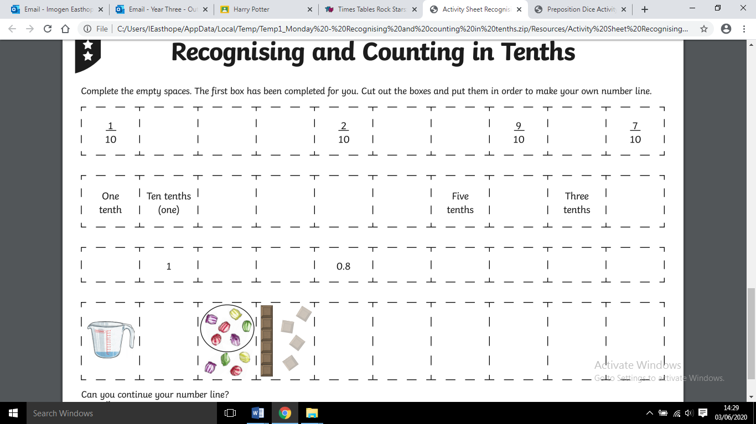
Monday 22nd June - GPaS:
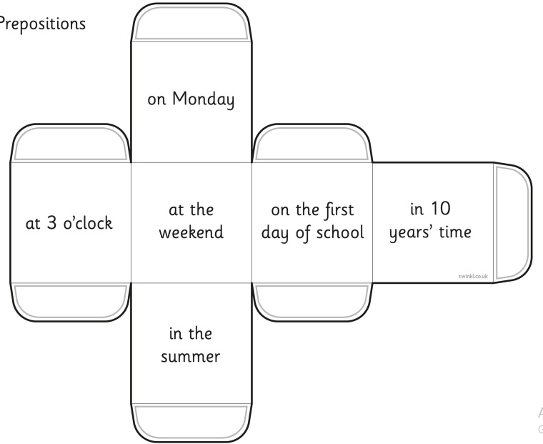

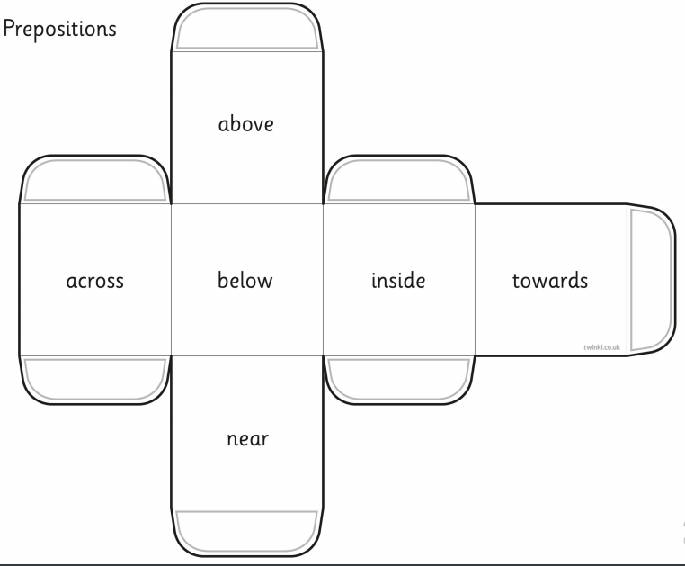

Monday 22nd June - SLoR:

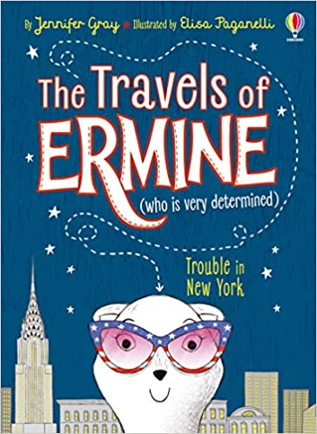
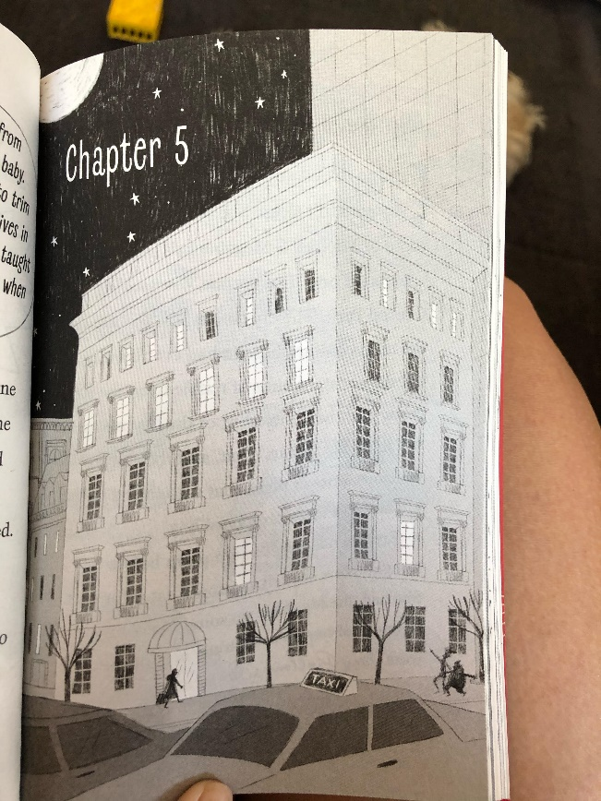

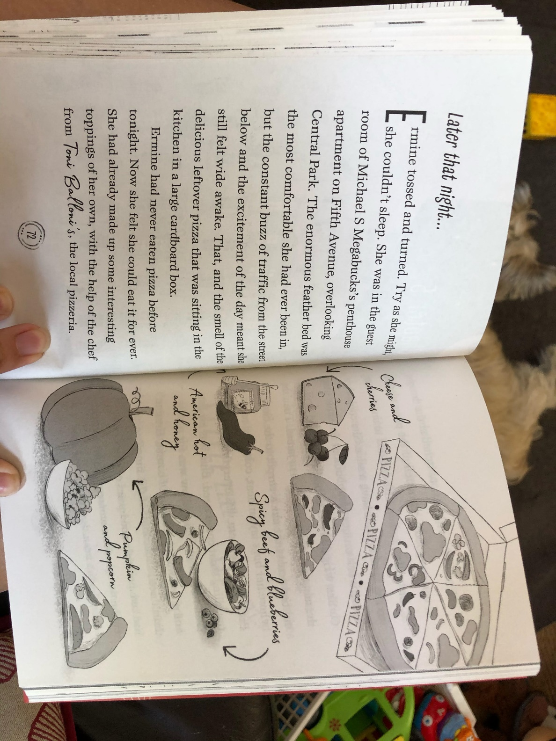
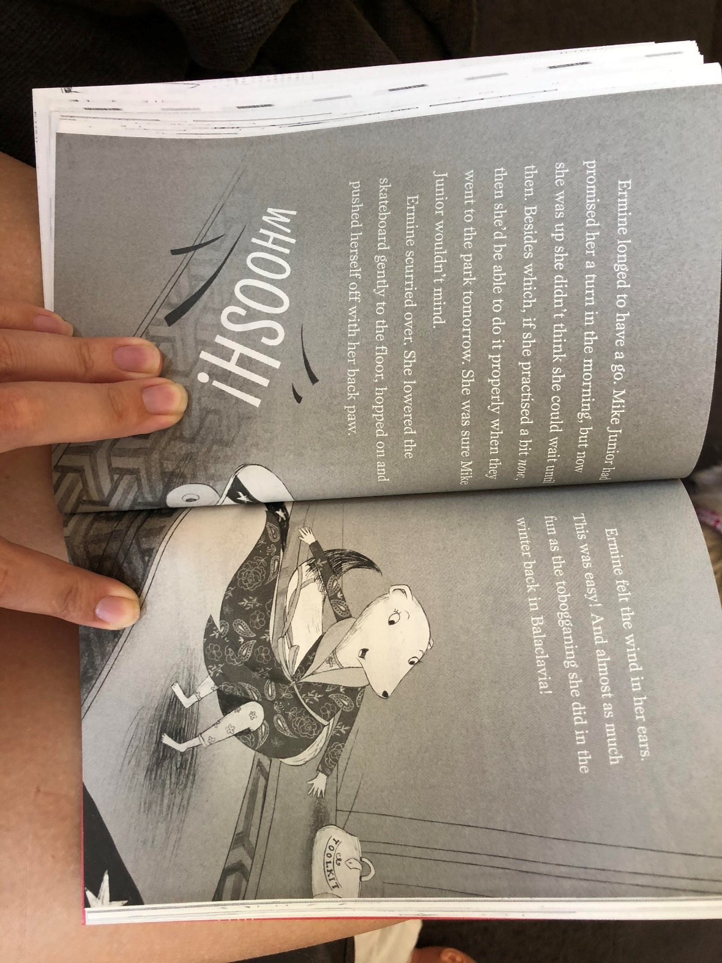
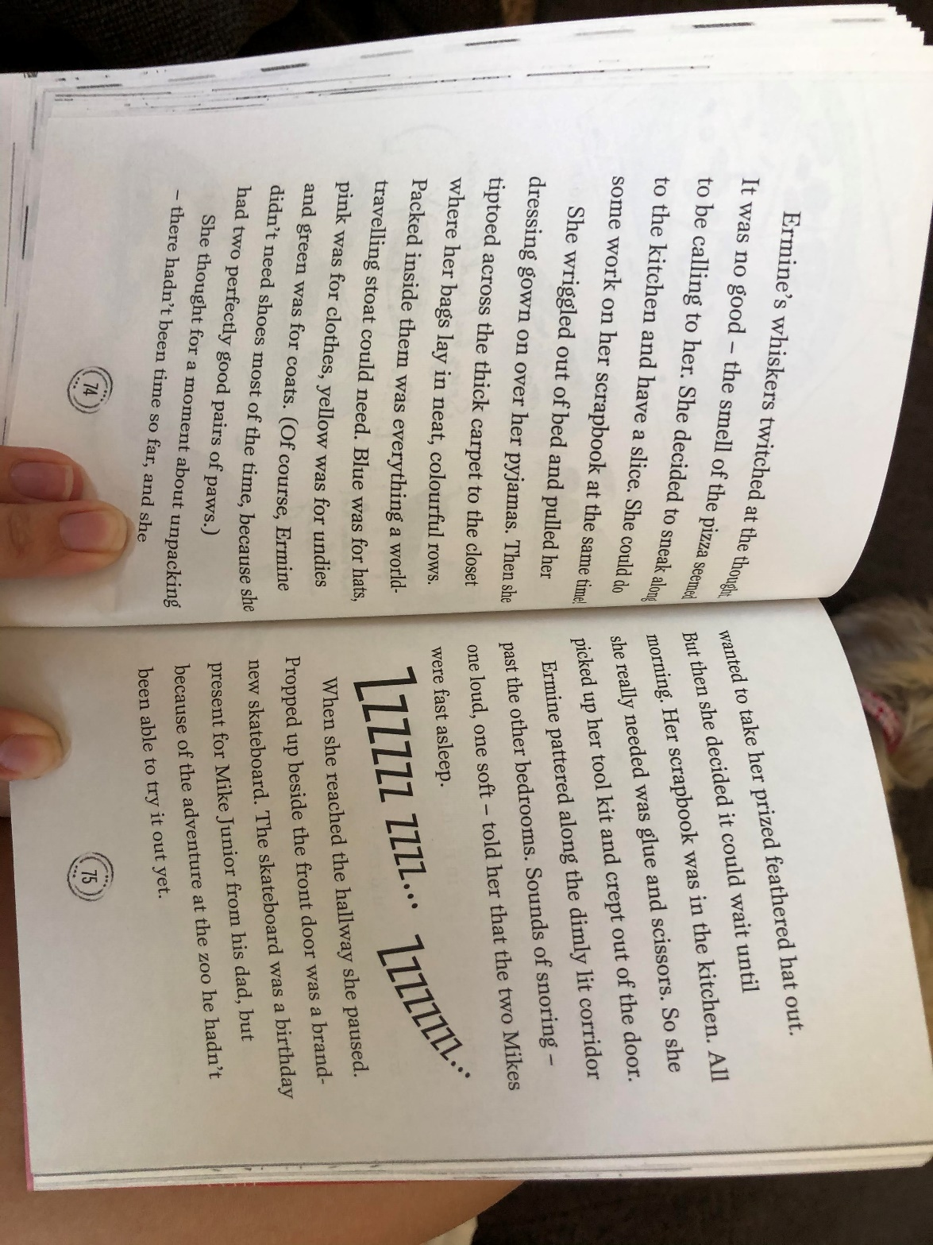
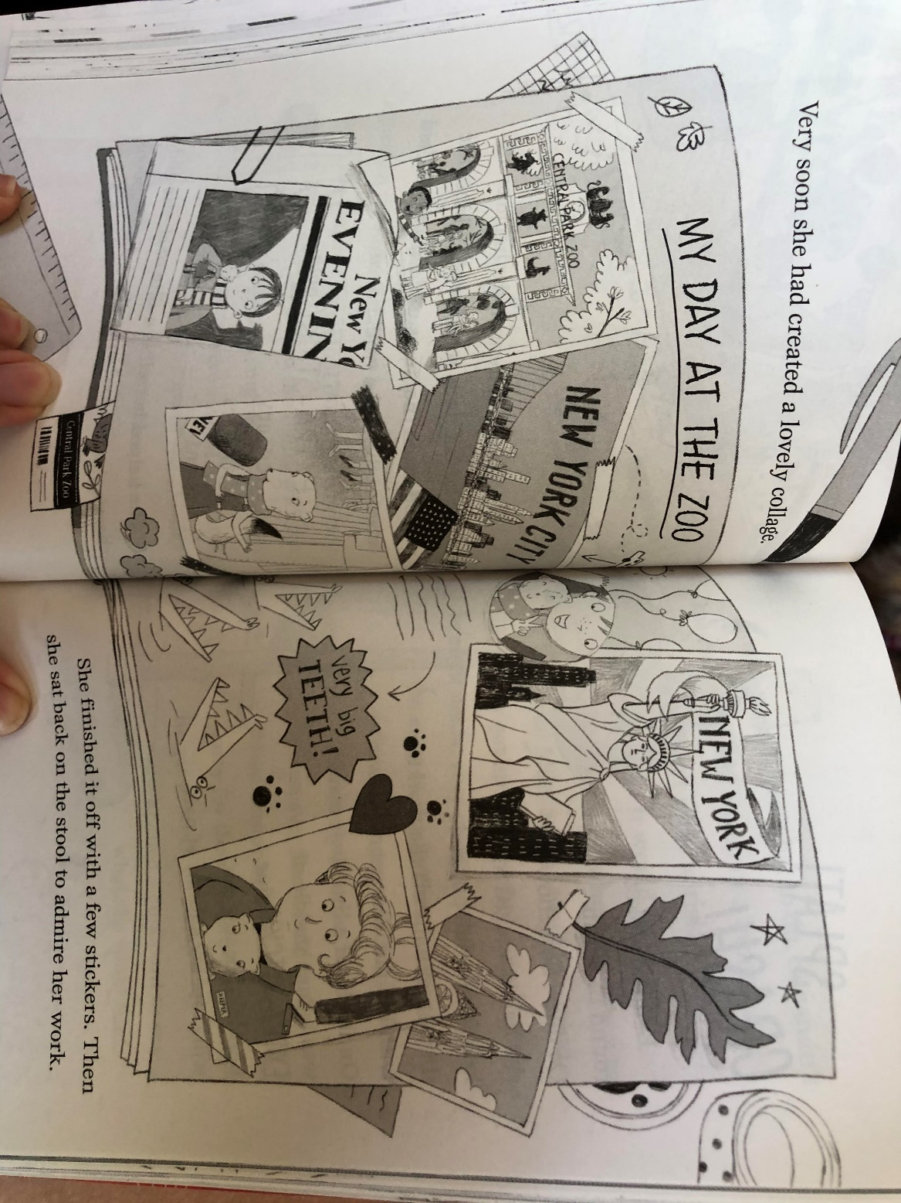
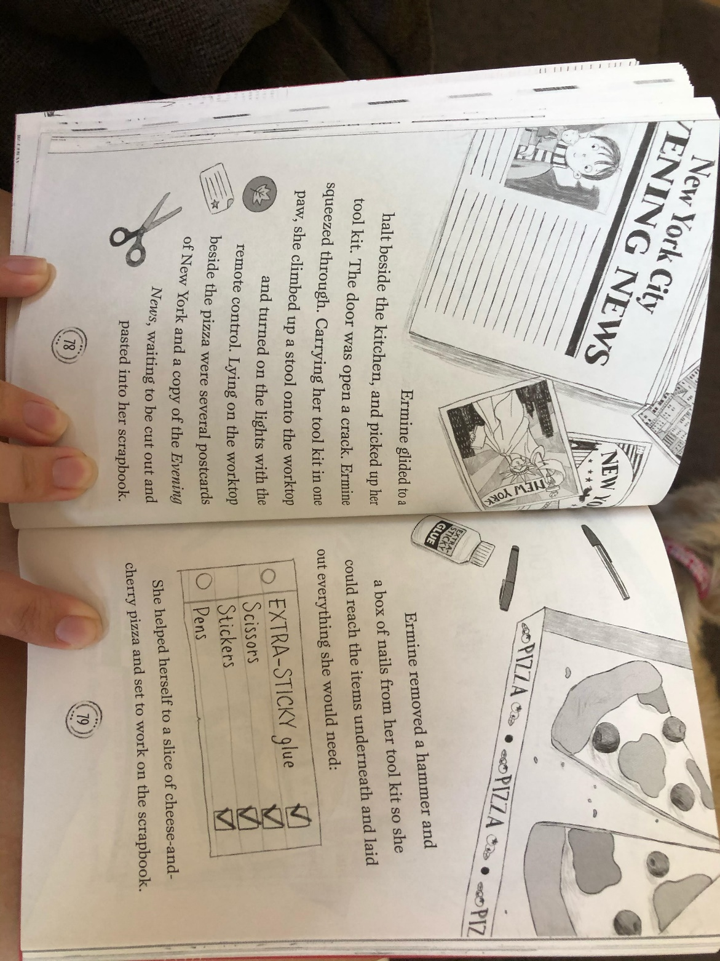
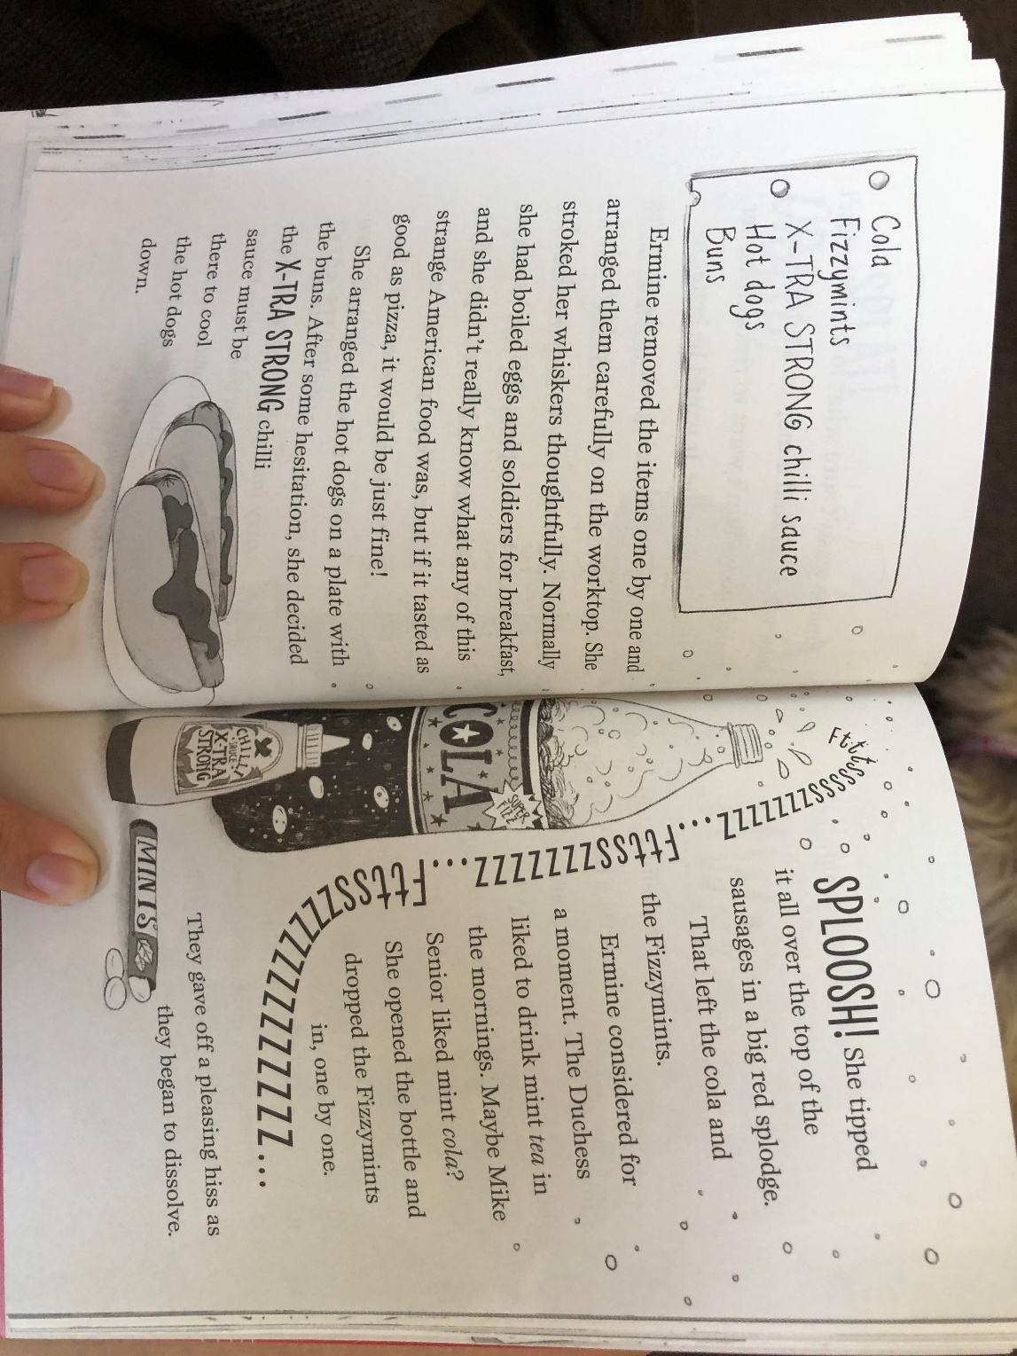
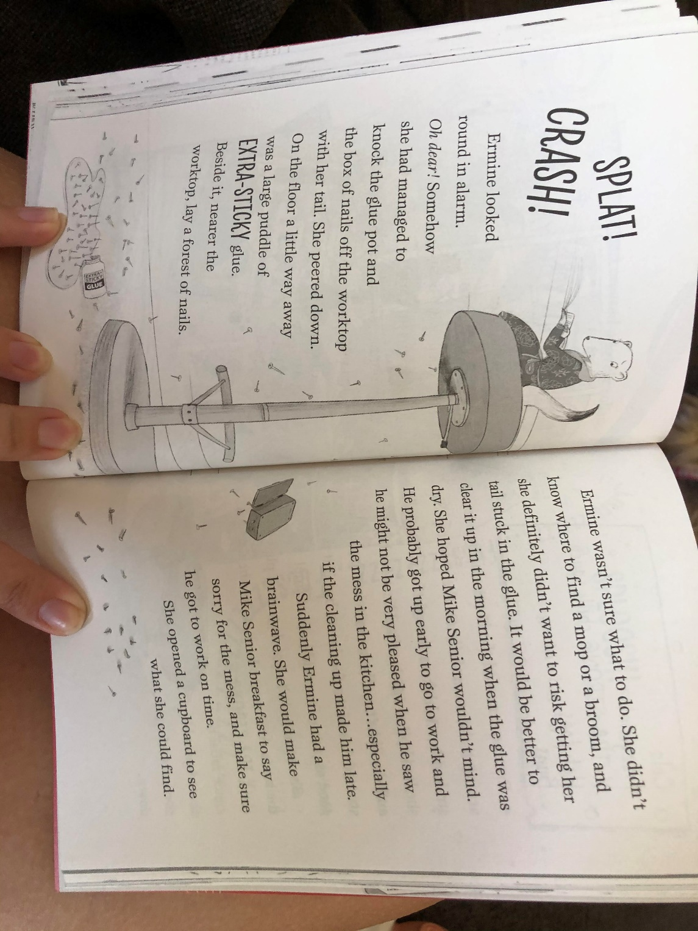
TASK ONE
Knowledge: Name the two reasons that Ermine is unable to sleep.

Comprehension: Why do you think that Ermine decides to complete some of her scrapbook? How might that help her in her current situation?

Apply: If you were Ermine, what would you have done when you made the mess on the floor?

Analysis: How do you think Ermine feels when she makes the mess all over the floor?

Evaluation: Do you think that Mike Senior will be happy with his breakfast in the morning? Explain your answer.

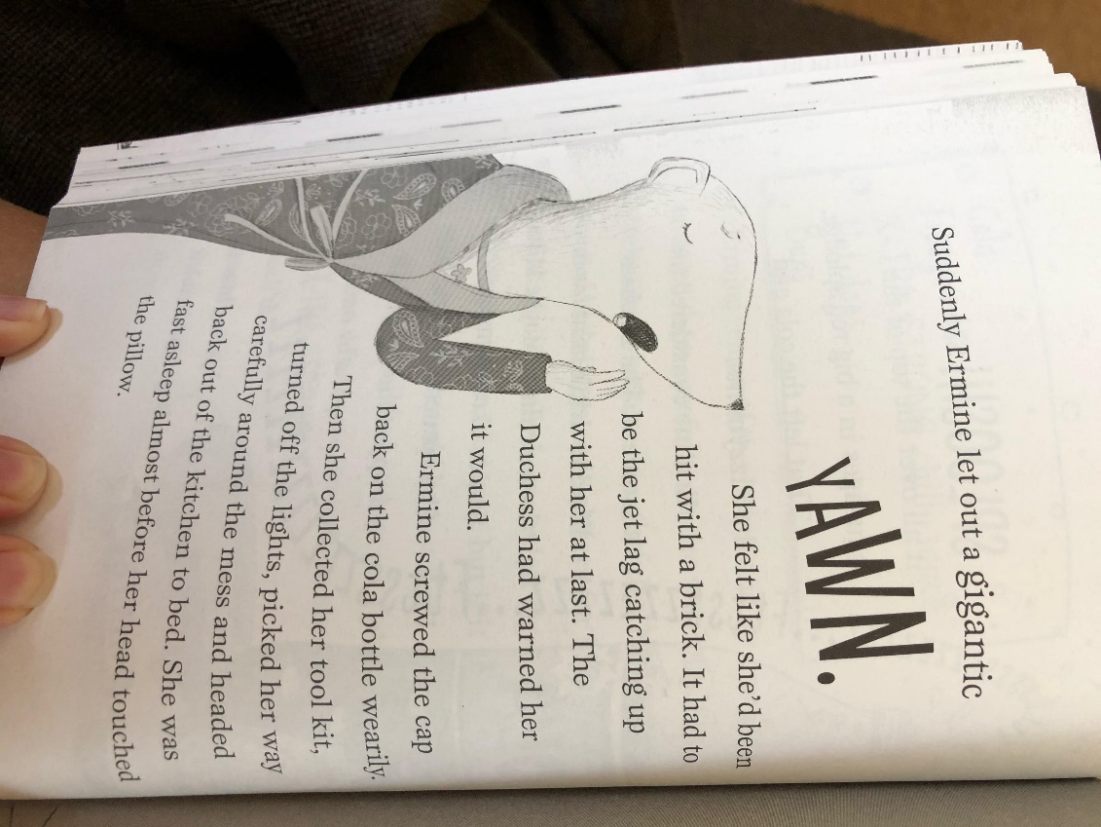

TASK ONE - ANSWERS
Knowledge: Name the two reasons that Ermine is unable to sleep.
The traffic outside and the exciting day.
Comprehension: Why do you think that Ermine decides to complete some of her scrapbook? How might that help her in her current situation?
She can’t sleep so maybe doing her scrapbook will make her feel tired and help her to sleep.
Apply: If you were Ermine, what would you have done when you made the mess on the floor?
I might have left the glue to dry but collected up the nails to protect Mike Senior’s feet in the morning. (or any other relevant answer)
Analysis: How do you think Ermine feels when she makes the mess all over the floor?
I think she feels guilty because she wants to do something for Mike Senior to say that she’s sorry.
Evaluation: Do you think that Mike Senior will be happy with his breakfast in the morning? Explain your answer.
I think he’ll appreciate the thought that Ermine put into the breakfast but he’ll think it is horrible because the hotdogs will be too spicy and the Cola will be minty. (or any other relevant answer)

TASK TWO

Go through the text and identify words that you are not familiar with/ don’t know the meaning of. Use a dictionary to find the meaning of the words. You can use online dictionaries if you do not have a dictionary at home.

Example:

penthouse - a flat on the top floor of a tall building, typically one that is luxuriously fitted.

Tuesday 23rd June - Maths:

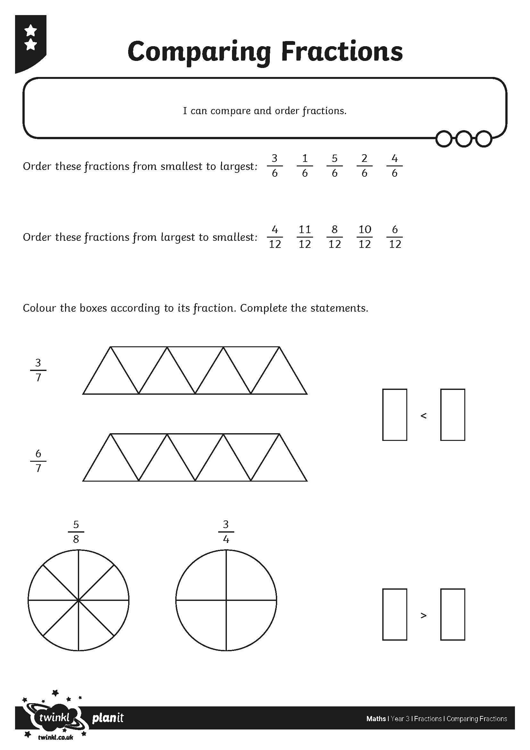
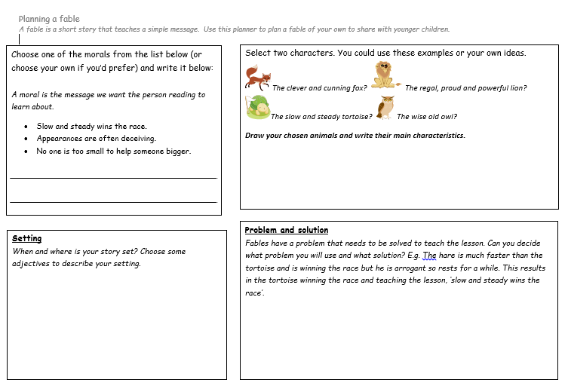
Tuesday 23rd June - English
Tuesday 23rd June - Jigsaw Task 1:

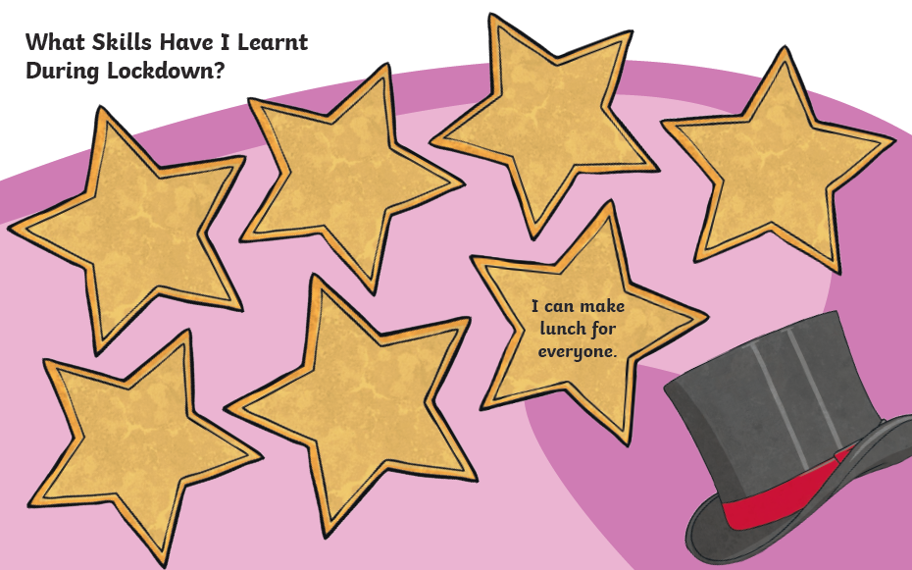

Tuesday 23rd June - Jigsaw Task 2:

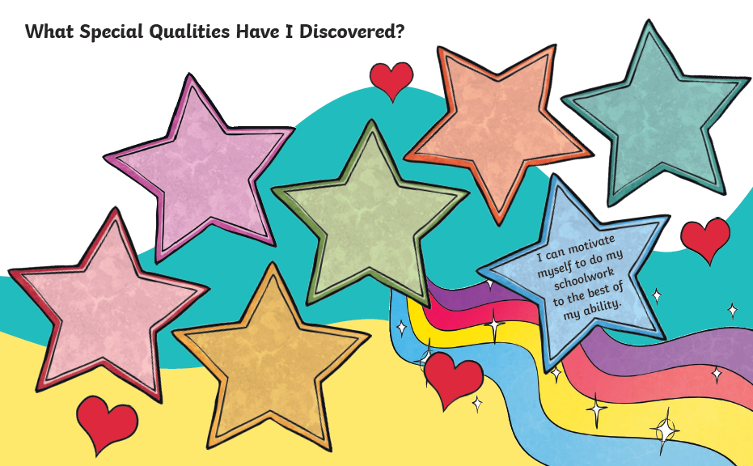

Wednesday 24th June – Maths (mild):
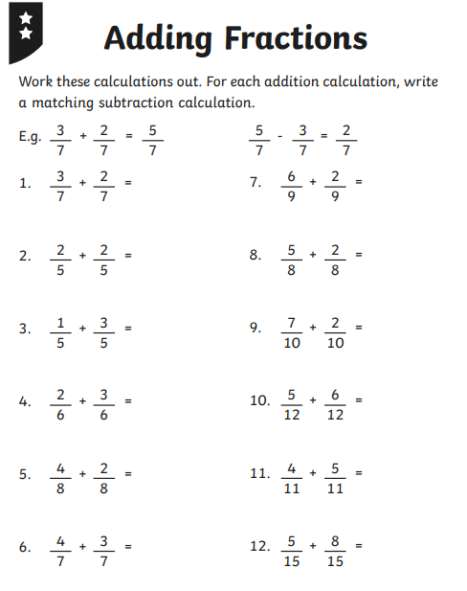

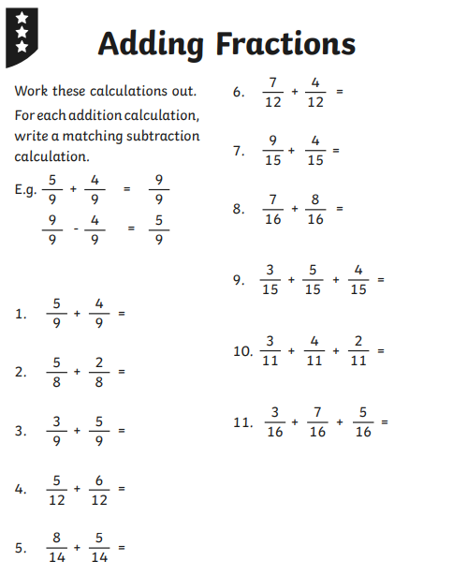
Wednesday 24th June - Maths (hot/spicy):

Wednesday 24th June – English (paragraphs):
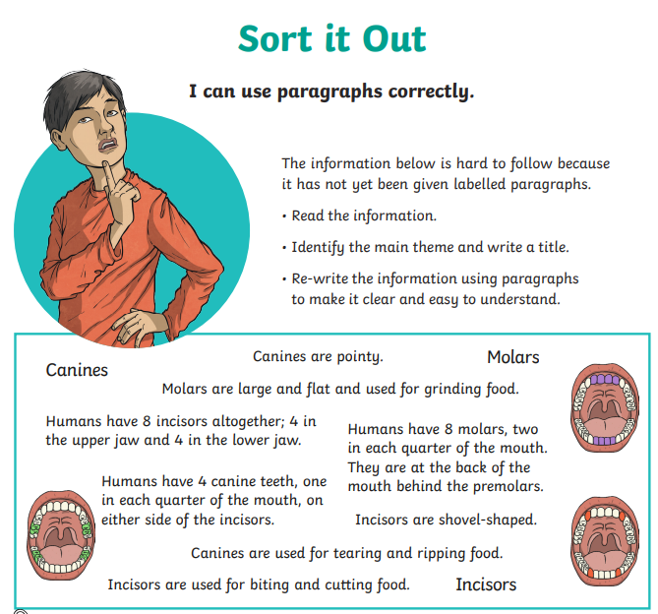

Wednesday 24th June - Science:

LO: To be able to think of ways of answering a question.
SC: I can identify what the task is.
I can suggest ideas for how to complete the task.

How can a rocket be made that will fly at least three metres?

Equipment
- A 2l bottle
- A cardboard tube
- A piece of A4 paper
My design

Method
1._____________________________________________________________________________________________________________________________________________ 2._____________________________________________________________________________________________________________________________________________
3._____________________________________________________________________________________________________________________________________________ 4._____________________________________________________________________________________________________________________________________________
Evaluation

When I launched my rocket

Thursday 25th June – Maths

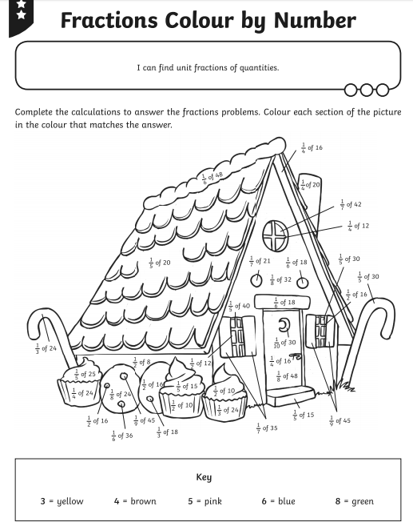

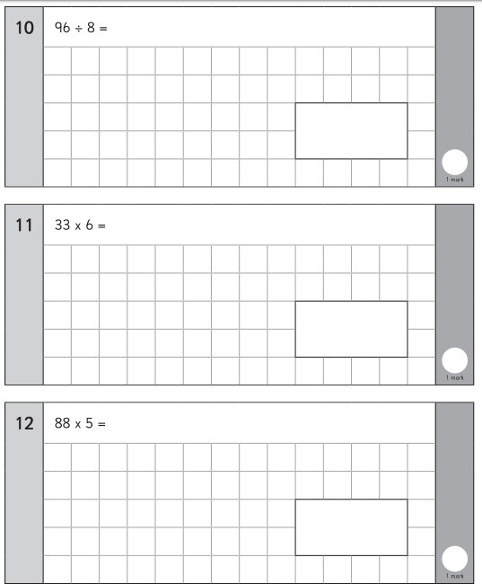
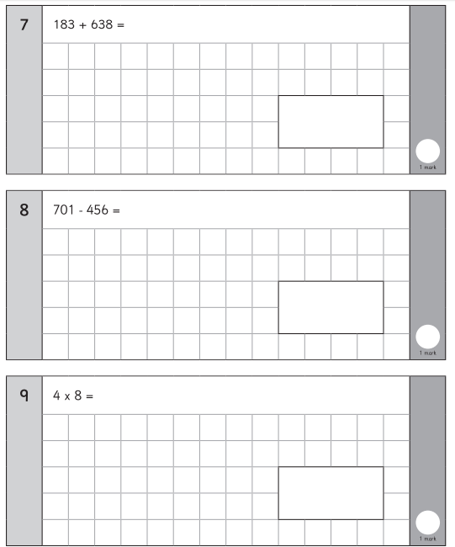
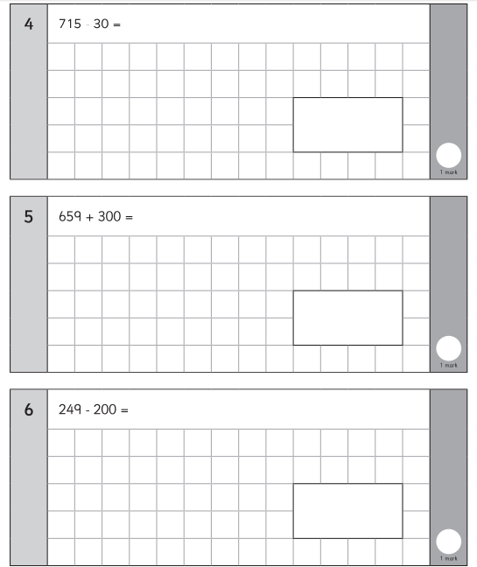
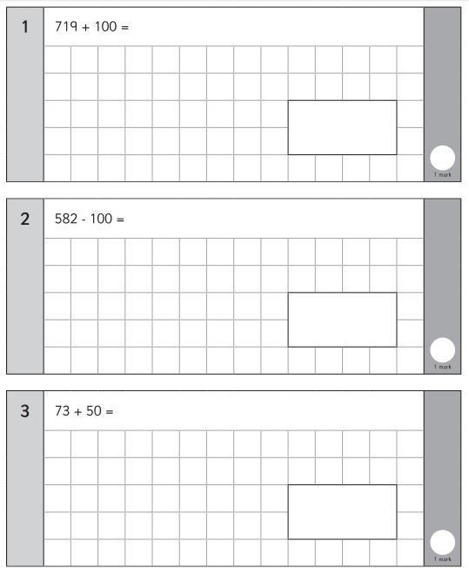
Friday 26th June - Maths:

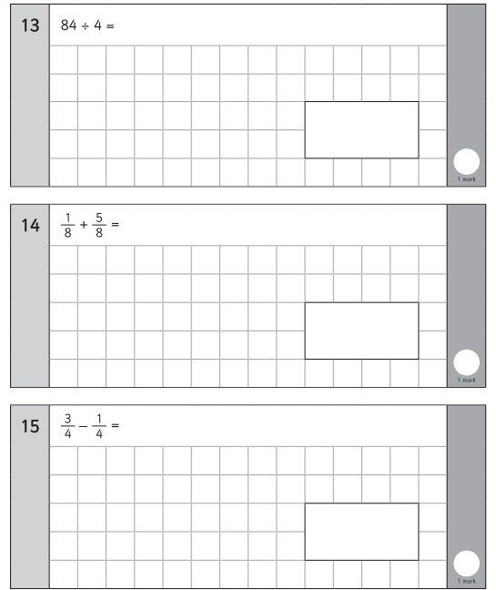

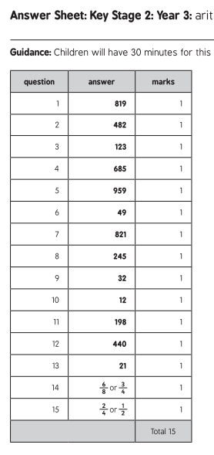

Week 11 Spellings:

Suffix - ful
peaceful
helpful
painful
delightful
careful
thoughtful
truthful
beautiful

MILD
Words with the au sound
sauce
pause
fault
haunt
launch
August

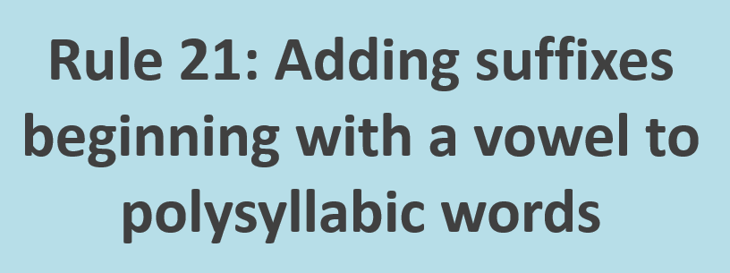

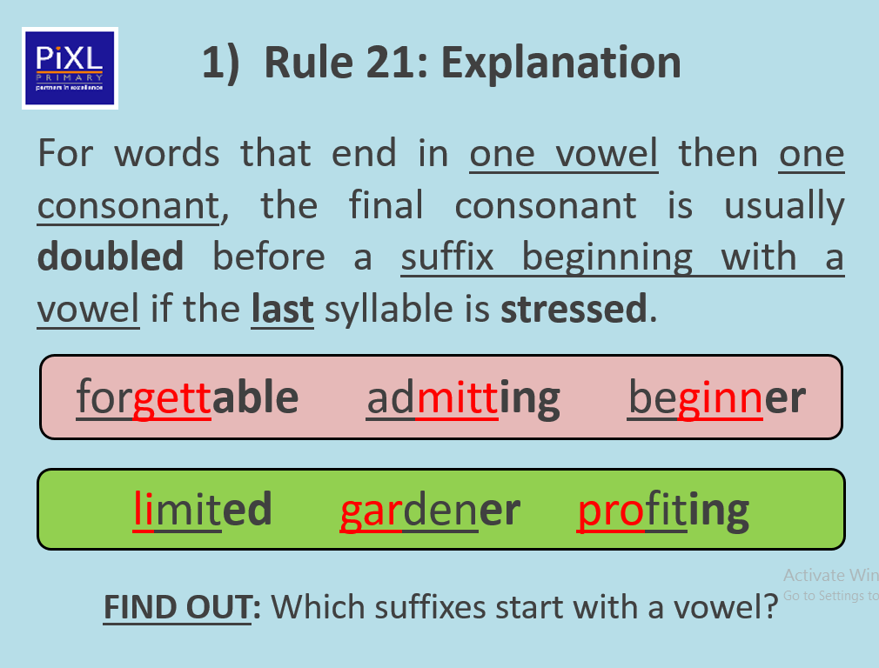

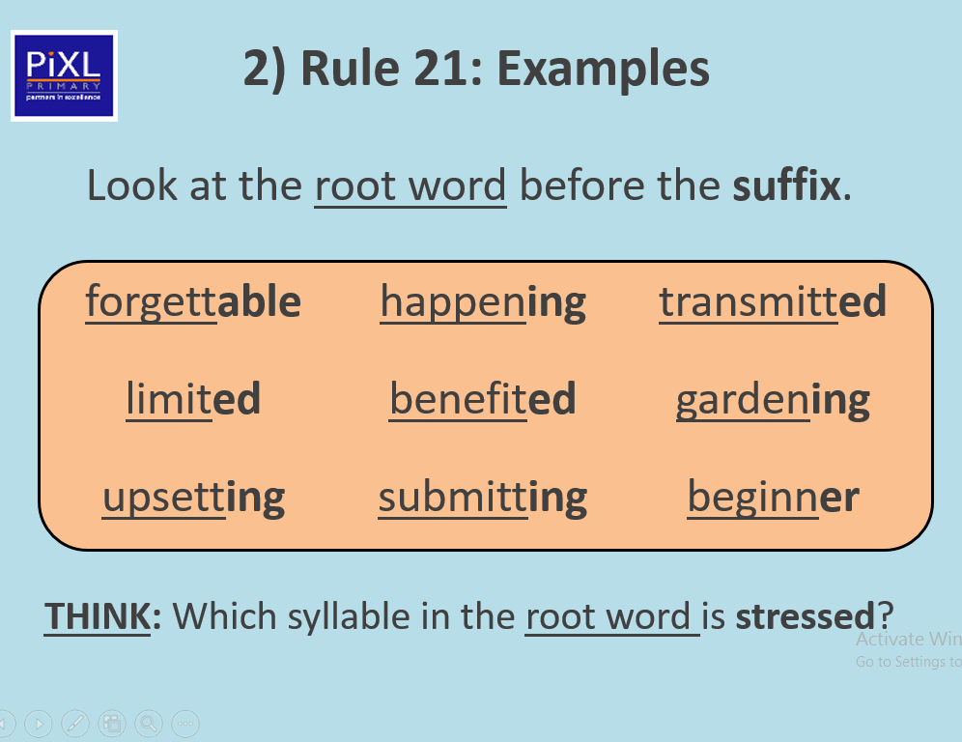
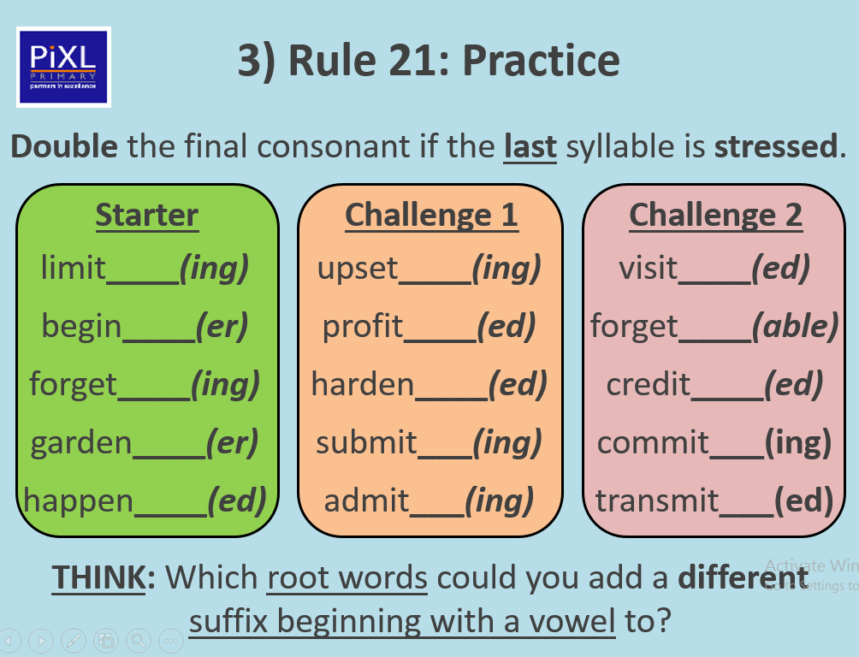
ACTIVITY ONE

ACTIVITY TWO – Choose three words from each column and put them into nine different sentences.



