

Learning Activities
Year 3
2019-20
Self-isolation learning
Week 10 (Worksheets)

Monday
Maths: Time English (GPAS): Determiners
SLOR: The Travels of Ermine (Chapter 4)

Tuesday
Maths: Time English: Creating a poster to advertise your play
Jigsaw: E-Safety

Wednesday
Maths: Time English (GPAS): Quiz
Science: Observation lesson

Thursday
Maths: Time English: Role-play
Topic: Locating different European countries

Friday
Maths: Time English: Spellings
PE: Learn flamenco and salsa dancing

Monday 15th June - Maths Starter:
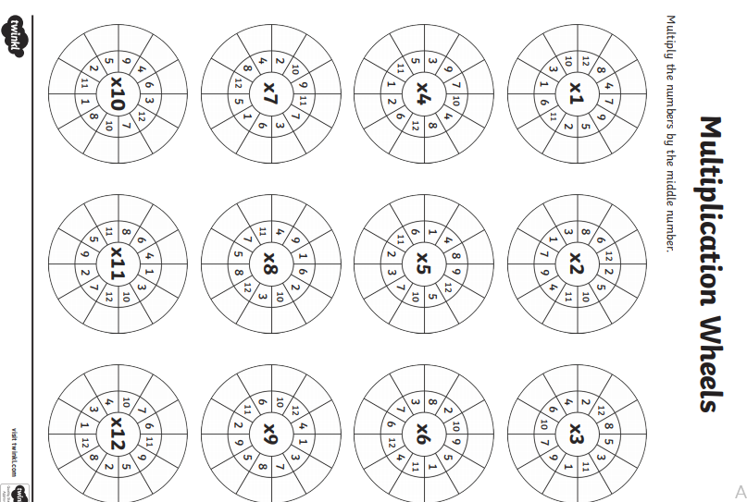

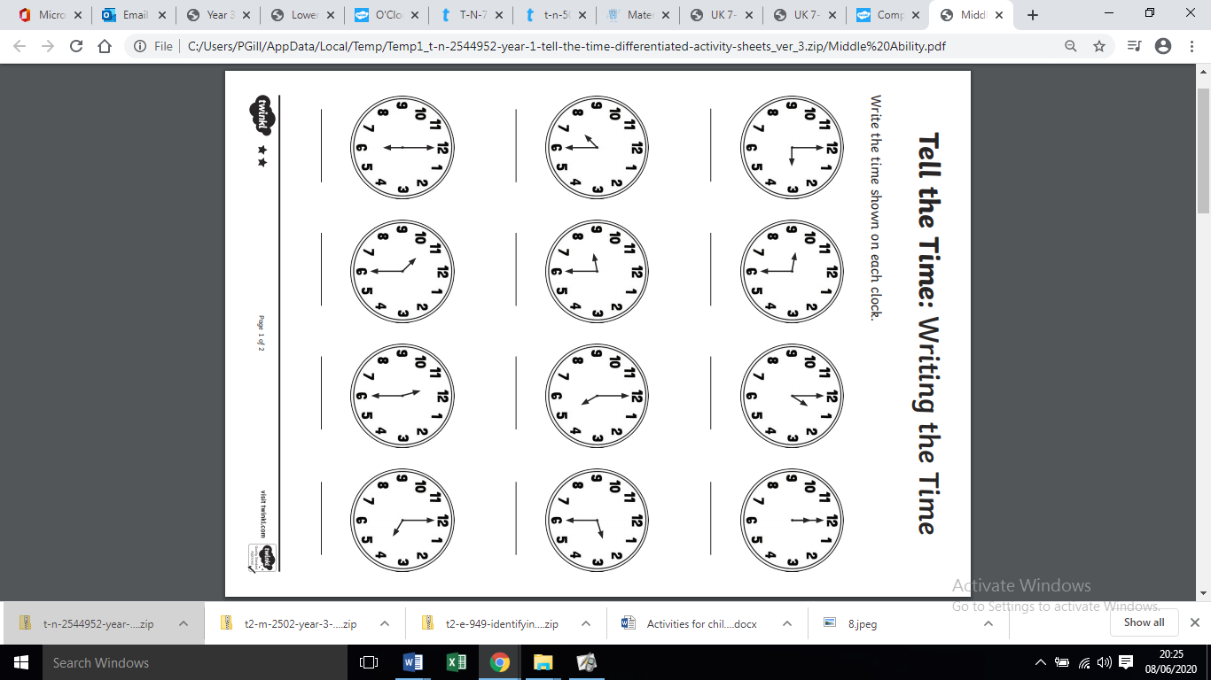
Monday 15th June – Maths Activity 1:

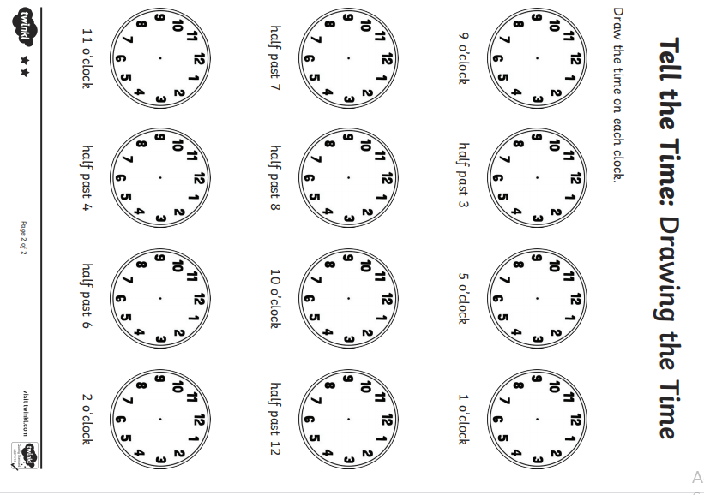
Monday 15th June - Maths Activity 2:

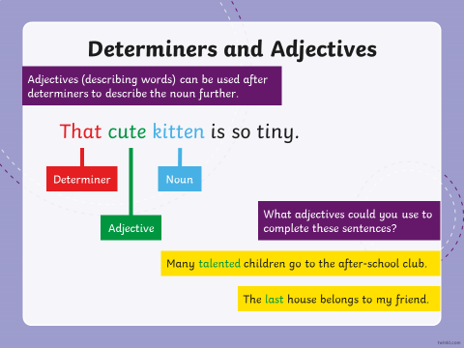
Monday 15th June - GPaS explanation of determiners:
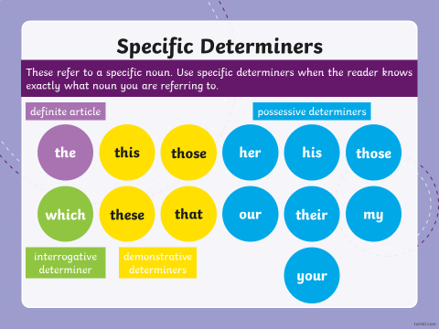
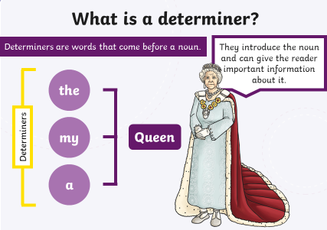

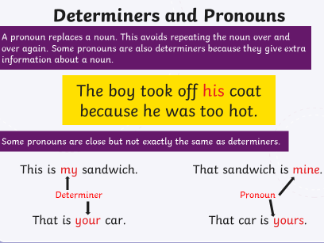

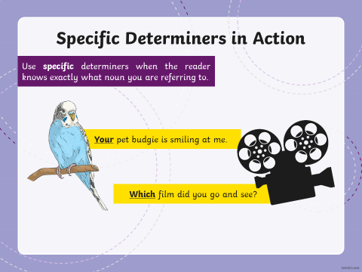

Monday 15th June – GPaS activity
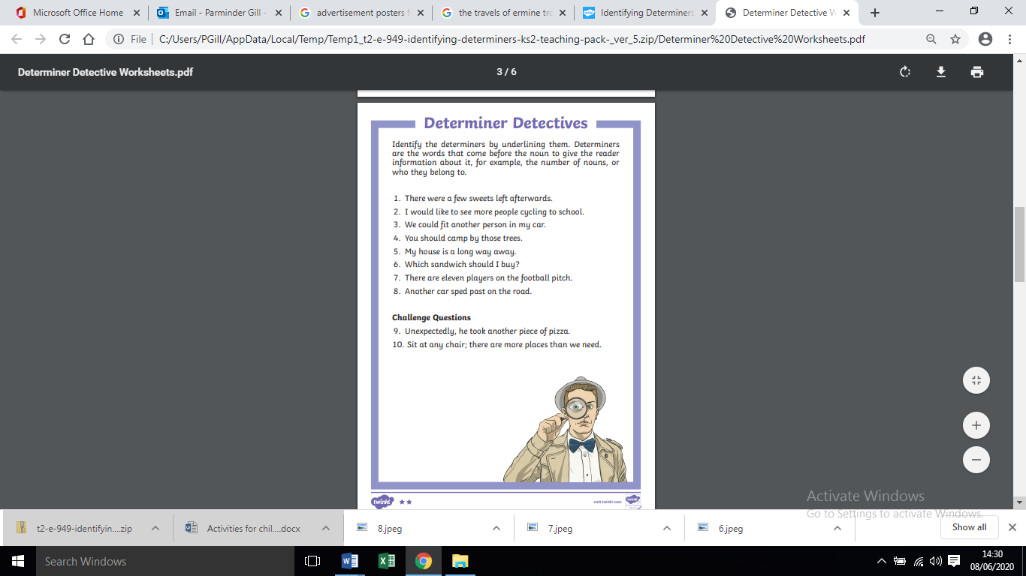

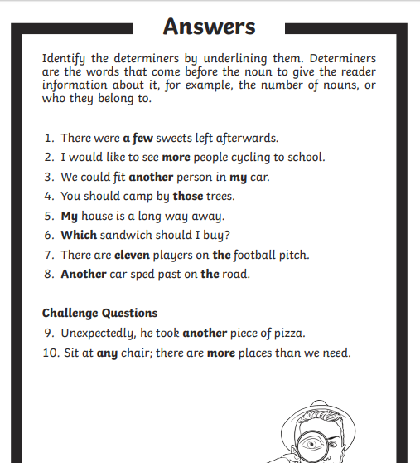
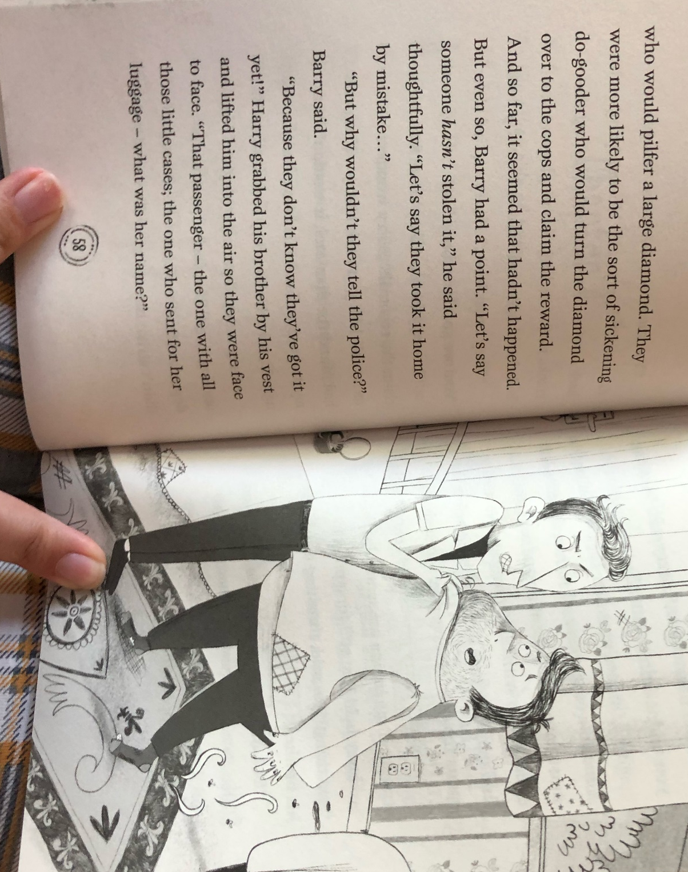
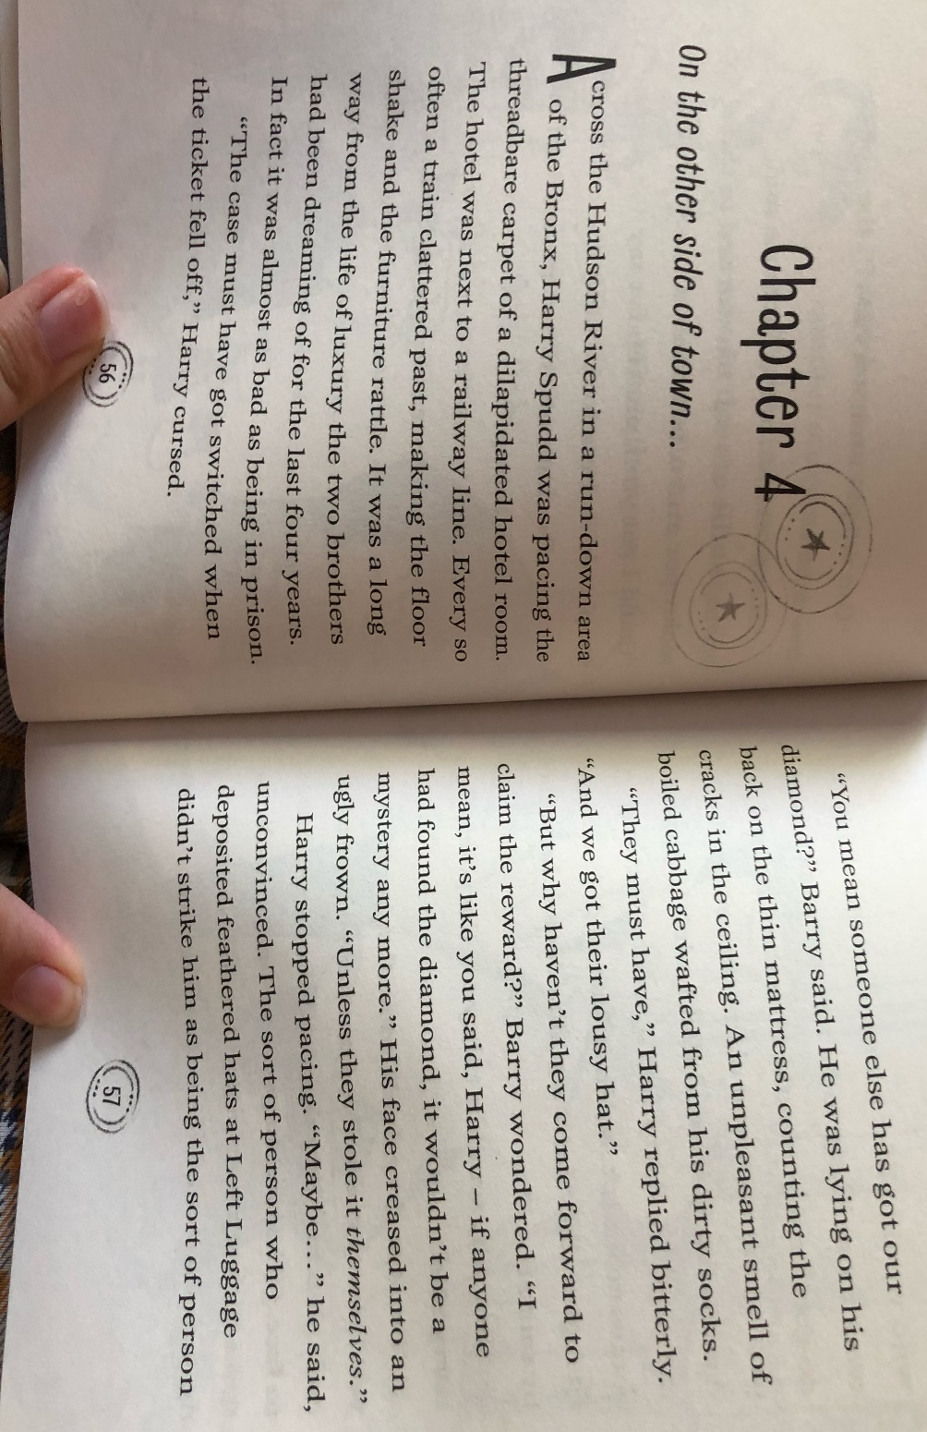
Monday 15th June - SLOR:

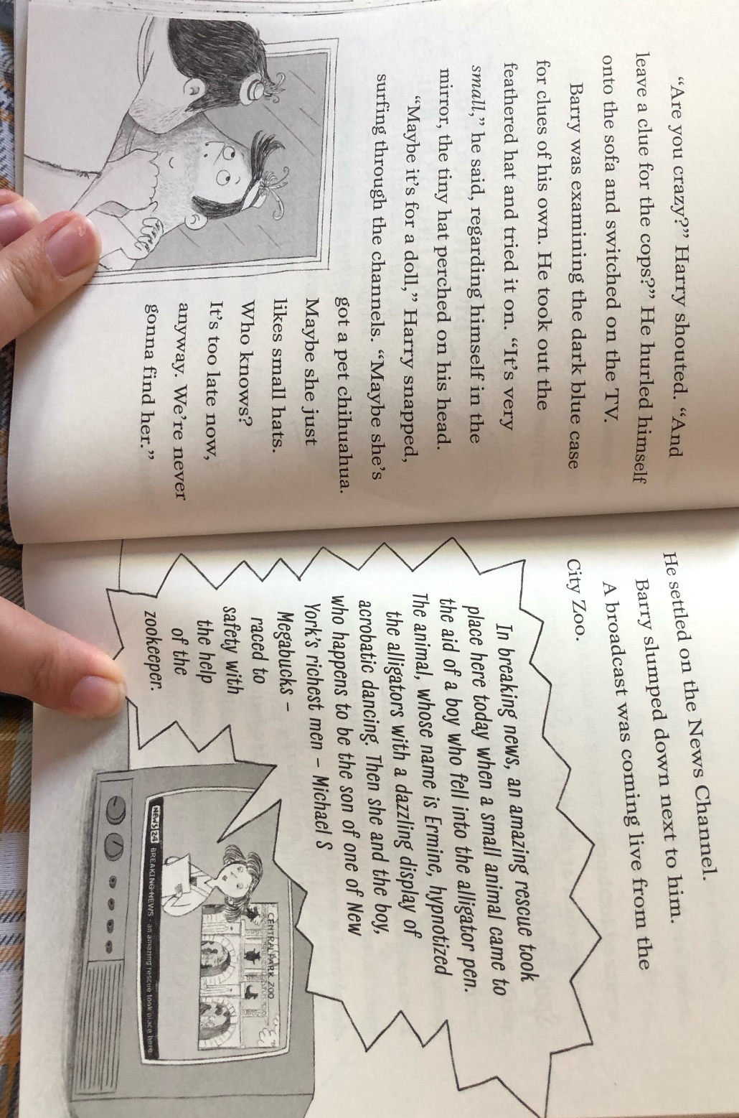
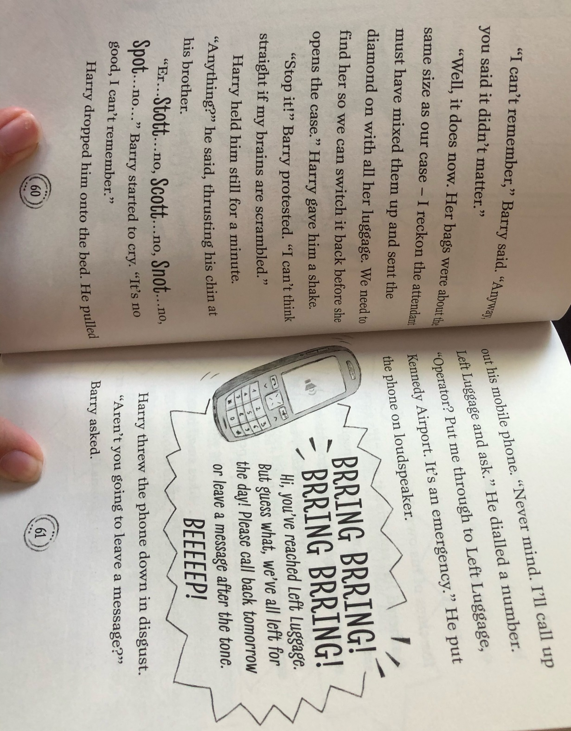
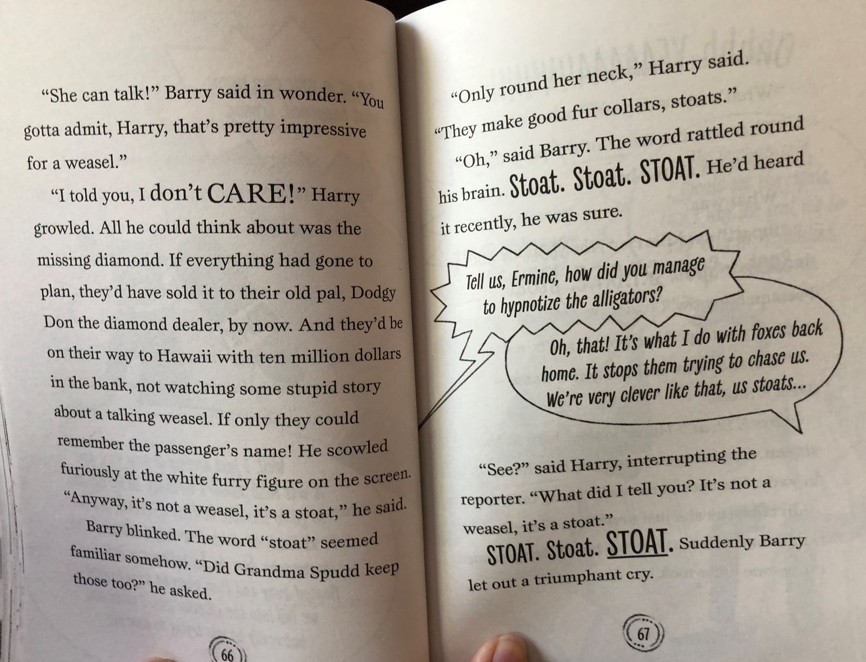
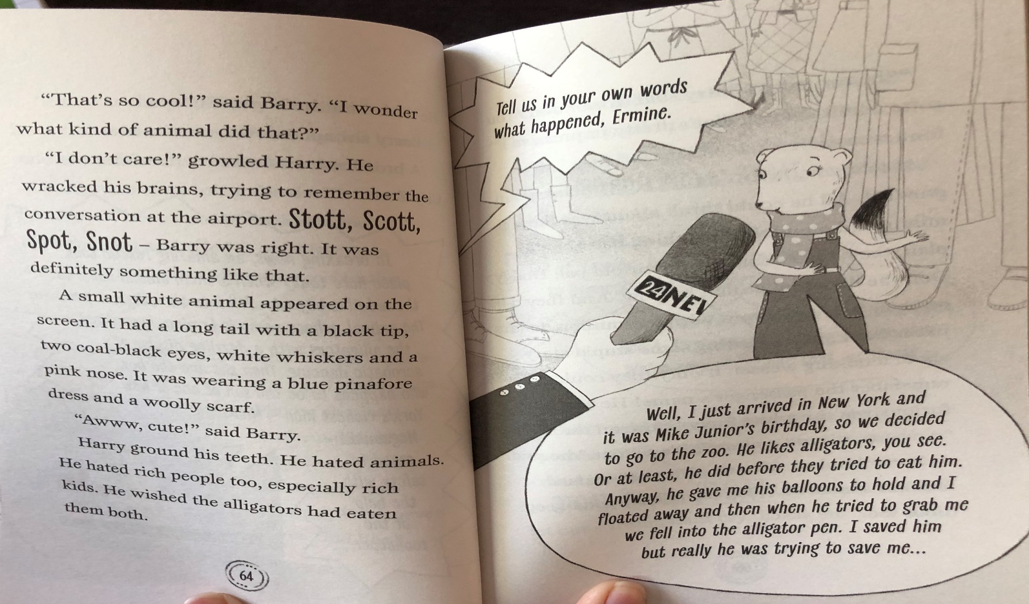
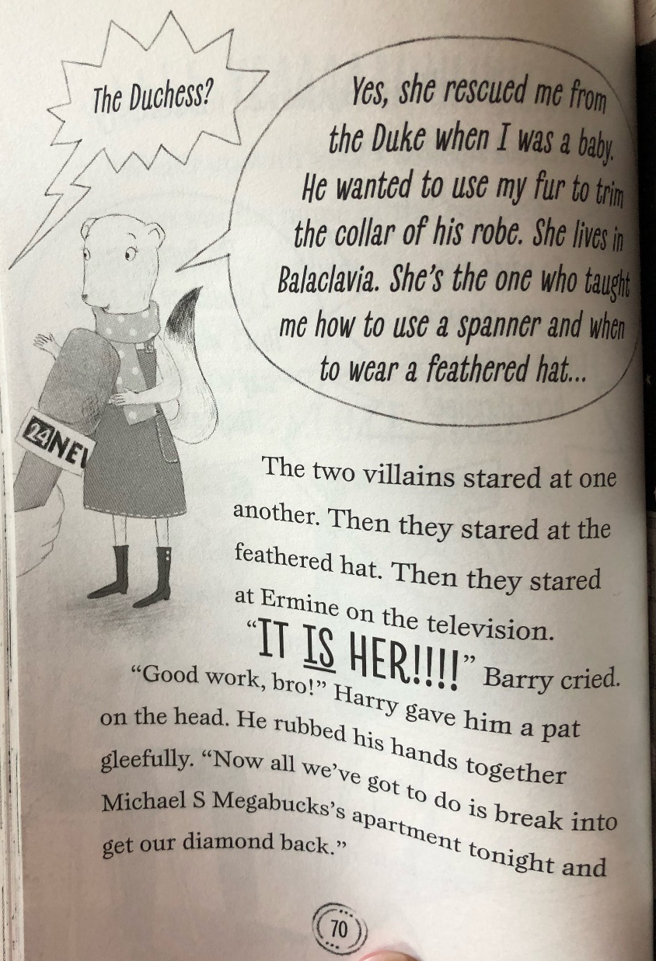
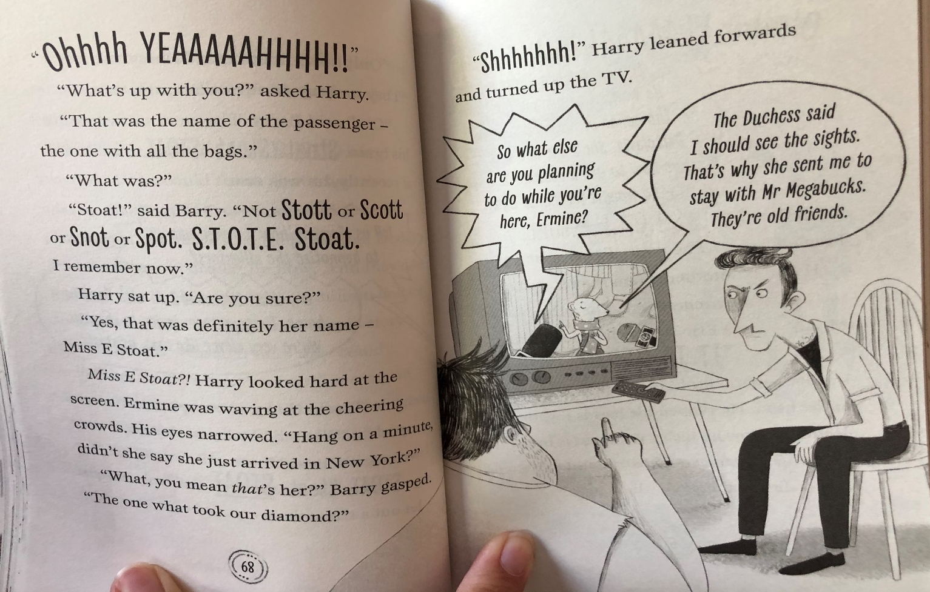
TASK ONE

Knowledge: Why was Harry Spud pacing around the dilapidated hotel room?

Comprehension: How would you describe Harry or Barry’s personality?

Apply: If you were Barry, how would you advise your brother Harry on how to get the diamond back?

Analysis: Why do you think an ‘unpleasant smell wafted from Barry’s feet?’

Evaluation: Do you think that Harry and Barry will be successful in breaking into Michael S Megabucks’ apartment and stealing the diamond? Explain your answer.
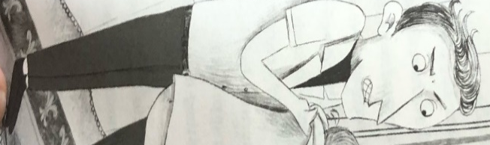
TASK TWO
Create a ‘Role on the wall’ for a character of your choice.
You can refer to previous chapters to find more information about their personality.
First draw a picture of your chosen character. Then list adjectives around your picture to describe their personality using evidence from the text. See example below:

Harry is quite mean and
aggressive towards his
brother because in the text
it says he shook him and
threw him onto the bed.

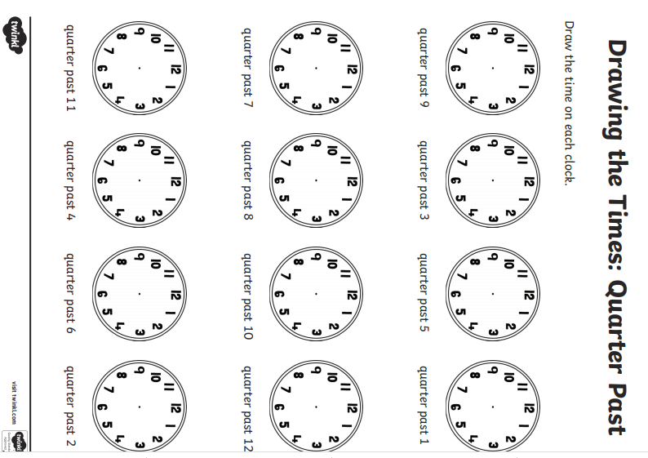
Tuesday 16th June - Maths

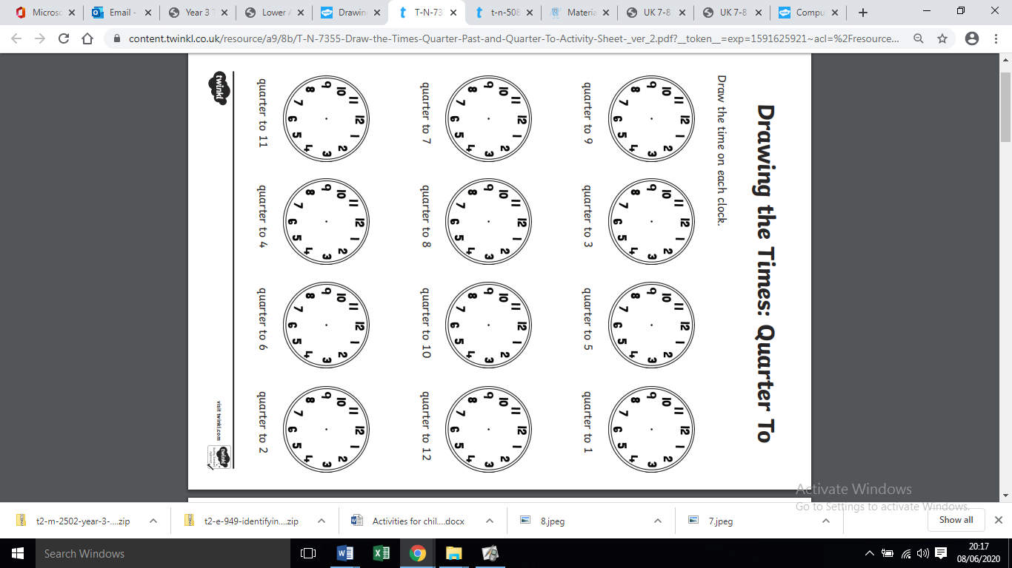
Tuesday 16th June - Maths


Tuesday 16th June - English


Remember to include:
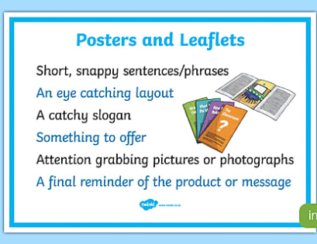

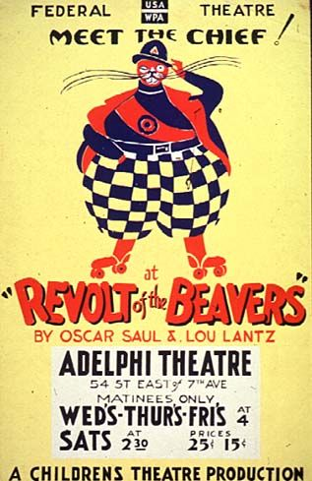

Tuesday 16th June - Jigsaw: E-safety
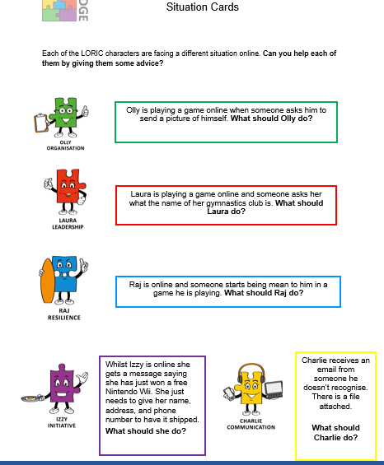

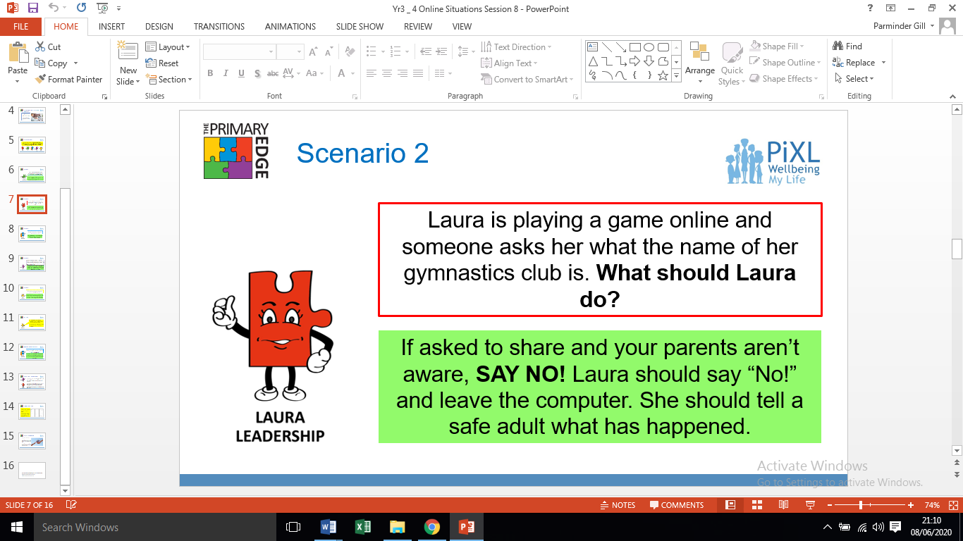
Answers
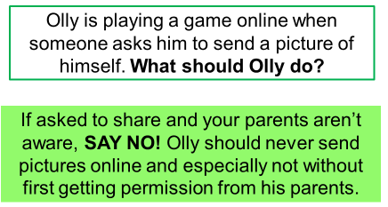

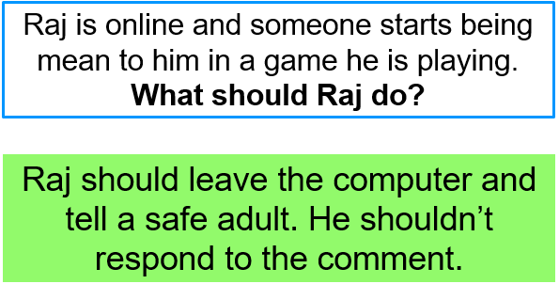

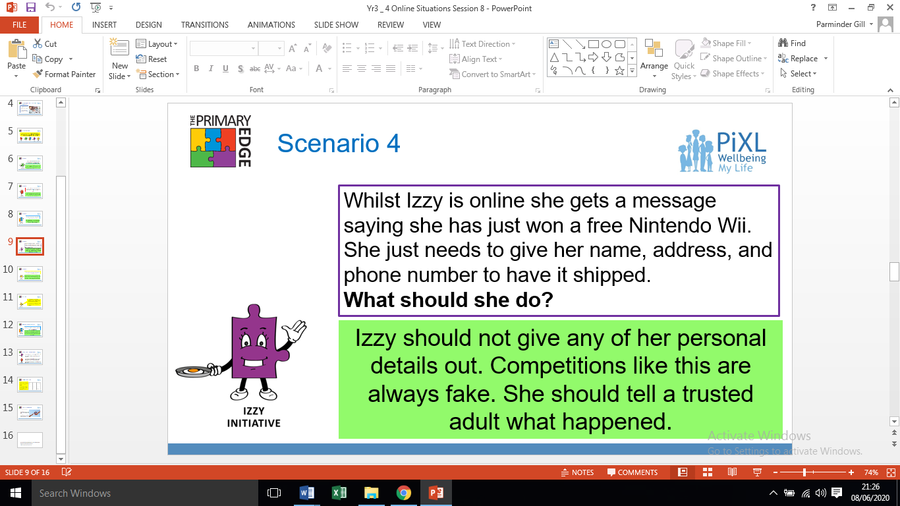
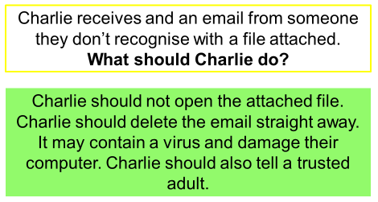

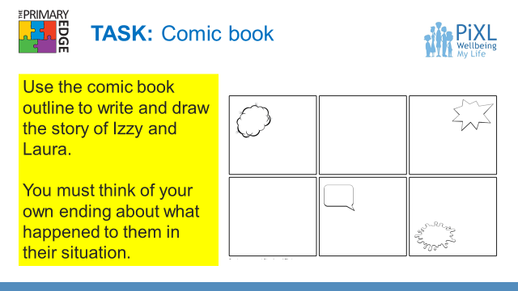
Task 2-
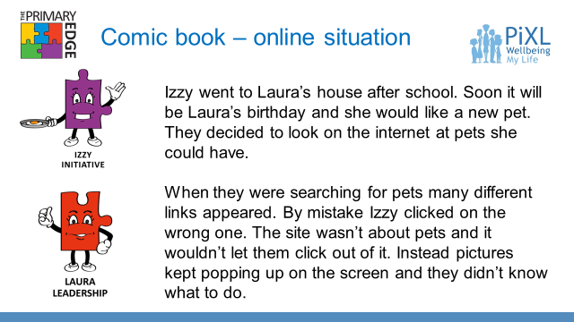
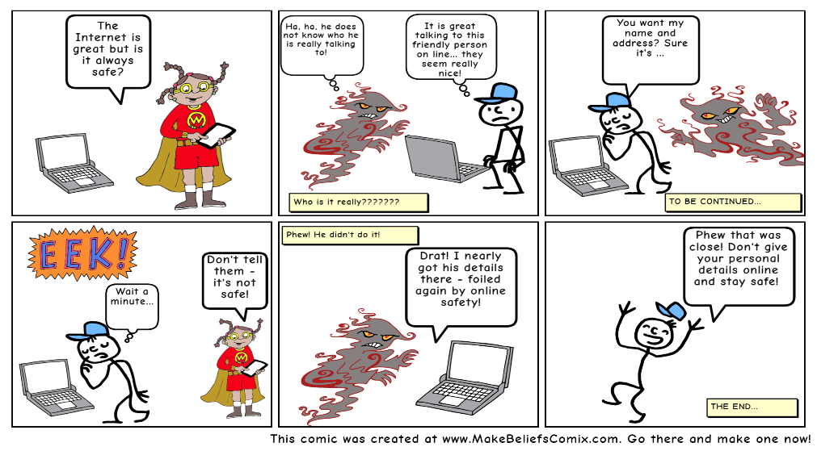
Comic book examples
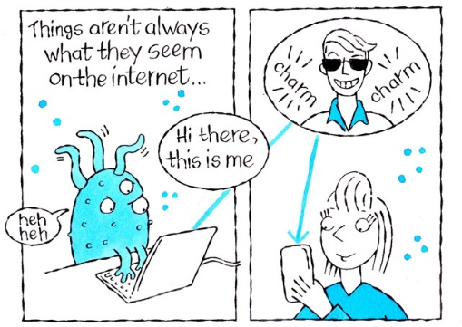

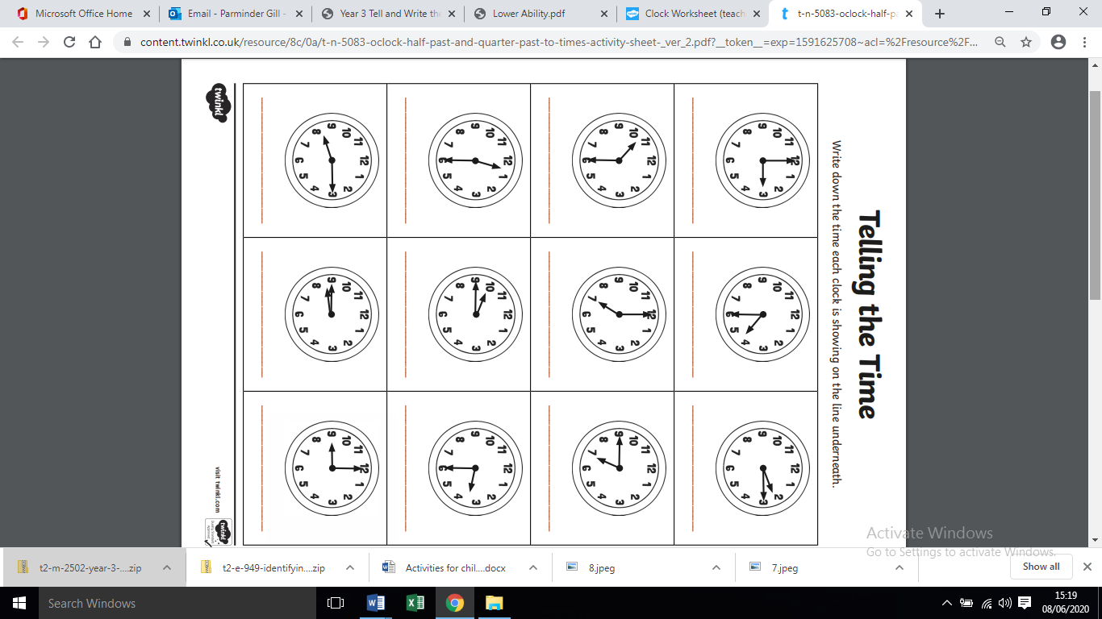
Wednesday 17th June - Maths:

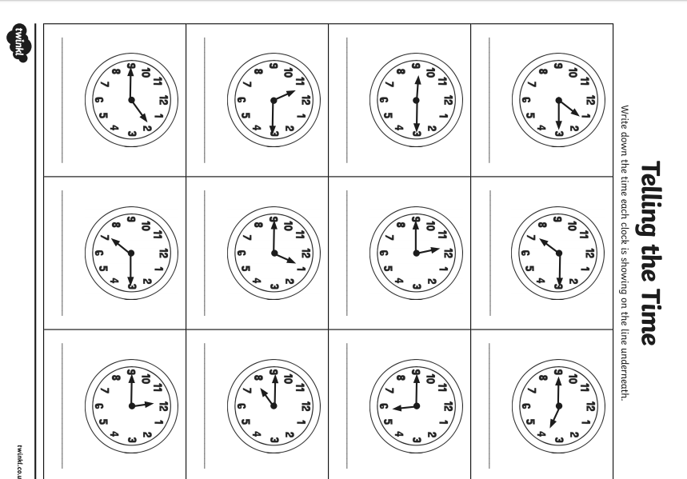

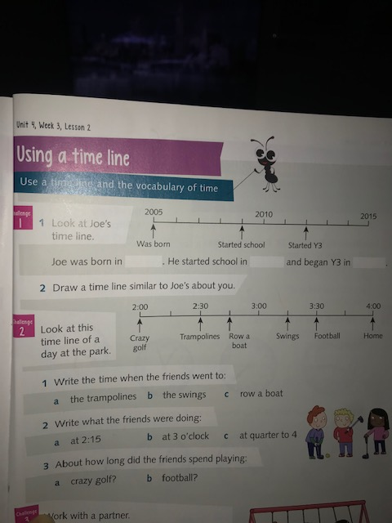
Wednesday 17th June – Maths extension/challenge:

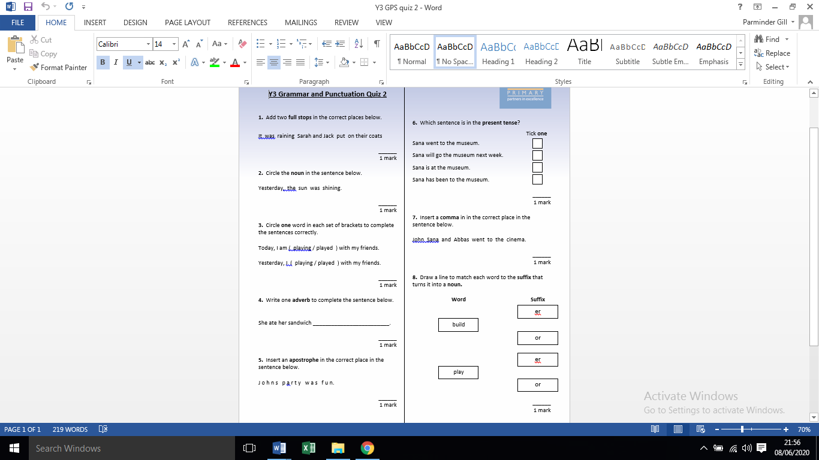
Wednesday 17th June – GPaS quiz

Answers
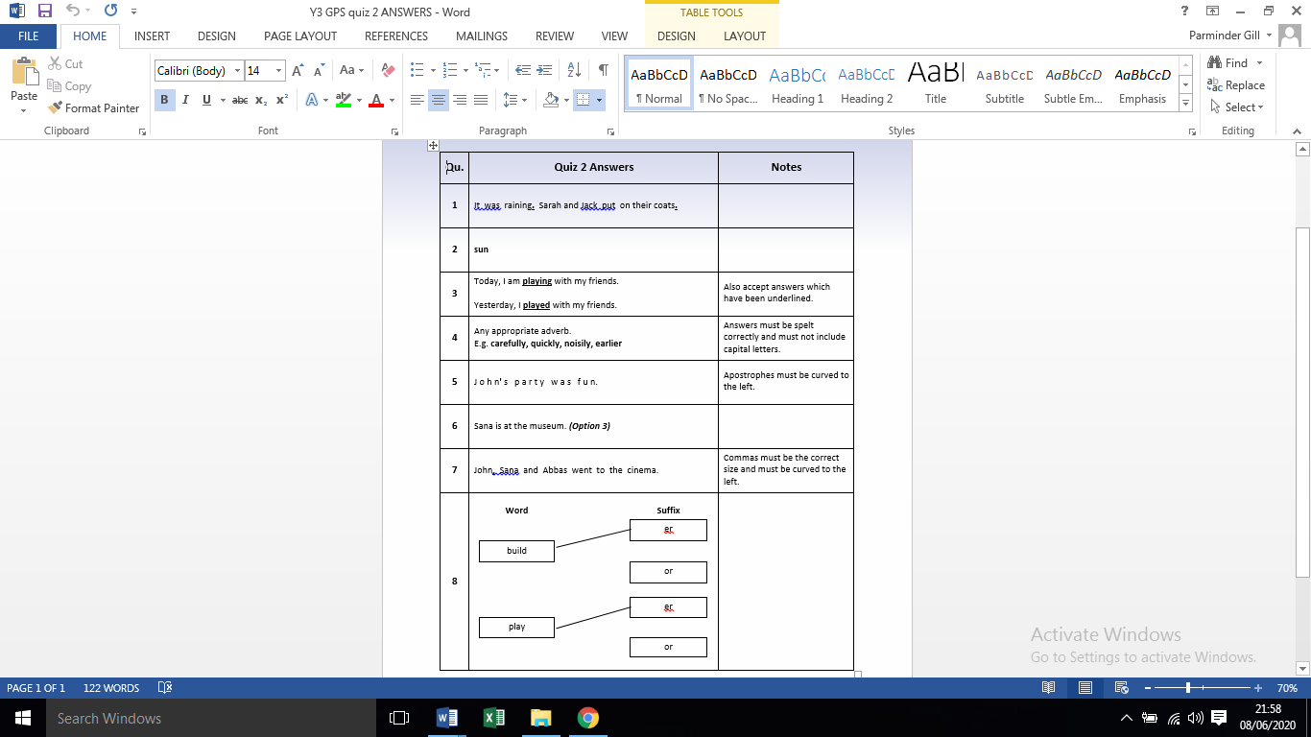

Wednesday 17th June - Science:
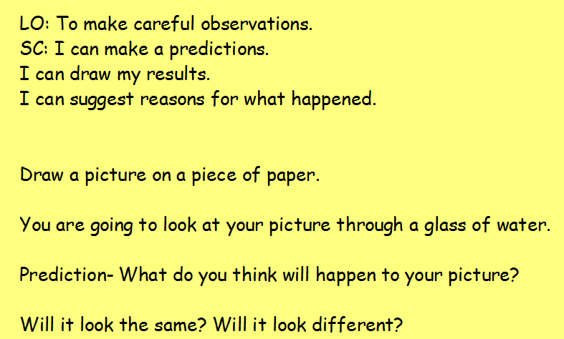

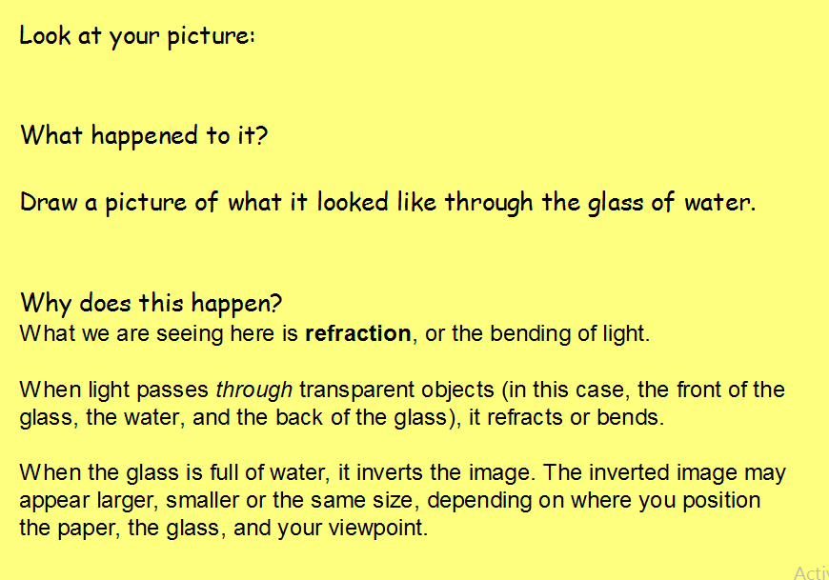

Thursday 18th June – Maths:
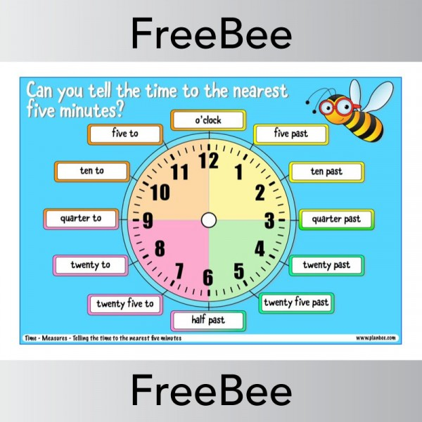

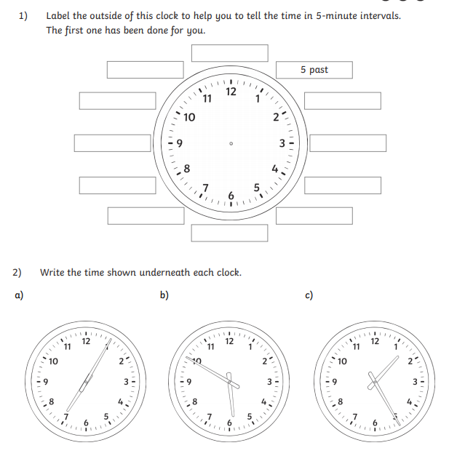
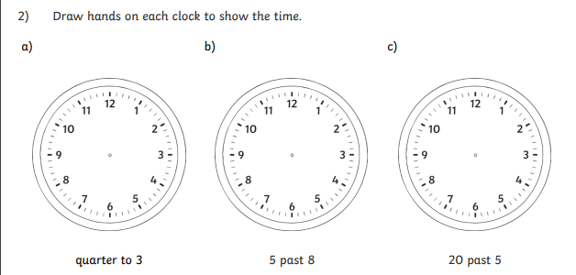
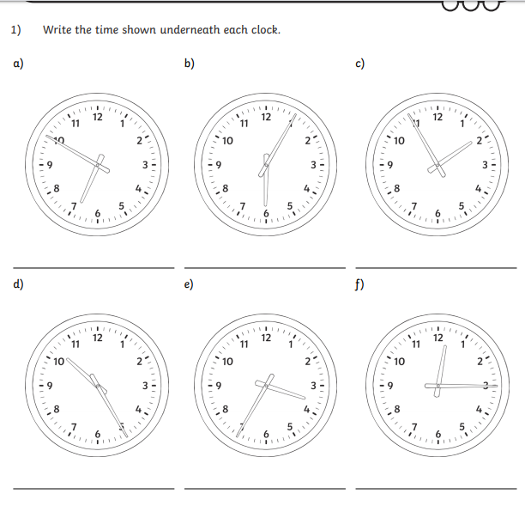
Thursday 18th June - Topic
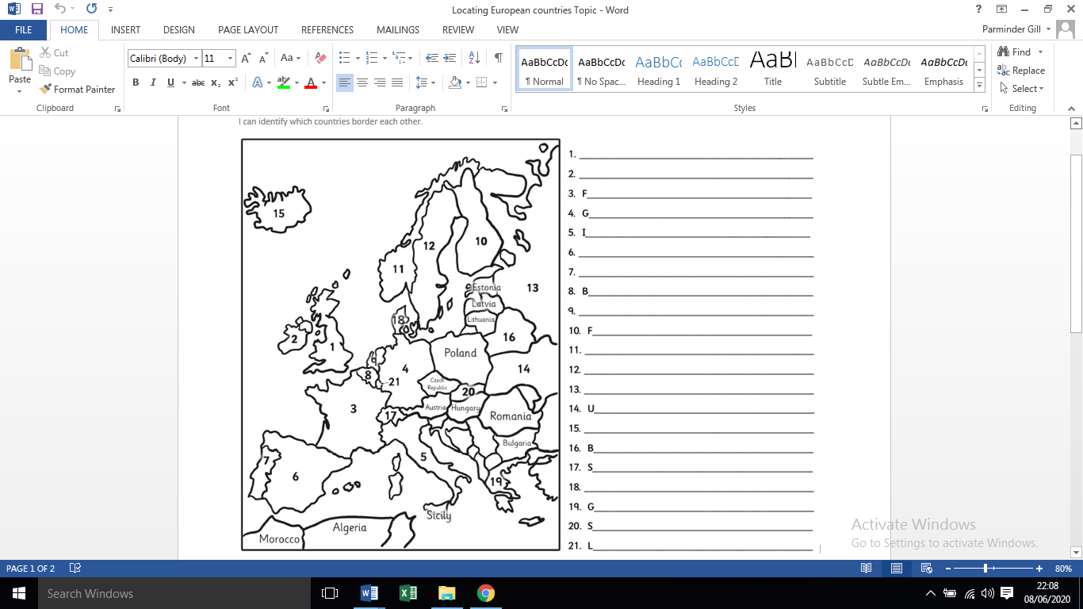

Answers

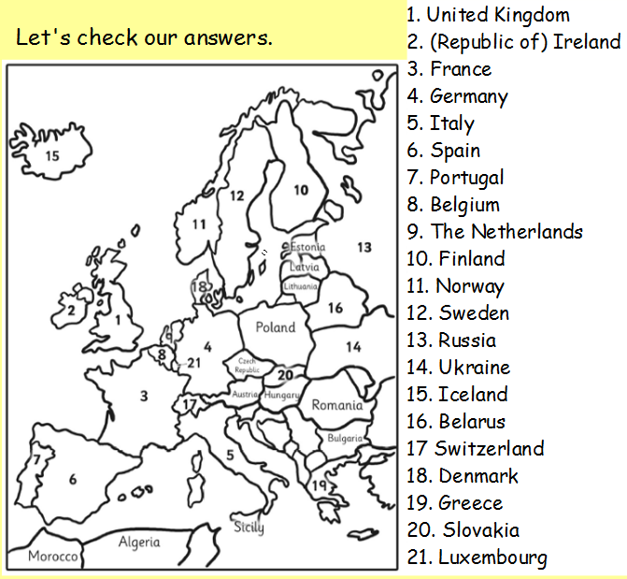

Friday 19th June - Maths
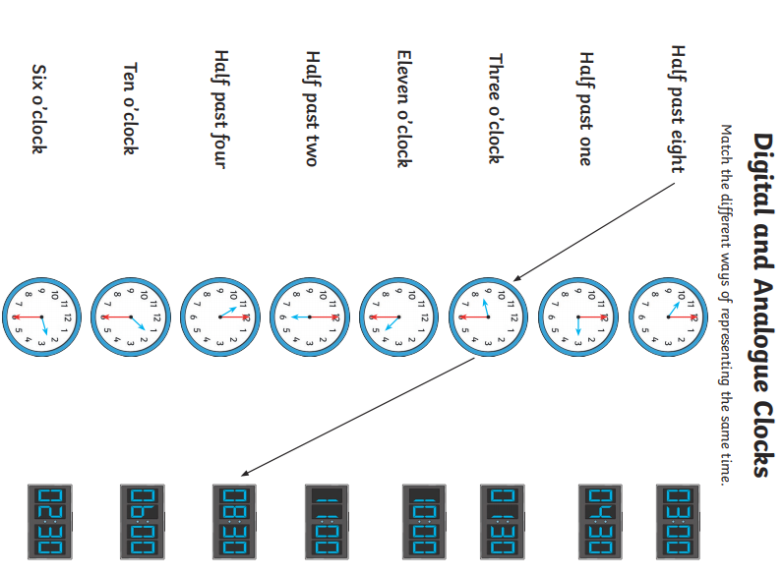

Friday 19th June – Maths:

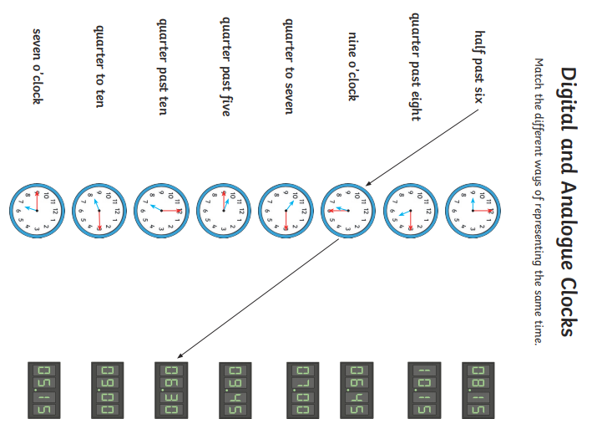
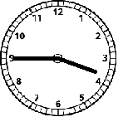 | 11:30 | 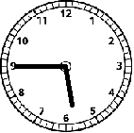 | 9:45
12:15 | Quarter to four | 7:30 | 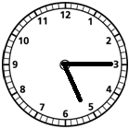
Quarter to ten | 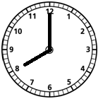 | 5:15 | 3:45
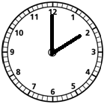 | Quarter to six | 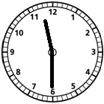 | 5:45
Eight o’clock | 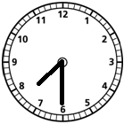 | 8:00 | Quarter past five
Half past eleven | Quarter past twelve | Two o’clock | 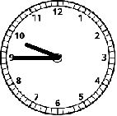
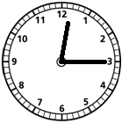 | 2:00 | Half past seven
Extension - Cut out the cards and match the digital times to the analogue clocks

Week 10 Spellings:

MILD

Words with the oe sound
toe
foe
hoe
woe
oboe
sloe

Suffix - ed
skipped
helped
watched
danced
tried
replied
cooked
lied

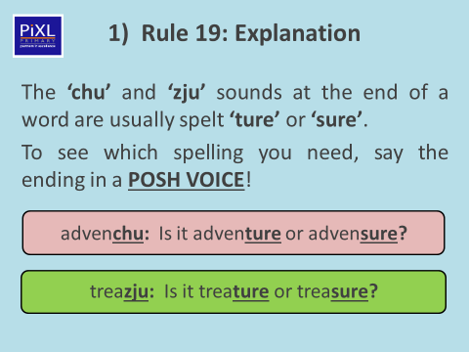

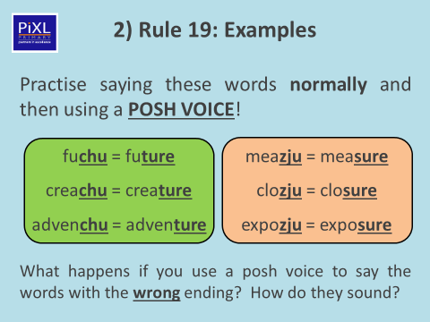

Task 1- Copy and complete the word using ‘sure’ or ‘ture’
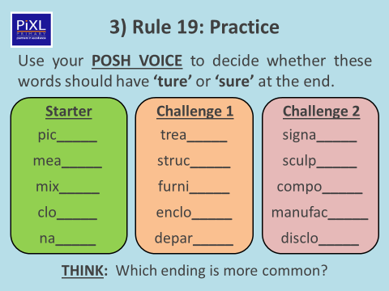

Task two- Read the information in the ‘Exceptions’ box. Then choose
Ten different words and write them into sentences. Please make sure you extend your sentences and add description. Do not write simple, short BORING sentences!

E.g Boring sentence- ‘I found some treasure’.
Interesting sentence- ‘As I was walking through the impenetrable woods, I caught sight of a large sculpture entangled in vines. Intrigued, I walked towards it’.



