

Learning Activities
Year 3
2019-20
Self-isolation learning
Week 9 (Worksheets)

Monday
Maths: Practise 4 times tables and times table facts English (GPAS): Quiz
SLOR: The Travels of Ermine

Tuesday
Maths: Practise 3 times tables and multiplication English: Planning a play script
Jigsaw: Babies

Wednesday
Maths: Practise 4 times tables and division English (GPAS): Present perfect tense
Science: Fair tests

Thursday
Maths: 8 times table practise and word problems (multiplication) English: Play script
Topic: Vincent Van Gogh

Friday
Maths: 8 times table practise and word problems (division) English: Spellings
PE: How many in 100 seconds?

Maths Monday:
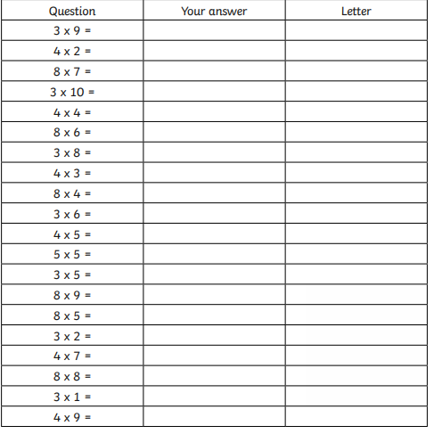
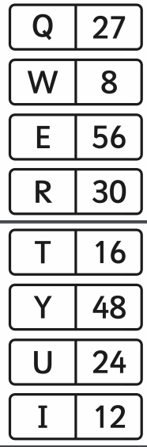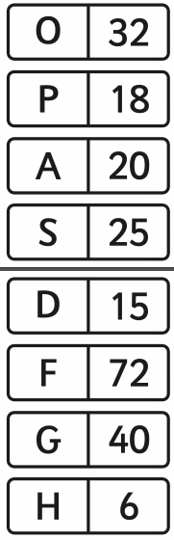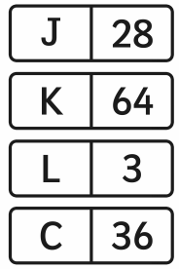
English (GPAS) Monday:
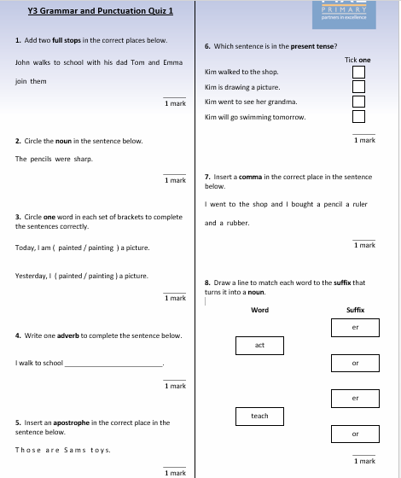
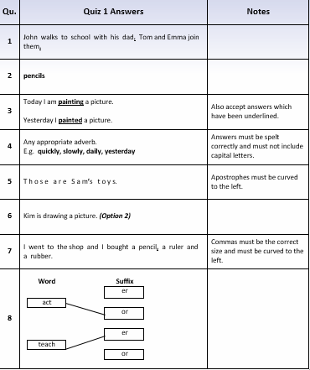

SLOR:
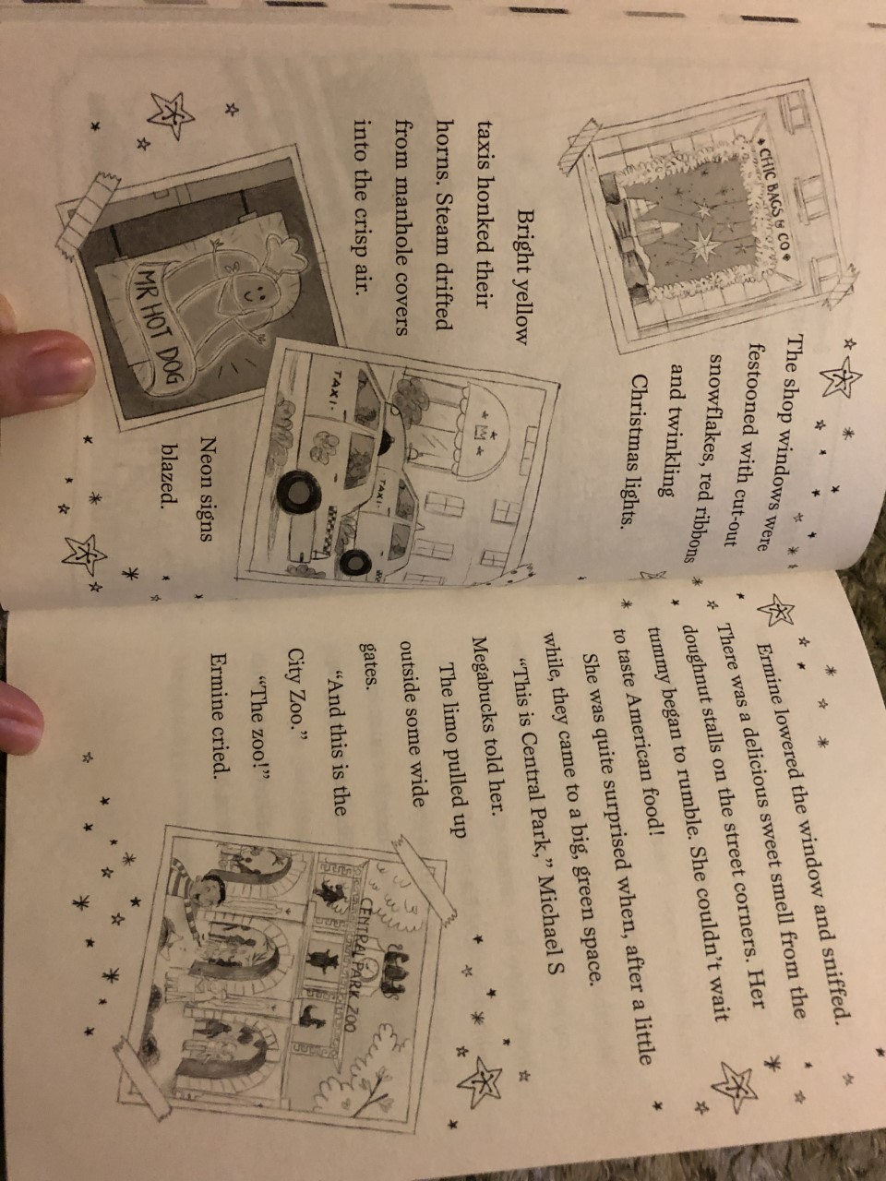
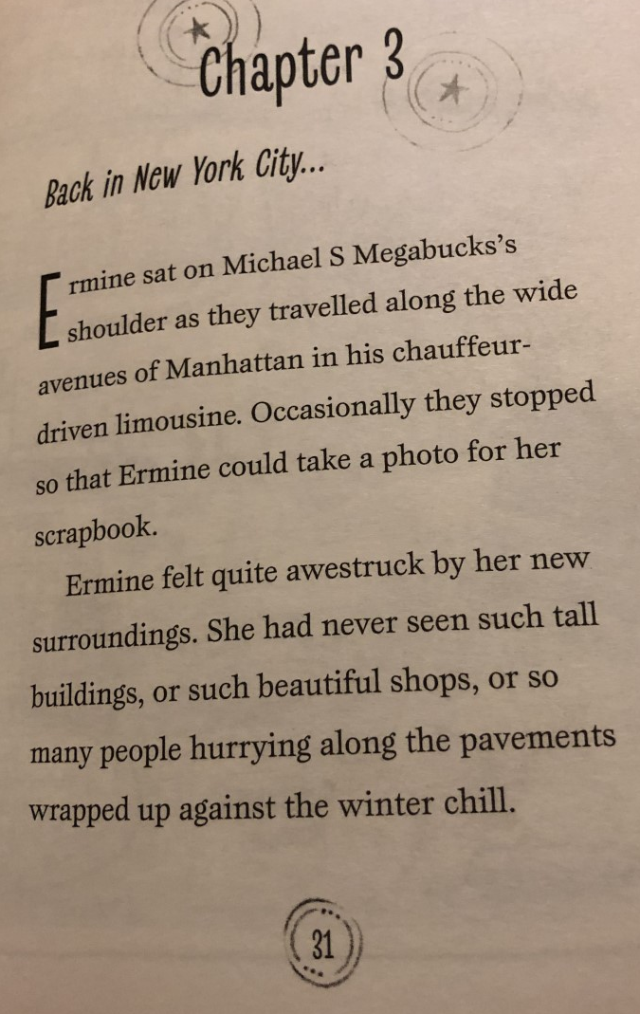

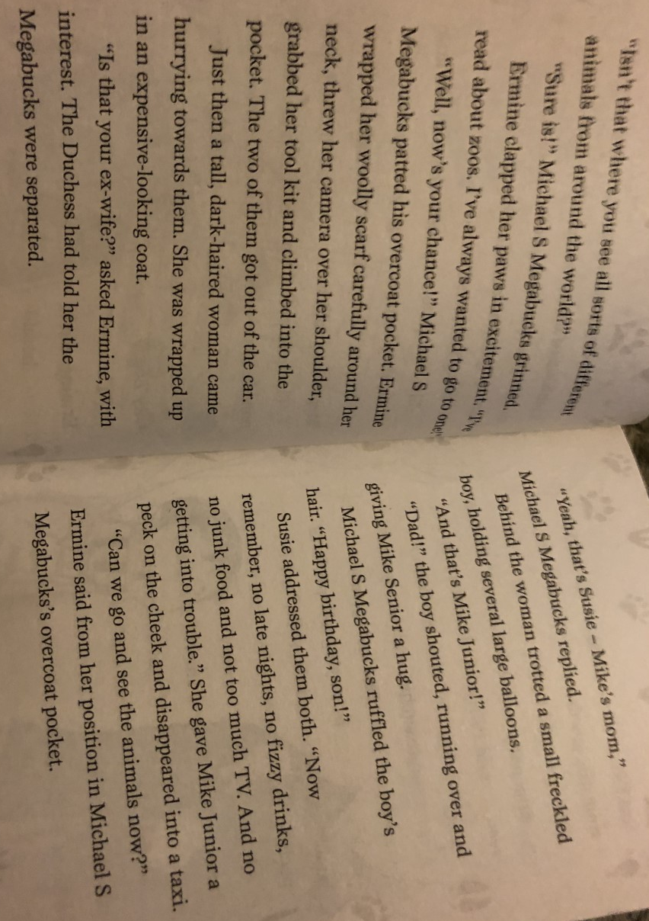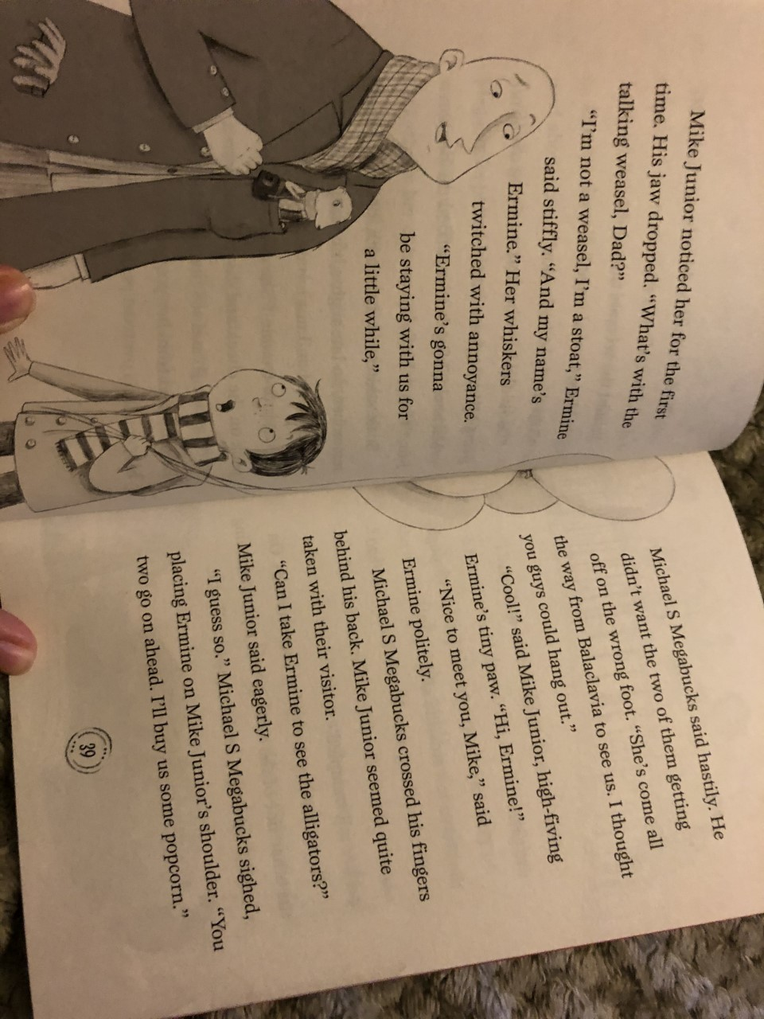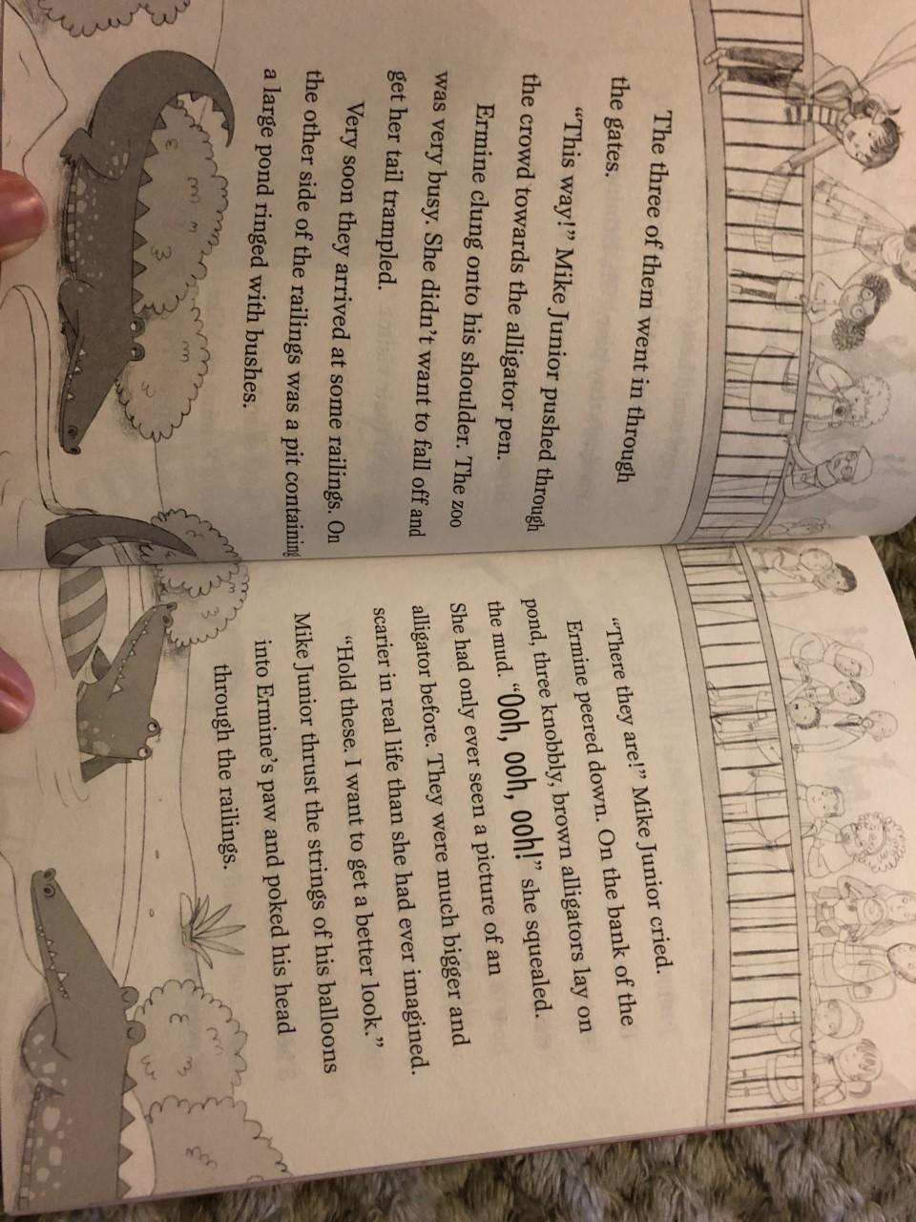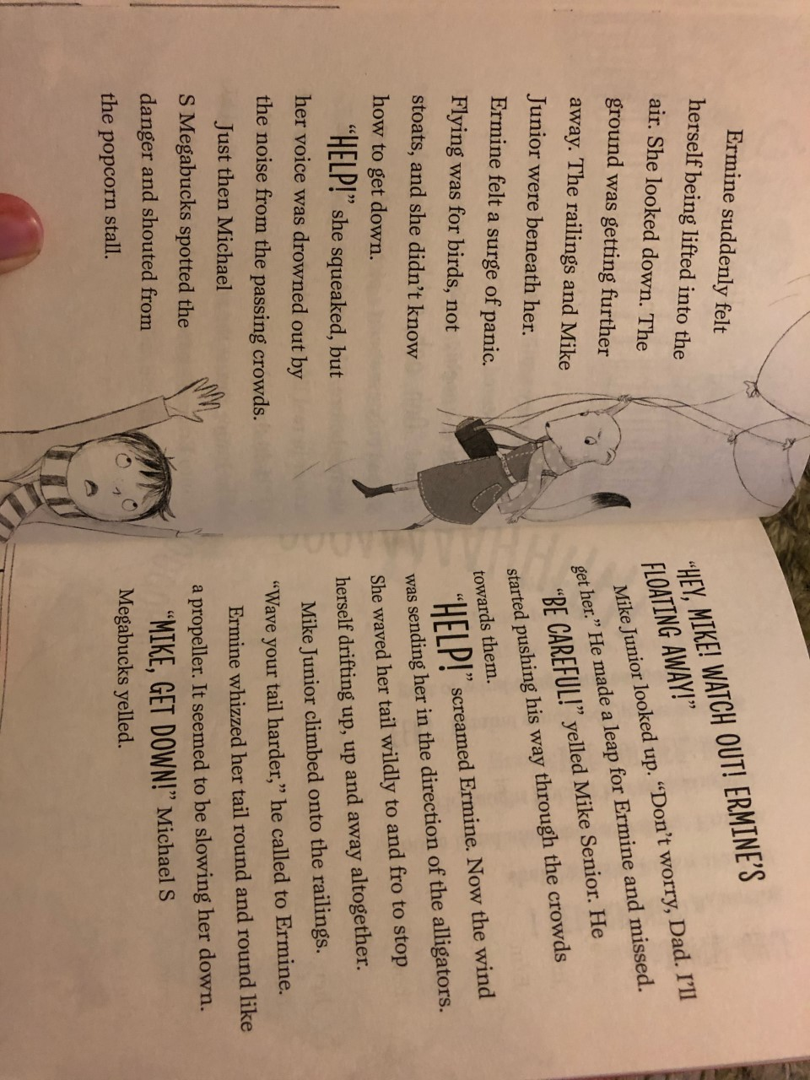
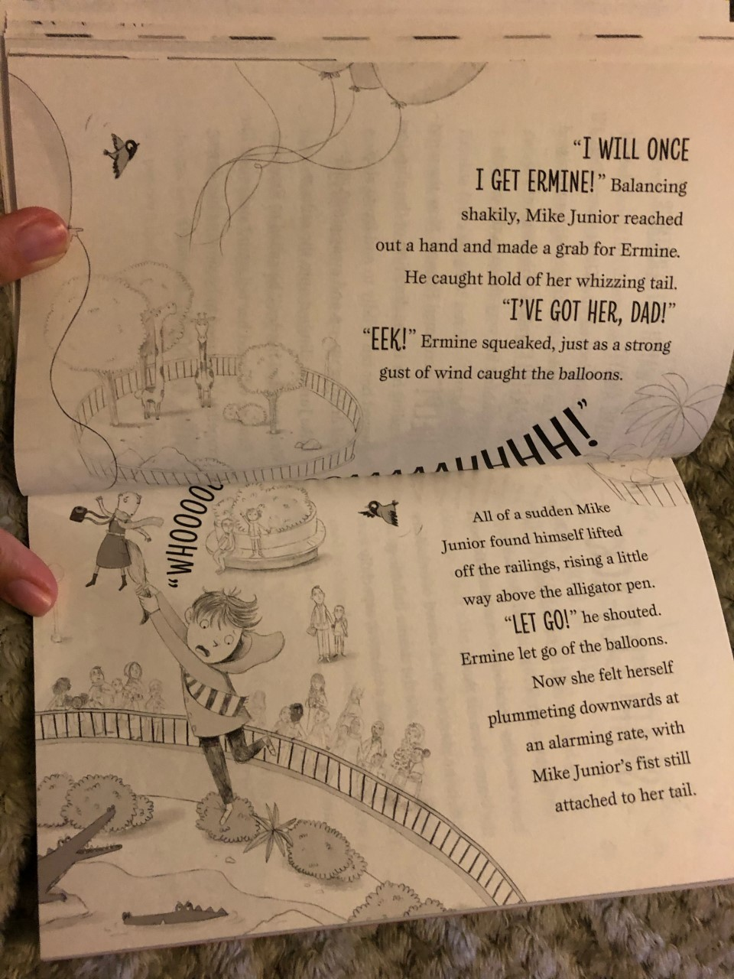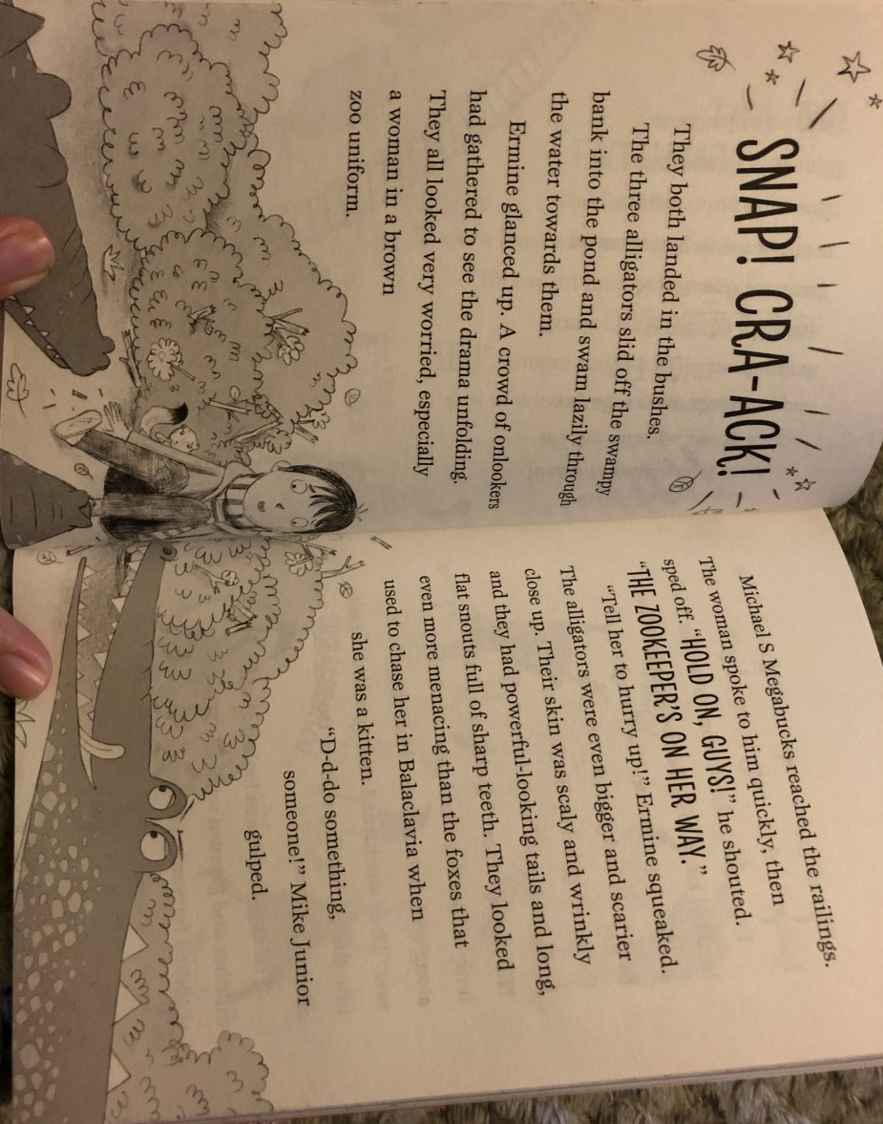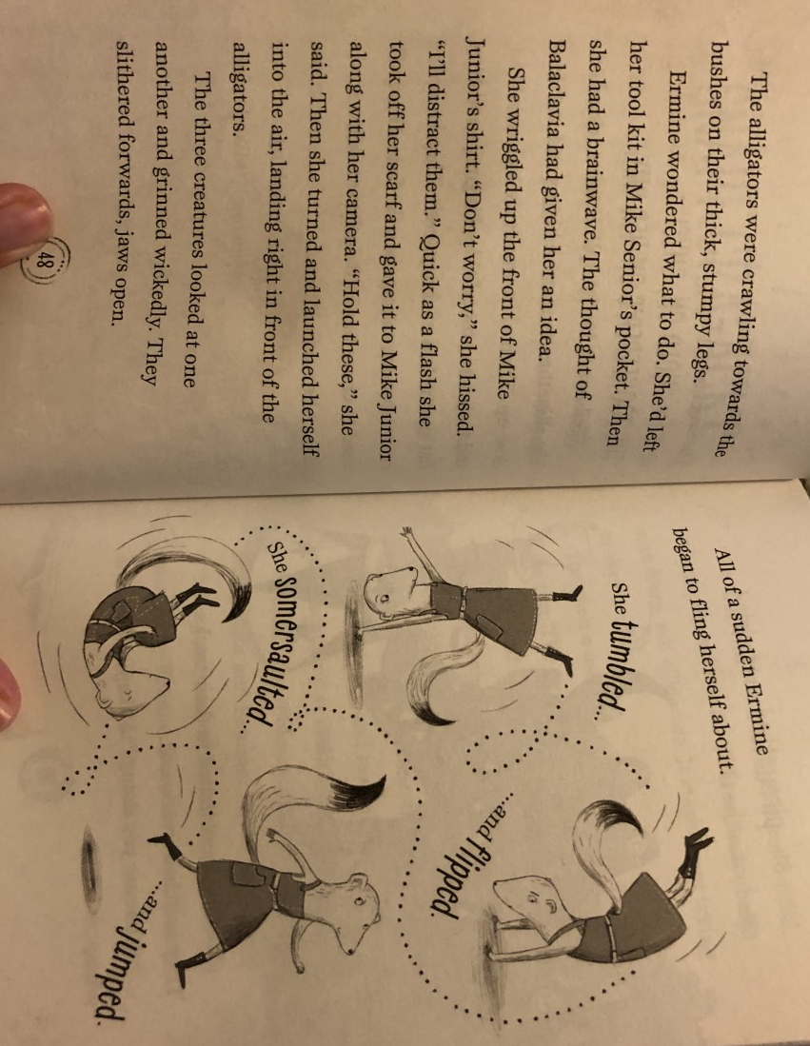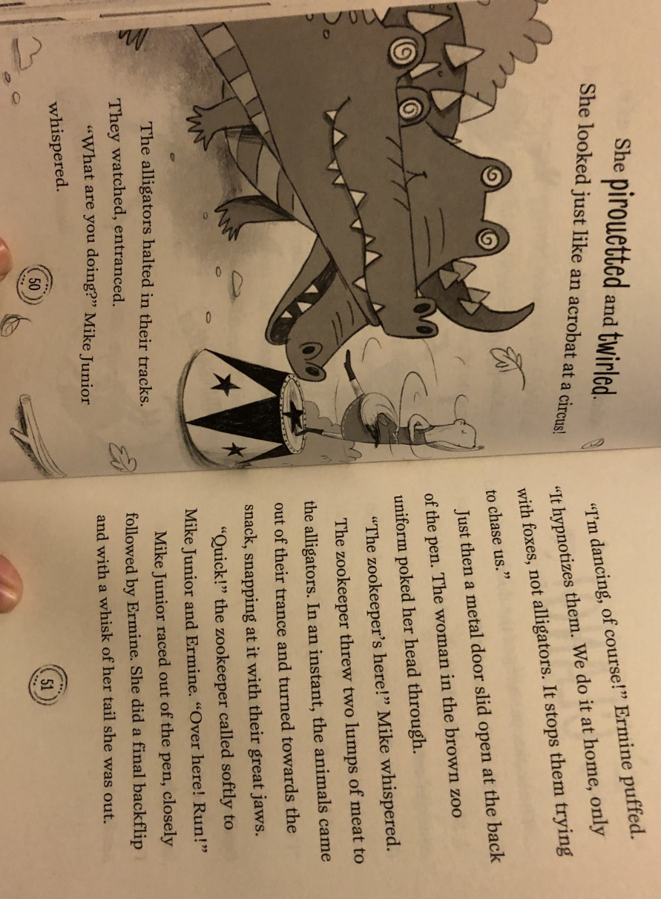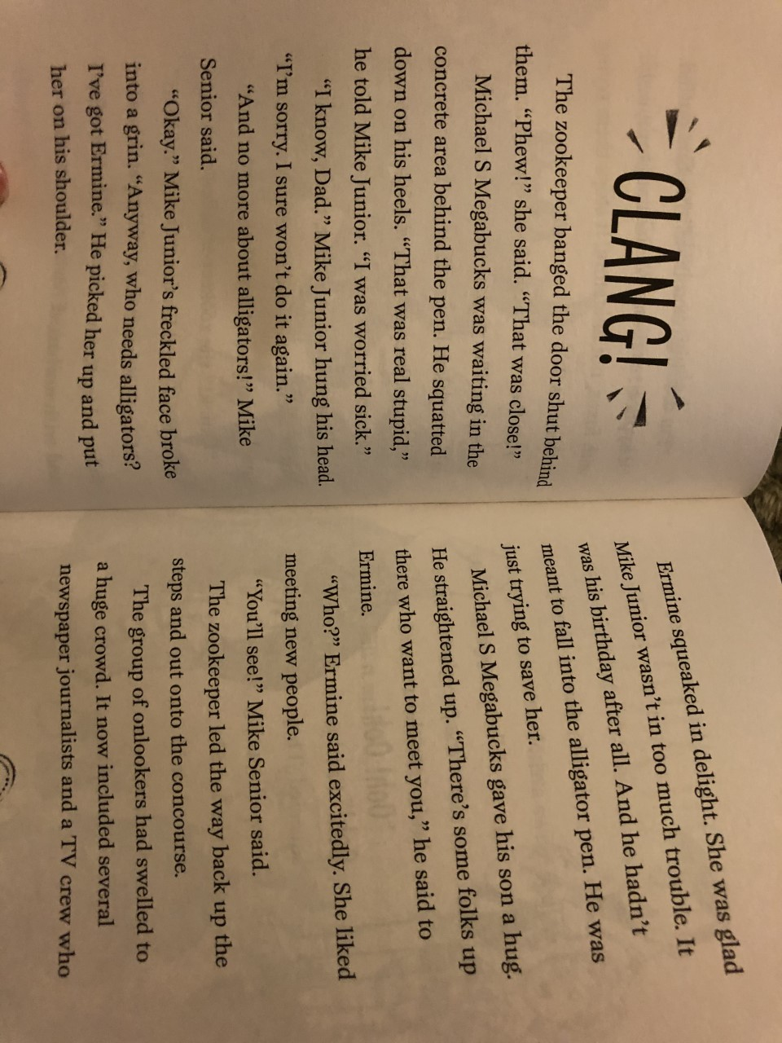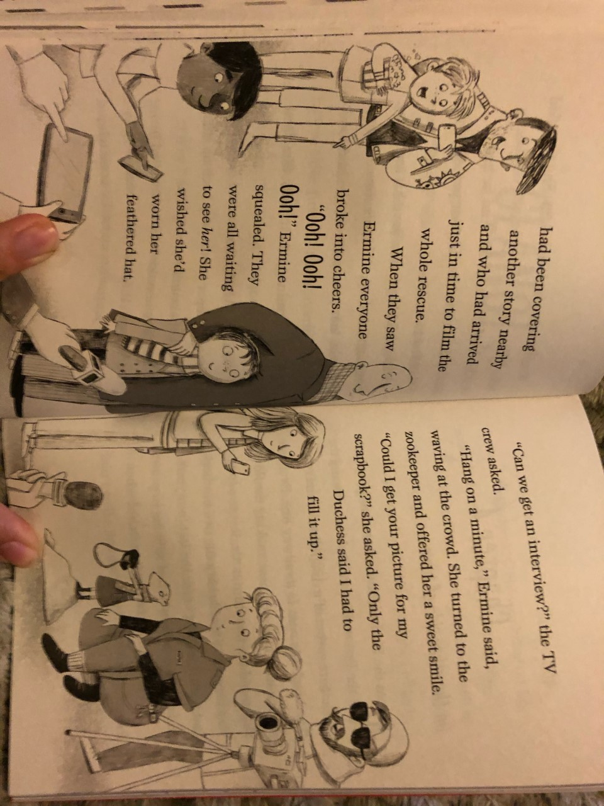
TASK ONE

Go through the text and identify words that you are not familiar with/ don’t know the meaning for. Use a dictionary to find the meaning of the words. You can use online dictionaries if you do not have a dictionary at home.

Example:

Awestruck – filled with or revealing awe.

If you still don’t understand the definition you may need to look up another word.
Awe- a feeling of reverential respect mixed with fear or wonder.
TASK TWO
Draw five pictures (in chronological order) summarising the main parts of the chapter. Write a simple sentence underneath each picture.

Example:
Ermine, Mr Megabucks and Mike Junior went to the Zoo.

Maths Tuesday:
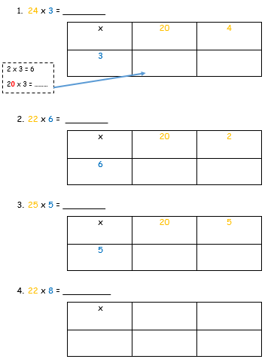
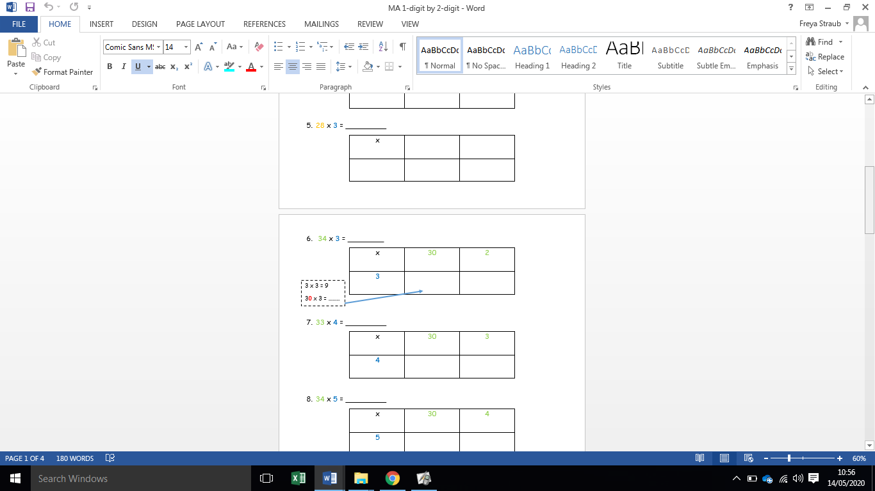

Extension:
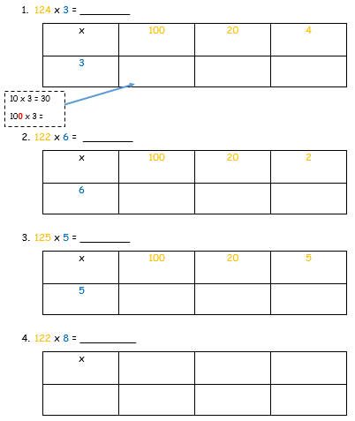
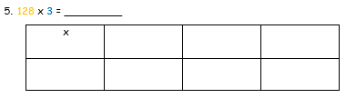

English Tuesday:

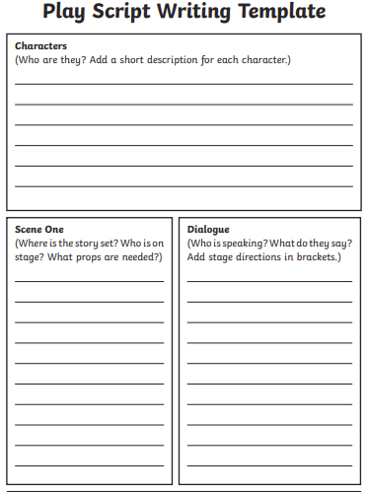

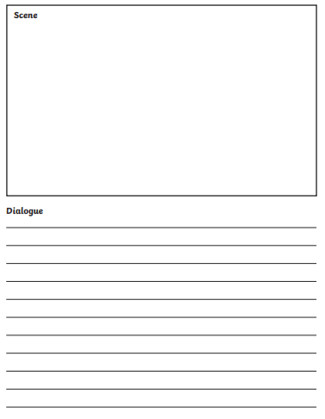

Maths Wednesday:
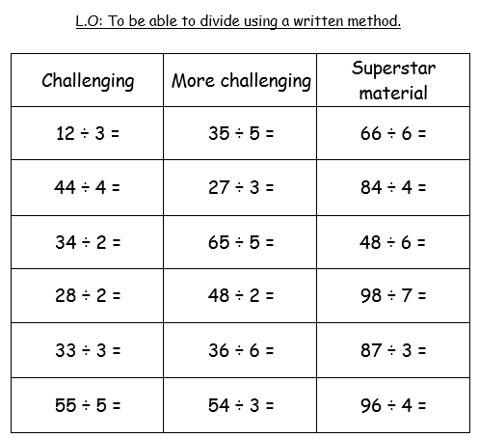

Science:
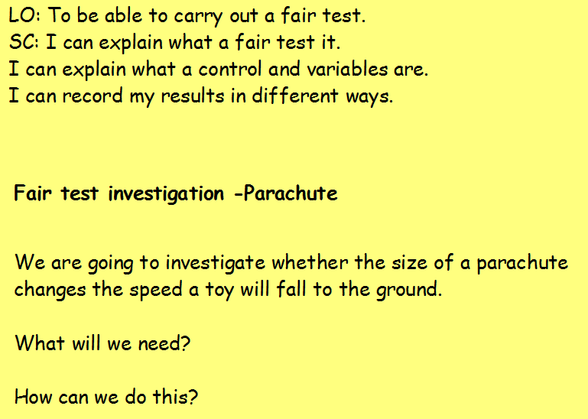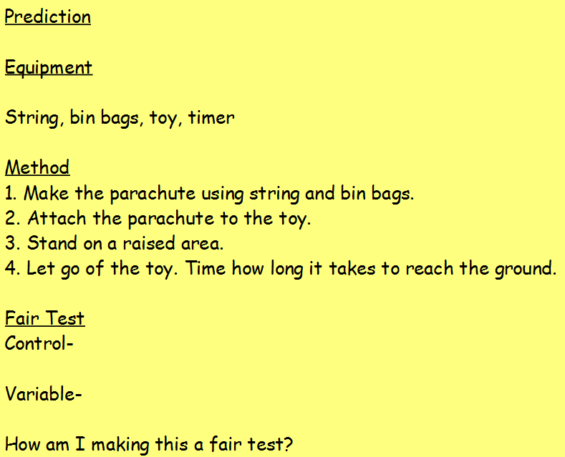
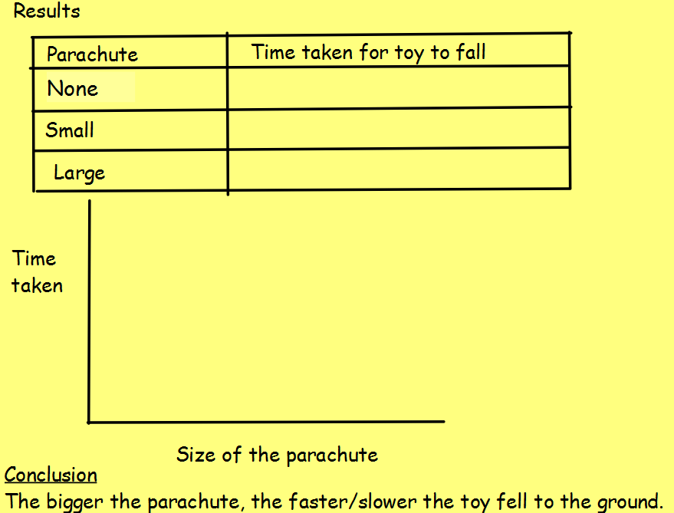

Maths Thursday:

- Jane thinks that each person at her party will eat three biscuits each. There will be six people how many biscuits will she need. __________________
2. There are 6 sparklers in a box. Sam has 4 boxes. How many sparklers does he have altogether? __________________


- The teacher needs each table to have four pencils. There are 5 tables. How many pencils will she need all together? ___________

- Ben wants to buy 4 lollies for each of his seven friends.
How many lollies will he need to buy? ____________

5. Lucy has 3 racks of CD’s. Each rack holds 10 CDs. How many has she altogether? ______________


6. Jay’s class are collecting shoes to send to Malawi. His class collected 6 pairs of shoes. How many individual shoes were collected altogether in Year 5? ______________


7. It takes Laura 2 minutes to walk to Swingate Primary School each day. She walked to school and back every day for 5 days. How many minutes did Laura spend walking to and from school in one week? (Remember 2 mins EACH WAY) ______________


8. There are 6 sets of twins in St. John’s School. They each get a sticker from Mrs. Charles. How many stickers does Mrs. Charles have to buy? _______________
Extension: Two step word problem.
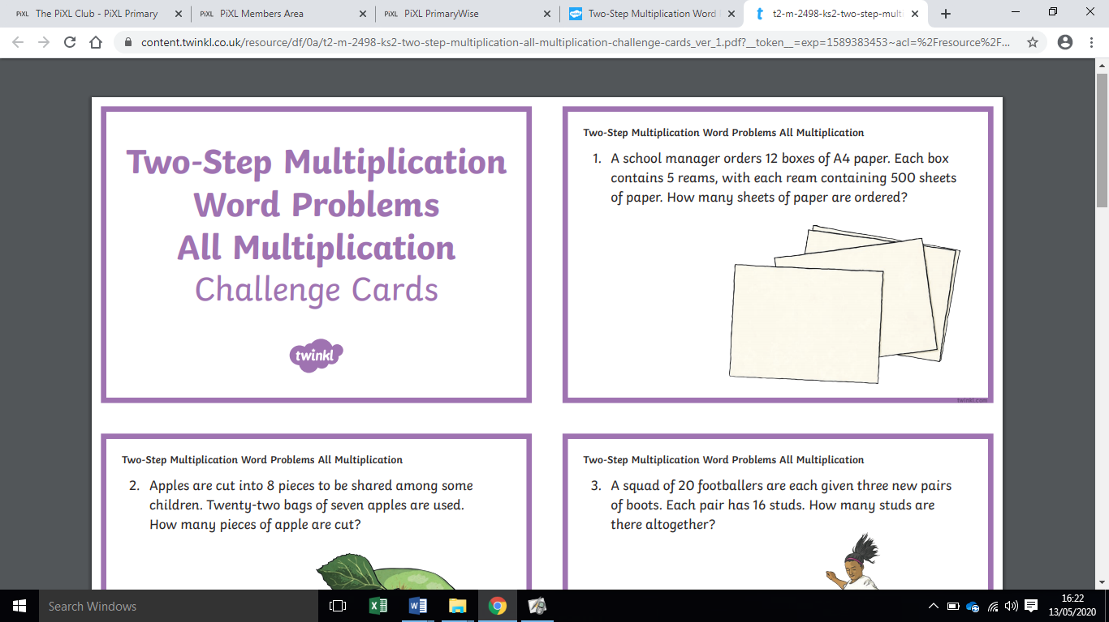

English: Play script poster

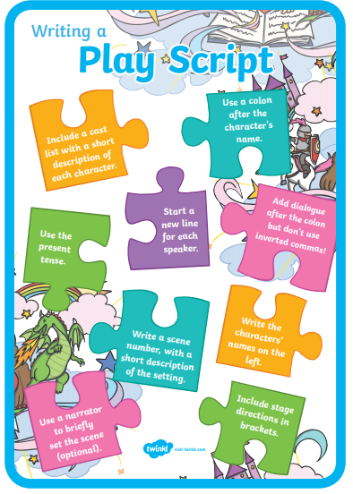

Topic:



Friday maths:
One step word problems (no remainders):

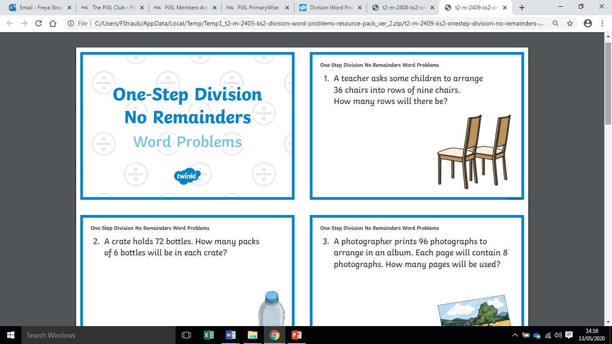
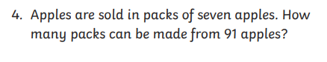
One Step word problems (remainders):

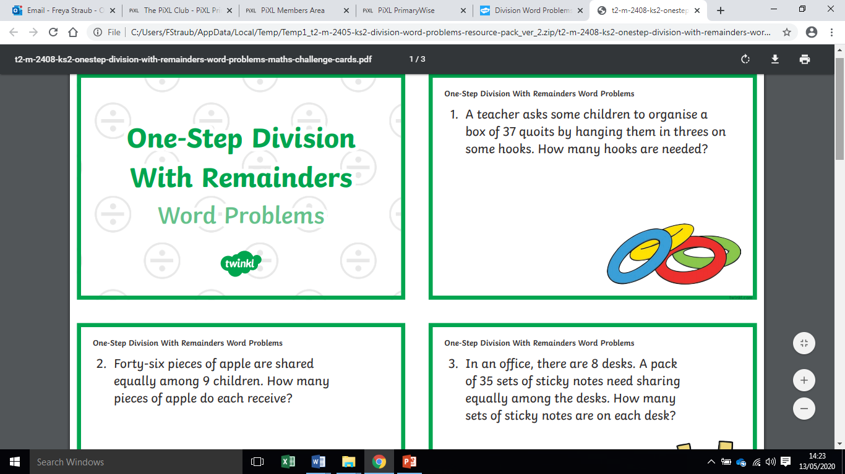
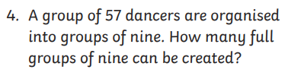
Extension: Two-Step word problems:

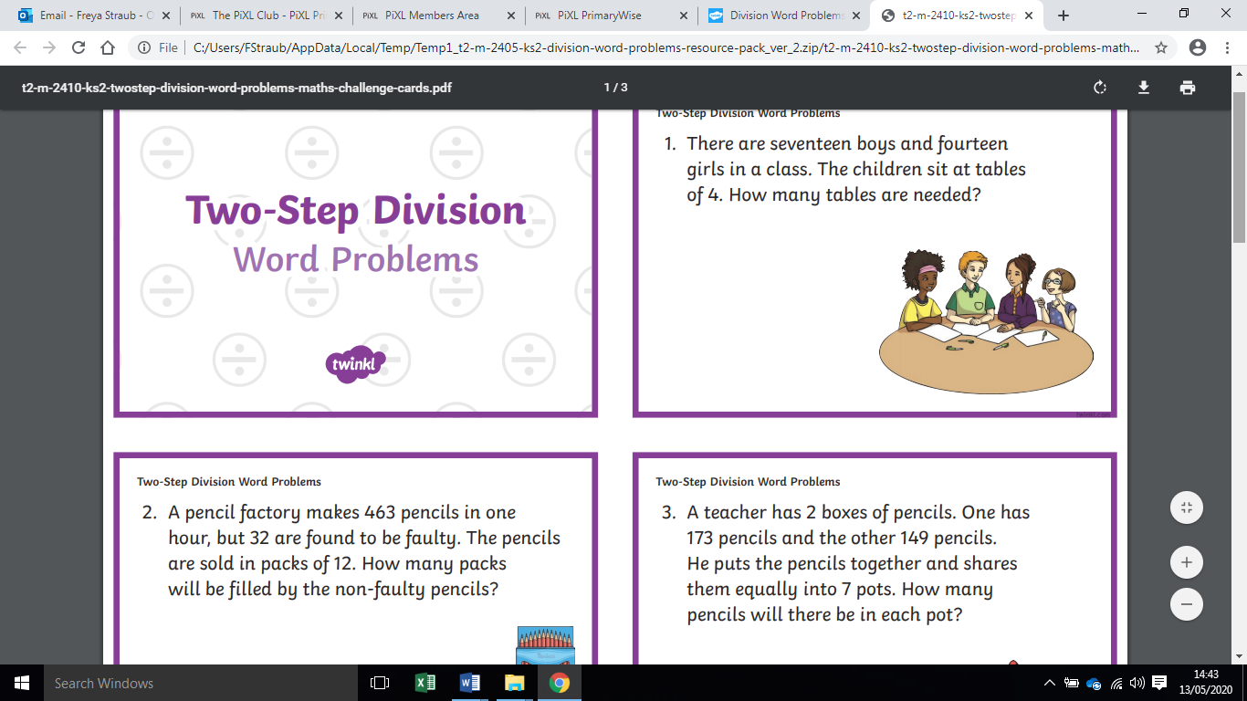
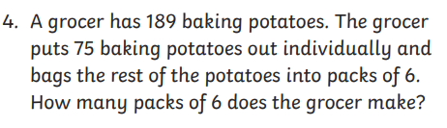

Spellings:

Contractions
shouldn’t
wouldn’t
couldn’t
won’t
can’t
doesn’t
aren’t
they’ve

MILD
Words with the ew sound
blew
flew
drew
knew
few
grew

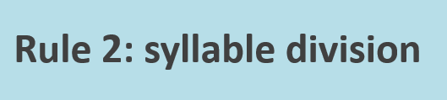
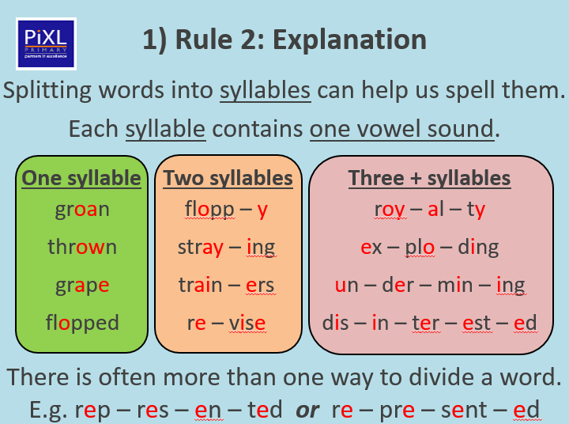

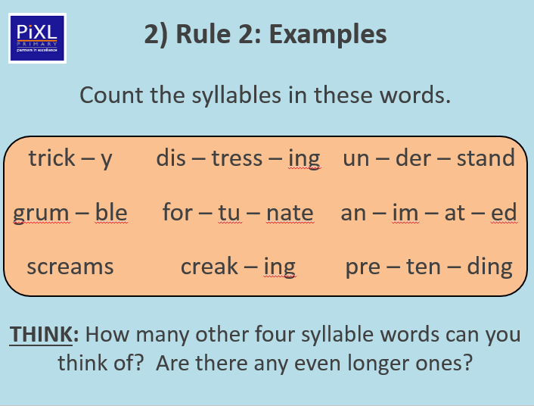

Activity one:
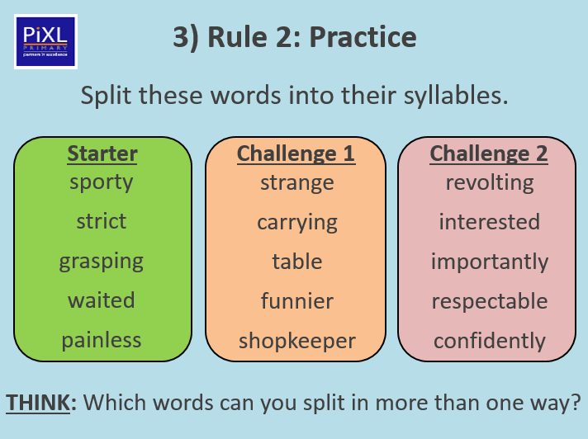

ACTIVITY ONE

ACTIVITY TWO – Choose three words from each column and put them into nine different sentences.



