

Learning Activities
Year 3
2019-20
Self-isolation learning
Week 8 (Worksheets)
Monday
Maths: Practise 3 times tables and mentally + and - English (GPAS): Word classes
SLOR: The Travels of Ermine

Tuesday
Maths: Practise 4 times tables and adding and subtracting English: Poem
Jigsaw: Changes in animals and humans as they grow

Wednesday
Maths: Practise 4 x tables, + and – word problems English (GPAS): subordinate clauses
Science: Plants – Function of flowers

Thursday
Maths: 8 times table practise, + and – word problems English: Limericks
Topic: French

Friday
Maths: 8 times table practise and arithmetic test English: Spellings
PE: Range of exercises to choose from (see links)

Monday maths:
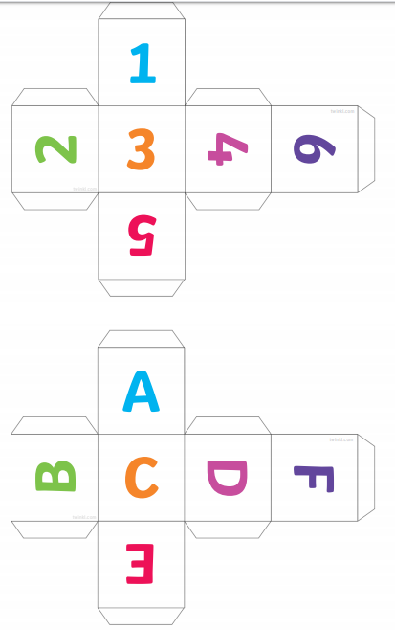

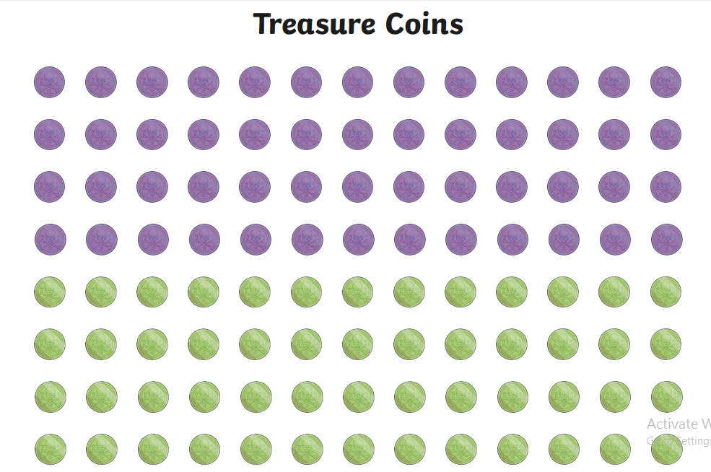
Monday maths:
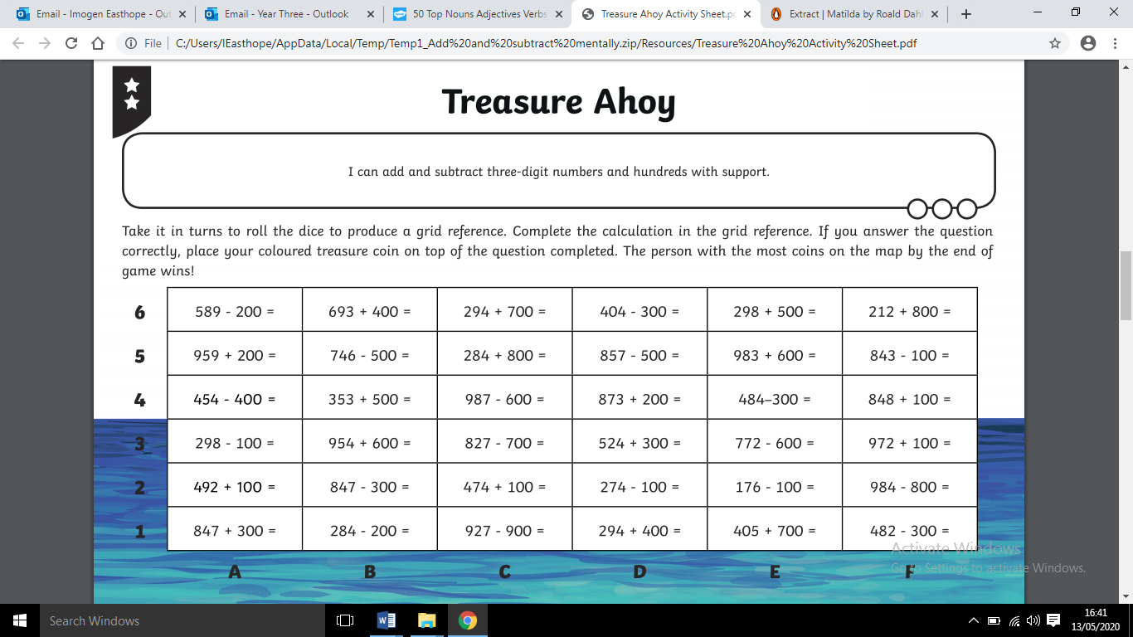
Monday maths:
Monday GPaS:

Read this extract from ‘Matilda’ by Roald Dahl. Identify the nouns, adjectives, verbs and adverbs by high-lighting or underlining them in a different colour. You can choose your own colours. Make sure you complete the key.
Key

Noun

Adjective

Verb

Adverb

By the time she was three, Matilda had taught herself to read by studying newspapers and magazines that lay around the house. At the age of four, she could read fast and well and she naturally began hankering after books. The only book in the whole of this enlightened household was something called Easy Cooking belonging to her mother, and when she had read this from cover to cover and had learnt all the recipes by heart, she decided she wanted something more interesting.
‘Daddy,’ she said, ‘do you think you could buy me a book?’
‘A book?’ he said. ‘What d’you want a flaming book for?’
‘To read, Daddy.’
‘What’s wrong with the telly, for heaven’s sake? We’ve got a lovely telly with a twelve-inch screen and now you come asking for a book! You’re getting spoiled, my girl!’
Nearly every weekday afternoon Matilda was left alone in the house. Her brother (five years older than her) went to school. Her father went to work and her mother went out playing bingo in a town eight miles away. Mrs Wormwood was hooked on bingo and played it five afternoons a week. On the afternoon of the day when her father had refused to buy her a book, Matilda set out all by herself to walk to the public library in the village. When she arrived, she introduced herself to the librarian, Mrs Phelps. She asked if she might sit awhile and read a book. Mrs Phelps, slightly taken aback at the arrival of such a tiny girl unaccompanied by a parent, nevertheless told her she was very welcome.
‘Where are the children’s books please?’ Matilda asked.
‘They’re over there on those lower shelves,’ Mrs Phelps told her. ‘Would you like me to help you find a nice one with lots of pictures in it?’
‘No, thank you,’ Matilda said. ‘I’m sure I can manage.’
From then on, every afternoon, as soon as her mother had left for bingo, Matilda would toddle down to the library. The walk took only ten minutes and this allowed her two glorious hours sitting quietly by herself in a cosy corner devouring one book after another. When she had read every single children’s book in the place, she started wandering round in search of something else.

Monday SLoR:
TASK TWO

Write a prediction about what you think will happen next in the story. Who does the feathered hat belong to? Who now has the diamond? What will the robbers do next?

TASK ONE
Knowledge: Why did the Duke set a trap to catch Ermine?

Comprehension: How would you describe Ermine’s personality?

Apply: If you were Ermine, where would you like to travel in the world and why?

Analysis: Why do you think Harry gave Barry a kick at the ‘Left Luggage’ desk?

Evaluation: Do you think that Harry and Barry will still go to Hawaii? Explain your answer.

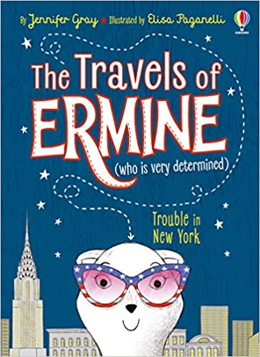

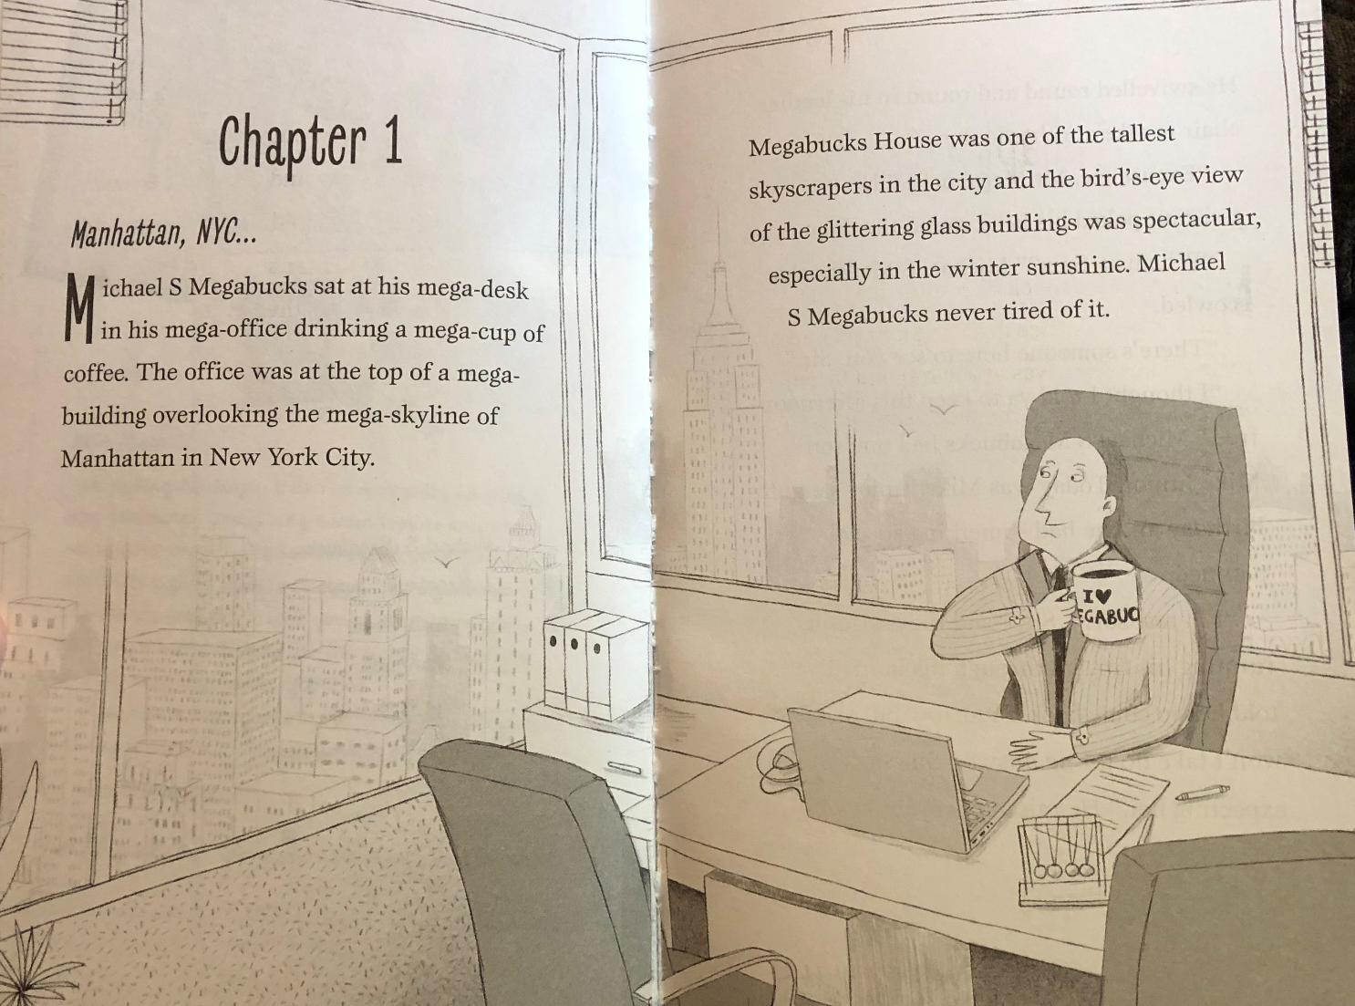

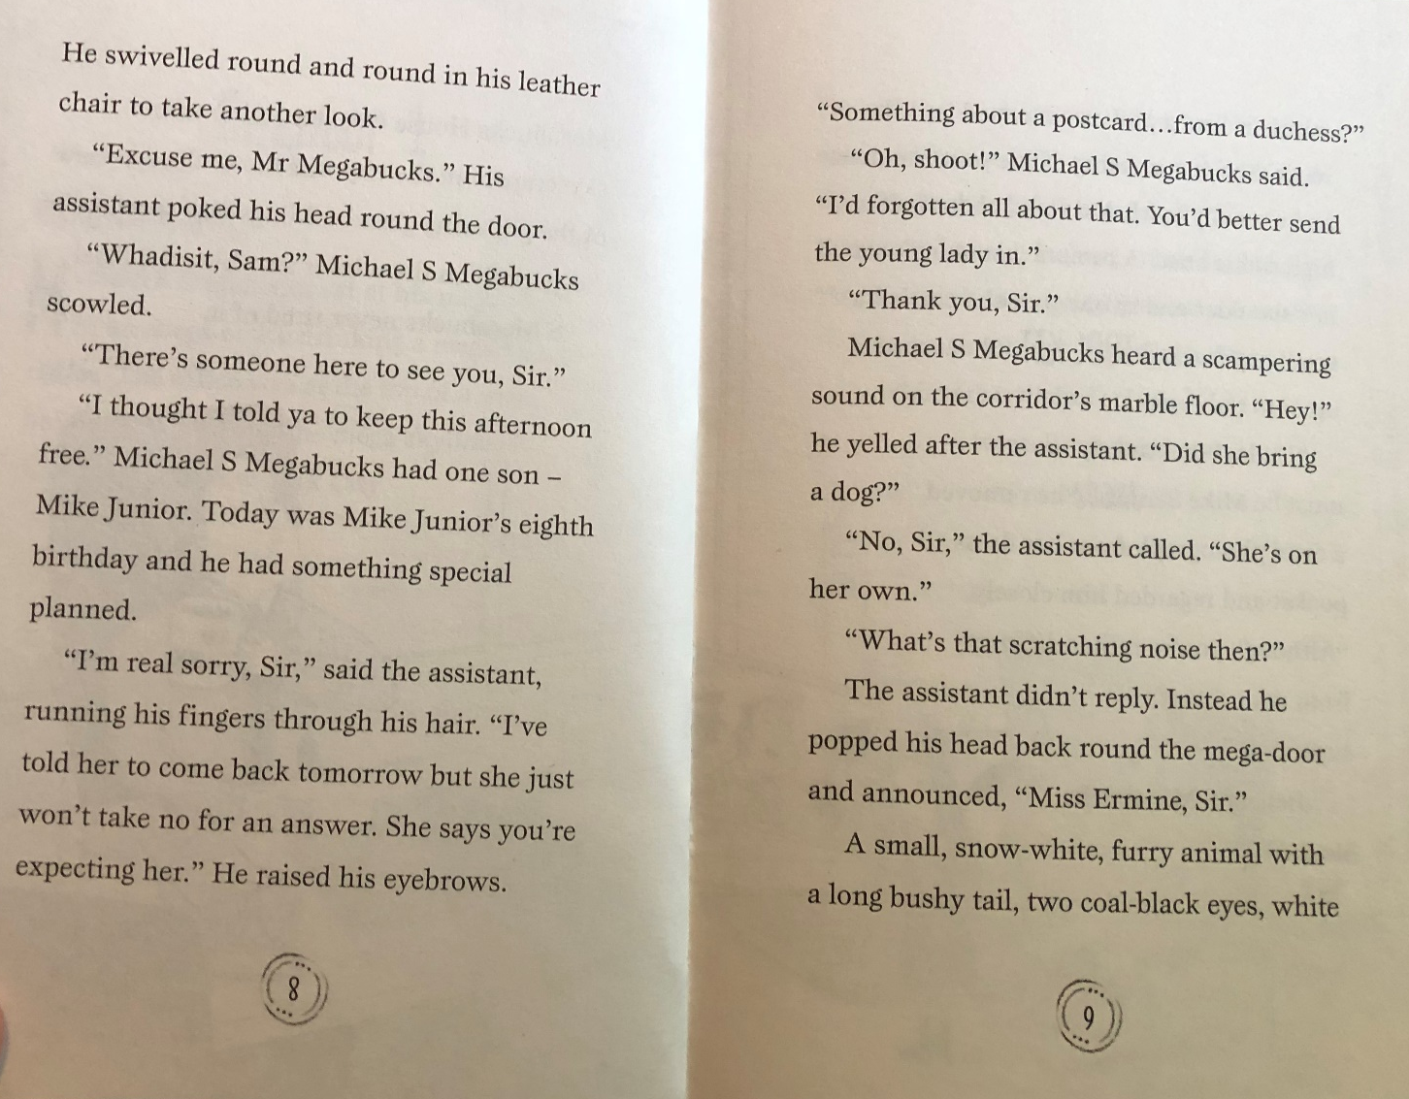

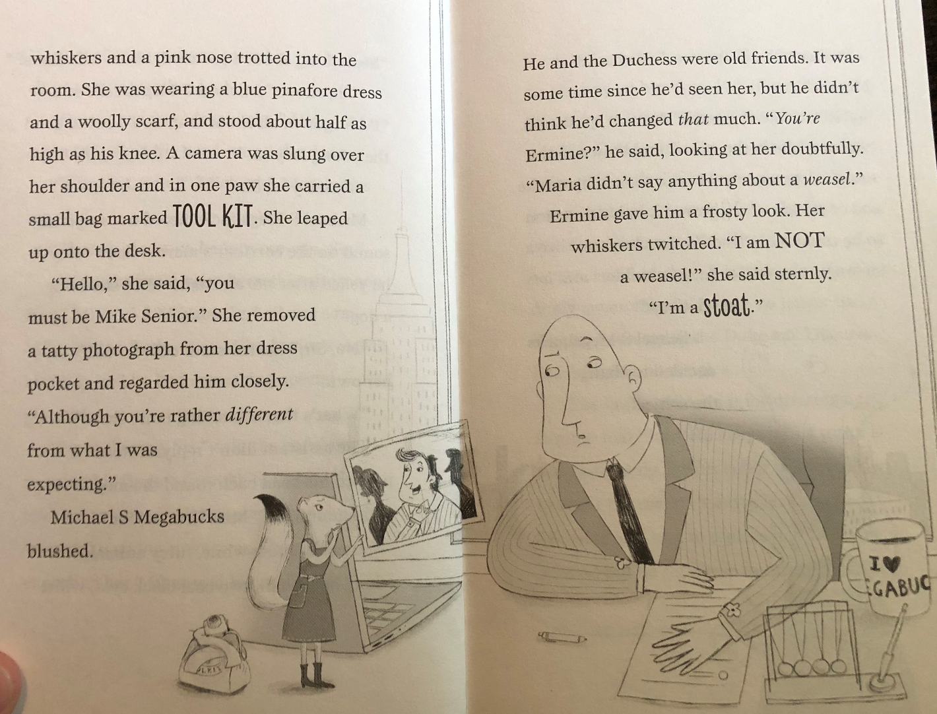

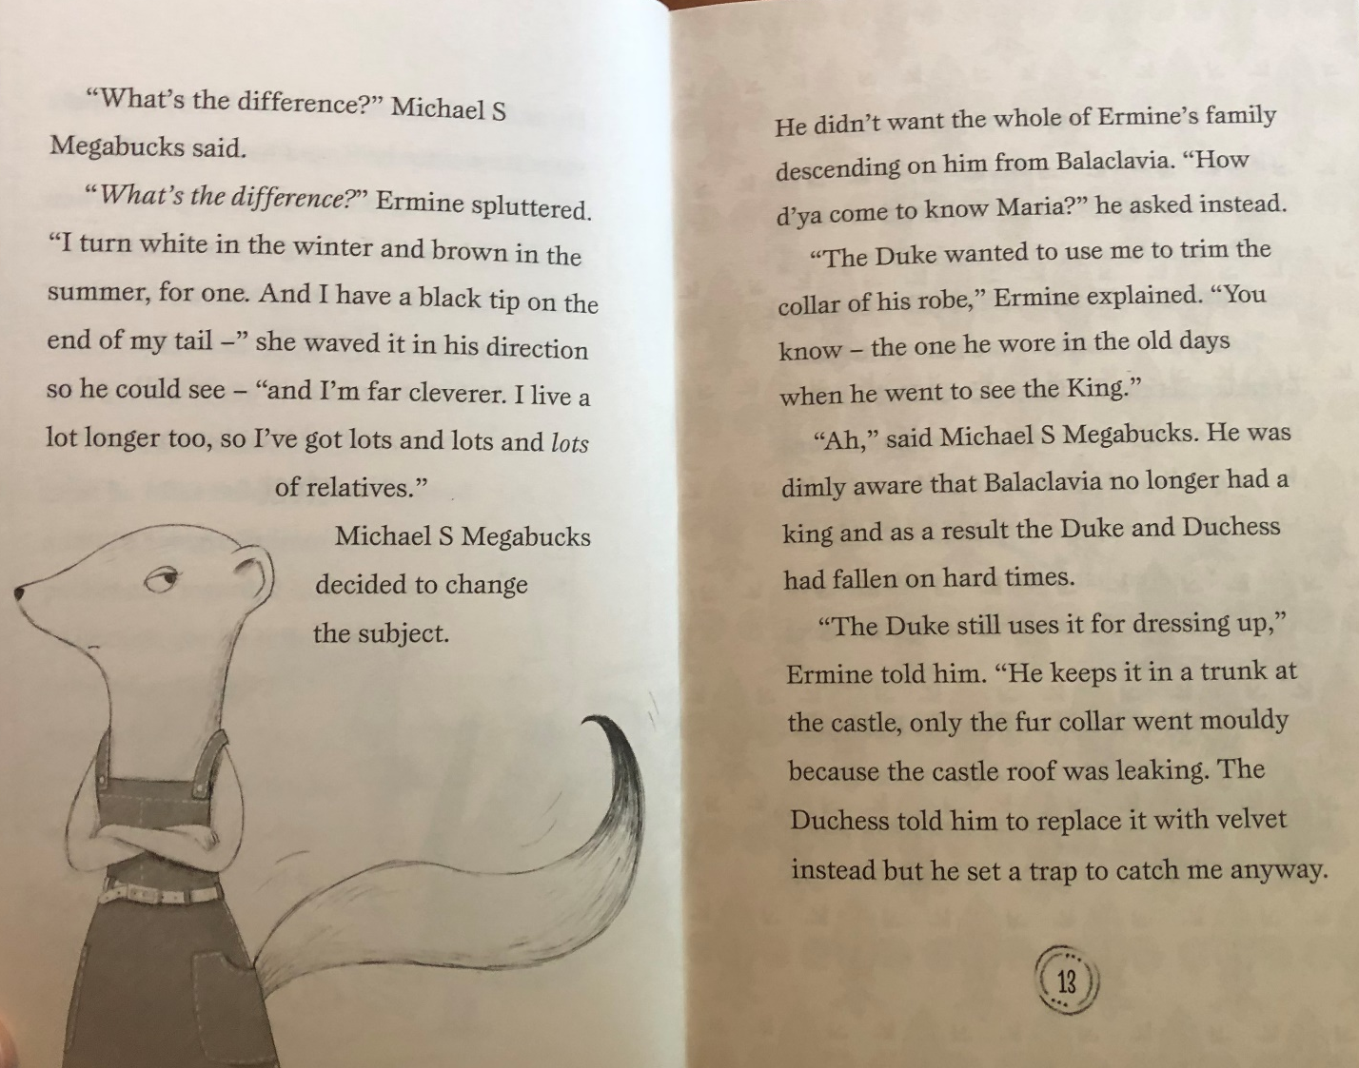

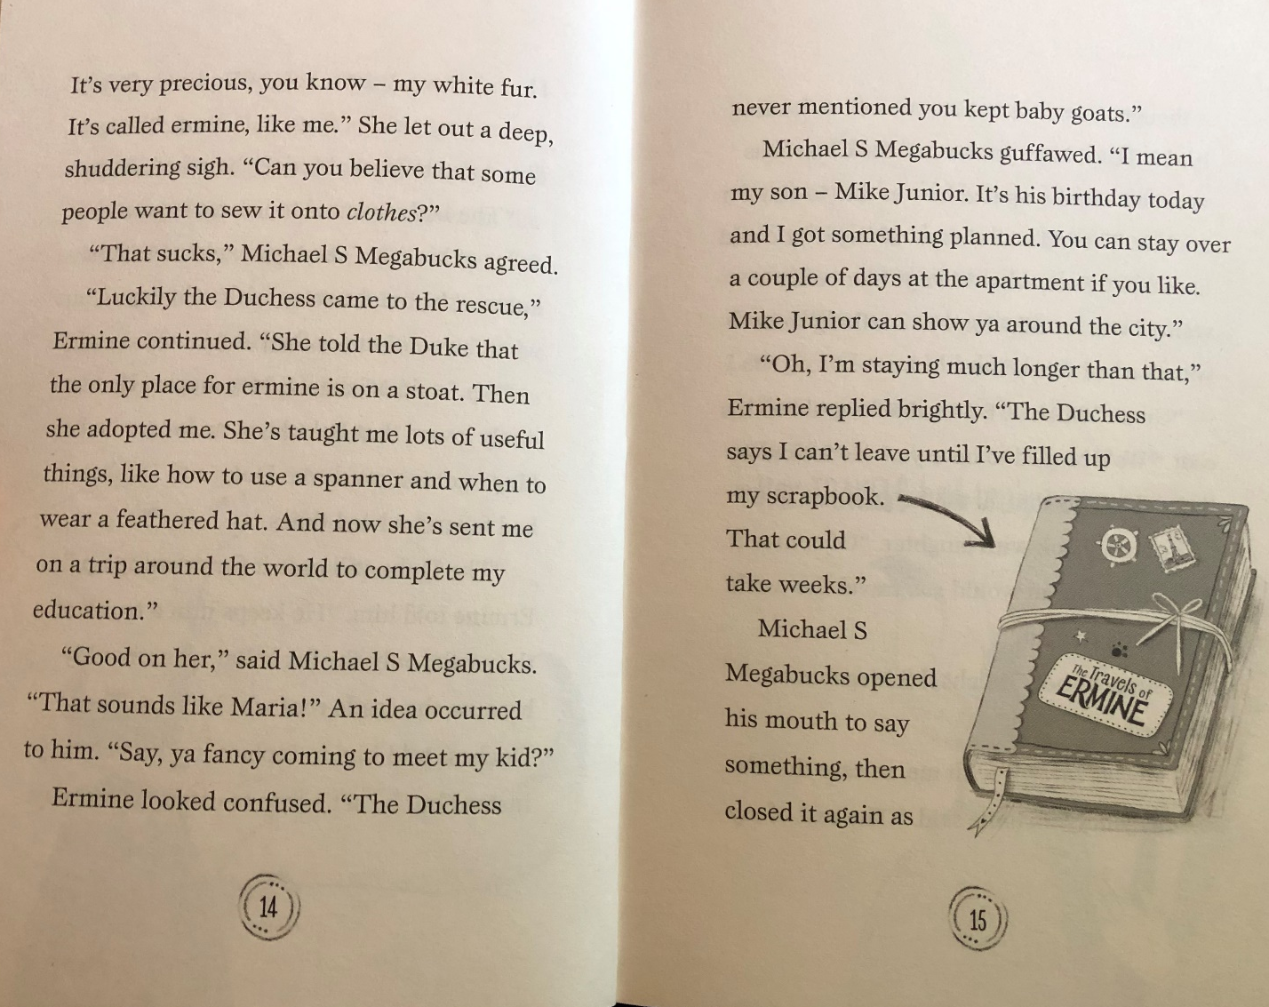

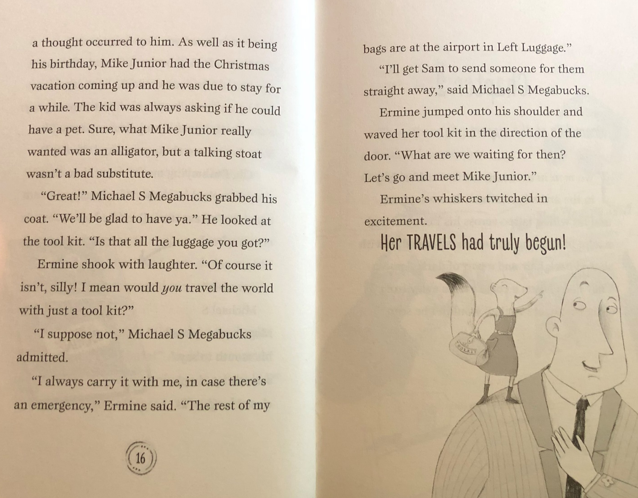

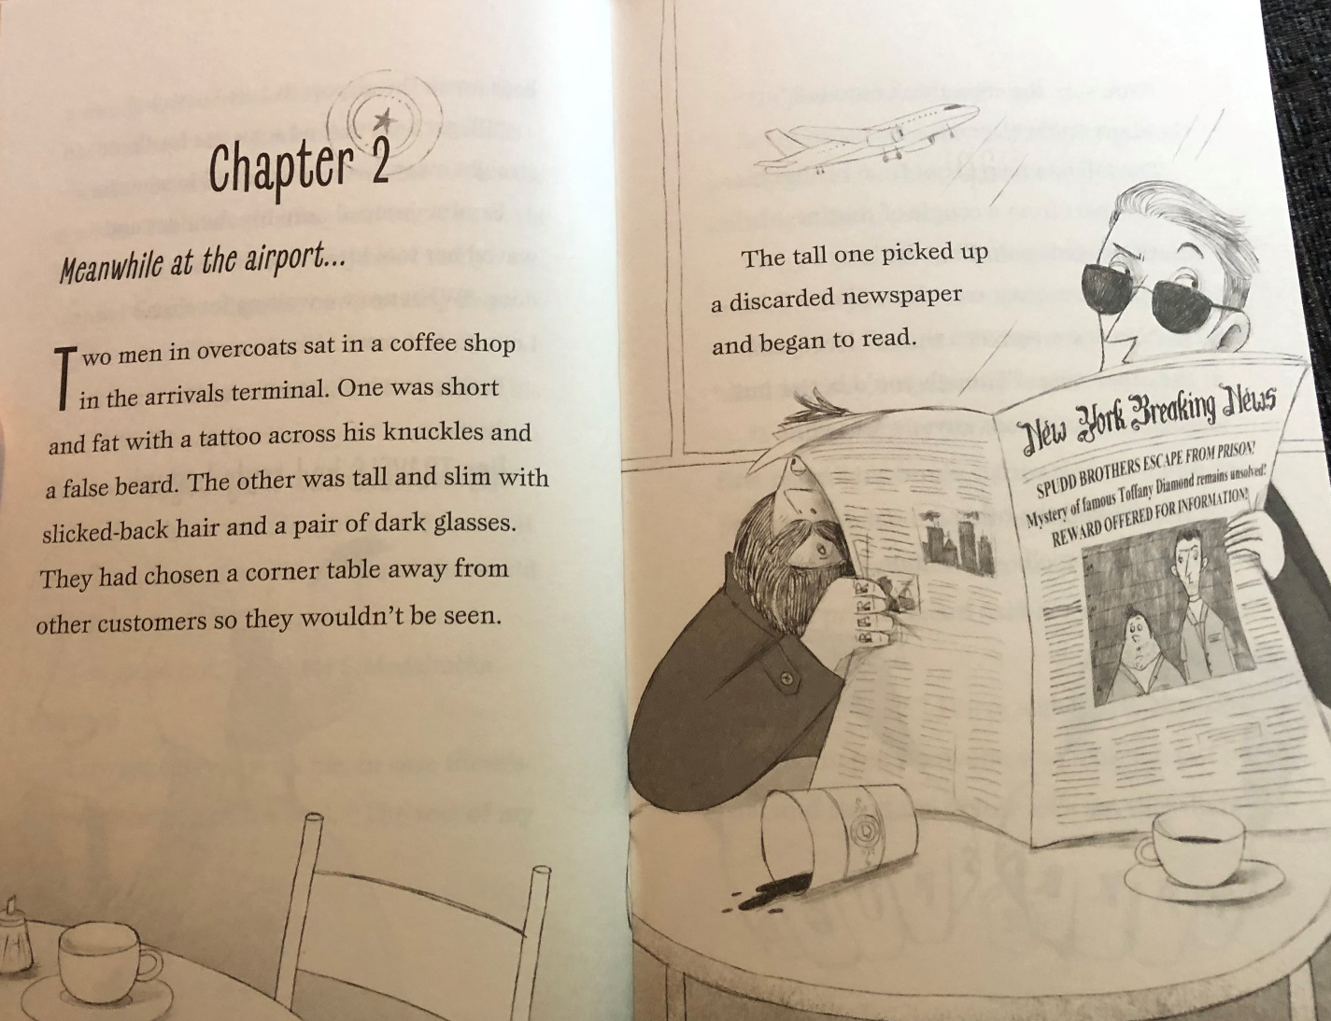

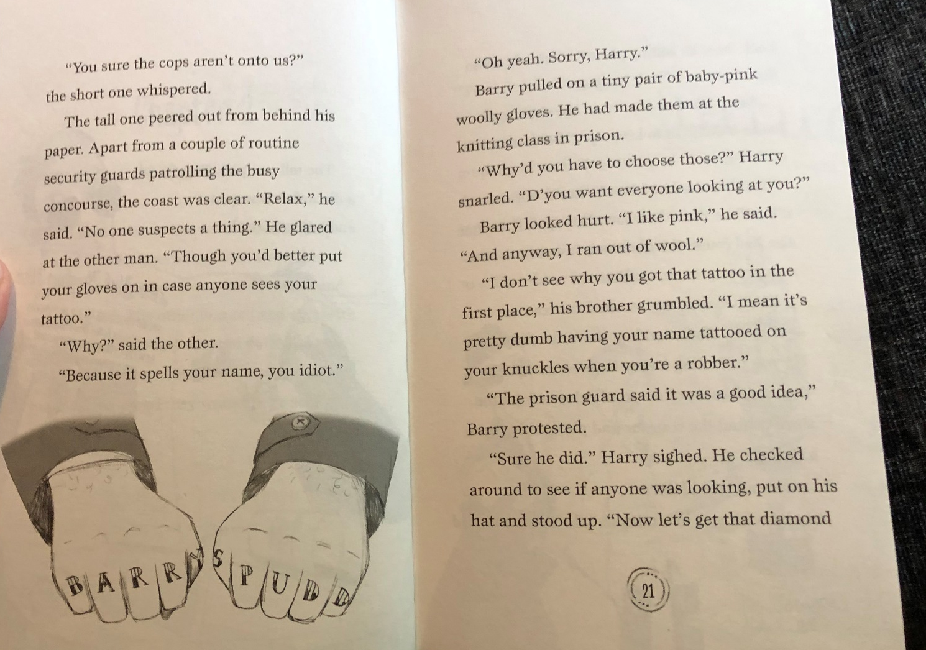

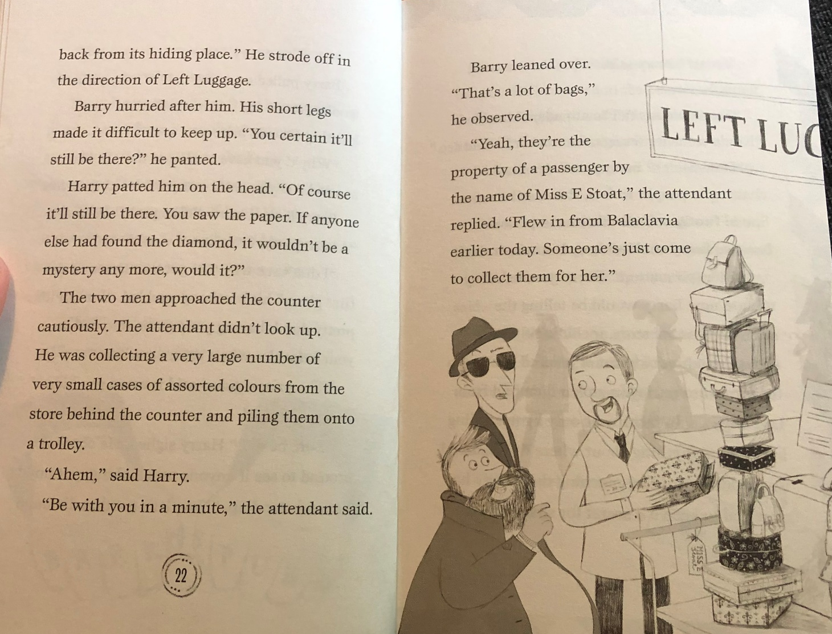

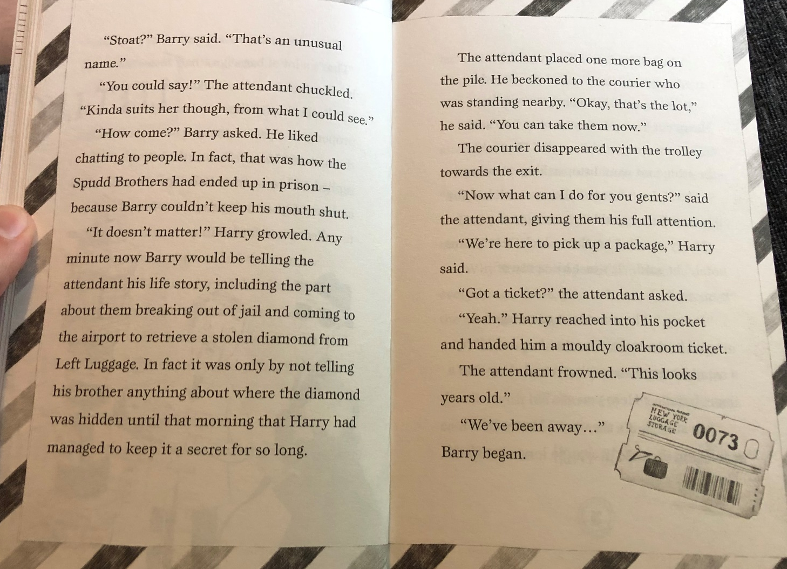

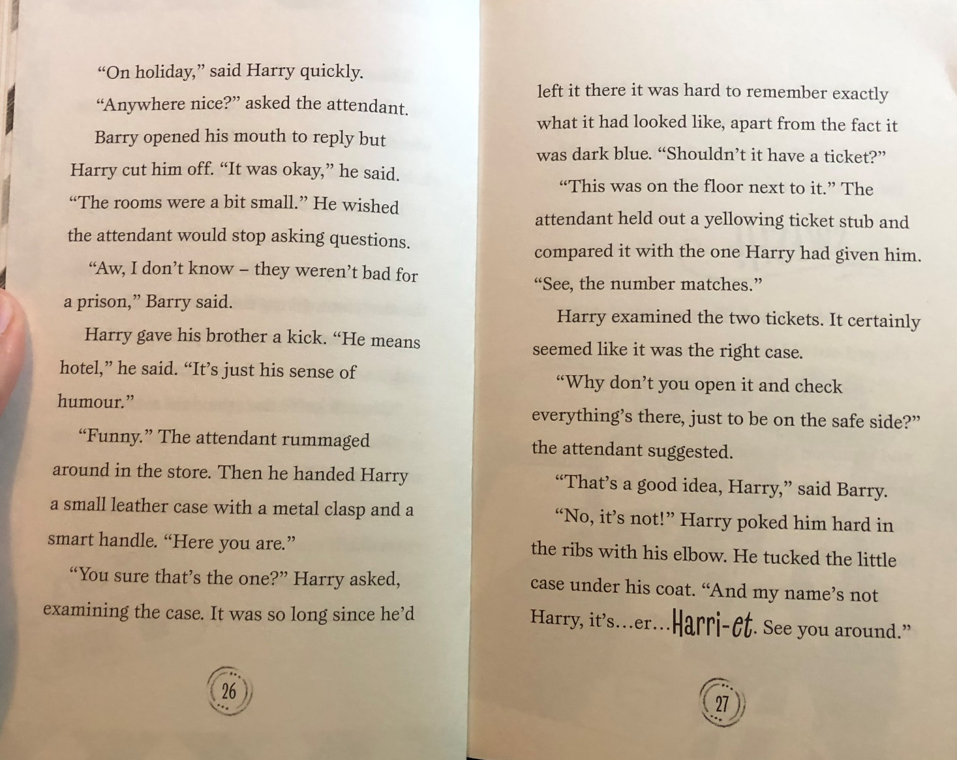

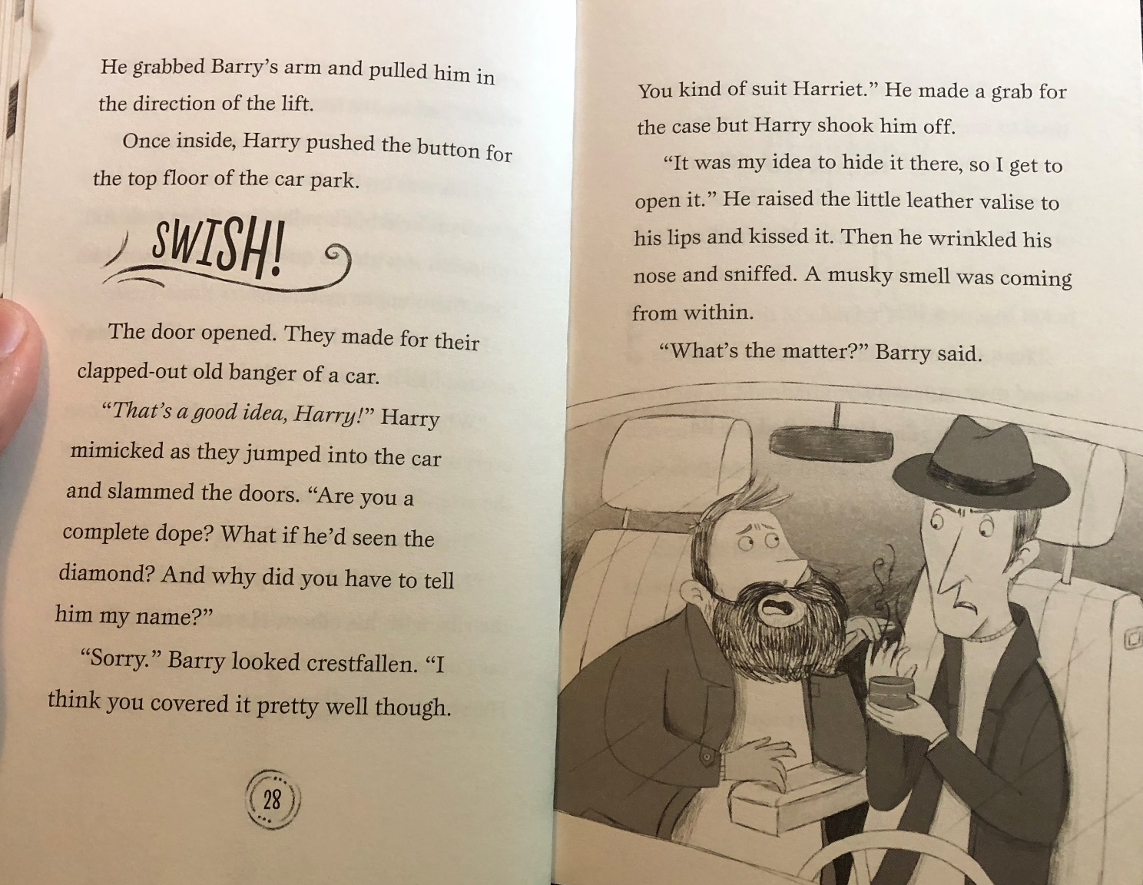

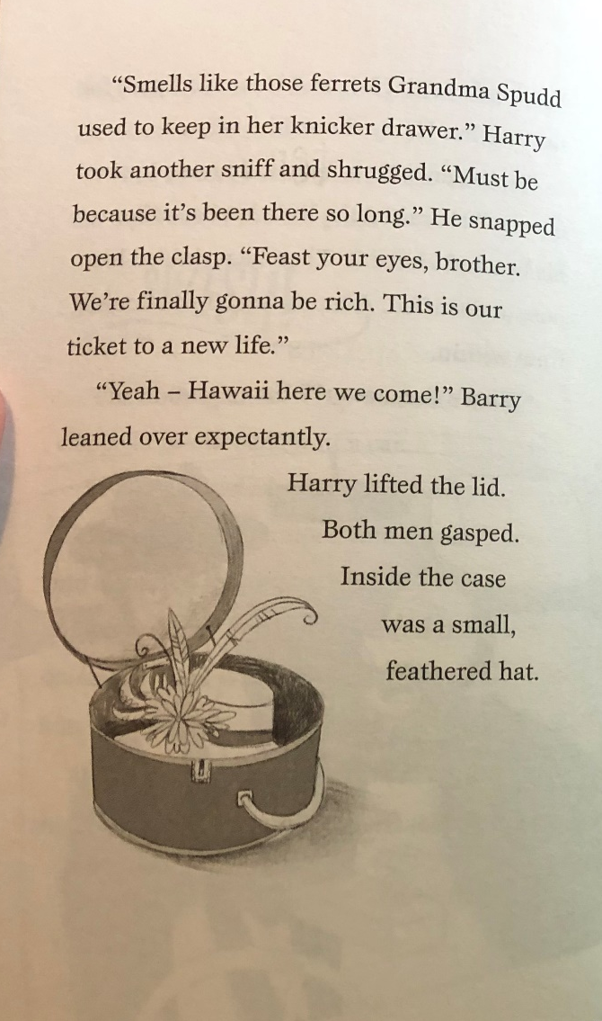
TASK ONE - ANSWERS
Knowledge: Why did the Duke set a trap to catch Ermine?
He wanted to use her fur for the collar of his robe.
Comprehension: How would you describe Ermine’s personality?
Confident, proud, intelligent, organised (or any other relevant answer).
Apply: If you were Ermine, where would you like to travel in the world and why?
Any relevant answer which is explained.
Analysis: Why do you think Harry gave Barry a kick at the ‘Left Luggage’ desk?
Harry was angry that Barry told the attendant they had just been in prison and wanted to stop him from saying more.
Evaluation: Do you think that Harry and Barry will still go to Hawaii? Explain your answer.
No, because they need to sell the diamond for the money to get to Hawaii and the diamond is now missing.

Tuesday English:

The Magic Box

Verse 1 (favourite sounds)
I will put in the box,

Verse 2 (favourite things)
I will put in the box,

Verse 3 (imaginary items)
I will put in the box,

Verse 4 (what it’s made from)

My box is fashioned from and and

With on the lid and in the corners.

It’s hinges are

Tuesday Jigsaw (pairs games):

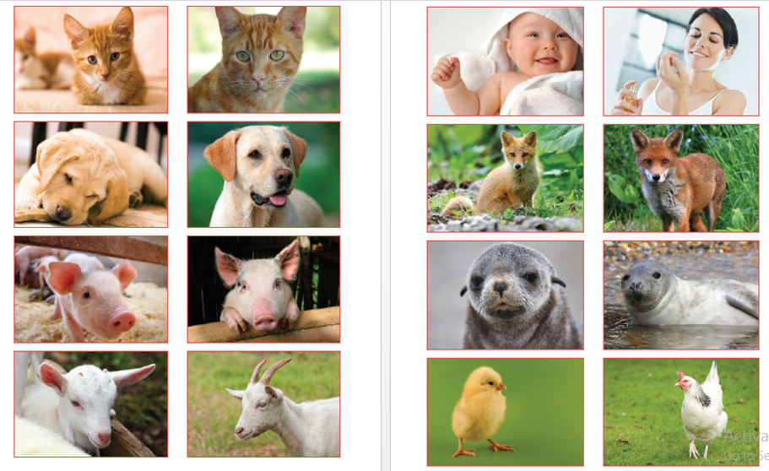

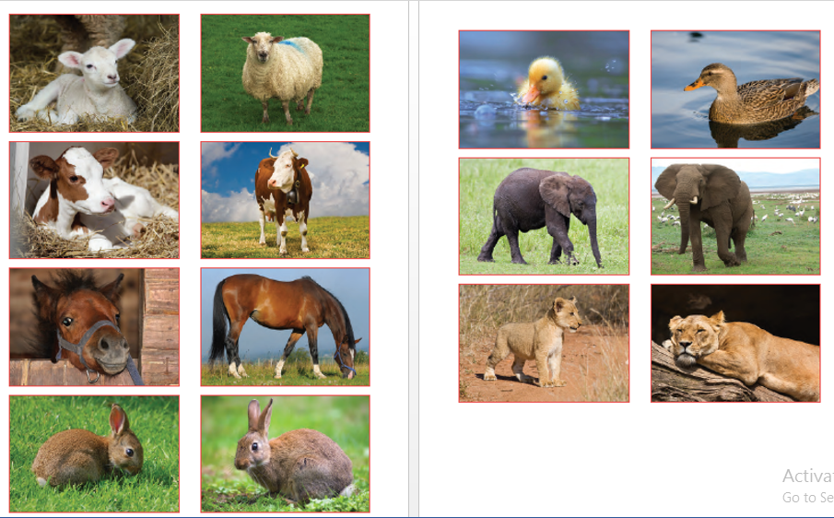

Tuesday Jigsaw (task 3 template):

From birth | Young child/animal | Adult

From birth | Young child/animal | Adult

From birth | Young child/animal | Adult

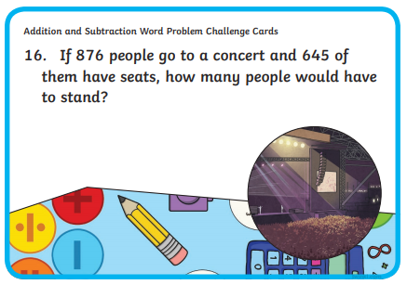
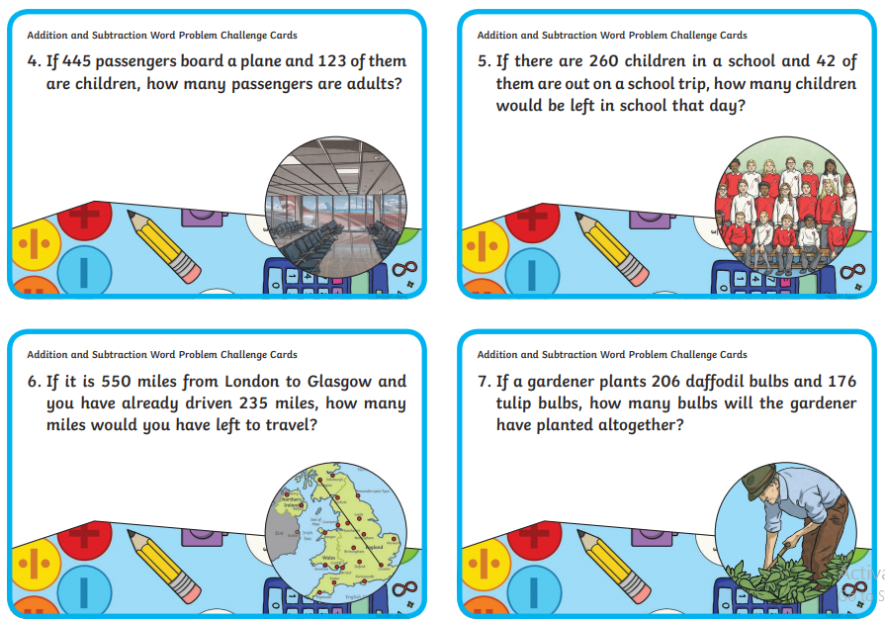
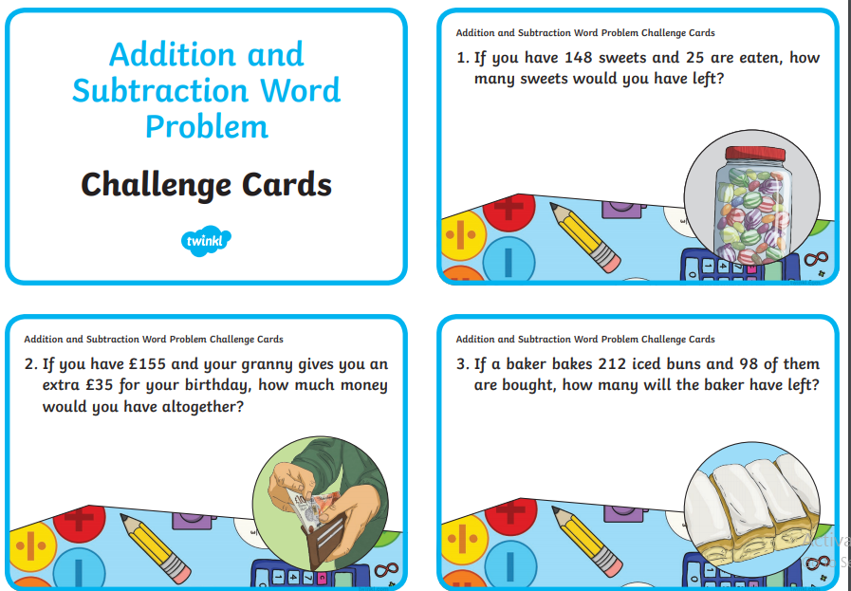
Wednesday and Thursday maths (mild):
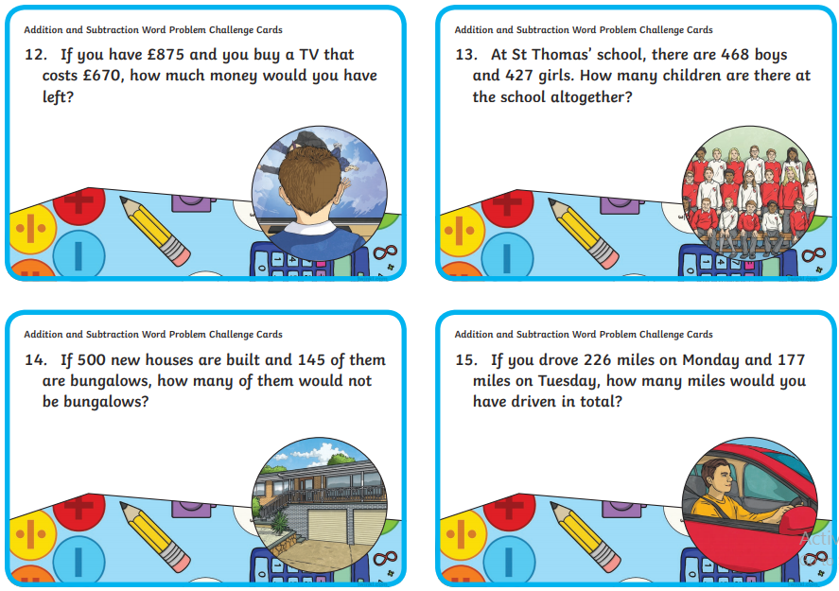
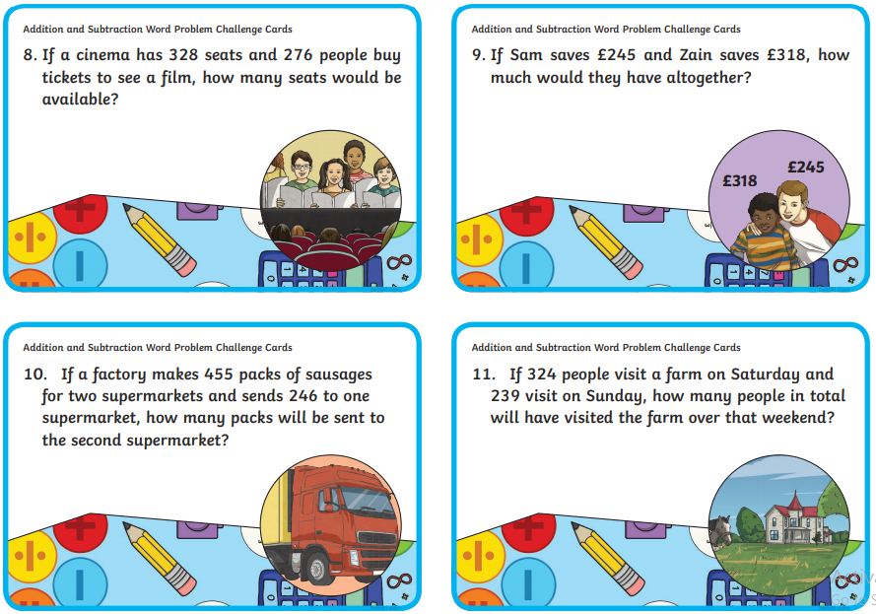

Wednesday and Thursday maths (hot/spicy)

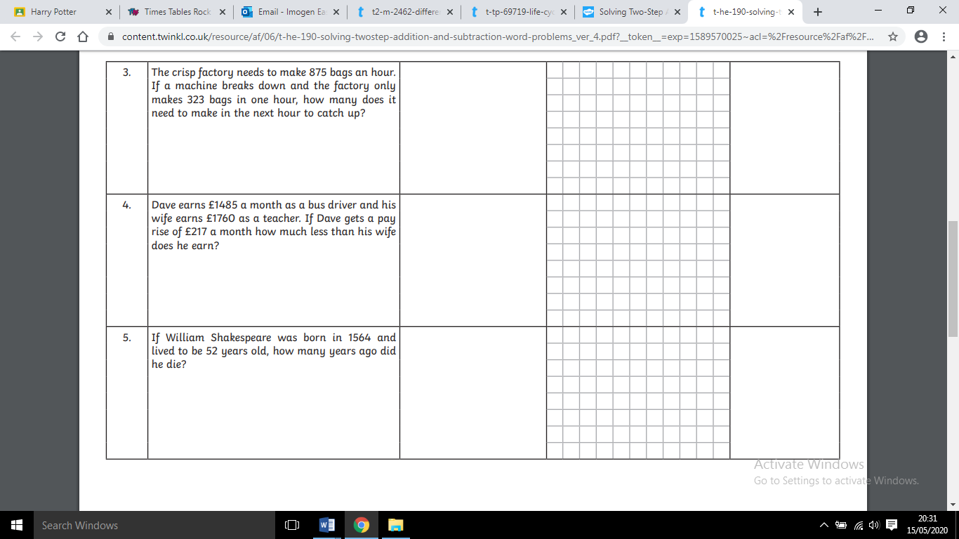
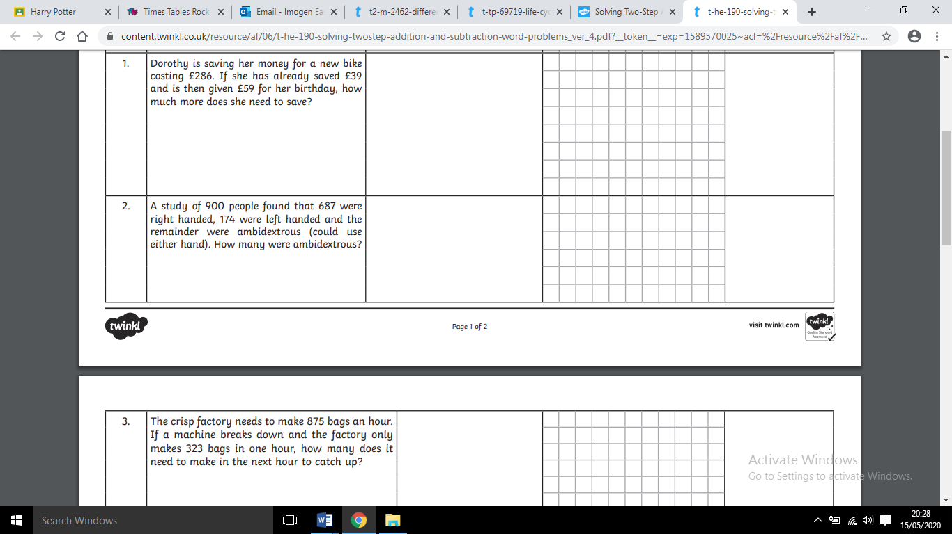
Q. | Word problem | Two steps | Working out | Answer

1. Julia has 92 conkers. Tamara has 58 more. How many conkers does Tamara have? | 2. Michael had 162 stickers. He swapped 45 for a comic and 28 for a poster. How many stickers does he have now?
3. Danielle scored 138 on level 1 of her computer game. She scored 197 on level 2. However, she lost 72 points. What is her total score? | 4. At the archery competition, our team was Seema and Yusef. Seema scored 182, and Yusef scored 236. The winning team’s score was 511. How many less than the winning team did our team of Seema and Yusef score?
5. Mrs Gill makes 238 cakes for the Children In Need Cake Sale, but Mrs Manchester buys 29 of them before the sale starts and Miss Bell buys 45. How many cakes are left for the sale? | 6. Miss Boon took 57 children on a camping trip. They met up and camped with two more school groups, one with 46 children, and the other with 64. How many children were there in total at the camp?
7. 603 spectators attended a football match this week. That is 263 fewer people than last week. How many spectators were there last week? | 8. One length of a swimming pool is 25 m. Luke has swum three lengths so far. He is trying to swim 500m. How many more lengths does he need to swim?
9. Last week Ellie scored 279 in archery. For her First Class award she must score 401.  How many more points must she score before she can achieve her First Class award? | 10. The teachers bought a new box of tea bags for the staff room. The boxed contained 480 tea bags. Last week, they used 86 bags. This week they used 155 tea bags. How many tea bags are left?

Wednesday science:
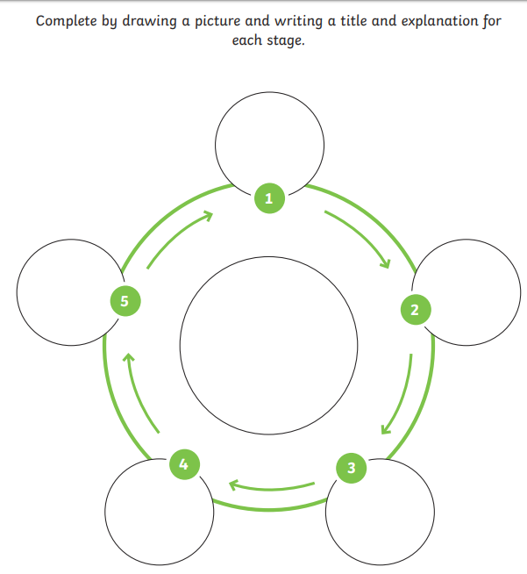

Thursday English (mild):
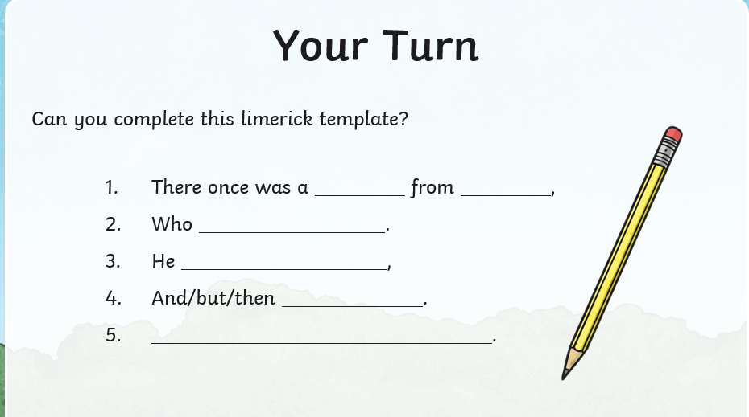

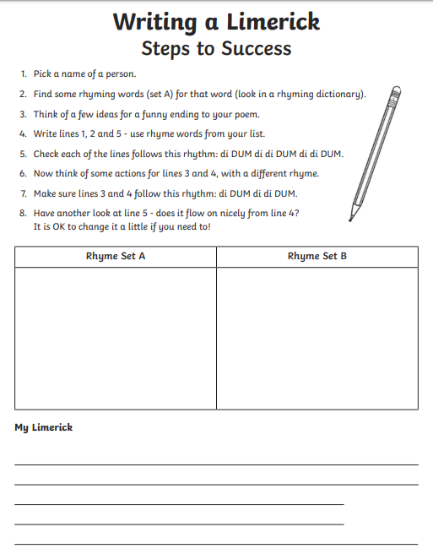
Thursday English (hot/spicy):

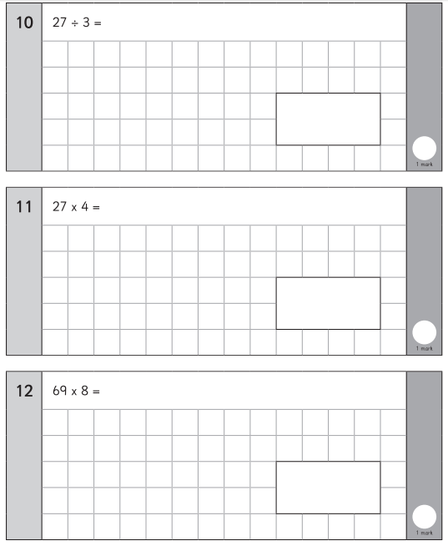
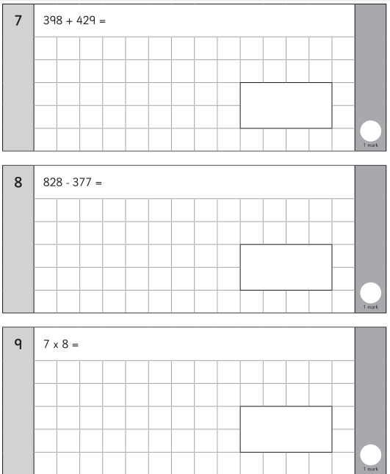
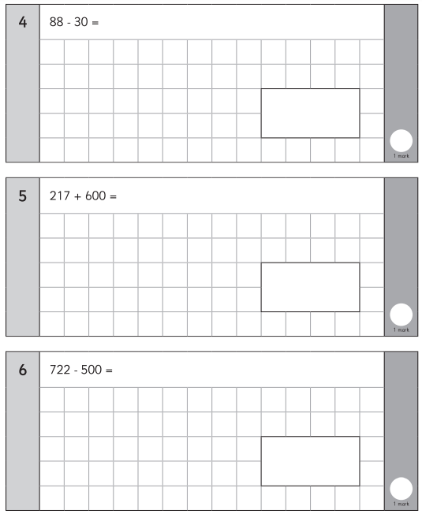
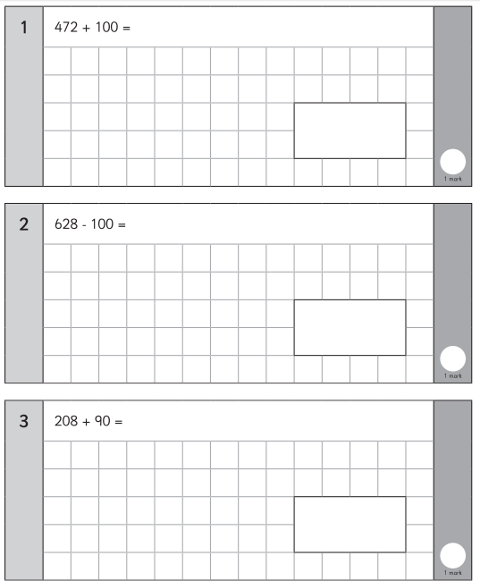
Friday maths:

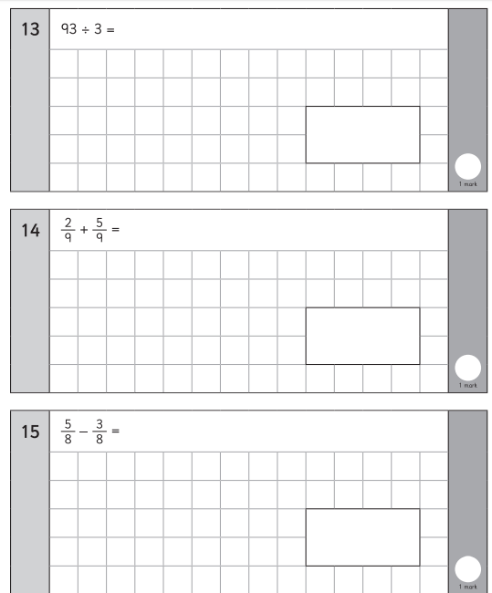

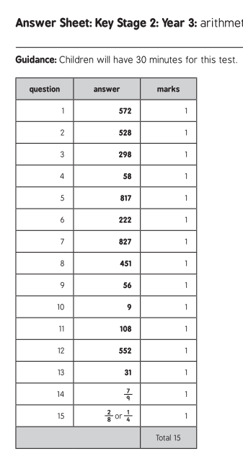

Spellings:

who
whole
wild
with
write
would
you
your

MILD
Words with the ph sound:
photo
phone
sphere
nephew
trophy
graph

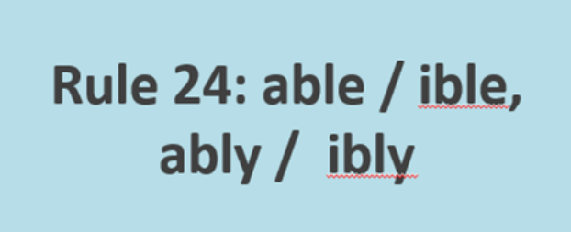

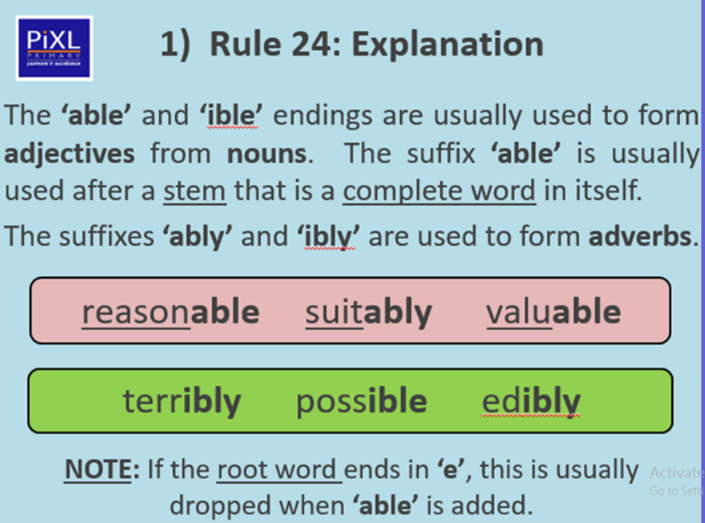

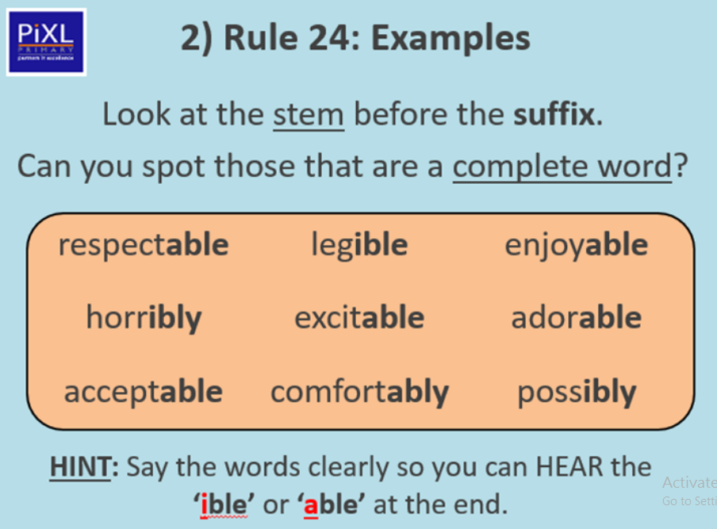
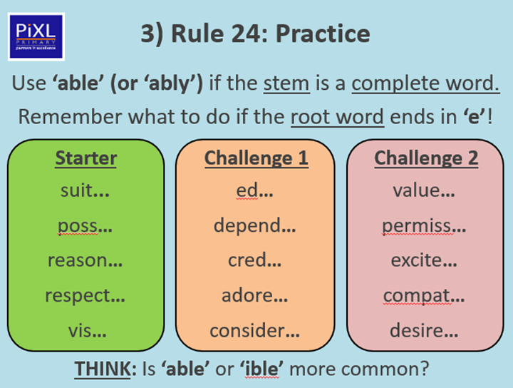
ACTIVITY ONE

ACTIVITY TWO – Choose three words from each column and put them into nine different sentences.



