
Learning Activities
Year 3 2019-20

Self-isolation learning Week 8
Lessons set  Every child is expected to complete three pieces of learning per day. Most of what is listed below has been taught in school. This is for revision and will allow children to practise skills already learnt. Where new skills are being introduced, we will provide as much support as possible by means of videos, pictures and websites. Please do not hesitate to email the year 3 email address if you have any questions regarding the learning.  For every piece of learning completed to a good standard will be rewarded with 5HP.  Please share your hard work on Twitter and via email, we would love to see how you are all getting on! |  | Additional comments  Worksheets attached do not need to be printed. Use them to access questions matching LOs (learning objectives). They can be copied and written onto paper for children to complete.
Monday | Maths  Starter: 3 times tables  Sing: https://www.youtube.com/watch?v=dzVyBQ5uTbo  https://www.youtube.com/watch?v=9XzfQUXqiYY  Play: https://www.timestables.co.uk/3-times-table.html  L.O. To be able to add and subtract mentally.  Task 1: Watch this video of Miss Easthope explaining how to mentally add and subtract tens and hundreds:  https://imogen-easthope.wetransfer.com/downloads/fbb1106eba82ee17f5ebb4653356a2e820200513153440/fce566a03bbeab20aaa27ef42887c04d20200513153440/093968  Practise adding and subtracting these questions mentally:  Task 2: You will need a partner for this task, maybe your sibling, a grown up at home or you could even Facetime a friend.  Make 2 dice. You can use the templates provided or make your own. One dice should have 1-6 on it, the other A-F.  Next, cut out two sets of 36 coloured counters (you can either make your own or use the templates provided).  Finally, you are ready to play ‘Treasure Ahoy!’. Roll the dice to get your coordinates and try to answer the question. Remember, you should be adding or subtracting in your head! If you answer correctly, place a coloured counter over the question. The person with the most counters on the board at the end of the game wins!  Try a daily 10: https://www.topmarks.co.uk/maths-games/daily10  English (GPAS): Nouns, adjectives, verbs and adverbs  Watch the video below to recap on what nouns, adjectives, verbs and adverbs are:  https://www.youtube.com/watch?v=7zRih61HCZs  Task: Read the text and identify the nouns, adjectives, verbs and adverbs. Underline/highlight:  Nouns - blue  Adjectives - red  Verbs - yellow  Adverbs - green  Extension: Can you make a poster for one of the word classes? Explain what the word class is and give examples of that word class.  SLOR: Read Chapters 1 and 2 of ‘The Travels of Ermine’ attached.  Task 1: Answer the questions attached.  Task 2: Write a prediction about what you think will happen next in the story. Who does the feathered hat belong to? Who now has the diamond? What will the robbers do next? | Remember to play 10 garage games of TT Rockstars every week.  Worksheets attached.  Text attached.  Remember to continue to read at least 3 times at home.  Story and activities attached.
  42 + 30 | 84 – 50
  126 + 60 | 156 – 30
  257 + 400 | 874 – 600
  92 + 500 | 527 – 400
  179 + 50 | 121 - 40
Tuesday | Maths  Starter: 4 times tables - sing 4 times table song:  Sing: https://www.youtube.com/watch?v=lBmSshEDVnQ  https://www.youtube.com/watch?v=9ue9Kux95H0  Play: https://www.timestables.co.uk/4-times-table.html  L.O: To be able to add and subtract using a formal written method.  Watch the stage 3 videos on our school website to jog your memories on how to add and subtract using the year 3 methods.  Addition:https://www.swingate.medway.sch.uk/page/?title=Addition&pid=99  Subtraction:https://www.swingate.medway.sch.uk/page/?title=Subtraction&pid=100  Task: Complete these questions using the methods as shown in the videos. Watch out for questions when you may need to bridge or exchange:  Extension: Try these word problems:  Miss Straub bought 30 cakes and Mrs Gill bought 24 more. Miss Easthope ate 15 of the cakes. How many cakes were left?  Ms Tulett collected 112 stickers and Mrs Manchester added 56 more to the collection. Miss Bell used 39 of the stickers with Owl class. How many stickers were left?  Try a daily 10:  https://www.topmarks.co.uk/maths-games/daily10  English:  LO: To be able to write a poem.  Watch: https://www.bbc.co.uk/bitesize/clips/zkpmhyc  Write your own poem called ‘The Magic Box’. What will you put in yours?  Mild – Use the template.  Hot/Spicy – Write your own (aim for four verses).  Remember to use:  - Alliteration (two or more words starting with the same sound e.g. silk sari on a summer night)  - Onomatopoeia (words which sound like their meaning e.g. swish, crack, sizzle, crunch)  - Simile (comparing one thing to something else e.g. a diamond as bright as the dazzling moon)  - Metaphor (saying one thing is something else e.g. a blanket of snow)  - Personification (making something which is not alive seem alive e.g. a snowman with a rumbling belly)  Decorate your poem with all of the things that you would put in your box.  Extension: Perform your poem and send it to us via email or on Twitter!  Watch: Here are some top tips for performing a poem:  https://www.youtube.com/watch?v=RvV23xoZRkI  https://www.youtube.com/watch?v=wFCcbFtd6Zo  Here are some more videos of poems being performed:  https://www.youtube.com/watch?v=7BxQLITdOOc&t=198s  https://www.youtube.com/watch?v=uQerZSWZ4hw  https://www.youtube.com/watch?v=ByAg5aoyAN4  Jigsaw:  L.O To be able to understand that in animals and humans, lots of changes happen between conception and growing up.  Task 1 – Pairs game:  Cut out the cards and turn them upside down. Play the pairs game. Match the baby to the grown up.  Once you have successfully paired the cards, what differences do you notice between each baby and grown up?  Task 2 - Discussion:  - Look at the baby pictures. How do they make you feel? What do you think it is that makes you feel like that?  - What is the role of the mother and of the father in growing and looking after the baby?  - What do you think it’s like to have a new baby in the family? What do they need?  Task 3 – Drawing:  Choose three of the baby cards from your earlier pairs game. Draw what they will look like at each stage of their lives e.g. baby, child, adult. When you have finished, you should be able to see a change between each picture. | Template for mild attached.  Pairs game attached.  Template attached.
  34 + 25 = | 67 – 23
  41 + 36 = | 89 – 45
  152 + 24 = | 166 - 51
  133 + 55 = | 285 – 34
  225 + 162 = | 378 - 143
  440 + 328 = | 469 – 328
  39 + 23 = | 82 – 47
  135 + 59 = | 163 – 25
  547 + 281 = | 438 – 214
  696 + 135 = | 534 - 356
Wednesday | Maths:  Starter: 4 times tables  Play: Hit the button to practise your 4 times tables.  https://www.topmarks.co.uk/maths-games/hit-the-button  L.O. I can add and subtract to solve word problems.  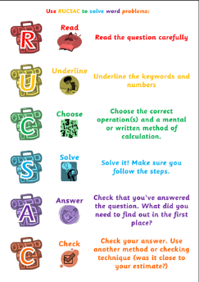  Task:  Use a RUCSAC to solve:  Mild – single step word problems  Hot/Spicy – two step word problems  Extension:  Can you write three of your own single or two step word problems and get a friend/sibling or grown up to solve them?  Try a daily 10:  https://www.topmarks.co.uk/maths-games/daily10  English (GPaS): Subordinate clauses  A subordinate clause can’t stand alone in a sentence because it doesn’t make sense. It must be paired with a main clause to give more detail. Subordinate clauses can be found at the start, the middle and the end of a sentence. The sentences below give examples of each.  - Sitting happily, the chicken laid eggs.  - The chicken, who was busy laying eggs, sat happily.  - The chicken laid eggs, sitting happily.  In the first and third examples, ‘the chicken laid eggs’ is the main clause – it makes sense on its own. ‘Sitting happily’ is the subordinate clause – it doesn’t makes sense on its own, it provides extra detail for the main clause. In the second, ‘The chicken sat happily’ is the main clause and ‘who was busy laying eggs’ is the subordinate. You may also notice that when your subordinate clause is in the middle of a sentence, it is normally separated by commas.  Watch: https://www.youtube.com/watch?v=DTBS9IgF7iE This is a GPaS lesson brought to you from a fellow teacher in another school who has kindly shared resources! Pause the video when asked and have a go at adding your own subordinate clauses to the main clauses.  Science:  L.O: I can identify and describe the life cycle of a flower.  Task 1:  Watch the videos showing the life-cycle of two different plants:  https://www.bbc.co.uk/bitesize/clips/zystsbk  https://www.bbc.co.uk/bitesize/clips/zhrb4wx  Makes notes about what has happened to the plants from start to finish.  Task 2:  After you have watched the videos, you should be able to see these steps in a flower’s life-cycle:  - Formation and growth of the flower-bud  - The flower opening  - The flower withering and the petals dropping off  - As the flower withers, the fruit or seeds begins to grow in the middle of it  - The fruit grows in size and becomes juicy, or dries and splits open, releasing the seeds inside.  Watch: https://www.youtube.com/watch?v=AcSgaUBwIn4  Create a life-cycle of a plant or flower of your choice. Each stage should have a title, a picture and a sentence explaining what is happening. | Questions attached.  Please note: mild problems and hot/spicy problems attached will need to split in half for both Wednesday’s and Thursday’s maths lessons. If you do the mild problems today and found them easy, try some of the hot/spicy problems tomorrow.  Template attached.
Thursday | Maths:  Starter: 8 times tables  Sing: https://www.youtube.com/watch?v=0X620IeUkYE  https://www.youtube.com/watch?v=kN3RG5iLKpo  L.O. I can add and subtract to solve word problems.  Task:  Use a RUCSAC to solve:  Mild – single step word problems  Hot/Spicy – two step word problems  Extension:  Can you write three of your own single or two step word problems and get a friend/sibling or grown up to solve them?  Try a daily 10:  https://www.topmarks.co.uk/maths-games/daily10  English:  L.O: To be able to write a limerick.  After your poetry writing on Tuesday, today you’re going to have a go at writing a limerick.  Watch: https://www.youtube.com/watch?v=Wy65TkCadfU  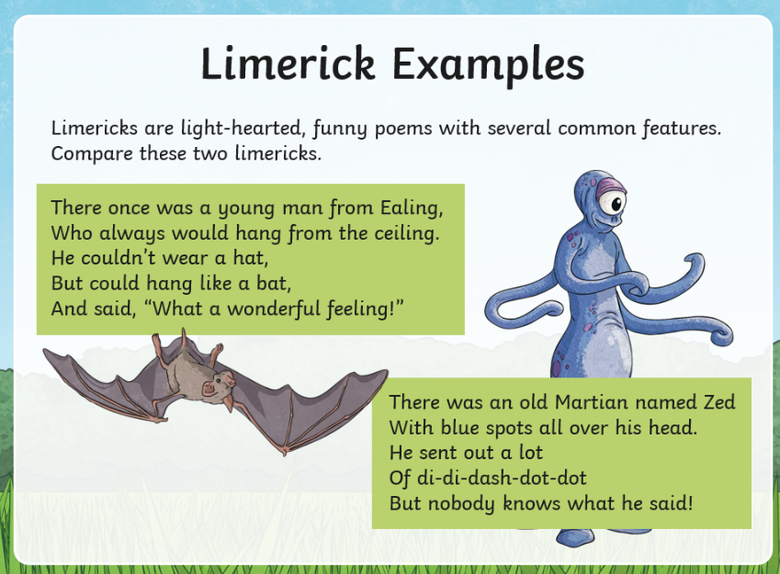  Look at these examples of limericks:  Here are the rules for a limerick:  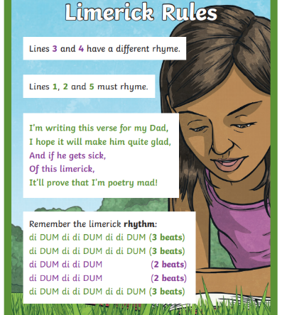  Lines 1, 2 and 5 are longer and have approximately the same number of syllables (usually 8-10) in each.  Lines 3 and 4 are shorter, with the same number of syllables (5-6).  Task: Try writing your own limerick.  Mild – Use the template provided. Remember to think about  rhyming words and maybe note these down before  you begin.  Hot/Spicy – Use the template provided.  Extension: Perform your poem and send it to us via email or on Twitter!  Topic:  L.O: To be able to design and make a leaflet.  Our new topic is ‘Eurovision’ where we will be learning all about the continent of Europe.  Task 1: Make a list of everything you know about Europe. What’s the main currency? Which countries are in Europe? Do you know any European languages/foods/sports/dances/ music? Remember: This should be things you ALREADY know. So please don’t cheat and use the internet!  Today, you are going to do learn about France! France is one of the countries in Europe.  Task 2: Research France using the websites below or some of your own if you’d like:  http://www.primaryhomeworkhelp.co.uk/france.html  https://www.coolkidfacts.com/france-facts/  https://www.natgeokids.com/uk/discover/geography/countries/facts-about-france/  Create a poster all about France and the things you have learnt after your research. Include:  - A title  - Key facts on a range of things (e.g. food, monuments, history, cities, currency, population etc.)  - Colourful pictures  Task 3: You are going to be in the Eurovision Song Contest!  Watch: https://www.youtube.com/watch?v=K253_MHt_9c  Eurovision is a singing competition which takes place annually. Participating countries will nominate one act to compete for them with the hope of winning. The last time England won was in 1997 with Katrina and the Waves with the song ‘Love shine a light’.  Watch: https://www.youtube.com/watch?v=u-o5v3wpI1o  You are going to participate for France and this year, their chosen song is, ‘Heads, shoulders, knees and toes’. Now, because you are competing for France, you’re going to have to learn the song and perform it…in French!  Watch: https://www.youtube.com/watch?time_continue=38&v=0EFXCdryyRM  Once you’ve learnt the song, perform to your family (with the actions of course) and then maybe send it to us via email or Twitter! We’d love to see your performances too! | Questions attached.  Please note: mild problems and hot/spicy problems attached will need to split in half for both Wednesday’s and Thursday’s maths lessons. If you did the mild problems yesterday and found them easy, try some of the hot/spicy problems today.  Templates attached.
Friday | Maths:  Starter: 8 times tables  Play: https://www.topmarks.co.uk/times-tables/coconut-multiples  Arithmetic test practise: Answer the questions from the arithmetic test. Try to remember the methods you have learnt in school.  Try a daily 10:  https://www.topmarks.co.uk/maths-games/daily10  English: Spellings  Practise the Year 3 and 4 Common Exception Words. You can do this by drawing the word, covering, acting, spelling out loud, tests etc.  Weekly spelling rule: ‘able’, ‘ible’, ‘ably’ and ‘ibly’.  PE:  Create your own workout! Think about movements/ stretches/exercises which get your heart beating and your blood pumping. Once you have thought of six different movements/stretches/exercises, combine them altogether to create your own workout.  Extension: Try these exercises  Have a go at Oti Mabuse’s daily dance class for kids:  https://www.youtube.com/user/mosetsanagape  Joe Wicks the body coach’s daily PE lessons:  https://www.youtube.com/user/thebodycoach1  Cosmic kids yoga has loads of different sessions to try:  https://www.youtube.com/user/CosmicKidsYoga  Try moving whilst learning with these videos:  https://www.bbc.co.uk/teach/supermovers/ks2-collection/zr4ky9q | Arithmetic test and answers attached.  Weekly spellings and lessons on the weekly spelling rule are attached.

Learning Activities
Year 3 2019-20

Self-isolation learning Week 9
Lessons set  Every child is expected to complete three pieces of learning per day. Most of what is listed below has been taught in school. This is for revision and will allow children to practise skills already learnt. Where new skills are being introduced, we will provide as much support as possible by means of videos, pictures and websites. Please do not hesitate to email the year 3 email address if you have any questions regarding the learning.  For every piece of learning completed to a good standard will be rewarded with 5HP.  Please share your hard work on Twitter and via email, we would love to see how you are all getting on! |  | Additional comments  Worksheets attached do not need to be printed. Use them to access questions matching LOs (learning objectives). They can be copied and written onto paper for children to complete.
Monday | Maths  Starter: 4 times tables - sing 4 times table song:  Sing: https://www.youtube.com/watch?v=lBmSshEDVnQ  https://www.youtube.com/watch?v=9ue9Kux95H0  Play: https://www.timestables.co.uk/4-times-table.html  L.O. To multiply and divide using times table facts.  Use your knowledge of the 3, 4 and 8 times tables to complete the treasure hunt and reveal the secret letters.  PARENTS: You can chose whether you want to print and hide the letters around your house or to let your children read the letters off the computer screen and match them to your answers.  Try a daily 10: https://www.topmarks.co.uk/maths-games/daily10  English (GPAS): Quiz  Complete the Year 3 GPaS quiz.  This is a great opportunity to identify strengths and weaknesses.  Extension: Create a table of the GPaS topics you are great at and the GPaS topics that need some more revision and practise.  SLOR: Read Chapter 3 of ‘The travels of Ermine’ attached.  Task 1: L.O. To give/explain the meaning of words in context.  Task 2: L.O. To identify the main ideas drawn from a story and summarise them. | Remember to play 10 garage games of TT Rockstars every week.  Resources attached.  Quiz attached.  Remember to continue to read at least 3 times at home.  Story and activities attached.
Tuesday | Maths  Starter: 3 times tables  Sing: https://www.youtube.com/watch?v=dzVyBQ5uTbo  https://www.youtube.com/watch?v=9XzfQUXqiYY  Play: https://www.timestables.co.uk/3-times-table.html  L.O: To be able to multiply using the grid method.  Task: Complete the attached worksheet (2 digits by 1 digit numbers)  Extension: Complete the attached worksheet (3 digit by 1 digit numbers).  Try a daily 10:  https://www.topmarks.co.uk/maths-games/daily10  English: Play scripts (This topic will be covered over the next two weeks, please don’t misplace your work)  LO: To plan a play script  Watch: https://www.bbc.co.uk/bitesize/topics/zsn4h39/articles/z24vjty  https://www.bbc.co.uk/bitesize/topics/zsn4h39/articles/zx8kng8  Use the planning format as a guide to create your own play. It can be about anything you want it to be! Remember you are only planning it today you don’t have to write it yet.  Jigsaw:  L.O To understand how babies grow and develop in the mother’s uterus and understand what a baby needs to live and grow.  To express how I might feel if I had a new baby in my family.  Recap from last week: What does a baby need to grow and survive?  Did you think of love and affection as well as the physical things (milk, nappies, cot, etc.)  Task 1: Let's think about the start of a baby's life.  Where does a baby begin to grow?  How does it grow?  Task 2: Draw a picture of a baby and around the edge of your picture design a collage showing all the things a baby needs to survive, to live and to grow.  Extension: Reflect.  What are the three most important things a baby needs in order to survive and grow? | Worksheets attached.  Template attached.
Wednesday | Maths:  Starter: 4 times tables  Play: Hit the button to practise your 4 times tables.  https://www.topmarks.co.uk/maths-games/hit-the-button  L.O. To be able to divide using the bus stop method.  Complete all the challenge questions.  How many questions are you going to complete? Are you going to complete the more challenging questions? Or are you superstar material? Make us proud  Try a daily 10:  https://www.topmarks.co.uk/maths-games/daily10  English (GPaS): Present perfect tense  Watch: https://www.youtube.com/watch?v=fXN8hY0WwGg  Play: https://www.gamestolearnenglish.com/perfect-tense-game/  Science:  L.O: To carry out a fair test.  Watch: https://www.bbc.co.uk/bitesize/topics/z2ddmp3/articles/zpctrwx  Follow and complete the slides to carry out a fair test investigation.  If you do not have the resources at home to carry out the investigation do not panic! The conclusion of the investigation is not the focus for the lesson. The aim for the lesson is for your children to understand the importance of making tests fair.  Extension: Explain what a fair test is. Why is it important to have a control? | Questions attached.  Slides attached.
Thursday | Maths:  Starter: 8 times tables  Sing: https://www.youtube.com/watch?v=0X620IeUkYE  https://www.youtube.com/watch?v=kN3RG5iLKpo  L.O. To solve word problems using the grid method.  Task: Complete the multiplication word problems.  Extension: Try two step multiplication word problems.  Try a daily 10:  https://www.topmarks.co.uk/maths-games/daily10  English: Play scripts (This topic will be covered over the next two weeks, please don’t misplace your work)  L.O: To write a play script.  RECAP: https://www.bbc.co.uk/bitesize/topics/zsn4h39/articles/zx8kng8  In today’s lesson you are going to write your play by following our plan. Use the attached poster to remind you of what to include in your play.  Topic:  L.O: To take inspiration from the greats to create a masterpiece.  Today we are learning about the European country: The Netherlands  Watch the video: https://www.youtube.com/watch?v=kPWJj69A7UM  They had a very famous artist called Vincent Von Gogh who we will be focusing on today.  Watch the video: https://www.tate.org.uk/kids/explore/who-is/who-vincent-van-gogh  Your task is to recreate the masterpiece ‘Starry Night’.  - Start by sketching the main shapes in the picture.  - Look at the main colours he has used. Consider what colours you will need.  - Colour your creation using any resources you have (we recommend pastels or crayon)  - Send us pictures via email or Twitter; we’d love to see how these turn out! | Worksheet attached.  Poster attached.  Picture of ‘Starry Night’ attached.
Friday | Maths:  Starter: 8 times tables  Play: https://www.topmarks.co.uk/times-tables/coconut-multiples  L.O. To answer word problems using the bus stop method.  Task: Complete the division word problems (no remainders and remainders)  Extension: complete the two step division word problems.  Try a daily 10:  https://www.topmarks.co.uk/maths-games/daily10  English: Spellings  Practise the Year 3 and 4 Common Exception Words. You can do this by drawing the word, covering, acting, spelling out loud, tests etc.  Weekly spelling rule: syllable division.  PE: Try these exercises  Complete the attached sheet. How many in 100 seconds?  Why not make it a challenge and ask a family member to join you? Who can complete the most?  EXT: More to try:  Joe Wicks the body coach’s daily PE lessons:  https://www.youtube.com/user/thebodycoach1  Cosmic kids yoga has loads of different sessions to try:  https://www.youtube.com/user/CosmicKidsYoga  Try moving whilst learning with these videos:  https://www.bbc.co.uk/teach/supermovers/ks2-collection/zr4ky9q | Weekly spellings and lessons on the weekly spelling rule are attached.  Worksheet attached.

