

Learning Activities
Year 3
2019-20
Self-isolation learning
Week 7 (Worksheets)
Monday
Maths: Practise 4 times tables and measuring English (GPAS): Adverbials
Reading: Listen to an audiobook SLOR: The Tale of Jemima Puddle-Duck

Tuesday
Maths: Practise 3 times tables and comparing measures English: Postcard
Jigsaw: Being a good global citizen

Wednesday
Maths: Practise 4 times tables and perimeter English (GPAS): past and present tense
Science: Plants – Function of flowers

Thursday
Maths: 8 times table practise and perimeter English: Letter Writing
Topic: Leaflet about the colosseum

Friday
Maths: 8 times table practise and arithmetic test English: Spellings
PE: Range of exercises to choose from (see links)

Monday maths:

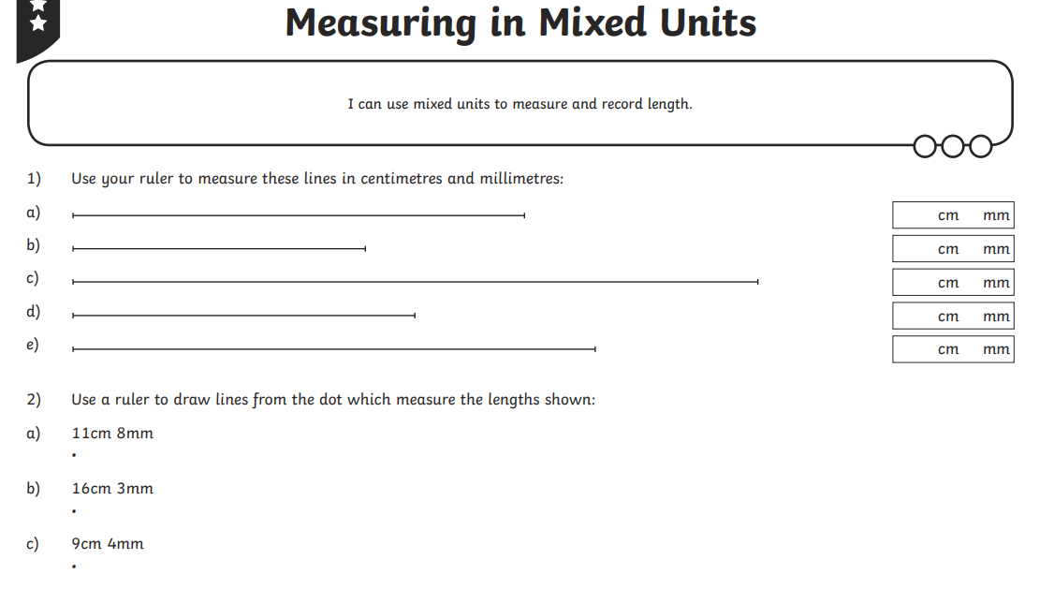

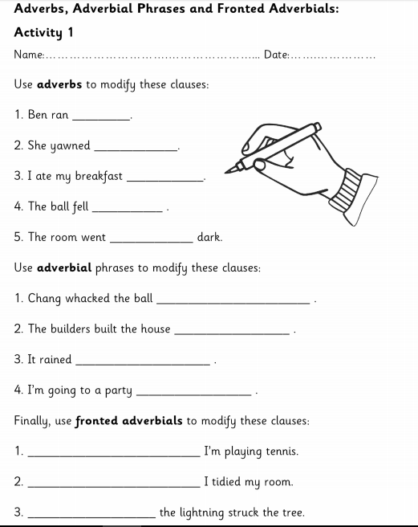
Monday GPaS:

rapidly.

over the fence.

After lunch,

Monday SLoR:
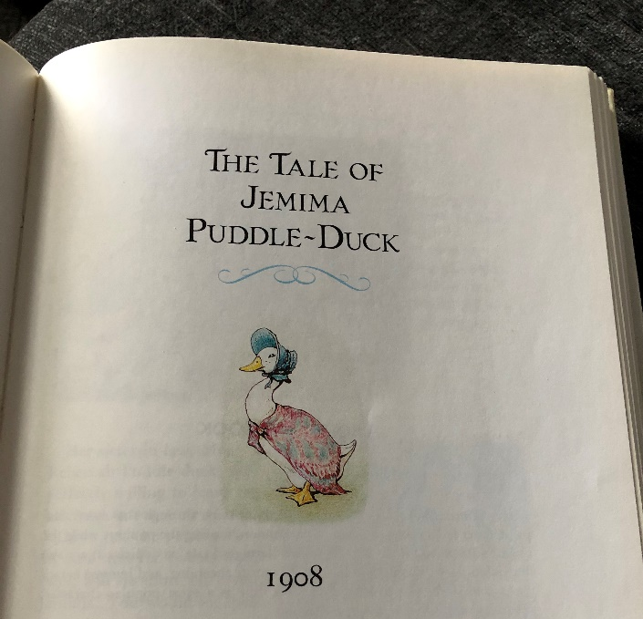

TASK ONE
Knowledge: Why did Jemima leave the farm?

Comprehension: How would you describe the fox’s character?

Apply: If you were Jemima, when would you have become suspicious of the fox?

Analysis: Why do you think Kep gained the help of two fox-hound puppies?

Evaluation: Do you think that Kep and the fox-hound puppies solved the problem in the right way? Explain your answer.

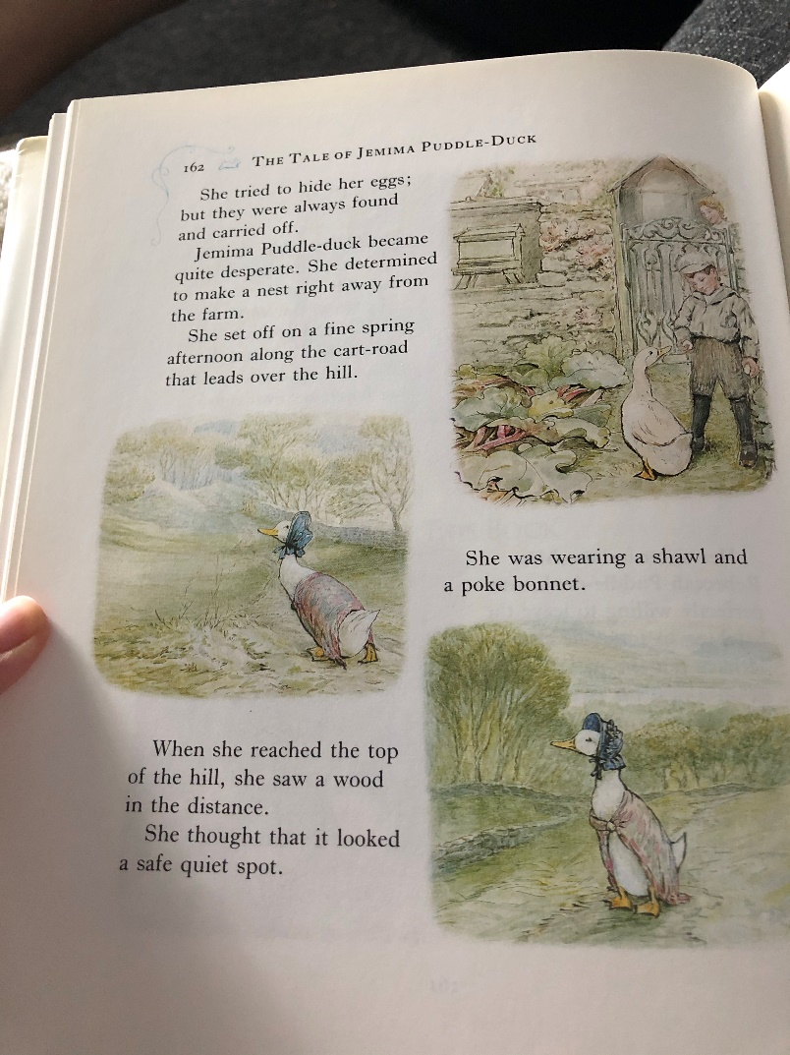
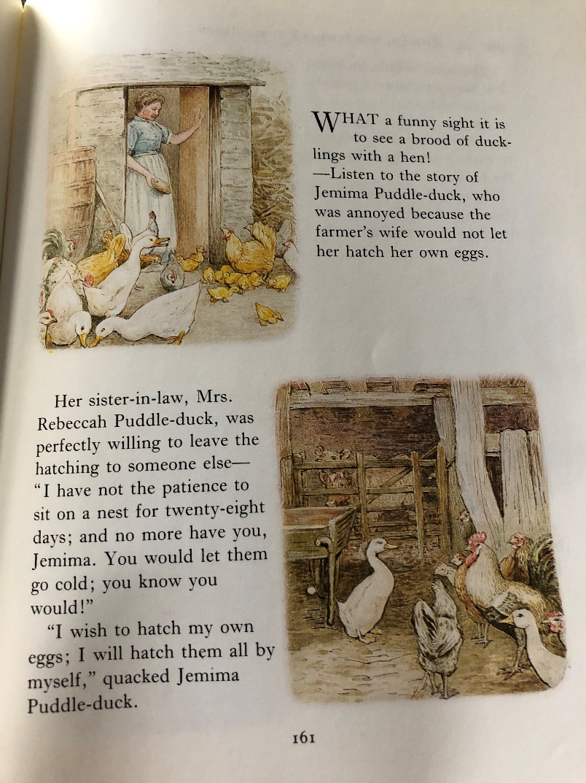
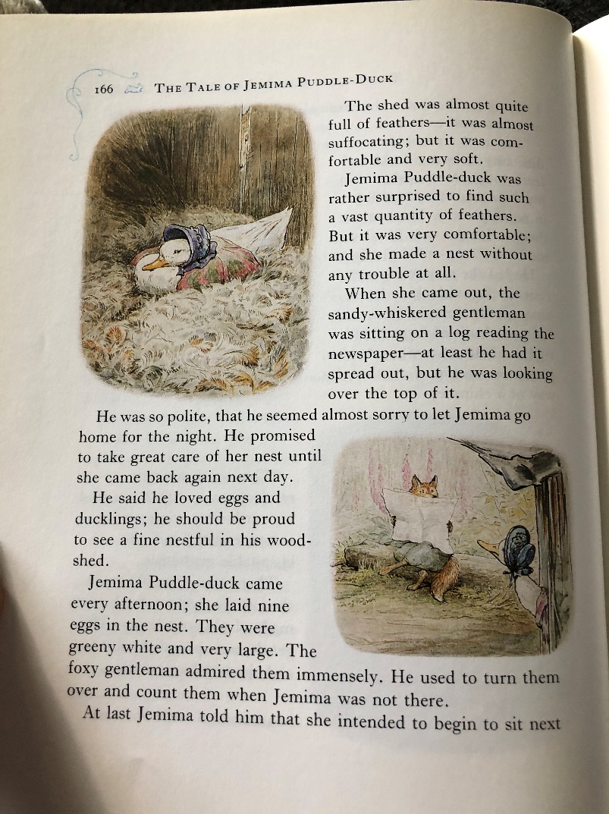
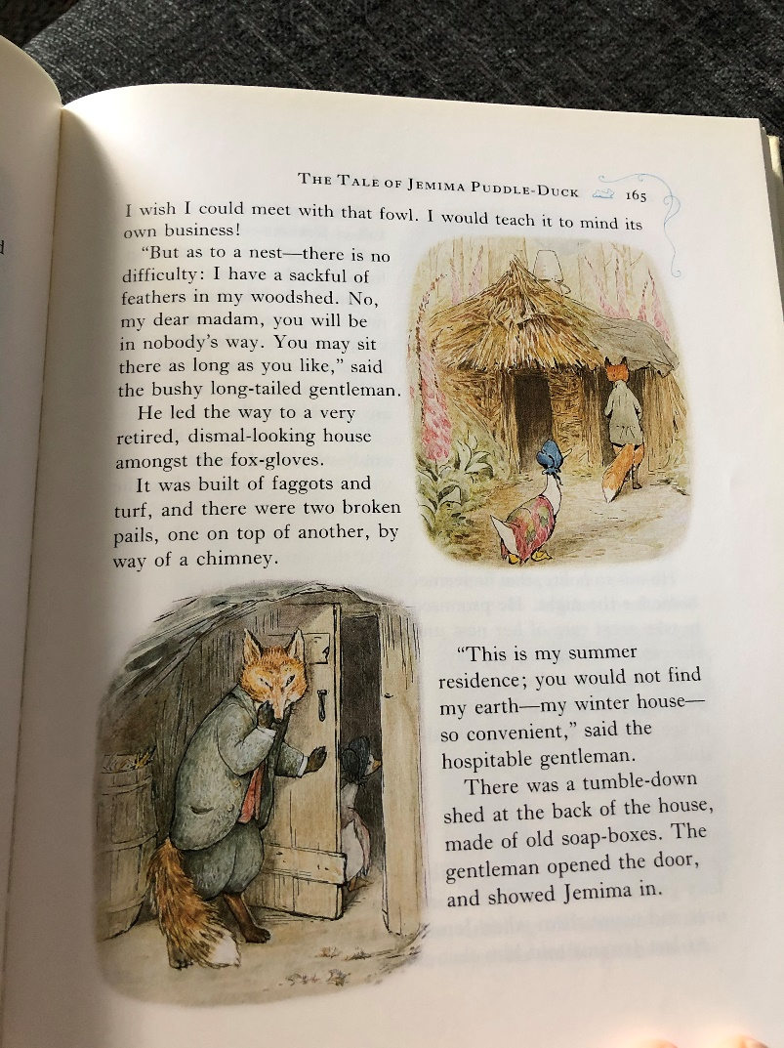
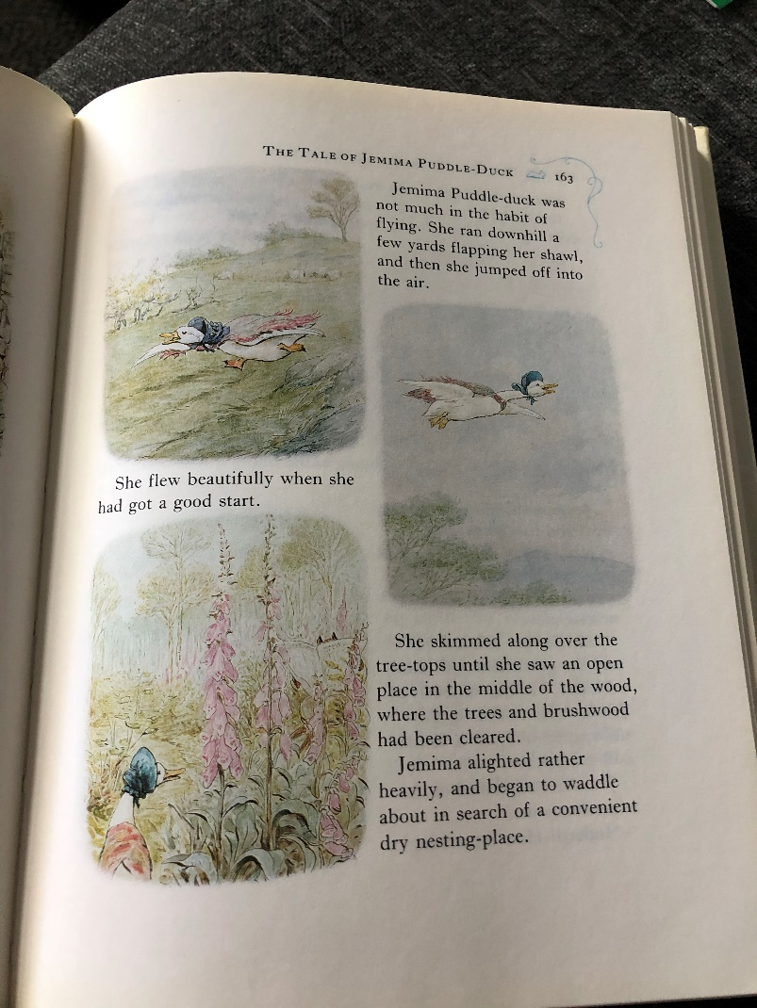
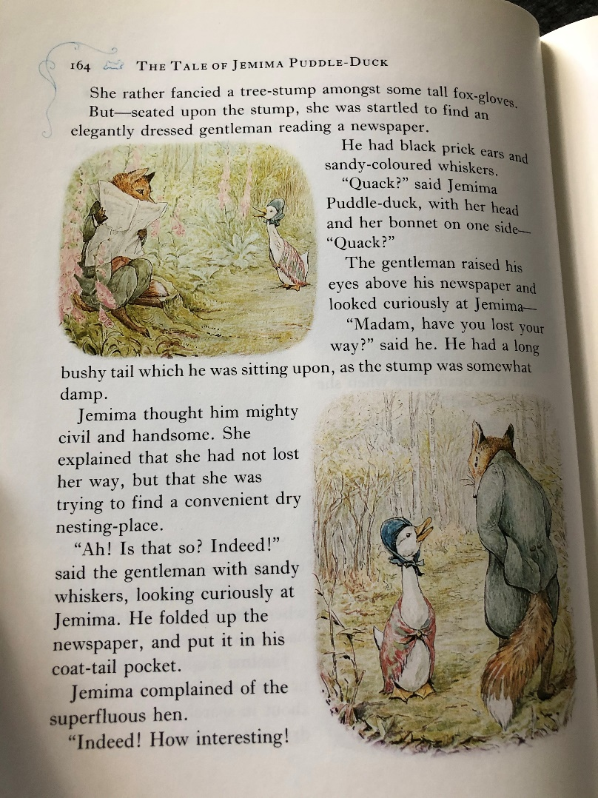

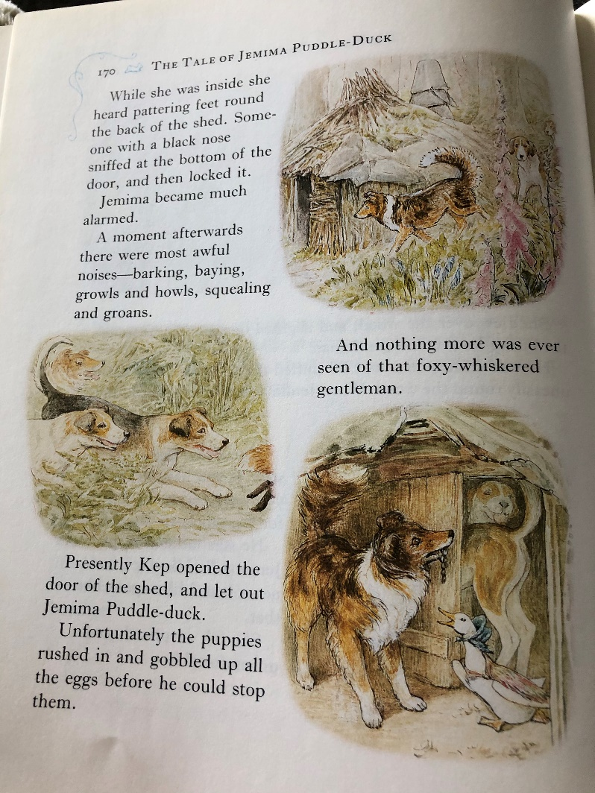
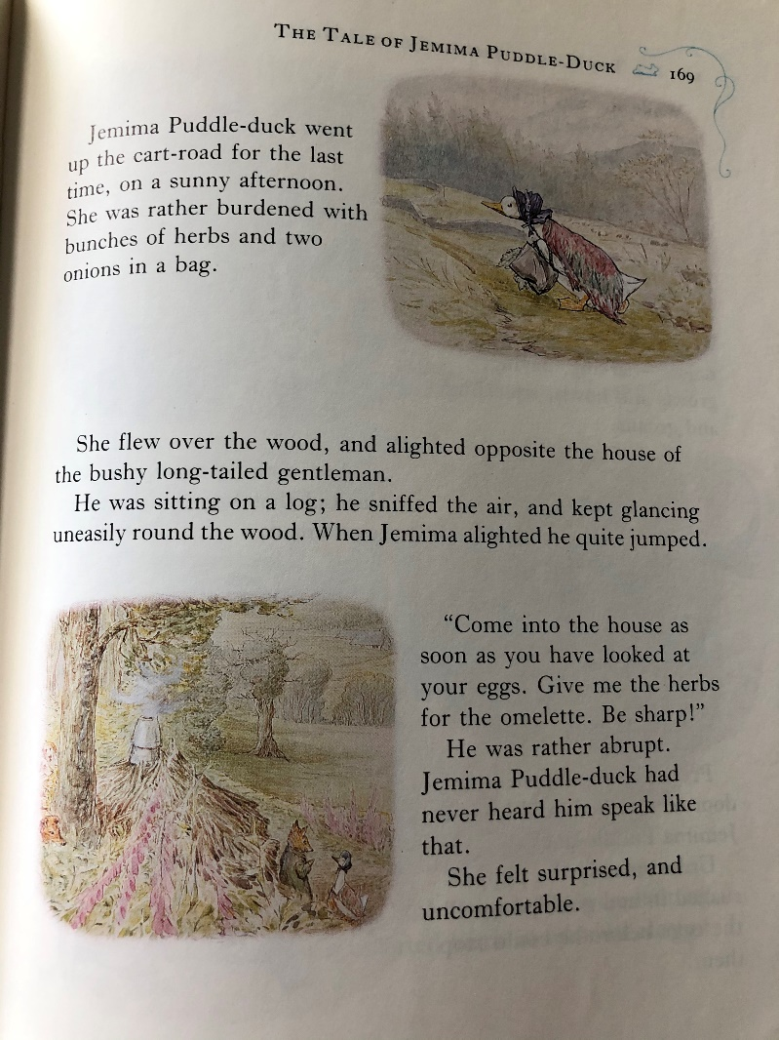
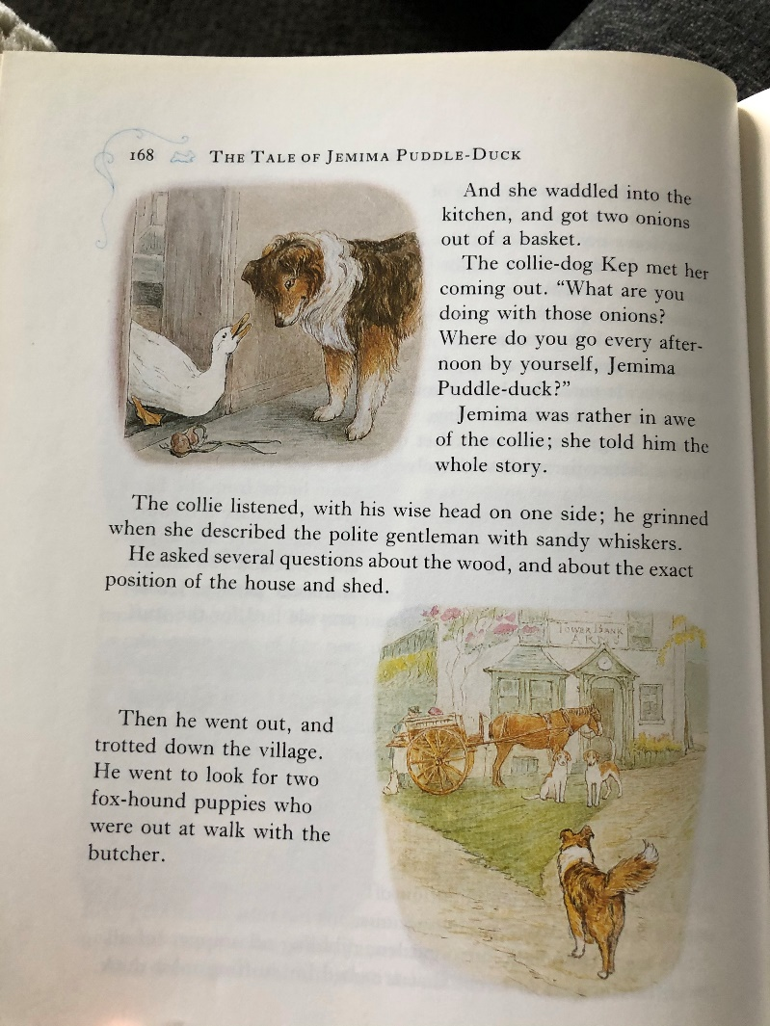
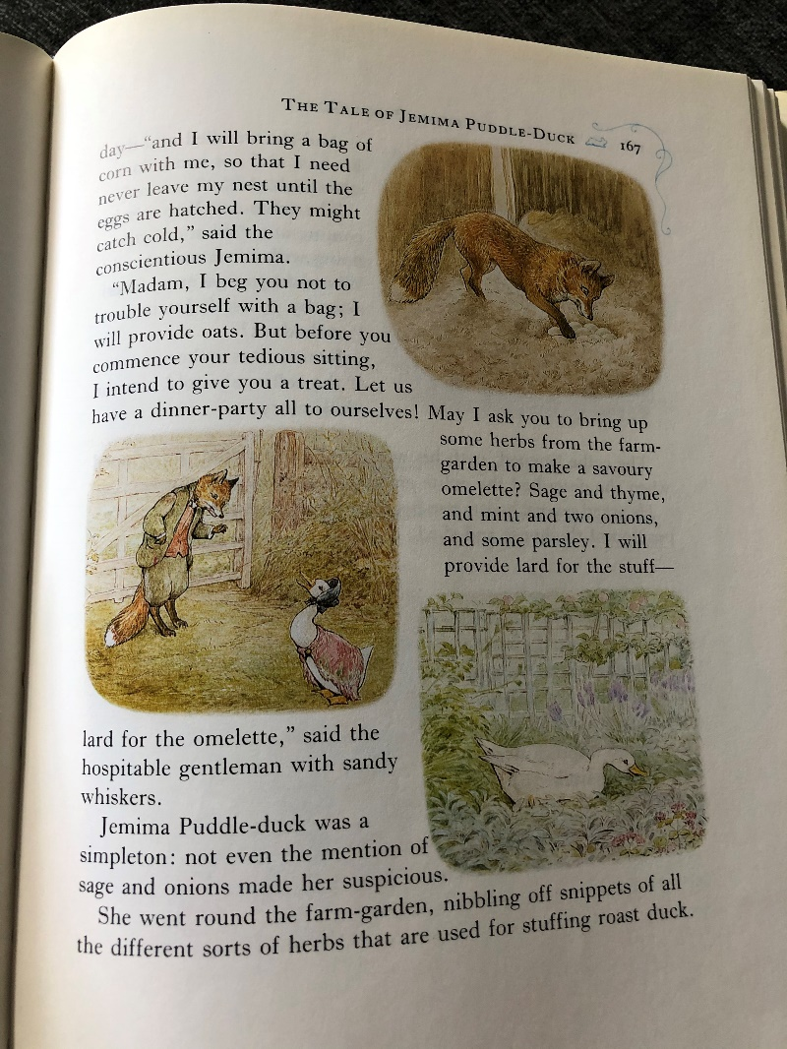

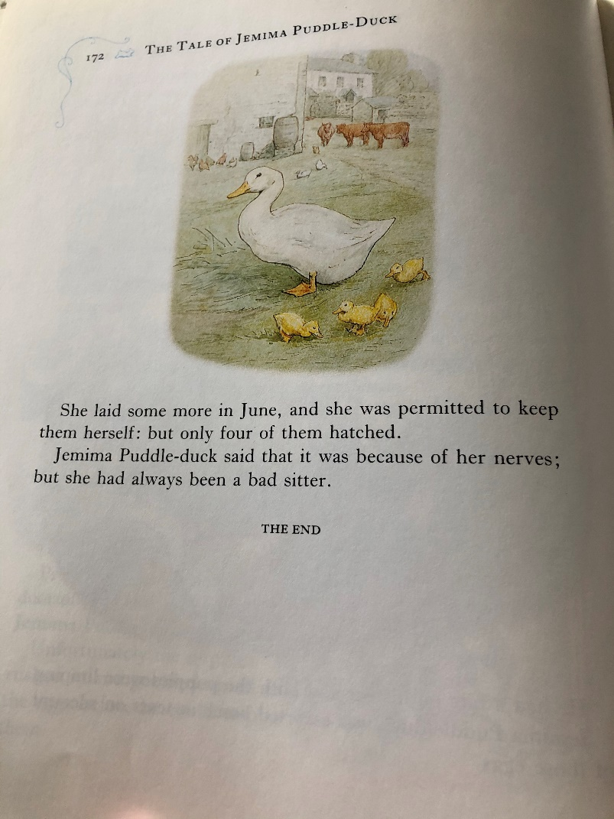
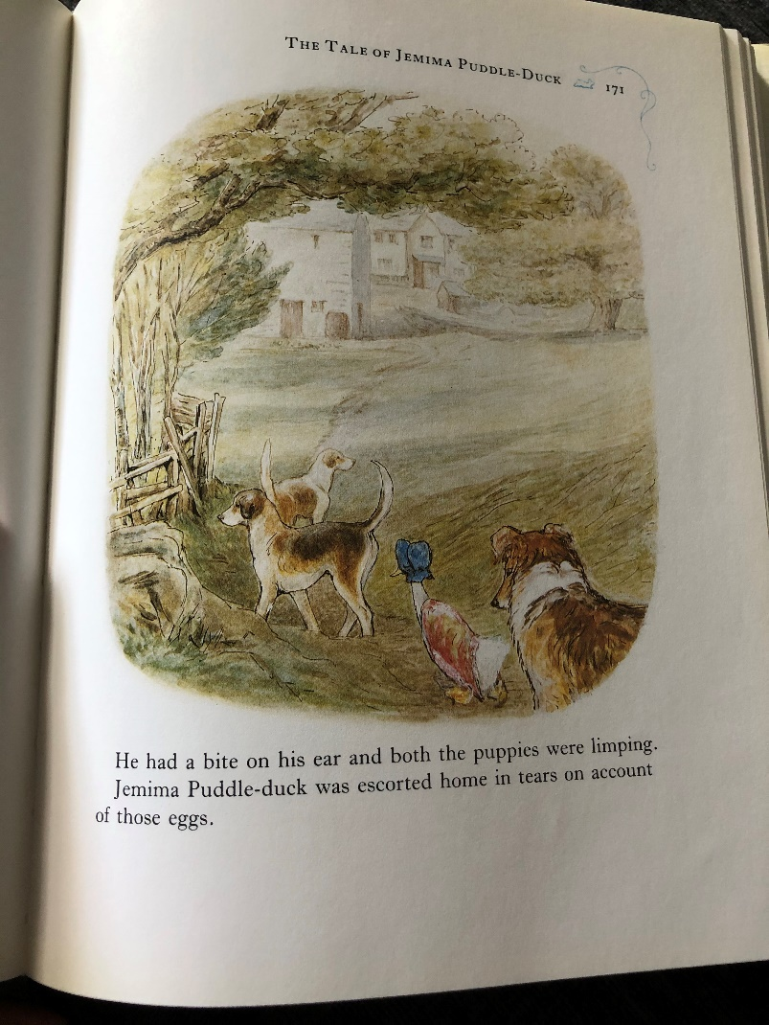
TASK TWO
Create a storyboard or comic strip summarising the story. Draw five pictures (in chronological order) depicting the main events and then write a simple sentence underneath each picture.

Example:

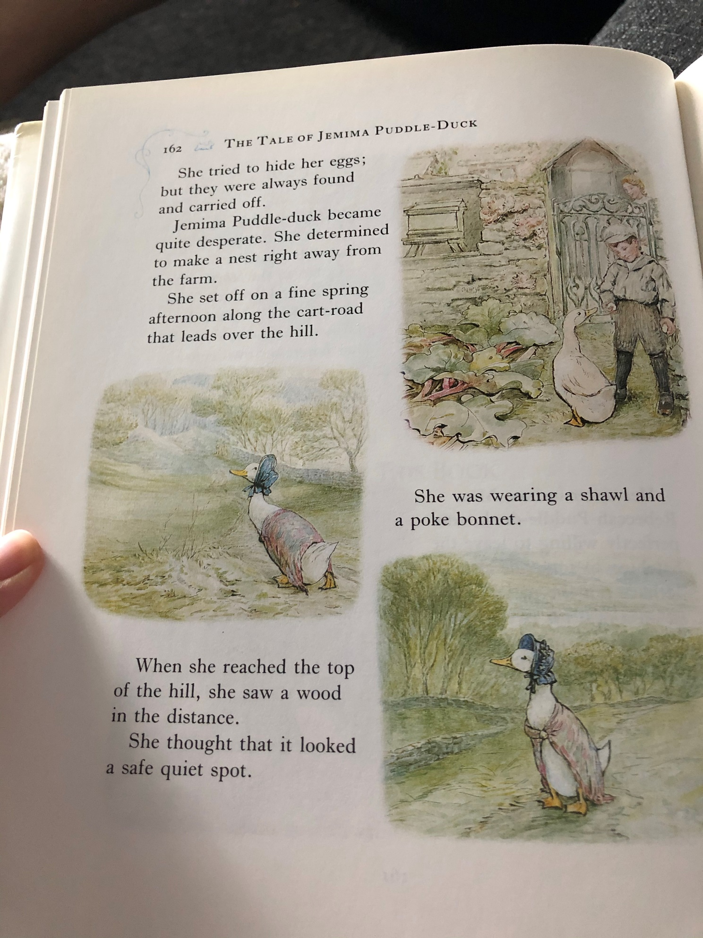
Jemima left the farm in search of a perfect place to build a nest.
TASK ONE - ANSWERS
Knowledge: Why did Jemima leave the farm?
She left so that she could lay and hatch her own eggs.
Comprehension: How would you describe the fox’s character?
The fox is very sly and cunning. He pretends to be kind so that Jemima will trust him.
Apply: If you were Jemima, when would you have become suspicious of the fox?
Accept any relevant answer as long as it is justified.
Analysis: Why do you think Kep gained the help of two fox-hound puppies?
They are the best dogs for tracking down foxes and Kep needed to find the fox quickly.
Evaluation: Do you think that Kep and the fox-hound puppies solved the problem in the right way? Explain your answer.
Accept any relevant answer as long as it is explained well.

Tuesday maths:

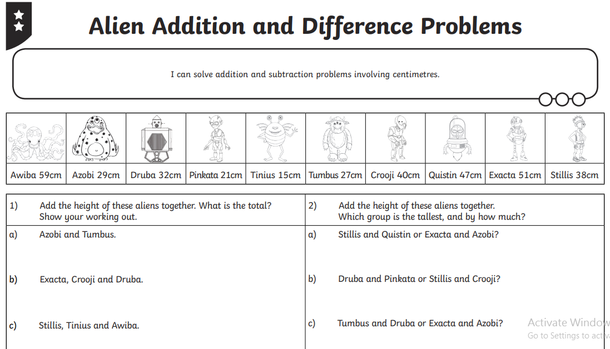

Tuesday Jigsaw (wants and needs):

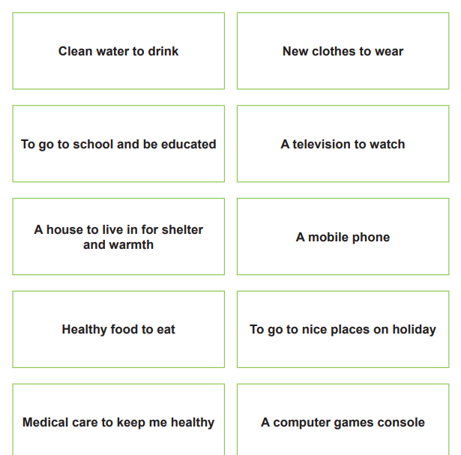

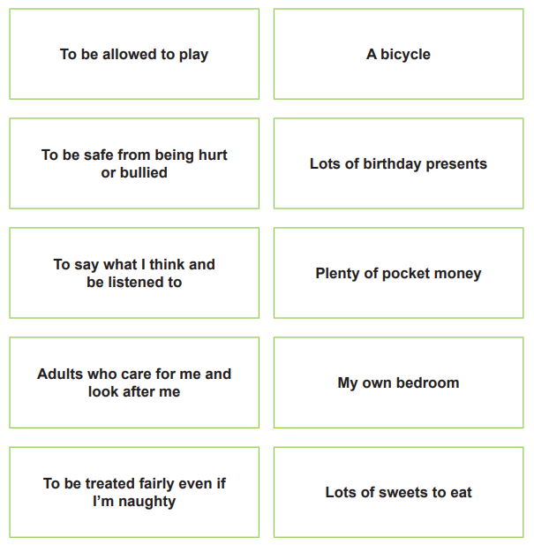

Tuesday Jigsaw (match the quote to the picture):

Quote | Picture
1) I have to fetch water from the well twice a day - before and after school. It can sometimes take me up to an hour since it is 2 km away and I often have to wait my turn at the well. Even though I wake up really early, I am still often late for class. After school, I find it difficult to find the time to do my homework and play with my friends since, I have to fetch more water and do other household chores to help my parents. | 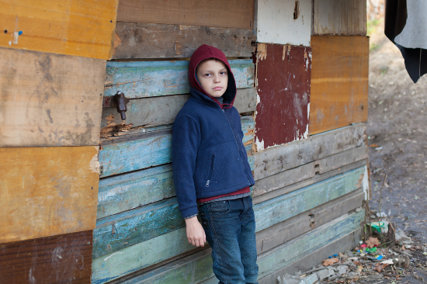  A
2) My parents were not able to go to school since they were very poor and had to help out on the farm. They want me to go to school to get a good education, but most of the time they are unable to afford the school fees and necessary school supplies. Also, if I help them work, we are less likely to go without food. They are considering making my sister and I quit school so we can help out around the house while our brothers go to school. They think it isn’t as important for girls to get an education. |   B
3) My dad lost his job and we have been struggling to pay the bills. They turned off our gas, since we couldn’t pay and we’ve been having a tough time this winter. Even if we cuddle up with all of our blankets, it’s still really cold. Sometimes when it’s really cold, we all go over to my aunt’s house and sleep in the living room so that we can spend the night without freezing. |   C
4) My birth mother was unable to take care of me so I was taken into foster care. Some of the families I have lived with have been OK, but others have not been so nice. Some haven’t cared what I said or thought and didn’t treat me so well. Luckily for me, I am currently living with a family that is really nice and supportive. They are even talking about adopting me. I really hope they do, because it is really difficult to move around so much and not have a place to call home. I would really like a forever family because then I would feel loved. | 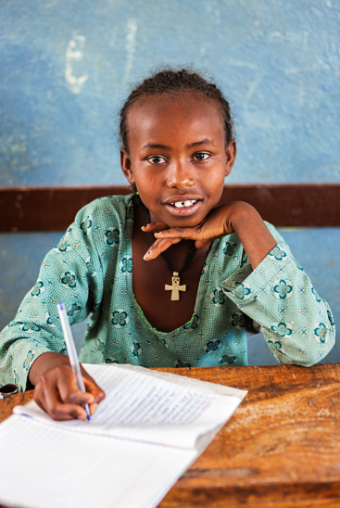  D

Wednesday maths:

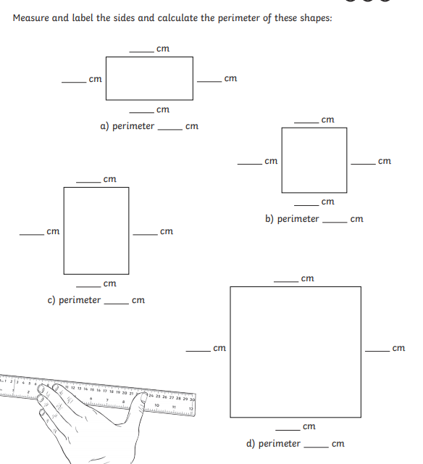

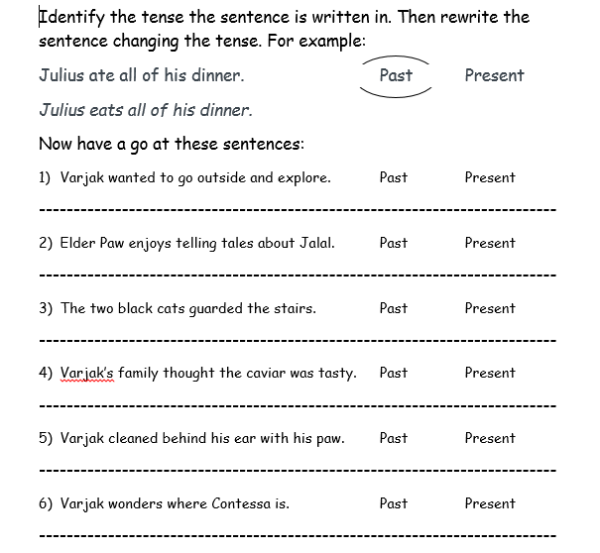
Wednesday GPaS:

Wednesday science:
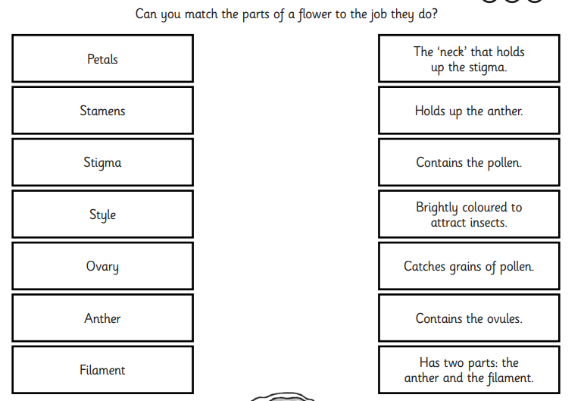

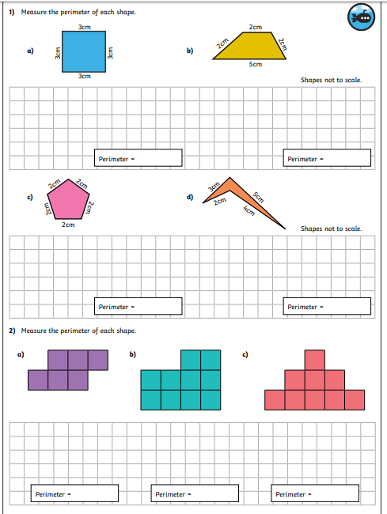
Thursday maths:

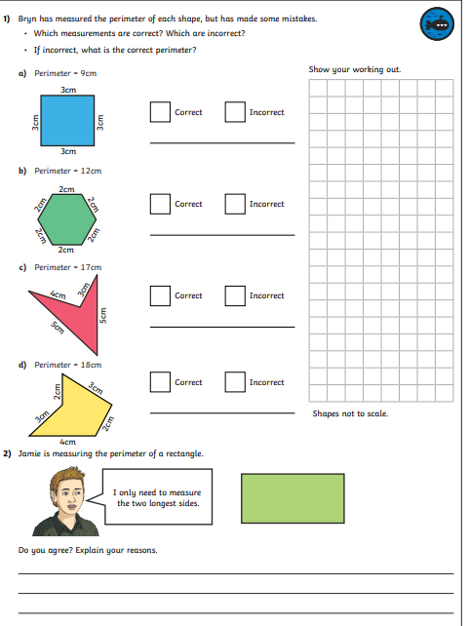
Thursday maths extension:

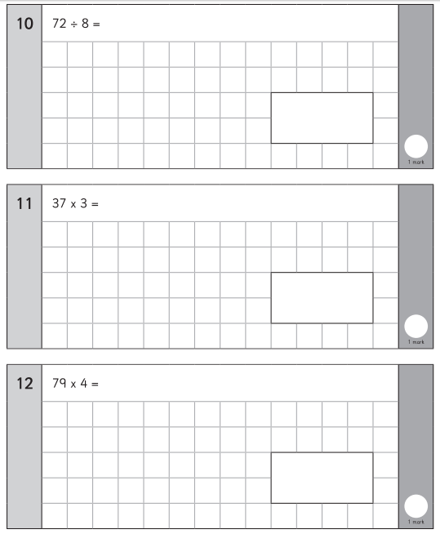
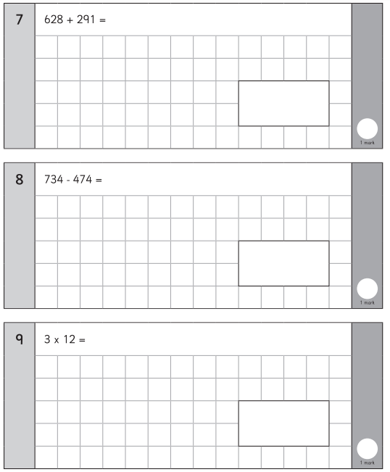
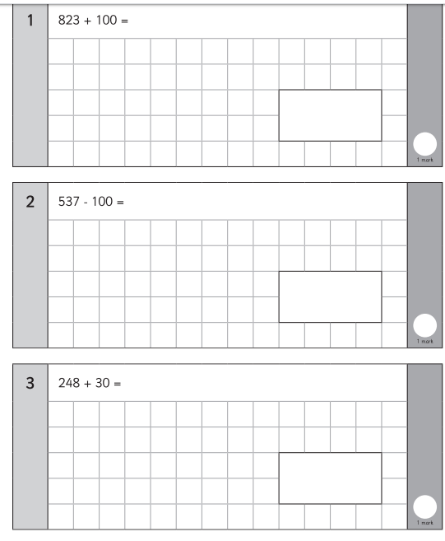
Friday maths:
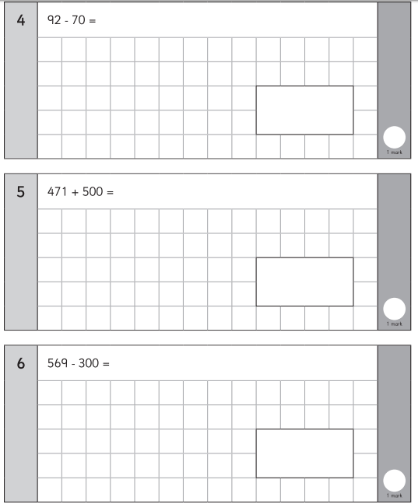

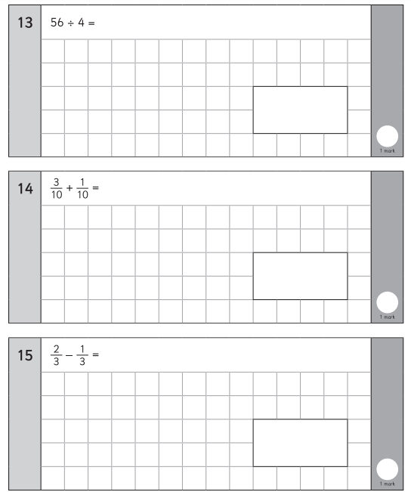

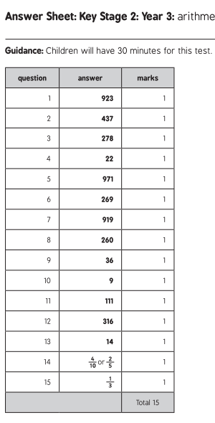

Spellings:

various
weight
woman
women
accident
accidentally
actual
actually

MILD
Words with the wh sound
where
which
while
what
whale
wheel

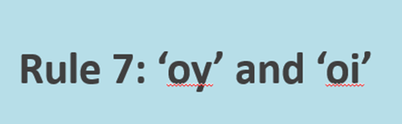

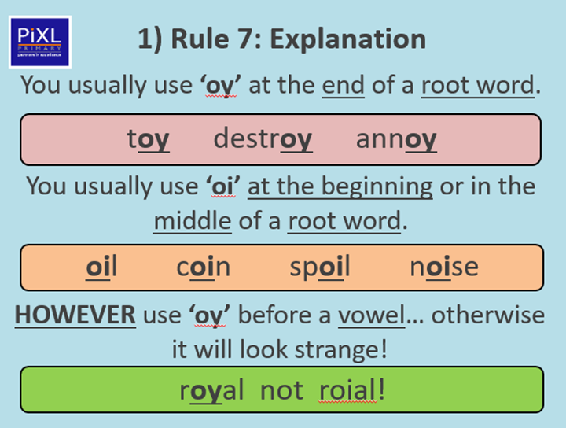

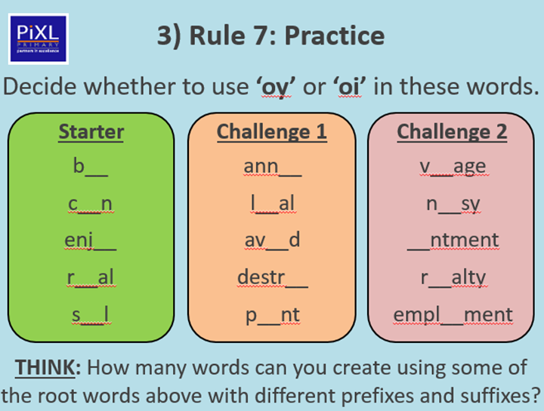
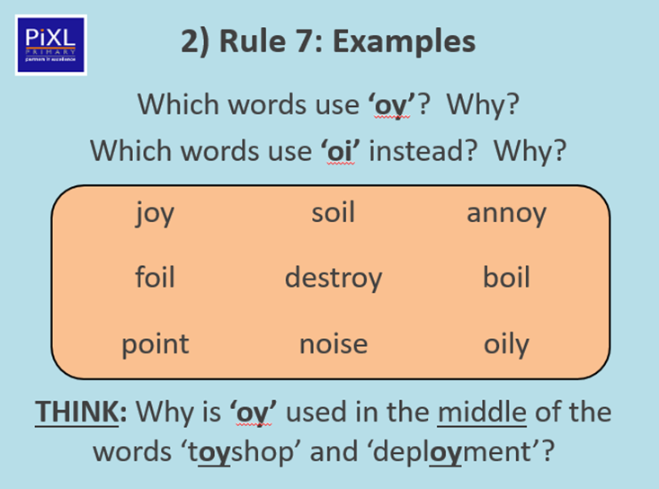
ACTIVITY ONE

ACTIVITY TWO – Choose three words from each column and put them into nine different sentences.



