
Learning Activities
Year 3 2019-20

Self-isolation learning Week 7
Lessons set  Every child is expected to complete three pieces of learning per day. Most of what is listed below has been taught in school. This is for revision and will allow children to practise skills already learnt. Where new skills are being introduced, we will provide as much support as possible by means of videos, pictures and websites. Please do not hesitate to email the year 3 email address if you have any questions regarding the learning.  For every piece of learning completed to a good standard will be rewarded with 5HP.  Please share your hard work on Twitter and via email, we would love to see how you are all getting on! |  | Additional comments  Worksheets attached do not need to be printed. Use them to access questions matching LOs (learning objectives). They can be copied and written onto paper for children to complete.
Monday | Maths  Starter: 4 times tables - sing 4 times table song:  Sing: https://www.youtube.com/watch?v=lBmSshEDVnQ  https://www.youtube.com/watch?v=9ue9Kux95H0  Play: https://www.timestables.co.uk/4-times-table.html  L.O. To be able to measure in centimetres and millimetres.  Task 1: Order these lengths from shortest to longest:  8mm, 23m, 10m, 45m, 58cm, 11cm, 3m, 2mm, 4cm, 22cm.  Task 2: Measure and draw the lines on the sheet with a ruler in centimetres and millimetres (as shown below):  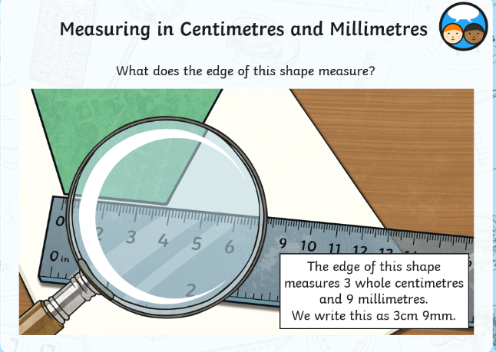  Extension: Do you have a tape measure at home? If so, try measuring some larger items in your house in metres and centimetres and record these.  Try a daily 10: https://www.topmarks.co.uk/maths-games/daily10  English (GPAS): Adverbs and adverbial phrases  Watch the video below to recap on how to use adverbs and adverbial phrases.  https://www.youtube.com/watch?v=B3hR3BHpeho  Task: Complete the activity sheet attached.  Extension: Can you write five sentences of your own about your family or friends using adverbs, adverbial phrases or fronted adverbials?  Reading: Go online and listen to an audiobook.  Audible (30 day free-trial): https://www.audible.co.uk/cat/Children-Audiobooks/535836031?ref=a_hp_b1_desktop_footer_column_3_6&pf_rd_p=de074e1d-99f3-434c-9e03-d1528d7a6c17&pf_rd_r=MR981VN15XMAJ8HC8P4Y  SLOR: Read ‘The Tale of Jemima Puddle-Duck’ attached.  Task 1: Answer the questions attached.  Task 2: Make a story board/comic strip summarising the key events in the story (should include pictures and a sentence for each picture). | Remember to play 10 garage games of TT Rockstars every week.  See attached worksheet  Worksheet included  Remember to continue to read at least 3 times at home.  Story and activities attached.
Tuesday | Maths  Starter: 3 times tables  Sing: https://www.youtube.com/watch?v=dzVyBQ5uTbo  https://www.youtube.com/watch?v=9XzfQUXqiYY  Play: https://www.timestables.co.uk/3-times-table.html  L.O: To be able to add, subtract and compare heights in centimetres.  Watch the stage 3 videos on our school website to jog your memories on how to add and subtract using the year 3 methods.  Addition:https://www.swingate.medway.sch.uk/page/?title=Addition&pid=99  Subtraction:https://www.swingate.medway.sch.uk/page/?title=Subtraction&pid=100  Task: Complete the attached worksheet. Add the measurements together to find the total heights. Subtract the total measurements to find the difference between the two pairs.  Try a daily 10:  https://www.topmarks.co.uk/maths-games/daily10  English:  LO: To be able to write a postcard recounting your favourite day of lockdown.  Write a postcard to Miss Boon recounting your favourite day of lockdown so far. One side of the postcard should contain your recount whilst the other should have a bright and colourful picture of your favourite day. Remember to include the following-  -use past tense  -time adverbials  - describe how you felt  -use first person (I, we, my etc.)  -use exciting vocabulary  If you have a stamp, post your postcard to Miss Boon at Swingate Primary School. She would love to hear from you all!  Jigsaw:  L.O To be able to empathise with children whose lives are different to mine and appreciate what I may learn from them.  Task 1:  Look at the wants and needs cards. Some of them are ‘needs’ – the things that you really can’t live without. Others are ‘wants’ – the things which make life a bit easier or more pleasant. Sort the cards into what you think are ‘wants’ and ‘needs’.  Task 2:  Look at the four pictures and read the four quotes. Which quote do you think matches to which picture? Why do you think this?  After you’ve made the pairs, think about these questions:  Do all children have their basic needs provided for?  What are the similarities and differences between your life and the lives of these children?  What rights do you think all children should have?  Task 3:  The United Nations is an organisation in which the countries of the world try to agree on what needs to be done to make the world a fairer and safer place for everyone. They have produced a ‘Convention on the Rights of the Child’ - a list of the basic needs that should be met for all children everywhere in the world.  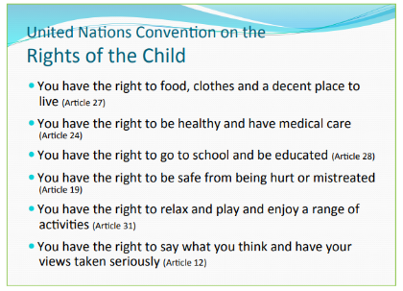  Design a poster for one of these rights. The poster must say what this right means and why it’s important. | Worksheet is attached.  Worksheet attached.  Cards attached.  Pictures and quotes attached.
Wednesday | Maths:  Starter: 4 times tables  Play: Hit the button to practise your 4 times tables.  https://www.topmarks.co.uk/maths-games/hit-the-button  L.O. I can measure the perimeter of squares and rectangles.  Watch this video which explains how to calculate the perimeter of polygons (shapes made from only straight sides):  https://www.youtube.com/watch?v=AAY1bsazcgM&t=15s  Task:  Use a ruler to measure each side of the shape (to the nearest cm) and then calculate the perimeter of the shape.  Extension:  Draw a shape which has a perimeter of:  - 20cm  - 16cm  - 24cm  Try a daily 10:  https://www.topmarks.co.uk/maths-games/daily10  English (GPaS): Past and present tense  Play: https://wordwall.net/resource/56616/english/past-tense-game - Spin the wheel. The wheel will land on a present tense verb. Can you say that verb in the past tense? E.g. The wheel lands on ‘walk’ so you say the past tense ‘walked’. If you get it correct, eliminate the verb. Keep going until all the verbs have been eliminated. How long did it take you? Can you beat the time?  Task: Complete the worksheet. Identify whether the sentence is written in the past or present tense and then re-write the sentence in the opposite tense.  Science:  L.O I can identify and describe the function of the flower.  Task 1:  Watch the video explaining the different parts of a flower: https://www.youtube.com/watch?v=A5Pf4_LXyC4  Match the parts of a flower to the job that they do. See attached worksheet.  Task 2:  Look inside a couple of different flowers (the more the better). Identify the different parts. Dissect the flowers and stick them on a sheet, then label. Look at each part closely using a magnifying glass (if you have one). Cut open an ovary to describe what can be found inside. If you’re unable to gain access to flowers, draw a diagram of a flower and label it. Labelled parts should be: petals, stamens, stigma, style, ovary, anther and filament.  Task 3:  Watch the video showing how the pollen from one plant must fertilise the female parts of another plant.  http://www.bbc.co.uk/learningzone/clips/how-plants-produce-seeds/2255.html  If you have flowers in your garden, record the number/type of pollinating insects which you see pollinating the flowers over a period of time. If you do not have flowers in your garden, research and create a list of all wildlife which are involved in pollinating flowers. | Worksheet is attached.  Worksheet attached.  Worksheet attached.
Thursday | Maths:  Starter: 8 times tables  Sing: https://www.youtube.com/watch?v=0X620IeUkYE  https://www.youtube.com/watch?v=kN3RG5iLKpo  L.O. To be able to measure the perimeter of polygons and solve problems involving perimeter.  No need for a ruler today! Use the measurements provided to calculate the perimeters of the provided shapes. Note for parents: When you reach number 2, work on the basis of each side of a square is equal to 1cm.  Extension: Try some reasoning questions based on perimeter. Explain which perimeters are correct or incorrect.  Try a daily 10:  https://www.topmarks.co.uk/maths-games/daily10  English:  L.O: To be able to write a letter including key features.  Write your teacher a letter. We are all missing you very much and would love to hear how you’re getting on and what you’ve been up to during the lockdown. Remember to include:  -address  -date  -who you’re writing to  -past tense  -time adverbials  - describe how you felt  -use first person (I, we, my etc.)  -use exciting vocabulary  -paragraphs to organise your writing  -your name  If you have a stamp, post your letter to your teacher at Swingate Primary School. You never know, you may get a reply!  Topic:  L.O: To be able to design and make a leaflet.  1) Research about the Roman colosseum. Here are some useful websites/videos but feel free to find more of your own:  https://www.natgeokids.com/uk/discover/history/romans/colosseum/  https://www.ducksters.com/history/ancient_rome/colosseum.php  https://kids.kiddle.co/Colosseum  https://www.youtube.com/watch?v=e-x74MFiWkg  https://www.youtube.com/watch?v=U6oPfmJcU8s  2) Next, organise your research into sub-headings. For example: What is it? When and how was it built? How big was it? What are the different areas of the colosseum? What events took place here?  3) Complete a plan. Make a leaflet and decide where all of your front page, sub-headings, information and pictures will go ready for your final leaflet.  4) Use your plan and your research to complete a neat version of your leaflet. Send us pictures via email or Twitter; we’d love to see how these turn out! | Worksheet attached.  Worksheet attached.
Friday | Maths:  Starter: 8 times tables  Play: https://www.topmarks.co.uk/times-tables/coconut-multiples  Arithmetic test practise: Answer the questions from the arithmetic test. Try to remember the methods you have learnt in school.  Try a daily 10:  https://www.topmarks.co.uk/maths-games/daily10  English: Spellings  Practise the Year 3 and 4 Common Exception Words. You can do this by drawing the word, covering, acting, spelling out loud, tests etc.  Weekly spelling rule: ‘oy’ and ‘oi’.  PE: Try these exercises  Have a go at Oti Mabuse’s daily dance class for kids:  https://www.youtube.com/user/mosetsanagape  Joe Wicks the body coach’s daily PE lessons:  https://www.youtube.com/user/thebodycoach1  Cosmic kids yoga has loads of different sessions to try:  https://www.youtube.com/user/CosmicKidsYoga  Try moving whilst learning with these videos:  https://www.bbc.co.uk/teach/supermovers/ks2-collection/zr4ky9q | Arithmetic test and answers attached.  Weekly spellings and lessons on the weekly spelling rule are attached.

