

Learning Activities
Year 3
2019-20
Self-isolation learning
Week 6 (Worksheets)
Monday
Maths: Practise 3 times tables and multiplication English (GPAS): Sentence types
SLOR:

Tuesday
Maths: 4 times tables and multiplication English: Recounts
Jigsaw: Keeping myself safe online

Wednesday
Maths: 4 times tables and division English (GPAS): prefixes
Science: Plants – function of a flower

Thursday
Maths: 8 times table practise & multiplication and division English: fact file
Topic: Roman numerals

Friday
Maths: 8 times table practise and arithmetic test practise English: Spellings
PE: How skilled am I when bouncing a ball?

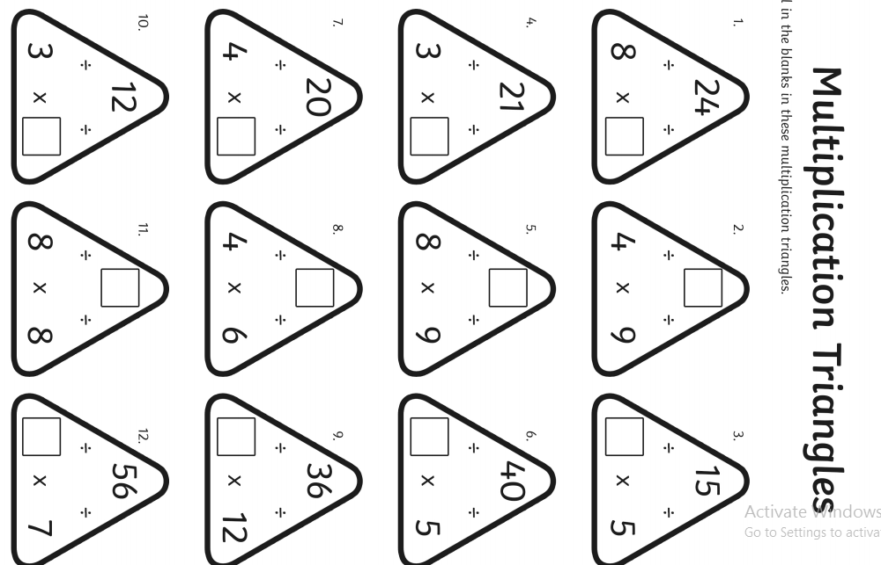
Maths Monday-
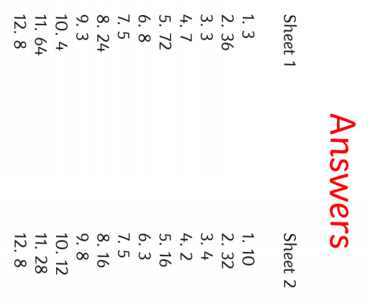
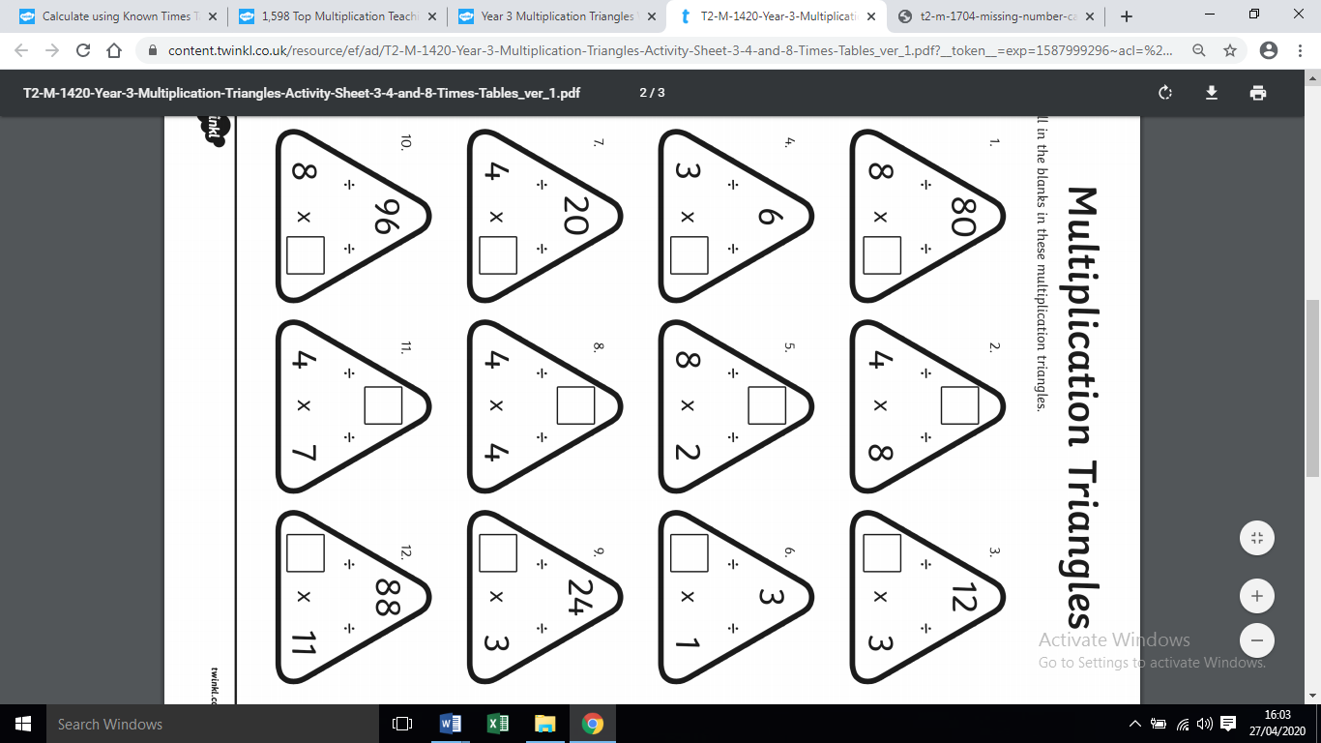

Monday’s GPaS:
LO: To recognise different sentence types
Success Criteria
I can identify a question
I can identify a statement
I can identify a command
I can identify an exclamation

Statements - Statements are sentences which tell you something. They end with a full stop.

Questions - Questions are sentences that ask you something. They usually end with a question mark.

Commands - Commands are sentences that tell you to do something. They are often urgent or angry and can ……be very short.

Exclamations - Exclamations are sentences that begin with ‘what’ or ‘how’. They are full sentences, include a ……verb and end with an exclamation mark.

Underline each sentence in the correct colour.

- Is it cold outside?
- How kind of him to do that!
- Climb up that tree.
- “What a nice young man!” shouted Anne.
- It is great fun going to the park.
- A puppy will grow up to be a dog.
- Should you really eat 7 chocolate bars?
- Get down from the roof!

Now have a go at creating your own. Make sure you label what it is (statement, question, command or exclamation).

SLoR - Please use last week’s story ‘The tale of Squirrel Nutkin’
TASK ONE
Go through the text and identify words that you are not familiar with/ don’t know the meaning for. Use a dictionary to find the meaning of the words. You can use online dictionaries if you do not have a dictionary at home.

Example:

impertinent – not showing proper respect; rude

TASK TWO
Create a role on the wall for any character of your choice. Draw a picture in the middle and write about the character using evidence from the text. E.g
Squirrel Nutkin is rude and has no manners because in the text it says’ Nutkin was excessively impertinent’.

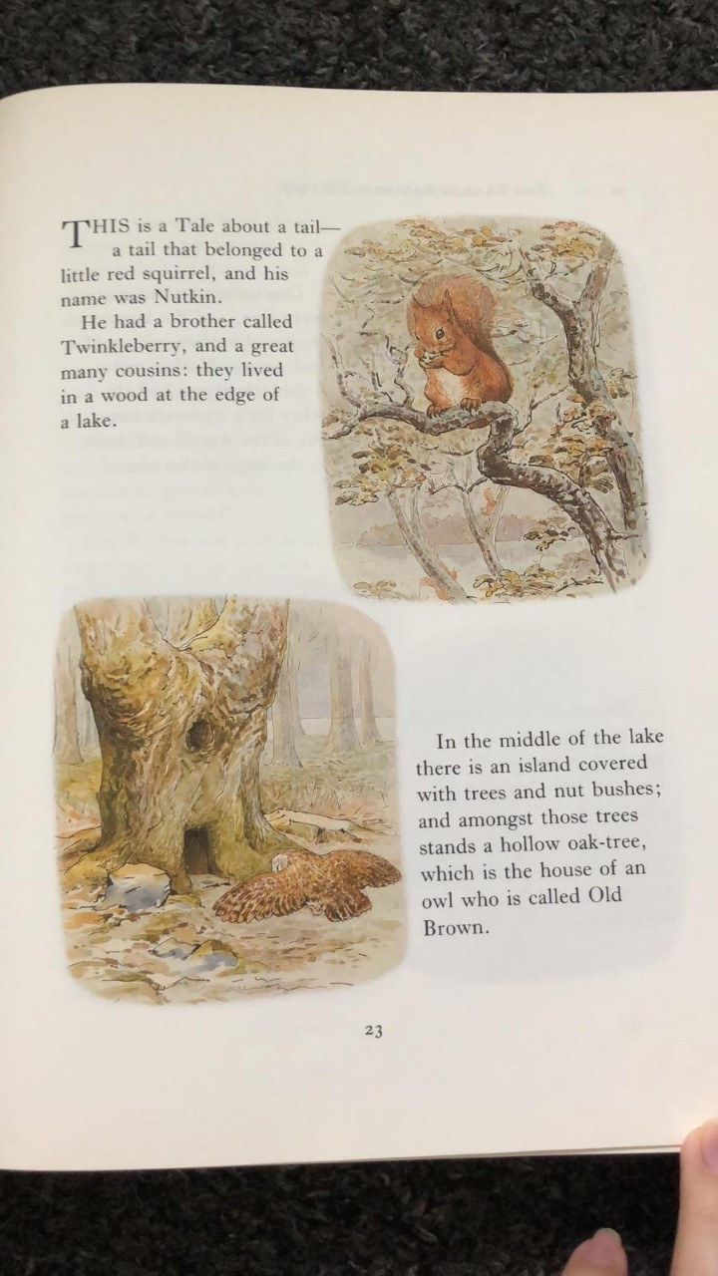

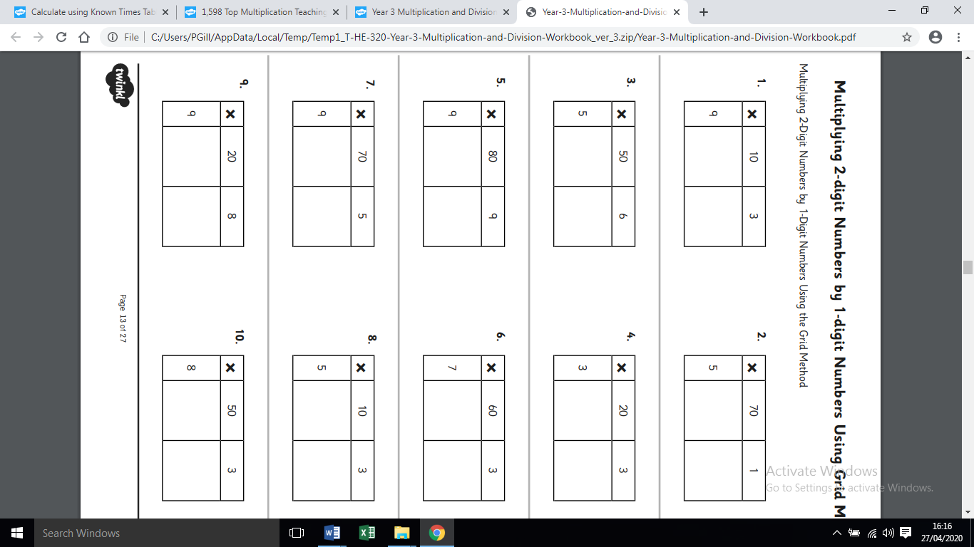
Tuesday’s Maths

Wednesday’s Maths
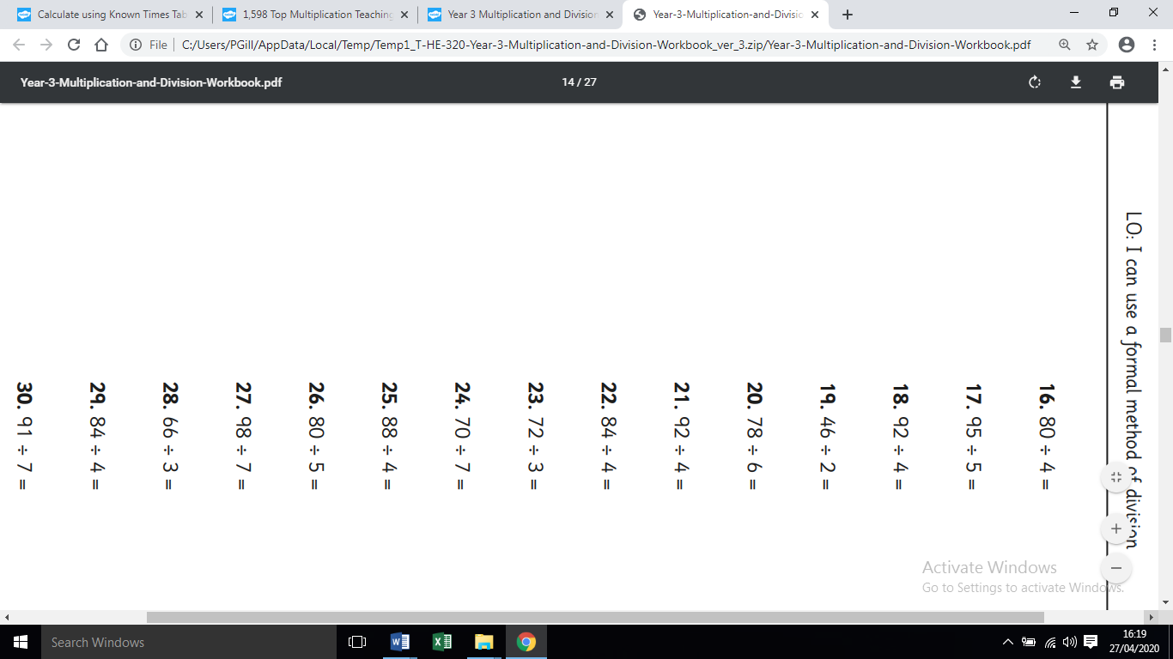
Thursday’s Maths – Two tasks
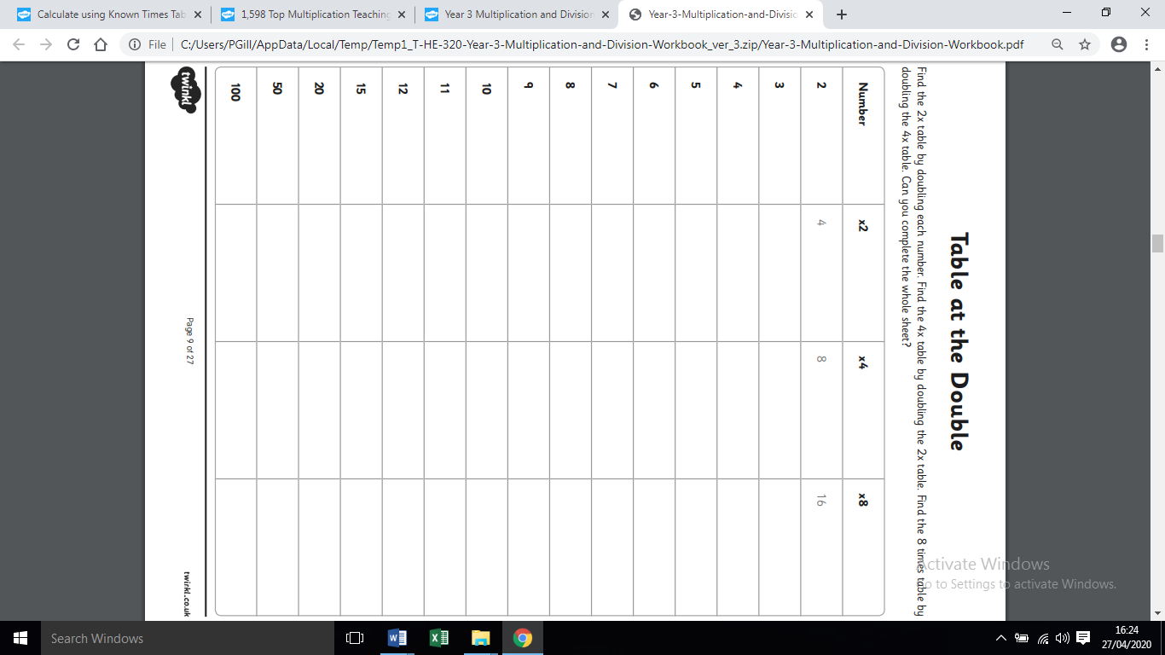

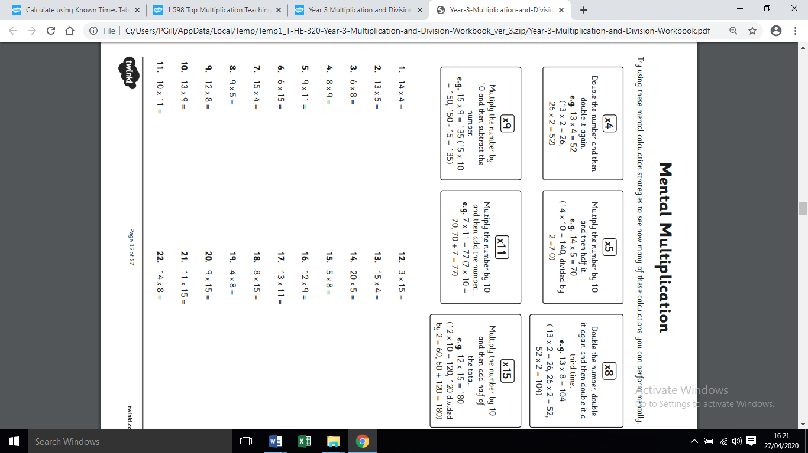
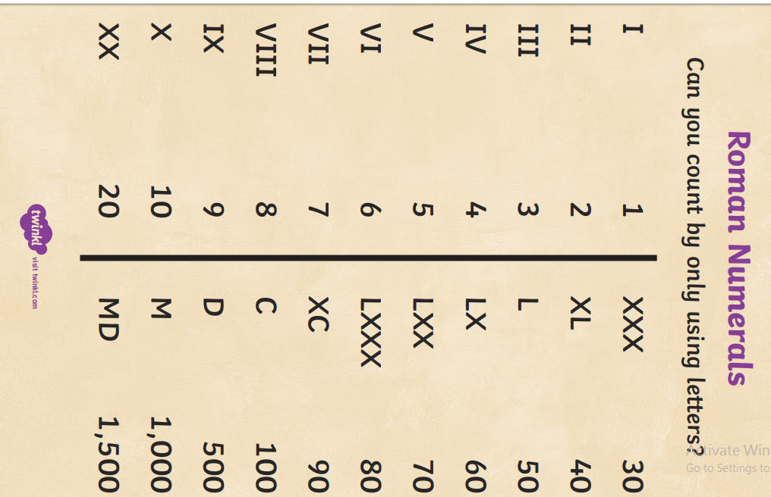
Thursday’s topic
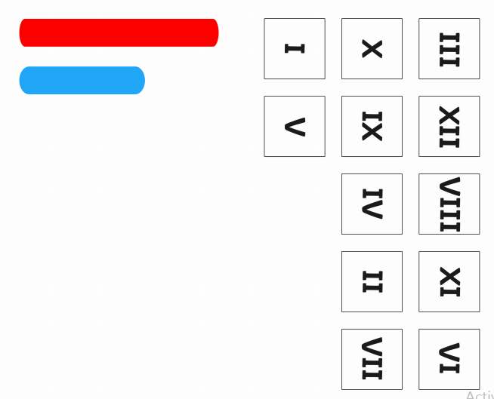
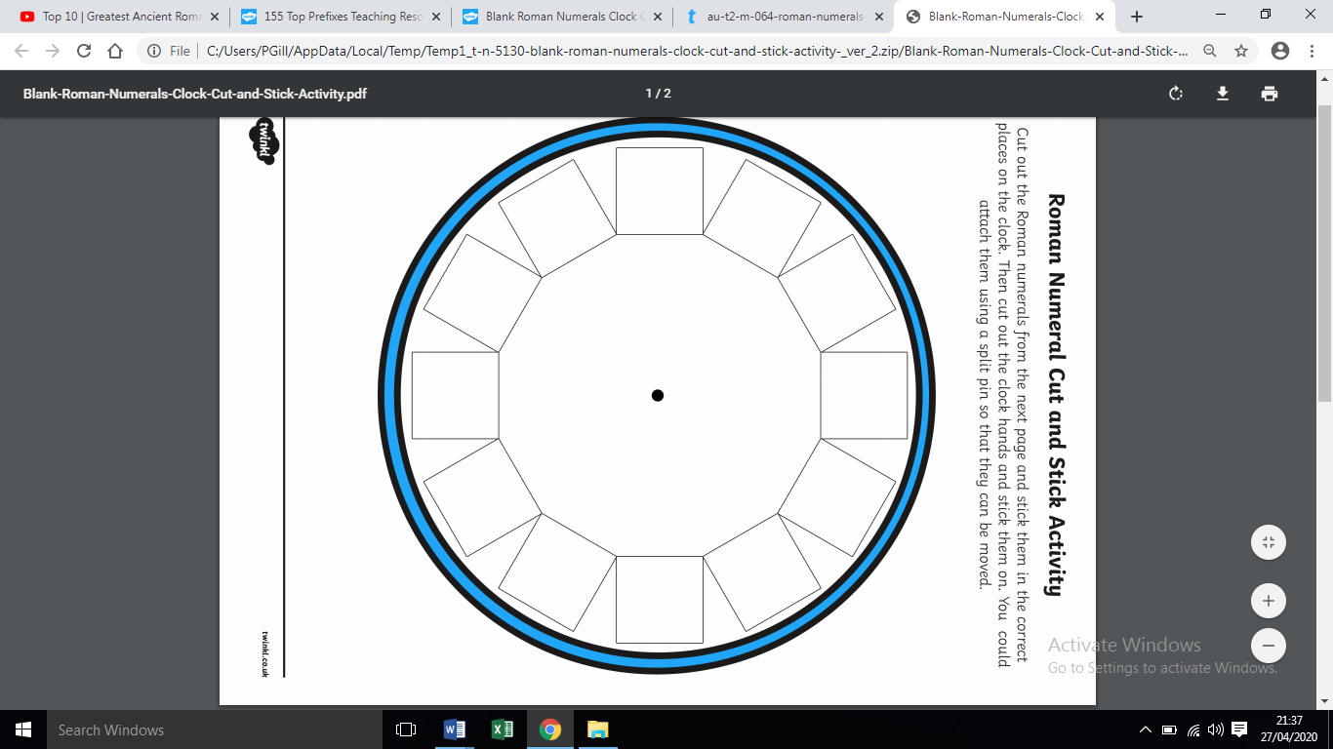
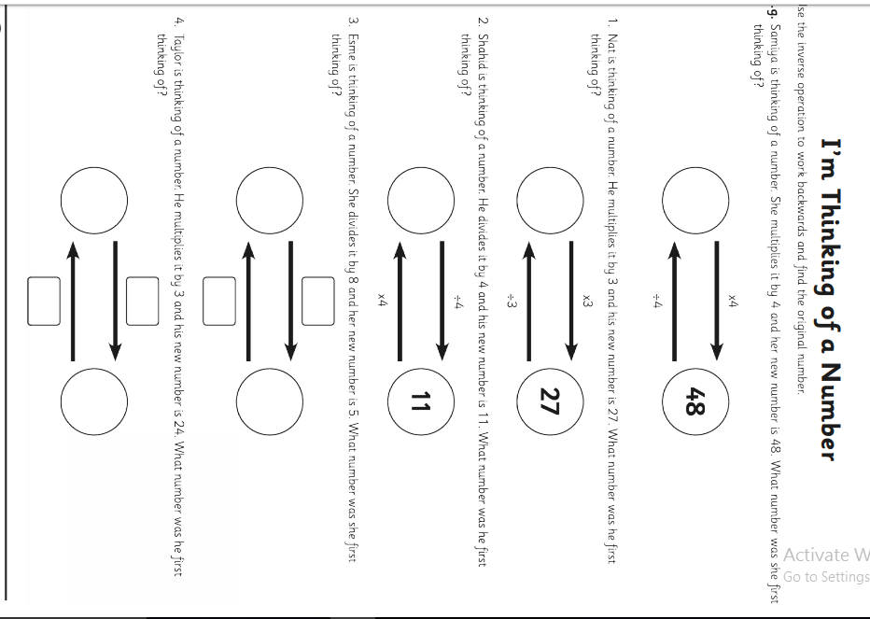
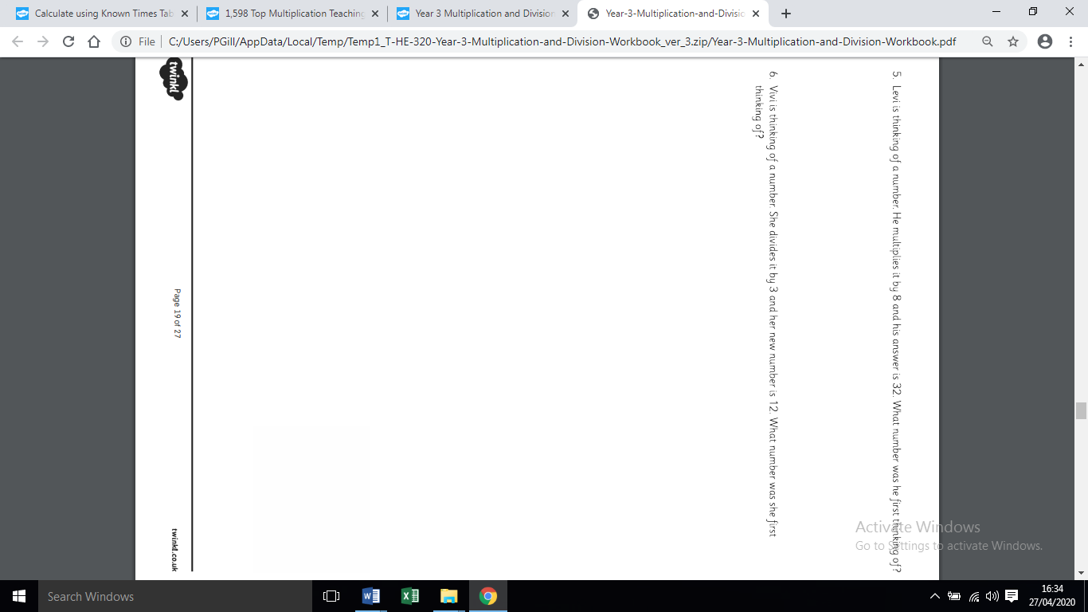
Friday- Maths

Jigsaw:
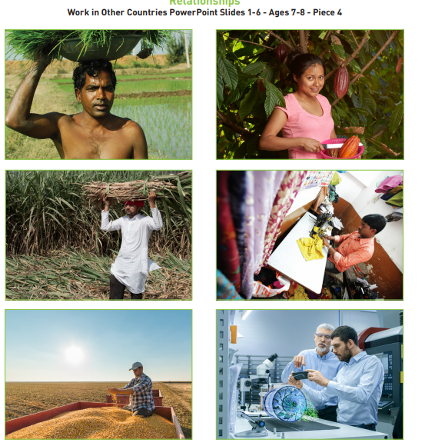
Match the picture to the items you have.
Choose one picture and answer the following questions:

• What is happening in the picture? • How does the food/clothes in the picture look different from how we receive it? • How do you think the person’s life in the picture is different to yours? • How does this person help you? • Does knowing how this product is made influence what you might buy?
Spellings:

there
therefore
they
though
thought
through
to
today

MILD
Words with the aw sound
claw
law
saw
yawn
hawk
draw

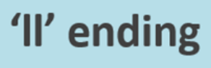
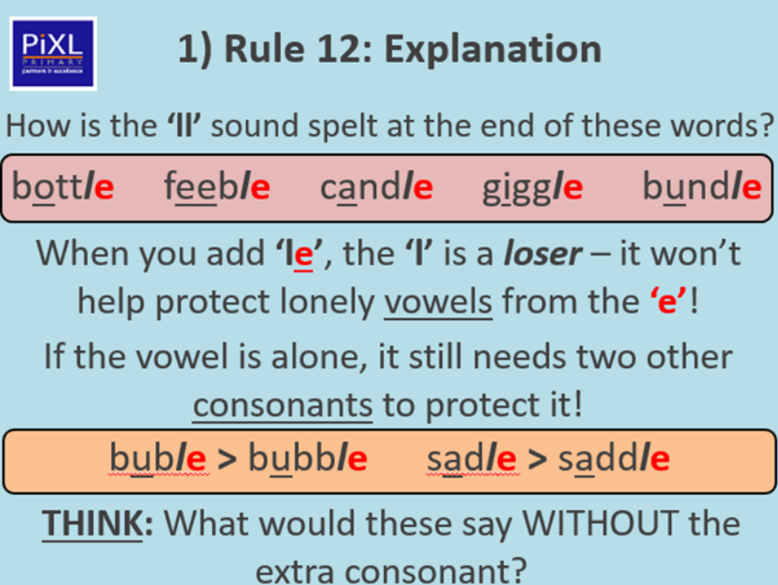

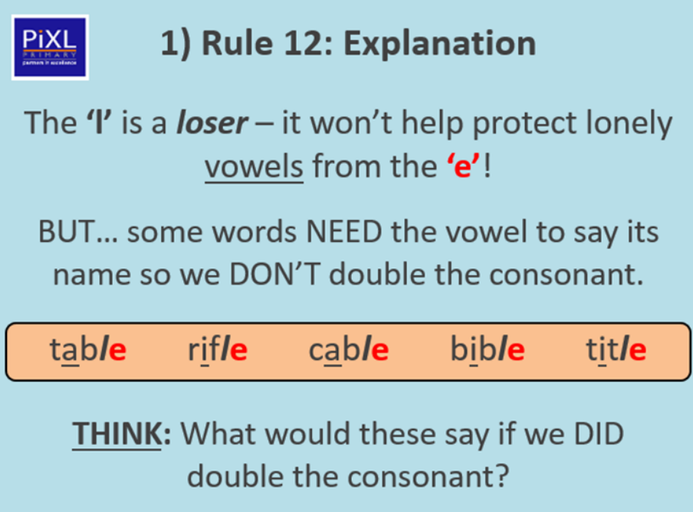
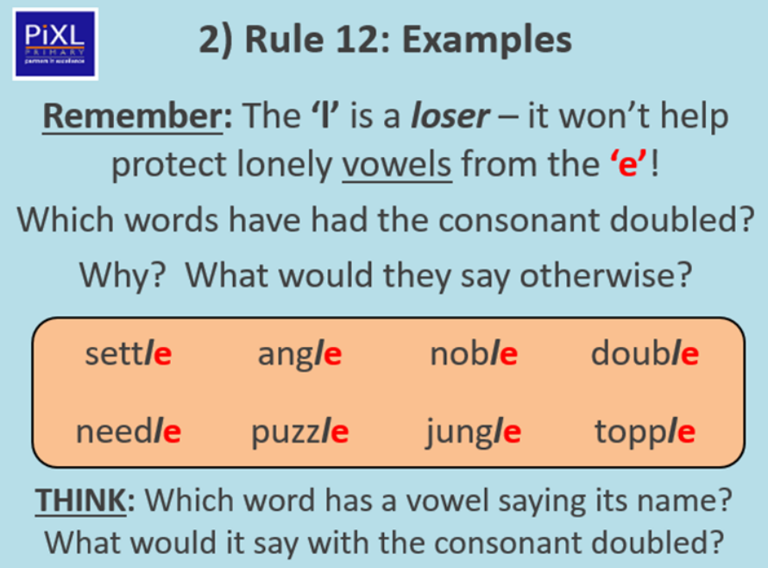

TASK ONE: Add the suffix to the root word.
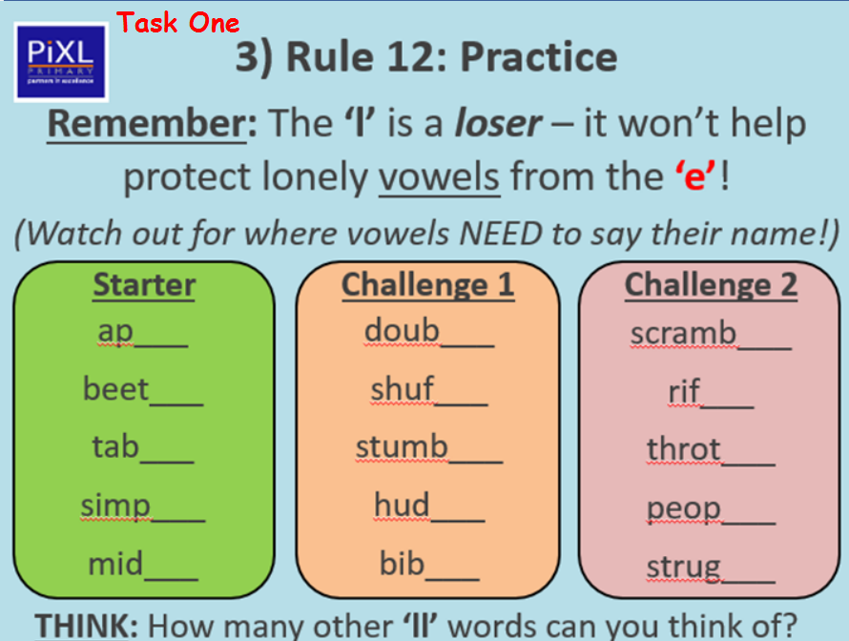

TASK TWO: Choose at least two words from each box and use them in a sentence.


