

Learning Activities
Year 3
2019-20
Self-isolation learning
Week 5 (Worksheets)

Monday
Maths: Practise 3 times tables and shape English (GPAS): Possessive apostrophe
SLOR: The Tale of Squirrel Nutkin

Tuesday
Maths: 4 times tables and Shape English: Diary entry
Jigsaw: Keeping myself safe online

Wednesday
Maths: 4 times tables and shape English (GPAS): Nouns, adjectives, verbs, adverbs
Science: Plants – Identifying functions of a stem and leaves

Thursday
Maths: 8 times table practise and shape English: Character description
Topic: Boudicca

Friday
Maths: 8 times table practise and arithmetic test practise English: Spellings
PE: Just dance

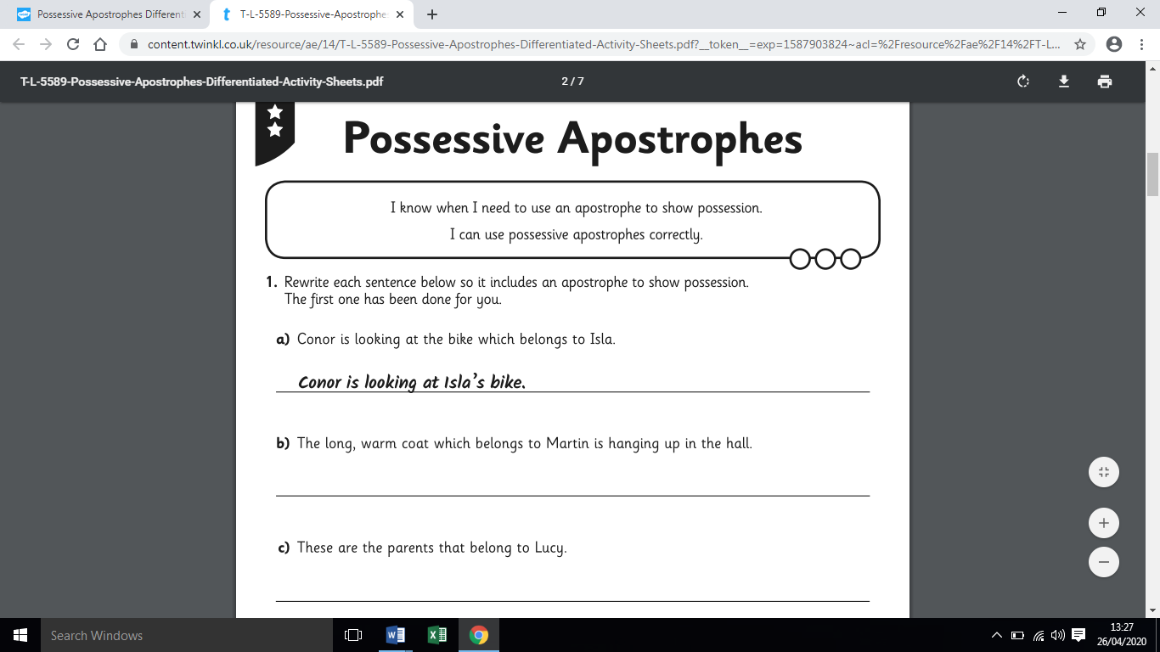
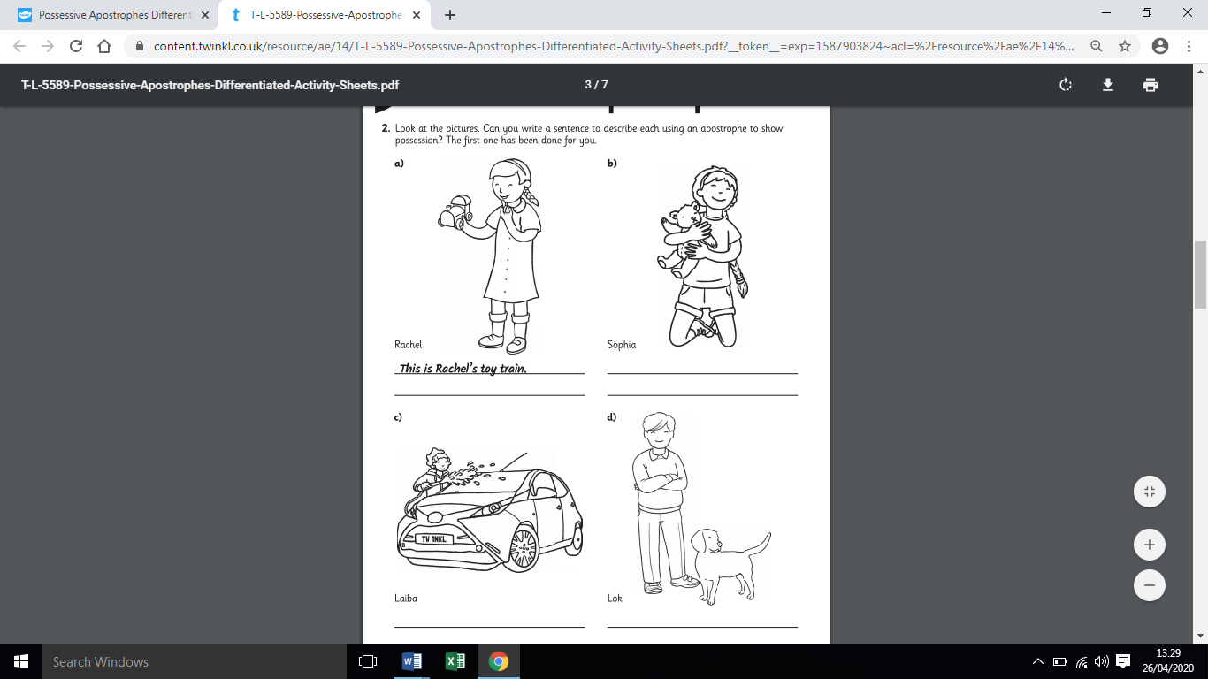
Monday -GPaS- Possessive apostrophes.
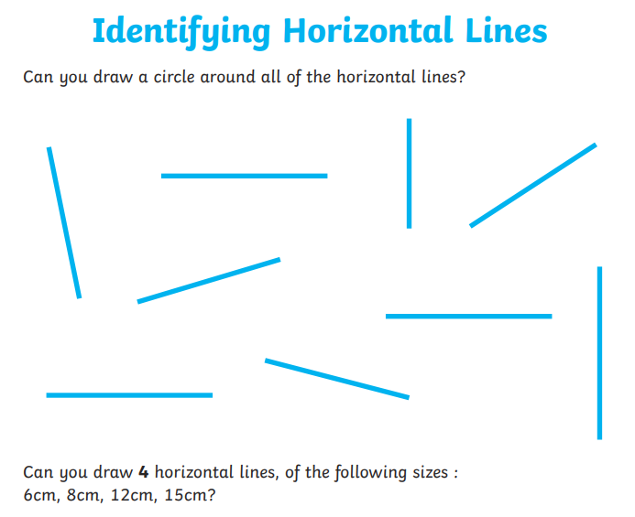
Monday Maths: Shape Task 1

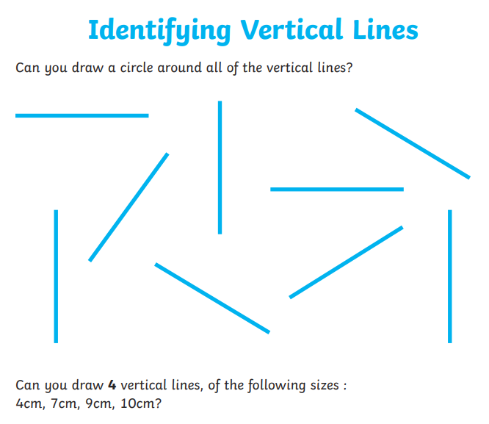
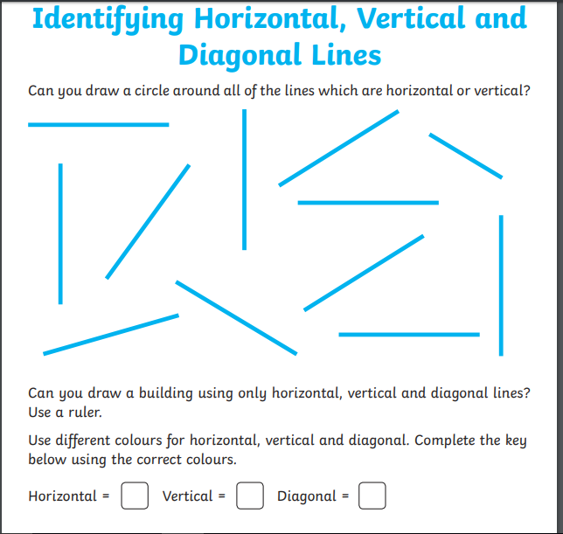
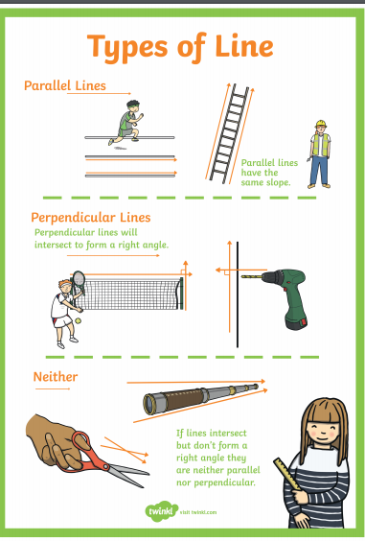

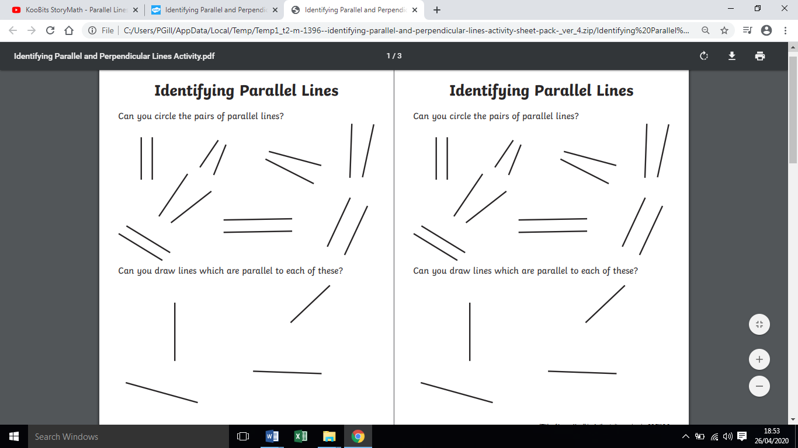
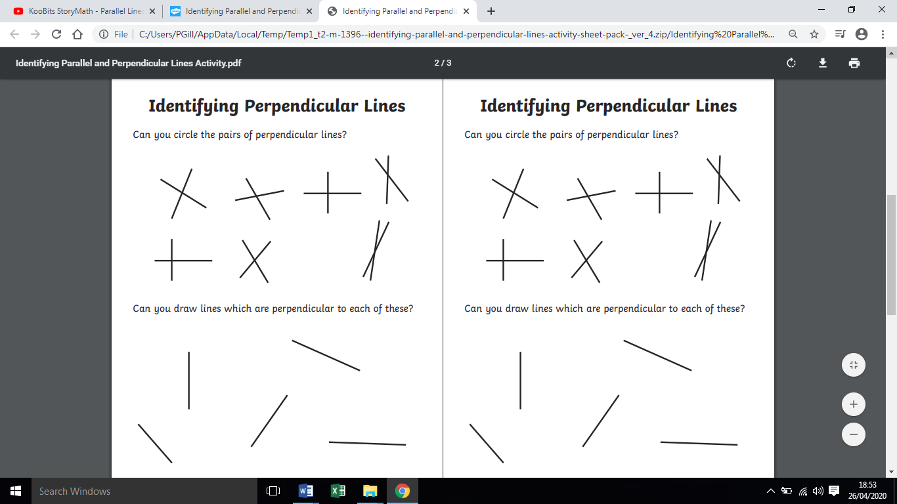
Task 2-Monday

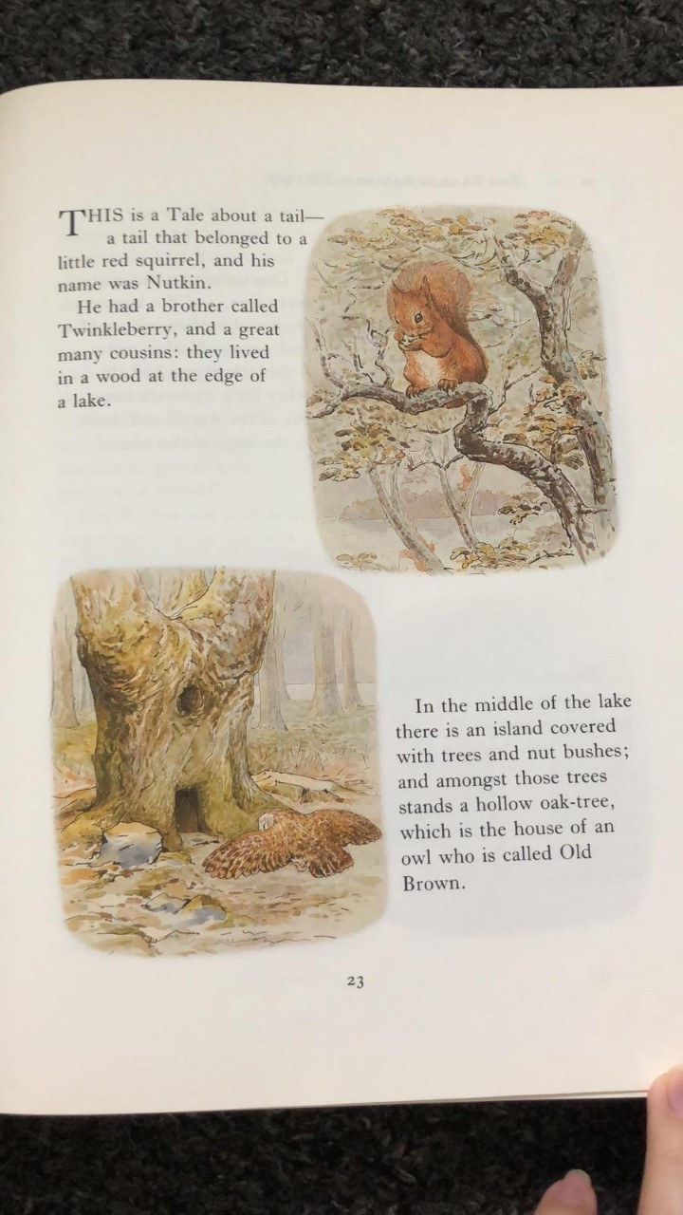
SLoR:
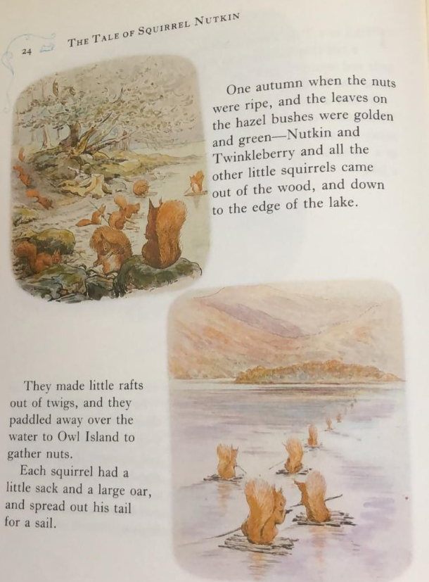
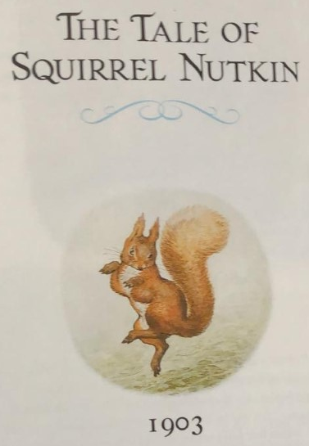
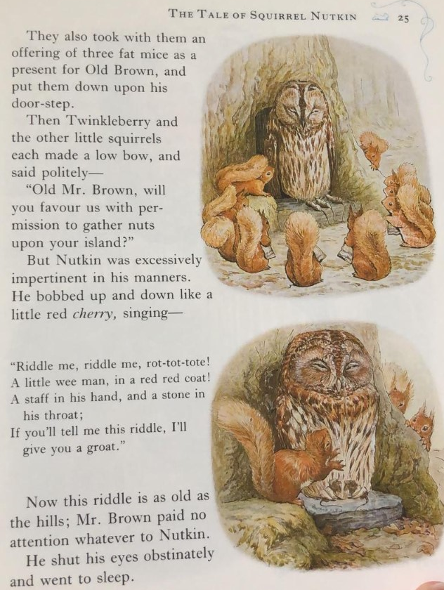
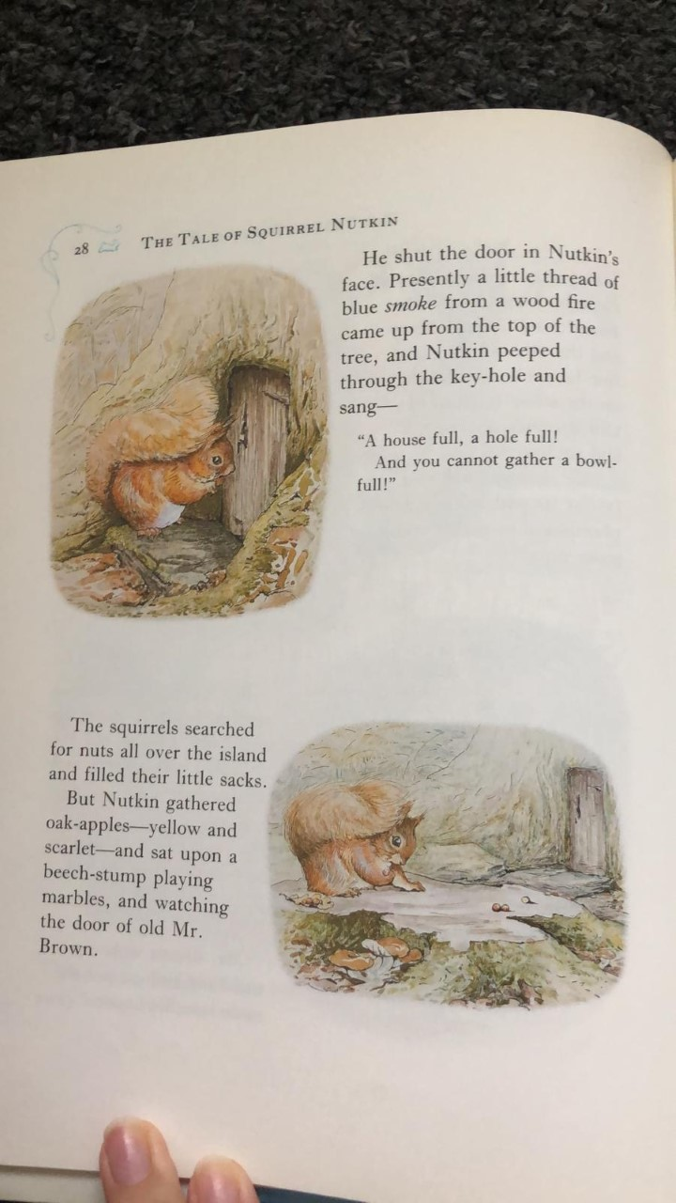
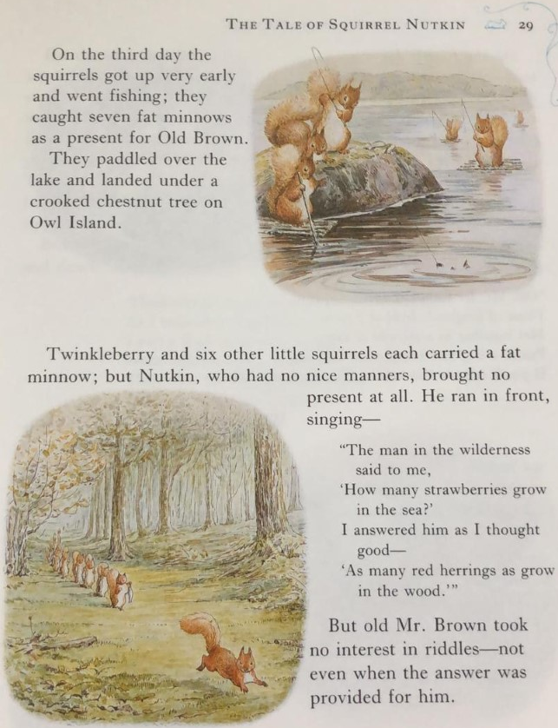
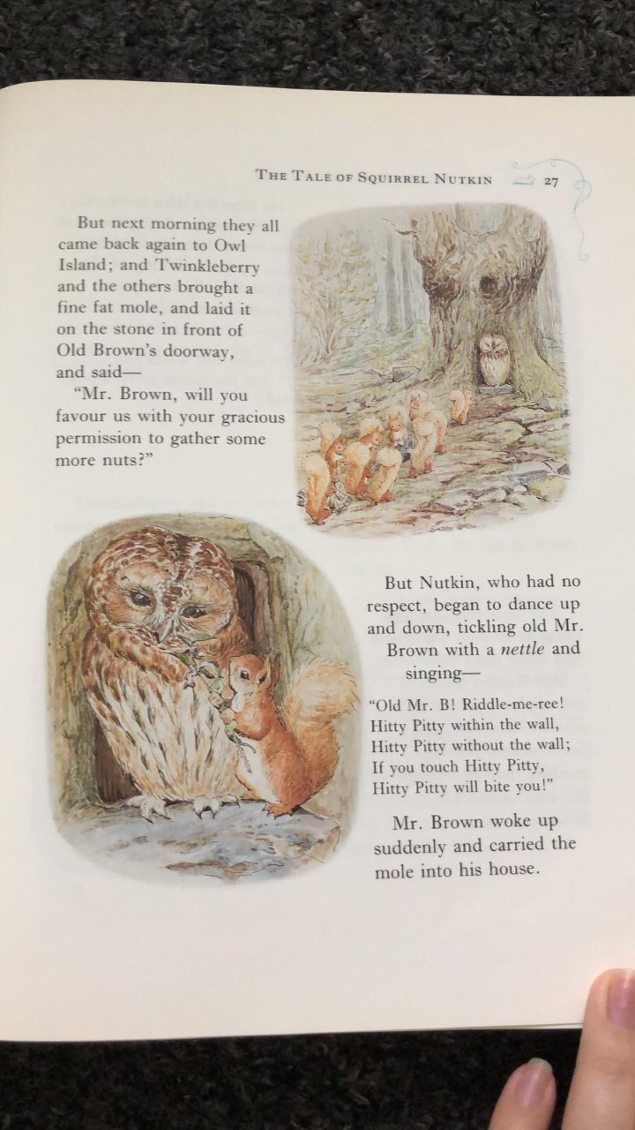
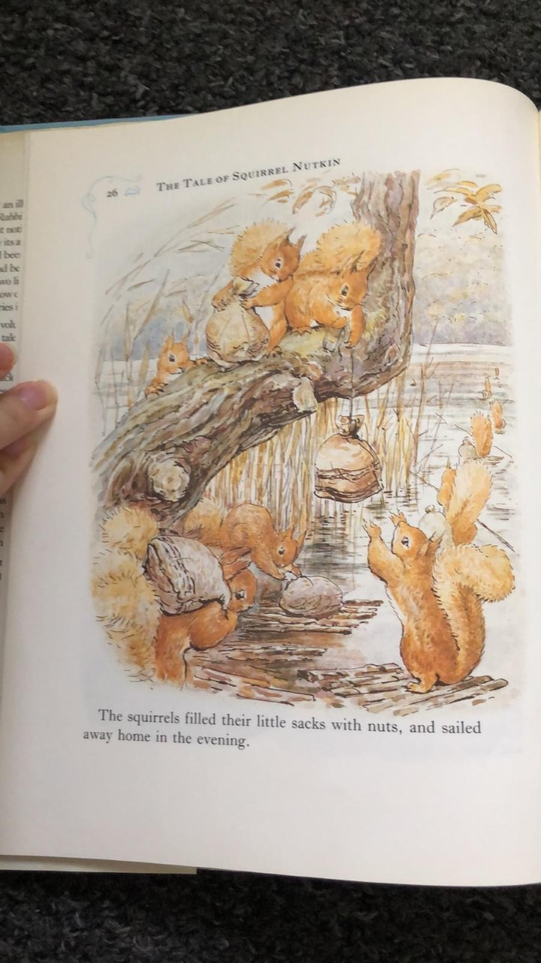
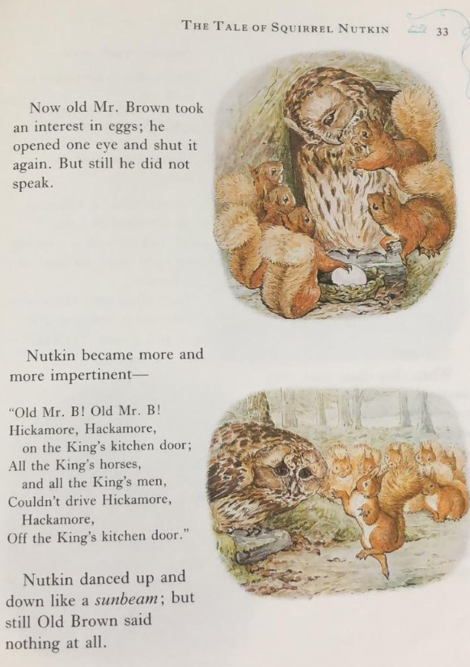
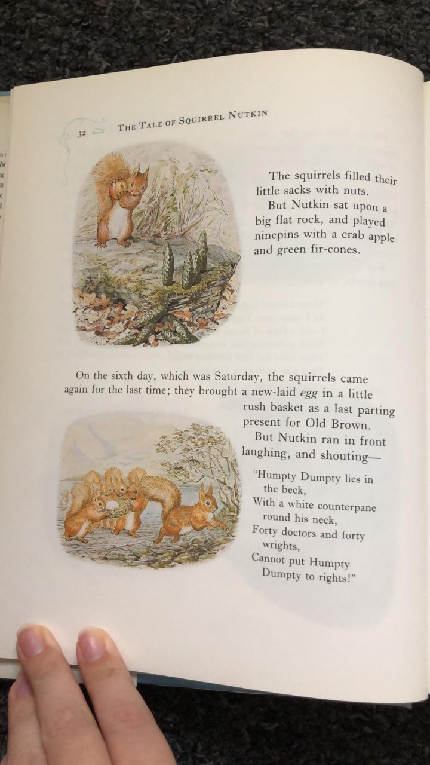
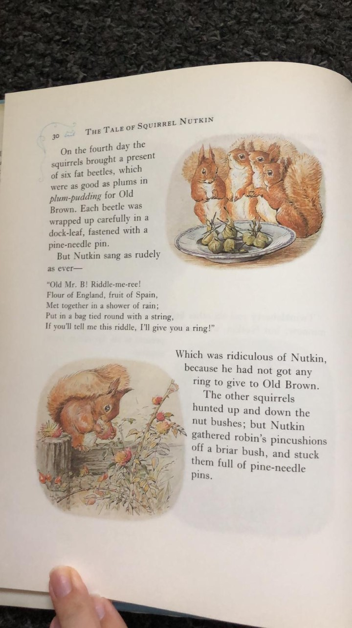
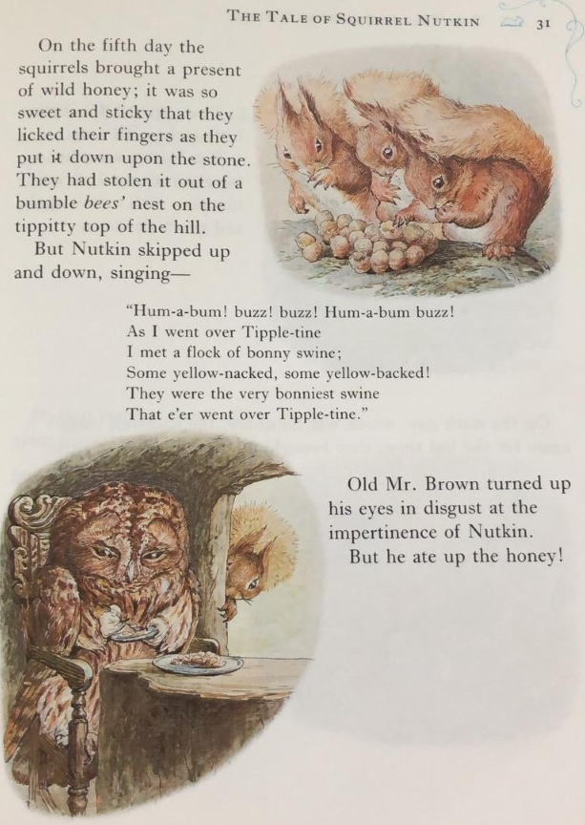
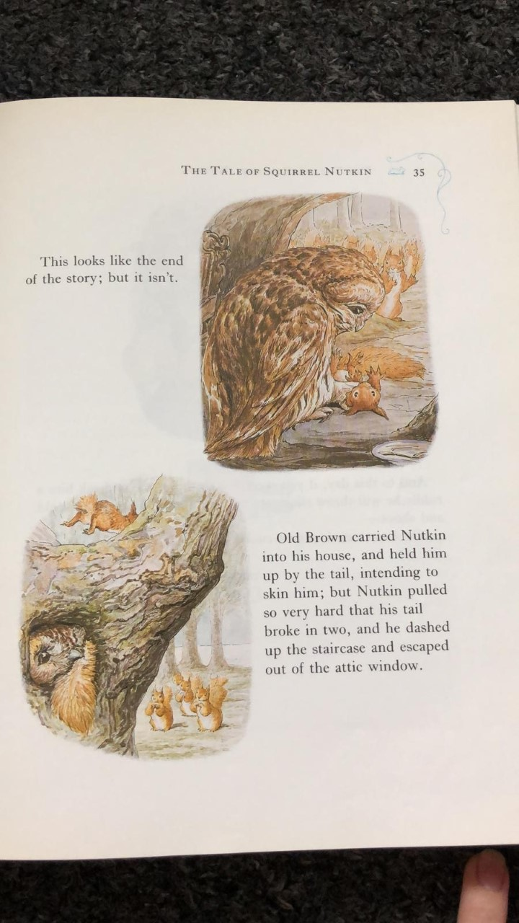
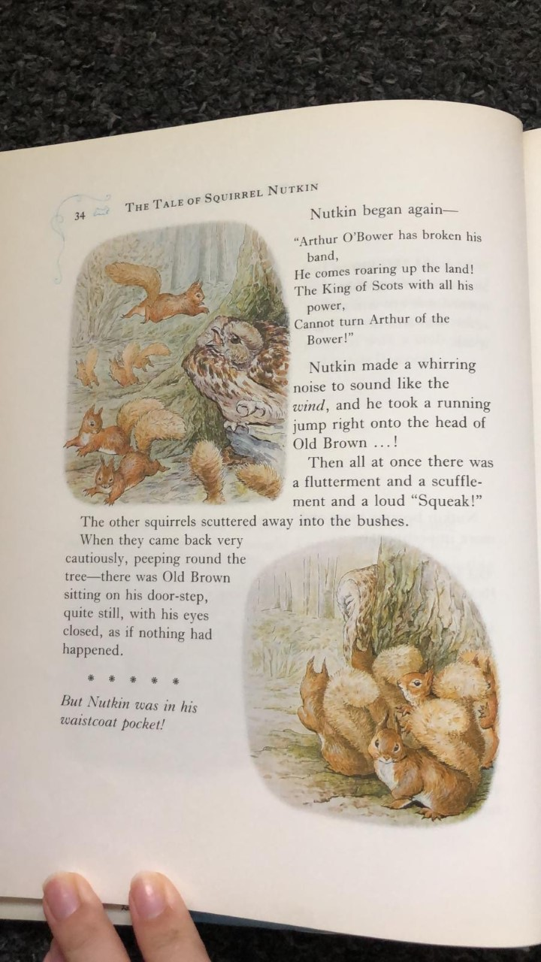
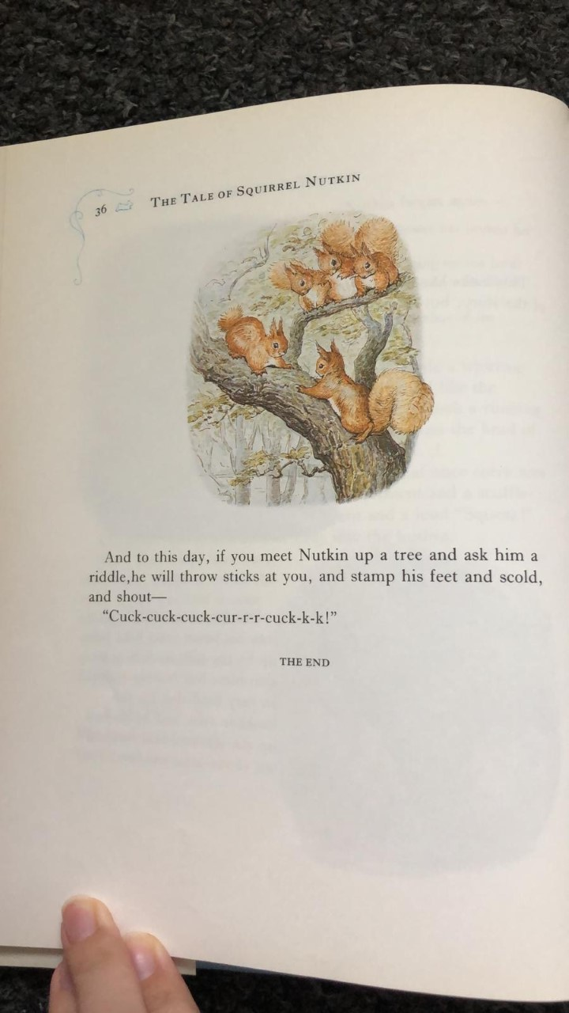
SLOR task 1: Answer the questions below:
- Where did Nutkin and his brother Twinkleberry live?
- Write down two ways the author describes the island.
- On page 24, what evidence is there to suggest the squirrels were very clever? You must provide two reasons.
- Look on page 25, explain what you think this line means and why.
‘But Nutkin was excessively impertinent in his manners’.
- Using evidence from the text, explain what Nutkin’s personality is like.

TASK TWO
Draw five pictures (in chronological order) summarising the main parts of the story you have read so far. Write a sentence underneath each picture.

Maths Tuesday: You will need a right angle finder for the activity.
If you don’t have a printer to print your right angle finder,
- Cut out a circle
- Fold it in half
- Now, fold it in half again
- You can now check for right angles!

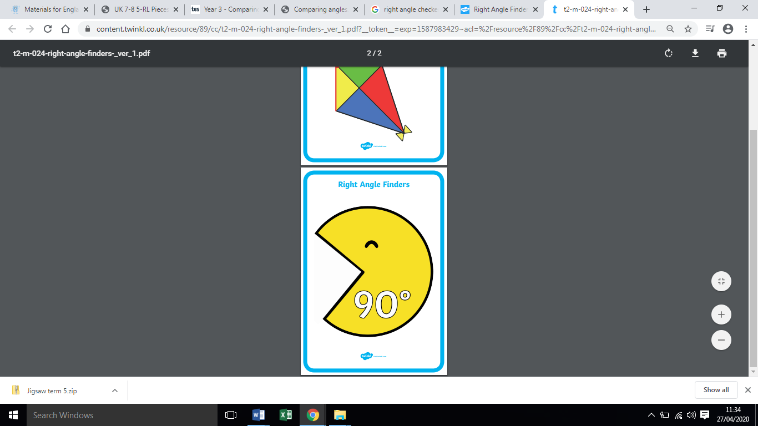

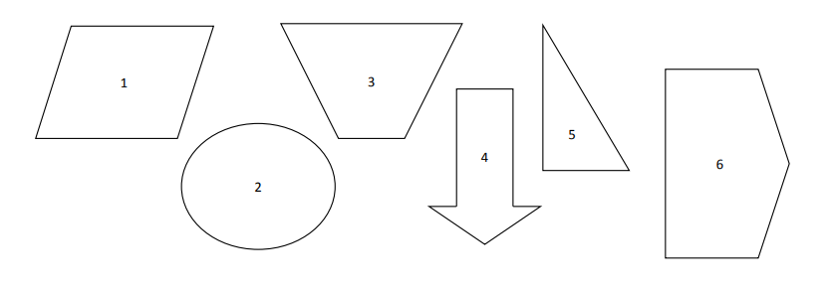
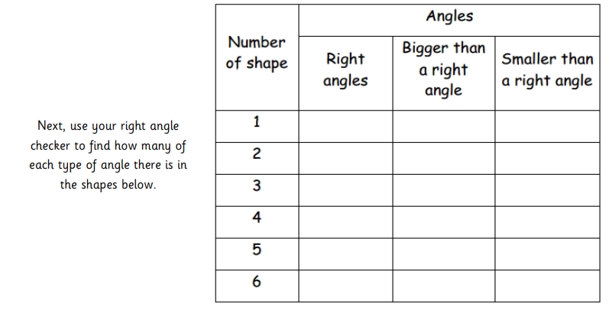
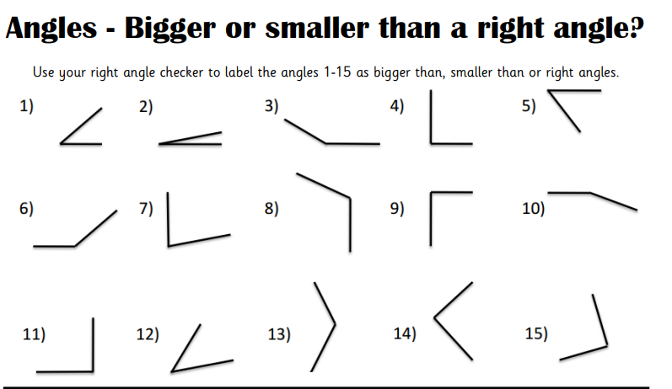
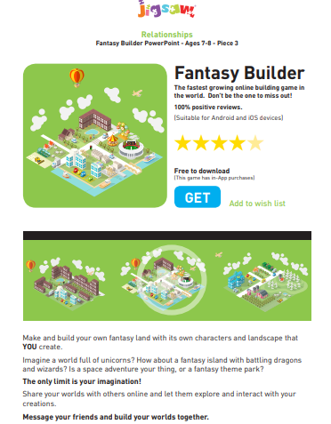
Jigsaw discussion activity 1:
-Is this a game they’d be tempted to download and play online?
-What is appealing about this game?
-How do they know it’ll be enjoyable?
-Are there any possible risks with this app?
Jigsaw activity 2- Rank these Top tips cards in order of the most important to the least important. Think about the following when deciding.
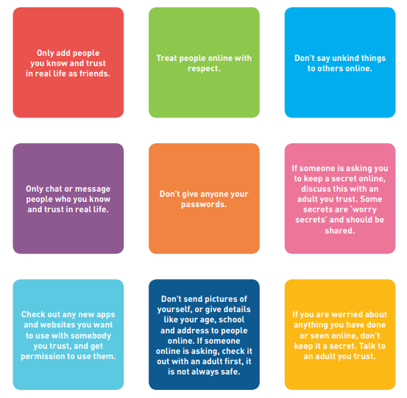
Which Top Tip do you think is most important? Which is least important? Do you think they are all of equal importance? Who would you go to if you were worried about anything online?
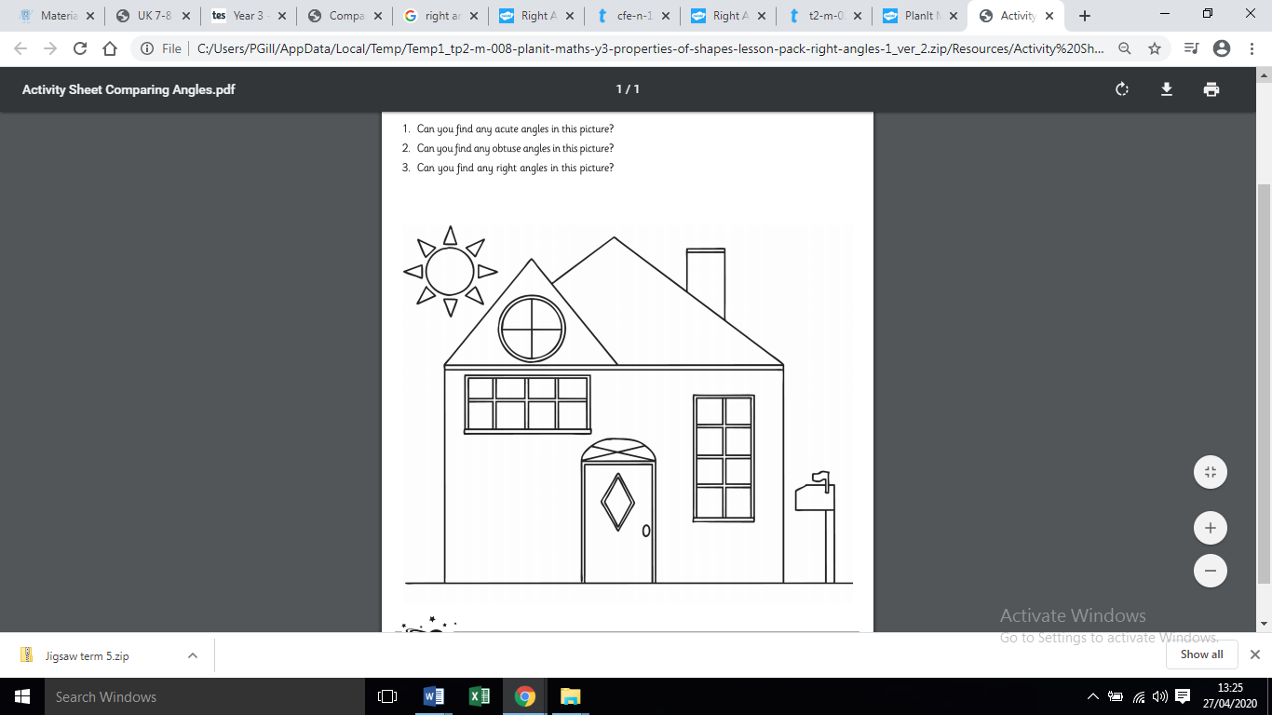
Wednesday Maths:

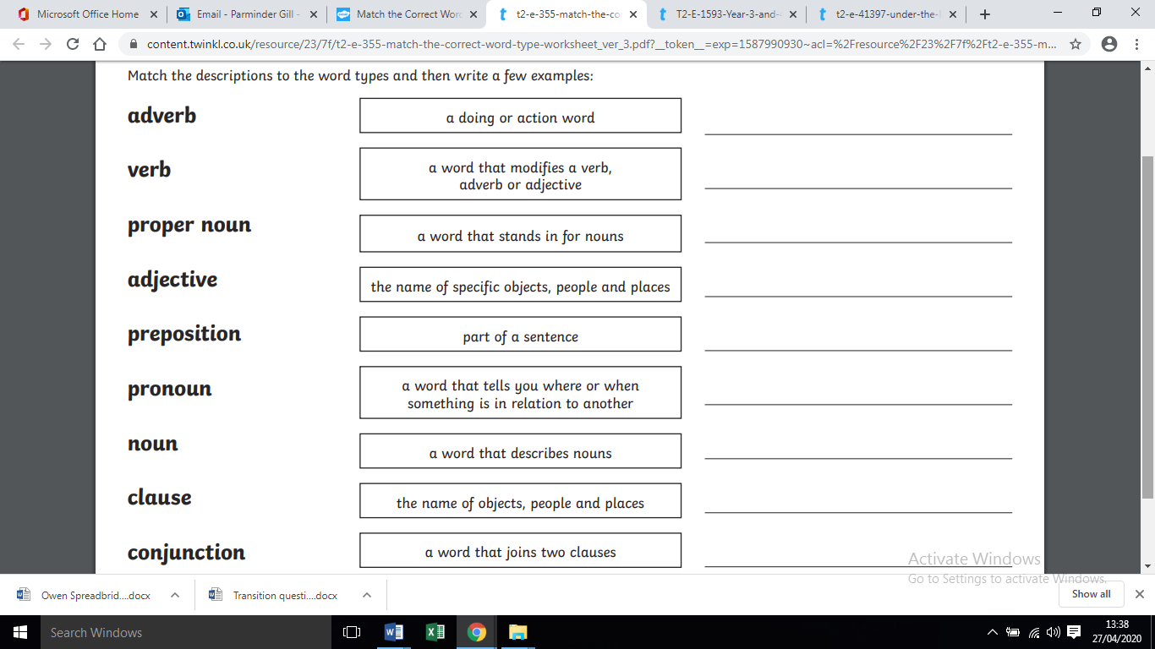
Wednesday’s GPaS

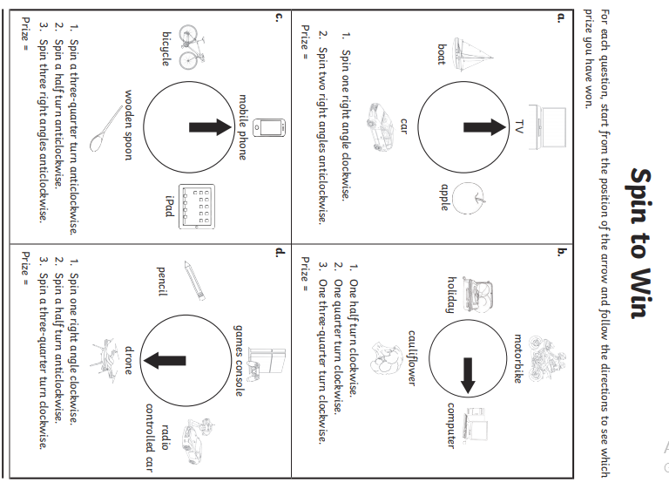
Maths Thursday
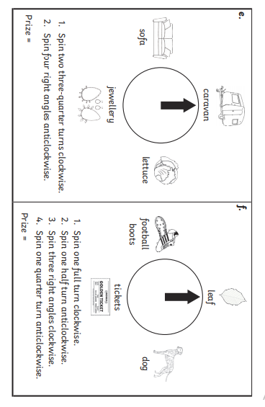
Thursday topic- Newspaper report planning sheet.
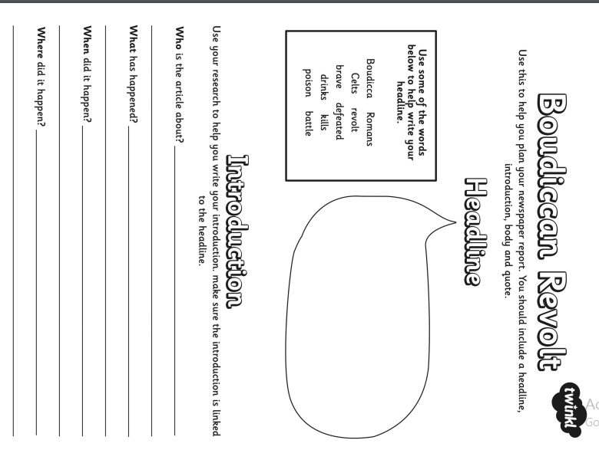

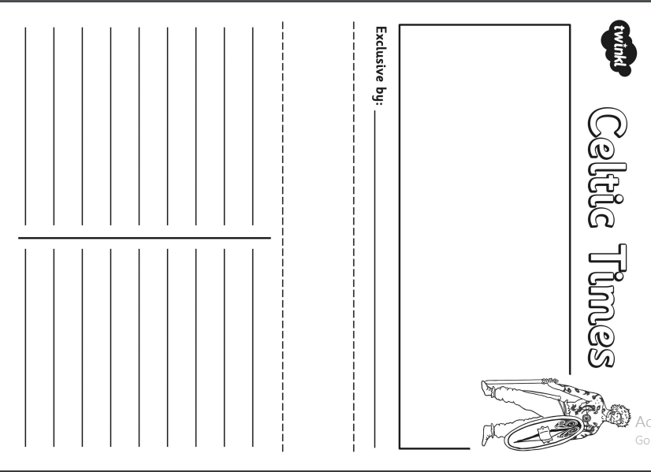
Friday-Maths- arithmetic test
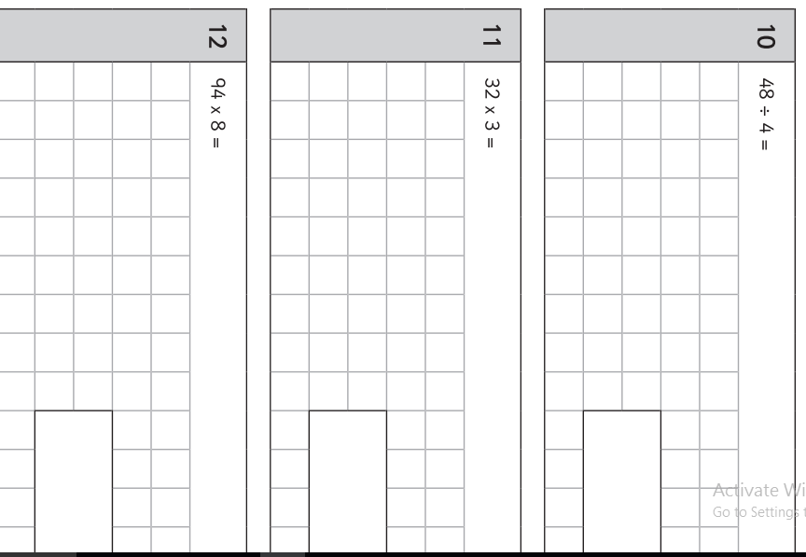
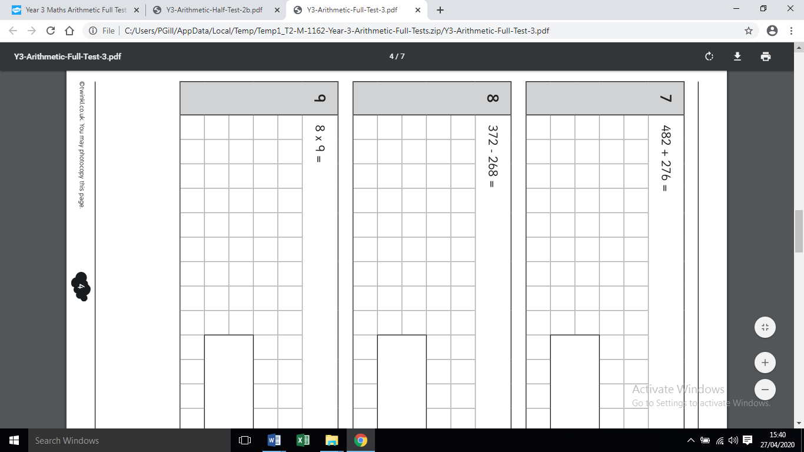
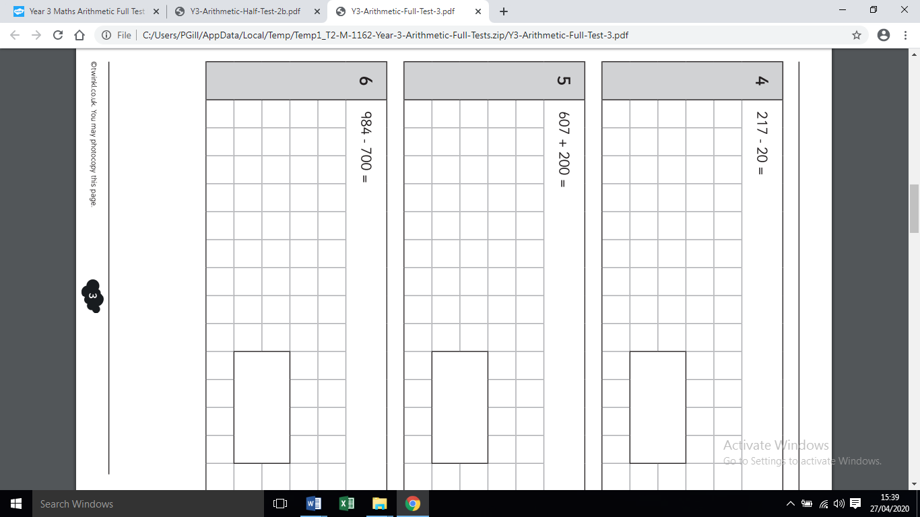
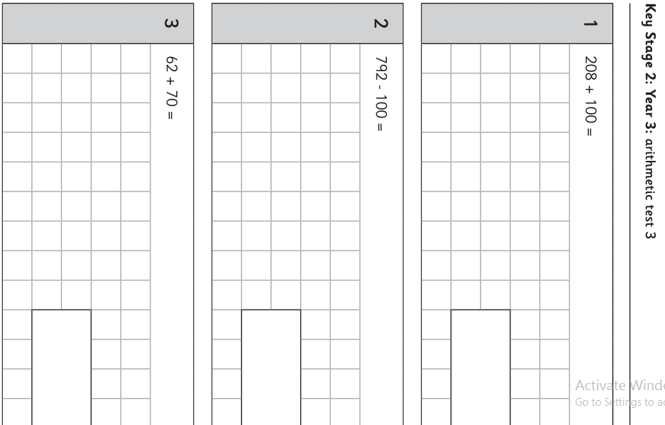

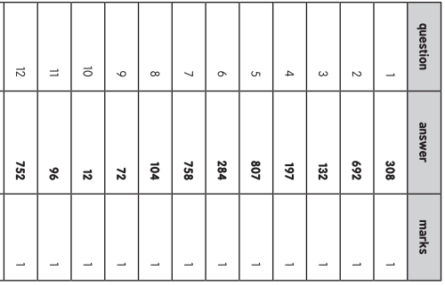

Spellings:

straight
strange
strength
sugar
suppose
sure
surprise
the

MILD
Words with the ue sound
glue
blue
true
argue
tissue
statue

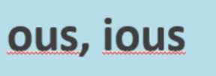
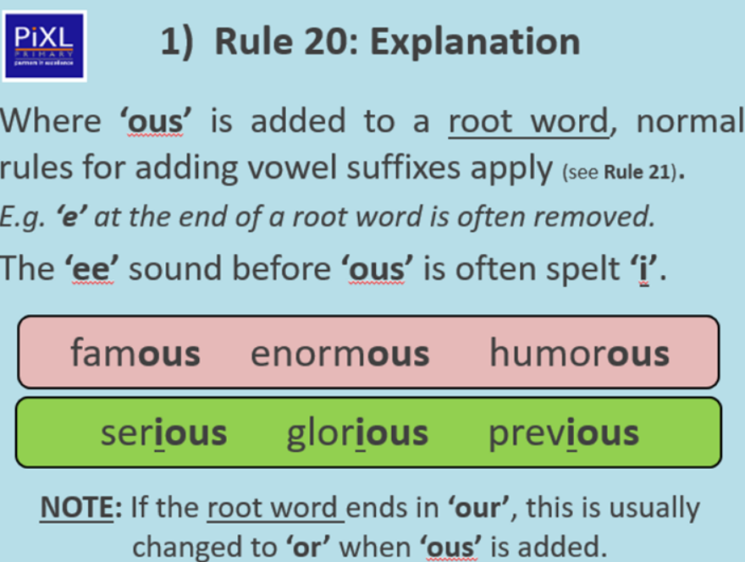
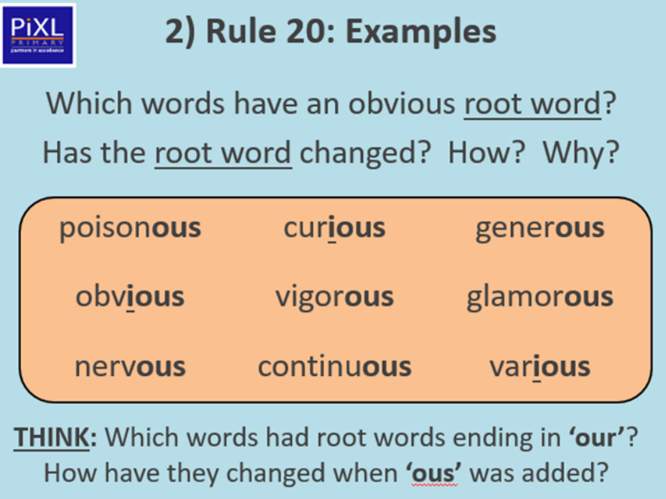

TASK ONE: Add ‘ous’ to the words. 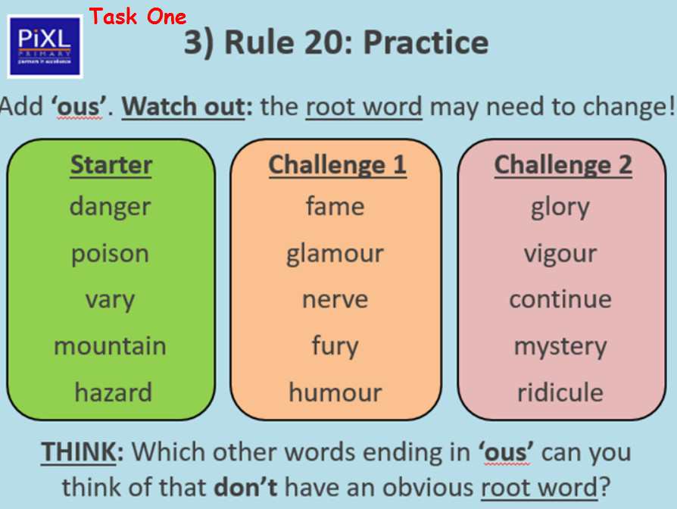
TASK TWO: Choose at least two words from each box and use them in a sentence.



