

Learning Activities
Year 3
2019-20

Self-isolation learning
Week 4 (Worksheets)
Monday
Maths: Practise 3 times tables and fractions English (GPAS): Conjunctions
SLOR: The Tale of Peter Rabbit

Tuesday
Maths: 4 times tables and equivalent fractions English: Diary writing
Jigsaw: Friendship

Wednesday
Maths: 4 times tables and add/subtract fractions English (GPAS): Suffixes
Science: Plants – Water investigation

Thursday
Maths: 8 times table practise and fractions of an amount English: Story Writing Topic: Roman children

Friday
Maths: 8 times table practise and fractions of an amount English: Spellings
PE: Gymnastics

Maths: L.O. To read fractions.
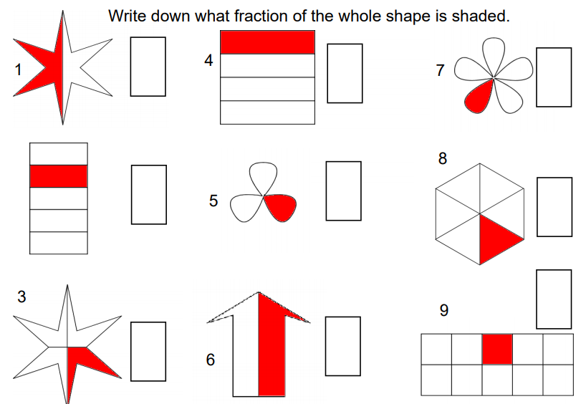

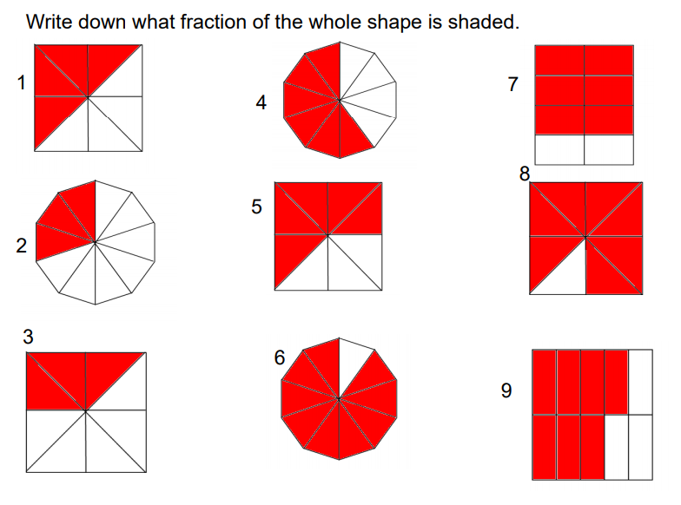
English (GPAS):
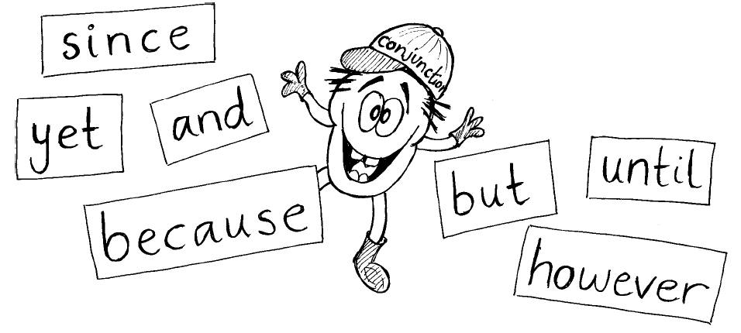
Conjunctions
Can you spot the conjunctions in these sentences? Underline them:
1. I put on my shoes and I went out to play.
2. I can’t eat my sweets until after dinner.
3. I can’t go out tonight because I have to stay in and do my homework.
4. It had been a long time since I had last played football.
5. I was going to eat the sweets but I saved them for my sister.
6. She was nice to me although she wouldn’t let me play with the lego.

Use conjunctions to make these sentences more interesting.
7. I can’t go swimming. I have forgotten my swimming trunks.

8. I’d like to go to the park. My mum won’t let me.

9. The old woman wanted to feed her dog. There was nothing in the cupboard.

10. I bought some sweets. I ate them on the way home.

11. The teacher was cross. She was late.

12. I went to the pictures. I really wanted to stay at home.

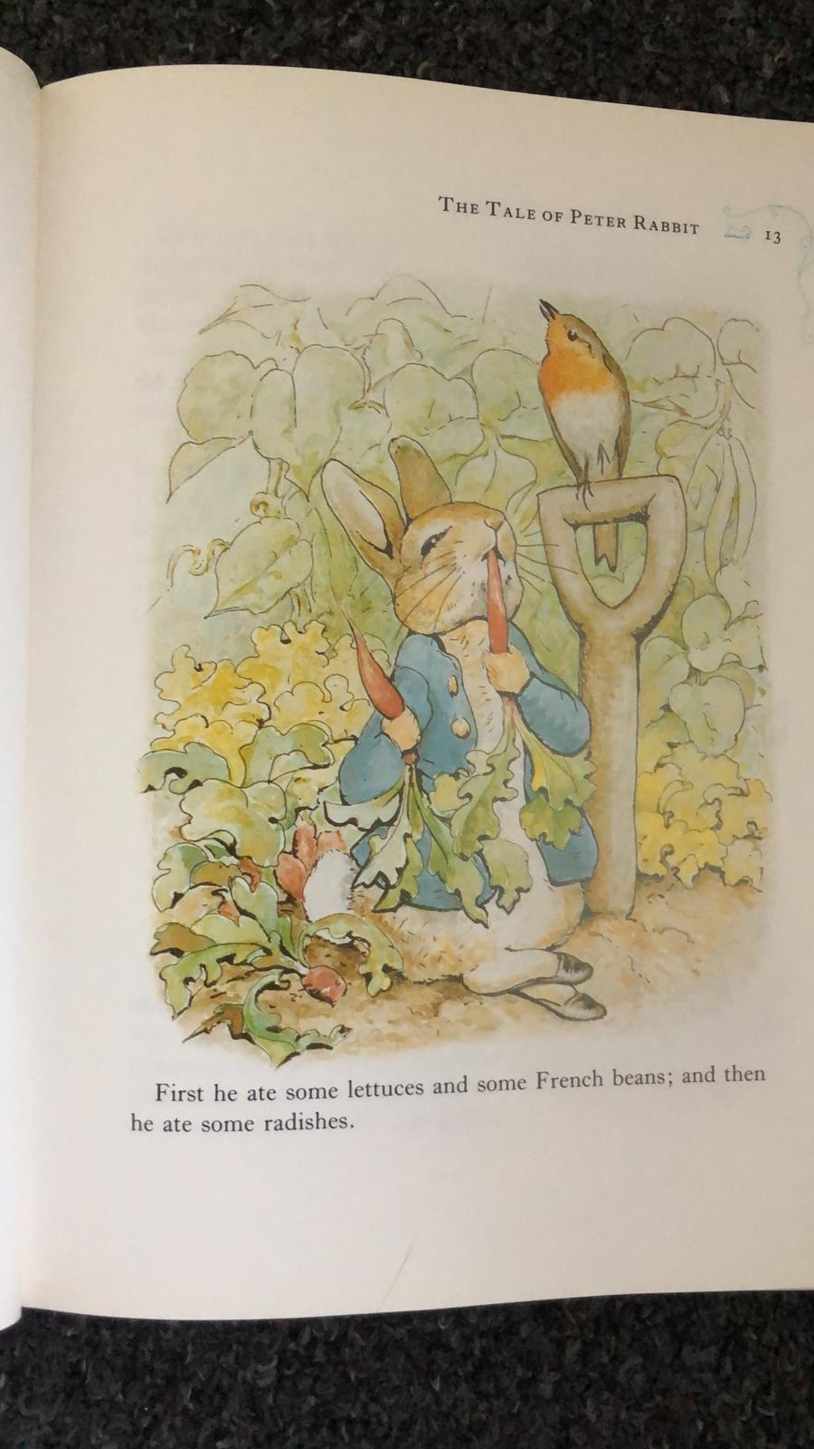
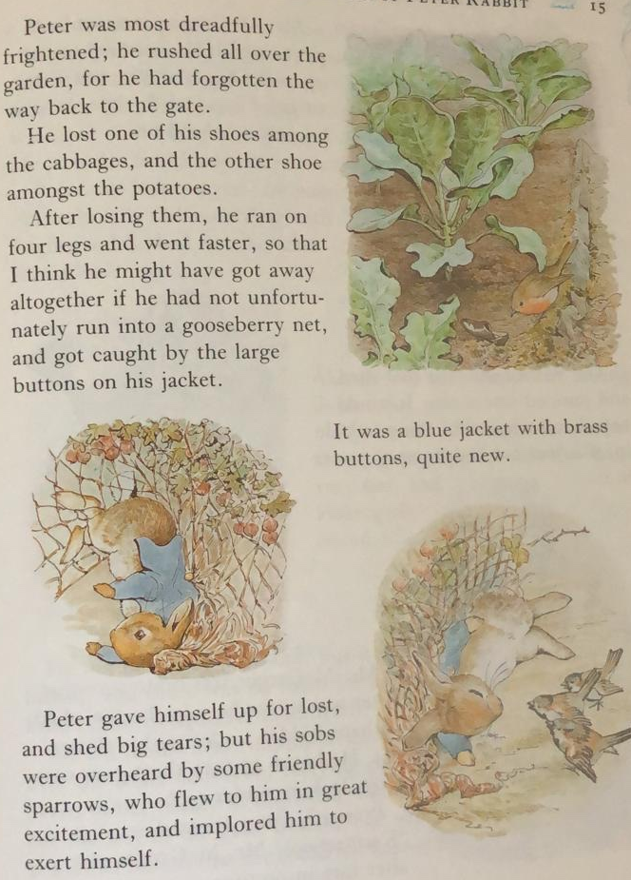
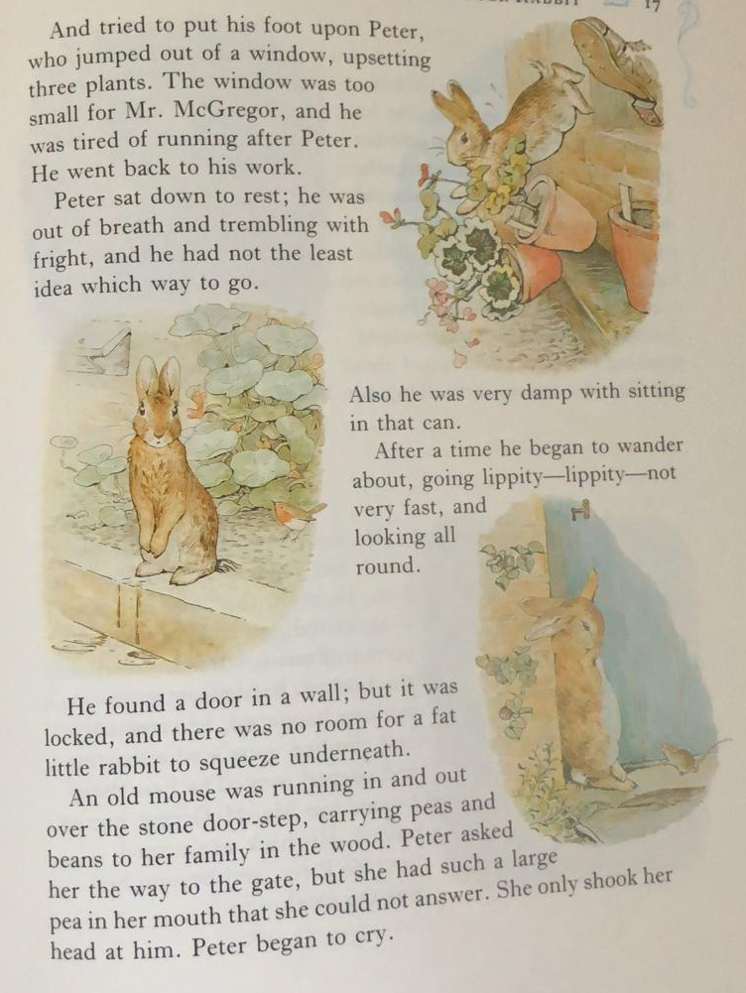
SLOR: 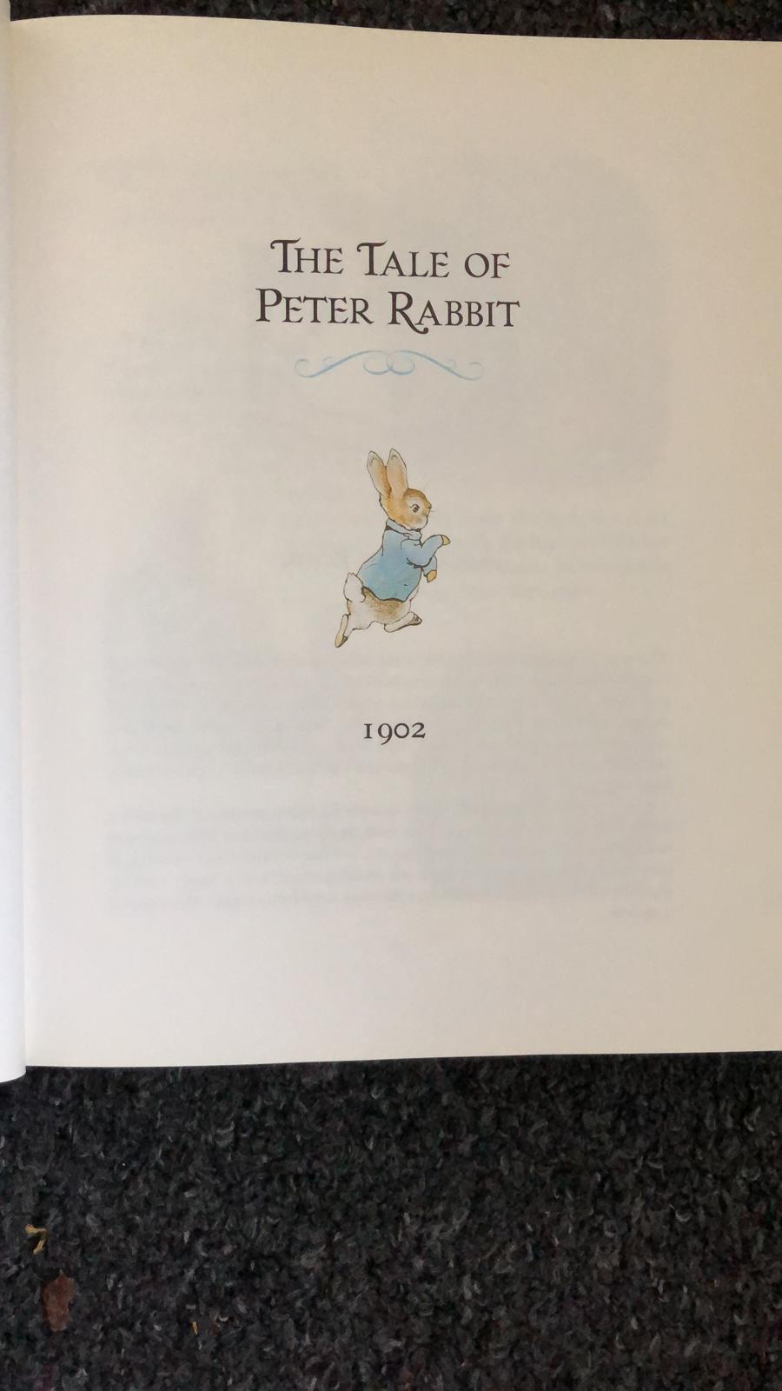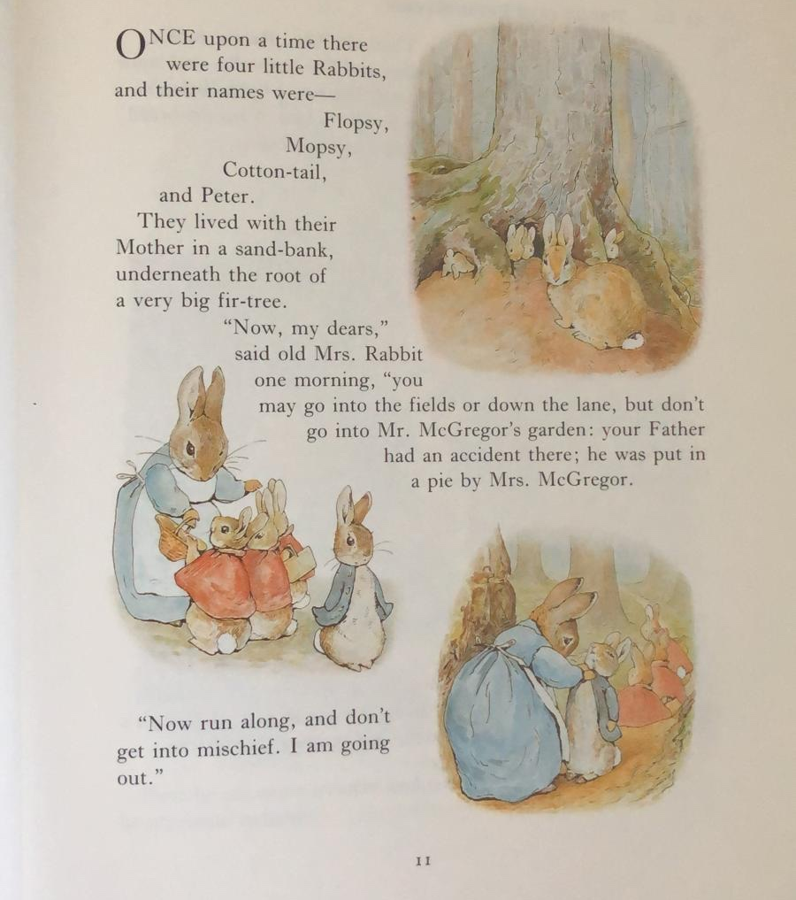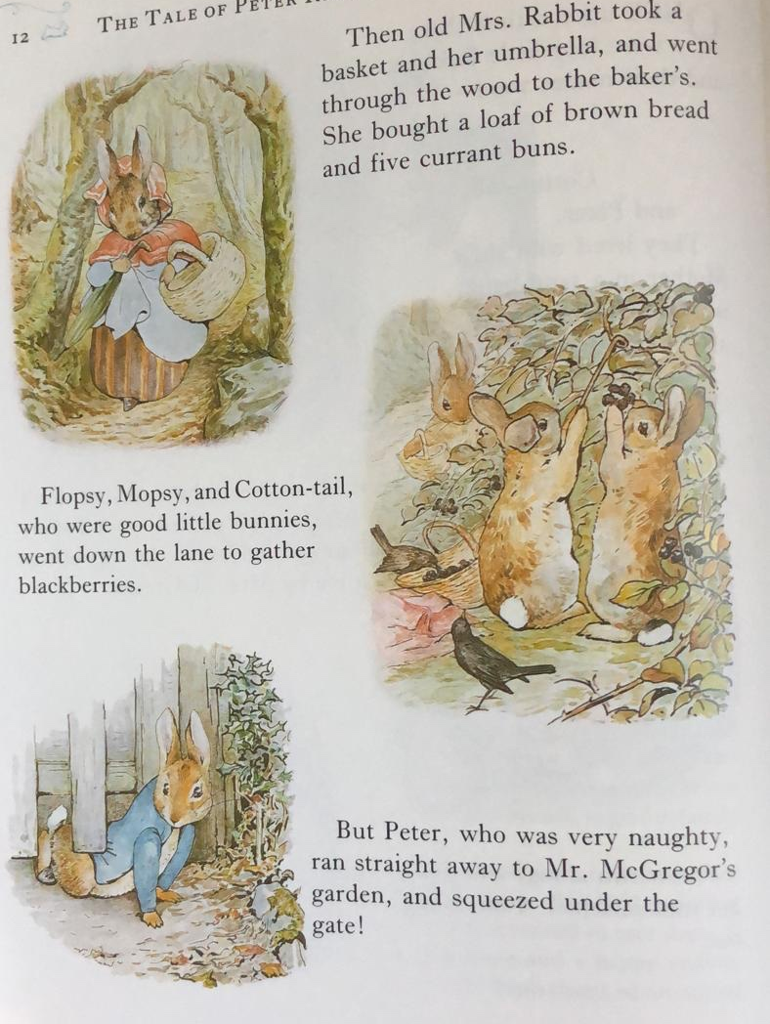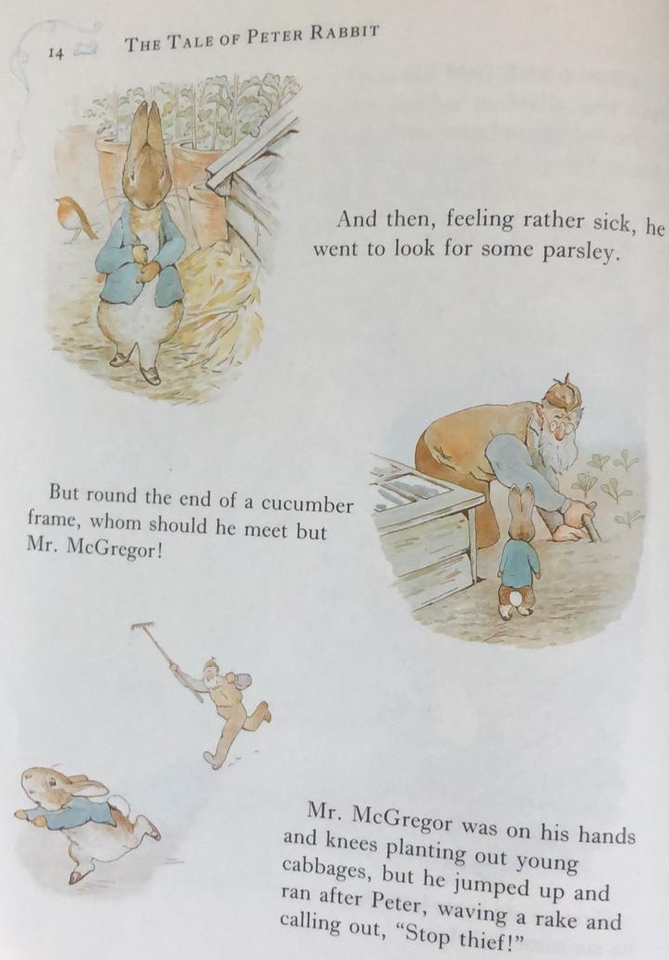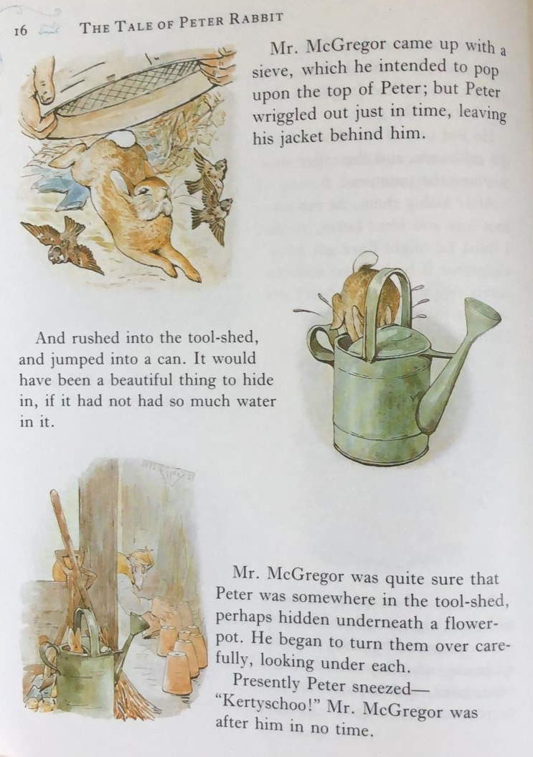
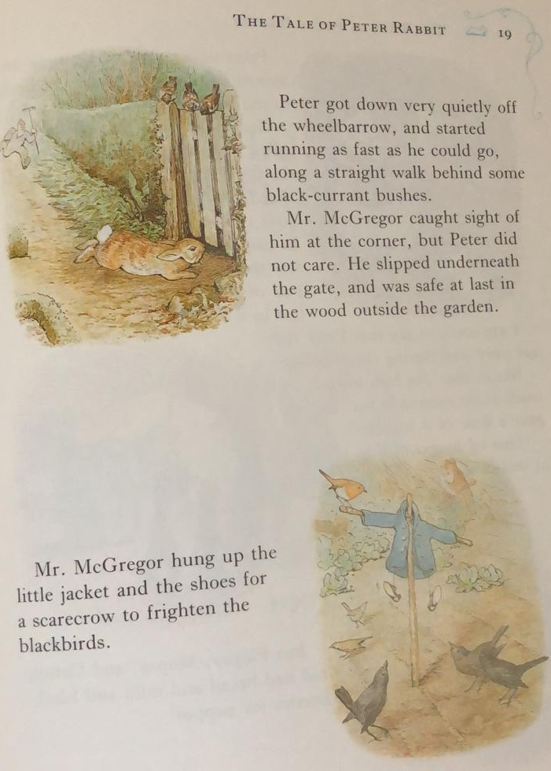
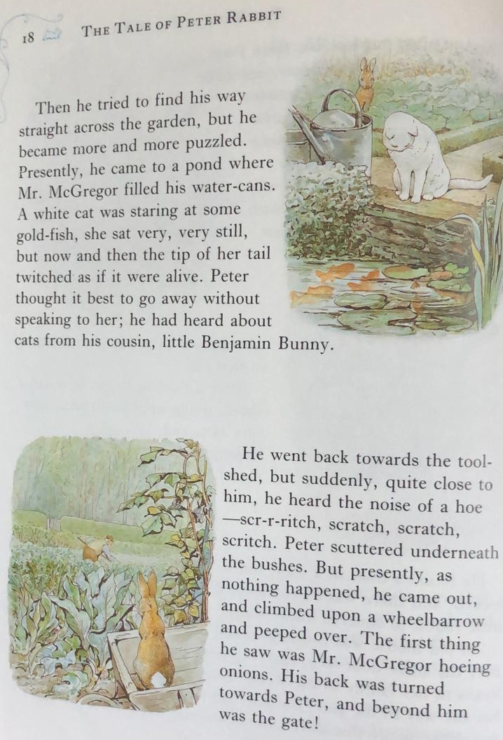
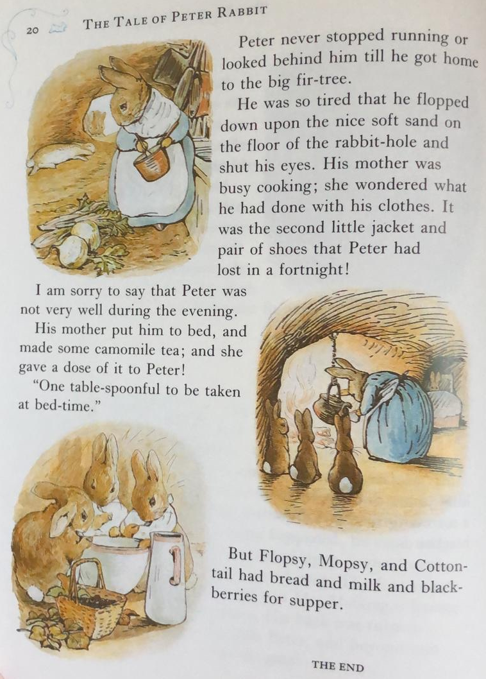
TASK TWO
Arrange the mixed up story sentences into sequential order.

Mr McGregor saw Peter and chased him.

Peter went into Mr McGregor’s garden.

Peter saw the gate and ran as fast as he could home.

Peter slept while his sisters enjoyed their dinner.

Mum warned Flopsy, Mopsy, Cotton-tail and Peter not go into Mr McGregor’s garden.
TASK ONE
Go through the text and identify words that you are not familiar with/ don’t know the meaning for. Use a dictionary to find the meaning of the words. You can use online dictionaries if you do not have a dictionary at home.

Example:

Exert - To make a physical or mental effort.

Jigsaw:

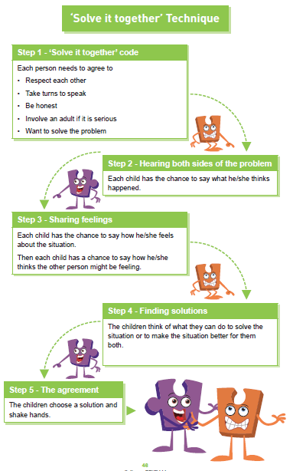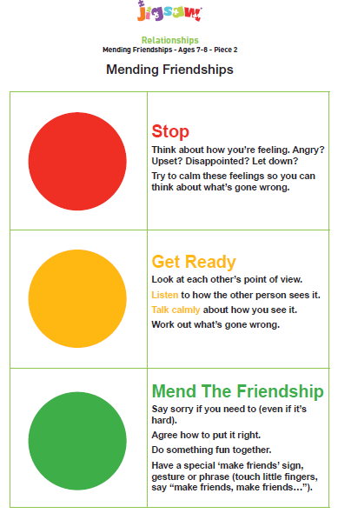

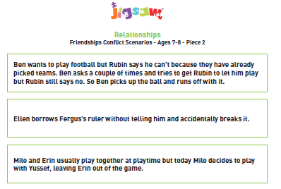
Maths: L.O. To make equivalent fractions
If you do not have access to a printer please write down a all the fractions from the sheet onto a piece of paper and then match them.

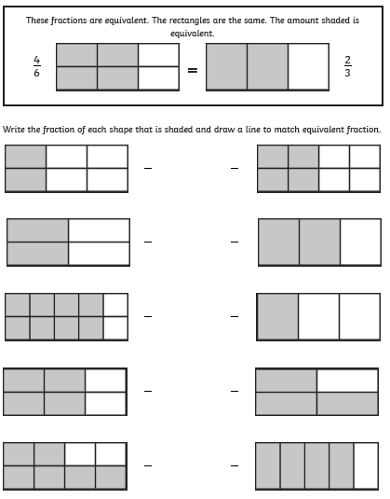

Fractions of an amount explanation
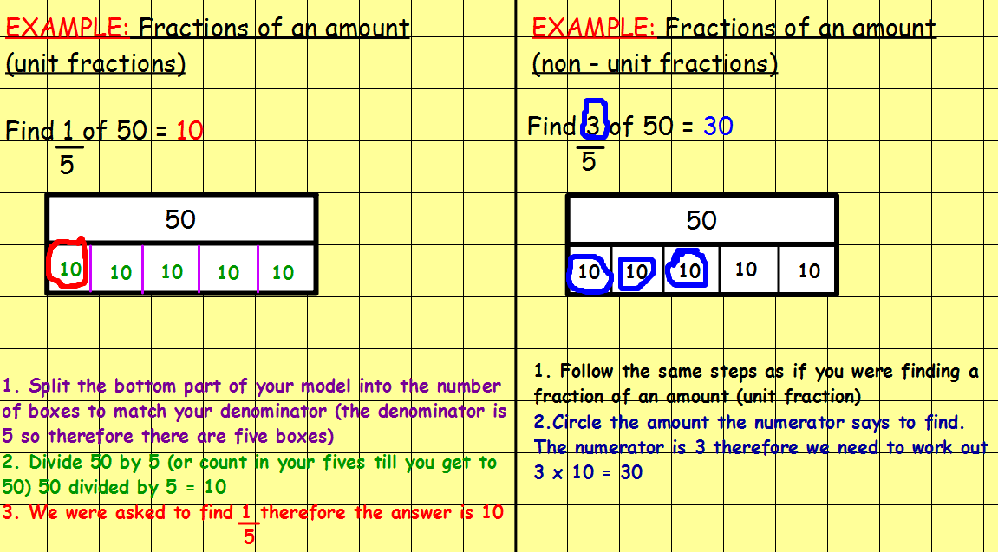

L.O. To find fractions of an amount (unit fractions)
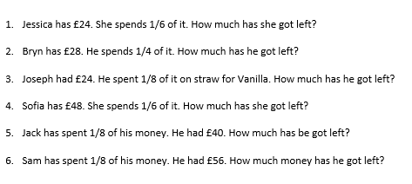
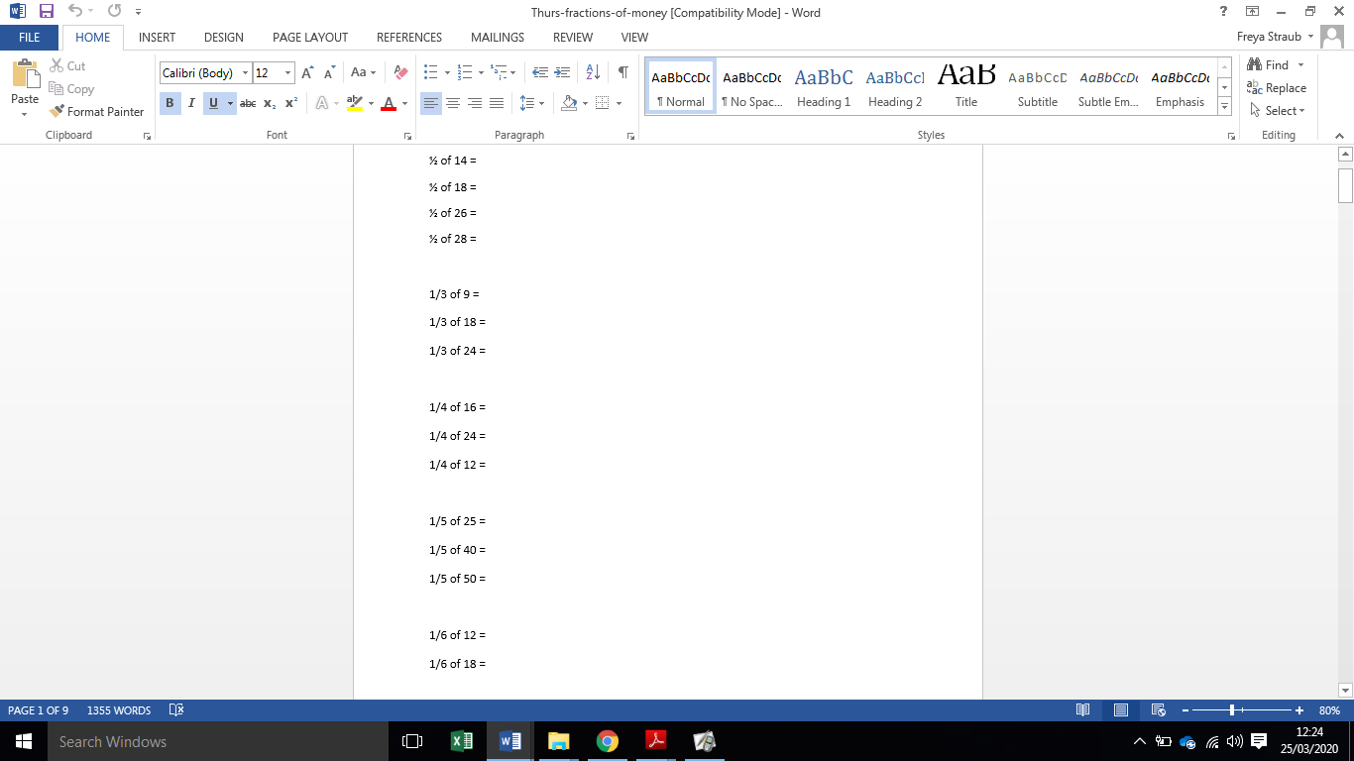
Topic:
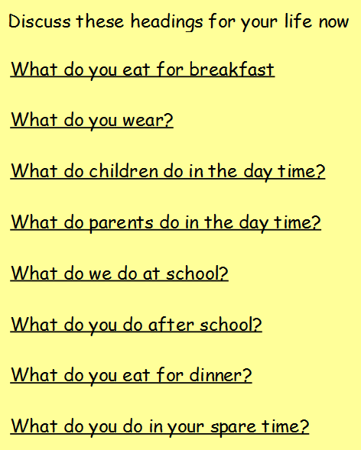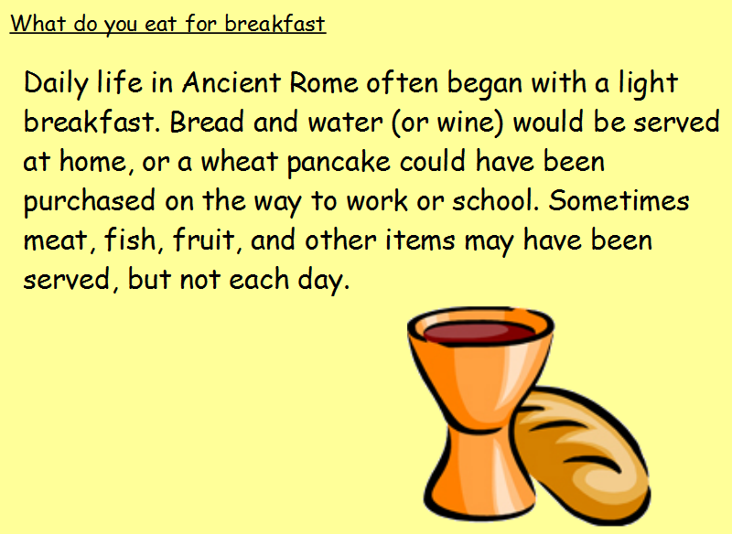
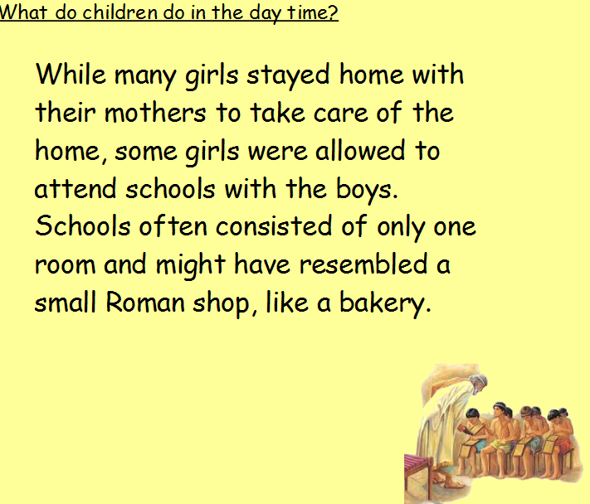
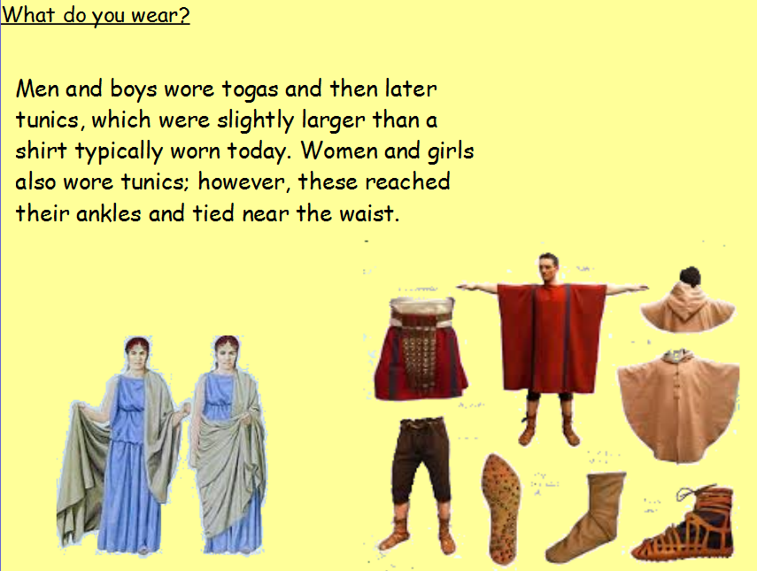
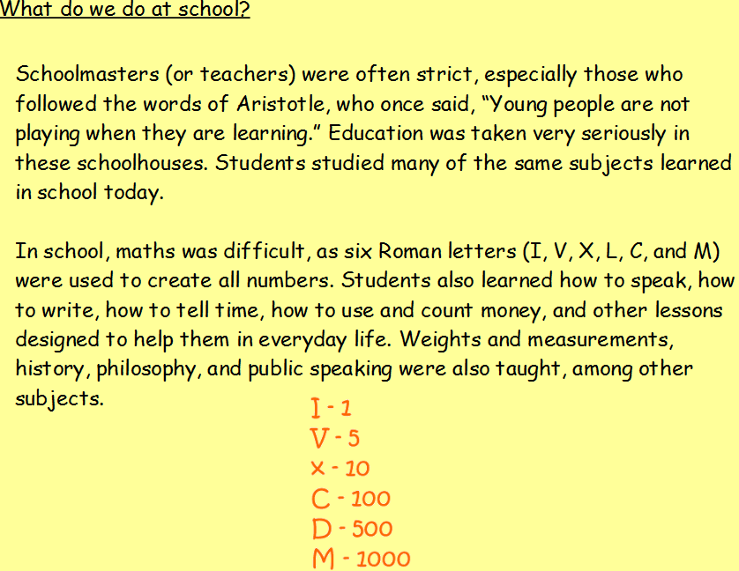
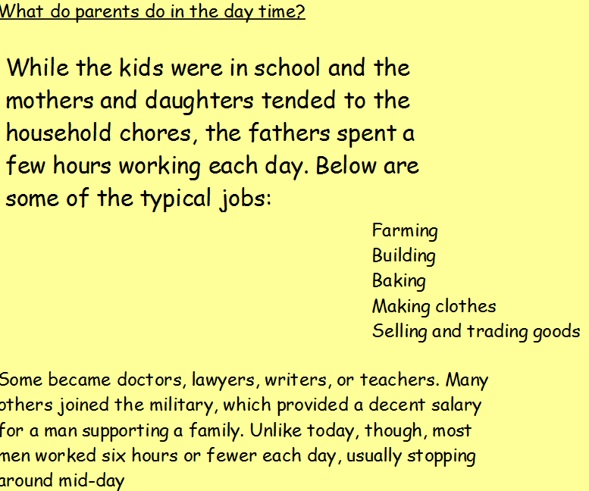

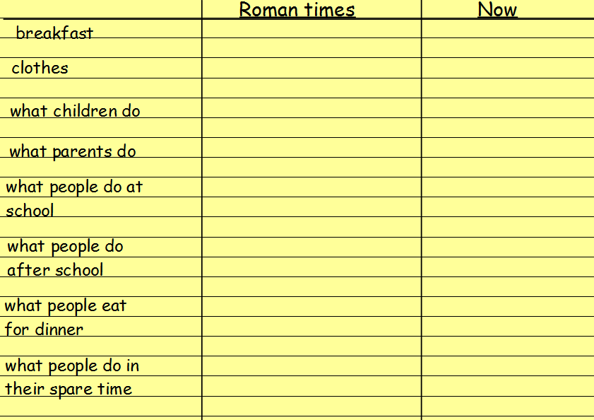
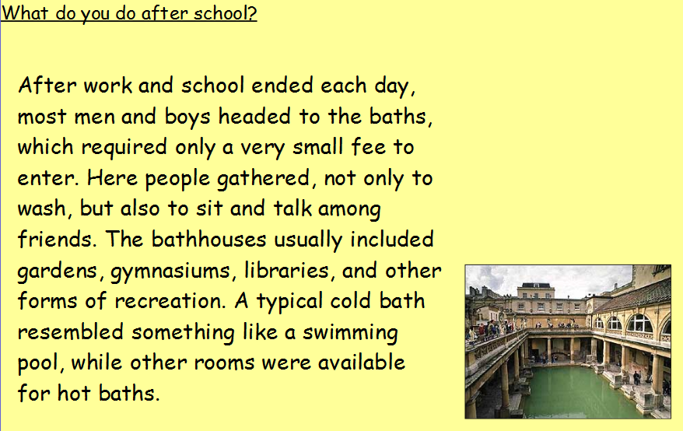
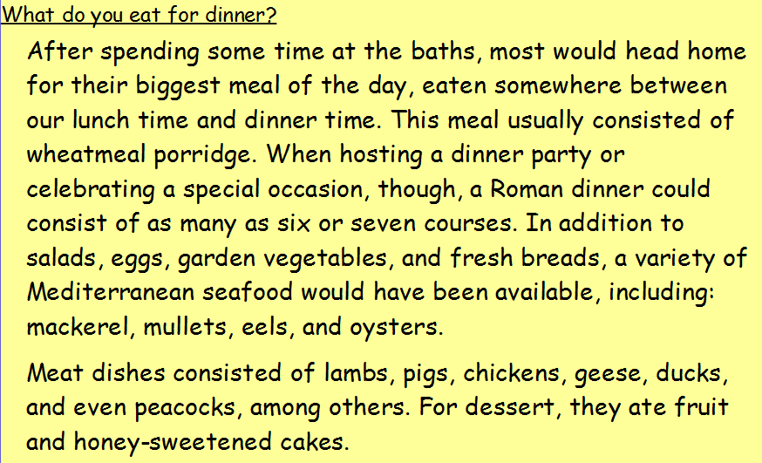
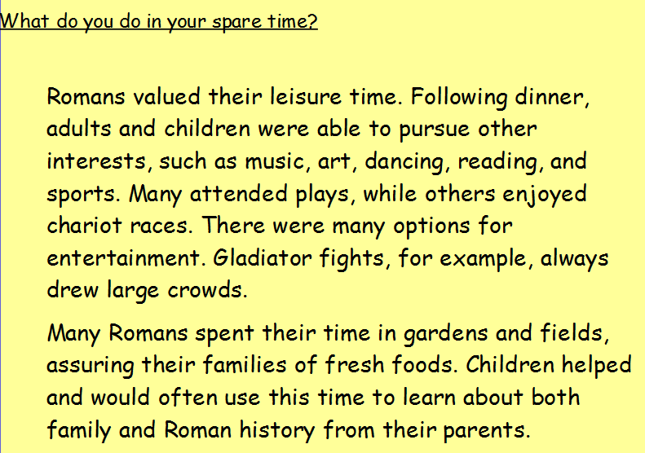

L.O. To find fractions of an amount (non-unit fractions)

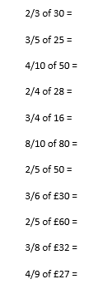

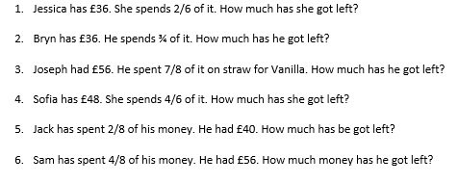

Spellings:
sentence
separate
she
should
so
some
special
steak

MILD
Words with the ir sound
bird
girl
third
first
shirt
whirl

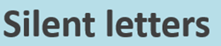
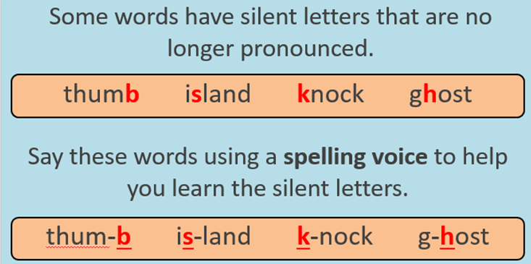
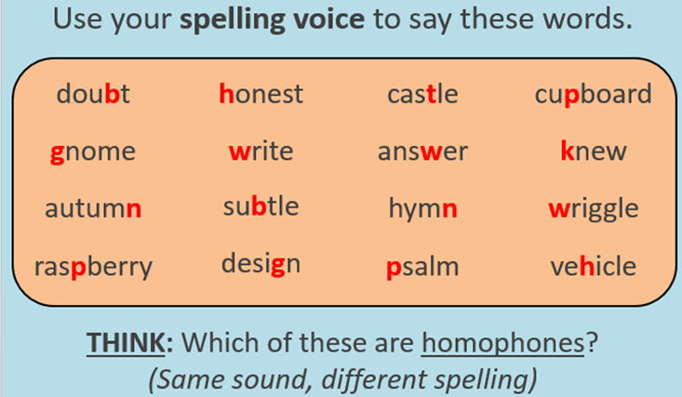
TASK ONE: Add the missing letter to the words below:

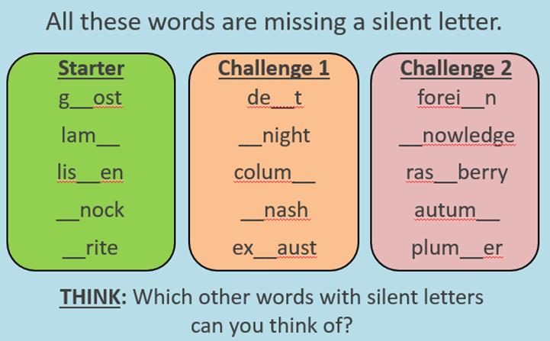

TASK TWO: Choose at least two words from each box and use them in a sentence.



