

Learning Activities
Year 3
2019-20
Self-isolation learning
Week 3 (Worksheets)
Monday
Maths: Practise 3 times tables and pictograms English (GPAS): Contractions
SLOR: The Tale of Peter Rabbit

Tuesday
Maths: 4 times tables and bar charts English: Character description
Jigsaw: Family role and responsibilities

Wednesday
Maths: 4 times tables and tables English (GPAS): prepositions
Science: Plants – Function of roots

Thursday
Maths: 8 times table practise and statistics test questions English: Letter Writing
Topic: Pompeii

Friday
Maths: 8 times table practise and arithmetic test practise English: Spellings
PE: Zumba

Maths:
L.O. To interpret and draw pictograms

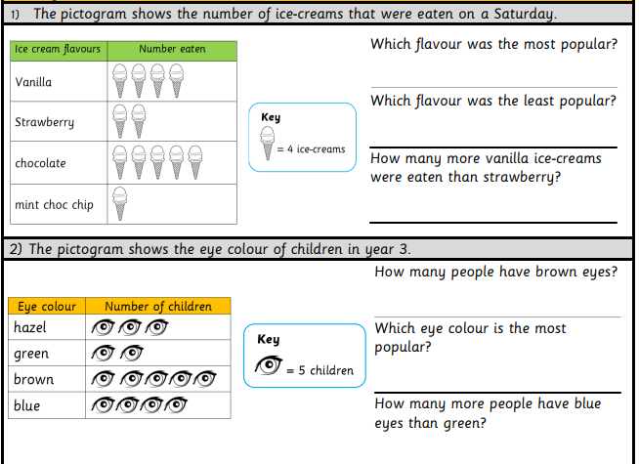
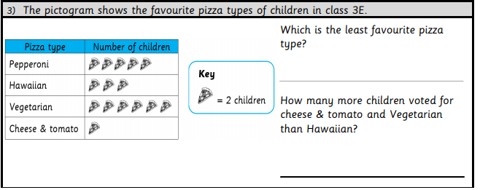

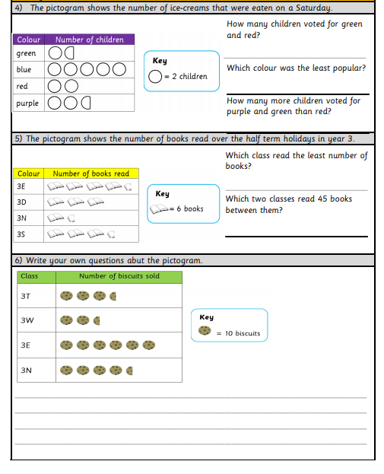

English: Contractions

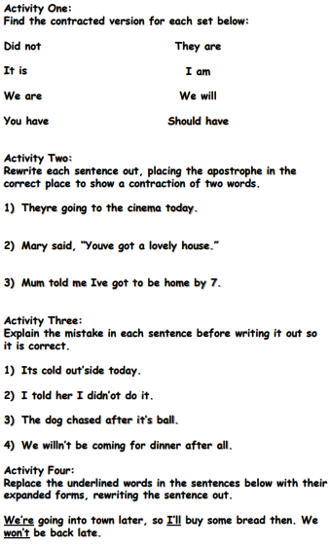

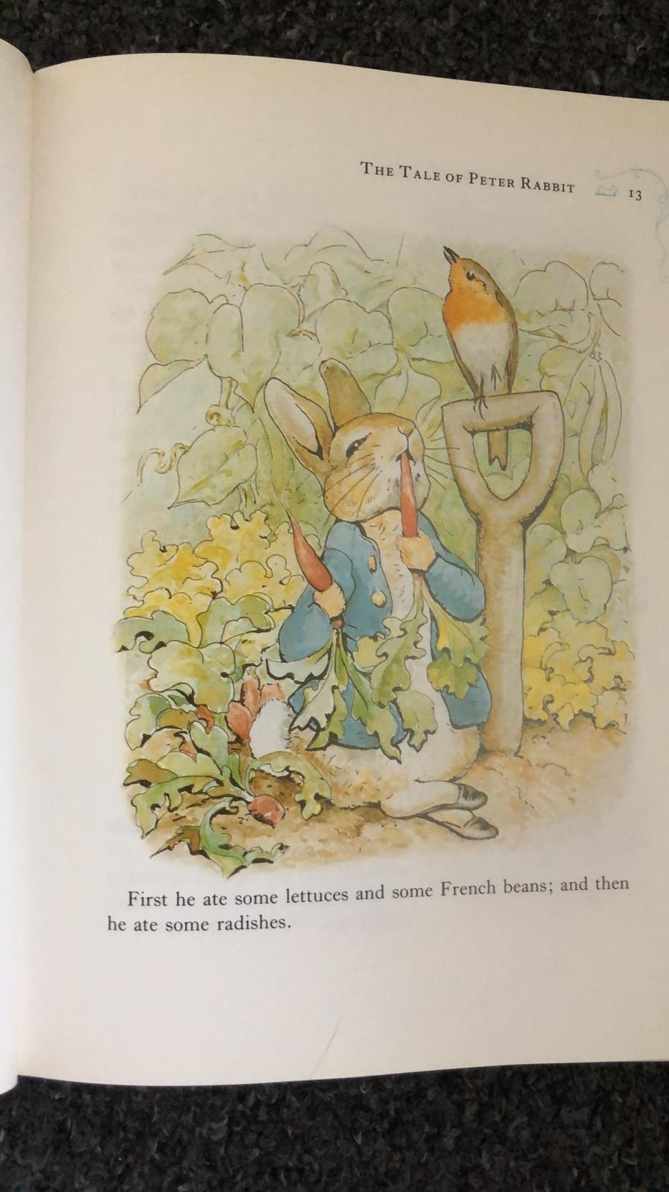
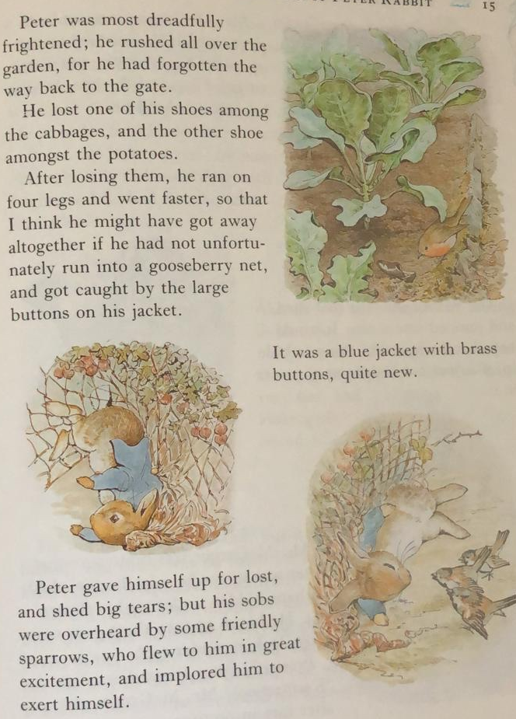
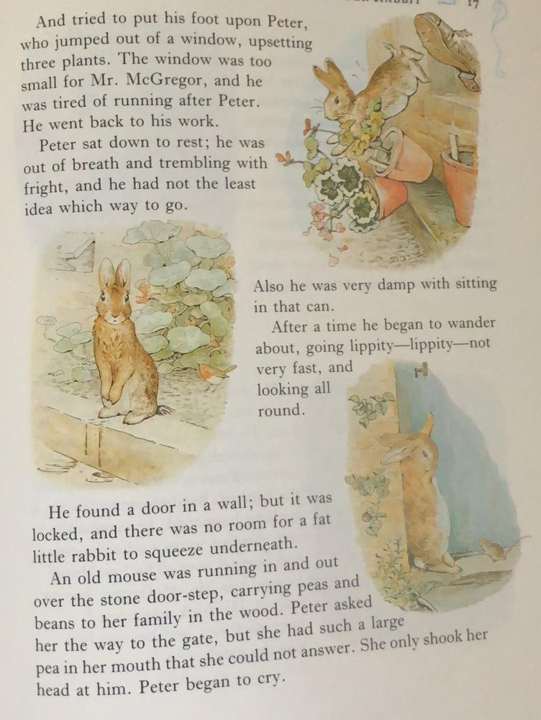
SLOR: 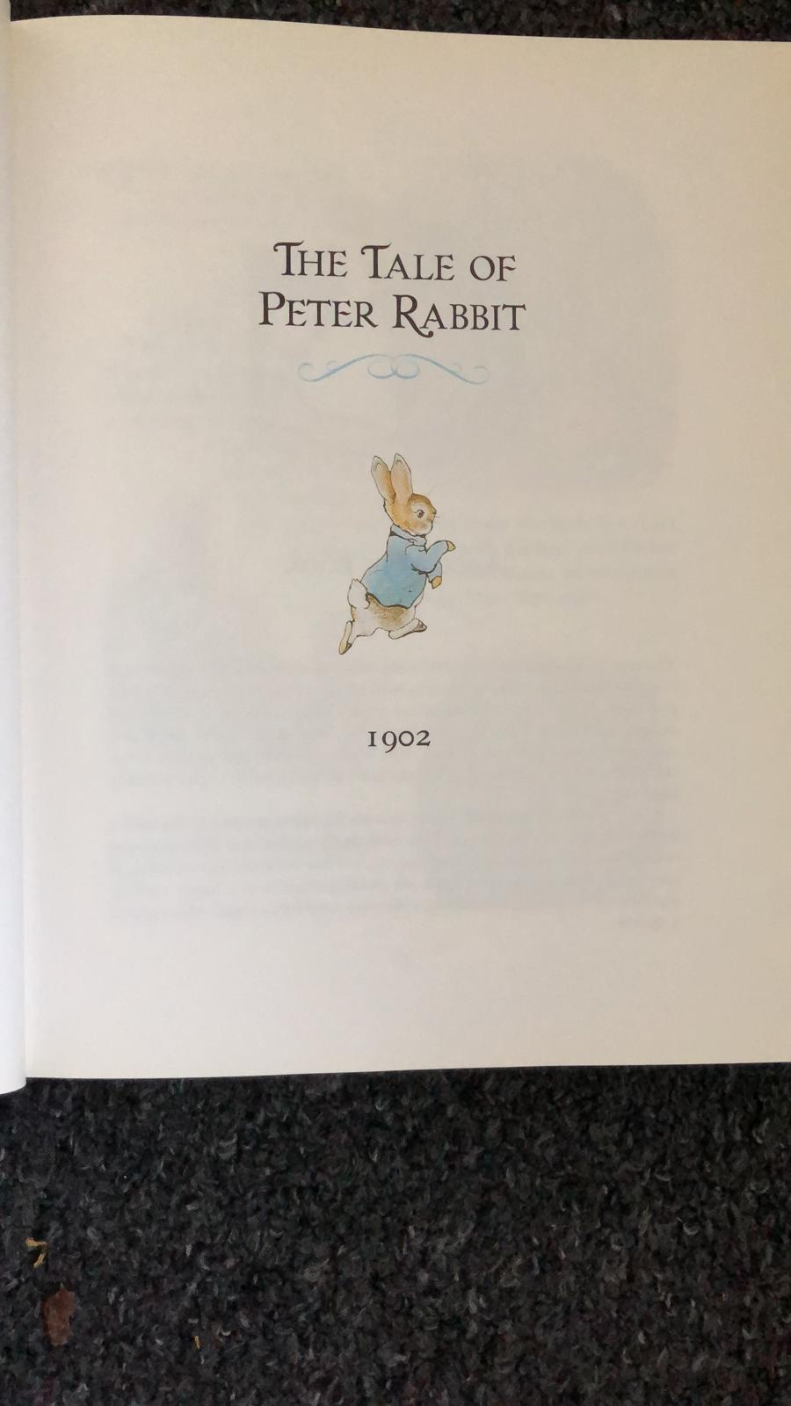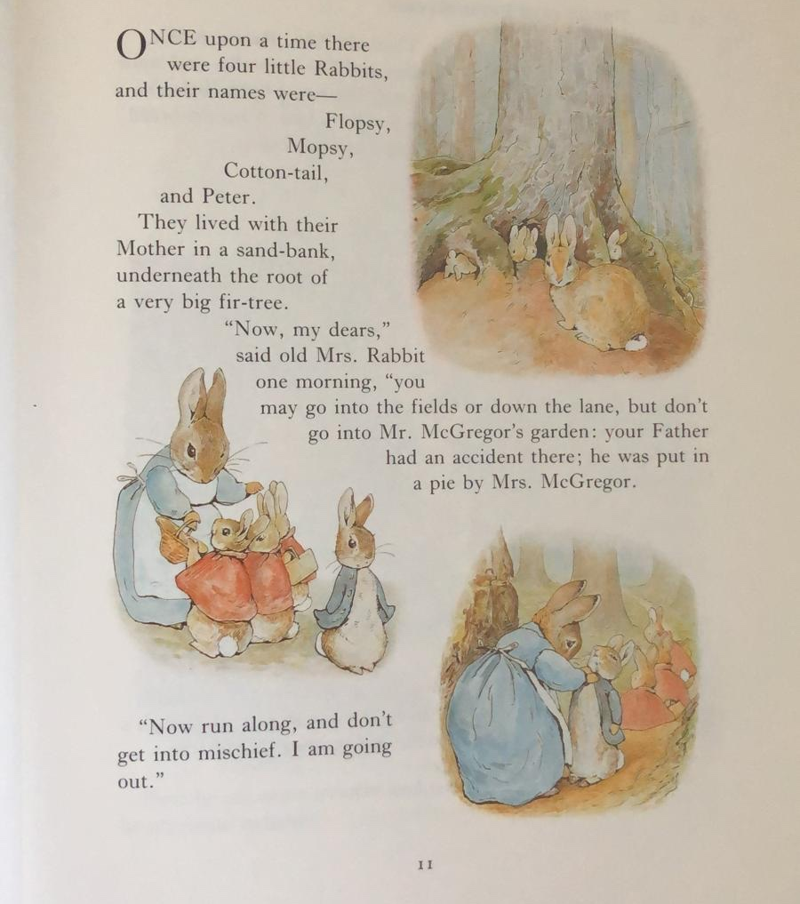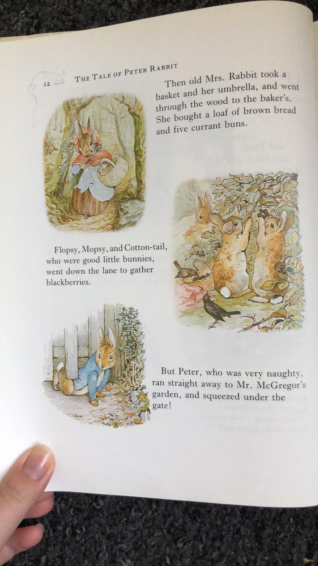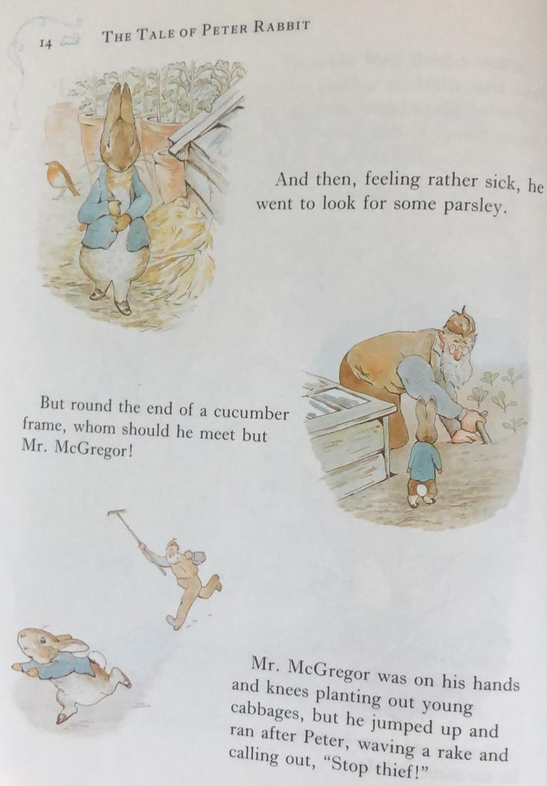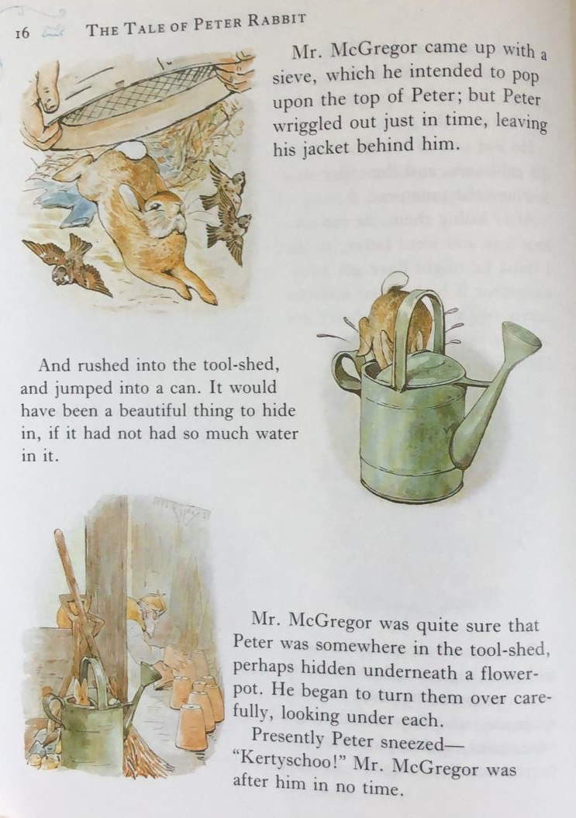
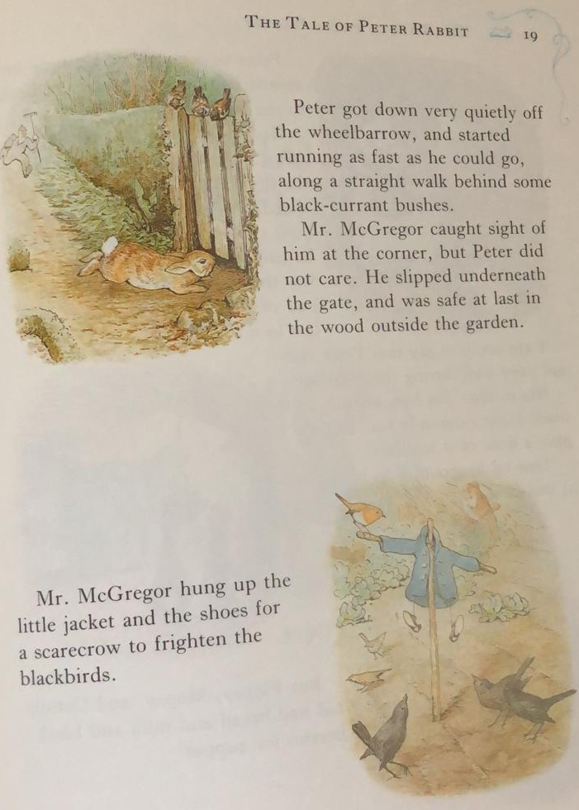
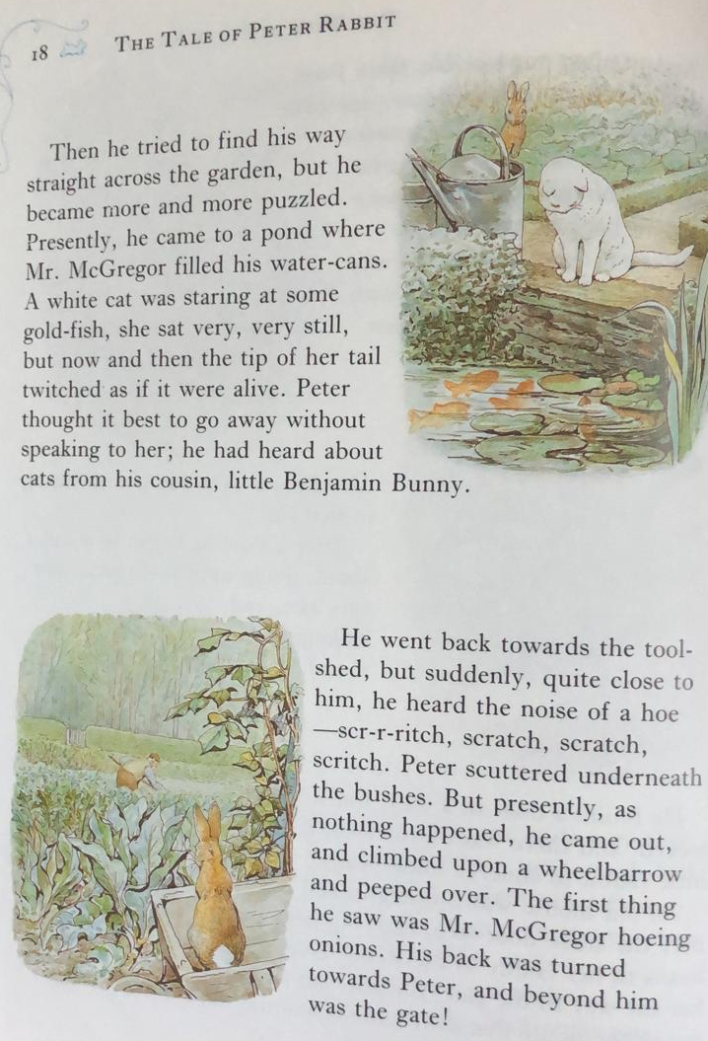
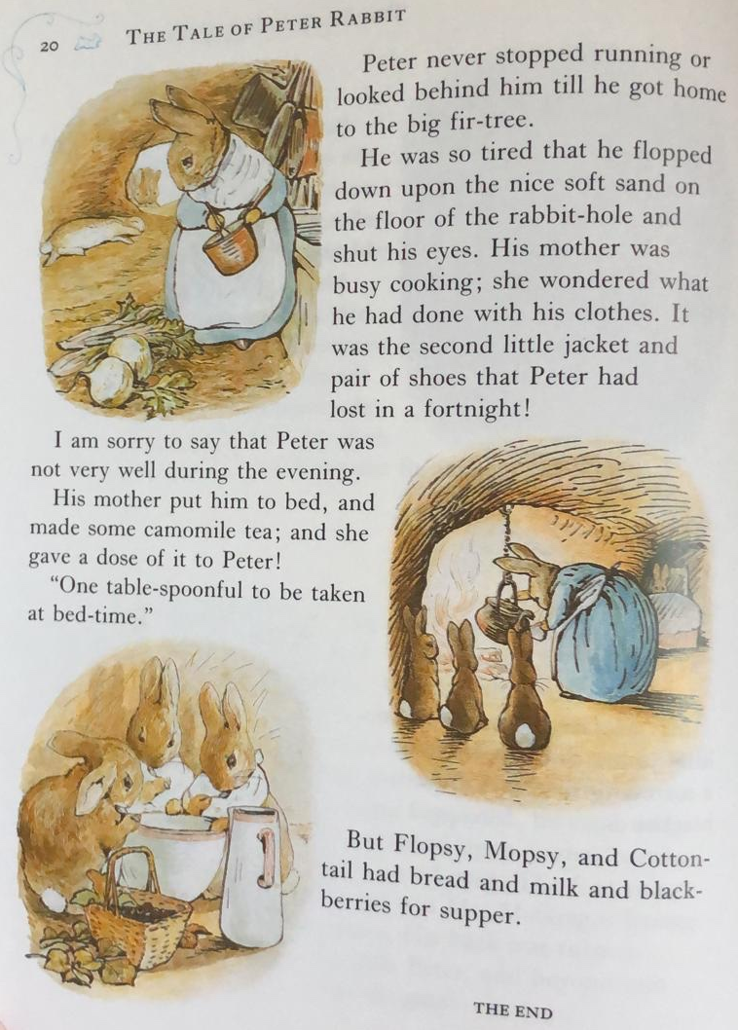
TASK ONE
Knowledge: What were the names of Peter’s three sisters?

Comprehension: How would you compare Peter and his sisters?

Apply: If you were Peter, would you have gone into Mr McGregor’s garden?

Analysis: Why do you think Peter lost two sets of clothes in a fortnight?

Evaluation: Do you think it was fair that Peter had no dinner and his sisters got to eat the nice bread, milk and blackberries?

TASK ONE: Answers
Knowledge: What were the names of Peter’s three sisters?
Flopsy, Mopsy and Cotton-tail
Comprehension: How would you compare Peter and his sisters?
His sisters are very well behaved whereas Peter doesn’t do what he is told.
Apply: If you were Peter, would you have gone into Mr McGregor’s garden?
Yes or No, ensure you have given an explanation.
Analysis: Why do you think Peter lost two sets of clothes in a fortnight?
He is adventurous and often gets himself into dangerous situations.
Evaluation: Do you think it was fair that Peter had no dinner and his sisters got to eat the nice bread, milk and blackberries?
Yes because he has already eaten loads in Mr McGregor’s garden and he didn’t follow his mum’s rules.
TASK TWO
Draw five pictures (in chronological order) summarising the main parts of the story. Write a simple sentence underneath each picture.

Example:
Peter went into the garden.

L.O. To interpret and present a bar chart.

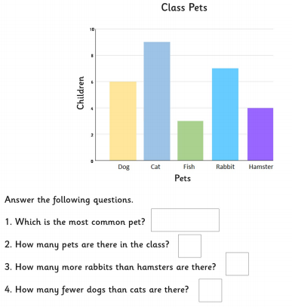
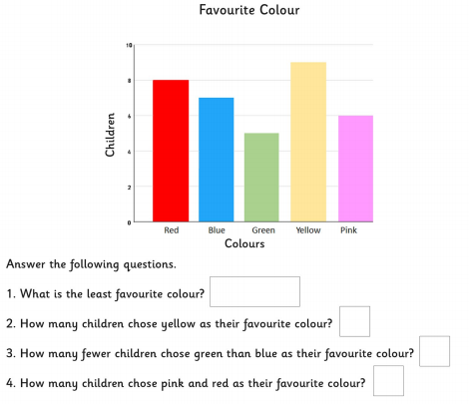

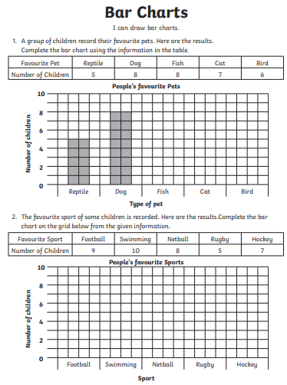

Maths: LO. To interpret tables.

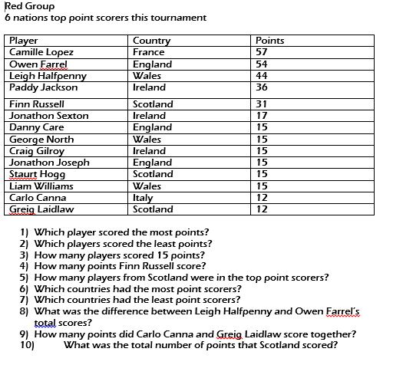

Maths: Assessment questions

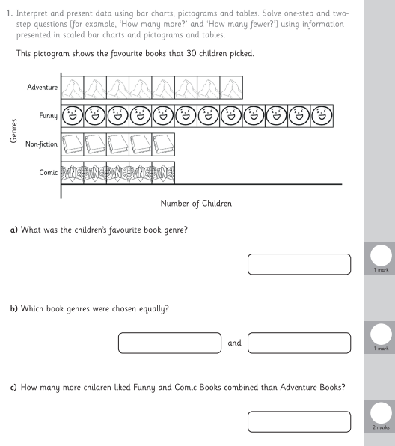
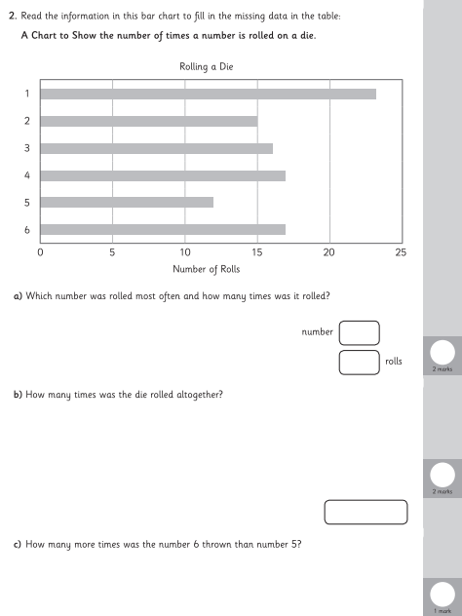
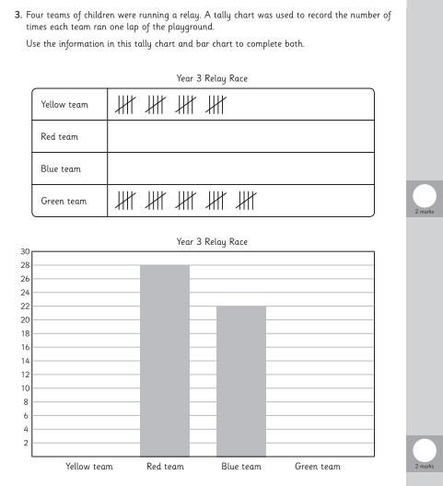
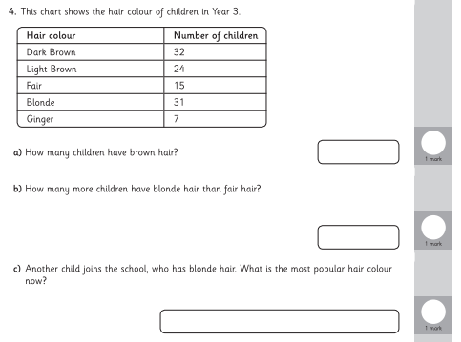

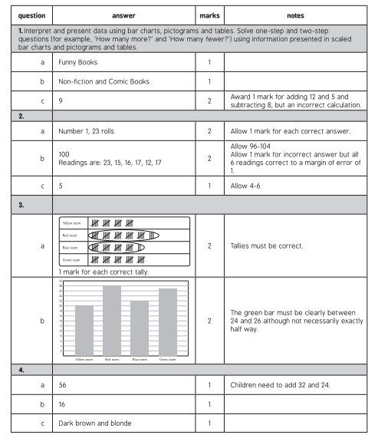

Topic: Mount Vesuvius

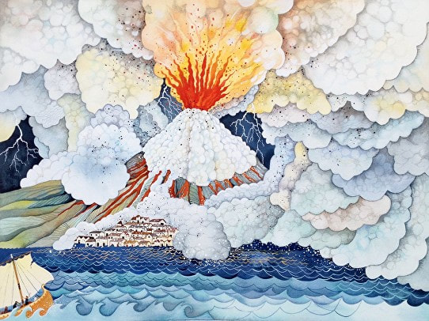

Maths: Arithmetic test

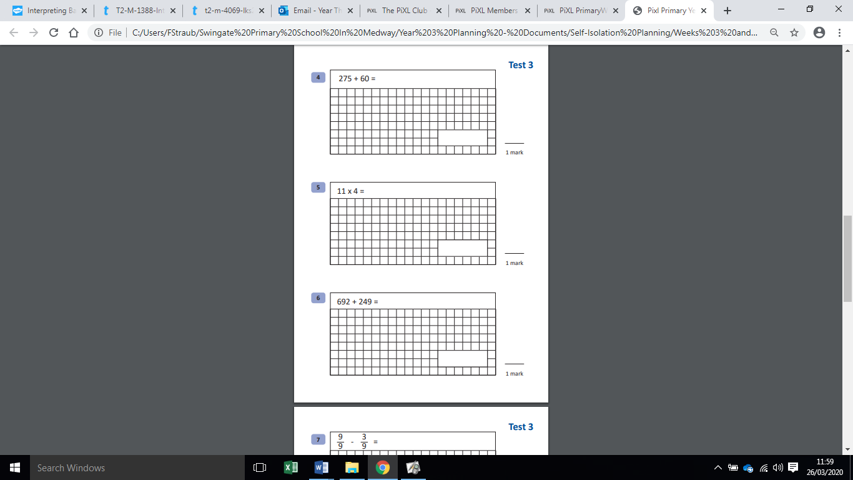
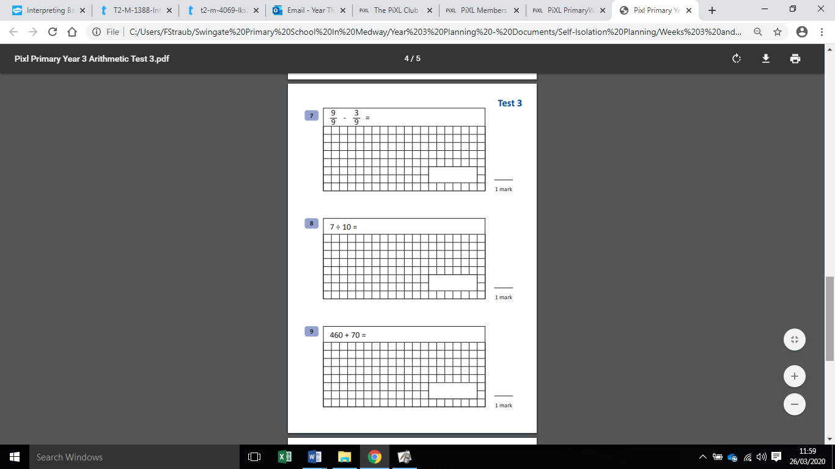
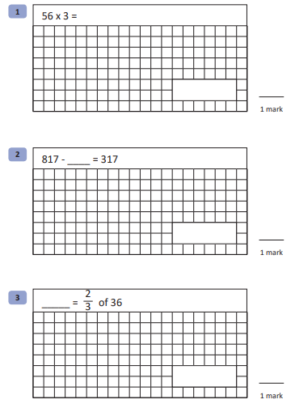
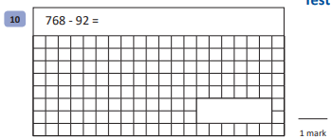

Spellings:

question
recent
regular
reign
remember
said
says
school

MILD
Words with the oy sound
joy
toy
annoy
destroy
enjoy
loyal

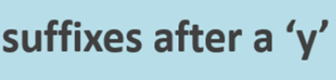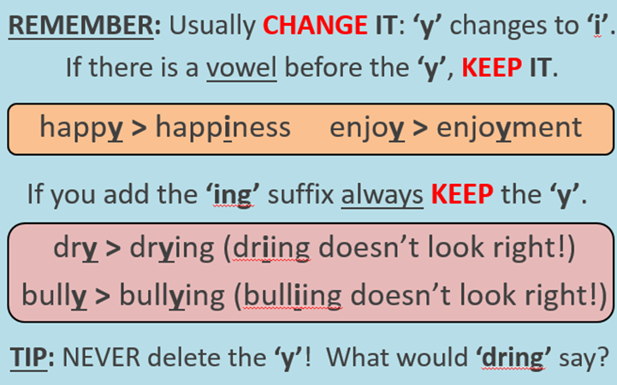
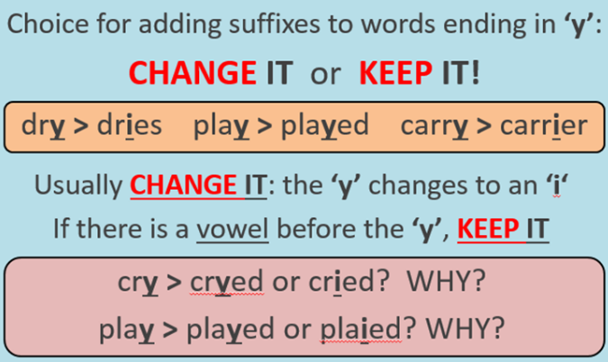
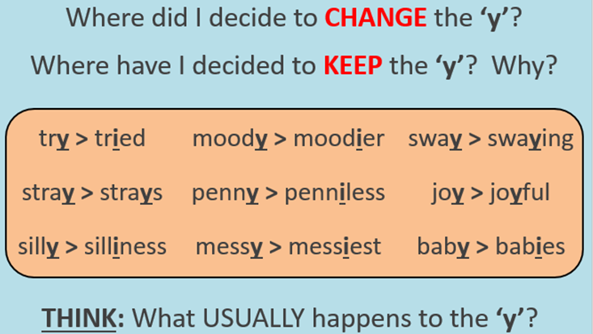

TASK ONE: Add the suffix to the root word. 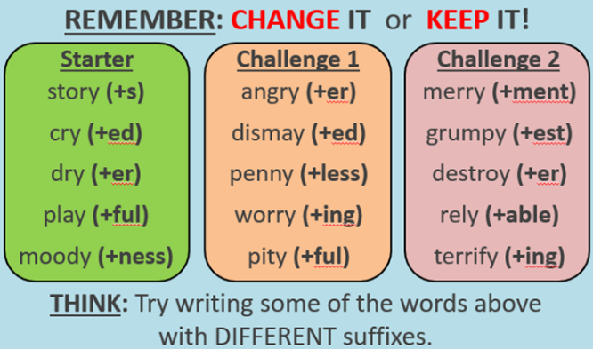

TASK TWO: Choose at least two words from each box and use them in a sentence.



