

Learning Activities
Year 3
2019-20

Self-isolation learning
Week 2 (Worksheets)
Monday
Maths: Practise 4 times tables
Divide 2 digits by 1 digit using the bus stop method English: Story Writing Reading: Audio Books

Tuesday
Maths: Multiply 2 digits by 1 digit using the grid method English: Role Play GPAS: Verbs and adverbs

Wednesday
Maths: Solve 3x, 4 x and 8x multiplication and division word problems English: Poster Jigsaw: Be Healthy

Thursday
Maths: Mental arithmetic test practise English: Comic Book Science: Bones Worksheet

Friday
Maths: Mental arithmetic test practise English: Spellings Topic: British Values
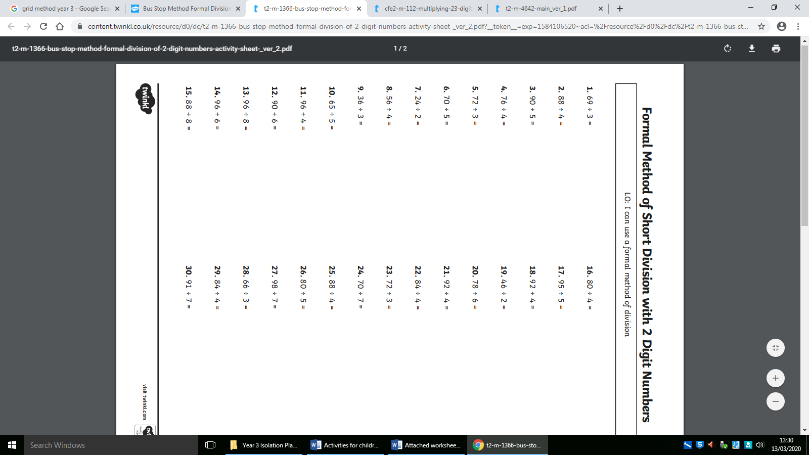

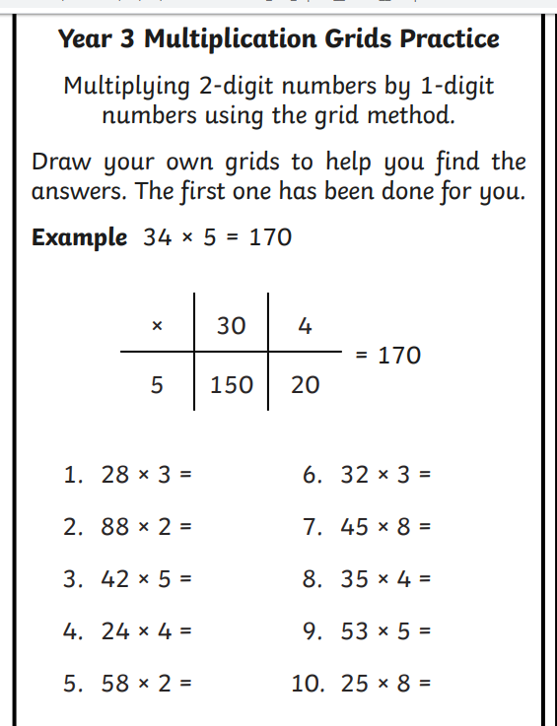

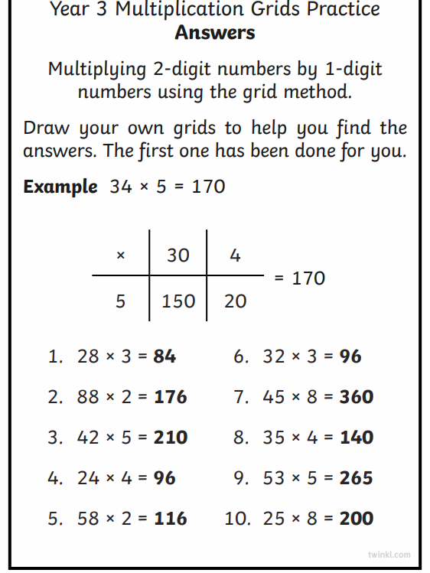

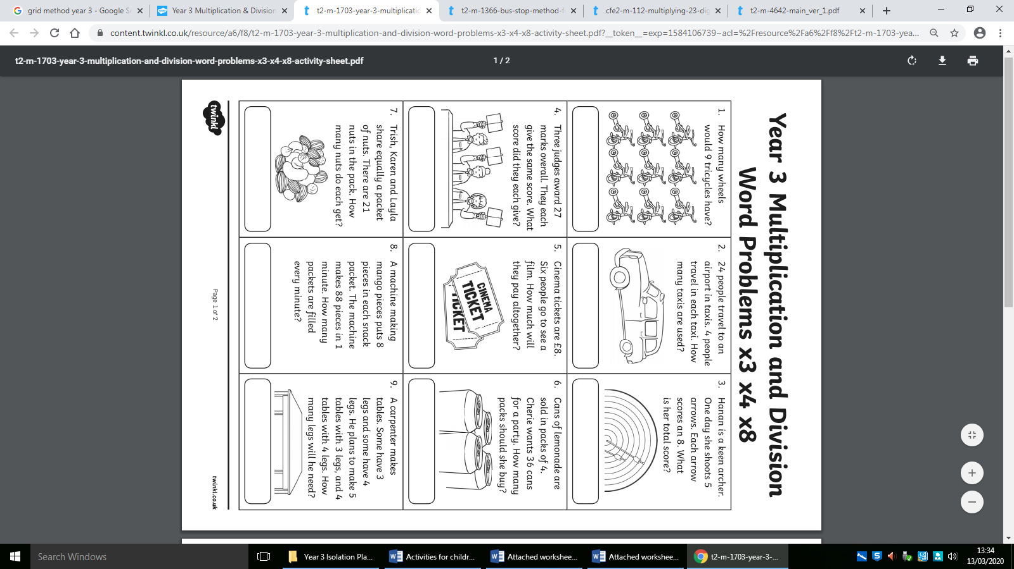
Word problems



