Week 13 Topic

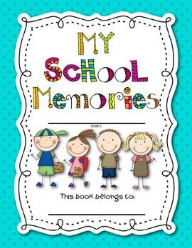
This week you are going to make a little ‘book’ for your new teacher, telling them all about you. It will really help them get to know you a little bit before you start. You can tell them all about what you’ve been up to in year 2, during your time doing home learning and what you are looking forward to during the summer holiday. You can also tell them what you’re looking forward to when you start in year 3.

Your new teacher will love reading and seeing all your wonderful ideas so make sure you make it as interesting as you can.


Finally, you will be writing a letter to your new teacher where you can tell them all the other interesting things about yourself and ask them some questions you might have about year 3. Remember to set your letter out correctly and include paragraphs. Look at the letters you have received from your teachers to help you with this.

For My New Teacher

All About Me

By___________________________

Things I liked about Year 2

Use the hearts to draw and write about things you liked about year 2.
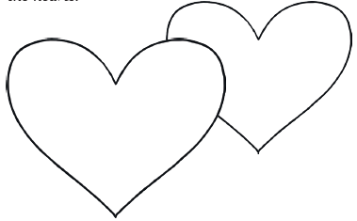

My favourite thing about Year 2 was:
____________________________________________________________________________________________________________
My favourite topic was
_____________________________________________
because
_____________________________________________

All About Me:

________________________________________________________________________________________________________________________________________________________________________________________________________________________________________________________________________________________________________________________________________________________________________

All About My Family:
____________________________________________________________________________________________________________________________________________________________________________________________________________________________________________________________________________________________________________________________________

Who my best friends are:

_________________________ ________________________
_________________________ ________________________

_________________________ ________________________
_________________________ ________________________

My hobbies:

_________________________ ________________________
_________________________ ________________________
My pets or favourite animals:

_________________________ ________________________
_________________________ ________________________

What I enjoyed about learning from home:

____________________________________________________________________________________________________________
What I’m looking forward to during the summer holiday:

____________________________________________________________________________________________________________

Skills I am bringing to Year 3:

____________________________________________________________________________________________________________

What I’d like to improve in Year 3:

____________________________________________________________________________________________________________

Dear
________________________________________________________________________________________________________________________________________________________________________________________________________________________________________________________________________________________________________________________________________________________________________________________________________________________________________________________________________________________________________________________________________________________________________________________________________________________________________________________________________________________________________________________________________________________________________________________________________________________

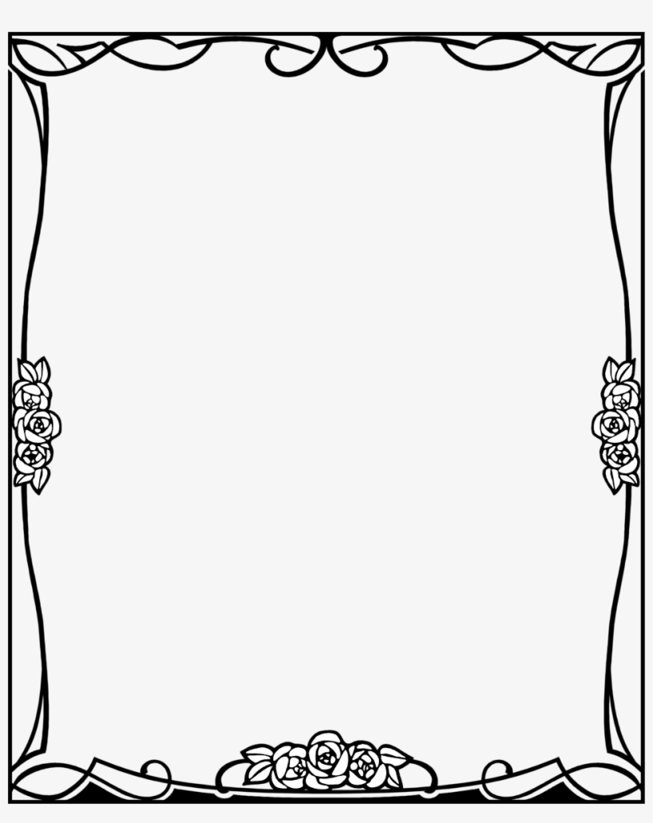
A special picture for you

