Monday SLOR –

Once there was a lighthouse keeper called Mr Grinling.
At night time he lived in a small, white cottage perched
high on the cliffs. In the day time he rowed his lighthouse
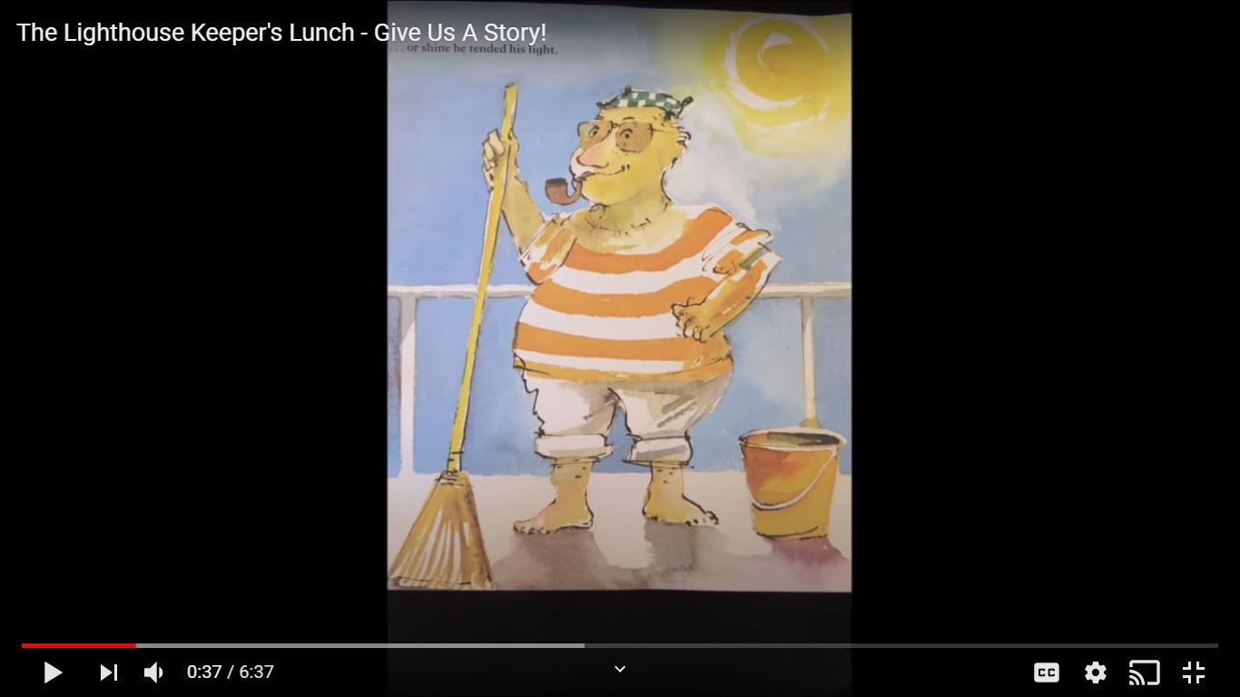
on the rocks to clean and polish the light.

Mr Grinling was a most industrious lighthouse keeper.
Come rain… or shine he tended his light. Sometimes at
night, as Mr Grinling lay sleeping in his warm bed, the
ships would toot to tell him that his light was shining
brightly and clearly out to sea.

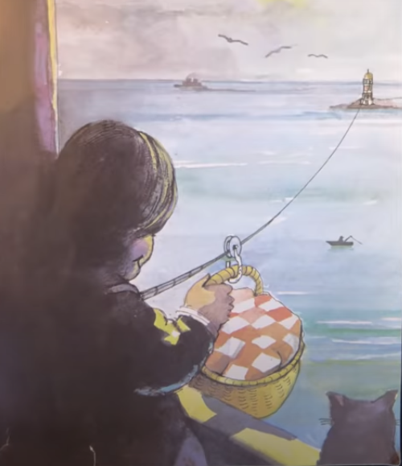
Each morning while Mr Grinling polished the light Mrs
Grinling worked in the kitchen of the little white cottage
on the cliffs concocting a delicious lunch for him. Once
she had prepared the lunch she packed it into a special
basket and clipped it on to the wire that ran from the
little white cottage to the lighthouse on the rocks.

But one Monday something terrible happened.

What do you think happened? (Use the last picture to help you)

Tuesday SLOR –
What do you remember from the beginning of the story yesterday?

Mrs Grinling had prepared a particularly appetising lunch. She had
made…A mixed seafood salad, A lighthouse sandwich, Cold chicken
Garni, Sausage and crisps, Peach Surprise, Iced Sea Biscuits, Drinks
and Assorted Fruit. She put the lunch in the basket as usual and sent
it down the wire. But the lunch did not arrive. It was spotted by three
scavenging seagulls who set upon it with great gusto.

What do you think the seagulls said to each other when they spotted the food?
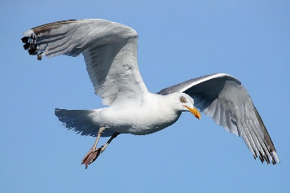



‘Clear off, you varmints,’ shouted Mr Grinling, but the seagulls took not the slightest notice.
That evening Mr and Mrs Grinling decided on a plan to baffle the seagulls. ‘Tomorrow I shall tie the nap-kin to the basket,’ said Mrs Grinling. ‘Of course, my dear,’ agreed Mr Grinling, ‘a sound plan.’

On Tuesday evening Mr and Mrs Grinling racked their brains for another plan. ‘They are a brazen lot, those seagulls,’ said Mrs Grinling. ‘Brazen indeed,’’ said Mr Grinling, ‘what shall we do?’ ‘Our cat does not appear to like seagulls,’ said Mrs Grinling. ‘No, my dear,’ said Mr Grinling, ‘Hamish is an accomplished seagull chaser.’ ‘Of course,’ exclaimed Mrs Grinling, ’tomorrow Hamish can guard the lunch.’ ’A most ingenious plan,’ agreed Mr Grinling. Hamish did not think that this plan was ingenious at all. He spat and hissed as Mrs Grinling secured him in the basket. ’There, there, Hamish,’ said Mrs Grinling consolingly, ’I’ll have a tasty piece of herring waiting for you when you arrive home.’ Sadly flying did not agree with Hamish. His fur stood on end when the basket swayed, his whiskers drooped when he peered down at the wet, blue sea and he felt much too sick to even notice the seagulls, let alone scare them away from the lunch.

‘Lackaday, lackaday’ said Mr Grinling sadly. ‘Miaow, miaow,’ agreed Hamish pitifully.
Wednesday SLOR –
So far Mr and Mrs Grinling’s ideas have not worked. Remind yourself
of their first two ideas before reading on. What idea would you try?

On Wednesday evening Mr and Mrs Grinling racked their brains again for
a new plan. ‘What shall we do?’ said Mr Grinling. Mrs Grinling looked
thoughtful. ’ I have it!’ she explained, ’just the mixture for hungry seagulls.’ ’Indeed, my
dear,’ said Mr Grinling, ’what have you in mind.’ ’Wait and see,’ said Mrs Grinling, ’just wait
and see.’
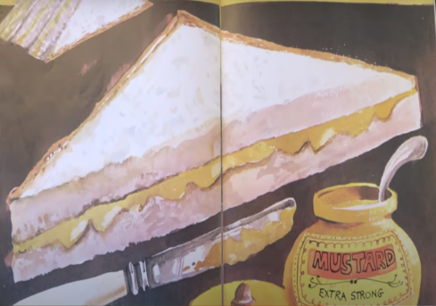
’Mustard sandwiches,’ chuckled Mr Grinling. ’A truly superb plan,
my dear, truly superb.’ On Thursday morning Mrs Grinling carefully
packed the sandwiches and sent them off down the wire to the
expectant seagulls.

On Friday Mrs Grinling repeated the mustard mixture. The seagulls were not impressed.

What do you think the seagulls are saying to each other now?

Thursday SLOR –

So, on Saturday, up in the little white cottage on the cliffs,
a jubilant Mrs Grinling put away the mustard pot before she
prepared a scrumptious lunch for Mr Grinling. While he waited
for his lunch down in the lighthouse on the rocks, Mr Grinling
sang snatches of old sea shanties as he surveyed the coastline
through his telescope and this is what he
saw…..

’Ah well, such is life,’ mused Mr Grinling
as he sat down to enjoy a leisurely lunch
in the warm sunshine.

What did Mr Grinling see through his telescope?

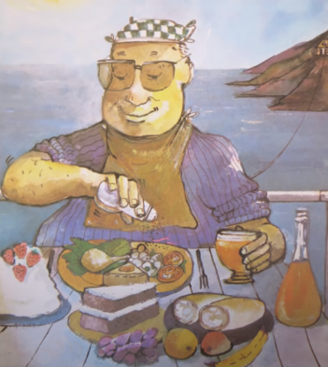
How was Mr Grinling feeling at the end of the story? How do you know?

