Day 1
We have learnt so much in Maths this year. This week we are going to focus on lots of different skills and topics we have covered. If you find any of these tricky, please email and ask for extra support from your teacher, as then you will be ready to go to year 3 as excellent mathematicians!

1. 24+32=
2. 53+18=
3. 30+70=
4. 42-11=
5. 100-55=
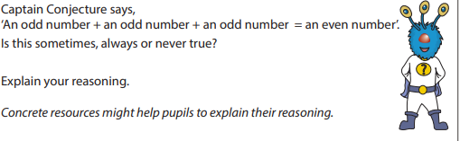
Challenge:

Day 2
1. 12 ÷ 6=
2. 3 x 8=
3. 24 ÷ 4=
4. 30 ÷ 6 =
5. 2 x 13 =
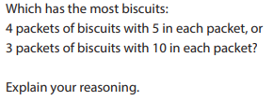
Challenge:

6. 12+5+15=
7. 28-27=
8. 42+40=
9. 63-14=
10. 23-15=

6. ½ of 28 =
7. ¼ of 16 =
8. ¾ of 20=
9. 1/3 of 18 =
10. 2/3 of 18=

Day 3
1. 16 = ___+ 8
2. ___- 4 = 8
3. 11 + ___ = 13
4. 24 - ___= 7
5. ____+ 5 = 20
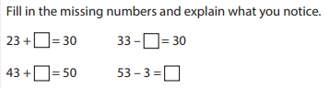
Challenge

Day 4
Write < > or = to make these correct.
1. 12___34
2. 89___57
3. 21+4___25
4. 15___11-2
5. 20___12+9
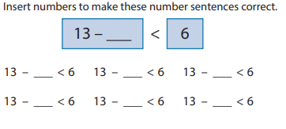
Challenge:

6. 34 = 13 + ___
7. 12 + ___ = 32
8. 9 = 27 - ___
9. 5 + ___ + 3 = 15
10. ____-20 = 30

6. 13+2___12+4
7. 2+4+5___2
8. 2x4___2x2
9. 13-4___5
10. 19___28-10

Day 5
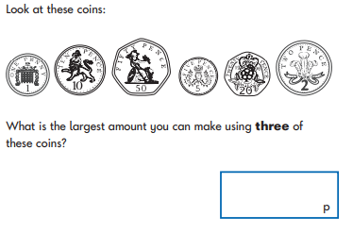
1.

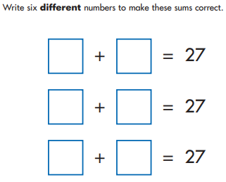
2.

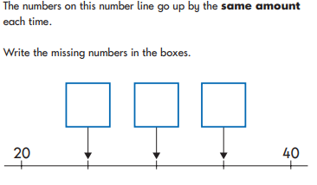
3.

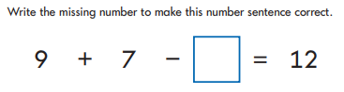
4.

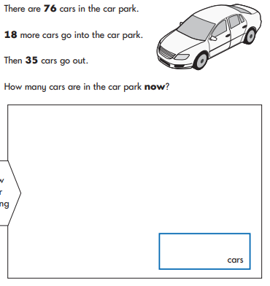
5.

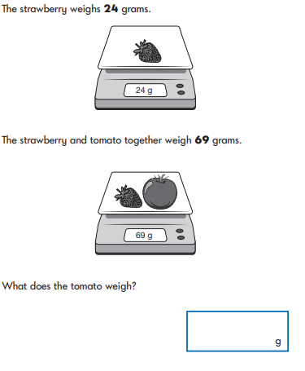
6.

