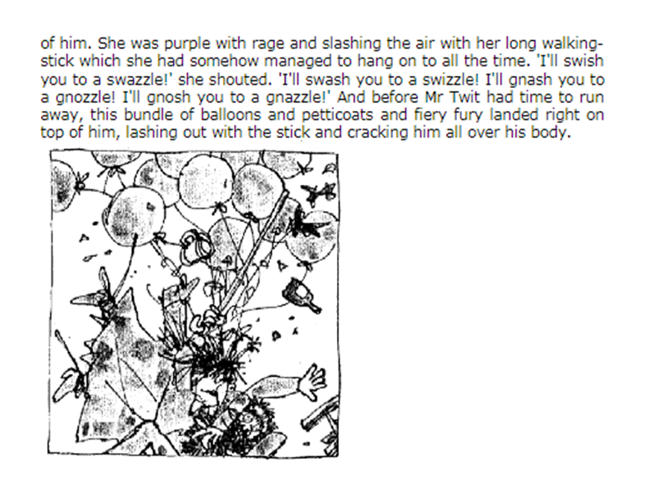
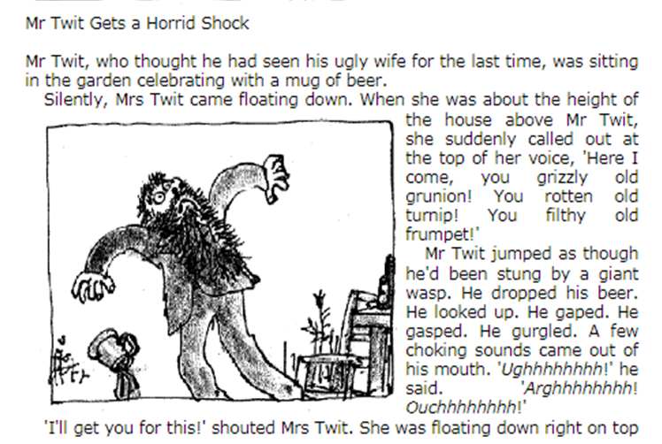
Day 1
Find and copy the word that Mr Twit uses to describe his wife.
_________________________
Find and copy two words that explain how Mrs Twit came down from the sky.
________________________

Find and copy the word that shows Mr Twit was surprised to see Mrs Twit.
_______________________

Find and copy the word that means Mr Twit lost his beer.
_______________________
Find and copy the word that shows Mrs Twit was hitting the air with her stick.
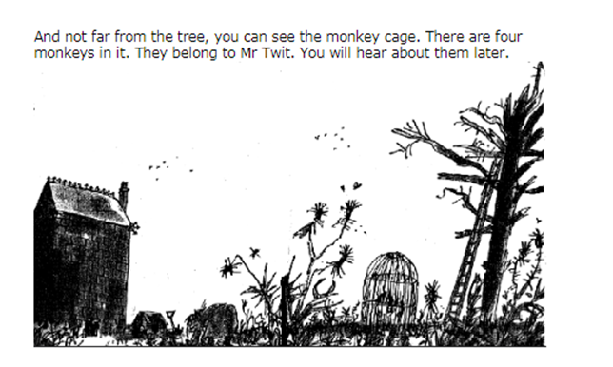
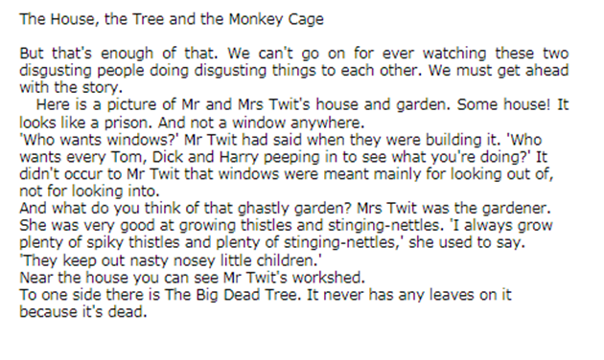
_______________________

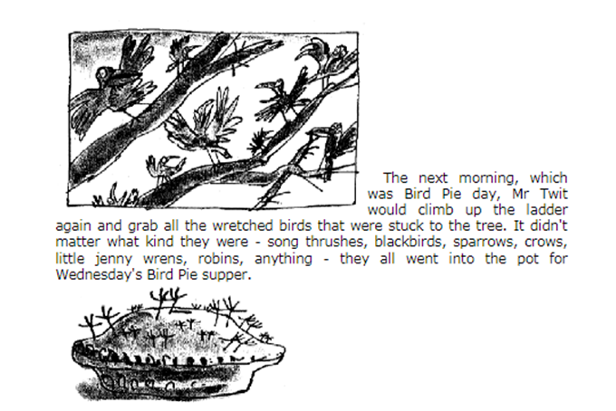
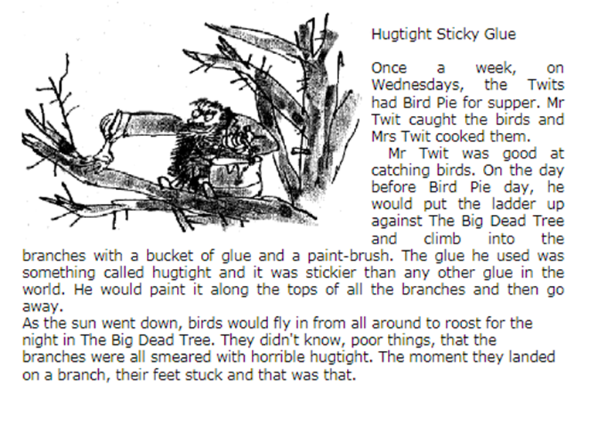
Day 2
1. Which day of the week do Mr and Mrs Twit have Bird Pie for supper?

2. Who caught the birds and who cooked them?

3. What did Mr Twit climb into the branches with?

4. What was the name of Mr Twits glue?

5. What did Mr Twit do with his glue the day before Bird Pie day?
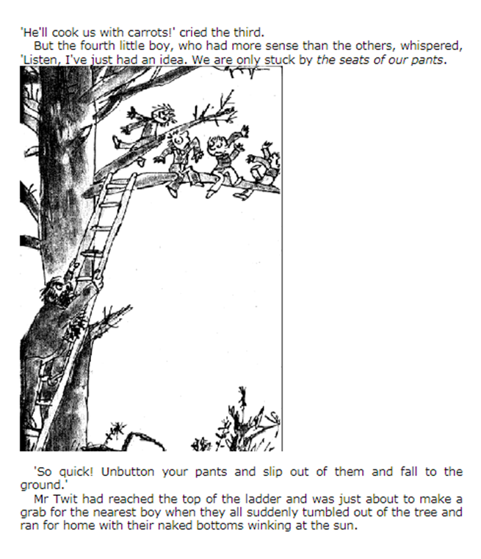
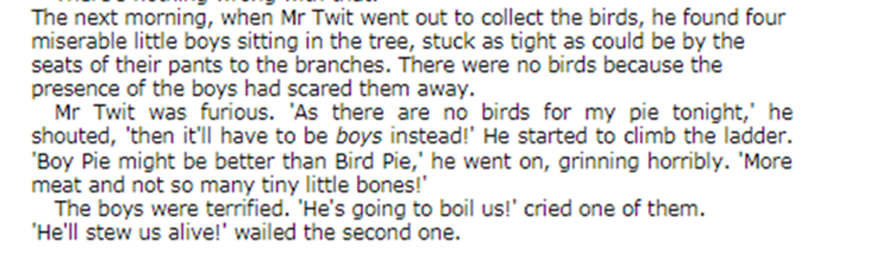
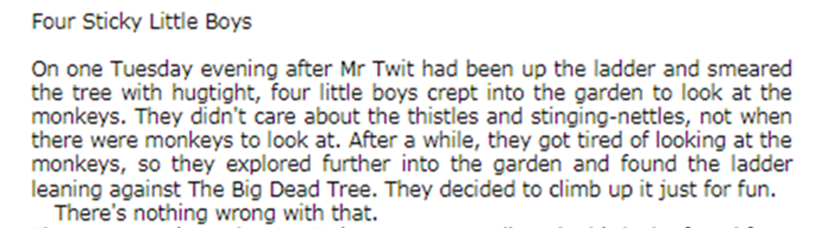
Day 3
1. Who did Mr Twit find sitting in the tree?

2. Why were there no birds in the tree?

3. Why did Mr Twit say Boy Pie might be better than Bird Pie?

4. What did the third boy say when Mr Twit started to climb the ladder?

5. Why did the boys tumble out of the tree?

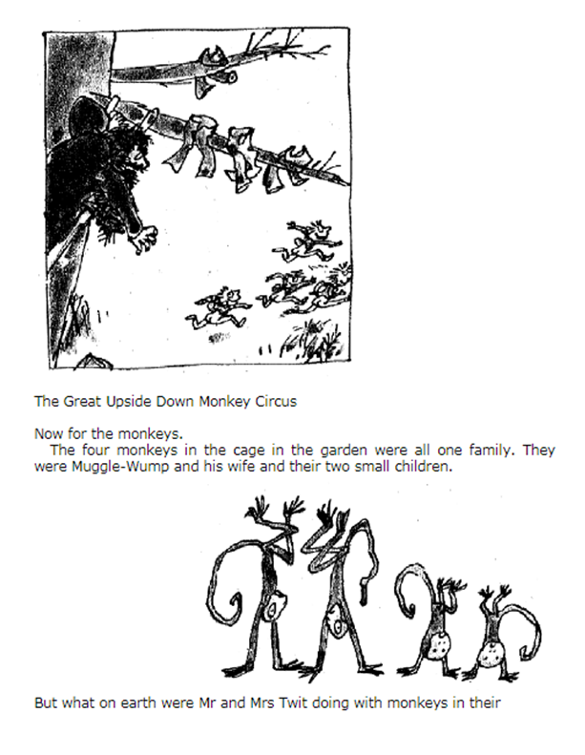
Day 4
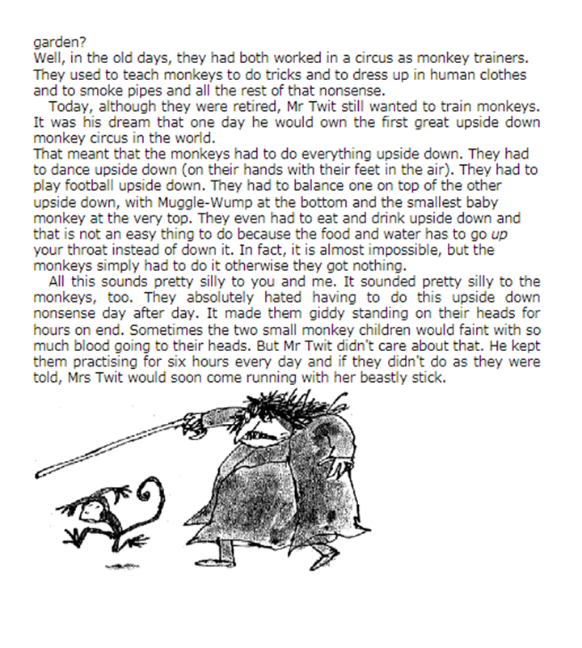

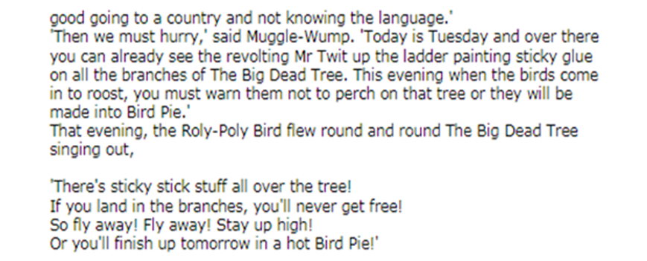
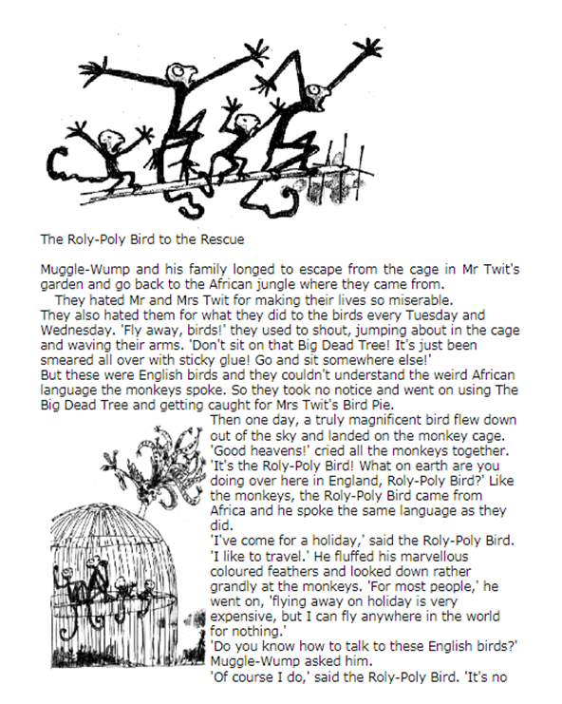

Create a storyboard to summarise what has happened in the most recent part of the story (what you have read today).

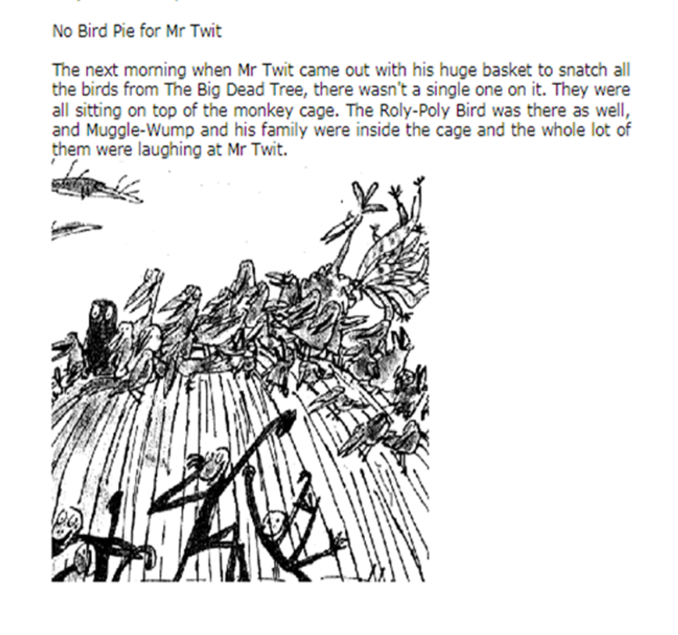
Day 5

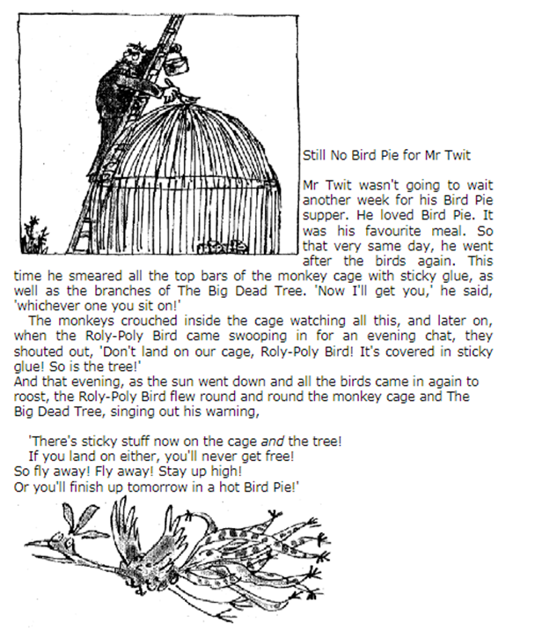

Create a poster to warn people about the sticky glue. You could use some of the ideas from the Roly-Poly bird’s song.

