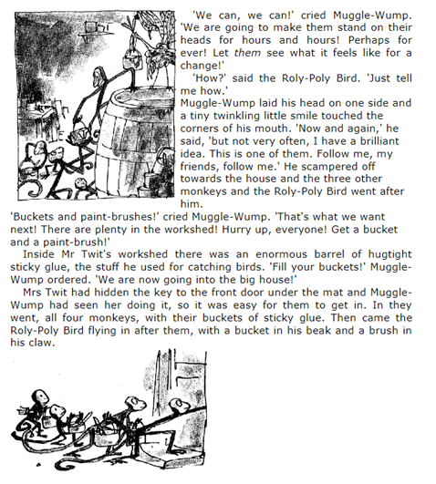
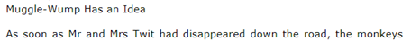
Day 6

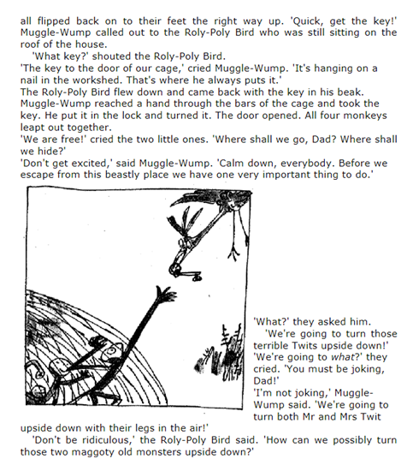

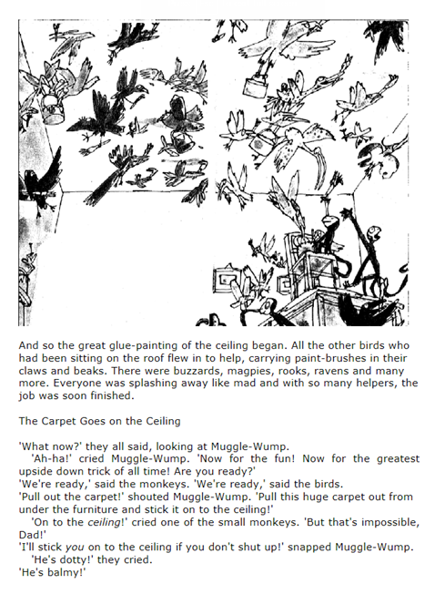
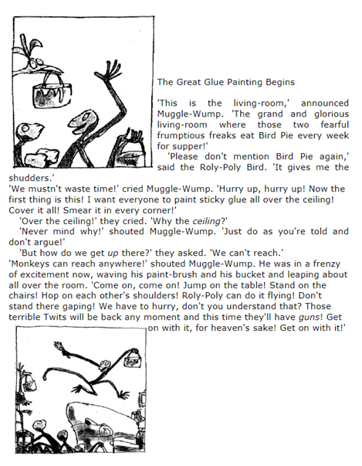
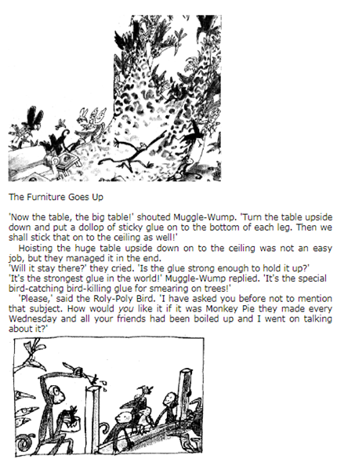

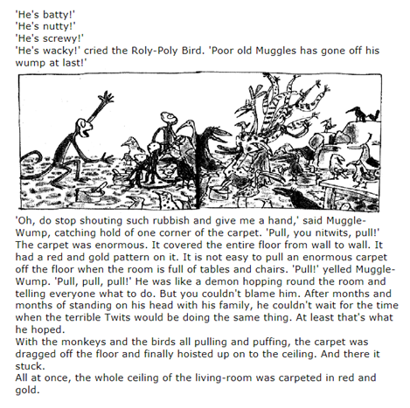

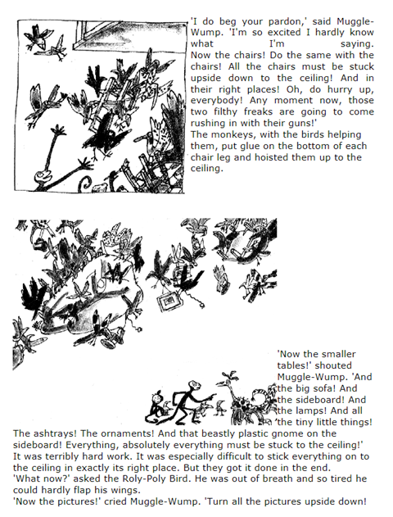
Draw a picture to show what has happened in the most recent part of the story. Alternatively you could act out this part of the story, asking your family members to help you, or you could create puppets and retell the story this way.
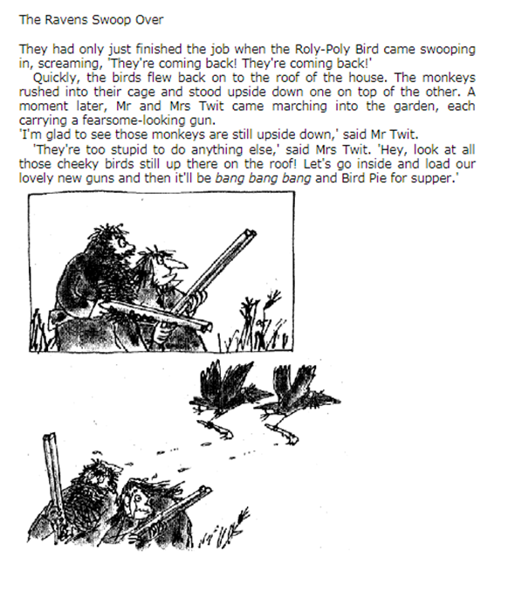
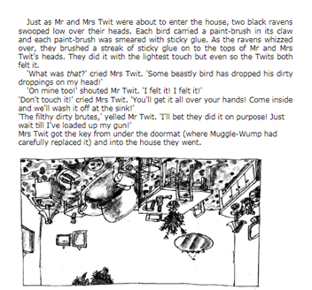
Day 7

How do you think The Twits are going to react when they walk inside? What will they say? What will they do?

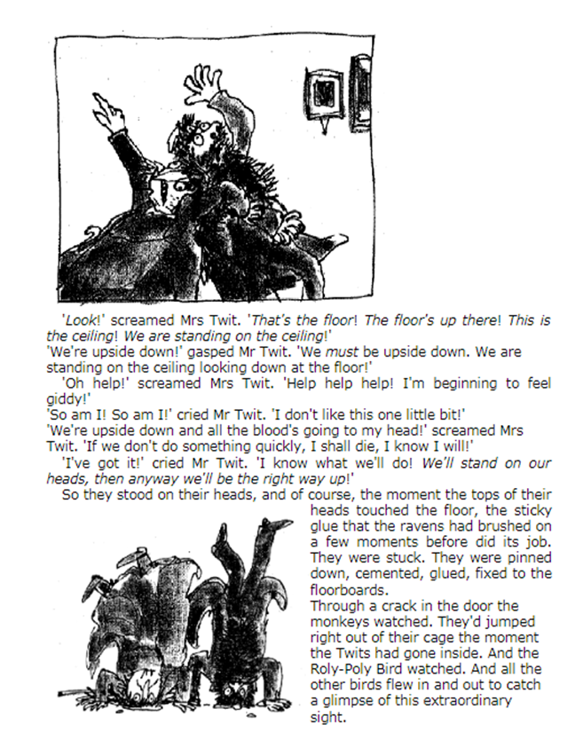
Day 8
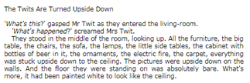

Do you think The Twits deserved what they got? Why?

Was it a good idea to glue them
to the floor?

Would you have tricked them differently?

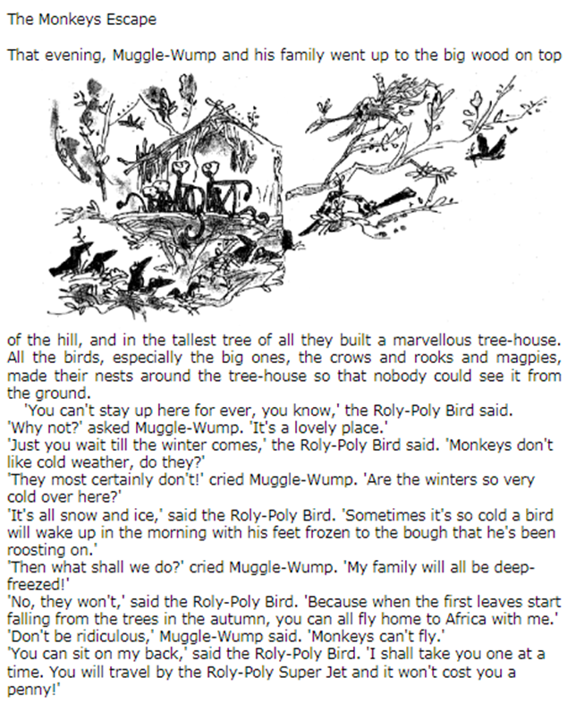
Day 9
Explain the characteristics of each animal.

Which character do you prefer? Muggle-Wump or Roly-Poly Bird? Why?

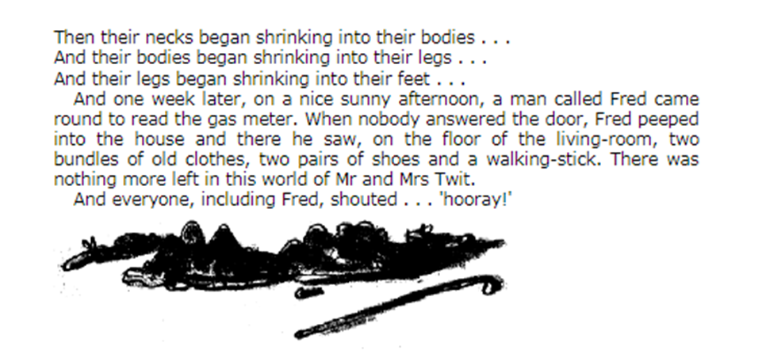
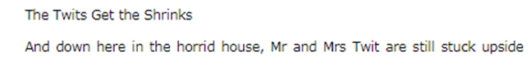
Day 10

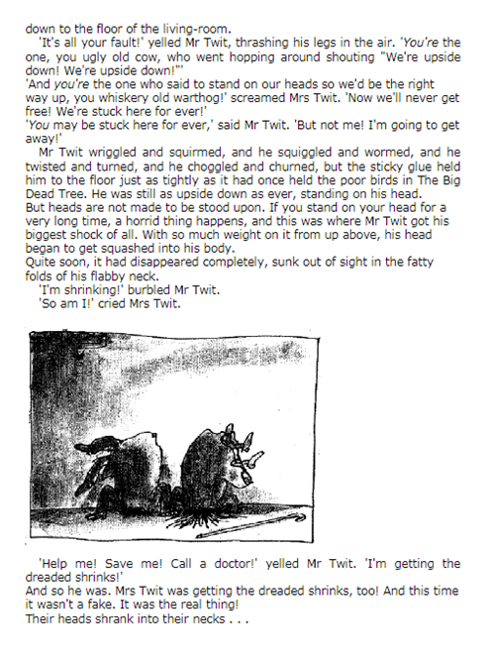

Create a book review for The Twits.

