Why do we need to do a warm up?

A warm up should gently prepare the body for exercise by gradually increasing the heart rate and circulation. This will loosen the joints and increase blood flow to the muscles.

Stretching the muscles prepares them for physical activity and prevents injuries.
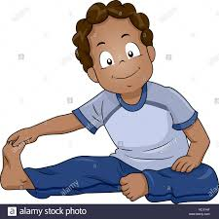
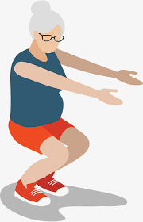
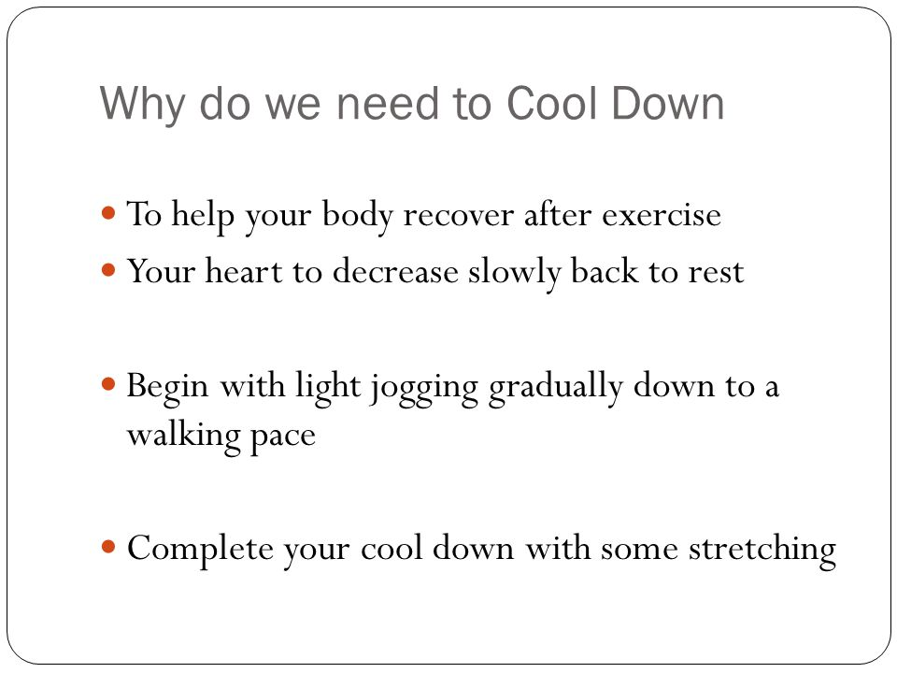
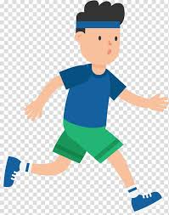
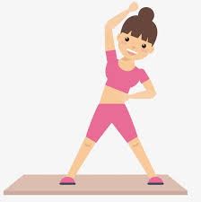

Here is a warm up example to get you started.


