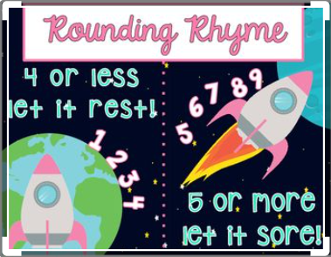
Week 12 maths:

Monday:

In year 2 children are taught to:

- identify
- represent and
- estimate numbers

This week we are going to look at rounding numbers in order to estimate answers.

Rounding numbers to the nearest ten.
When rounding to the nearest 10 you need to look at the number in the ones column to decide whether to round up or down. Remember when rounding to the nearest 10 your answer will end with at least 1 zero.

- 32 → 30
- 76 → 80
- 59 → 60
- 68 → 70
Examples:
- 24 → 20 2. 25 → 30

The digit in the ones column will decide whether the answer will be 20 or 30.

4 or less, the number is rounded down

5 or more, the number is rounded up

- 43 → 40
- 91 → 90
- 75 → 80
- 54 → 50
- 27 → 30
- 88 → 90
- 11 → 10
- 66 → 70
Rounding numbers to the nearest ten.
Even when the number has hundreds you still need to look at the number in the ones column to decide whether to round up or down. Remember when rounding to the nearest 10 your answer will end with at least 1 zero.

- 143 → 140
- 184 → 180
- 229 → 230
- 155 → 160
Examples:
- 724 → 720 2. 725 → 730

The digit in the ones column will decide whether the answer will be 720 or 730.

- 169 → 170
- 316 → 320
- 241 → 240
5 or more, the number is rounded up

4 or less, the number is rounded down

- 402 → 400
- 367 → 370
- 478 → 480
- 723 → 720
- 942 → 940

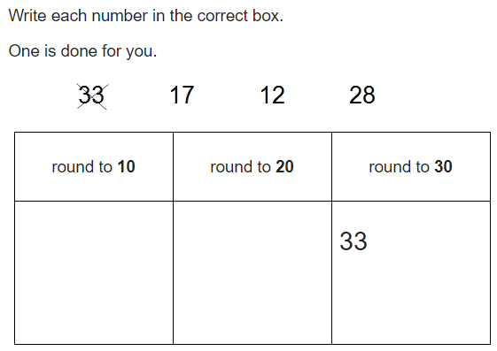
Challenge questions:

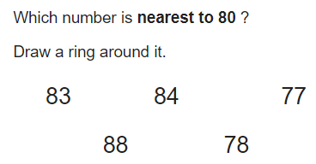

17
28
12
Answer = 78

Tuesday:

Rounding numbers to the nearest hundred.
When rounding to the nearest 100 you need to look at
the number in the tens column to decide whether to
round up or down. Remember when rounding to the
nearest 100 your answer will end with at least 2 zeros.

- 143 → 100
- 569 → 600
- 184 → 200
Examples:
- 724 → 700 2. 754 → 800

The digit in the tens column will decide whether the answer will be 700 or 800.

- 229 → 200
- 150 → 200
- 209 → 200
4 or less, the number is rounded down

5 or more, the number is rounded up

- 246 → 200
- 362 → 400
- 537 → 500
- 481 → 500
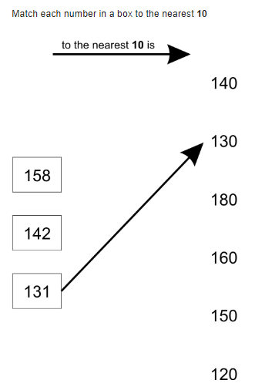
- 673 → 700
- 822 → 800

Challenge questions:

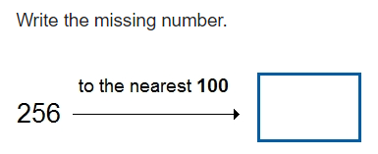

300

Wednesday: Round the numbers

Remind yourself of the rules for rounding to the nearest 10 and 100 to help you answer the following questions. Remember when rounding to the nearest 10 your answer will end with at least 1 zero and when rounding to 100 your answer will end with at least 2 zeros.

- to the nearest hundred
543 → 500

- to the nearest ten
269 → 270

- to the nearest ten
784 → 780

- to the nearest hundred
329 → 300

- to the nearest hundred
450 → 500

- to the nearest ten
746 → 750

- to the nearest hundred
609 → 600

- to the nearest ten
862 → 860

- to the nearest ten
558 → 560

- to the nearest hundred
411 → 400

Round these amounts to the nearest ten.

- 242cm → 240cm
- 367p → 370p
- 183l → 180l
- 219cm → 220cm
- 277m → 280m
- 108ml → 110ml
- 249p → 250p
- 461m → 460m

- 36p → 40p
- 71m → 70m
- 58cm → 60cm
- 67p → 70p
- 42ml → 40ml
- 94p → 90p
- 75l → 80l
- 56cm → 60cm

Round these amounts to the nearest hundred.

- 242cm → 200cm
- 367p → 400p
- 183l → 200ml
- 219cm → 200cm
- 270m → 300m
- 108ml → 100ml
- 249p → 200p
- 461m → 500m

Challenge question:
Sam says “464 rounded to the nearest 10 is 470” Is he right or wrong? Explain your answer below.

He is wrong because the digit in the ones column is 4. If a digit is worth 4 or less, the rule is the number is rounded down, so the correct answer is 460.

Thursday:
Today you are going to use your rounding skills to help you estimate answers. Round the numbers to the nearest 10, work out the answer and write the original number sentence in the column that you think is closest to the real answer.
Example:

62 + 25 =
First, I will look at the digit in the ones column in the first number so I can decide whether to round down to 60 or up to 70. Then I will do the same with the second number. So this is what I will end up with:
60 + 30 = 90 (as my estimate)
1
Example:

9 + 23 =
First, I will round the 9 to 10, then I will look at the digit in the ones column of the 23 so I can decide whether to round down to 20 or up to 30. So this is what I will end up with:
10 + 20 = 30 (as my estimate)
Have a go at these:

11 + 18 = | 13 + 11 = | 12 + 14 = | 16 + 13 =
Est:  10 + 20 = 30 | Est:  10 + 10 = 20 | Est:  10 + 10 = 20 | Est:  20 + 10 = 30
17 + 12 = | 8 + 13 = | 9 + 19 = | 14 + 16 =
Est:  20 + 10 = 30 | Est:  10 + 10 = 20 | Est:  10 + 20 = 30 | Est:  10 + 20 = 30

28 - 11 = | 33 - 11 = | 42 - 14 = | 36 - 11 =
Est:  30 - 10 = 20 | Est:  30 - 10 = 20 | Est:  40 - 10 = 30 | Est:  40 - 10 = 30
37 - 12 = | 29 - 13 = | 38 - 9 = | 44 - 16 =
Est:  40 - 10 = 30 | Est:  30 - 10 = 20 | Est:  40 - 10 = 30 | Est:  40 - 20 = 20
Write in here the number sentences you think are closer to 20  (without working them out) | Write in here the number sentences you think are closer to 30  (without working them out)

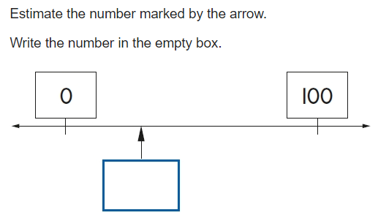

Challenge question:

A number around 30
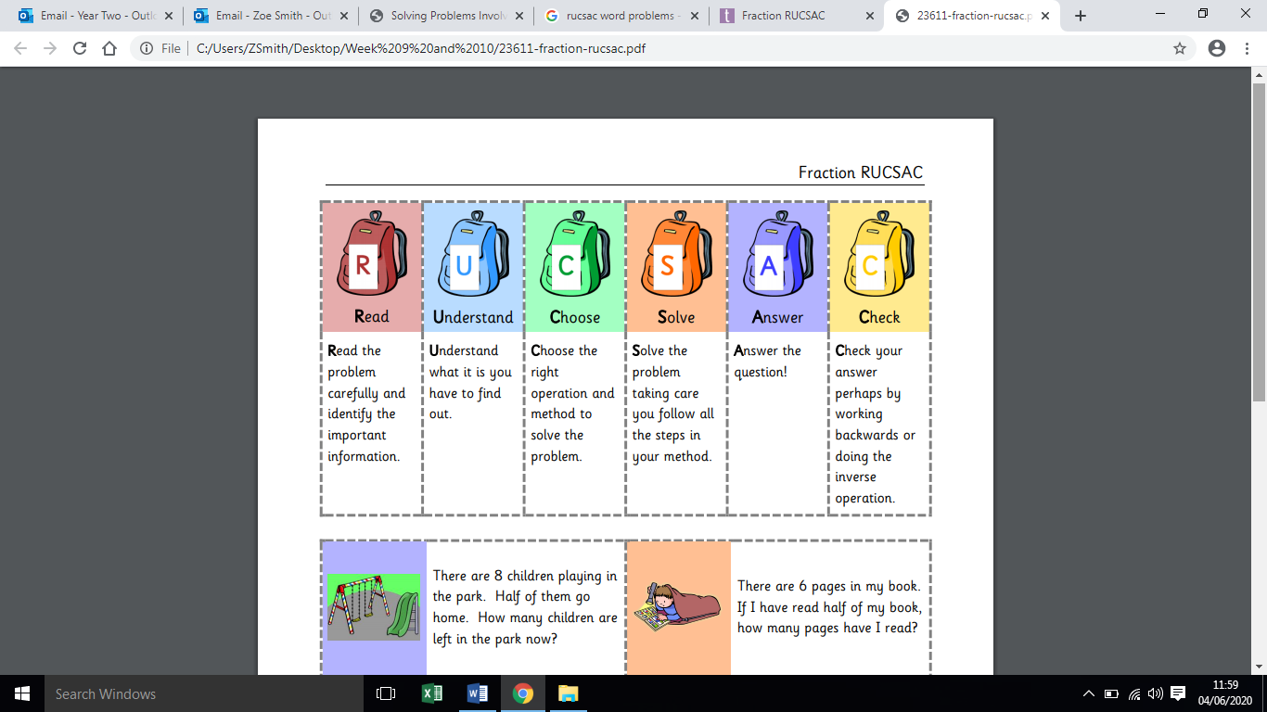
Friday:
Today you are going to use your rounding
and estimating skills to help you answer
word problems. Use the RUCSAC guidance
to help you:

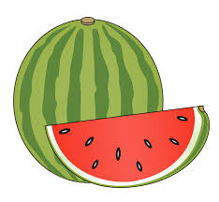
Word problems:
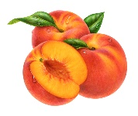
- Jessica grew 24 peaches. Mary grew 37 watermelons.
Estimate how many much fruit they grow altogether.
20 + 40 = 60
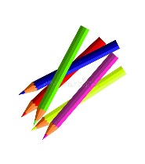
- There were 31 pencils in the drawer. Mrs Smith took out 17 pencils
for children to use.
Estimate how many pencils were now in the drawer.
30 - 20 = 10
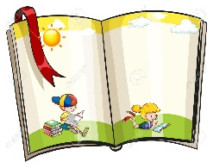
- Mrs Williams read 56 pages of a book, then a further 42 pages.
Estimate how many pages they read in total.
60 + 40 = 100

- Claire founds 37 sea shells on the beach. Laura found 49 sea shells
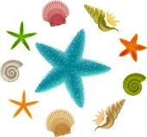
and 12 starfish.
Estimate how many items they found altogether.
40 + 50 + 10 = 100


- Adele had 103ml of water in her bottle in the morning. By the afternoon, she had drunk 32ml of water.
Estimate the amount of water left in the bottle.
100 - 30 = 70

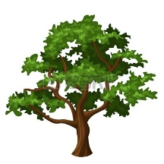
- An oak tree grew 43cm in May, 78cm in June and 65cm in July.
Estimate how much it grew altogether.
40 + 80 + 70 = 190

