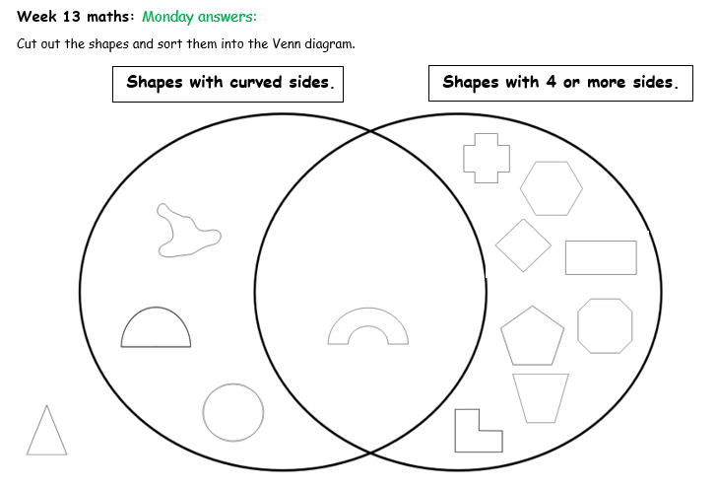
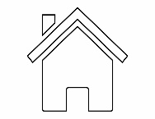

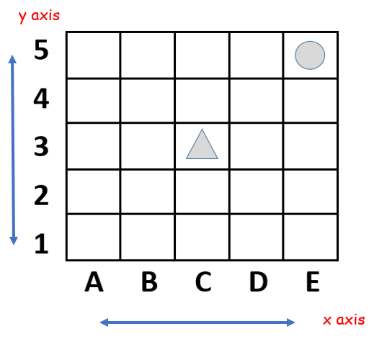
Wednesday answers:

- Where is the triangle? (C,3)
- Where is the circle? (E,5)
- Draw a house in D4
- Draw a tree in B5
Draw your own objects and give their co-ordinate:
I’ve put a___________ in _____
I’ve put a ___________in _____


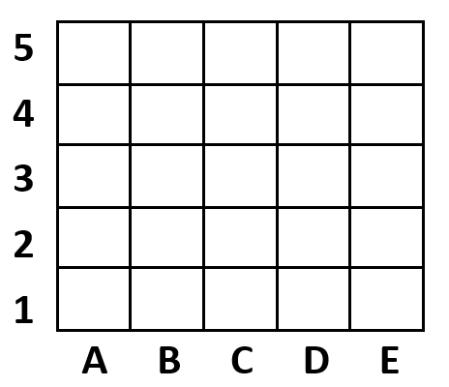



Draw your own shapes/objects in boxes to create your own map and give their co-ordinates:
I’ve put a___________ in _____
I’ve put a ___________in _____
I’ve put a___________ in _____
I’ve put a ___________in _____
I’ve put a ___________in _____
Show this route on your map:
A1, A2, B2, C2, C3, C4, D4, E4, E5
What route would you like someone to follow on your map?
___________________________________________
Thursday answers: Treasure Island co-ordinates
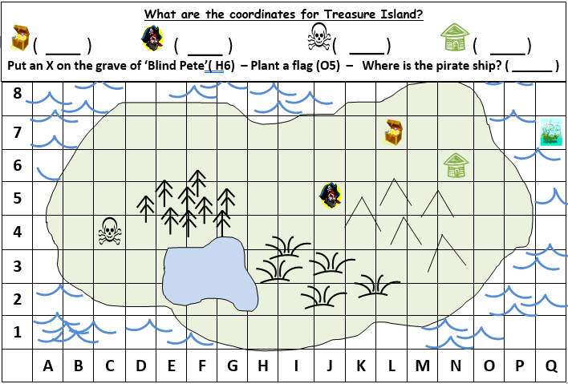
L,7
N,6
C,4
J,5
Q,7

X

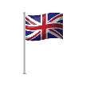

Try this one and see if you can answer the questions.
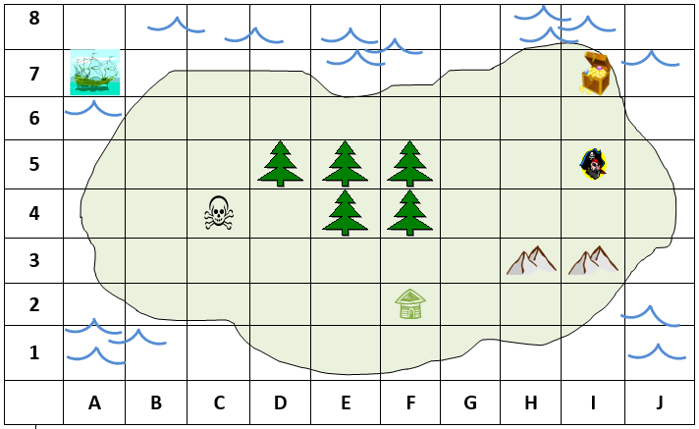

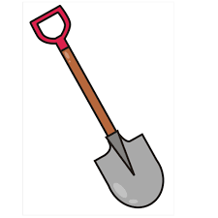

X

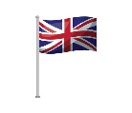



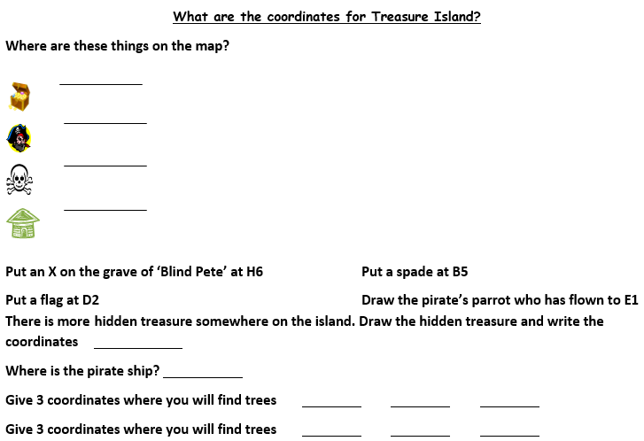

(I,7)
(I,5)

(C,4)

(F,2)

G4

(A,7)
(F,5)
(E,5)
(D,5)
(F,4)
(E,4)
(I,3)
(H,3)
Give 2 coordinates where you will find mountains

