Week 13 maths:
This week we are looking at sorting data using Venn diagrams.
Try this interactive game to get you going. Make sure you choose an option from each section: https://mathsframe.co.uk/en/resources/resource/83/sort_shapes_venn



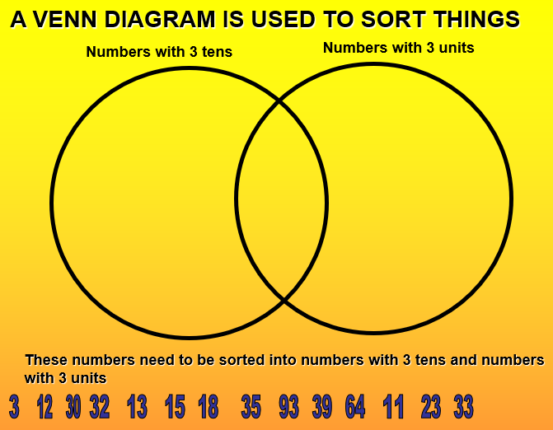

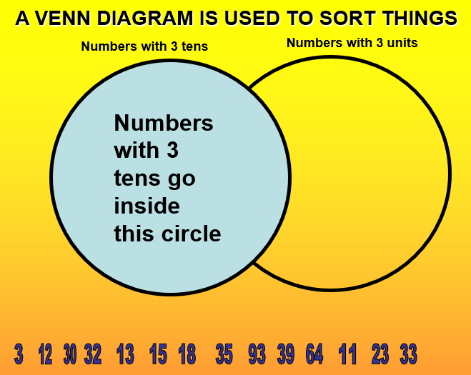

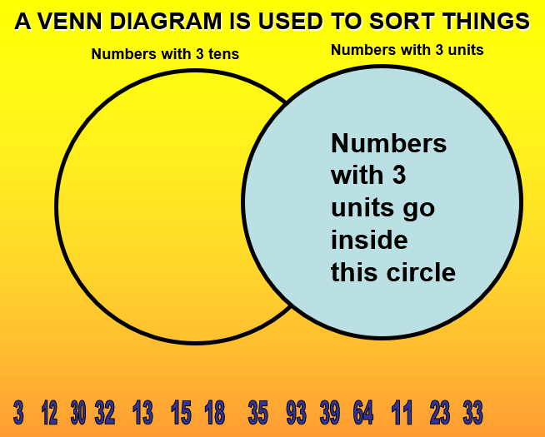

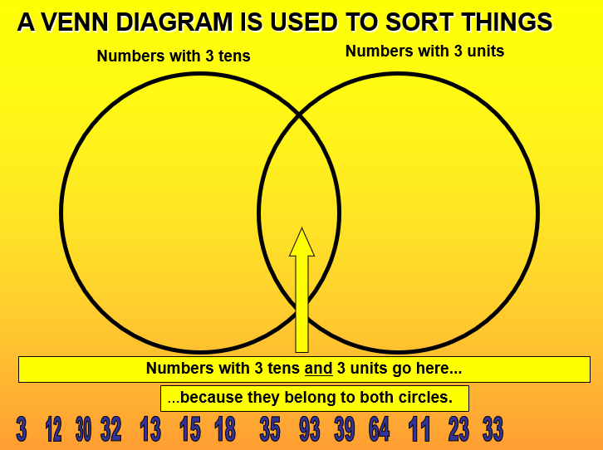

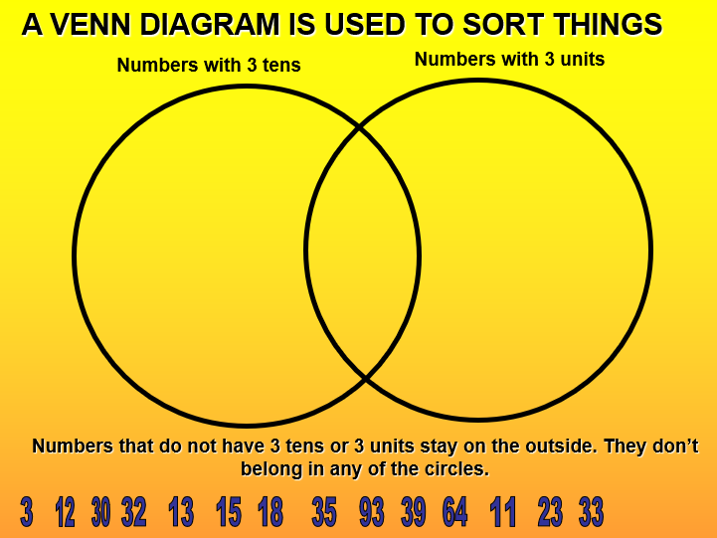

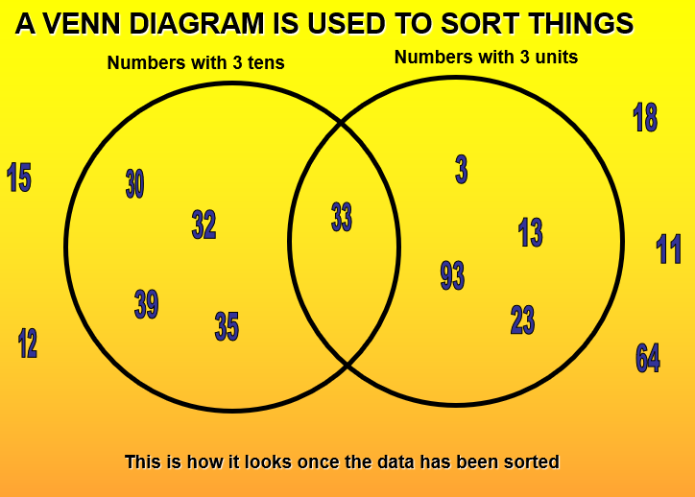

Monday:
Cut out the shapes and sort them into the Venn diagram.
Shapes with curved sides.
Shapes with 4 sides.
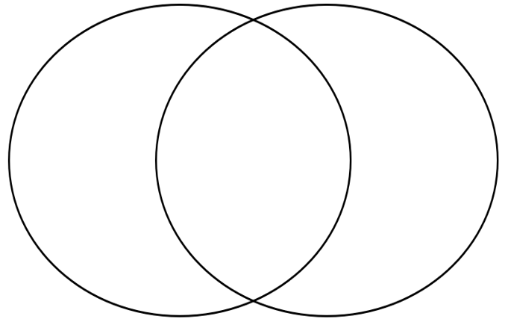


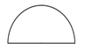
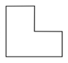


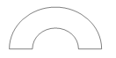
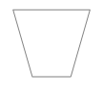
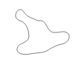
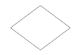





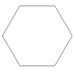
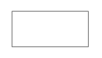

Tuesday: Today you are going to collect some things around your home to sort into the Venn diagram
below. You can draw them or just their name in.

Things you can eat

.
Things that are red

.

Tuesday: Now use the Venn diagram to either find another way of sorting the things you have collected or you can choose some different object (perhaps from the garden). Think carefully about your 2 headings (length, colour, solid, liquid etc) You can draw them or just write the name in.

.

.

Wednesday: Today you are going to plot co-ordinates on a grid.
Coordinates are always written in brackets, with the two numbers / letters separated by a comma.
The first number / letter tells you the point on the x axis and the second the point on the y axis.
Have a go at this game to give you a better idea of how coordinates work: http://www.scootle.edu.au/ec/viewing/L350/index.html#

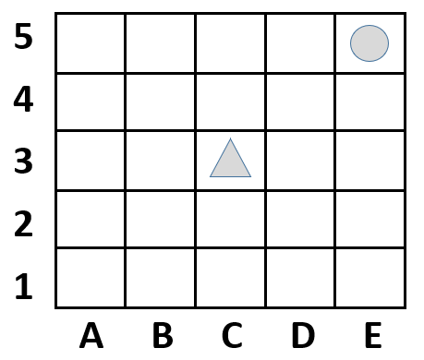
y axis
To find the co-ordinates of the , I would look along the x axis FIRST until I reach the column the is in. I can see it is in the column marked C.
Then I would look along the y axis until I reach the row the is in. I can see it is in the row marked 3, so I would write the co-ordinates as:
(C, 3)

x axis

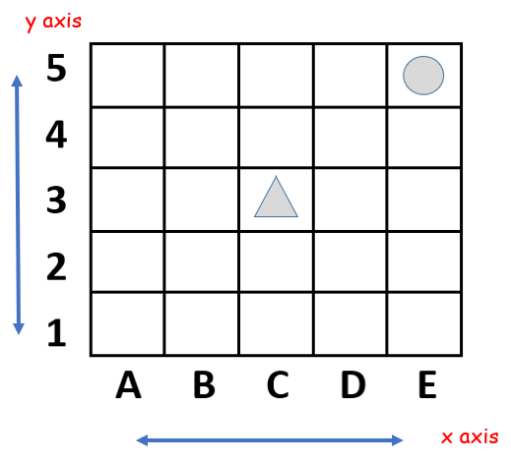

- Where is the triangle? _____
- Where is the circle? _____
- Draw a house in D4
- Draw a tree in B5
Draw your own objects and give their co-ordinate:
I’ve put a___________ in _____
I’ve put a ___________in _____

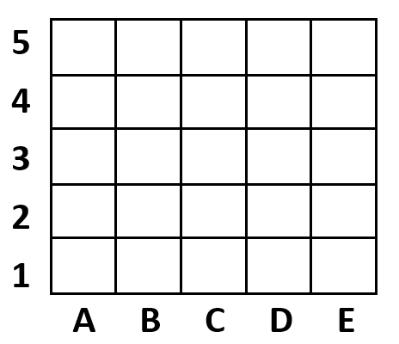

Draw your own shapes/objects in boxes to create your own map and give their co-ordinates:
I’ve put a___________ in _____
I’ve put a ___________in _____
I’ve put a___________ in _____
I’ve put a ___________in _____
I’ve put a ___________in _____
Show this route on your map:
A1, A2, B2, C2, C3, C4, D4, E4, E5
What route would you like someone to follow on your map?
___________________________________________
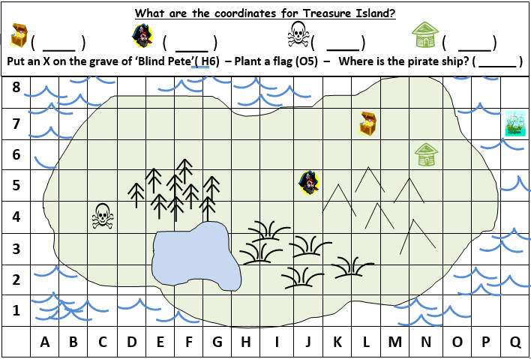
Thursday: Treasure Island co-ordinates

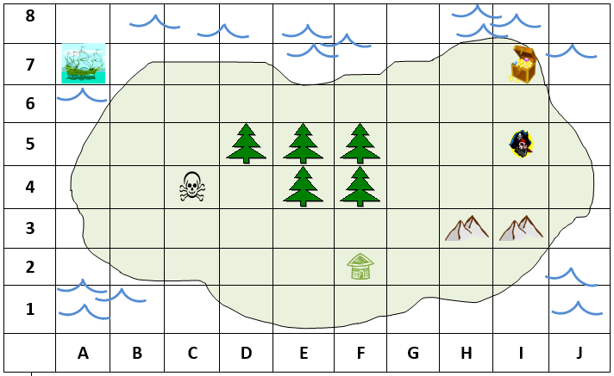
Try this one and see if you can answer the questions.

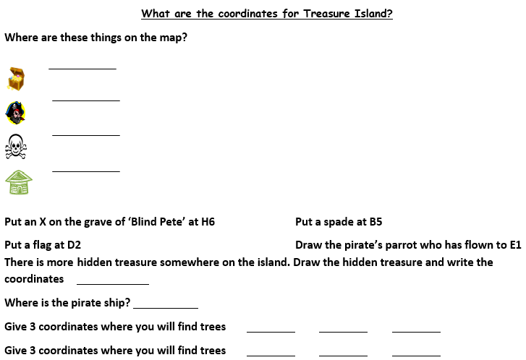

Friday: use the blank grid to design your own island with landmarks to find the co-ordinates for.
You can be as imaginative as you like and it can be any sort of island.
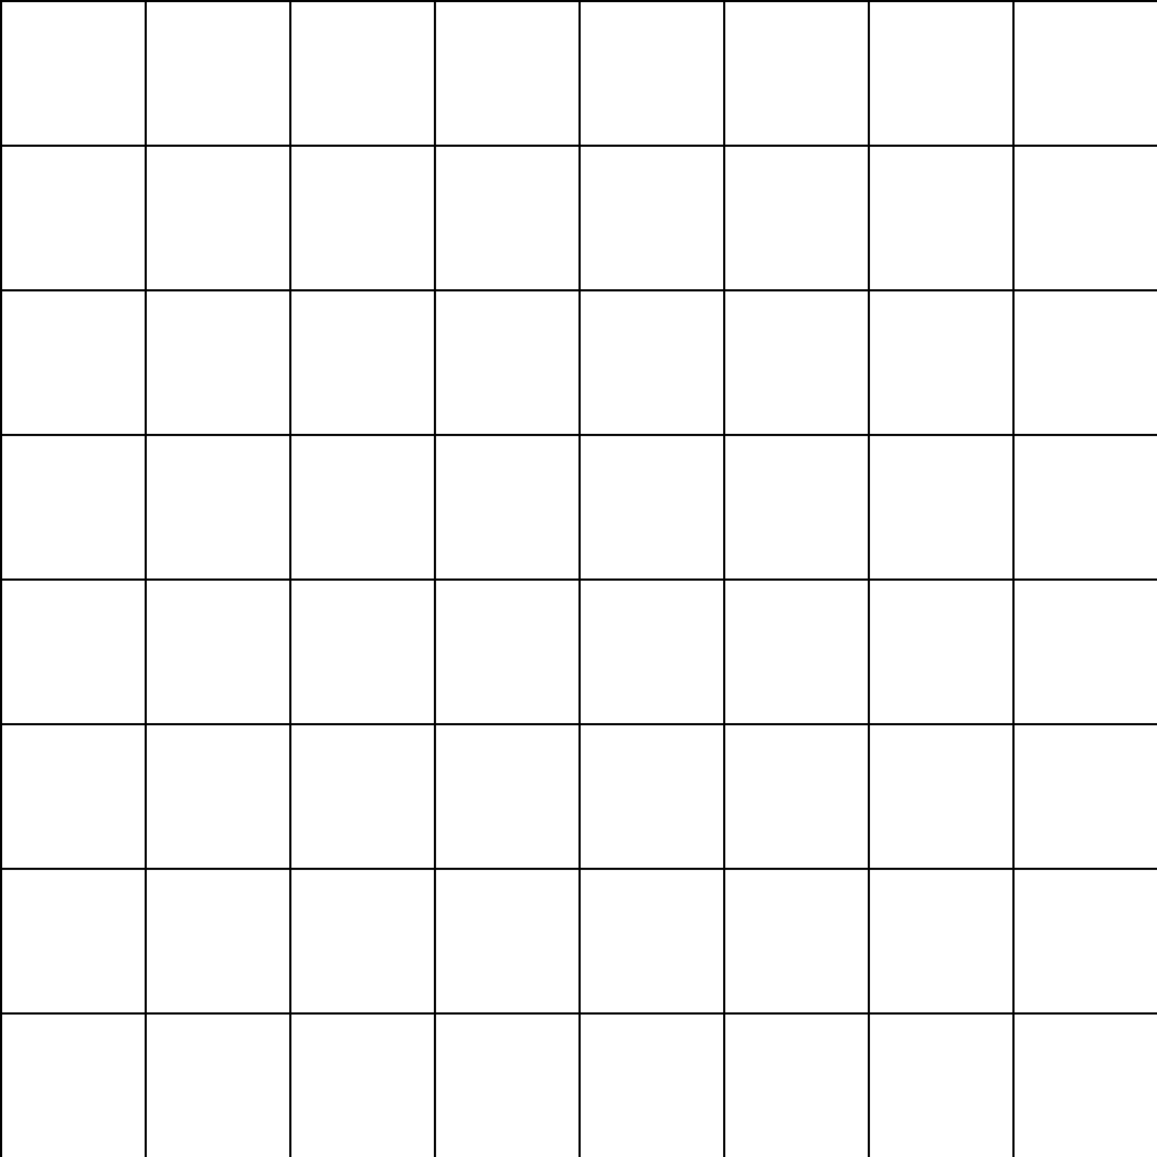

Come up with some questions for someone in your house to find the coordinates for. You can even get them to draw landmarks or objects in coordinates you have given.

