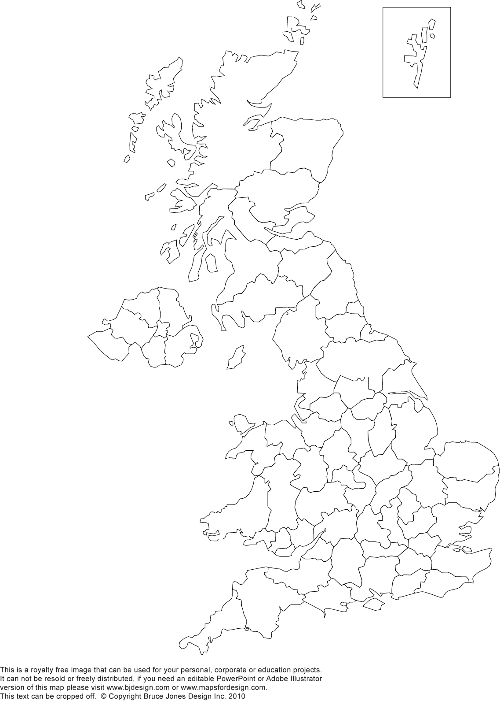
Map of the UK

Can you label the countries that make up the UK?
Shade them in neatly once you have labelled them.

Can you label the following counties:
- Kent
- Dorset
- Devon
- Sussex
- Hampshire

Map showing the counties of England
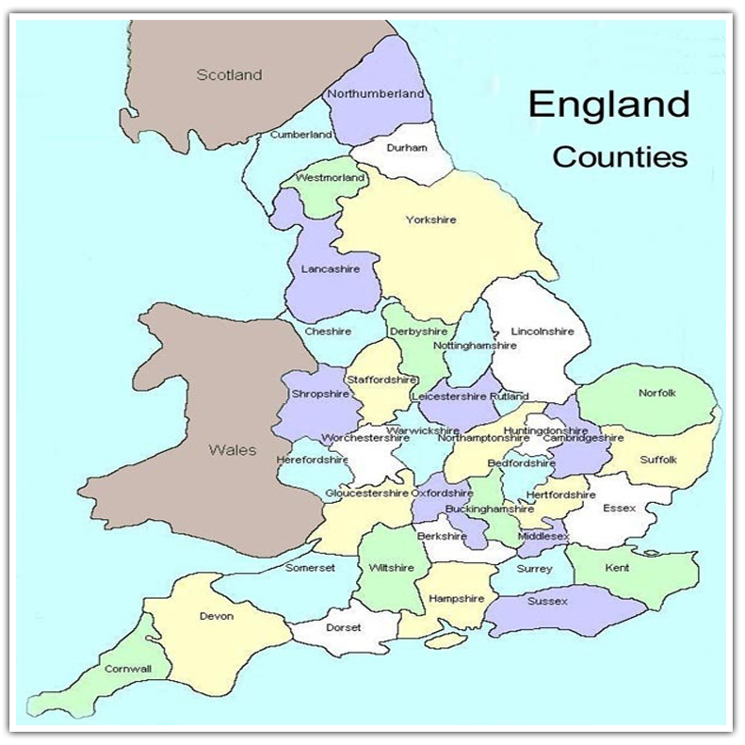
Did you label the counties correctly?

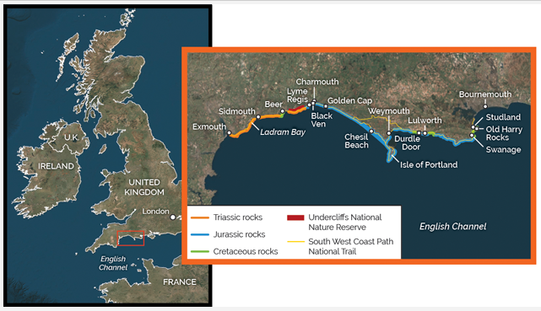
Map showing the Jurassic Coastline – show this on your map

