Fossil Facts

Fossil Facts
Have you ever wondered how we know so much about the dinosaurs, even though it’s been millions of years since they walked the Earth? Well, we have fossils to thank for that!
Fossils can give scientists clues about animals and plants that lived a long, long time ago.

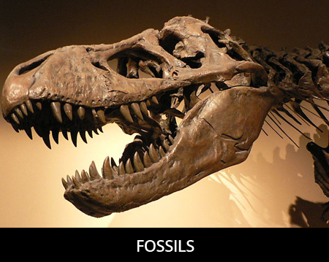

What exactly are fossils, and how do they form?
Fossils are nature’s records of animals and plants that lived a long, long time ago. Most of the time when we think of fossils, we think of animal remains that have turned to stone over time. How does this happen?

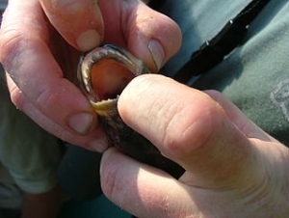

Well, sometimes the body of a dead animal sinks into dirt or mud. Some parts of the animal’s body will decay over time, but harder, stronger parts like teeth and bones will remain.
These remains stay in the mud for a very long time, and eventually more mud starts pressing down on top of the animal’s remains.

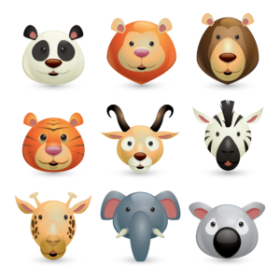

Over time, minerals from the surrounding dirt, rock, and other debris turn the remains into a hard fossil. This fossil is basically a stone copy of the original object.
Fossils can also form through a process called petrification, which happens when minerals replace previously living material. Wood and bone are often petrified, and so are many dinosaur fossils.
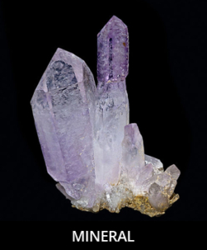

Sometimes, insects or small pieces of plants are found preserved in amber. This happens when animals or plants get trapped in sticky resin from trees, which eventually hardens into amber with the organism (plant or animal) still stuck inside.
Sometimes even footprints and burrows (holes that animals live in) can be fossilised.
For example, dinosaur footprints from long ago may have filled with sediment (sand, mud, little pieces of rock) and then eventually hardened into fossils.
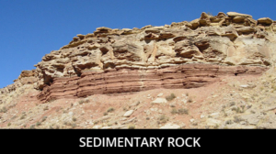

What is paleontology?
The study of life that existed in geologic periods many, many years ago is called palaeontology. The scientists who study palaeontology are called palaeontologists, and they mostly use fossils to learn about the past.
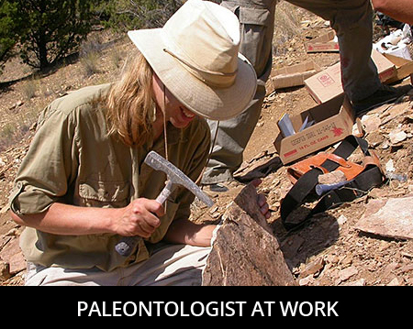

Palaeontologists say that most animals don’t fossilise, and that only a very small number of dinosaurs who lived will ever be found as fossils. That means that many dinosaurs and other animals existed that we will never even know about!

What can we learn from fossils?
Fossils can give us a lot of information about the past that we never would have known without them: what animals and plants looked like, where animals travelled, what animals ate, and more.
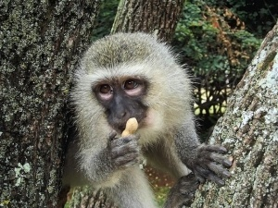

Fossils like footprints can help us learn about an animal’s size and shape. For example, if an animal had very big footprints, he was probably a very big animal.
Footprints can also tell us where and how far animals usually travelled. Fossilised burrows also give us information about where animals lived.

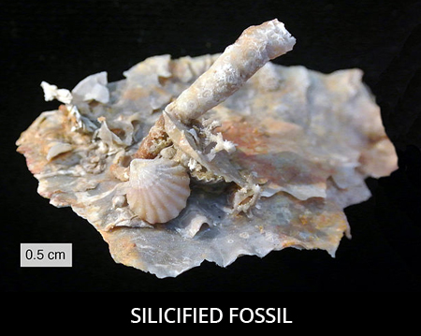

Did you know that even poop can be fossilised? Fossils of poop are called coprolites, and they can tell us what a creature ate.
That, along with fossilised teeth, tell us which dinosaurs were carnivores (meat eaters), which were herbivores (plant eaters), and which were omnivores (ate both meat and plants).
Coprolites from the Tyrannosaurus rex have been found containing tiny pieces of bones, telling scientists that the T-rex ate other animals for lunch!
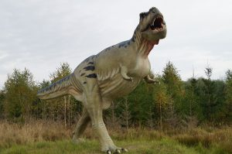

Fun facts about fossils
Fossils have been found on every continent in the world.
The largest fossil ever discovered is a petrified tree found in Thailand. The tree was more than 237 feet (72 meters) long, and was probably much taller when it was still living!

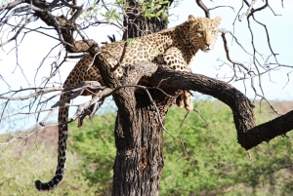

Fossils are also the reason scientists can estimate when the dinosaurs went extinct.
The largest dinosaur scientists have discovered is the Argentinosaurus, which was 110 feet long and lived in… Argentina!
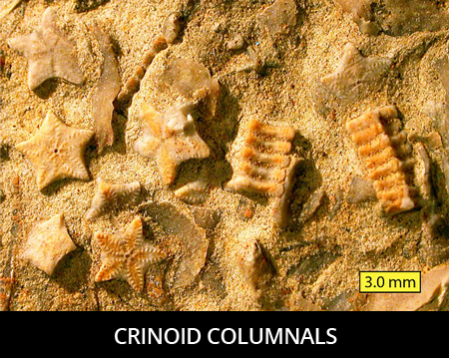

Fossils are important because they give us clues about what life was like a long time ago.
If we didn’t have fossils, we would never even know that dinosaurs existed!

