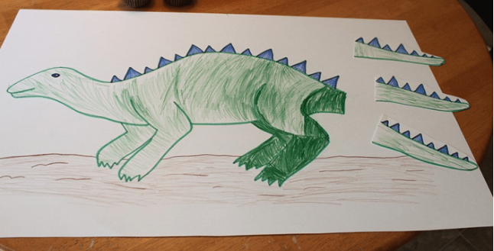
Pin the tail on the dinosaur game

- First draw your own dinosaur and colour it in.
- Cut out a tail (or three) for him.
- Use a sock or tea towel for a blindfold.
- Choose someone to play first and give them a tail.
- You might want to spin then once or twice (only if it’s safe).
- See if they can pin the tail in the correct place.
- If they fail, they have to do the exercise you choose.
- If they succeed, YOU have to the exercise they choose.

GOOD LUCK!

