Make Your Own Fantasy Jurassic Park

Create your own fantasy Jurassic Park using toy dinosaurs (or other animals!) and items from around the home.
Set up the scene in your garden, patio or around the house, take a photo, then email it to:

https://jurassiccoast.org/what-is-the-jurassic-coast/things-to-do/jurassic-coast-home-learning-activities/

All photos received will get a free fossil shark tooth!
We’d love to see your creations too so don’t forget to email them to your teacher.

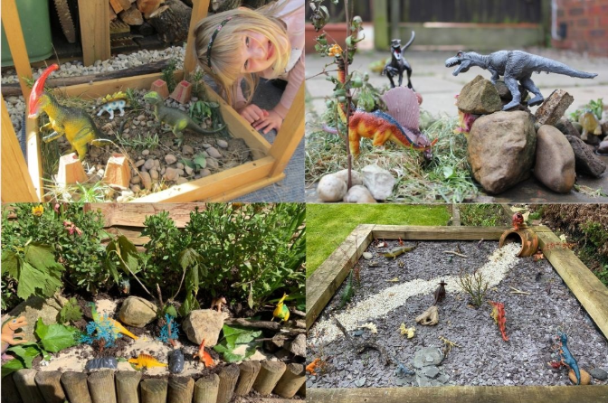
Here’s some examples to get you going…

