Week 10 – Maths
Over the next two weeks we will be looking at some word problems. Word problems can be about anything and can require any of the four operations to solve them. (add, subtract, divide, times)
Just like we do in school, follow the RUCSAC method to help you.
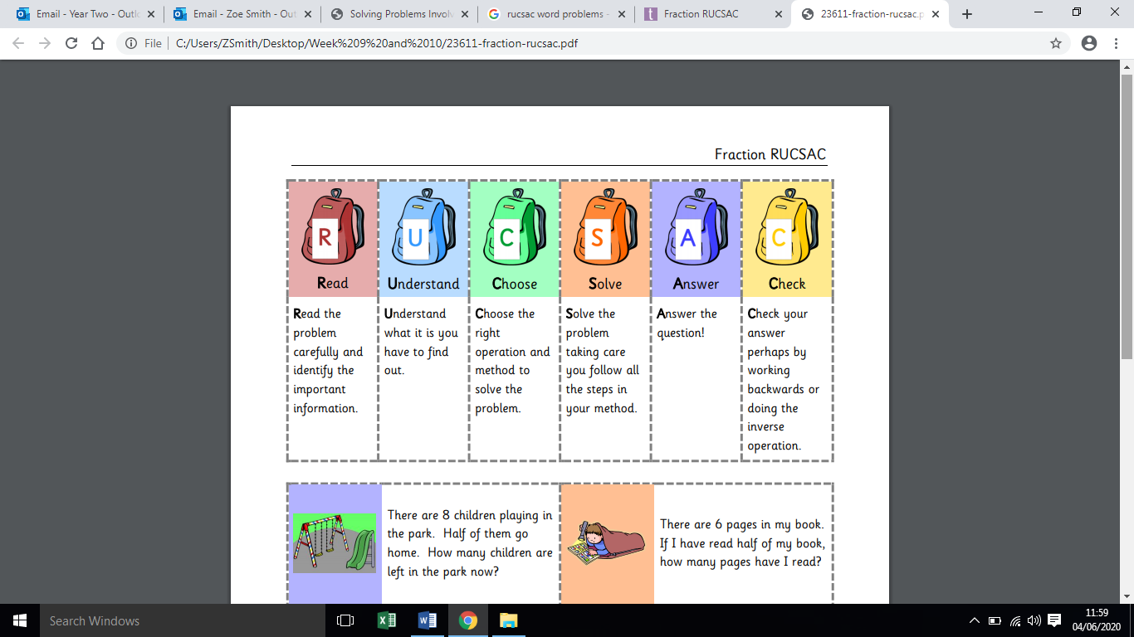

Here are some reminders to help you understand what the questions are asking you:

How much higher? What is the difference?
This refers to the gap between the two numbers so if you took the lowest number away from the highest number then you will see the difference, what is left in between or how much more there is.

What is the total?
This is how much you have when you put all the amounts together.

All answers will be posted on our Google Classroom if they are not on here so please email in if you don’t already have the log in details and we will send them to you.
Monday – Week 10

Warm up activity: Complete the questions below. The first side has pictures to help you. The second side is blank for you to draw or write the numbers yourself. Remember to write the number sentence to help you.
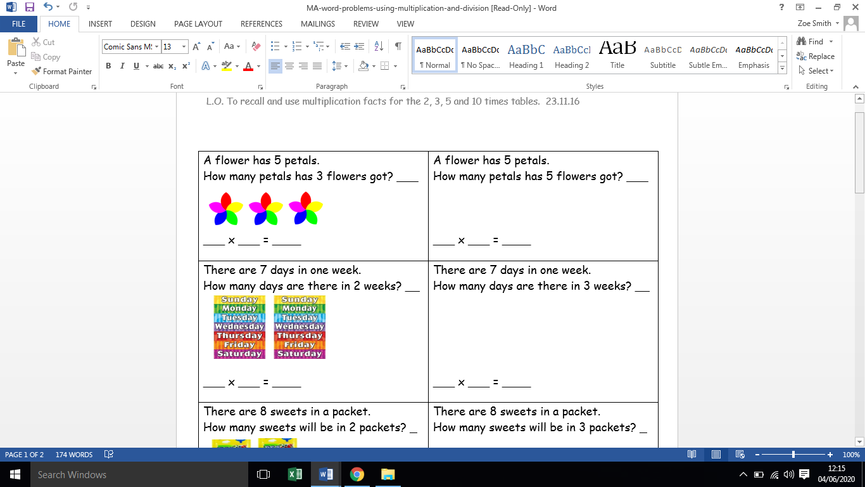
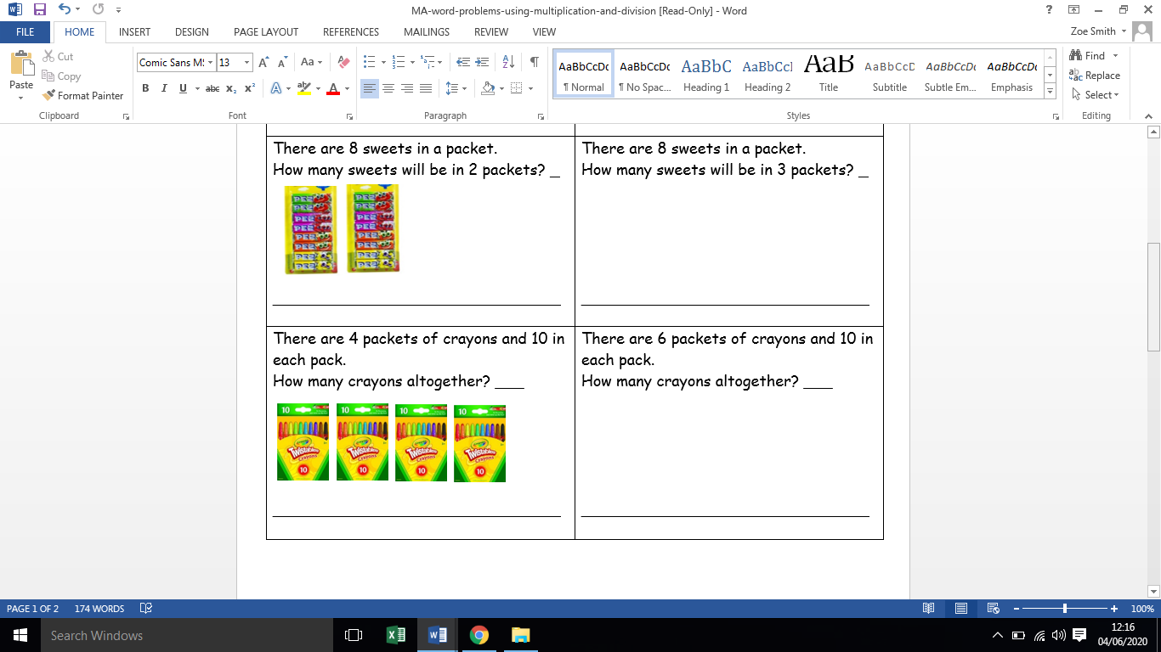

Main task – Solve the word problems below. Don’t forget to show your working out. You may want to draw a bar model or circles to help you with the harder ones.

Example: There are 4 wheels on one car. How many wheels will there be on 5 cars?
4 x 5 = 20


- 12 children are at a party. They each eat 2 cakes. How many cakes are eaten altogether?
- Dad is doing the washing. He has 14 socks. How many pairs of socks does he have now?

- Eddie gave half of his cars to his brother. He now has 10. How many cars did he have to start with?

- There are 15 worms in a bucket. Sam shares the worms fairly between 5 chickens. How many worms does each chicken get?

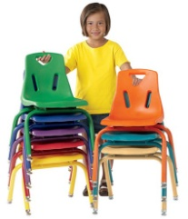
- There are 20 chairs. They get stacked in piles of 5. How many stacks of chairs will there be when they have been put away?

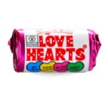
- Joe buys 6 trays of sweets. There are 10 packets of sweets on each tray. How many packets of sweets did he buy altogether?

Tuesday – Week 10
Today we are going to solve problems involving various measures.

Warm up activity: Can you read the measurements in these pictures?

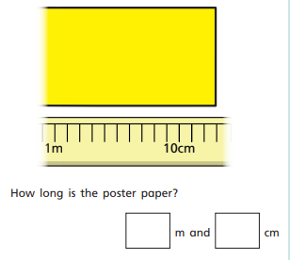
What temperature is showing on
each thermometer?
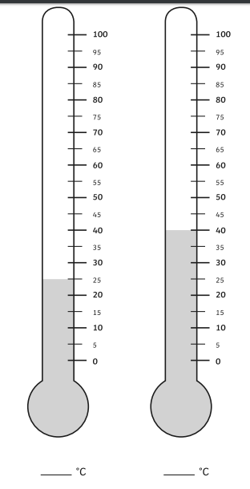

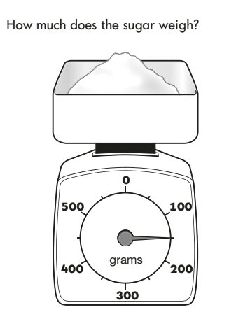

_________ g

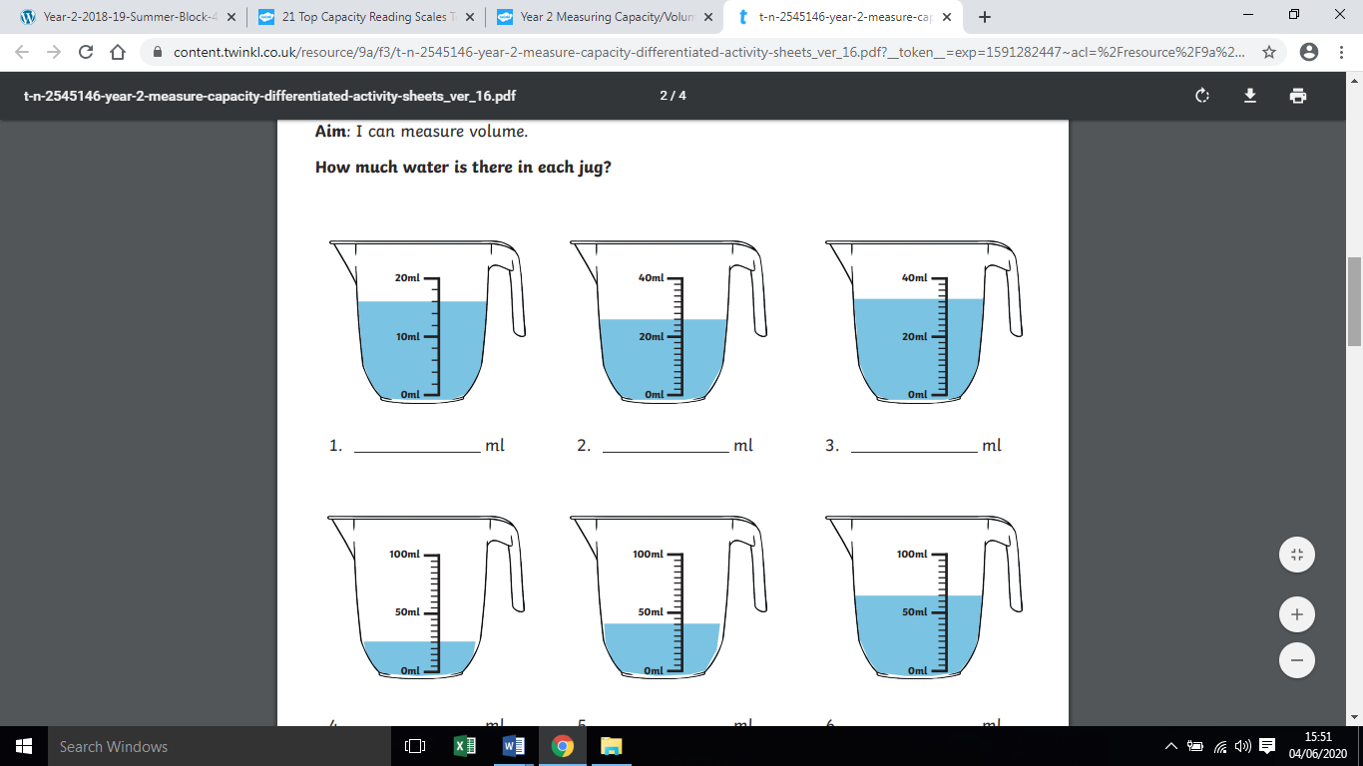

Main task – Solve the word problems below about the school activities.

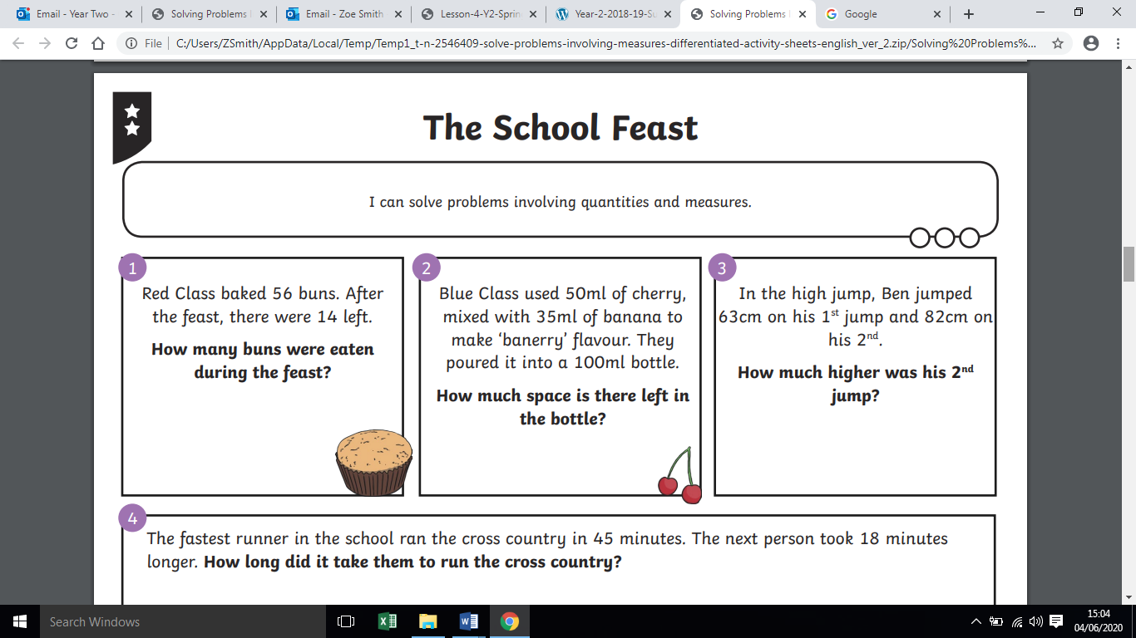
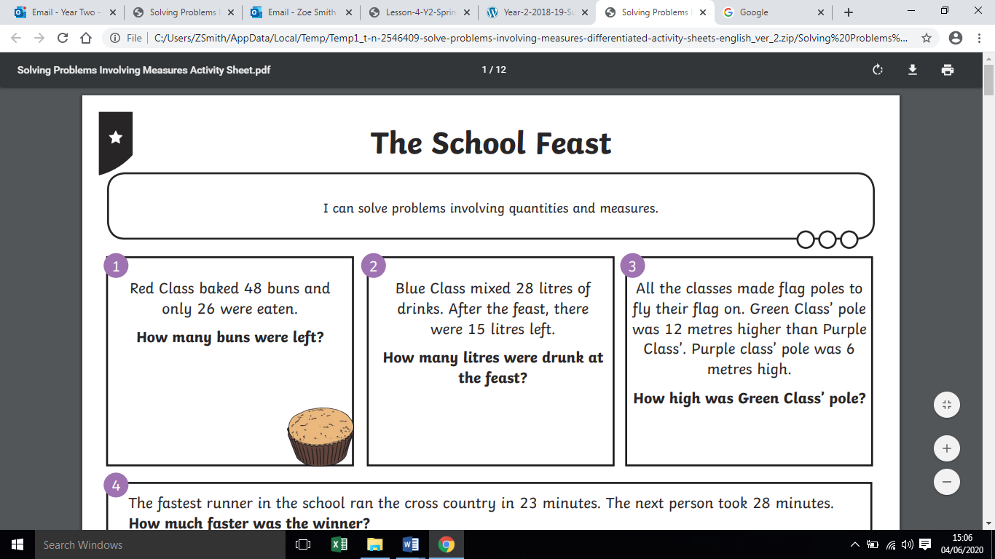

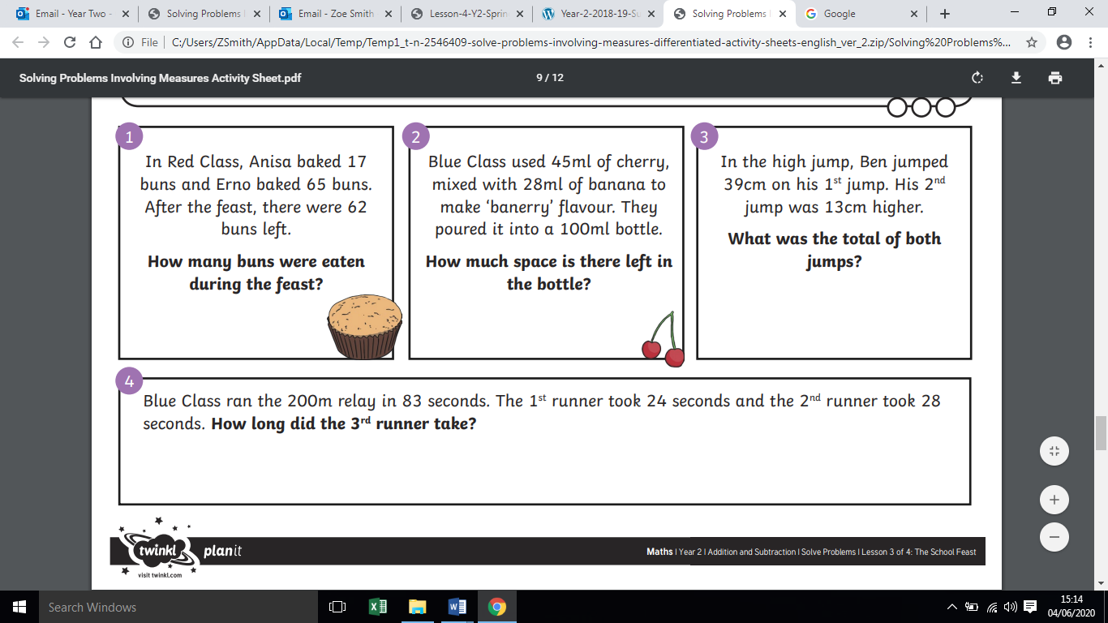

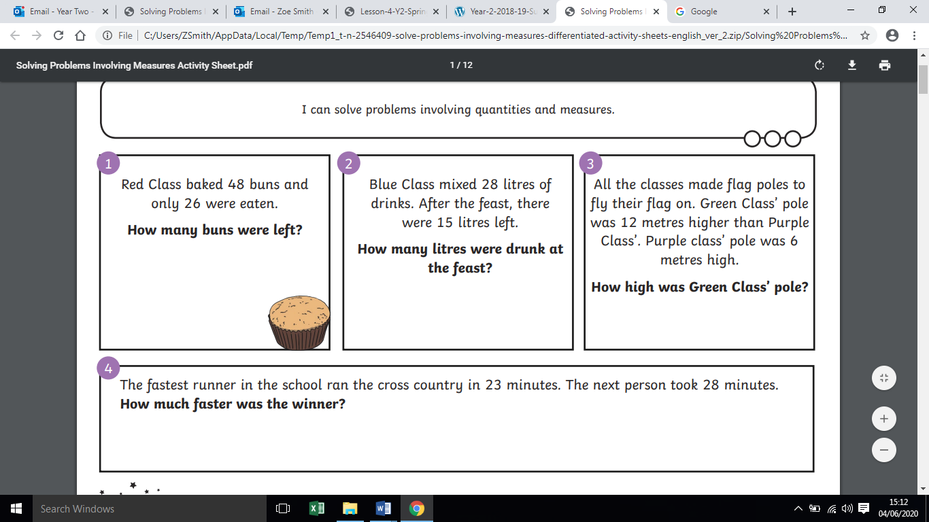

Wednesday – Week 10
Reasoning and Problem Solving: It is a really good skill to be able to reason and problem solve. You need to be able to describe your thought process and the reasons behind your thoughts.
For example: I think the missing number below is 10 because I have noticed that the other numbers are jumping up in 2’s. I know that in the 2 times table the number 10 comes after number 8 and before number 12.

0, 2, 4, 6, 8, ______, 12, 14, 16, 18, 20.

Warm up - What do you think is missing here? Remember to explain your thinking underneath.

10, 9, 8, ____, 6, 5, 4,

15, 20, 25, 30, 35, ______, 45, 50

0, 3, 6, 9, 12, 15, _____

Main task: Read through the problems below. Write your answer and explain your thinking beside each problem.
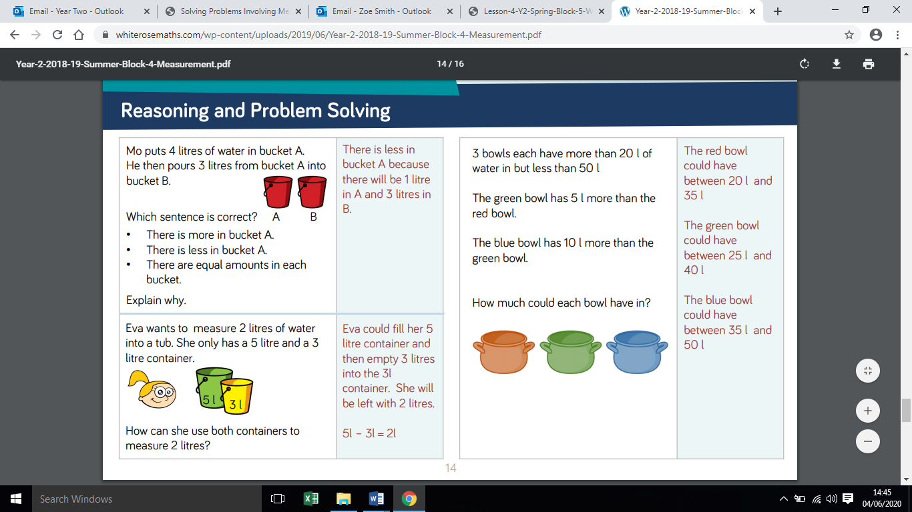
___________________________________________________________________________________________________________________________________________________________________________________________________________________________________________________________________________________________________________________________________________________________________

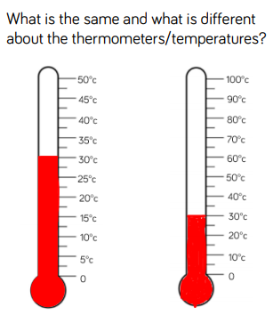
___________________________________________________________________________________________________________________________________________________________________________________________________________________________________________________________________________________________________________________________________________________________________

___________________________________________________________________________________________________________________________________________________________________________________________________________________________________________________________________________________________________________________________________________________________________

___________________________________________________________________________________________________________________________________________________________________________________________________________________________________________________________________________________________________________________________________________________________________

Thursday – Week 10
Task 1: Can you identify each 3D shape? Cut them out and match them up.
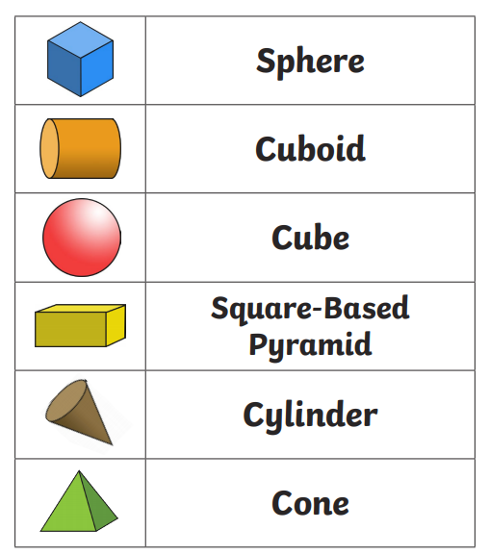

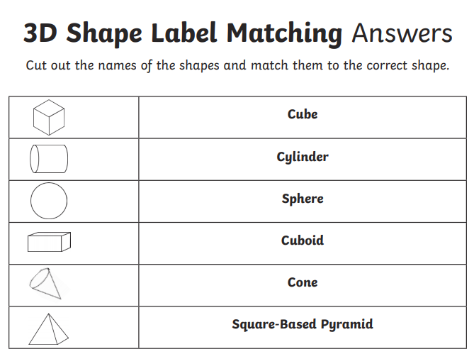

Task 2: 3D shape and properties matching cards.
If you can, print the cards and play with a partner. There will be a quiz on our Google Classroom tomorrow if you would like to play along to test your knowledge.
Friday – Week 10
Just for fun……

Task 1: Colour by 3D shape. Please choose a picture to colour.
Task 2: Play along with the 3D properties quiz on the Year Two Google Classroom if you have access to it.

