Monday – Week 11
For the next few days we will be recapping fractions and solving and reasoning about fraction word problems
Quick reminder:
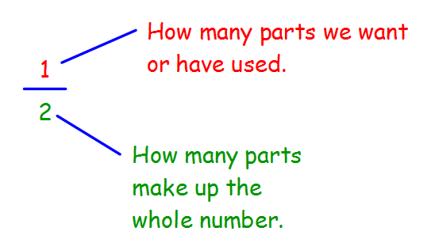
Warm up: Complete the questions below.
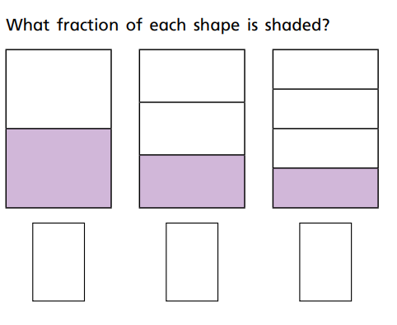

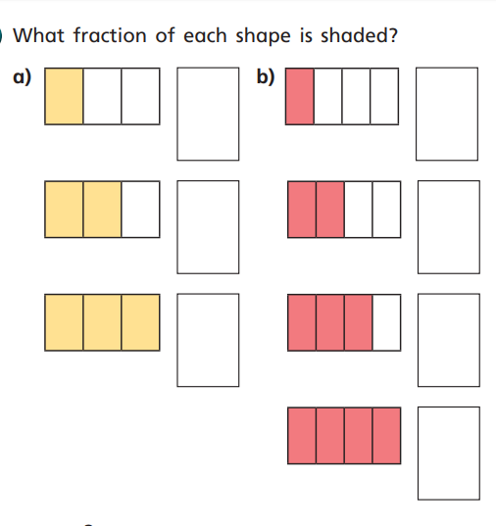

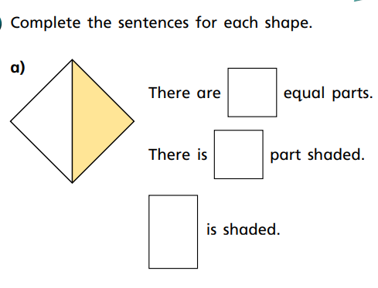

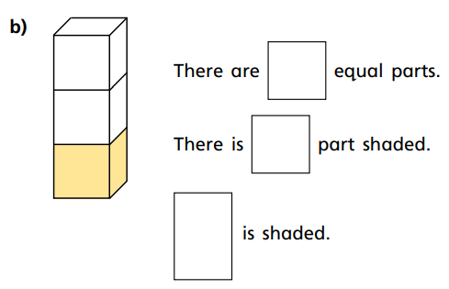

Main task: Answer the word problems below. Remember to use RUCSAC to help you and write your number sentence to show your working out.
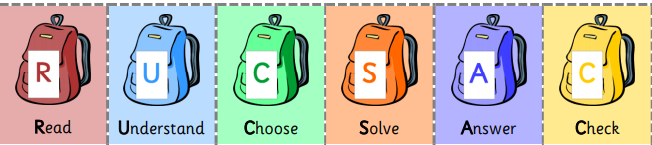

For Example: There are 12 children running in a race but only a quarter of them reach the finish line. How many reach the finish line?
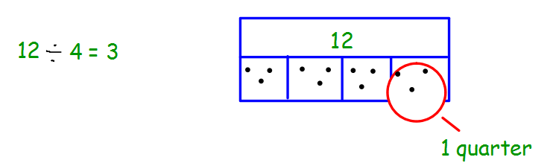
3 children cross the finish line.

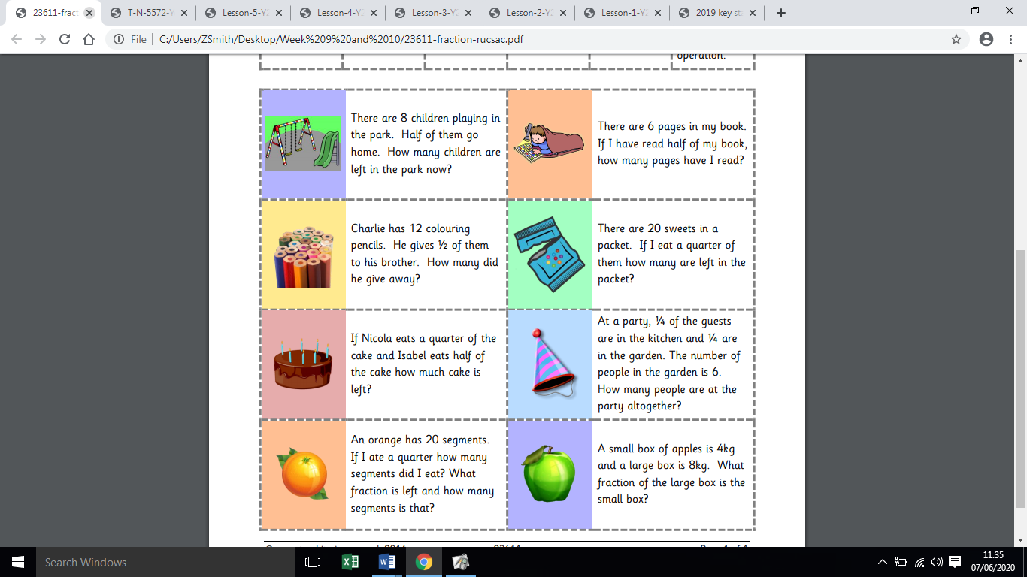

1.

2.

3.

4.

Tuesday - Week 11

Warm up: Solve the problems below.
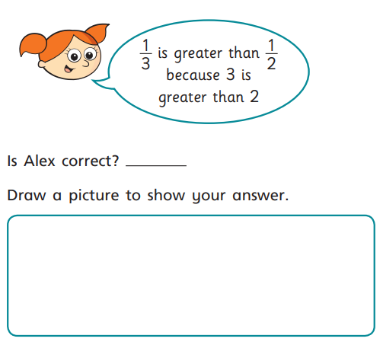

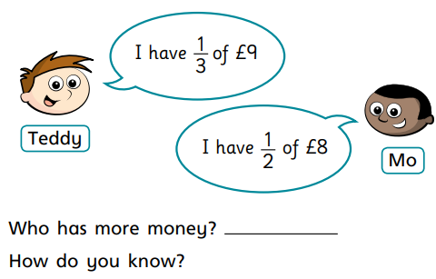

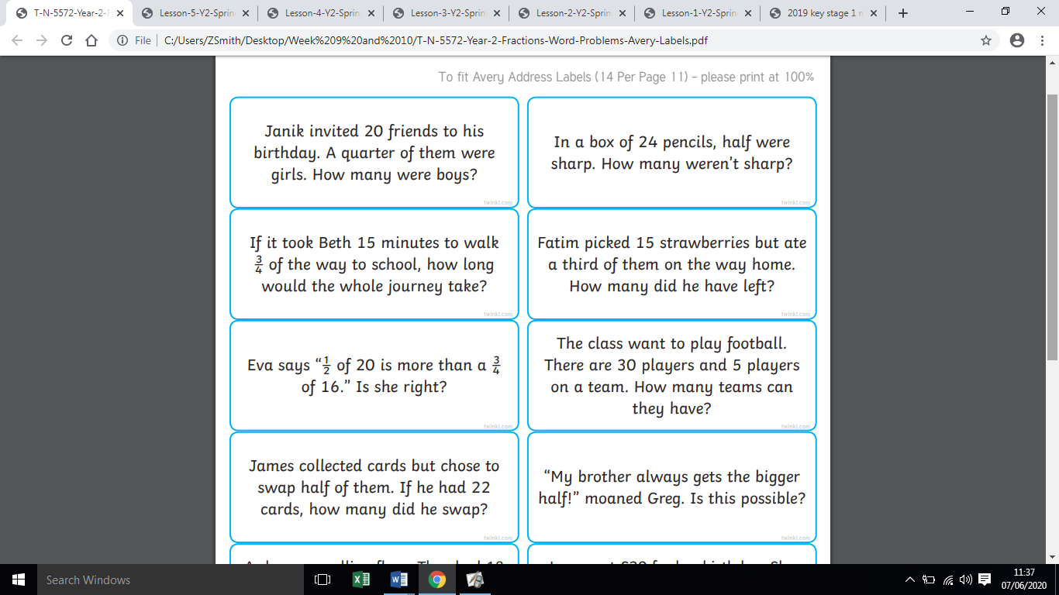

Main task: Solve the word problems below. Remember to use RUCSAC to help you and draw your working out to show your thinking.

1.

2.

3.

4.

5.

6.

Wednesday – Week 11 Today we are looking at equivalent fractions.

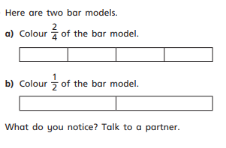
Warm up:

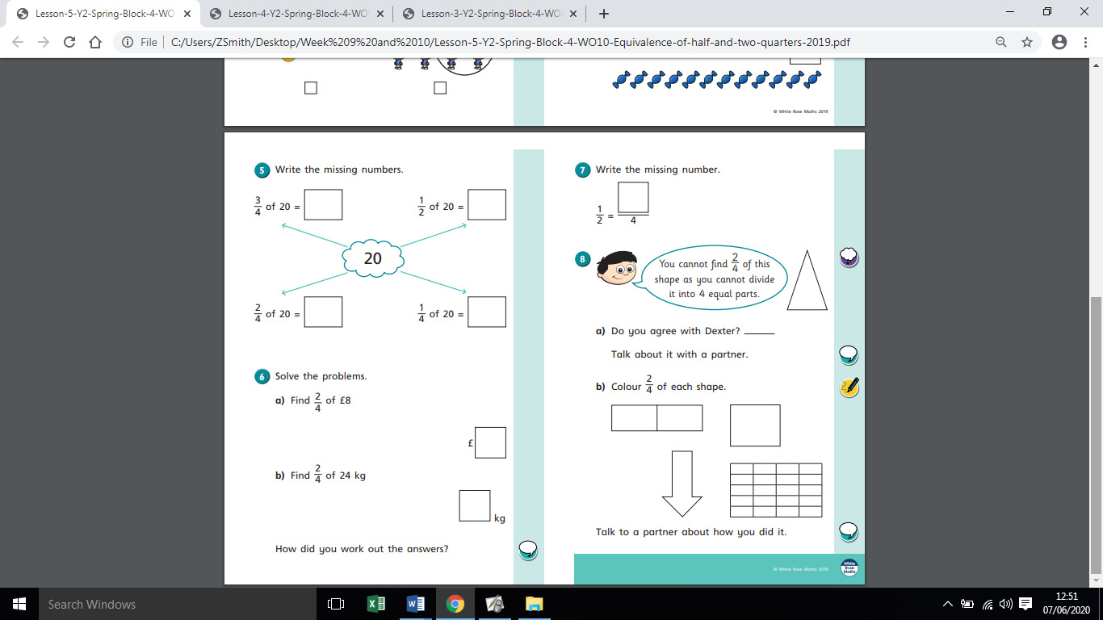

Main task:

- Please see ‘Fractions Strips’ document.

Cut out the strips and use them to answer the questions.

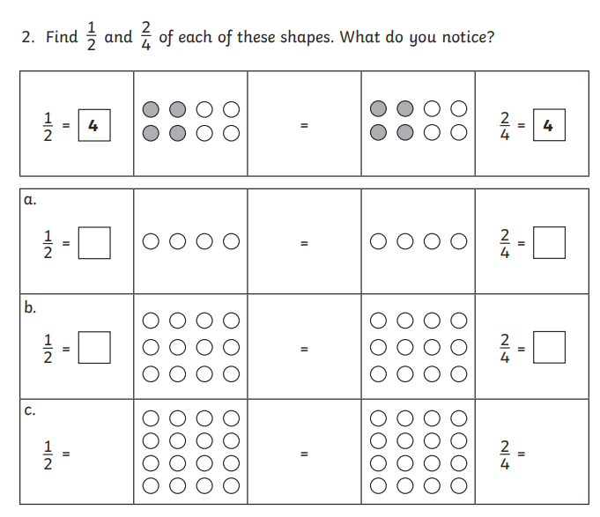

Thursday - Week 11
Today we are going to practise following different directions and turns.

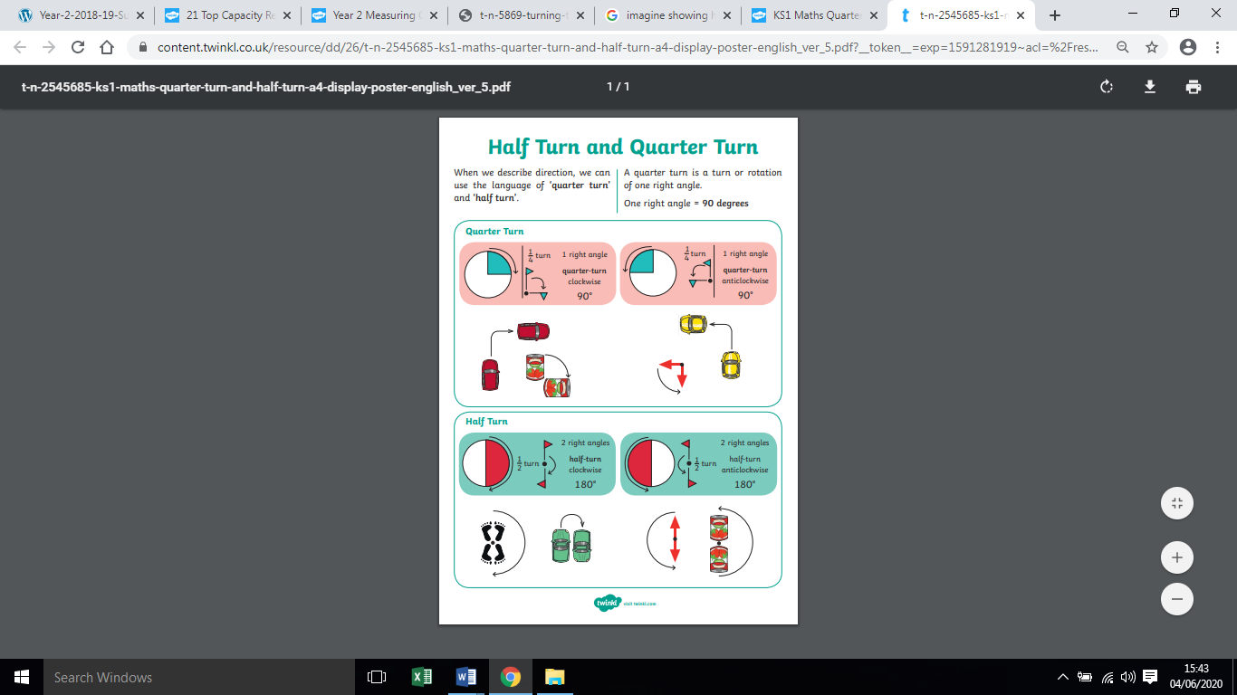

Main task - Cut out the turtles and stick them in the right position within each square. Always start with the turtle’s head pointing up right. (Please ignore the dice pictures, the activity has been adapted for home learning)
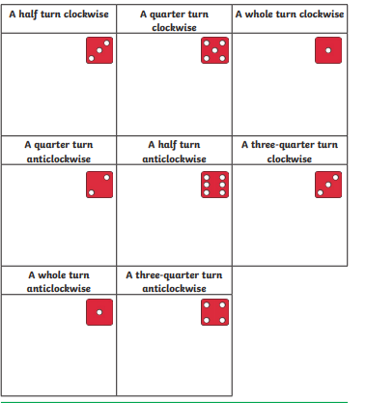

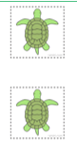
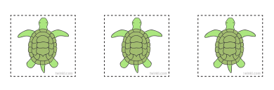
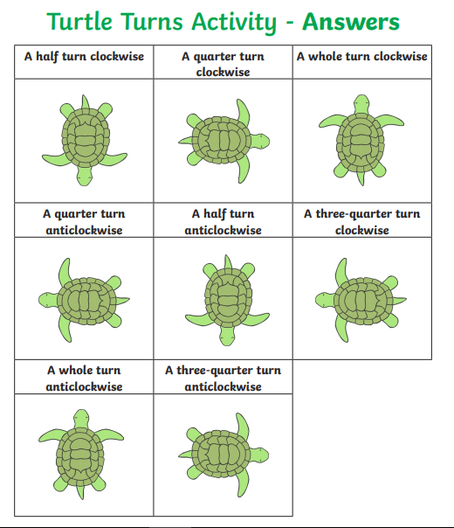

Friday – Week 11
Please see ‘Where’s Wally Direction Game’ document.

